Tools: Cisco Packet Tracer, YouTube, Google

Define and understand all topics, download cisco packet tracer to perform tasks listed below. You do not have to write a book, just enough to know what is needed. Show me that you understand the topics.

Once you complete the items below turn in any documents, spreadsheets, or diagrams used to complete this goal.

Task:

o Learn the OSI Model and show how it works

▪ What services are at each layer?

▪ What is encapsulation?

▪ What is ARP?

o Explain how a packet travels from a Router to an endpoint.

o Identify methods used to access and router or switch.

o What is a dongle and USB to serial interface cable, how do I know what USB port I am using?

o How to SSH – what commands to ssh in linux, what is putty, MobaXTerm

o Use Cisco Packet Tracer to set up a basic network - 1 router, 1 switch, and 1 host.

▪ Basic switch config:

Show how to configure a local username and password on a cisco switch or router

• Show commands used to turn a cisco interface on and off

• Show how to move endpoints from 1 vlan to another.

• Explain what Trunking is and how you would set it up?

• Show inter-vlan communication, router on a stick

• Show how to configure DHCP on a switch or router

• Configure DNS in Packet Tracer

• Basic ACL understanding -brief description

o Learn Subnetting/VSLM – give a brief description

▪ Give overview

• Host/network/CIDR-mask conversion

o Routing – Shown by brief write-up, Key points

▪ Overview

• OPSF

• EIGRP

▪ How to read routing table (basic-writeup)

• Unix

• Cisco

o Default Gateway

▪ What is it, why is it important

▪ How to configure the default gateway- what cmds-show screenshots for:

• Windows

• Unix

• Cisco

o How to change IP address/Networks on Unix and Windows GUI and CLI

o Know some Network Troubleshooting

• Ping

o Router

o Google.com

• Routing

o Tracert

o Traceroute

Networking

**OSI Model:**

The OSI Model (Open Systems Interconnection Model) is a framework used to describe the functions of a networking system. The OSI model characterizes computing functions into a universal set of rules and requirements to support interoperability between different products and software. In the OSI reference model, the communications between a computing system are split into seven different abstraction layers: Physical, Data Link, Network, Transport, Session, Presentation, and Application.

[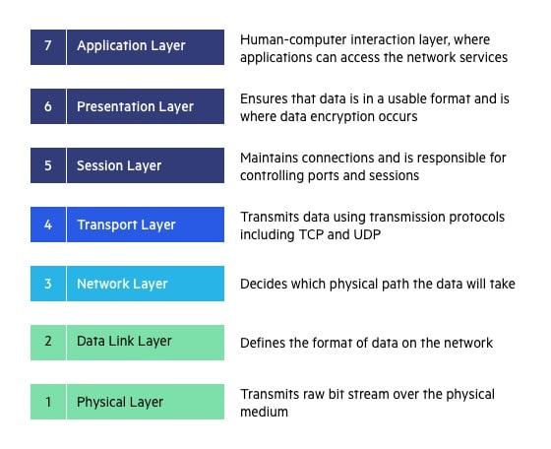](https://www.imperva.com/learn/wp-content/uploads/sites/13/2020/02/OSI-7-layers.jpg)

Services at each layer

**Application Layer**

* allows users to log on as a remote host.
* This layer provides access to global information about various services. This layer provides services which include: e-mail, transferring files, distributing results to the user, directory services, network resources and so on

**Presentation Layer**

* Data conversion
* Character code translation
* Compression
* Encryption and Decryption
* Serialization

**Session Layer**

* Authentication
* Authorization
* Session restoration (checkpointing and recovery)

**Transport Layer**

* Connection-oriented communication
* Datagram protocol and internet protocol
* Same order delivery
* Reliability
* Flow control
* Congestion avoidance
* Multiplexing ports

**Network Layer**

* Connectionless communication
* Host addressing
* Message forwarding

**Data Link Layer**

* Encapsulation of network layer data packets into frames (a process by which a lower-layer protocol receives data from a higher-layer protocol and then places the data into the data portion of its frame.)
* Frame synchronization
* In the logical link control (LLC) sublayer:
* Error control (automatic repeat request, ARQ), in addition to ARQ provided by some transport-layer protocols, to forward error correction
* ARP (a communication protocol used to discover the data-link layer address) ARP works between Layers 2 and 3 of OSI model. The MAC address exists on Layer 2 of the OSI model, the data link layer. The IP address exists on Layer 3, the network layer.
* In the medium access control (MAC) sublayer:
* Physical addressing (MAC addressing)
* LAN switching (packet switching), including MAC filtering, Spanning Tree Protocol (STP), Shortest Path Bridging (SPB) and TRILL (Transparent Interconnection of Lots of Links)
* Data packet queuing or scheduling
* Store-and-forward switching or cut-through switching
* Quality of service (QoS) control
* Virtual LANs (VLAN)

**Physical Layer**

* The physical layer performs bit-by-bit or symbol-by-symbol data delivery over a physical transmission medium (ex. network hubs, cabling, repeaters, network adapters or modems.)

**Advantages of OSI Model**

* The OSI model helps users and operators of computer networks:
* Determine the required hardware and software to build their network.
* Understand and communicate the process followed by components communicating across a network.
* Perform troubleshooting, by identifying which network layer is causing an issue and focusing efforts on that layer.
* The OSI model helps network device manufacturers and networking software vendors:
* Create devices and software that can communicate with products from any other vendor, allowing open interoperability
* Define which parts of the network their products should work with.
* Communicate to users at which network layers their product operates – for example, only at the application layer, or across the stack.

Routing

**Overview**

Routing is the process by which systems decide where to send a packet. Routing protocols on a system “discover” the other systems on the local network. When the source system and the destination system are on the same local network, the path that packets travel between them is called a direct route. If a packet must travel at least one hop beyond its source system, the path between the source system and destination system is called an indirect route. The routing protocols learn the path to a destination interface and retain data about known routes in the system's routing table. Accessing the router can be done wirelessly or using an Ethernet cable

**IPv4 router configuration**

Beginning in privileged EXEC mode, follow these steps to manually assign IP information to a VLAN interface:

|  |  |  |
| --- | --- | --- |
|  | **Command** | **Purpose** |
| **1.** | **configure terminal** | Enter global configuration mode. |
| **2.** | **interface vlan** vlan-id | Enter interface configuration mode, and enter the VLAN to which the IP information is assigned. The VLAN range is 1 to 4094. |
| **3.** | **ip address** ip-address subnet-mask | Enter the IP address and subnet mask. |
| **4.** | **exit** | Return to global configuration mode. |
| **5.** | **show interfaces vlan** vlan-id | Verify the configured IP address. |
| **6.** | **copy running-config startup-config** | (Optional) Save your entri |

**Network configuration in Cisco Packet Tracer**