Predicting On-Time Delivery in a Supply Chain Using Weka
Name: Jahnavi S Srinag
Tool Used: Weka
Date: October 30, 2025

Introduction
This project focuses on predicting whether a delivery will reach on time or be delayed using historical logistics data. Machine learning classification techniques are applied using the Weka tool to analyze data, train a predictive model, and evaluate its performance.

Problem Statement
You are working for a logistics company and need to predict whether a new delivery will be 'On Time' or 'Delayed'. The goal is to build a classification model using Weka that can help the company anticipate potential delays and improve operational efficiency.
Proof of Weka Installation


Dataset Description
The dataset used in this project contains 10,999 records and 12 attributes describing each shipment. These include details about the shipping mode, product cost, weight, customer interactions, and delivery status. The target variable is 'Reached.on.Time_Y.N' which indicates whether the delivery reached on time.
ALL ATTRIBUTES
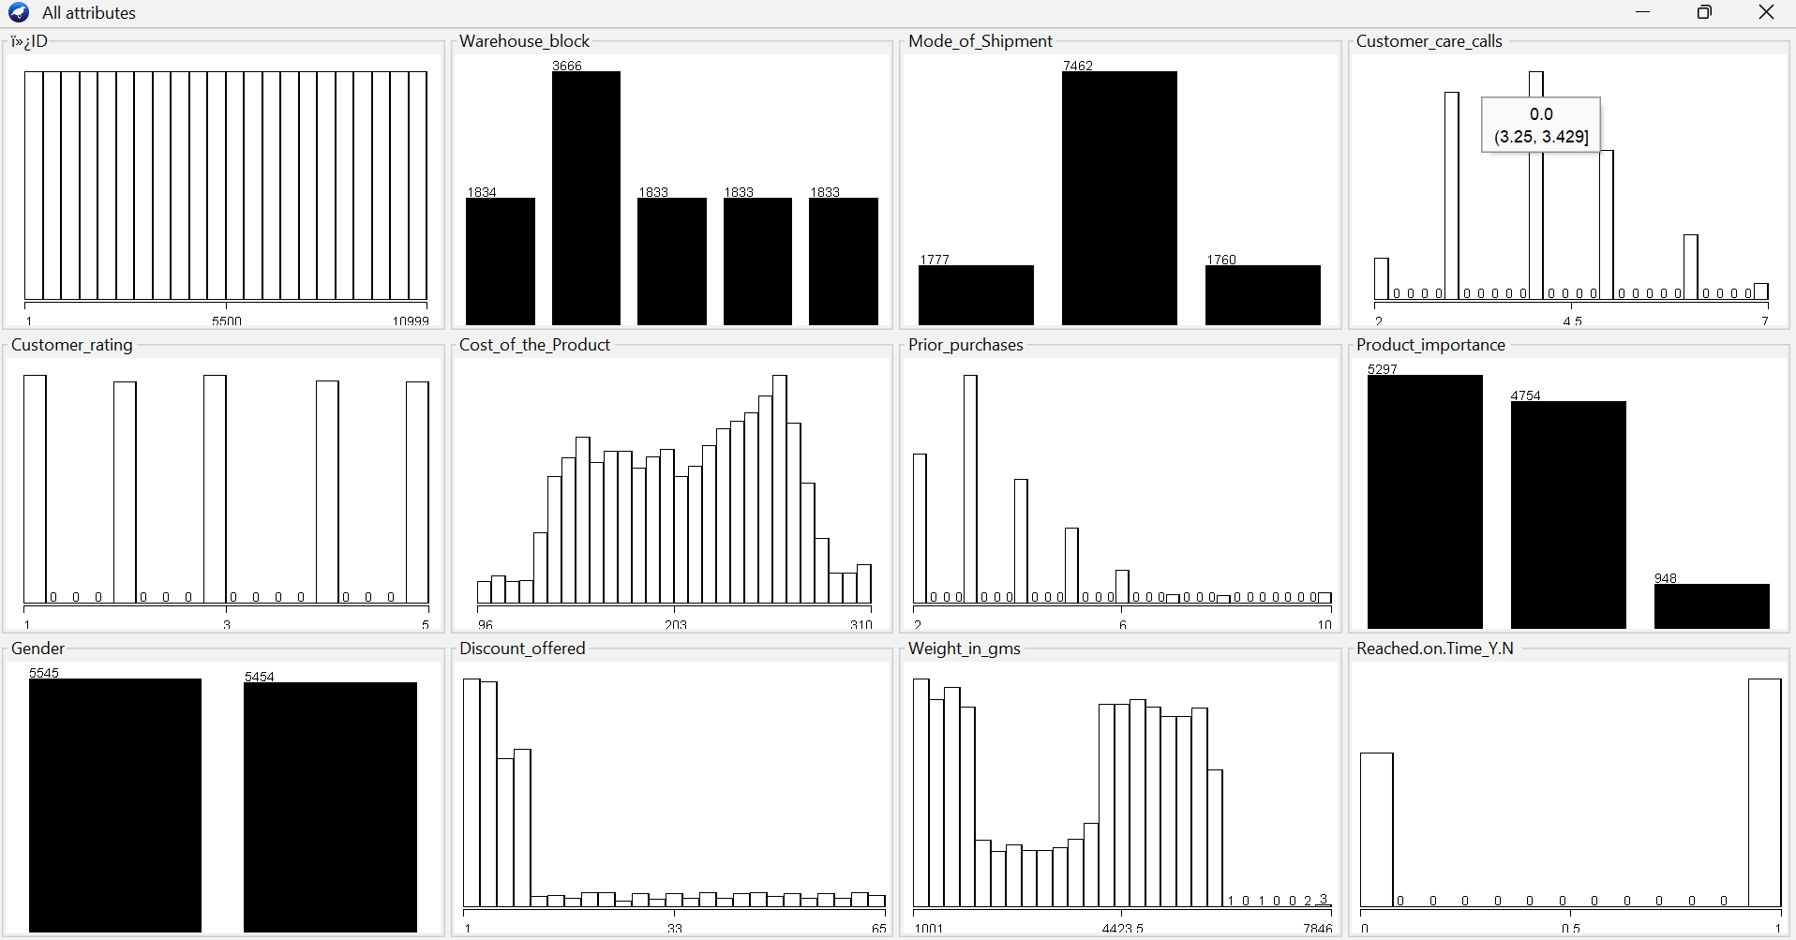

a)ALGORITHM: RANDOM FOREST
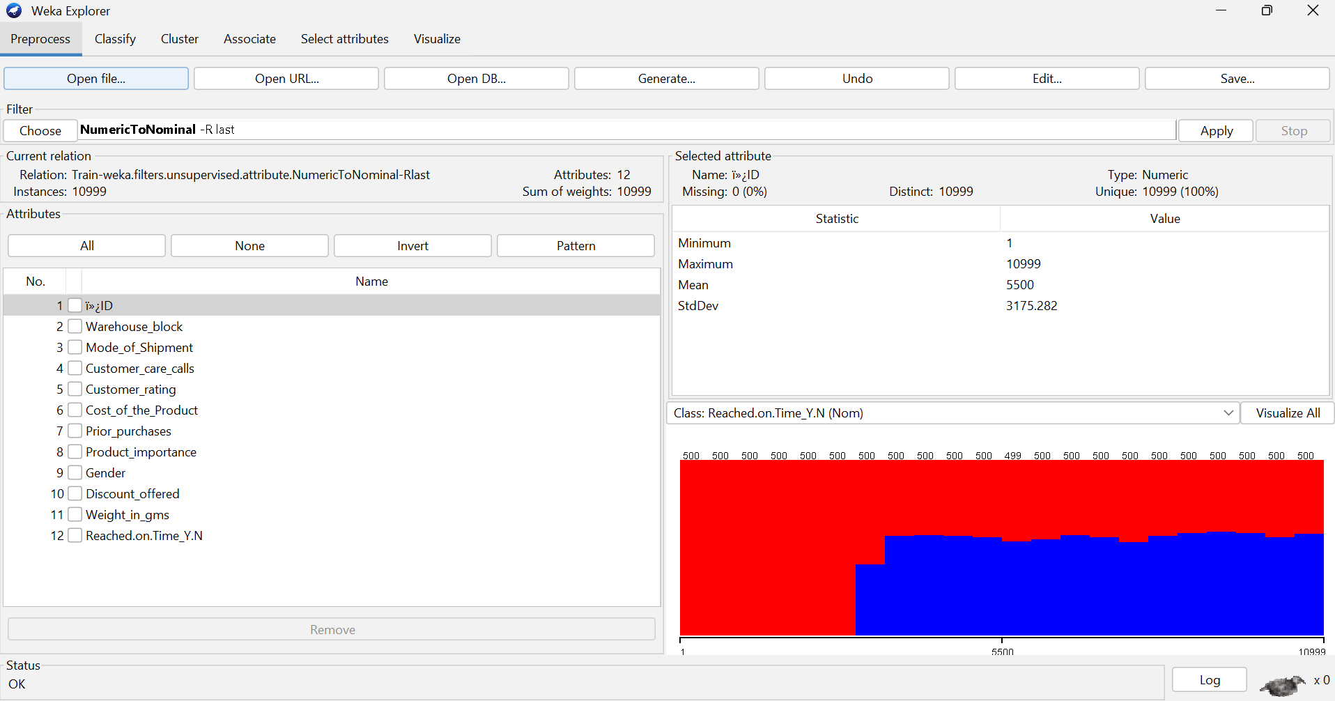

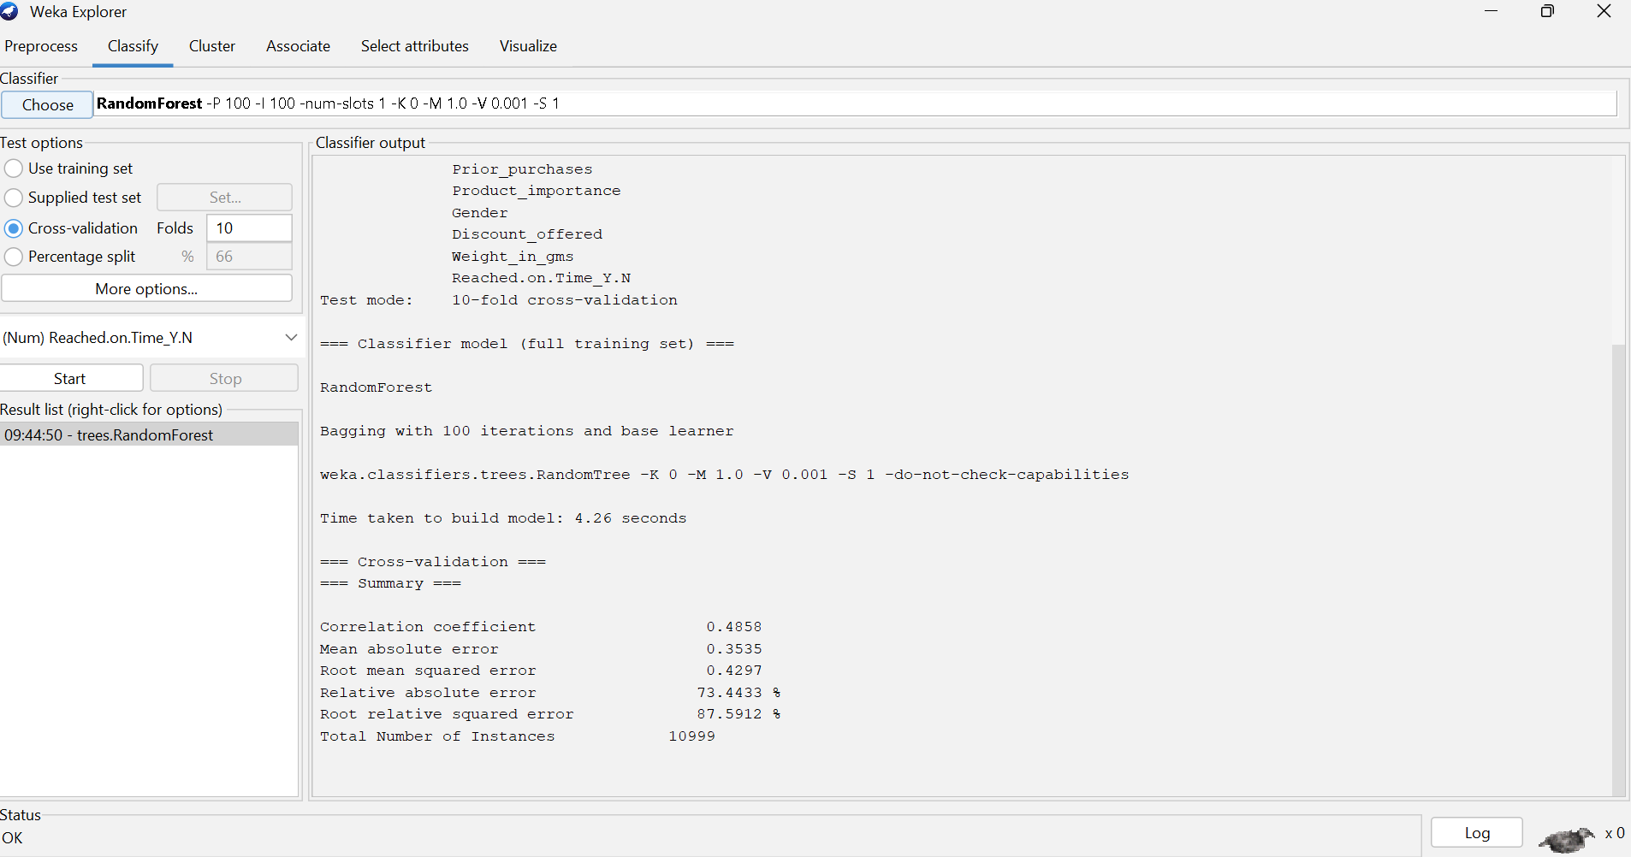
6. Evaluation Results
After running the RandomForest model, Weka produced performance metrics such as accuracy, precision, recall, and F-measure for each class, along with a confusion matrix.
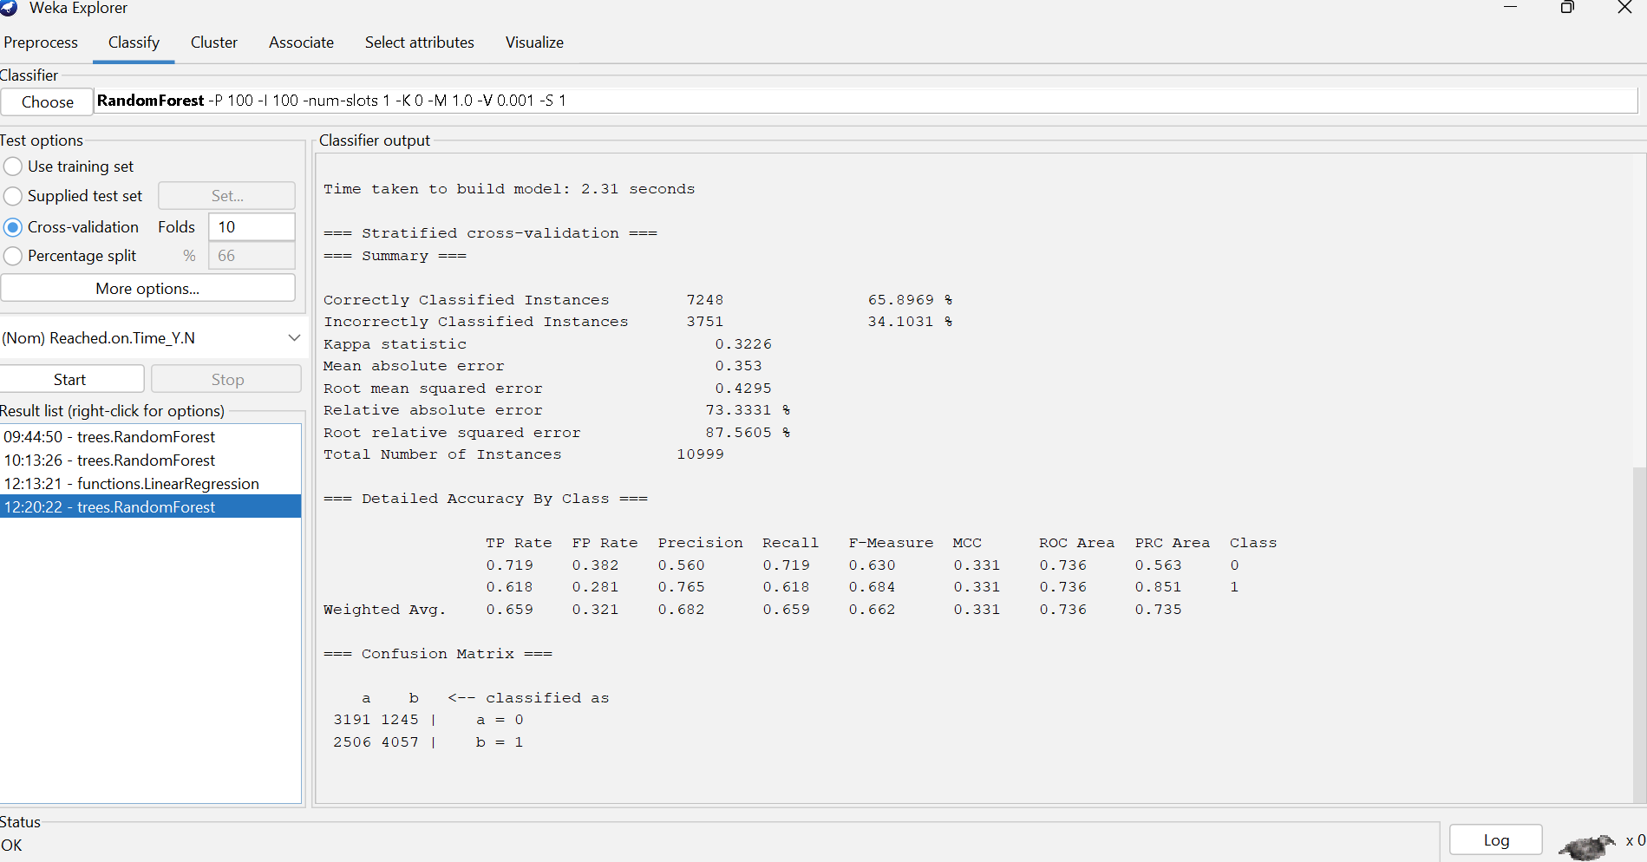

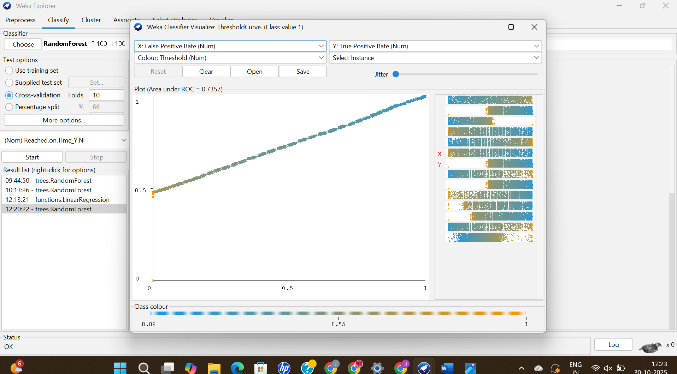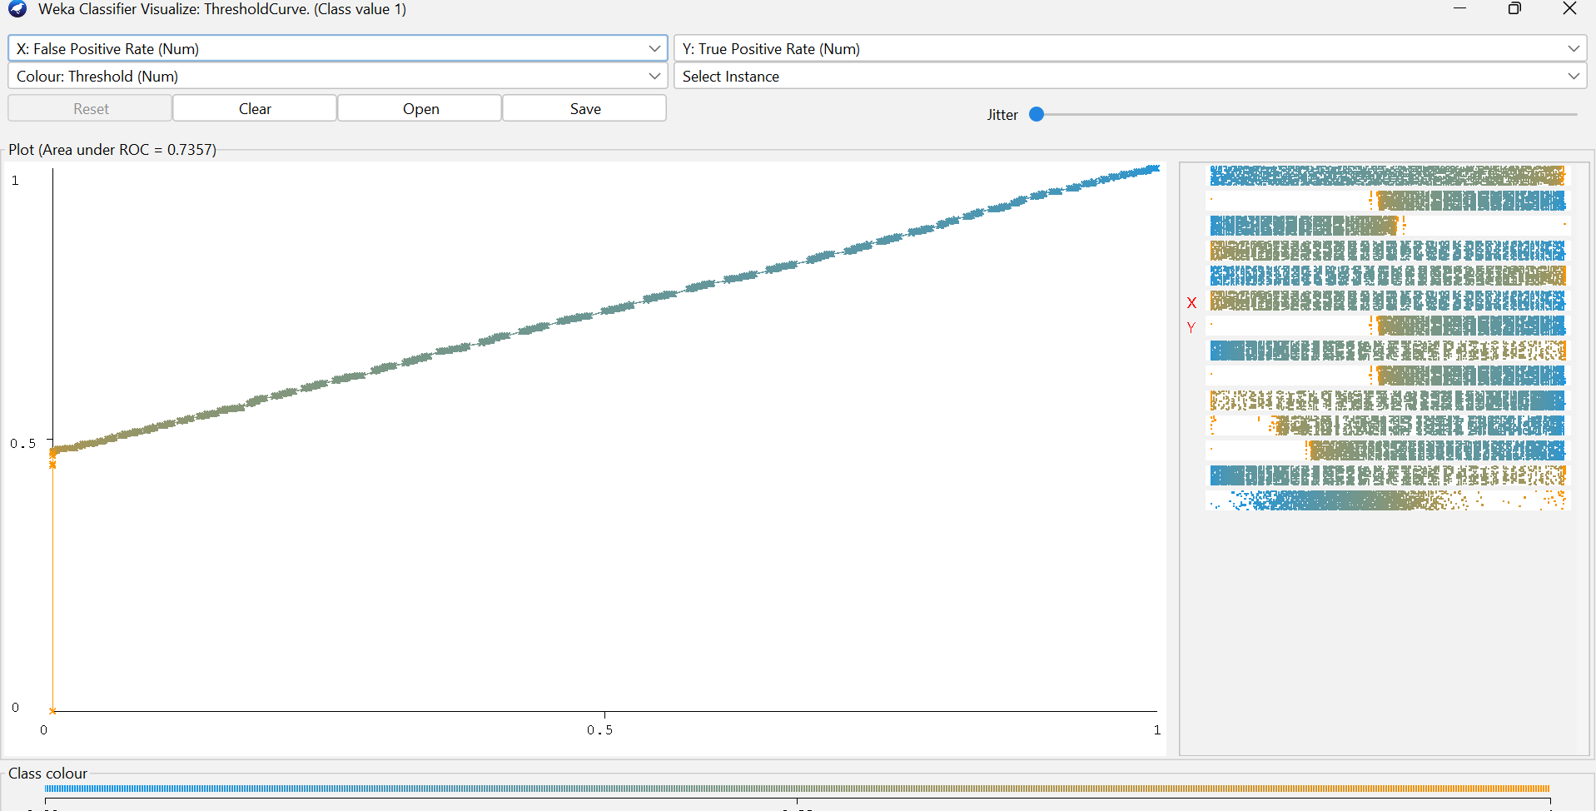

b)ALGORITHM: NAÏVE BAYES
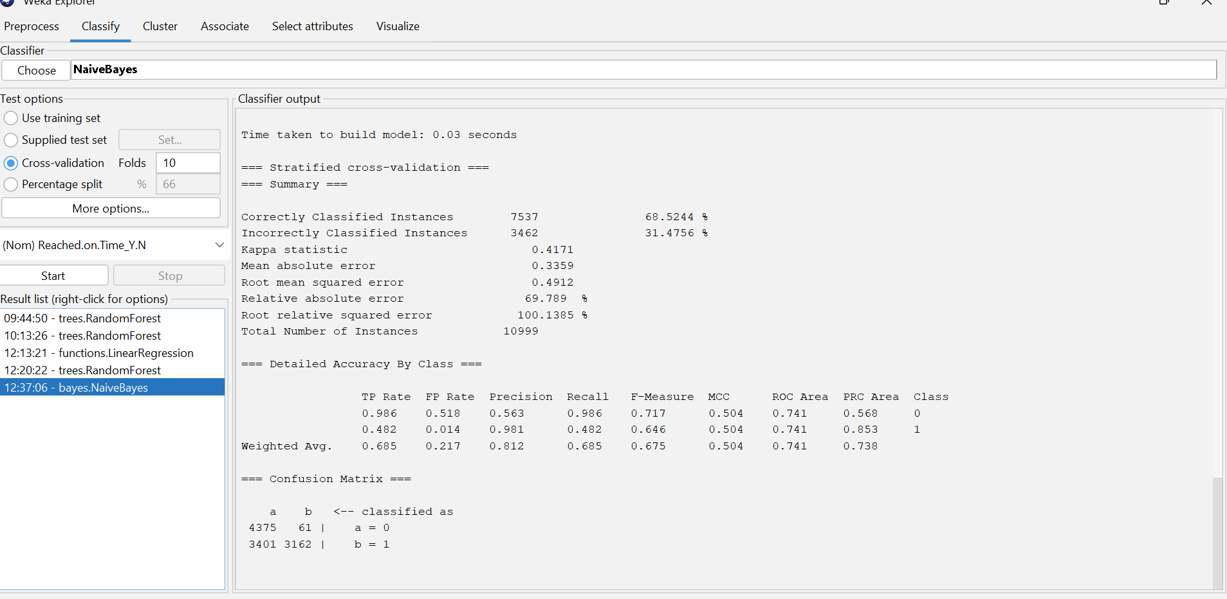
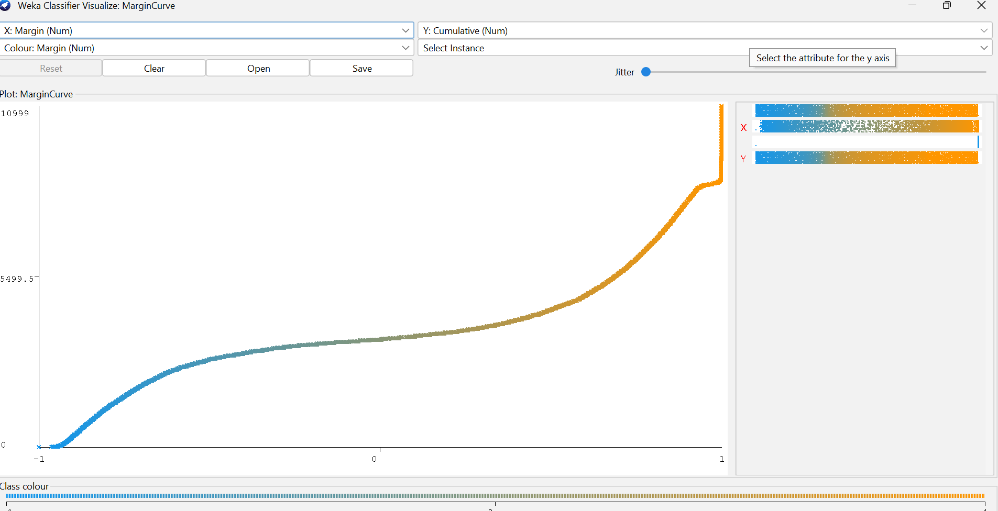

c)ALGORITHM:LOGISTIC REGRESSION
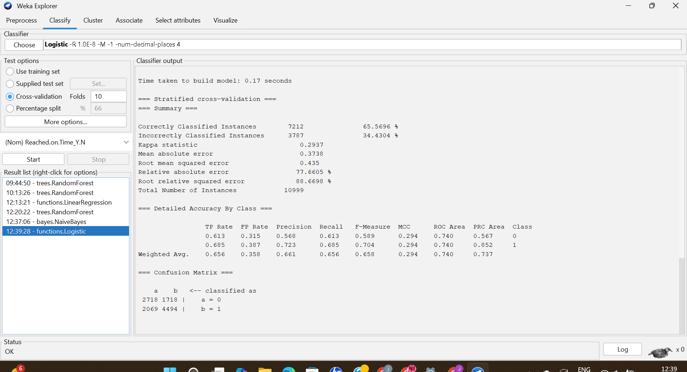
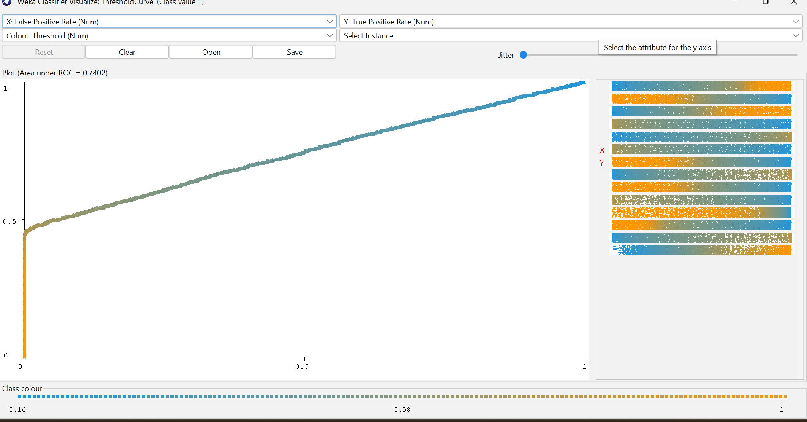
SUMMARY
Algorithm | Accuracy (%) | Kappa Statistic | Remarks
RandomForest | 65.89 | 0.32 | Performs moderately well; handles mixed data types but may need more trees or parameter tuning for better accuracy.
Logistic | 65.59 | 0.29 | Produces consistent but slightly lower accuracy; linear model struggles to capture complex relationships in data.
Naive Bayes | 68.52 | 0.41 | Achieved the highest accuracy and Kappa value; performs best on this dataset, likely due to independent feature behavior.

Among the three algorithms tested, Naive Bayes achieved the best performance, with an accuracy of 68.52% and a Kappa statistic of 0.41, indicating moderate agreement between predicted and actual classes.
RandomForest and Logistic performed similarly, with accuracies around 65%, suggesting the data may have non-linear patterns that simple models cannot fully capture.
Further tuning of RandomForest hyperparameters (like number of trees or depth) or feature engineering could potentially improve performance.

Conclusion
This project used the Weka tool to predict whether deliveries would be on time or delayed. The dataset was preprocessed, and the target attribute was converted to nominal for classification. Three algorithms — RandomForest, Logistic Regression, and Naive Bayes — were tested using 10-fold cross-validation. Among them, Naive Bayes performed the best with an accuracy of 68.52%, followed by RandomForest and Logistic Regression. Graphs like the ROC Curve and Classifier Error Plot helped visualize model performance. Overall, the project showed how Weka can be effectively used for data analysis, model building, and performance comparison in logistics prediction.

