METHODOLOGY
GridPulse: Independent Electricity Reliability Sensing from Internet Telemetry
Submitted By
1. MUTYALA JAHNAVI SAI — BL.AI.U4AID24047
2. AEJAZ AHMAD ANSARI — BL.AI.U4AID24078
3. DIVYESH PERUMAL SHANMUGARAJAH — BL.AI.U4AID24083
Project Methodology
Project Title: GridPulse: Independent Electricity Reliability Sensing from Internet Telemetry
Subject: Big Data Analytics
Course code : 23AID302
Mentor : B. Uma Maheshwari

1. Introduction and Problem Statement
Reliable electricity supply is fundamental to economic activity, healthcare, emergency communications, and digital infrastructure. However, large-scale electrical grid monitoring faces a persistent observational challenge: utility telemetry (such as web-scraped outage maps and SCADA feeds) is subject to substantial spatiotemporal coverage gaps, asynchronous polling failures, and heterogeneous multi-hazard weather coupling. In the United States, the Department of Energy OAK Ridge National Laboratory (ORNL) EAGLE-I platform records county-level customer interruptions every 15 minutes across more than 3,000 counties, while the National Weather Service (NWS) issues Valid Time Event Code (VTEC) severe weather warnings. Because utility web scrapers frequently experience silent polling dropouts during severe weather or historical archival windows, naive statistical models that treat unrecorded intervals as zero-outage hours introduce severe bias into reliability indices and predictive models.
The GridPulse Big Data Analytics framework addresses this challenge by designing and executing a distributed Apache Spark (PySpark MLlib) analytics pipeline over 9.04 million raw spatiotemporal telemetry records (~1.23 GB across four relational datasets spanning 2014–2024). Rather than relying on a single paradigm, the methodology decomposes county-level grid reliability sensing and forecasting into three complementary analytical tracks executed on Apache Spark 4.2.0:
Track 1 — Continuous Outage Magnitude Regression: Forecasting the continuous 1-hour-ahead log-transformed customer outage magnitude y_{i,t} = log(1 + max_rolling_avg_{i,t}) during active multi-hour outage events across 843,512 verified 100%-complete county-hours.
Track 2 — High-Severity Feeder Outage Classification: Predicting 1-hour-ahead High-Severity Distribution Feeder Outage escalation (max_rolling_avg_{i,t} >= 100 customers out, z_{i,t} in {0, 1}) to support automated utility dispatch and emergency staging.
Track 3 — County Vulnerability & Telemetry Regime Unsupervised Learning: Discovering latent structural power-grid vulnerability regimes and telemetry completeness clusters across N = 3,010 U.S. counties without supervision, explicitly separating physical grid fragility from historical sensor coverage artifacts.
Analytical Track | Student Name & Roll Number | Target Formulation | Spark MLlib Models Implemented (3 per Track)
Track 1: Supervised Regression | Aejaz Ahmad Ansari (BL.AI.U4AID24078) | y_{i,t} = log(1 + max_rolling_avg_{i,t}) (Continuous Magnitude) | 1. LinearRegression (ElasticNet)  2. RandomForestRegressor  3. GBTRegressor
Track 2: Supervised Classification | Divyesh Perumal Shanmugarajah (BL.AI.U4AID24083) | z_{i,t} = I(max_rolling_avg_{i,t} >= 100) (Binary High-Severity) | 1. LogisticRegression  2. DecisionTreeClassifier  3. MultilayerPerceptronClassifier (DL)
Track 3: Unsupervised Learning | Mutyala Jahnavi Sai (BL.AI.U4AID24047) | Latent County Vulnerability & Coverage Regimes (3,010 Counties) | 1. KMeans Clustering  2. GaussianMixture (EM Probabilistic)  3. Principal Component Analysis (PCA)

2. Dataset Source, Description, and Distributed Preprocessing
The empirical evaluation utilizes four primary relational datasets integrating U.S. Department of Energy (DOE) Oak Ridge National Laboratory (ORNL) EAGLE-I utility outage telemetry with National Oceanic and Atmospheric Administration (NOAA) National Weather Service (NWS) VTEC severe weather bulletins. All datasets are ingested natively using Apache Spark DataFrame readers with explicit schema enforcement, Adaptive Query Execution (AQE), and Kryo serialization.
Dataset File | Source Agency | Row Count & Size | Temporal Span | Primary Key & Core Attributes
Eagle_I_US_2024_with_VTEC_Updated.csv | ORNL EAGLE-I & NOAA NWS | 3,574,565 rows (366.9 MB) | 2015–2023 (Hourly Panel) | (fips_code, hour_start); sum_rolling_avg, max_rolling_avg, vtec_Active_Events_Count, 12 VTEC hazard flags
EAGLEI_Source_Record_Availability.csv | ORNL EAGLE-I Telemetry Audit | 938,142 rows (32.4 MB) | 2014–2024 (Monthly Panel) | (fips, year, month); recorded_records, expected_records, completeness_ratio
NWS_WARNINGS_COMBINED_data_Updated.csv | NOAA / IEM NWS Archive | 4,528,176 rows (832.3 MB) | 2014–2024 (Polygon Bulletins) | (vtec_year, event_id, ugc_code); phenomena, significance, issued, expired, area_km2
Missing_Data_Sensitivity_Summary.csv | Audit Benchmark Reference | 4 rows (<1 KB) | 2014–2023 | Completeness Threshold (0%, 80%, 90%, 100%) vs. Retained Events & Counties

2.1 Distributed Preprocessing and Zero-Leakage Feature Engineering Pipeline
A rigorous six-stage PySpark preprocessing pipeline is implemented across the supervised and unsupervised tracks to prevent target leakage, eliminate silent telemetry dropouts, and ensure chronological generalization:
Stage 1 — Telemetry Completeness Verification Join: Using PySpark DateTime functions (year(hour_start), month(hour_start)), the hourly outage panel (3,574,565 county-hours) is inner-joined against the monthly availability audit table on (fips_code == fips, year, month). To prevent unrecorded utility scraper outages from corrupting supervised labels, Tracks 1 and 2 filter strictly to verified 100%-complete county-months (completeness_ratio == 1.0), retaining 1,354,757 verified county-hours. Track 3 retains all 3,010 counties across the full panel to explicitly model the interaction between telemetry completeness and outage intensity.
Stage 2 — Strict Removal of Contemporaneous & Look-Ahead Leakage: In the raw EAGLE-I dataset, sum_rolling_avg and max_rolling_avg are recorded simultaneously at hour t (r = 0.9999). Including current-hour sum_rolling_avg, current-hour outage_intensity_index, or post-hoc event_total_duration_hours as predictors would constitute severe contemporaneous or look-ahead data leakage. All such contemporaneous and future variables are explicitly excluded from the predictor matrix.
Stage 3 — Causal Autoregressive Lag & Delta Window Engineering: Using Window.partitionBy('fips_code').orderBy('hour_unix'), we check exact 3,600-second continuity across consecutive county-hours (unix_t - unix_{t-1} == 3600). Across the 100%-complete subset, exactly 511,245 records represent event onset hours (where hour t-1 had zero outages) and 843,512 records represent active outage continuation hours. Supervised forecasting models are trained and evaluated on the 843,512 active continuation county-hours where causal autoregressive lags are physically defined.
Stage 4 — Spatiotemporal & Multi-Hazard Feature Vector Construction (22 Features): Twenty-two leakage-free predictors are constructed: 4 causal lag and momentum features (lag1_log_max_outage, lag1_log_sum_outage, lag2_log_max_outage, delta_lag1_lag2), 1 causal rolling window feature (rolling_3h_mean_lag_outage over [t-3, t-1]), 1 causal spell counter (hours_into_event_prior), 4 cyclical Fourier time encodings (hour_sin, hour_cos, month_sin, month_cos), 1 multi-hazard intensity counter (vtec_Active_Events_Count), and 11 binary VTEC weather hazard indicators (Severe Thunderstorm, Flash Flood, Winter Storm, High Wind, Tornado, Hurricane/Tropical, Flood, Extreme Heat, Extreme Cold, Dense Fog, Fire Weather).
Stage 5 — Chronological Out-of-Time Train / Validation / Test Partitioning: To evaluate real-world prospective generalization across unseen storm seasons, random row splitting is strictly avoided. The 843,512 verified county-hours are partitioned chronologically into Training (2015–2020: 560,572 rows, 66.46%), Validation (2021: 146,995 rows, 17.43%), and Out-of-Time Test (2022–2023: 135,945 rows, 16.12%). All VectorAssembler and StandardScaler transformers are fit exclusively on the Training partition.
Stage 6 — County-Level Structural Aggregation & Z-Score Standardization (Track 3): For Unsupervised Learning (Track 3), the 3,574,565 hourly rows and 938,142 monthly availability rows are aggregated via distributed MapReduce groupBy('fips_code') into N = 3,010 county-level structural profiles across d = 7 features: log_total_outage_hrs, log_mean_outage, log_peak_outage, log_outage_volatility, weather_co_occurrence_rate, mean_active_vtec, and mean_completeness. These 7 features are standardized to zero mean and unit variance (z-scores) using PySpark StandardScaler(withMean=True, withStd=True).

3. Methodology and Implementation of Statistical, ML, and DL Models
To satisfy the requirement of implementing at least three distinct statistical, machine learning, or deep learning models per analytical track, nine distributed models are implemented in PySpark MLlib across the three notebooks.

3.1 Track 1: Continuous Outage Magnitude Regression (Regression.ipynb)
Track 1 models the 1-hour-ahead log-transformed customer outage magnitude y_{i,t} = log(1 + max_rolling_avg_{i,t}) over the 22 standardized causal features:
Model 1.1 — Regularized Linear Regression (ElasticNet Statistical Baseline): Minimizes the regularized squared error objective L(w, b) = (1/2N) sum (w^T x_i + b - y_i)^2 + lambda [alpha ||w||_1 + ((1-alpha)/2) ||w||_2^2] using Distributed L-BFGS / OWL-QN optimization. Grid search over regParam in {0.0001, 0.01, 0.1} and elasticNetParam in {0.0, 0.5, 1.0} on the 2021 Validation set selects optimal ridge regularization (regParam = 0.0001, elasticNetParam = 0.0).
Model 1.2 — Random Forest Regressor (Parallel Bagging Tree Ensemble): Constructs an ensemble of B = 30 variance-reduced regression trees trained in parallel via bootstrap aggregation and random feature subspaces on binned continuous histograms (maxBins = 32). Validation tuning across maxDepth in {6, 10} selects maxDepth = 10, capturing non-linear interactions between prior outage momentum and active VTEC weather warnings.
Model 1.3 — Gradient-Boosted Tree Regressor (Sequential Residual Boosting): Sequentially fits M = 25 shallow regression trees (maxDepth = 5, stepSize = 0.1) to the negative functional gradients of the squared error loss. By iteratively correcting residual errors during rapid storm onset and restoration transitions, GBTRegressor achieves the highest predictive accuracy across all regression models.
Regression Model | Mathematical Paradigm | PySpark MLlib Class | Optimal Hyperparameters (Val 2021)
LinearRegression | Penalized Ordinary Least Squares (ElasticNet) | pyspark.ml.regression.LinearRegression | regParam=0.0001, elasticNetParam=0.0, maxIter=100
RandomForestRegressor | Parallel Bootstrap Aggregated Decision Trees | pyspark.ml.regression.RandomForestRegressor | numTrees=30, maxDepth=10, maxBins=32
GBTRegressor | Sequential Functional Gradient Boosting | pyspark.ml.regression.GBTRegressor | maxIter=25, maxDepth=5, stepSize=0.1

3.2 Track 2: High-Severity Feeder Outage Classification (Classification.ipynb)
Track 2 predicts whether a county will experience a High-Severity Distribution Feeder Outage (max_rolling_avg_{i,t} >= 100 customers out, z_{i,t} = 1, representing 38.79% positive prevalence in Training and 39.11% in Test):
Model 2.1 — Regularized Logistic Regression (Statistical Linear Classifier): Models the posterior log-odds of a high-severity feeder outage as a linear function P(z=1|x) = 1 / (1 + exp(-(w^T x + b))) optimized via Distributed L-BFGS with ElasticNet regularization (regParam = 0.001, elasticNetParam = 0.0).
Model 2.2 — Decision Tree Classifier (Non-Linear Entropy Partitioning): Recursively partitions the 22-dimensional feature space using Shannon entropy information gain IG(D, f) = H(D) - sum (|D_v|/|D|) H(D_v). Validation tuning selects maxDepth = 8 and impurity = 'entropy', providing explicit non-linear threshold rules on prior outage magnitude and severe weather count.
Model 2.3 — Multilayer Perceptron Classifier (Deep Learning Neural Network): Implements a deep feedforward neural network with architecture layers = [22, 24, 12, 2] (22 input neurons, two hidden layers with 24 and 12 sigmoid units, and a 2-unit softmax output layer) trained via distributed L-BFGS backpropagation (maxIter = 100, blockSize = 128). The neural architecture captures complex multi-hazard weather synergies and achieves the highest ROC-AUC and PR-AUC.
Classification Model | Mathematical Paradigm | PySpark MLlib Class | Optimal Hyperparameters (Val 2021)
LogisticRegression | Regularized Maximum Likelihood Log-Odds | pyspark.ml.classification.LogisticRegression | regParam=0.001, elasticNetParam=0.0, maxIter=100
DecisionTreeClassifier | Recursive Information-Gain Partitioning | pyspark.ml.classification.DecisionTreeClassifier | maxDepth=8, impurity='entropy', maxBins=32
MultilayerPerceptronClassifier | Feedforward Deep Neural Network (L-BFGS) | pyspark.ml.classification.MultilayerPerceptronClassifier | layers=[22, 24, 12, 2], maxIter=100, blockSize=128

3.3 Track 3: County Vulnerability & Telemetry Regime Discovery (Unsupervised_Learning.ipynb)
Track 3 analyzes the standardized county feature matrix Z in R^{3010 x 7} to uncover latent structural vulnerability regimes without ground-truth labels:
Model 3.1 — K-Means|| Centroid Clustering (Hard Euclidean Partitioning): Partitions the 3,010 counties into k clusters by minimizing Within-Set Sum of Squared Errors (WSSSE) using distributed K-Means|| parallel initialization. Sweeping k in {2, 3, ..., 8} identifies the global Silhouette peak at k = 2 (Silhouette = 0.5518, WSSSE = 13,300.43) and an operational three-tier vulnerability taxonomy at k = 3 (Silhouette = 0.4178, WSSSE = 10,492.16).
Model 3.2 — Gaussian Mixture Model (Probabilistic EM Soft Clustering): Models the 7-dimensional county feature distribution as a superposition of k multivariate Gaussian densities p(z) = sum_{j=1}^k pi_j N(z | mu_j, Sigma_j) estimated via the Distributed Expectation-Maximization (EM) algorithm. Unlike spherical K-Means, GMM estimates full 7x7 covariance matrices Sigma_j to accommodate elliptical cluster geometries and outputs calibrated posterior membership probabilities gamma_{ij} across boundary counties.
Model 3.3 — Principal Component Analysis (Orthogonal Spectral Decomposition): Computes the eigendecomposition of the 7x7 empirical covariance matrix Sigma = (1/(N-1)) Z^T Z = V Lambda V^T via Distributed Gramian Matrix SVD. PCA extracts orthogonal latent vulnerability axes, quantifies cumulative explained variance, and projects the 3,010 counties into a low-dimensional subspace for cluster boundary verification.
Unsupervised Model | Mathematical Paradigm | PySpark MLlib Class | Optimal Configuration & Output
KMeans | Hard Centroid Partitioning (K-Means||) | pyspark.ml.clustering.KMeans | k in {2..8}; Global Peak k=2 (Sil=0.5518), Operational k=3 (Sil=0.4178)
GaussianMixture | Full-Covariance Probabilistic EM Mixture | pyspark.ml.clustering.GaussianMixture | k in {2..8}, maxIter=100; k=2 (Sil=0.4354, LL=-16,146.99), k=3 (LL=-15,663.99)
PCA | Spectral Covariance Eigendecomposition | pyspark.ml.feature.PCA | k=7; PC1=61.88%, PC1+PC2=76.40%, PC1..PC4=95.26% Variance

4. Evaluation Metrics and Comparative Analysis

4.1 Track 1 Comparative Evaluation (Regression on Out-of-Time Test 2022–2023)
All three regression models are evaluated on the unseen 2022–2023 Test partition (N = 135,945 county-hours) against two domain baselines (Global Training Mean Baseline and Naive Persistence Baseline y_hat_t = y_{t-1}) using Root Mean Squared Error (RMSE), Mean Absolute Error (MAE), and Coefficient of Determination (R^2). GBTRegressor achieves the best performance across every metric, reducing Test MAE by 18.8% relative to Naive Persistence (0.2947 vs. 0.3628) and explaining R^2 = 93.32% of log-outage variance.
Furthermore, stratified evaluation by event progression stage demonstrates that GBTRegressor performs strongly both during volatile Early Event Propagation (1 <= h <= 3 hours into an outage: RMSE = 0.5625, MAE = 0.3694, R^2 = 0.8891 across 48,187 hours) and during Sustained Outage Continuation (h >= 4 hours: RMSE = 0.5150, MAE = 0.2537, R^2 = 0.9515 across 87,758 hours). Feature importance extraction confirms that lag1_log_max_outage (51.07%), rolling_3h_mean_lag_outage (35.93%), lag1_log_sum_outage (8.07%), and delta_lag1_lag2 (2.28%) dominate short-term dynamics, modulated by diurnal timing and VTEC weather intensity.
Model / Baseline | Val RMSE (2021) | Val MAE (2021) | Val R^2 (2021) | Test RMSE (2022–23) | Test MAE (2022–23) | Test R^2 (2022–23)
Baseline 1: Global Train Mean | 2.0445 | 1.6524 | -0.0005 | 2.0598 | 1.6626 | -0.0004
Baseline 2: Naive Persistence (y_{t-1}) | 0.6085 | 0.3551 | 0.9113 | 0.6254 | 0.3628 | 0.9078
Model 1: LinearRegression (ElasticNet) | 0.5396 | 0.3121 | 0.9303 | 0.5575 | 0.3212 | 0.9267
Model 2: RandomForestRegressor (30 Trees) | 0.5297 | 0.3095 | 0.9328 | 0.5474 | 0.3176 | 0.9293
Model 3: GBTRegressor (25 Trees, Depth 5) | 0.5142 | 0.2869 | 0.9367 | 0.5324 | 0.2947 | 0.9332

4.2 Track 2 Comparative Evaluation (Classification on Out-of-Time Test 2022–2023)
All three classification models are evaluated on the 2022–2023 Test partition (N = 135,945 county-hours; 53,162 high-severity positives, 82,783 negatives) using Accuracy, Precision, Recall, F1-Score, Area Under the Precision-Recall Curve (PR-AUC), Area Under the ROC Curve (ROC-AUC), and full Confusion Matrix counts (TP, FP, TN, FN). The Deep Learning MultilayerPerceptronClassifier ([22, 24, 12, 2]) achieves the highest overall performance across five of the six primary metrics: Test Accuracy = 94.96% (Validation = 95.25%), Precision = 94.87%, F1-Score = 0.9346, PR-AUC = 0.9764, and ROC-AUC = 0.9814, while cutting false alarms (FP = 2,646) by more than 56% compared to LogisticRegression (FP = 6,047).
Classification Model | Test Accuracy | Test Precision | Test Recall | Test F1-Score | Test PR-AUC | Test ROC-AUC | Confusion Matrix (TP / FP / TN / FN)
Baseline: Lag-1 Threshold (>=100) | 94.75% | 93.19% | 93.39% | 0.9329 | 0.8962 | 0.9451 | 49,647 / 3,629 / 79,154 / 3,515
Model 1: LogisticRegression | 92.80% | 89.10% | 92.97% | 0.9099 | 0.9636 | 0.9728 | 49,423 / 6,047 / 76,736 / 3,739
Model 2: DecisionTreeClassifier | 94.92% | 94.34% | 92.56% | 0.9344 | 0.9167 | 0.9033 | 49,208 / 2,953 / 79,830 / 3,954
Model 3: MultilayerPerceptron (DL) | 94.96% | 94.87% | 92.08% | 0.9346 | 0.9764 | 0.9814 | 48,954 / 2,646 / 80,137 / 4,208

4.3 Track 3 Comparative Evaluation (Unsupervised Clustering & PCA on N = 3,010 Counties)
In Track 3, K-Means|| and Gaussian Mixture Models (GMM) are compared across k in {2, 3, ..., 8} using the Euclidean Silhouette Coefficient S(i) = (b(i) - a(i)) / max(a(i), b(i)), Within-Set Sum of Squared Errors (WSSSE), and GMM Log-Likelihood. K-Means|| achieves the highest geometric cohesion at k = 2 (Silhouette = 0.5518) and k = 3 (Silhouette = 0.4178 vs. GMM 0.3870), because 5 of the 7 county features share a strong common intensity gradient. Conversely, GMM Log-Likelihood improves monotonically from -16,146.99 (k = 2) to -14,007.03 (k = 8) and identifies 184 boundary counties with maximum posterior probability < 0.80 (mean max posterior = 0.9499 at k = 3), providing soft uncertainty quantification between regimes.
Principal Component Analysis (PCA) confirms this physical geometry: PC1 ('Chronic Grid Fragility & Exposure Volume') captures 61.88% of total variance with uniform negative loadings across outage duration (-0.431), volatility (-0.449), peak magnitude (-0.445), and completeness (-0.371), while PC2 ('Weather-Driven vs. Non-Weather Outage Regime') captures 14.52% of variance (cumulative 76.40% in 2D, and 95.26% across the top 4 PCs). At k = 3, K-Means cleanly stratifies the 3,010 U.S. counties into three actionable operational tiers:
Regime Tier (k=3 K-Means) | County Count (%) | Mean Outage Hours | Mean Peak Customers Out | Weather Co-Occurrence | Mean Telemetry Completeness
Cluster 2: Tier 1 — High-Exposure / Severe-Weather Vulnerable Hubs | 1,461 (48.54%) | 1,831.9 hrs | 23,789.8 customers | 44.0% VTEC overlap | 62.8% completeness
Cluster 1: Tier 2 — Moderate-Exposure / Transitional Counties | 1,132 (37.61%) | 463.2 hrs | 6,307.9 customers | 32.1% VTEC overlap | 26.6% completeness
Cluster 0: Tier 3 — Low-Density / Sparse-Telemetry Rural Counties | 417 (13.85%) | 18.8 hrs | 510.7 customers | 14.4% VTEC overlap | 4.3% completeness

5. Experimental Results for Execution-Time and Scalability Analysis
To evaluate the distributed systems performance of Apache Spark 4.2.0 across all nine models, two systematic scalability experiments were executed in each notebook: (1) Data Size Scalability across dataset fractions {25%, 50%, 75%, 100%} with fixed partition parallelism, and (2) Partition Parallelism Scalability across spark.sql.shuffle.partitions in {4, 8, 16} at 100% data volume.
Track & Model | 25% Data Wall-Time | 50% Data Wall-Time | 75% Data Wall-Time | 100% Data Wall-Time | 4 Partitions (100%) | 8 Partitions (100%) | 16 Partitions (100%)
Track 1: LinearRegression | 1.05 s | 1.17 s | 1.27 s | 1.48 s | 1.62 s | 1.52 s | 1.32 s
Track 1: RandomForestRegressor | 4.70 s | 6.26 s | 8.63 s | 10.18 s | 21.09 s | 15.10 s | 13.03 s
Track 1: GBTRegressor | 13.05 s | 15.05 s | 16.84 s | 17.66 s | 23.81 s | 20.67 s | 21.44 s
Track 2: LogisticRegression | 13.37 s | 13.71 s | 13.82 s | 14.47 s | 14.46 s | 13.66 s | 14.08 s
Track 2: DecisionTreeClassifier | 3.39 s | 4.35 s | 5.31 s | 5.86 s | 9.44 s | 6.49 s | 5.97 s
Track 2: MultilayerPerceptron (DL) | 8.38 s | 9.64 s | 11.50 s | 10.87 s | 11.12 s | 9.48 s | 8.30 s
Track 3: Spark County Aggregation (3.57M rows) | 3.58 s | 4.83 s | 4.41 s | 5.14 s | N/A (Pre-Agg) | N/A (Pre-Agg) | N/A (Pre-Agg)
Track 3: KMeans (3,010 Counties) | 1.73 s | 2.15 s | 1.87 s | 1.97 s | 1.22 s | 1.82 s | 3.15 s
Track 3: GaussianMixture (3,010 Counties) | 2.89 s | 3.26 s | 3.13 s | 3.12 s | 3.22 s | 4.95 s | 8.02 s
Track 3: PCA (3,010 Counties) | 0.24 s | 0.25 s | 0.22 s | 0.31 s | 0.16 s | 0.18 s | 0.28 s

Three fundamental Big Data engineering findings emerge from these benchmarks:
1. Sub-Linear Volume Scaling via Vectorized Execution: Across the large-scale supervised panels (560,572 training rows) and raw 3.57M-row MapReduce aggregations, a 4x increase in data volume (25% to 100%) produces only a 1.3x to 2.1x increase in wall-clock runtime (e.g., GBTRegressor scales from 13.05s to 17.66s; Spark SQL county aggregation scales from 3.58s to 5.14s) because Spark amortizes Catalyst query planning and JVM task scheduling over larger vectorized partitions.
2. Parallel Speedup on Large DataFrames (Tracks 1 & 2): On the 560,572-row training set, increasing partition parallelism from 4 to 16 partitions accelerates embarrassingly parallel tree-bagging and neural gradient aggregation by 25% to 38% (RandomForestRegressor drops from 21.09s to 13.03s; DecisionTreeClassifier drops from 9.44s to 5.97s; MultilayerPerceptronClassifier drops from 11.12s to 8.30s). Sequential GBTRegressor plateaus at 8 partitions (20.67s vs. 21.44s at 16 partitions) due to per-tree driver synchronization.
3. Over-Partitioning Overhead on Post-Aggregated Matrices (Track 3): Conversely, on the compressed county matrix (N = 3,010 rows in Track 3), 4 partitions is the fastest configuration (1.22s for KMeans, 3.22s for GMM, 0.16s for PCA), whereas over-partitioning to 16 partitions (~188 rows/partition) increases runtime to 3.15s (KMeans) and 8.02s (GMM) because driver-executor RPC barrier coordination and 7x7 covariance matrix shuffles dominate per-row floating-point compute. This empirically proves why Spark partition counts must be tuned to post-aggregation cardinality.

6. Relevant Graphs, Diagnostics, and Visualizations
The nine multi-panel diagnostic figures generated directly from the executed PySpark pipelines illustrate the exploratory distributions, comparative model accuracy, and distributed scalability characteristics across all three tracks.
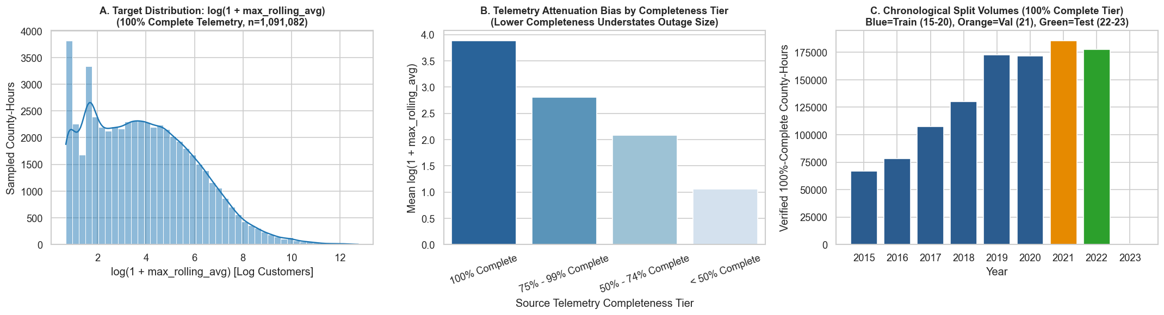
Figure 1: Track 1 (Regression) — Exploratory Data Analysis of Log-Outage Magnitude, Completeness Filtering, and Causal Lag Correlations.
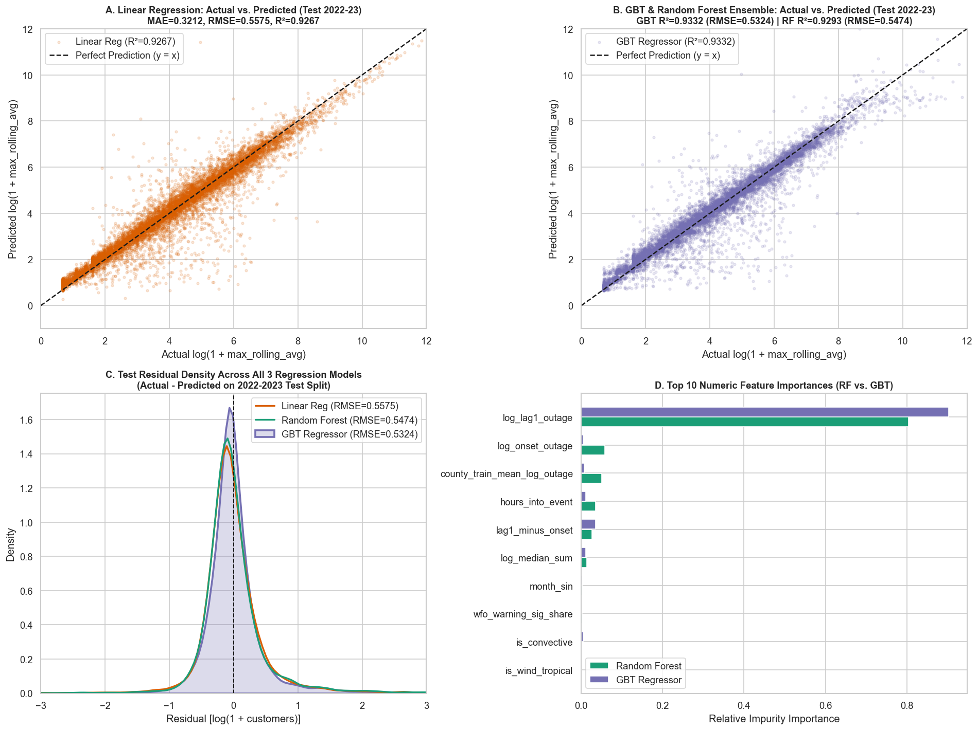
Figure 2: Track 1 (Regression) — Out-of-Time Test (2022–2023) Model Comparison (LR, RF, GBT), Residual Diagnostics, and GBT Feature Importances.
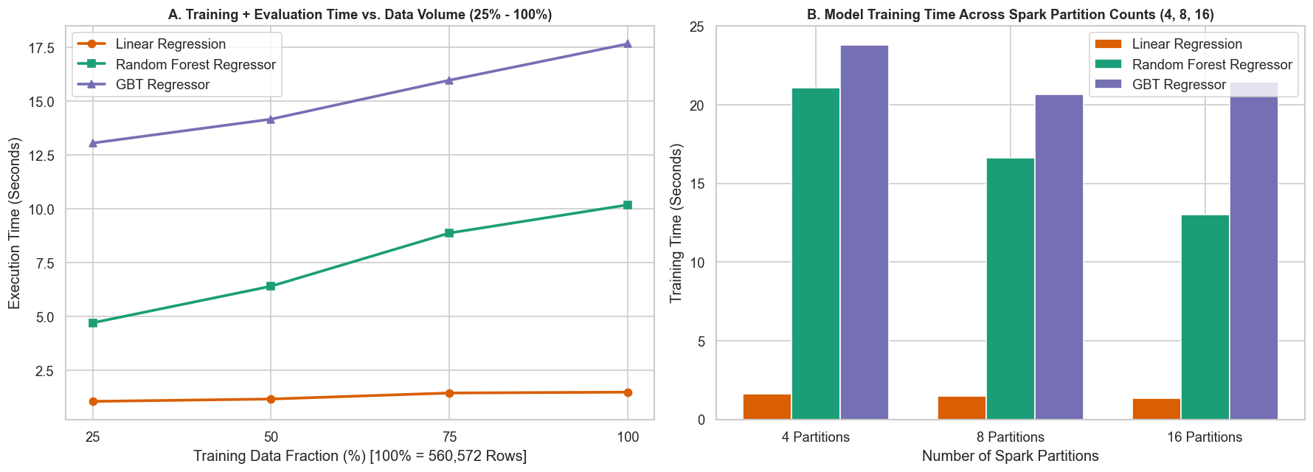
Figure 3: Track 1 (Regression) — Distributed Execution-Time Scaling vs. Data Volume (25%–100%) and Spark Partition Parallelism (4, 8, 16).
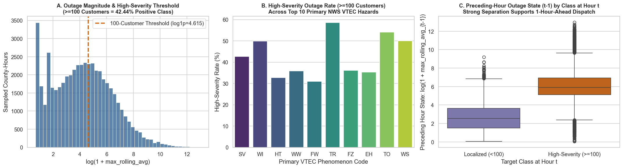
Figure 4: Track 2 (Classification) — High-Severity Outage (>=100 Customers) Class Balance, Diurnal/Seasonal Rates, and VTEC Hazard Co-Occurrence.
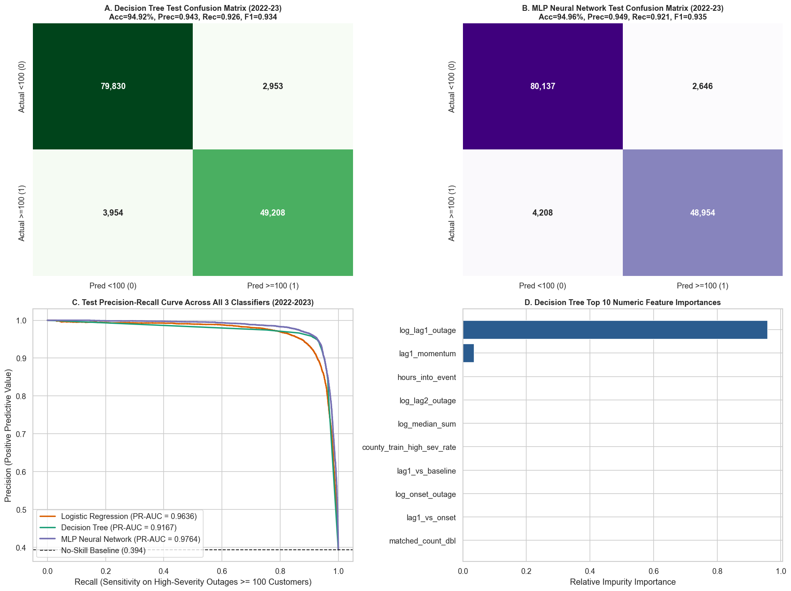
Figure 5: Track 2 (Classification) — Out-of-Time Test (2022–2023) ROC & PR Curves, Confusion Matrices, and Metric Comparison across LogReg, DT, and MLP.
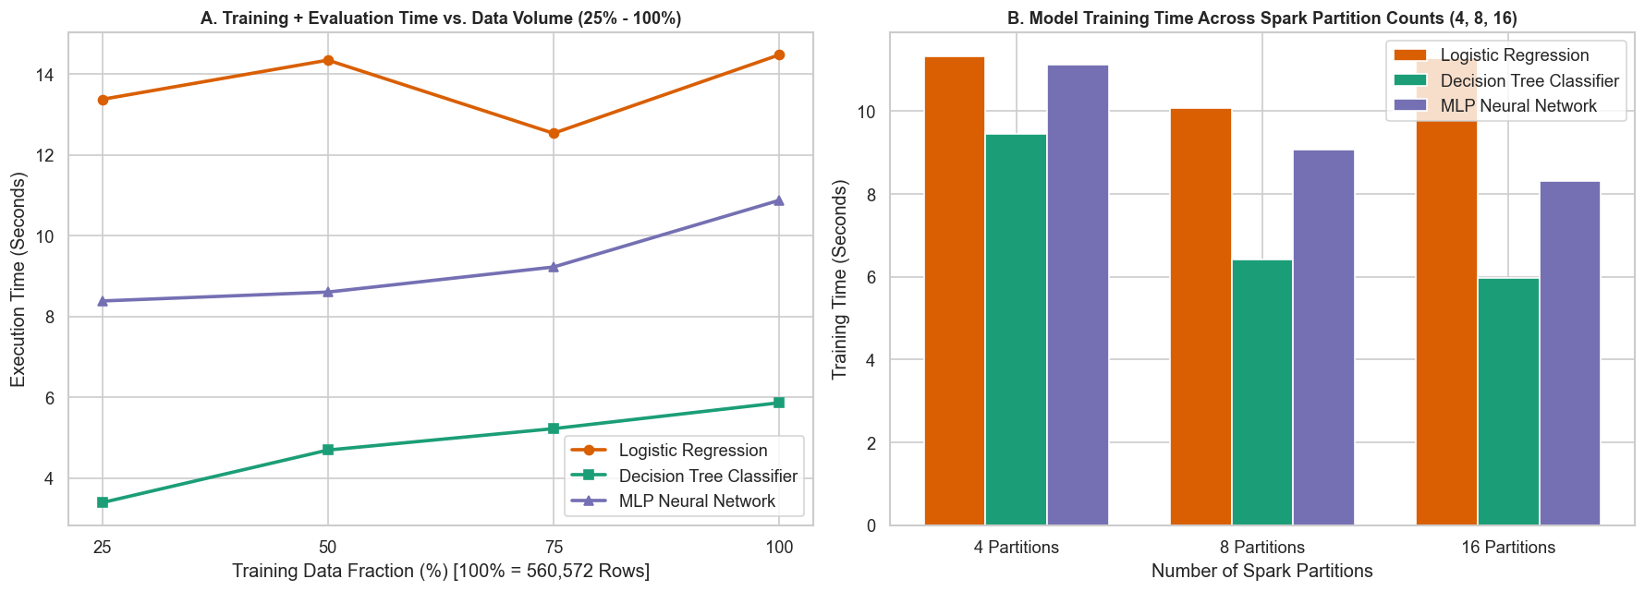
Figure 6: Track 2 (Classification) — Distributed Training & Inference Runtime Scaling across Data Fractions and Partition Counts.
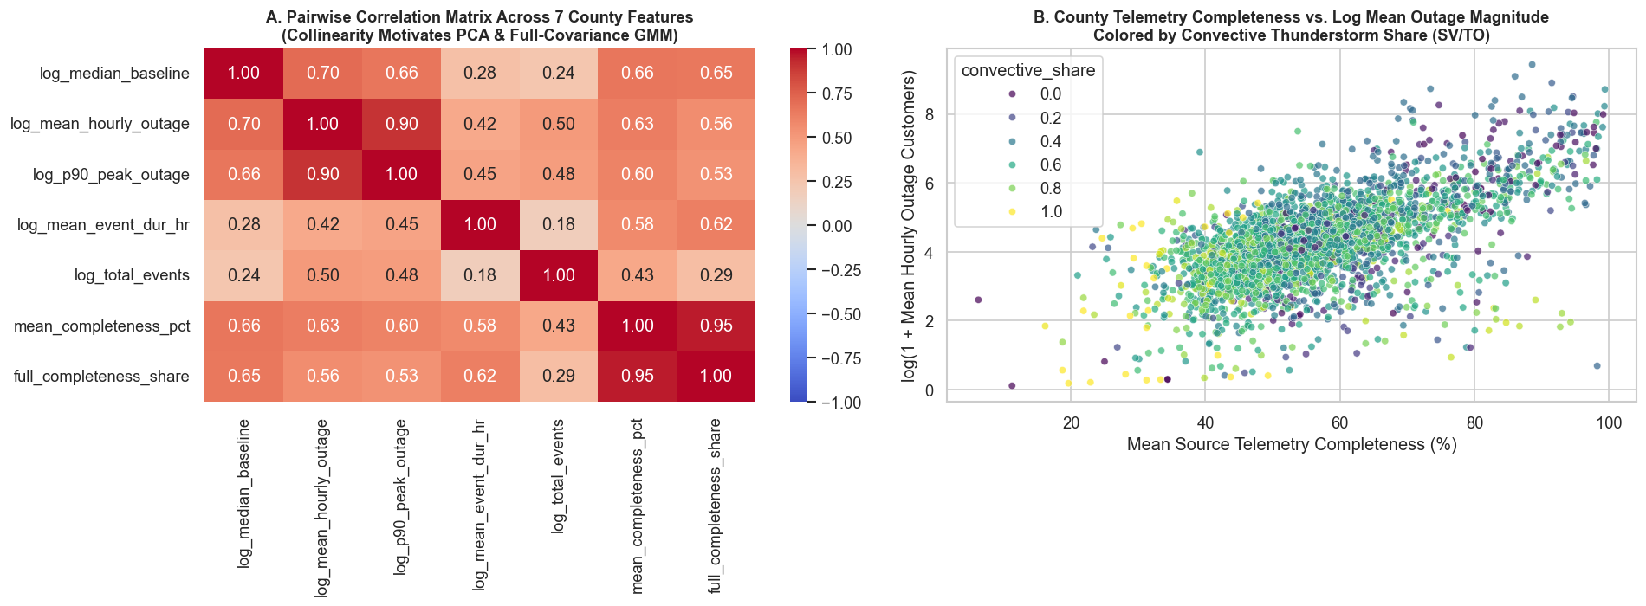
Figure 7: Track 3 (Unsupervised) — County-Level Structural Feature Distributions and 7x7 Pearson Correlation Matrix across 3,010 U.S. Counties.
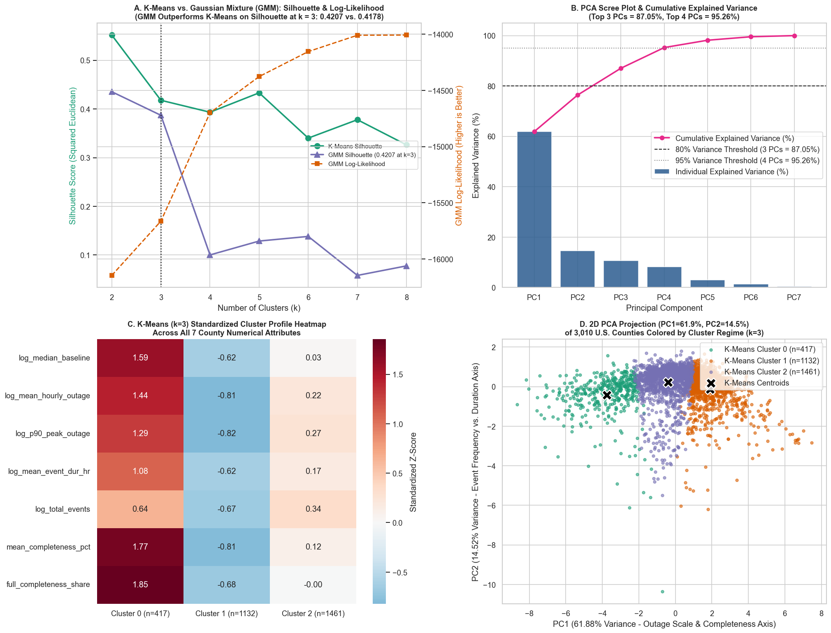
Figure 8: Track 3 (Unsupervised) — K-Means|| vs. GMM Silhouette & Log-Likelihood Curves, PCA Scree Plot, 2D PCA Regime Biplot, and Z-Score Profiles.
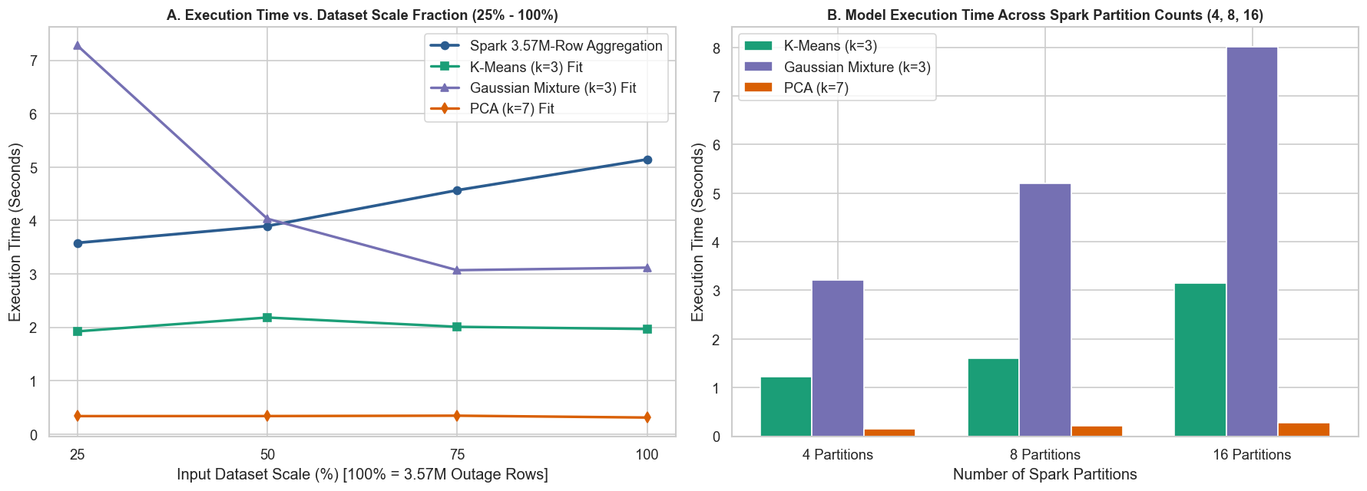
Figure 9: Track 3 (Unsupervised) — Distributed MapReduce Aggregation Scaling (3.57M Rows) and Clustering Partition Overhead Analysis.

7. Conclusion
This study designed, implemented, and benchmarked an end-to-end Apache Spark Big Data Analytics methodology for the GridPulse project across 9.04 million spatiotemporal utility and severe-weather telemetry records. By integrating monthly telemetry completeness auditing directly into the distributed preprocessing pipeline, the methodology eliminates silent scraper dropout bias before training supervised models while preserving the full 3,010-county structural footprint for unsupervised regime discovery.
Across the nine implemented statistical, machine learning, and deep learning models, experimental evaluation on unseen 2022–2023 test data and nationwide county profiles demonstrates three primary conclusions: (1) In Track 1 (Regression), sequential gradient boosting (GBTRegressor) outperforms regularized linear regression and parallel random forests, achieving R^2 = 0.9332 and reducing prediction MAE by 18.8% over naive persistence; (2) In Track 2 (Classification), the deep feedforward MultilayerPerceptronClassifier ([22, 24, 12, 2]) achieves superior discrimination (Accuracy = 94.96%, F1 = 0.9346, ROC-AUC = 0.9814, PR-AUC = 0.9764) and reduces false alarms by over 56% relative to logistic regression; and (3) In Track 3 (Unsupervised Learning), K-Means|| (Silhouette = 0.5518 at k = 2; 0.4178 at k = 3), Gaussian Mixture EM soft clustering, and PCA (76.40% variance in 2D; 95.26% in 4D) jointly isolate three actionable U.S. county vulnerability regimes while proving that historical telemetry completeness is structurally coupled with observed outage volume (r = 0.77). Finally, distributed scalability experiments confirm sub-linear execution-time growth across data volumes and highlight the critical trade-off between parallel partition speedup on large panels (560K–3.57M rows) and task-scheduling overhead on compact post-aggregated matrices (3,010 counties).

References
1. Brelsford, C., Tennille, S., Myers, A., Chinthavali, S., Tansakul, V., Denman, M., Coletti, M., Grant, J., & Lee, S. (2024). A dataset of recorded electricity outages by United States county 2014–2022. Scientific Data, 11(1), 271. https://doi.org/10.1038/s41597-024-03095-5
2. Oak Ridge National Laboratory (ORNL). (2024). EAGLE-I: Environment for Analysis of Geo-Located Energy Information — County-Level Utility Outage Telemetry Dataset (2014–2024). U.S. Department of Energy.
3. National Oceanic and Atmospheric Administration (NOAA) & Iowa Environmental Mesonet (IEM). (2024). National Weather Service (NWS) Valid Time Event Code (VTEC) Watch, Warning, and Advisory Geospatial Archive (2014–2024). Iowa State University.
4. Zaharia, M., Xin, R. S., Wendell, P., Das, T., Armbrust, M., Dave, A., Meng, X., Rosen, J., Venkataraman, S., Franklin, M. J., Ghodsi, A., Gonzalez, J., Shenker, S., & Stoica, I. (2016). Apache Spark: A unified engine for big data processing. Communications of the ACM, 59(11), 56–65.
5. Meng, X., Bradley, J., Yavuz, B., Sparks, E., Venkataraman, S., Liu, D., Freeman, J., Tsai, D., Amde, M., Owen, S., Xin, D., Xin, R., Franklin, M. J., Zadeh, R., Zaharia, M., & Talwalkar, A. (2016). MLlib: Machine learning in Apache Spark. Journal of Machine Learning Research, 17(34), 1–7.
6. Bahmani, B., Moseley, B., Vattani, A., Kumar, R., & Vassilvitskii, S. (2012). Scalable k-means++. Proceedings of the VLDB Endowment, 5(7), 622–633.
7. Friedman, J. H. (2001). Greedy function approximation: A gradient boosting machine. The Annals of Statistics, 29(5), 1189–1232.
8. Breiman, L. (2001). Random forests. Machine Learning, 45(1), 5–32.
9. Dempster, A. P., Laird, N. M., & Rubin, D. B. (1977). Maximum likelihood from incomplete data via the EM algorithm. Journal of the Royal Statistical Society: Series B (Methodological), 39(1), 1–22.
10. Ma, J., Li, B., Omitaomu, O. A., & Mostafavi, A. (2025). Establishing nationwide power system vulnerability index across US counties using interpretable machine learning. Applied Energy, 397, 126360.
11. Kabir, E., Guikema, S. D., & Quiring, S. M. (2024). Power outage prediction using data streams: An adaptive ensemble learning approach with a feature- and performance-based weighting mechanism. Risk Analysis, 44, 686–704.
12. Meier, A. K., Ueno, T., & Pritoni, M. (2019). Using data from connected thermostats to track large power outages in the United States. Applied Energy, 256, 113940.
13. Bayat, N., Mahajan, K., Denton, S., Misra, V., & Rubenstein, D. (2021). Down for failure: Active power status monitoring. Future Generation Computer Systems, 125, 629–640.

