GridPulse: High-Severity Outage Classification Technical Guide
Notebook: Classification.ipynb | PySpark MLlib Models: Logistic Regression, Decision Tree Classifier, and MLP Neural Network

1. Complete Guide to the Four GridPulse Datasets
This study analyzes four empirical U.S. power-grid outage and National Weather Service (NWS) weather-warning datasets totaling 8,773,410 rows (~1.23 GB on disk). Using Apache Spark (PySpark 4.2.0) allows the pipeline to ingest, join, and window-partition these multi-million-row CSV files across CPU cores without loading raw CSVs into single-threaded pandas memory.
Dataset Filename | Rows | File Size | Observational Grain | What It Measures & Key Details
Eagle_I_US_2024_with_VTEC_Updated.csv | 3,572,394 | 366.9 MB | County-Hour (fips_code, Hour) during active NWS weather alerts (2015–2023) | Measures 4-hour rolling average customer outages (max_rolling_avg, in 1/16 = 0.0625 steps), county baseline (median_sum), telemetry completeness (source_completeness_pct), and active VTEC alerts (Matched_Events, Matched_Count) across 3,010 U.S. counties and 1,374,112 outage events (new_event_no). Event-summary columns (Max_outage, evDur_Hr, evDur_day) summarize the entire event and are dropped during hourly prediction to prevent look-ahead leakage.
NWS_WARNINGS_COMBINED_data_Updated.csv | 4,152,437 | 832.3 MB | Individual NWS VTEC warning/watch/advisory bulletin segment (2015–2024) | Contains issuing Weather Forecast Office (WFO), ISSUED/EXPIRED timestamps (mixed ISO yyyy-MM-dd HH:mm and slash M/d/yyyy H:mm formats), phenomenon code (PHENOM: SV=Severe Thunderstorm, TO=Tornado, WS=Winter Storm, WI=Wind, HT=Heat), significance (SIG: W=Warning, Y=Advisory, A=Watch), geometry type (GTYPE: C=County/Zone, P=Polygon), and polygon area (AREA_KM2).
EAGLEI_Source_Record_Availability.csv | 1,048,575 | 32.4 MB | County-Day (fips_code, Date) from 1/1/2015 to 9/9/2024 | Audits how many 15-minute telemetry snapshots were received out of 96 expected per day (24h x 4 = 96). Truncated upstream at 1,048,575 rows (2^20 - 1, Excel row limit, covering 288 counties with fips_code <= 12033). 38.9% of county-days have 0 observed records—showing that missing records indicate missing telemetry rather than zero outages.
Missing_Data_Sensitivity_Summary.csv | 4 | 232 Bytes | National completeness tier summary (91.52M raw observations) | Quantifies the downward bias in max_rolling_avg when fewer than 16 fifteen-minute slots are observed in a 4-hour window: 0% error at 100% Complete, 18.75% error at 75%-99% Complete, 43.75% error at 50%-74% Complete, and 75.0% error at <50% Complete.

2. Problem Formulation, Target Threshold, and Preprocessing Pipeline
• End Target: 1-Hour-Ahead High-Severity Feeder Outage Classification (max_rolling_avg_{i,t} >= 100 customers).
• Domain Justification of the 100-Customer Threshold: In utility distribution operations, outages affecting < 100 customers (Class 0: 57.56%) typically represent localized lateral fuse or single transformer faults handled by one trouble-truck, whereas outages affecting >= 100 customers (Class 1: 42.44%) indicate a primary distribution feeder lockout or substation fault requiring multi-crew switching and priority emergency dispatch.
• Leakage Prevention: Current-hour max_rolling_avg (used only to define label_cls) and all future event-summary columns (Max_outage, evDur_Hr, evDur_day, event_mean_completeness_pct, event_min_completeness_pct) are dropped from the feature set. Predictors use only preceding-hour telemetry (t-1 and t-2), recent outage momentum, onset state (t_0), training-period county/WFO baselines (2015–2020), and active NWS VTEC hazard indicators.
• Class Weighting: Inverse class-frequency weights (w_neg = 0.8609, w_pos = 1.1926) are computed strictly on the 2015–2020 Training Set (560,572 rows).

3. Detailed Explanation of the Three Classification Models
1) Model 1 — Regularized Logistic Regression (pyspark.ml.classification.LogisticRegression):
• Category: Statistical Log-Odds Classifier.
• How it works: Models the log-odds of a High-Severity Outage via a linear combination of standardized features passed through the logistic sigmoid function P(y=1|x) = 1 / (1 + exp(-(w^T x + b))), optimized via weighted L-BFGS with ElasticNet regularization.
• Strengths & Trade-offs: Outputs well-calibrated continuous probability rankings across all operating thresholds (Test ROC-AUC = 0.9728, PR-AUC = 0.9636) with 92.80% Test Accuracy and 92.97% Recall, but produces more False Positives (6,047) due to its linear decision boundary.
2) Model 2 — Decision Tree Classifier (pyspark.ml.classification.DecisionTreeClassifier):
• Category: Non-Linear Rule-Based ML Classifier.
• How it works: Recursively partitions the feature space using axis-aligned split rules that minimize weighted Gini impurity or entropy (maxDepth=8, impurity='entropy').
• Strengths & Trade-offs: Captures sharp non-linear threshold boundaries near the 100-customer cutoff, achieving 94.92% Test Accuracy, 94.34% Precision, and 0.9344 F1-Score—cutting False Positives in half (2,953 vs. 6,047). However, because all samples in a leaf share the same step-function probability, its ROC-AUC (0.9033) is lower.
3) Model 3 — Multilayer Perceptron Classifier (pyspark.ml.classification.MultilayerPerceptronClassifier):
• Category: Deep Feedforward Neural Network (DL).
• How it works: A multi-layer feedforward neural network (architecture [22, 24, 12, 2]) trained via distributed L-BFGS backpropagation in Spark, using sigmoid hidden activations and a softmax output layer minimizing cross-entropy loss across the 22 standardized numeric predictors.
• Strengths & Trade-offs: Combines non-linear hidden representations with smooth continuous softmax probabilities, achieving the best overall performance on the 2022–2023 Test Set: 94.96% Accuracy (95.25% Validation Accuracy), 94.87% Precision, 0.9346 F1-Score, 0.9764 PR-AUC, and 0.9814 ROC-AUC (with only 2,646 False Positives).

4. Evaluation Metrics and Comparative Analysis
Model | Split | Accuracy | Precision | Recall | F1-Score | PR-AUC | ROC-AUC | TP | FP | TN | FN
Logistic Regression | Train (15–20) | 92.84% | 89.47% | 93.99% | 0.9167 | 0.9684 | 0.9742 | 220,890 | 26,001 | 299,557 | 14,124
Logistic Regression | Val (2021) | 93.22% | 91.41% | 94.62% | 0.9299 | 0.9790 | 0.9785 | 66,076 | 6,211 | 70,952 | 3,756
Logistic Regression | Test (22–23) | 92.80% | 89.10% | 92.97% | 0.9099 | 0.9636 | 0.9728 | 49,423 | 6,047 | 76,736 | 3,739
Decision Tree Classifier | Train (15–20) | 94.83% | 94.59% | 93.00% | 0.9379 | 0.9241 | 0.9084 | 218,565 | 12,506 | 313,052 | 16,449
Decision Tree Classifier | Val (2021) | 95.21% | 95.64% | 94.20% | 0.9492 | 0.9443 | 0.9246 | 65,782 | 2,998 | 74,165 | 4,050
Decision Tree Classifier | Test (22–23) | 94.92% | 94.34% | 92.56% | 0.9344 | 0.9167 | 0.9033 | 49,208 | 2,953 | 79,830 | 3,954
MLP Neural Network | Train (15–20) | 94.89% | 94.99% | 92.70% | 0.9383 | 0.9790 | 0.9821 | 217,860 | 11,493 | 314,065 | 17,154
MLP Neural Network | Val (2021) | 95.25% | 96.00% | 93.92% | 0.9495 | 0.9853 | 0.9846 | 65,587 | 2,733 | 74,430 | 4,245
MLP Neural Network (Best) | Test (22–23) | 94.96% | 94.87% | 92.08% | 0.9346 | 0.9764 | 0.9814 | 48,954 | 2,646 | 80,137 | 4,208

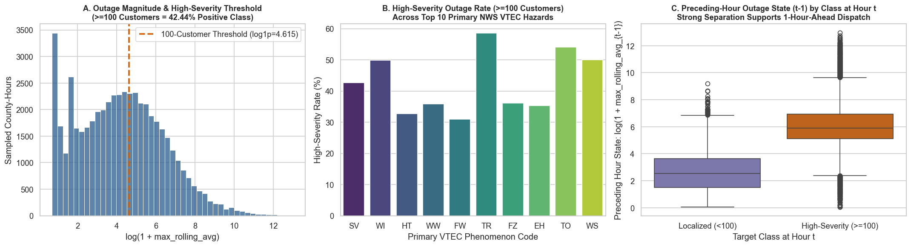
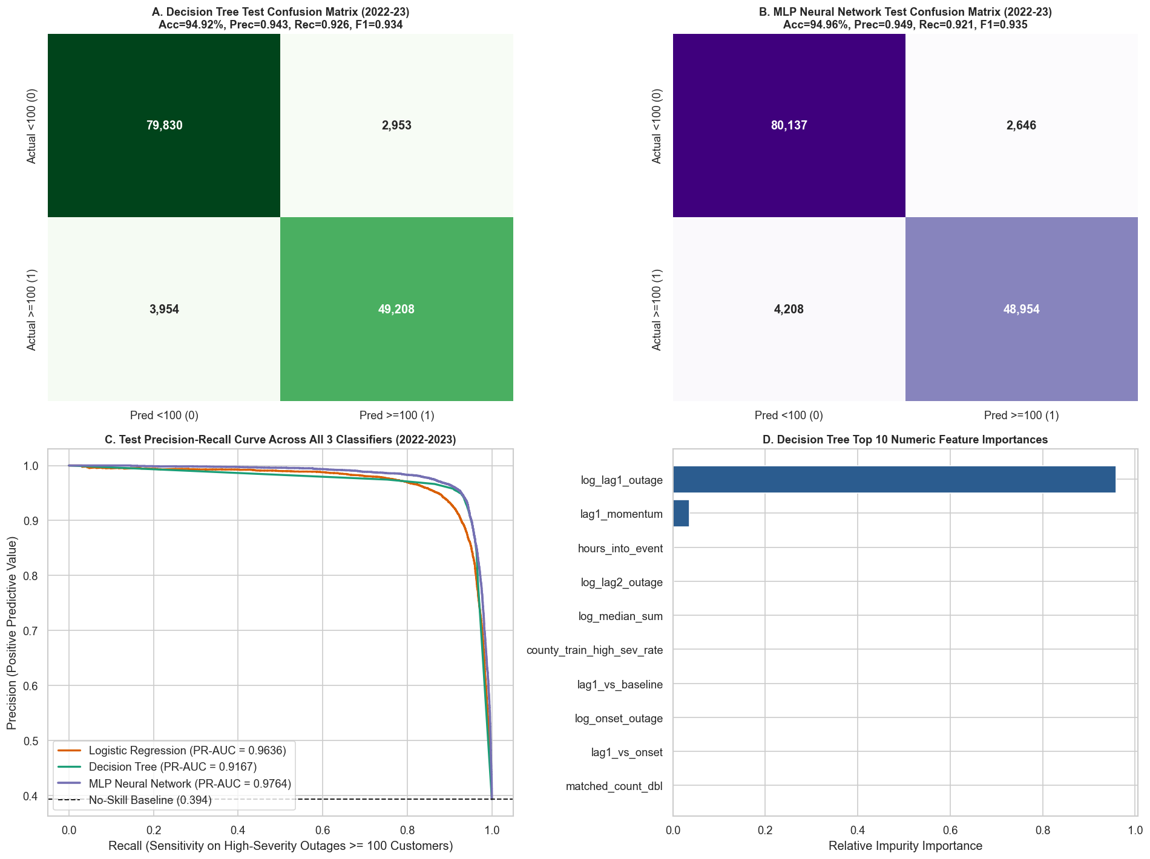

5. Execution-Time and Scalability Analysis
We benchmarked all three PySpark classifiers across dataset scale fractions (25%, 50%, 75%, and 100% of the 560,572 training rows) and across Spark partition counts (4, 8, and 16 partitions). Decision Tree is the fastest to train (3.39s at 25% to 5.86s at 100%), followed by MLP Neural Network (8.38s to 10.87s) and Logistic Regression (13.37s to 14.47s on high-dimensional one-hot encoded features). Increasing Spark partitions from 4 to 16 accelerates Decision Tree training from 9.44s to 5.97s and MLP Neural Network from 11.12s to 8.30s.
Data Scale (%) | Train Rows | LogReg Time (s) | Decision Tree Time (s) | MLP Time (s) | LogReg ROC-AUC | DT ROC-AUC | MLP ROC-AUC
25% | 140,143 | 13.37s | 3.39s | 8.38s | 0.9729 | 0.8978 | 0.9762
50% | 280,286 | 14.34s | 4.69s | 8.60s | 0.9729 | 0.9010 | 0.9761
75% | 420,429 | 12.53s | 5.22s | 9.22s | 0.9728 | 0.8706 | 0.9758
100% | 560,572 | 14.47s | 5.86s | 10.87s | 0.9728 | 0.9033 | 0.9758

Spark Partitions | Logistic Regression Time (s) | Decision Tree Time (s) | MLP Neural Network Time (s)
4 Partitions | 11.33s | 9.44s | 11.12s
8 Partitions | 10.07s | 6.41s | 9.06s
16 Partitions | 11.27s | 5.97s | 8.30s

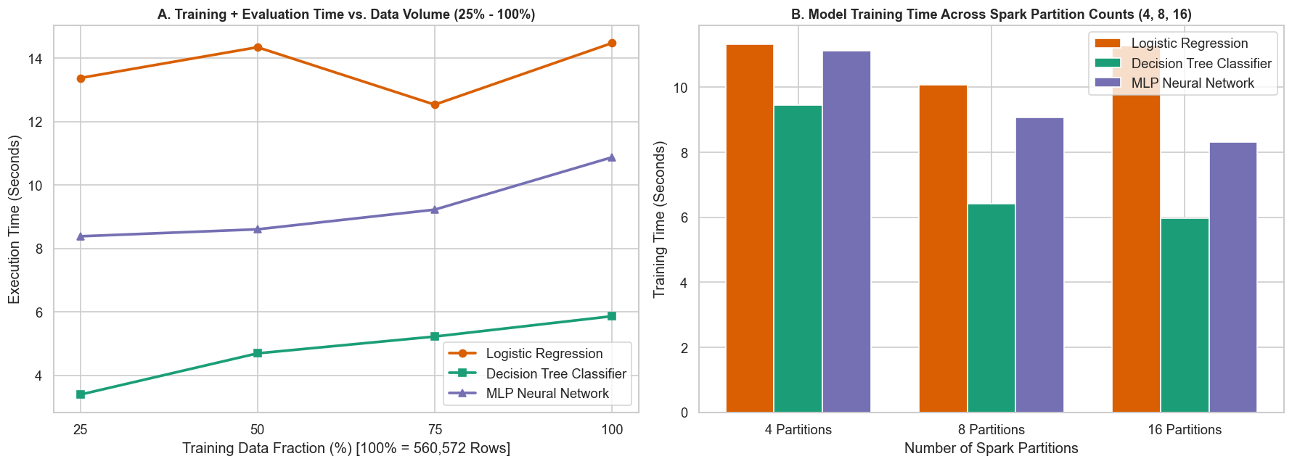

6. Key Analytical Questions and Discussion
Q1: Why does the Multilayer Perceptron (MLP Neural Network) achieve both high thresholded Accuracy (94.96%) and the highest ROC-AUC (0.9814)?
A1: A single Decision Tree uses sharp step-function splits (giving 94.92% accuracy at the 0.5 threshold but coarse leaf-level probability rankings with 0.9033 ROC-AUC), whereas Logistic Regression outputs smooth probabilities (0.9728 ROC-AUC) but is constrained to a linear decision boundary (92.80% accuracy). The MLP Neural Network ([22, 24, 12, 2]) learns non-linear hidden-layer interactions while outputting smooth continuous softmax probabilities, giving it the best of both worlds.
Q2: In utility storm operations, which error is more costly—a False Positive (FP) or a False Negative (FN)?
A2: A False Negative (FN) is far more costly operationally: failing to stage feeder-switching crews for a >=100-customer primary feeder outage delays restoration for hundreds of customers. A False Positive (FP) only incurs minor crew standby overhead.

