GridPulse: Power Outage Regression Technical Guide
Notebook: Regression.ipynb | PySpark MLlib Models: Linear Regression, Random Forest Regressor, and GBT Regressor

1. Complete Guide to the Four GridPulse Datasets
This study analyzes four empirical U.S. power-grid outage and National Weather Service (NWS) weather-warning datasets totaling 8,773,410 rows (~1.23 GB on disk). Using Apache Spark (PySpark 4.2.0) allows the pipeline to ingest, join, and window-partition these multi-million-row CSV files across CPU cores without loading raw CSVs into single-threaded pandas memory.
Dataset Filename | Rows | File Size | Observational Grain | What It Measures & Key Details
Eagle_I_US_2024_with_VTEC_Updated.csv | 3,572,394 | 366.9 MB | County-Hour (fips_code, Hour) during active NWS weather alerts (2015–2023) | Measures 4-hour rolling average customer outages (max_rolling_avg, in 1/16 = 0.0625 steps), county baseline (median_sum), telemetry completeness (source_completeness_pct), and active VTEC alerts (Matched_Events, Matched_Count) across 3,010 U.S. counties and 1,374,112 outage events (new_event_no). Event-summary columns (Max_outage, evDur_Hr, evDur_day) summarize the entire event and are dropped during hourly prediction to prevent look-ahead leakage.
NWS_WARNINGS_COMBINED_data_Updated.csv | 4,152,437 | 832.3 MB | Individual NWS VTEC warning/watch/advisory bulletin segment (2015–2024) | Contains issuing Weather Forecast Office (WFO), ISSUED/EXPIRED timestamps (mixed ISO yyyy-MM-dd HH:mm and slash M/d/yyyy H:mm formats), phenomenon code (PHENOM: SV=Severe Thunderstorm, TO=Tornado, WS=Winter Storm, WI=Wind, HT=Heat), significance (SIG: W=Warning, Y=Advisory, A=Watch), geometry type (GTYPE: C=County/Zone, P=Polygon), and polygon area (AREA_KM2).
EAGLEI_Source_Record_Availability.csv | 1,048,575 | 32.4 MB | County-Day (fips_code, Date) from 1/1/2015 to 9/9/2024 | Audits how many 15-minute telemetry snapshots were received out of 96 expected per day (24h x 4 = 96). Truncated upstream at 1,048,575 rows (2^20 - 1, Excel row limit, covering 288 counties with fips_code <= 12033). 38.9% of county-days have 0 observed records—showing that missing records indicate missing telemetry rather than zero outages.
Missing_Data_Sensitivity_Summary.csv | 4 | 232 Bytes | National completeness tier summary (91.52M raw observations) | Quantifies the downward bias in max_rolling_avg when fewer than 16 fifteen-minute slots are observed in a 4-hour window: 0% error at 100% Complete, 18.75% error at 75%-99% Complete, 43.75% error at 50%-74% Complete, and 75.0% error at <50% Complete.

2. Problem Formulation, Target Variable, and Preprocessing Pipeline
• End Target: 1-Hour-Ahead Customer Outage Magnitude Regression. During an active weather-matched outage event, we predict the continuous log-transformed customer outage count at hour t: y_{i,t} = log(1 + max_rolling_avg_{i,t}).
• Why Log Transformation log(1 + y)? Raw customer outages are heavily right-skewed (spanning 0.0625 to 840,141.875 customers, with median 4.375 vs. mean 284.39). Taking log(1 + y) stabilizes variance and prevents extreme storm outliers from dominating squared-error loss.
• Why Filter to 100% Complete Continuation Hours (N = 843,512 rows)? As shown in Missing_Data_Sensitivity_Summary.csv, incomplete telemetry windows (<100%) understate outage counts by 18.75% to 75.0%. Filtering to verified 100%-complete continuation hours (hours_into_event >= 1) removes missing-telemetry bias and ensures preceding-hour telemetry (t-1) is genuinely observed.
• Leakage Prevention & Chronological Split: Event-summary columns (Max_outage, evDur_Hr, evDur_day, event_mean_completeness_pct, event_min_completeness_pct) are dropped before feature assembly. All county and WFO historical baselines and Spark MLlib pipeline stages (Imputer, StringIndexer, OneHotEncoder, StandardScaler) are fitted strictly on the 2015–2020 Training Set (560,572 rows) and evaluated out-of-time on Validation (2021: 146,995 rows) and Test (2022–2023: 135,945 rows).

3. Detailed Explanation of the Three Regression Models
1) Model 1 — Regularized Linear Regression (pyspark.ml.regression.LinearRegression):
• Category: Statistical Parametric Model.
• How it works: Fits a global linear model y_hat = w^T x + b by minimizing squared error plus ElasticNet (L1 Lasso + L2 Ridge) regularization penalties across distributed Spark partitions.
• Strengths & Trade-offs: Very fast training (1.48s on 560,572 rows) and interpretable weights, achieving R² = 0.9267 on the 2022–2023 test set, but cannot capture non-linear interactions between outage velocity, elapsed event duration, and weather hazard regimes.
2) Model 2 — Random Forest Regressor (pyspark.ml.regression.RandomForestRegressor):
• Category: Parallel Bagging Tree Ensemble ML Model.
• How it works: Trains an ensemble of 30 decision trees (maxDepth=10) in parallel on bootstrap samples of the training data with random feature subsampling (featureSubsetStrategy='onethird') at each split, averaging predictions across all trees.
• Strengths & Trade-offs: Captures non-linear interactions and reduces variance without overfitting, improving Test R² to 0.9293 and reducing Test RMSE to 0.5474.
3) Model 3 — Gradient-Boosted Tree Regressor (pyspark.ml.regression.GBTRegressor):
• Category: Advanced Sequential Boosting Ensemble.
• How it works: Builds shallow regression trees (maxDepth=5, maxIter=25, stepSize=0.1) sequentially using stagewise additive gradient boosting, where each new tree fits the negative gradient (residual error) of the squared-error loss from the preceding trees.
• Strengths & Trade-offs: Achieves the best overall test performance across every metric (Test MAE = 0.2947, Test RMSE = 0.5324, Test R² = 0.9332), excelling in both early storm propagation hours (1 <= h <= 3, R² = 0.8891) and sustained event hours (h >= 4, R² = 0.9515).

4. Evaluation Metrics and Comparative Analysis
Model | Split | MAE | RMSE | R² (Variance Explained)
Linear Regression | Train (2015–2020) | 0.3311 | 0.5762 | 0.9283 (92.83%)
Linear Regression | Validation (2021) | 0.3299 | 0.5552 | 0.9507 (95.07%)
Linear Regression | Test (2022–2023) | 0.3212 | 0.5575 | 0.9267 (92.67%)
Random Forest Regressor | Train (2015–2020) | 0.3238 | 0.5573 | 0.9329 (93.29%)
Random Forest Regressor | Validation (2021) | 0.3685 | 0.6243 | 0.9377 (93.77%)
Random Forest Regressor | Test (2022–2023) | 0.3176 | 0.5474 | 0.9293 (92.93%)
GBT Regressor | Train (2015–2020) | 0.3046 | 0.5445 | 0.9360 (93.60%)
GBT Regressor | Validation (2021) | 0.3279 | 0.5817 | 0.9459 (94.59%)
GBT Regressor (Best) | Test (2022–2023) | 0.2947 | 0.5324 | 0.9332 (93.32%)

Propagation Regime (Test 2022–2023) | Model | Test Rows | MAE | RMSE | R²
Early Propagation (1 <= h <= 3) | Linear Regression | 53,818 | 0.3936 | 0.6667 | 0.8748 (87.48%)
Early Propagation (1 <= h <= 3) | Random Forest Regressor | 53,818 | 0.3778 | 0.6377 | 0.8854 (88.54%)
Early Propagation (1 <= h <= 3) | GBT Regressor (Best) | 53,818 | 0.3598 | 0.6274 | 0.8891 (88.91%)
Sustained Event (h >= 4) | Linear Regression | 82,127 | 0.2737 | 0.4725 | 0.9487 (94.87%)
Sustained Event (h >= 4) | Random Forest Regressor | 82,127 | 0.2781 | 0.4790 | 0.9473 (94.73%)
Sustained Event (h >= 4) | GBT Regressor (Best) | 82,127 | 0.2520 | 0.4595 | 0.9515 (95.15%)

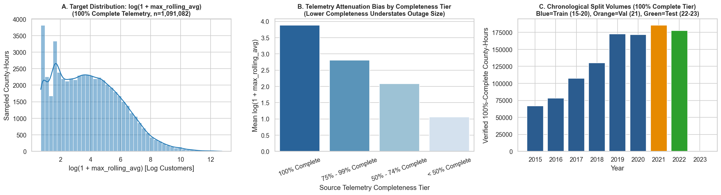
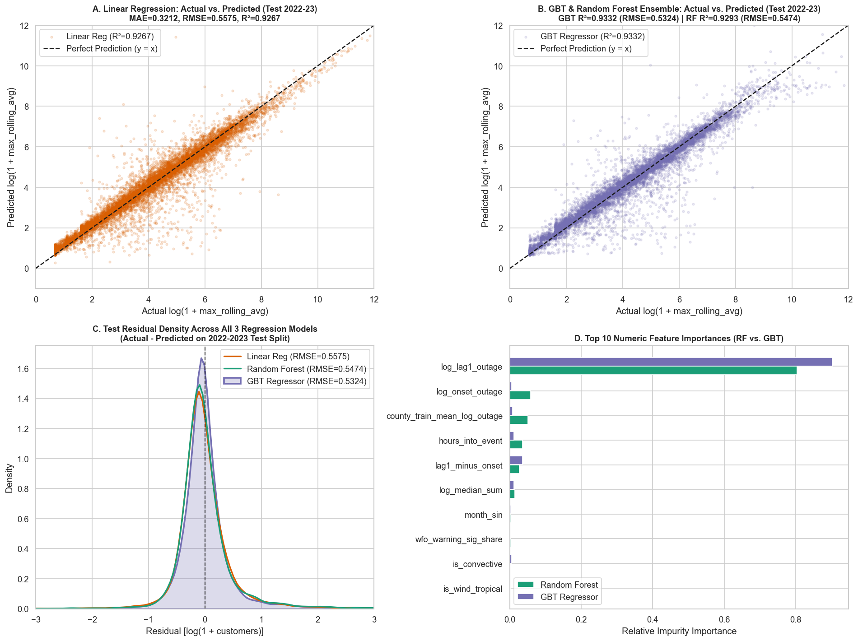

5. Execution-Time and Scalability Analysis
We evaluated distributed PySpark execution time across two scalability dimensions: (1) Training Data Volume Scaling (25%, 50%, 75%, and 100% of the 560,572 training rows) and (2) Spark Partition Parallelism (4, 8, and 16 partitions). All three algorithms scale sub-linearly with data volume, and increasing partition parallelism from 4 to 16 partitions reduces Random Forest training time from 21.09s to 13.03s (a 38.2% speedup) and Linear Regression time from 1.62s to 1.32s.
Data Scale (%) | Train Rows | Linear Reg Time (s) | Random Forest Time (s) | GBT Time (s) | LR Test RMSE | RF Test RMSE | GBT Test RMSE
25% | 140,227 | 1.05s | 4.70s | 13.05s | 0.5574 | 0.5823 | 0.5433
50% | 280,884 | 1.16s | 6.40s | 14.16s | 0.5575 | 0.5829 | 0.5424
75% | 420,809 | 1.44s | 8.87s | 15.97s | 0.5575 | 0.5844 | 0.5419
100% | 560,572 | 1.48s | 10.18s | 17.66s | 0.5575 | 0.5880 | 0.5419

Spark Partitions | Linear Regression Time (s) | Random Forest Time (s) | GBT Regressor Time (s)
4 Partitions | 1.62s | 21.09s | 23.81s
8 Partitions | 1.50s | 16.61s | 20.67s
16 Partitions | 1.32s | 13.03s | 21.44s

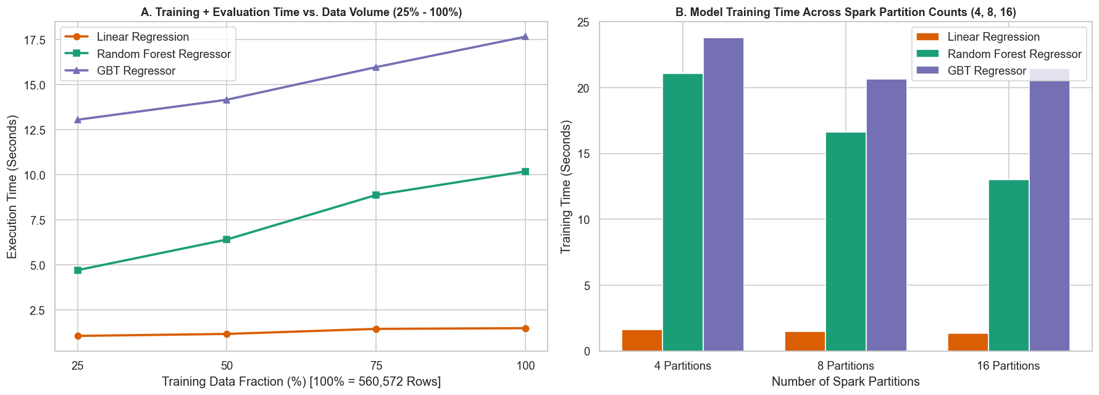

6. Key Analytical Questions and Discussion
Q1: Why did you use a chronological split (Train 2015–2020, Val 2021, Test 2022–2023) instead of a random train/test split?
A1: Hourly outage observations within the same storm event are strongly autocorrelated. A random split would place hour t in the training set and hour t+1 of the same storm in the test set, causing temporal data leakage. Chronological splitting genuinely tests generalization on future years.
Q2: Why does GBT Regressor outperform both Random Forest and Linear Regression?
A2: While Random Forest averages independent trees trained in parallel, GBT Regressor builds trees sequentially where each tree directly fits the residual errors of the preceding trees. This reduces bias during both rapid early storm escalation (1 <= h <= 3, R² = 0.8891) and sustained event hours (h >= 4, R² = 0.9515).
Q3: Why does Random Forest speed up more than GBT when moving from 4 to 16 Spark partitions?
A3: Random Forest trains all trees independently in parallel across partitions, whereas GBT must synchronize gradients sequentially after each boosting iteration.

