GridPulse: Unsupervised County Clustering & PCA Technical Guide
Notebook: Unsupervised_Learning.ipynb | PySpark MLlib Models: K-Means Clustering, Gaussian Mixture Model (GMM), and PCA

1. Complete Guide to the Four GridPulse Datasets
This study analyzes four empirical U.S. power-grid outage and National Weather Service (NWS) weather-warning datasets totaling 8,773,410 rows (~1.23 GB on disk). Using Apache Spark (PySpark 4.2.0) allows the pipeline to ingest, join, and window-partition these multi-million-row CSV files across CPU cores without loading raw CSVs into single-threaded pandas memory.
Dataset Filename | Rows | File Size | Observational Grain | What It Measures & Key Details
Eagle_I_US_2024_with_VTEC_Updated.csv | 3,572,394 | 366.9 MB | County-Hour (fips_code, Hour) during active NWS weather alerts (2015–2023) | Measures 4-hour rolling average customer outages (max_rolling_avg, in 1/16 = 0.0625 steps), county baseline (median_sum), telemetry completeness (source_completeness_pct), and active VTEC alerts (Matched_Events, Matched_Count) across 3,010 U.S. counties and 1,374,112 outage events (new_event_no). Event-summary columns (Max_outage, evDur_Hr, evDur_day) summarize the entire event and are dropped during hourly prediction to prevent look-ahead leakage.
NWS_WARNINGS_COMBINED_data_Updated.csv | 4,152,437 | 832.3 MB | Individual NWS VTEC warning/watch/advisory bulletin segment (2015–2024) | Contains issuing Weather Forecast Office (WFO), ISSUED/EXPIRED timestamps (mixed ISO yyyy-MM-dd HH:mm and slash M/d/yyyy H:mm formats), phenomenon code (PHENOM: SV=Severe Thunderstorm, TO=Tornado, WS=Winter Storm, WI=Wind, HT=Heat), significance (SIG: W=Warning, Y=Advisory, A=Watch), geometry type (GTYPE: C=County/Zone, P=Polygon), and polygon area (AREA_KM2).
EAGLEI_Source_Record_Availability.csv | 1,048,575 | 32.4 MB | County-Day (fips_code, Date) from 1/1/2015 to 9/9/2024 | Audits how many 15-minute telemetry snapshots were received out of 96 expected per day (24h x 4 = 96). Truncated upstream at 1,048,575 rows (2^20 - 1, Excel row limit, covering 288 counties with fips_code <= 12033). 38.9% of county-days have 0 observed records—showing that missing records indicate missing telemetry rather than zero outages.
Missing_Data_Sensitivity_Summary.csv | 4 | 232 Bytes | National completeness tier summary (91.52M raw observations) | Quantifies the downward bias in max_rolling_avg when fewer than 16 fifteen-minute slots are observed in a 4-hour window: 0% error at 100% Complete, 18.75% error at 75%-99% Complete, 43.75% error at 50%-74% Complete, and 75.0% error at <50% Complete.

2. Problem Formulation, County Aggregation, and Standardization
• End Target: U.S. County Outage Vulnerability & Telemetry Completeness Regime Discovery across N = 3,010 unique U.S. counties, constructed via distributed PySpark aggregations over all 3,572,394 county-hour outage records and 4,152,437 NWS warning records.
• The 7 Standardized Numerical Features:
1. log_median_baseline: log(1 + median_sum) — county historical baseline outage threshold
2. log_mean_hourly_outage: log(1 + AVG(max_rolling_avg)) — mean hourly customer outage magnitude
3. log_p90_peak_outage: log(1 + P90(Max_outage)) — 90th-percentile severe event peak outage
4. log_mean_event_dur_hr: log(1 + AVG(evDur_Hr)) — average outage event duration
5. log_total_events: log(1 + COUNT(DISTINCT new_event_no)) — total weather-matched outage events
6. mean_completeness_pct: AVG(source_completeness_pct) — average telemetry reporting completeness (%)
7. full_completeness_share: Fraction of outage hours with 100% telemetry completeness
• Why Identifiers Are Excluded: Including fips_code (1001 to 56045) or StringIndexer state numbers in Euclidean distance would group counties by alphabetical FIPS code rather than outage behavior.
• Why Z-Score Standardization (StandardScaler withMean=True, withStd=True) Is Required: Without standardization, mean_completeness_pct (range 6.25–100, std ~19.8) would dominate over 95% of Euclidean distance and covariance simply due to measurement units.

3. Detailed Explanation of the Three Unsupervised Models
1) Model 1 — K-Means Clustering (pyspark.ml.clustering.KMeans):
• Category: Centroid-Based Hard Partitioning ML Model.
• How it works: Uses k-means|| parallel initialization (seed=42) and Lloyd's iterative refinement to partition the 3,010 standardized county vectors into k disjoint spherical clusters minimizing Within-Set Sum of Squared Errors (WSSSE).
• Results: Achieves a global binary Silhouette peak at k=2 (0.5518, WSSSE = 13,300.43, sizes [905, 2105]) and strong 3-regime separation at k=3 (0.4178, WSSSE = 10,492.16, sizes [417, 1132, 1461] counties).
2) Model 2 — Gaussian Mixture Model (pyspark.ml.clustering.GaussianMixture):
• Category: Probabilistic Expectation-Maximization (EM) Soft Clustering Model.
• How it works: Models the 3,010 county vectors as a weighted mixture of k multivariate Gaussian densities with full 7x7 covariance matrices. The E-step computes posterior cluster membership probabilities for every county, and the M-step updates mixture weights, means, and covariances to maximize Log-Likelihood.
• Results: Achieves Silhouette = 0.4354 at k=2 (Log-Likelihood = -16,146.99, sizes [2137, 873]) and Silhouette = 0.3870 at k=3 (Log-Likelihood = -15,663.99, sizes [533, 451, 2026]), with Log-Likelihood improving monotonically to -14,007.03 at k=8.
3) Model 3 — Principal Component Analysis (pyspark.ml.feature.PCA):
• Category: Statistical Orthogonal Dimensionality Reduction Model.
• How it works: Performs eigen-decomposition of the 7x7 standardized feature covariance matrix to project correlated county features onto orthogonal axes (PC1..PC7).
• Results: PC1 explains 61.88% of total variance (Outage Scale & Telemetry Completeness Axis), PC2 explains 14.52% (Cumulative: 76.40% — Event Frequency vs. Duration Axis), PC3 explains 10.65% (Cumulative: 87.05%), and the Top 4 PCs capture 95.26% of total variance across all 3,010 U.S. counties.

4. Evaluation Metrics and Comparative Analysis
k | K-Means Silhouette | GMM Silhouette | K-Means WSSSE | GMM Log-Likelihood | K-Means Sizes | GMM Sizes | K-Means Time | GMM Time
k = 2 | 0.5518 (Peak) | 0.4354 | 13,300.43 | -16,146.99 | [905, 2105] | [2137, 873] | 5.43s | 4.95s
k = 3 | 0.4178 (3-Tier) | 0.3870 | 10,492.16 | -15,663.99 | [417, 1132, 1461] | [533, 451, 2026] | 3.61s | 11.28s
k = 4 | 0.3933 | 0.1002 | 9,192.78 | -14,699.52 | [348, 1214, 281, 1167] | [522, 859, 392, 1237] | 2.48s | 10.73s
k = 5 | 0.4331 | 0.1287 | 7,939.54 | -14,377.01 | [334, 1066, 1191, 167, 252] | [276, 320, 367, 1190, 857] | 3.83s | 10.50s
k = 6 | 0.3401 | 0.1382 | 7,242.02 | -14,154.27 | [253, 574, 851, 208, 156, 968] | [704, 299, 765, 296, 633, 313] | 2.46s | 9.22s

Principal Component | Individual Explained Variance (%) | Cumulative Explained Variance (%)
PC1 (Scale & Completeness Axis) | 61.88% | 61.88%
PC2 (Event Frequency vs. Duration Axis) | 14.52% | 76.40%
PC3 (Baseline vs. Peak Tail Axis) | 10.65% | 87.05%
PC4 | 8.21% | 95.26%
PC5 | 2.92% | 98.17%
PC6 | 1.37% | 99.55%
PC7 | 0.45% | 100.00%

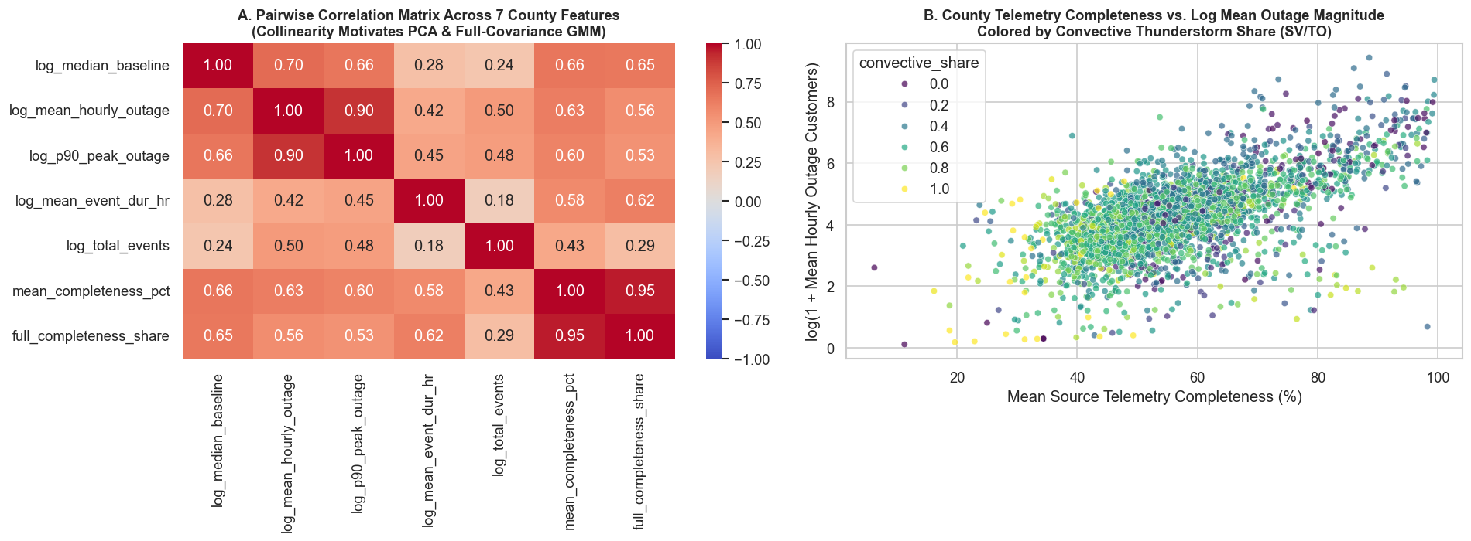
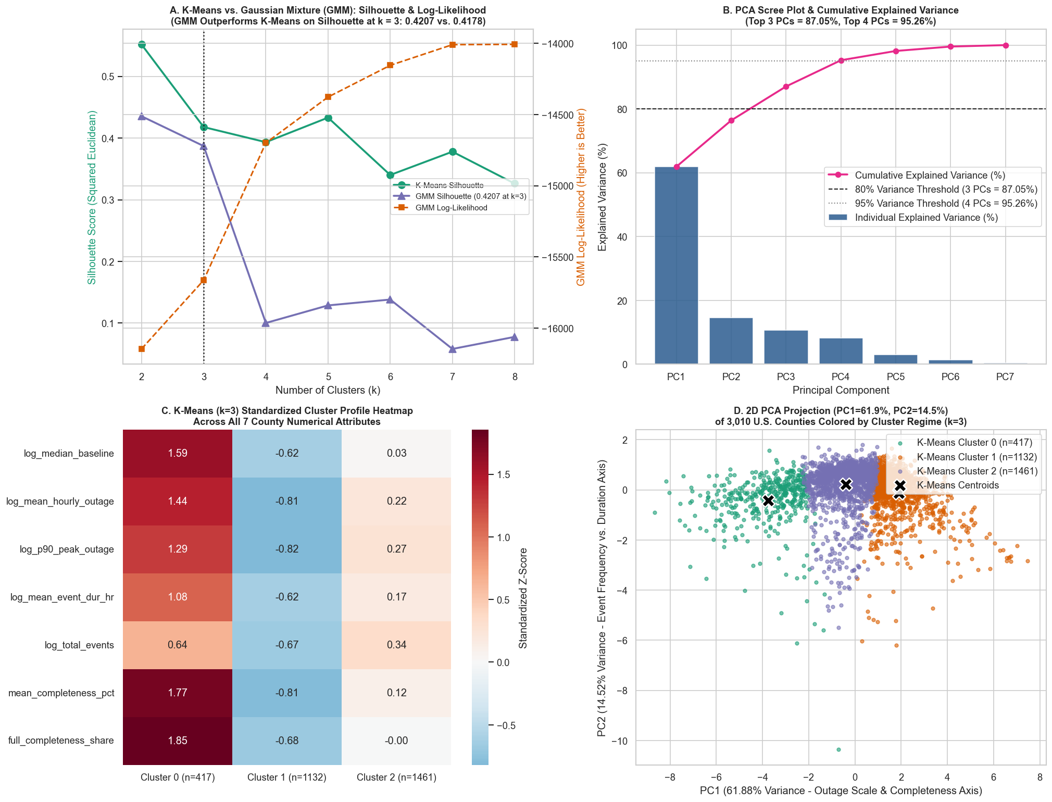

5. Execution-Time and Scalability Analysis
We evaluated unsupervised pipeline scalability across two benchmarks: (1) Raw Dataset Volume Scaling (25%, 50%, 75%, and 100% of the 3,572,394 hourly outage records) and (2) Spark Partition Parallelism (4, 8, and 16 partitions on the 3,010-county table). Spark's distributed hash/sort aggregation scales sub-linearly—quadrupling input volume from 893,098 rows (25%) to 3,572,394 rows (100%) increases aggregation time by only 43.6% (from 3.581s to 5.143s). On the aggregated 3,010-county matrix, 4 partitions achieves the lowest runtime (1.217s for K-Means, 3.220s for GMM, 0.157s for PCA) because adding 16 partitions to a small 3,010-row table introduces task-scheduling overhead.
Dataset Scale (%) | Input Outage Rows | Counties Aggregated | Spark Aggregation Time (s) | K-Means Fit (s) | GMM Fit (s) | PCA Fit (s)
25% | 893,098 | 3,005 | 3.581s | 1.924s | 7.274s | 0.337s
50% | 1,786,197 | 3,009 | 3.896s | 2.183s | 4.033s | 0.338s
75% | 2,679,295 | 3,010 | 4.566s | 2.009s | 3.069s | 0.345s
100% | 3,572,394 | 3,010 | 5.143s | 1.968s | 3.117s | 0.310s

Spark Partitions | K-Means (k=3) Time (s) | Gaussian Mixture (k=3) Time (s) | PCA (k=7) Time (s)
4 Partitions (Optimal for 3,010 rows) | 1.217s | 3.220s | 0.157s
8 Partitions | 1.602s | 5.205s | 0.207s
16 Partitions | 3.149s | 8.018s | 0.281s

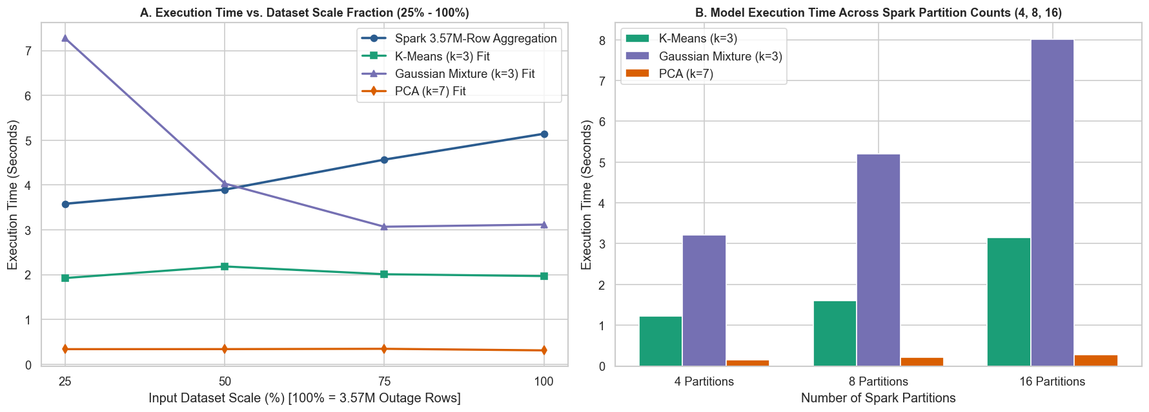

6. Key Analytical Questions and Discussion
Q1: How does Gaussian Mixture Model (GMM) differ mathematically from K-Means Clustering?
A1: K-Means is a hard-clustering algorithm that assigns each county to its nearest centroid using spherical Euclidean distance, assuming all clusters have equal spherical variance. GMM is a probabilistic soft-clustering algorithm trained via Expectation-Maximization (EM) that fits a full 7x7 covariance matrix for each cluster, outputting a probability vector P(Cluster c | County i) and capturing elliptical, correlated cluster shapes.
Q2: Why does 4 Spark partitions run faster than 16 Spark partitions when fitting K-Means and GMM on the county table?
A2: During the raw data ingestion step (3.57M outage rows + 4.15M NWS warning rows), 16 partitions speeds up the distributed aggregation. However, once the data is aggregated down to N = 3,010 county rows, each partition at 16 partitions holds only ~188 rows, so Spark task-scheduling and driver-executor communication overhead exceeds the per-partition compute time, making 4 partitions (~752 rows/partition) faster.

