PROBABILITY AND STATISTICS FOR MACHINE LEARNING - 1BMATAI301
NAME : JAHNAVI.B
SEC : AIML-02

Discrete Probability Distributions: Binomial, Poisson & Geometric

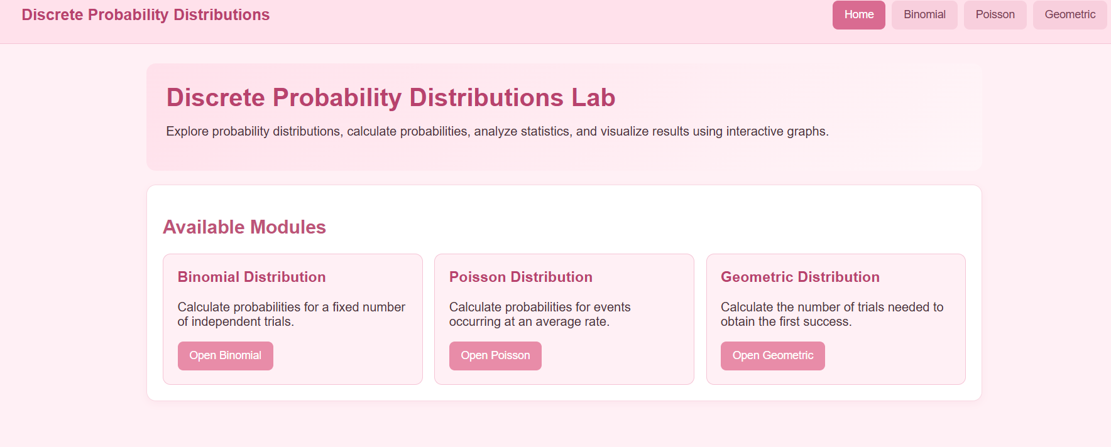

case 1: Manufacturing quality control
Steps to experiment on web application


1. Open the Binomial module in your Web application.
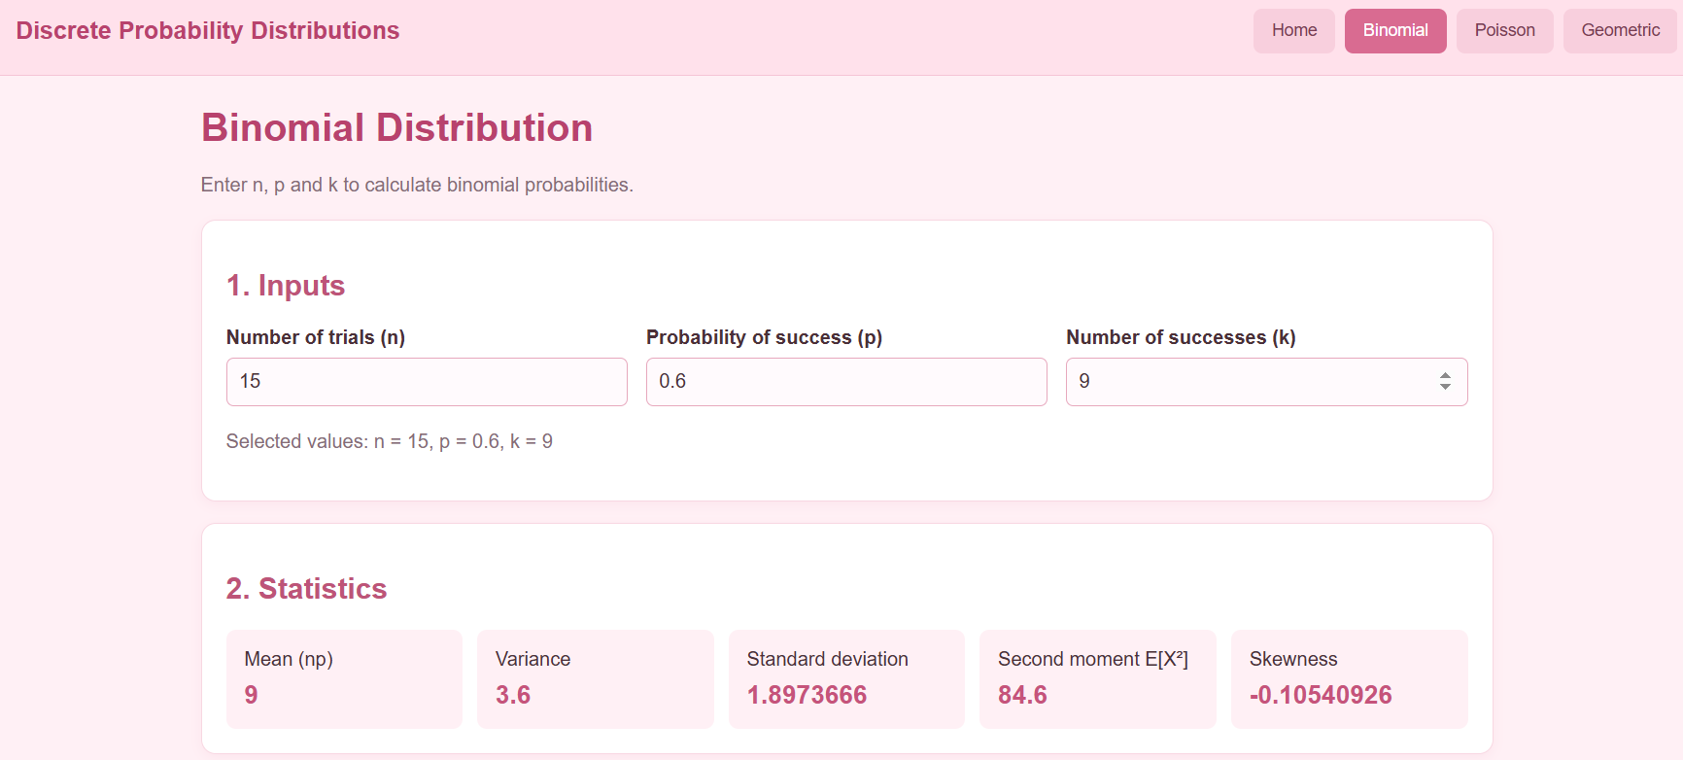
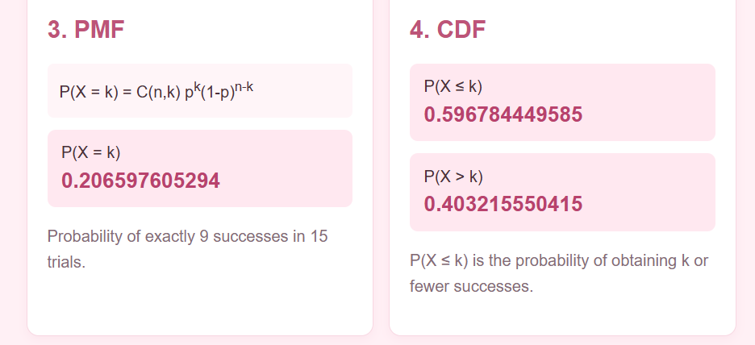
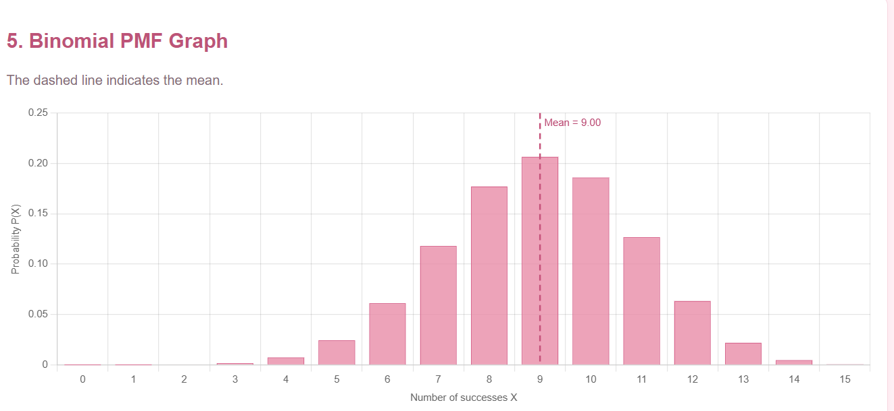

2. Enter n = 20 and p = 0.05.
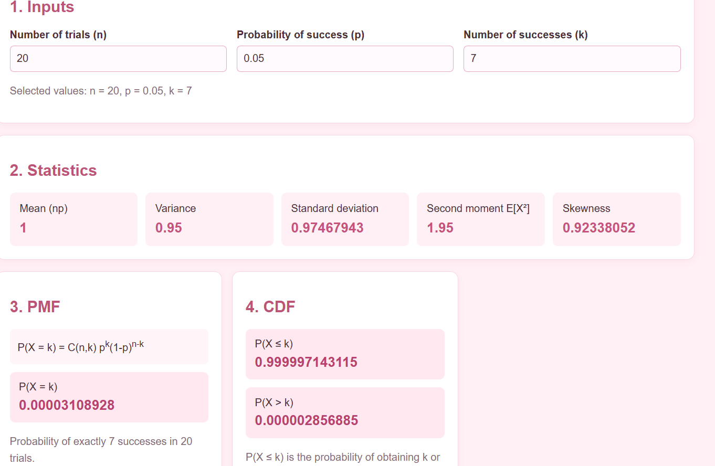
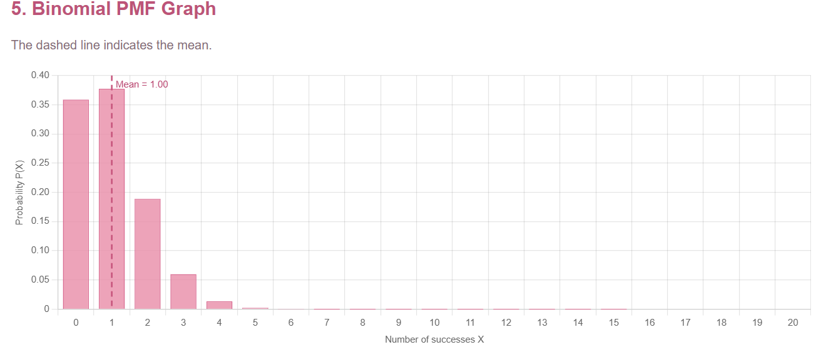

In this case study, the Binomial Distribution is used to analyze manufacturing quality by estimating the number of defective products in a sample of 20 items. The probability of a product being defective is assumed to be 5%. The developed application calculates statistical measures, determines the probabilities of different defect counts using PMF and CDF, and displays a graph to visualize the results. This helps manufacturers understand defect patterns, evaluate product quality, and identify unusual inspection outcomes.
3. Calculate the mean, variance, and probability of exactly 2 defects
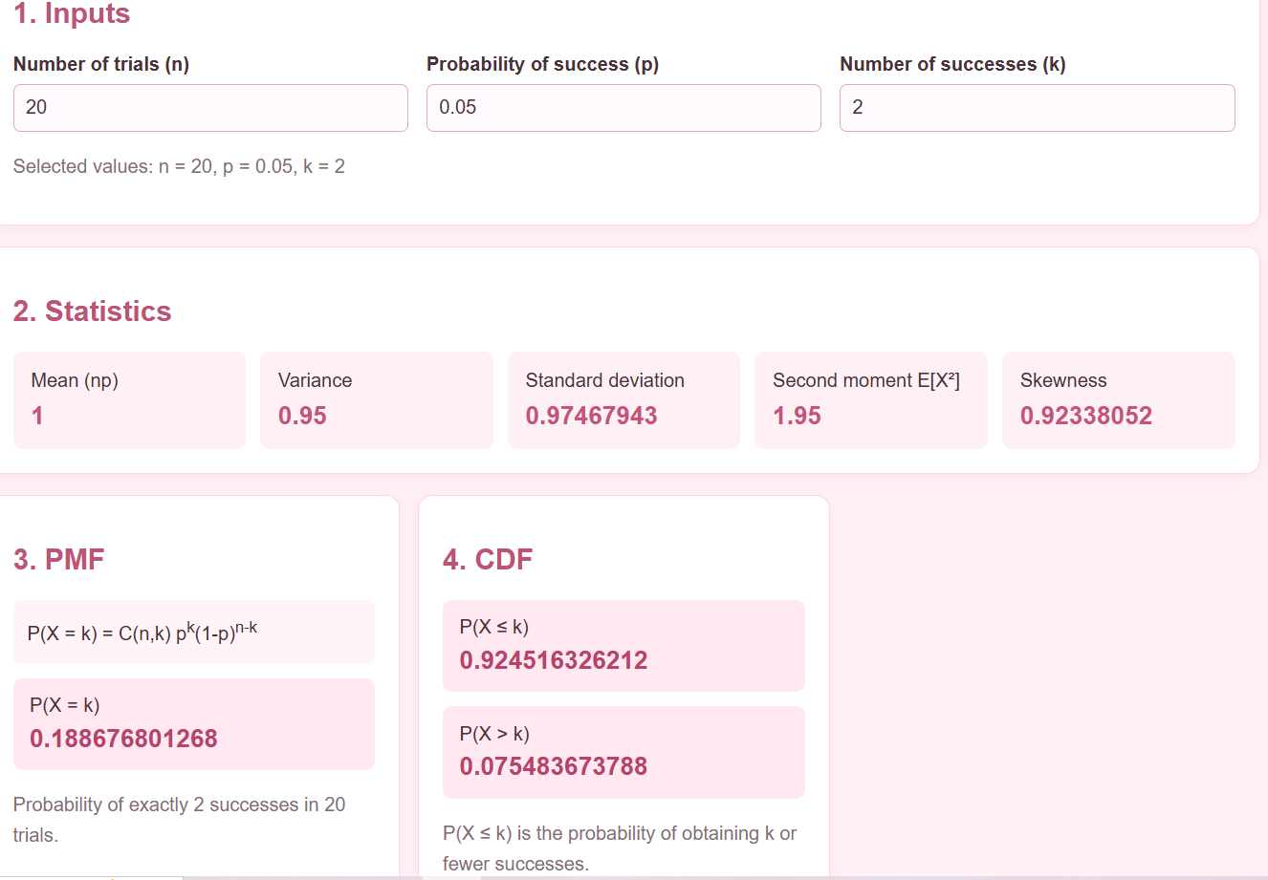

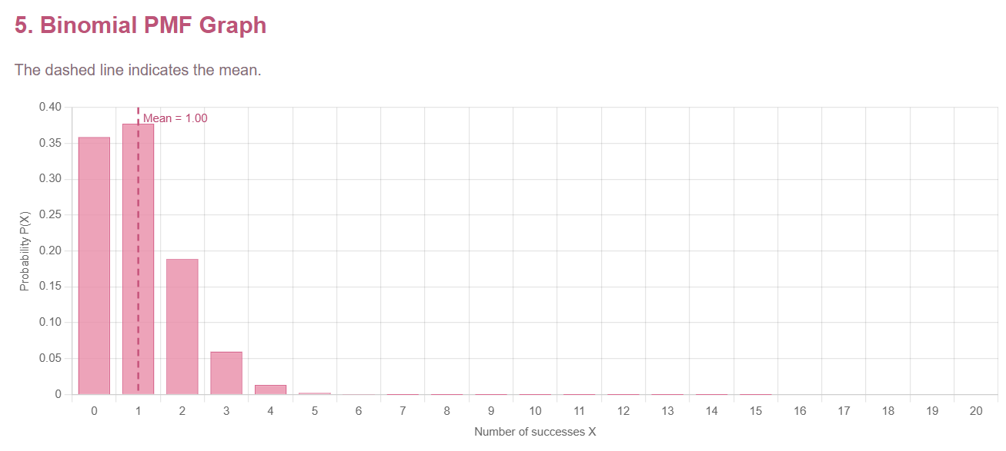

The application calculates the mean and variance for 20 inspected products with a 5% defect probability. It also determines the probability of finding exactly 2 defective products. These results help estimate the expected number of defects and assess product quality in the manufacturing process
4. View the PMF graph. The horizontal axis represents the number of defects and the vertical axis represents the probability of each count.
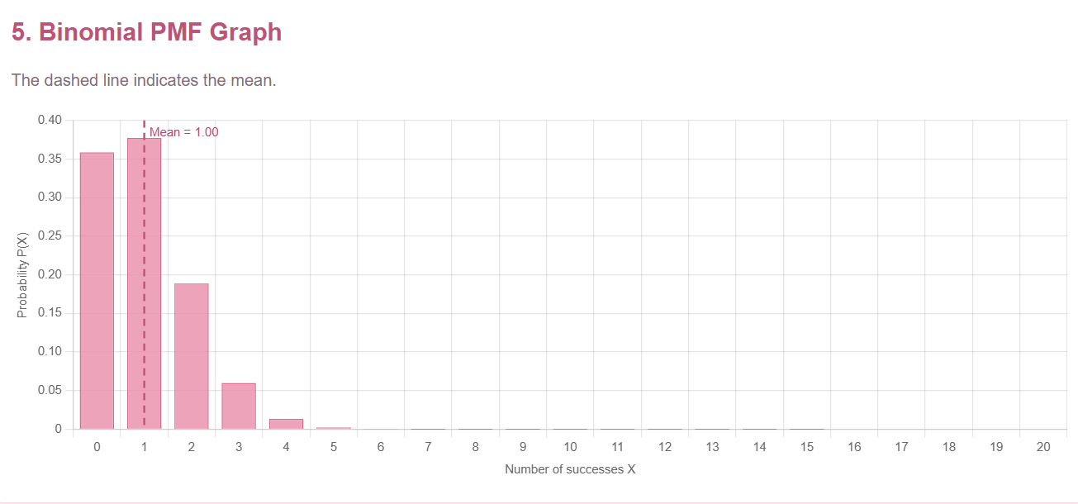

The PMF graph represents the probability of different numbers of defective products in a sample of 20 items. The horizontal axis shows the number of defects, while the vertical axis represents their corresponding probabilities. The graph indicates that smaller numbers of defects are more likely when the defect probability is 5%, helping assess the quality of manufactured products.
5. Change the defect probability from 0.05 to 0.10 . Observe how the distribution shifts toward larger defect counts

The defect probability was increased from 5% to 10% while keeping the sample size at 20 products. The PMF graph shifted towards higher defect counts, and the mean number of defective products increased from 1 to 2. This demonstrates how an increase in the defect rate can affect manufacturing quality.

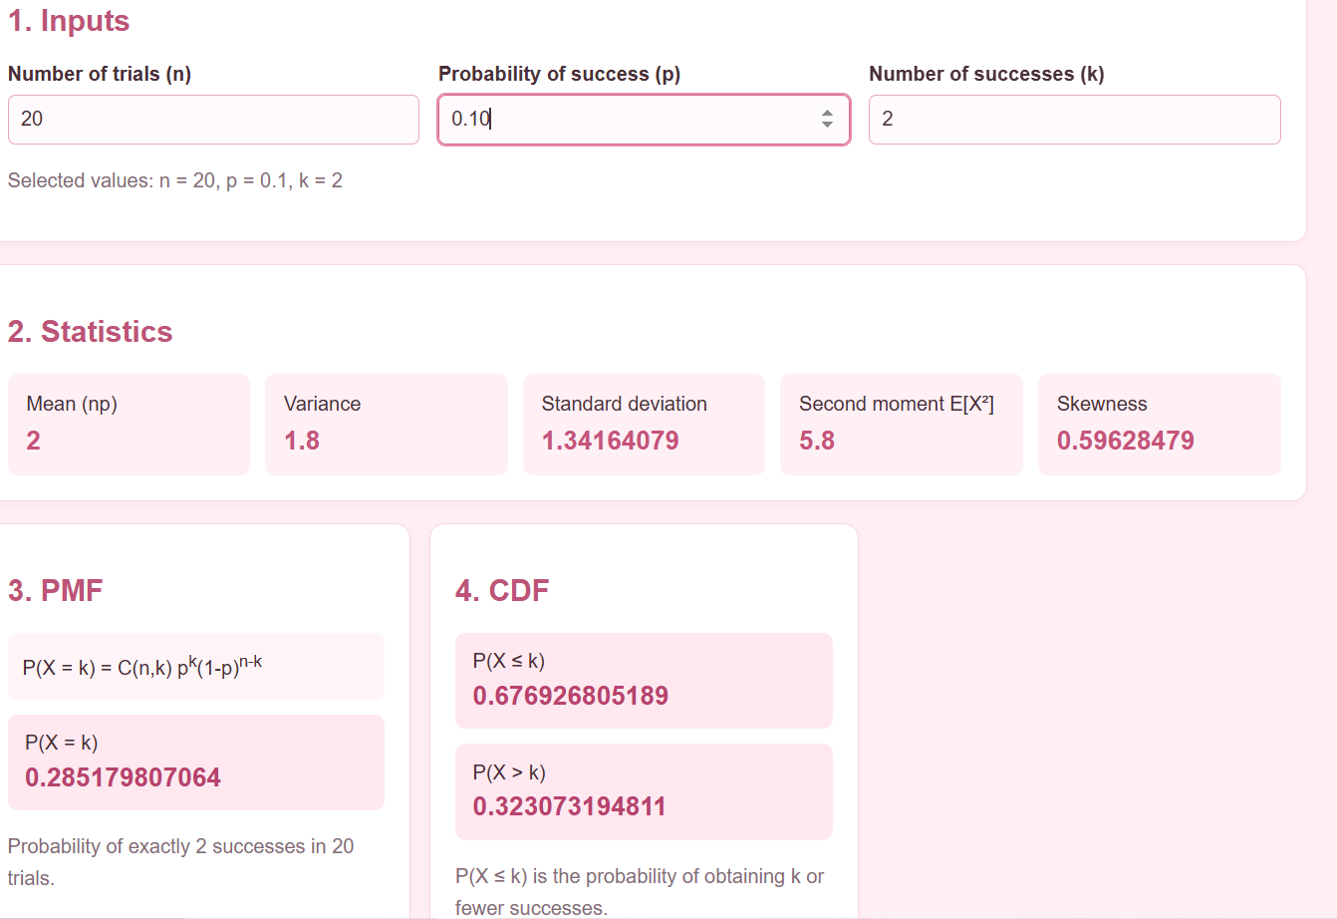
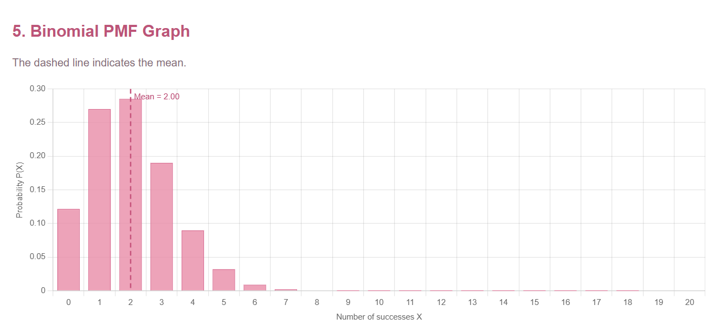

6. Open the Poisson module and enter lambda 5 for 100 inspected products. Compare the Poisson probabilities with the Binomial results.
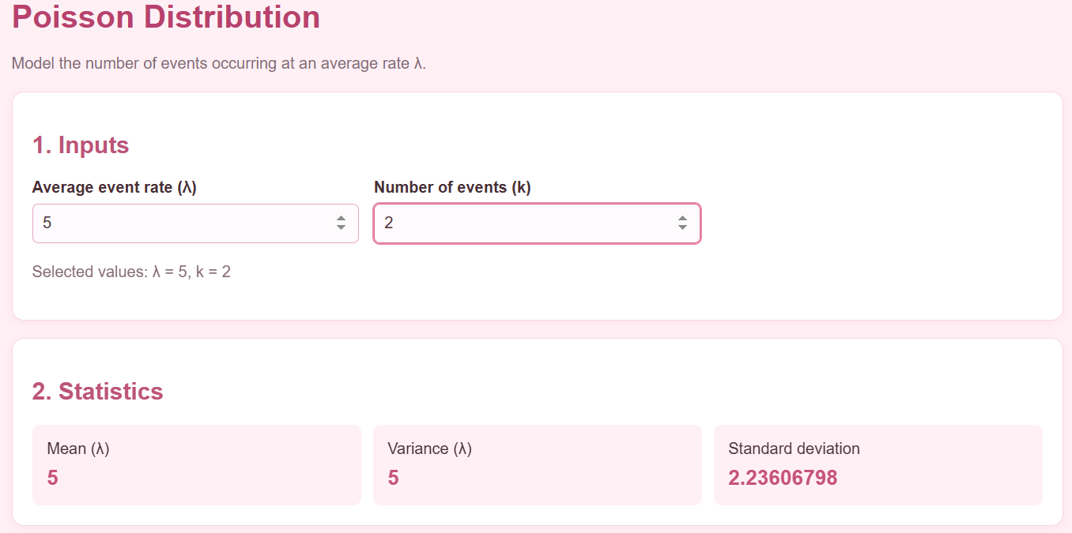
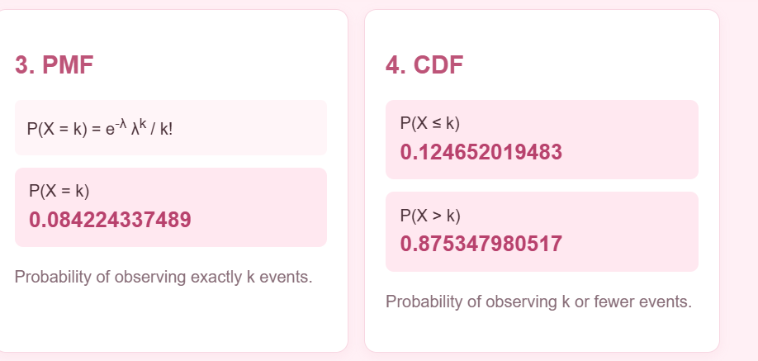
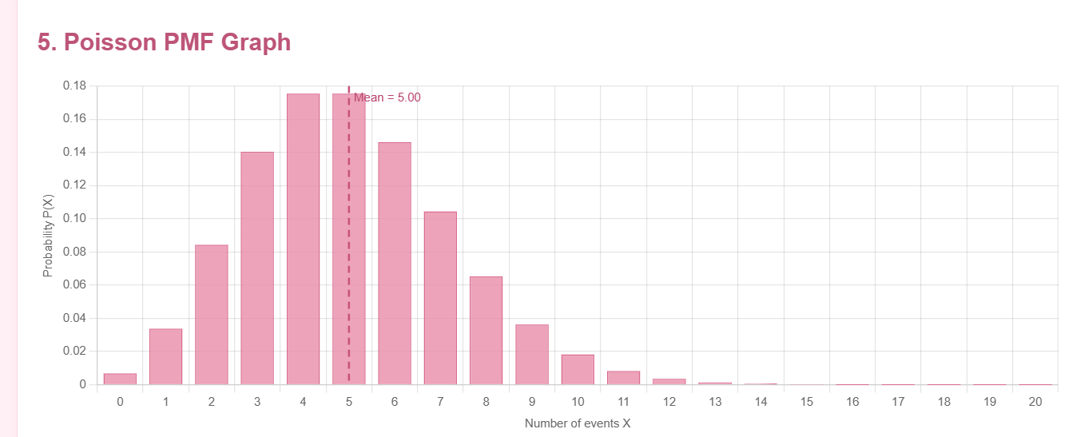

The Poisson Distribution was used to analyze the number of defective products among 100 inspected items, with an average defect count of 5. The calculated probabilities and PMF graph show the likelihood of different defect counts. Comparing these results with the Binomial Distribution helps demonstrate how both distributions can be used to analyze manufacturing defects.

7. Open the Geometric module and enter p=0.05. Examine the probability of detecting the first defect on different inspection attempts.
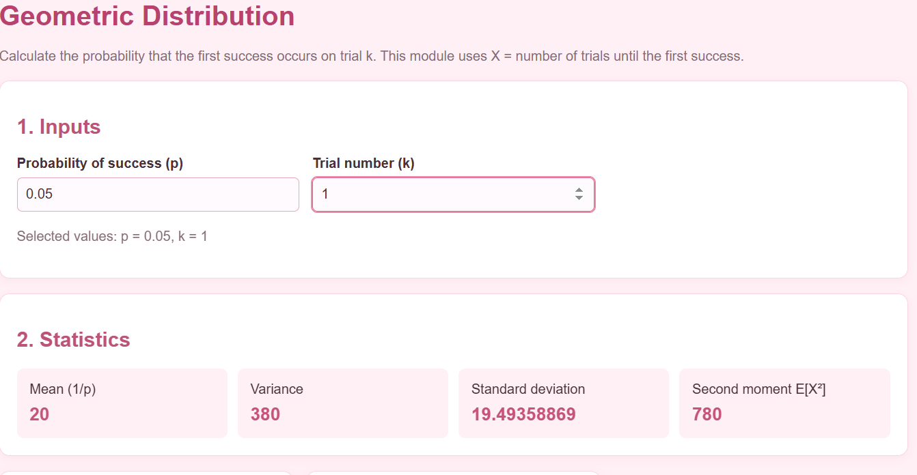
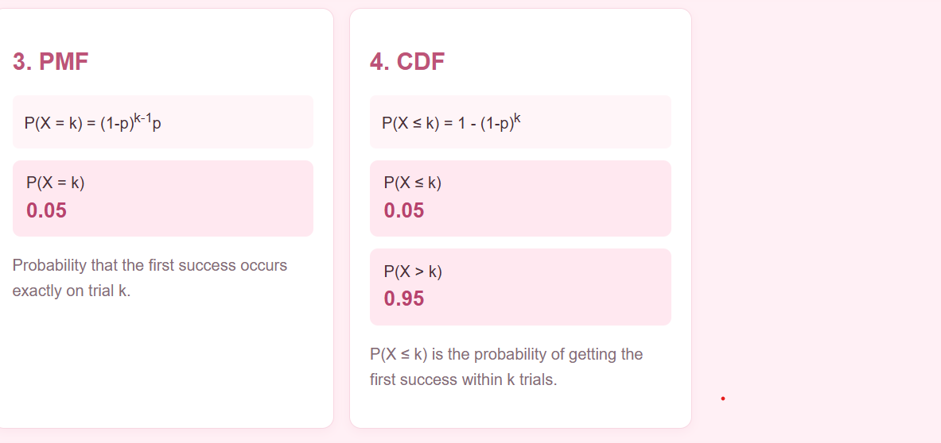

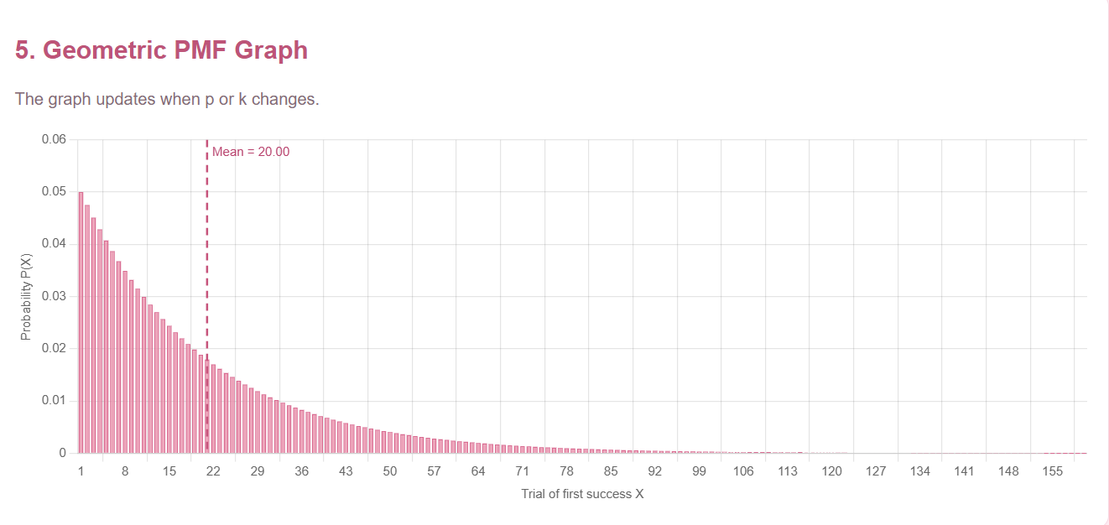
The Geometric Distribution module was configured with a defect probability of (p=0.05) to analyze the number of inspections required to detect the first defective product. The application calculates the probability of detecting the first defect on different inspection attempts. The results help estimate how long it may take to identify a defective product during manufacturing quality inspection.

8. Write down the numerical results, graph observations, and an inference about the quality-control process.
Numerical Results, Graph Observations, and Inference

1. Numerical Results

For the Binomial Distribution, the parameters are n = 50, p = 0.05, and k = 30.
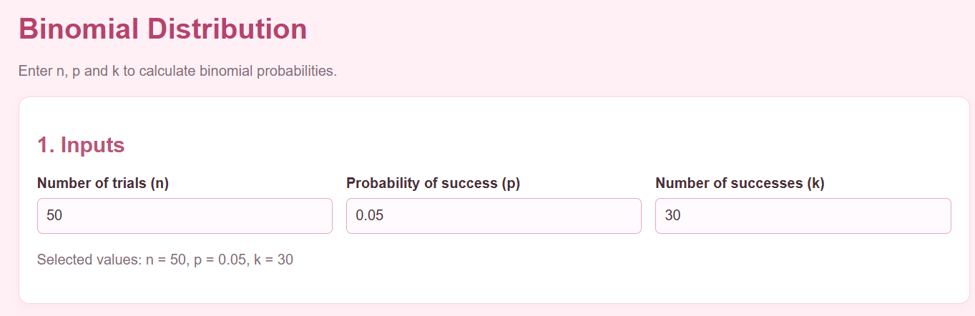
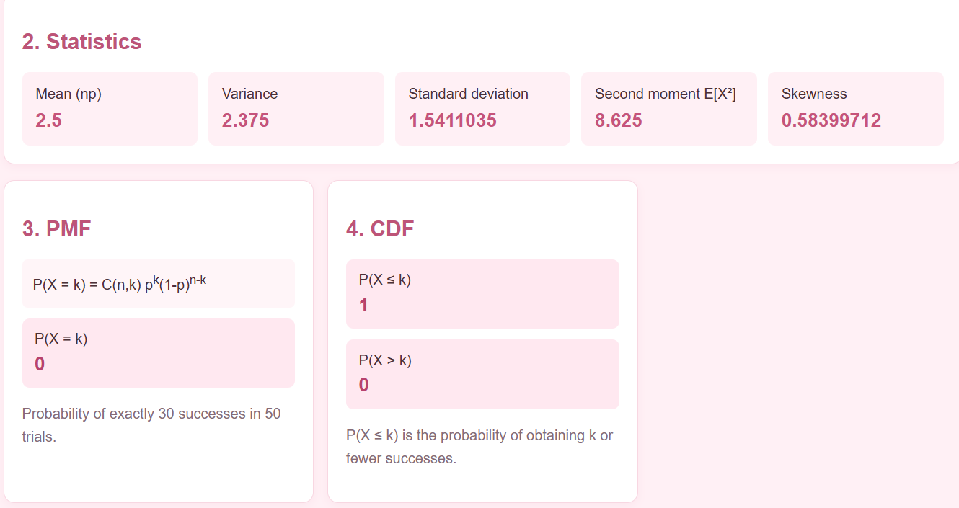
2. Graph Observations
The graph shows the highest probability around 2–3 defective products. The probability of finding 30 defective products is almost zero, indicating that such a high defect count is extremely unlikely.
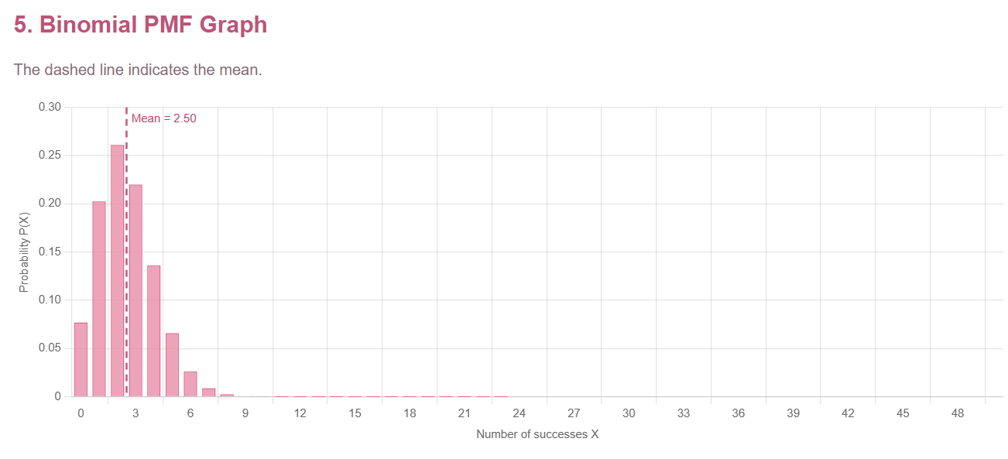

3. Inference About the Quality-Control Process
The Binomial Distribution helps monitor manufacturing quality by predicting defective products. Since 30 defects out of 50 are extremely unlikely at a 5% defect rate, such a result would indicate a possible quality issue requiring investigation.

case 2: Cloud operations and cybersecurity monitoring
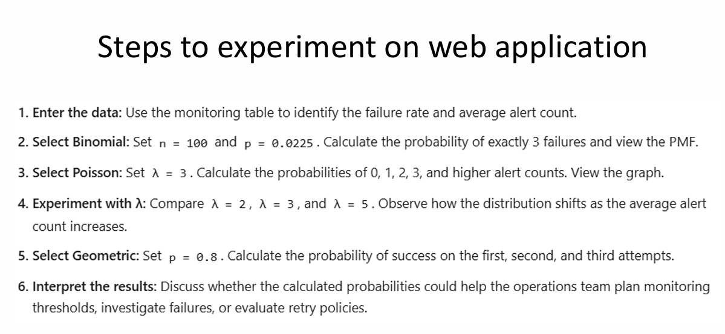

- Enter the data
- Binomial Distribution

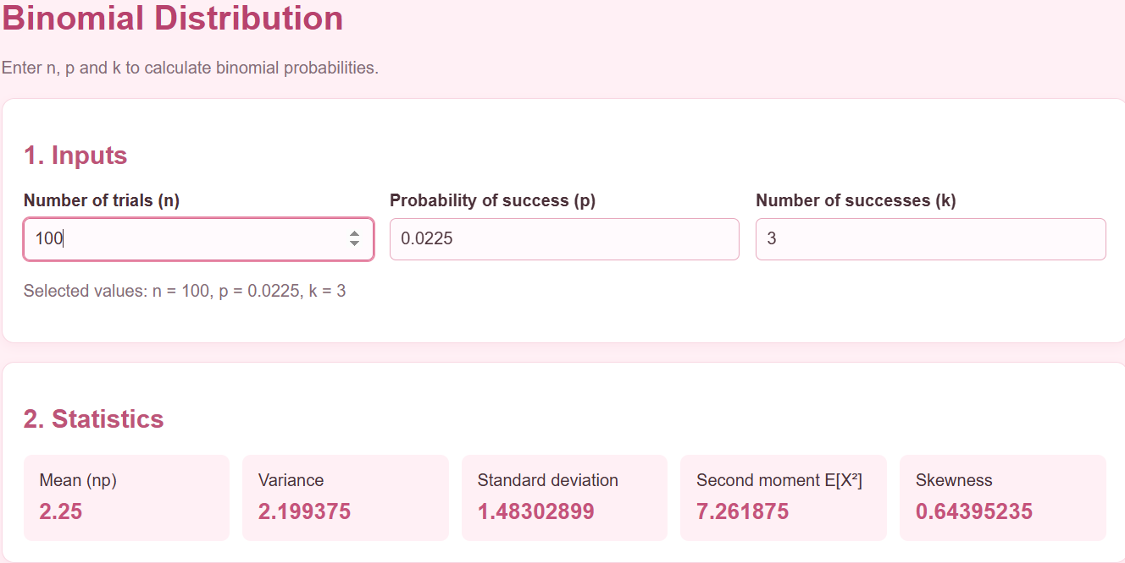
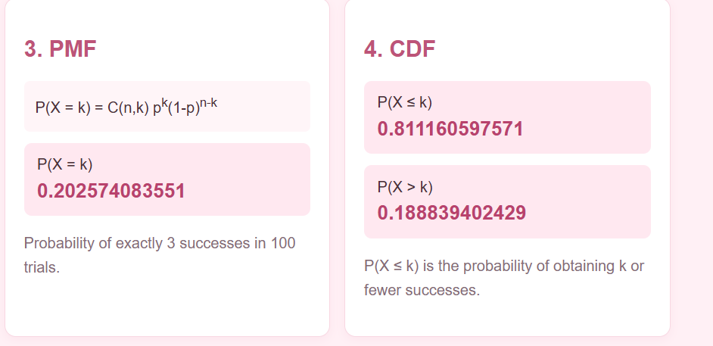
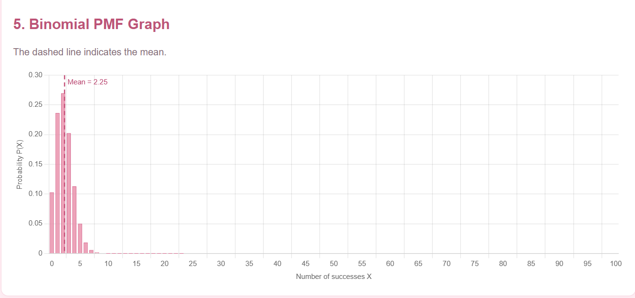
Graph Observation – Binomial Distribution
The graph shows that most cloud operations experience around 2–3 failures out of 100 trials. The probability of exactly 3 failures is approximately 21%, while higher failure counts generally have lower probabilities.
Inference
The binomial distribution helps the cloud operations and cybersecurity team estimate the likelihood of system failures. This information can support failure monitoring, identify unusual failure rates, and improve system reliability.

3.Poisson Distribution

K=0

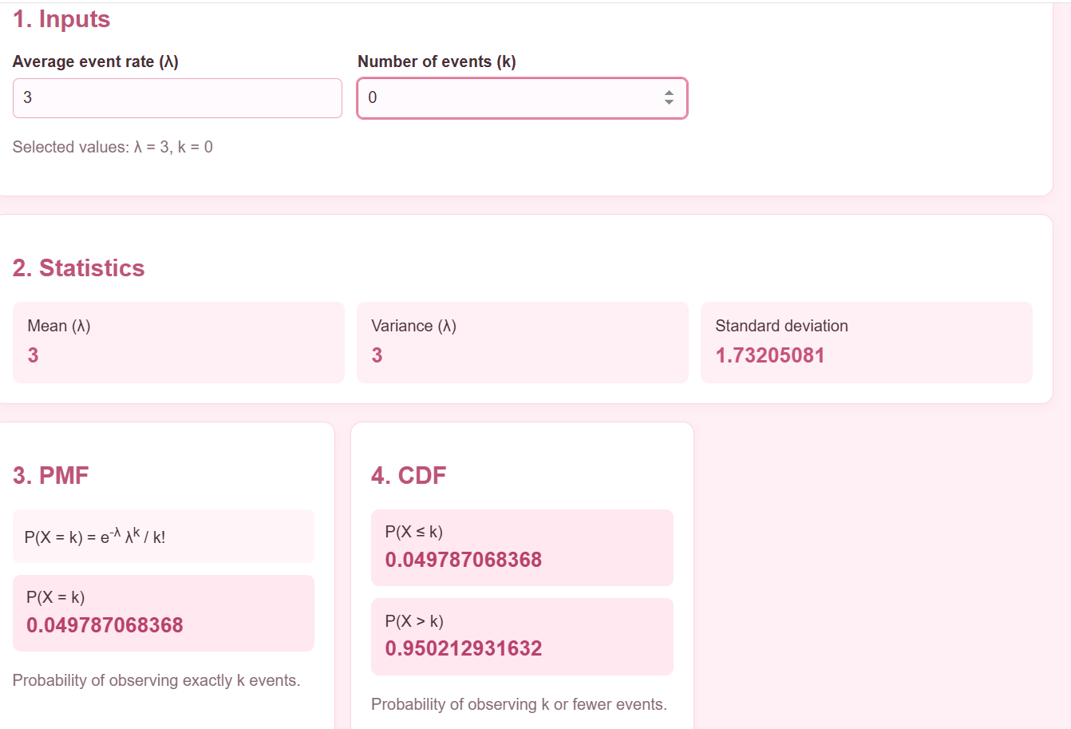
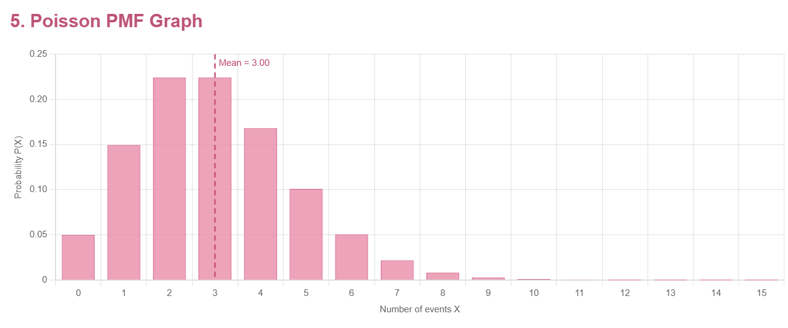

K=1
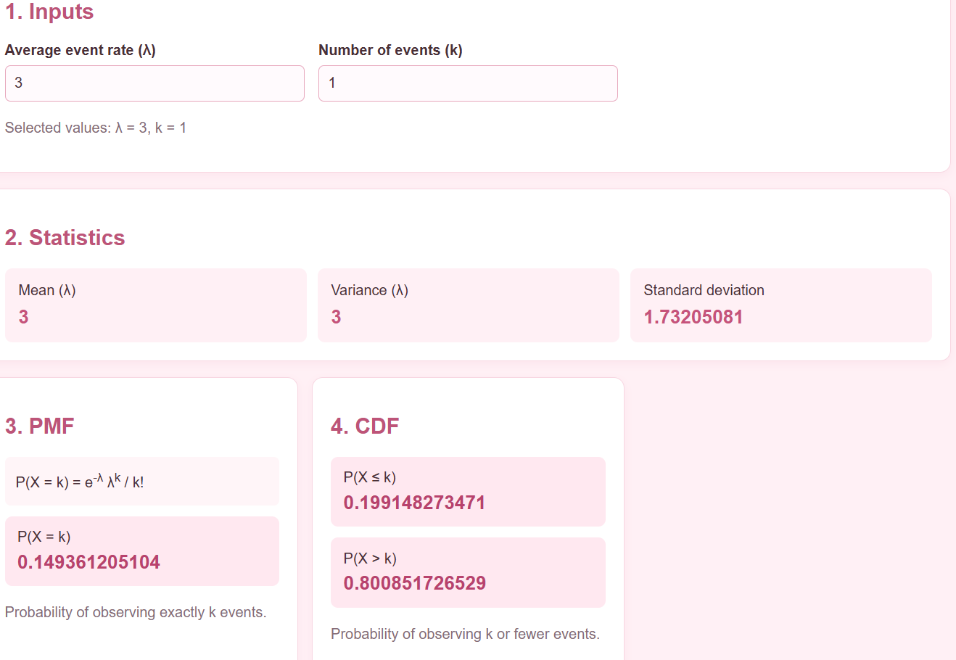

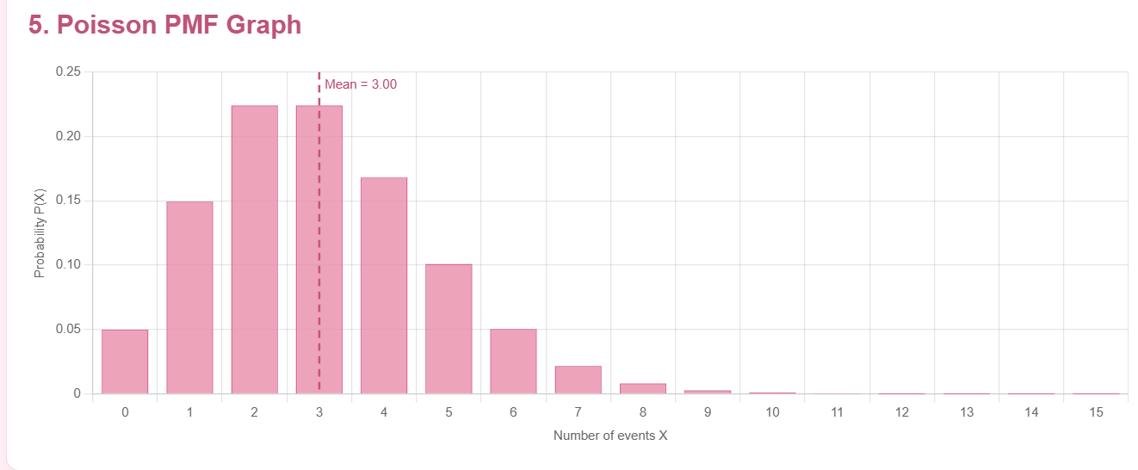

K=2
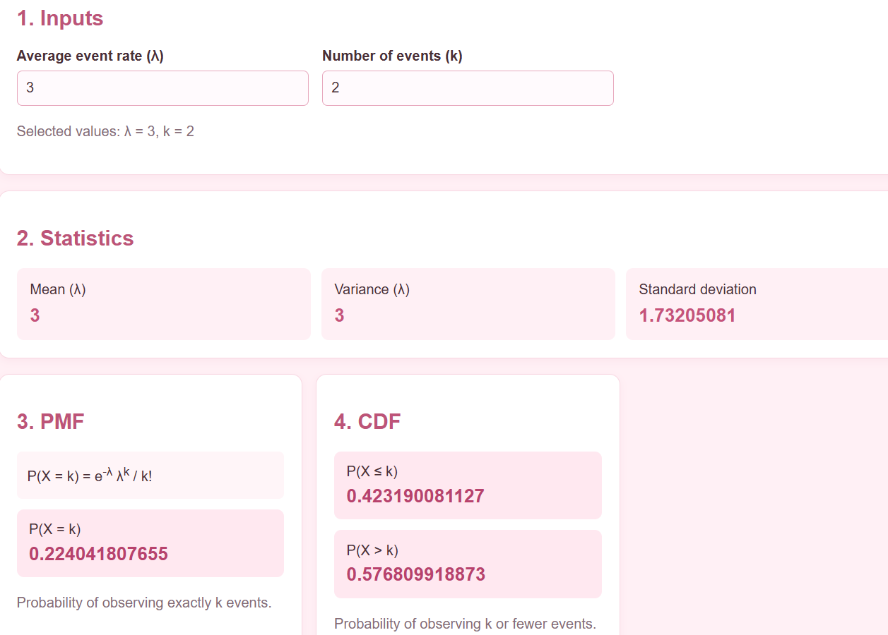

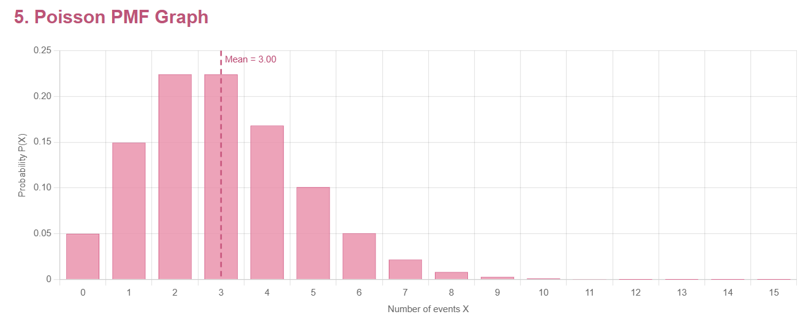

K=3
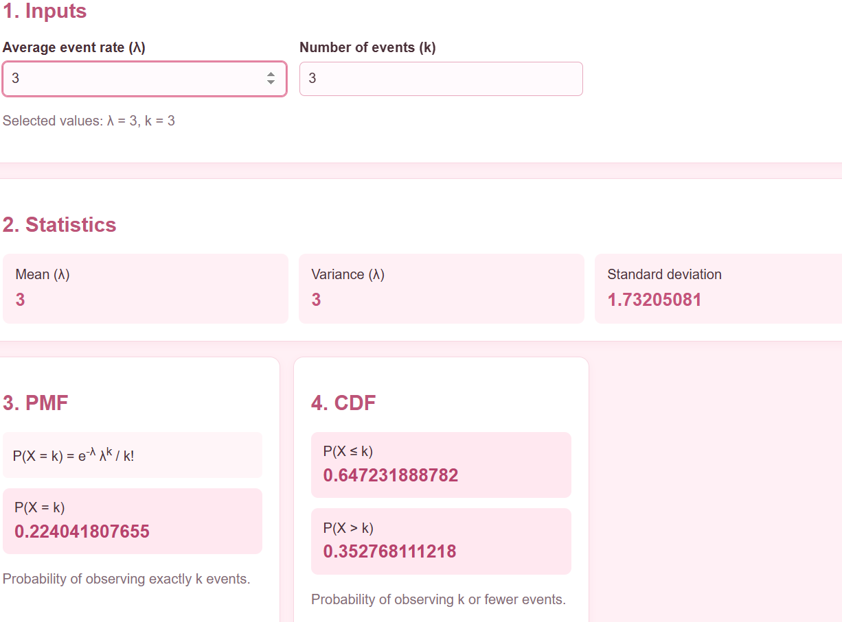
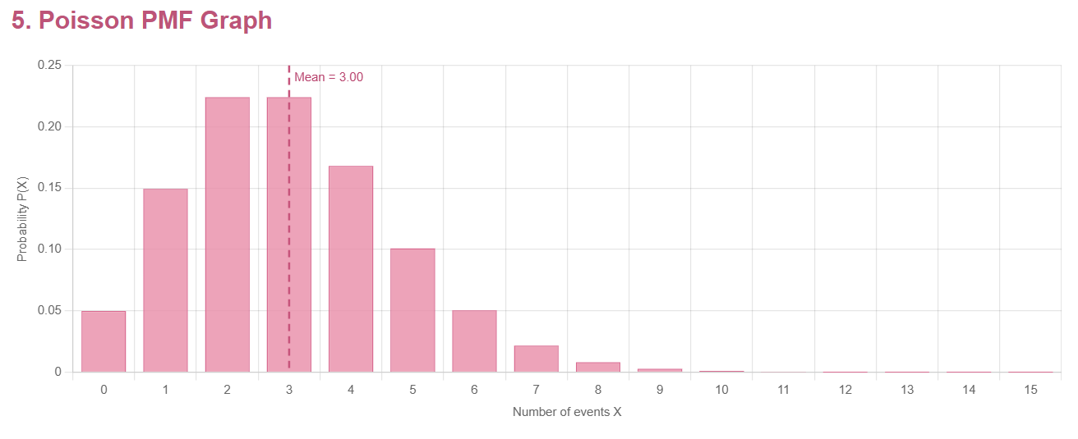
Graph Observation – Poisson Distribution
With an average alert count of lambda=3, the graph shows that the highest probabilities occur at 2 and 3 alerts. The probability of more than 3 alerts is approximately 35.28%.

Inference
The Poisson distribution helps the cloud operations and cybersecurity team estimate the number of alerts received during a monitoring period. This supports alert monitoring, workload planning, and the identification of unusually high alert activity.

4.Compare Different Poisson Parameters
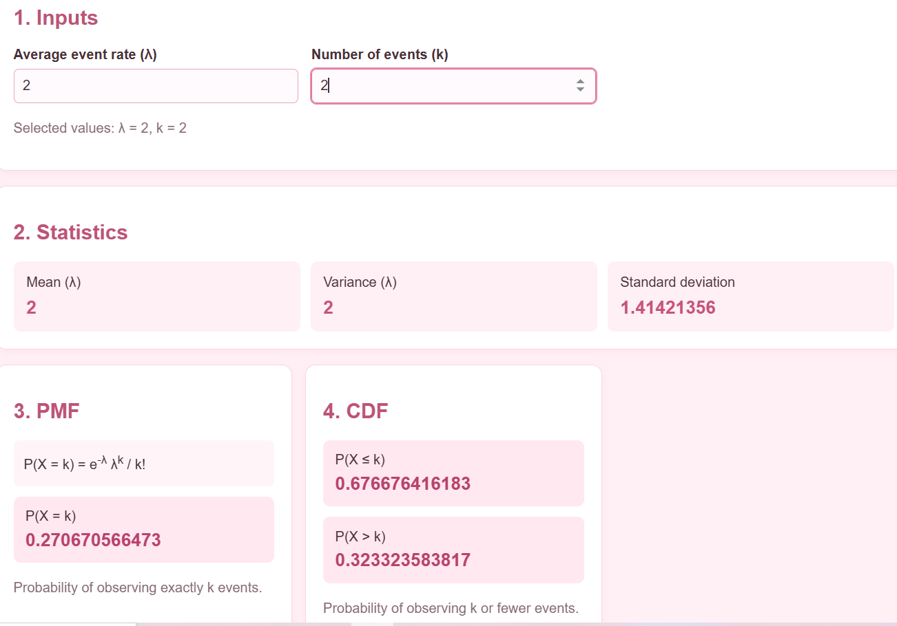
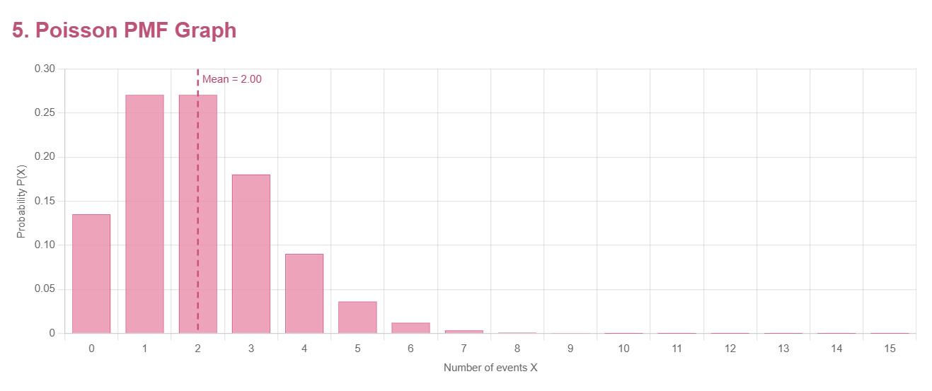
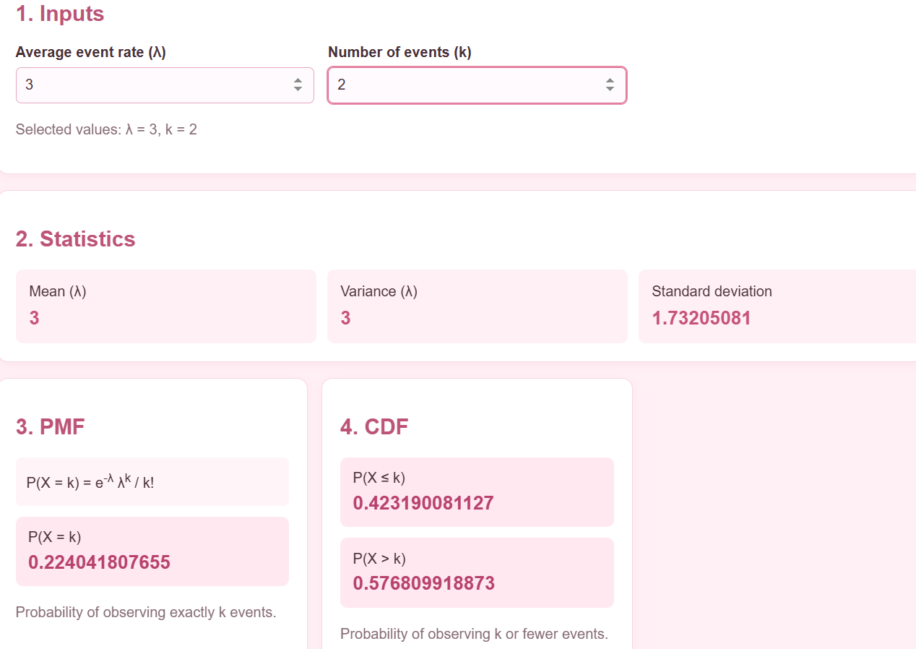
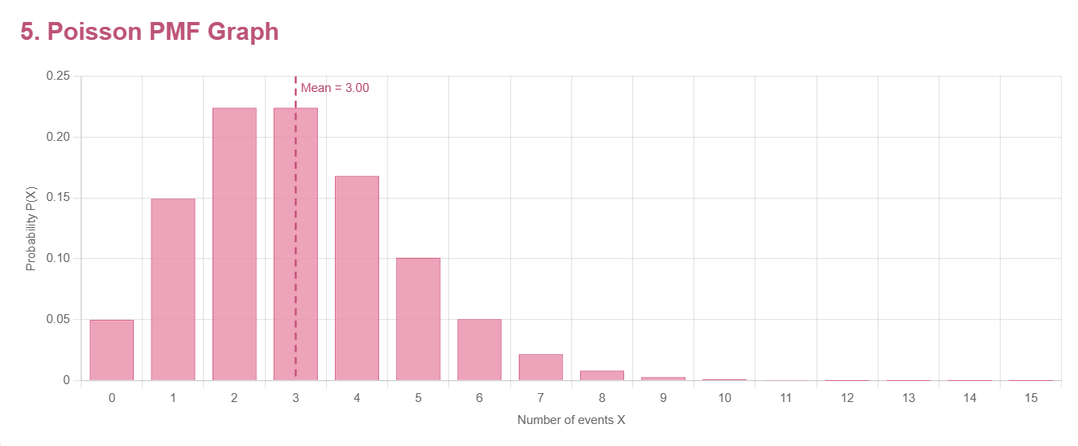
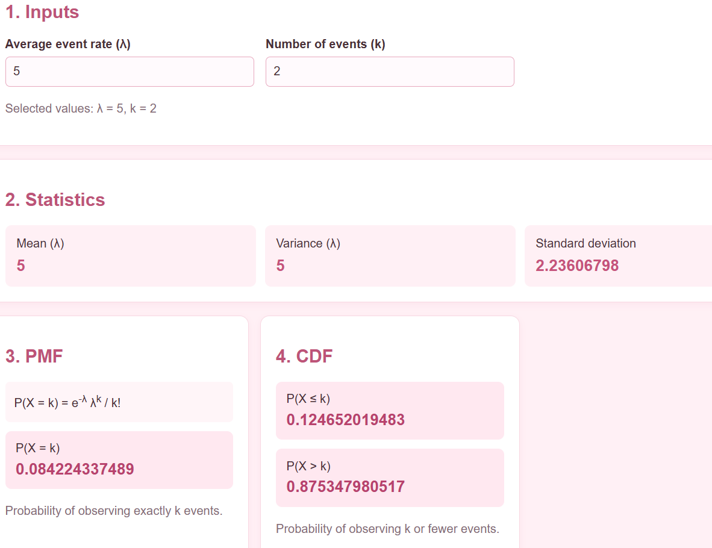
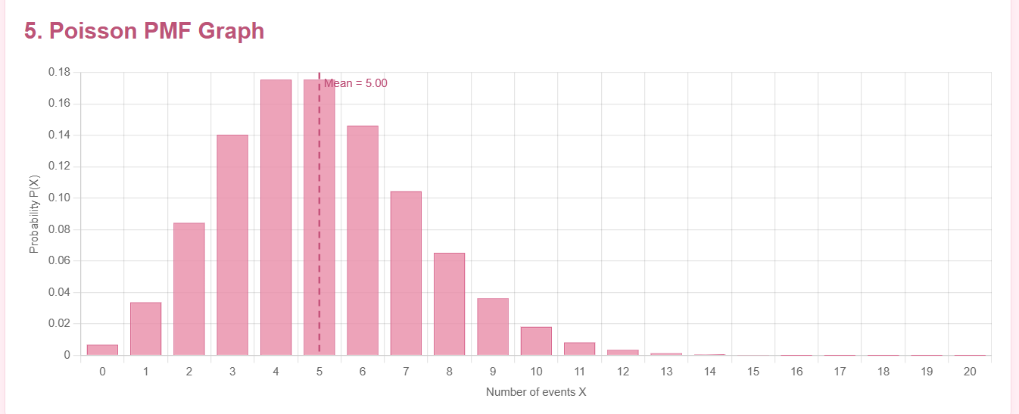
Graph Observation – Poisson Distribution (λ = 2, 3, 5)
The graph shows that as the average alert count (λ) increases from 2 to 3 and 5, the distribution shifts towards higher alert counts. For k = 2, the probabilities are 27.07% for λ = 2, 22.40% for λ = 3, and 8.42% for λ = 5. As lambda increases, the graph shifts towards larger alert counts

Inference
As the average number of cybersecurity alerts increases, the probability of observing exactly 2 alerts decreases. This comparison helps the cloud operations team understand changing alert patterns and plan appropriate monitoring thresholds.
5.Geometric Distribution
K=1
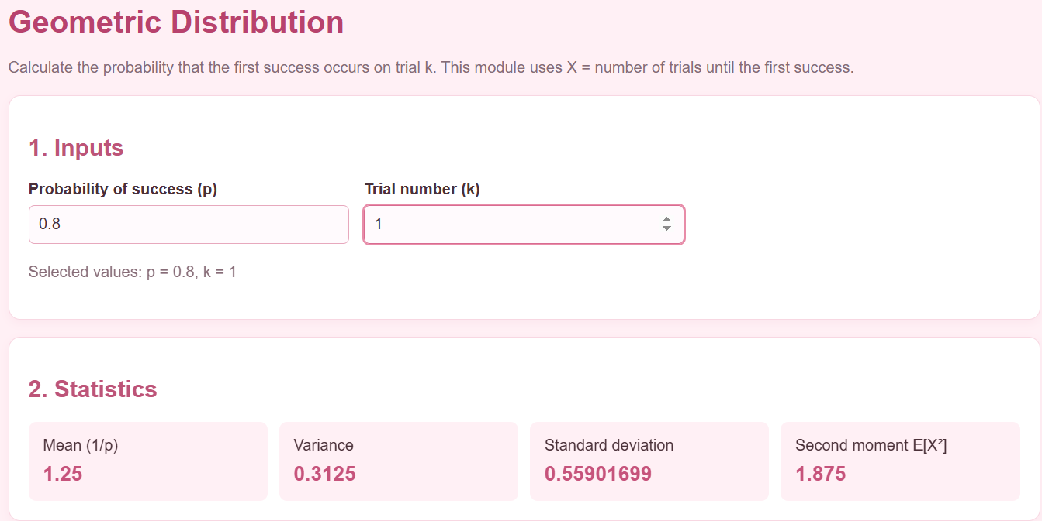
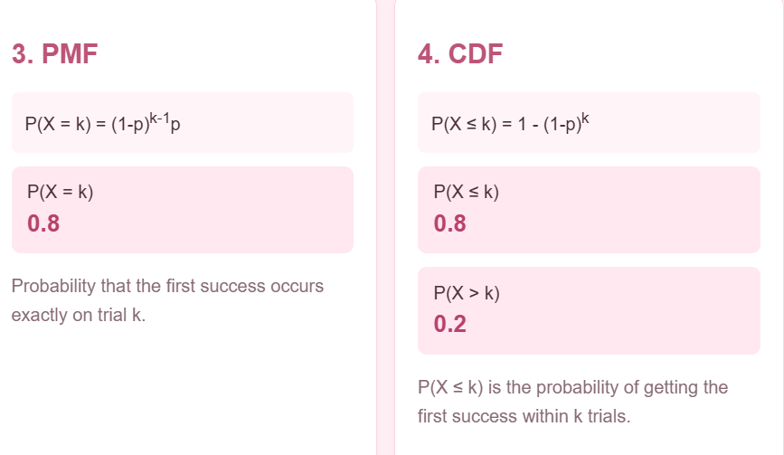
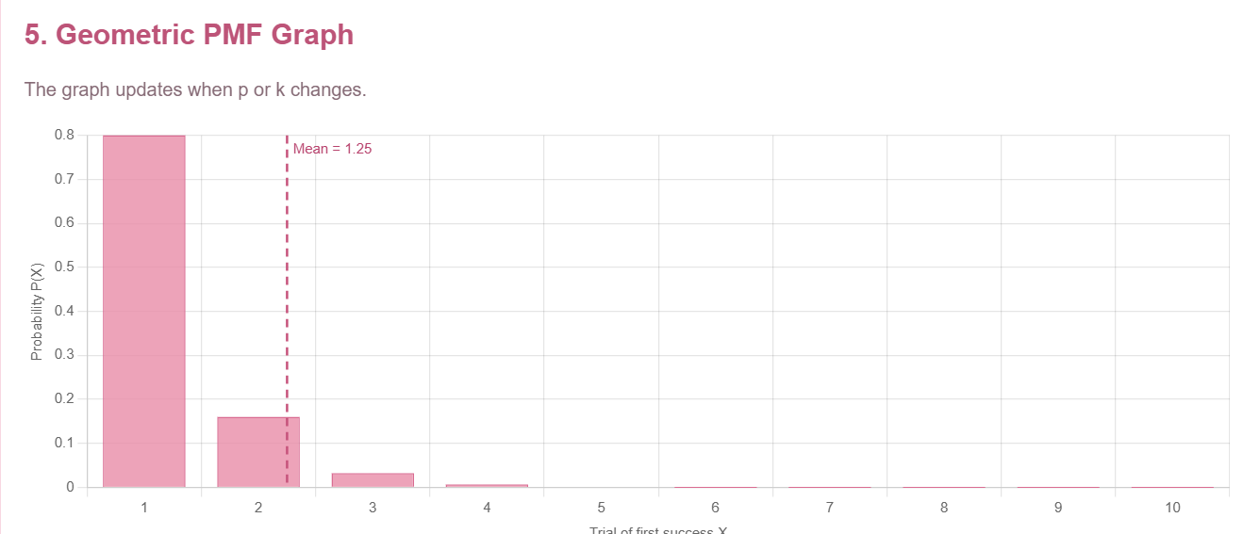
K=2
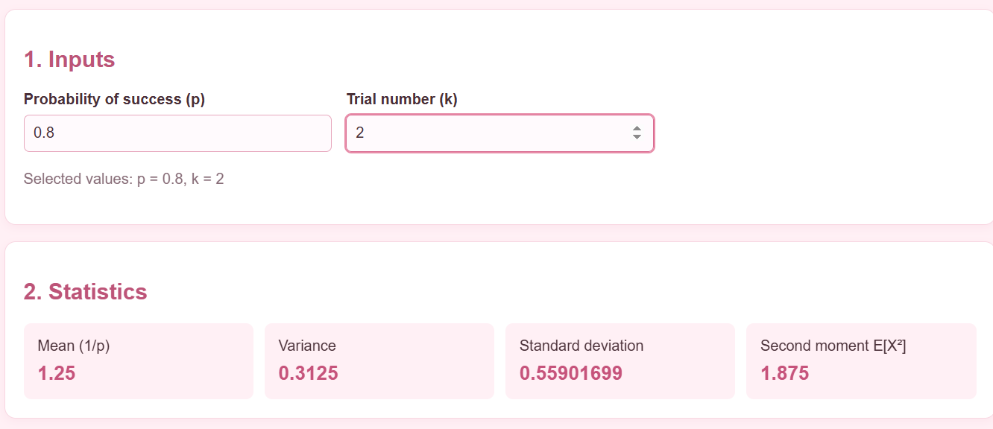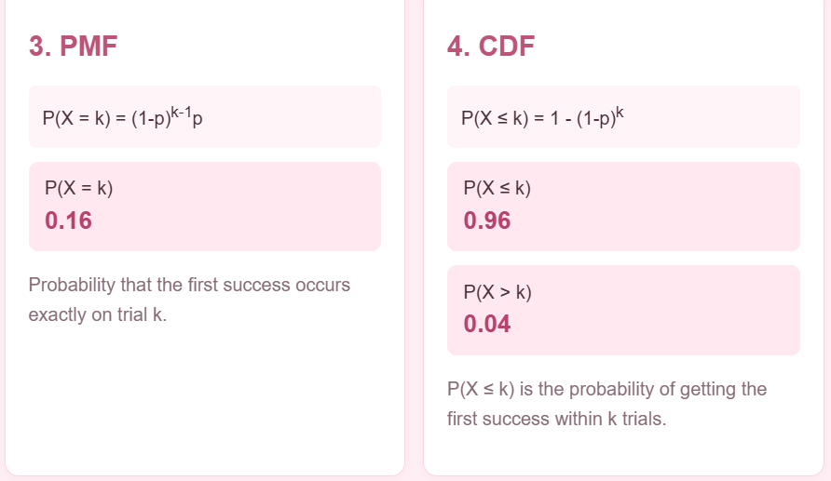
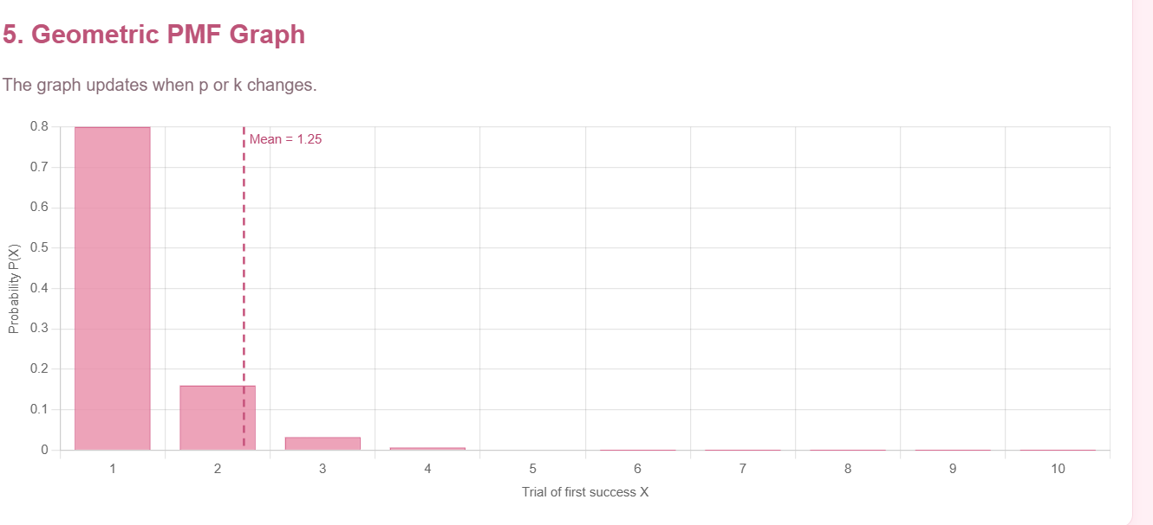
K=3
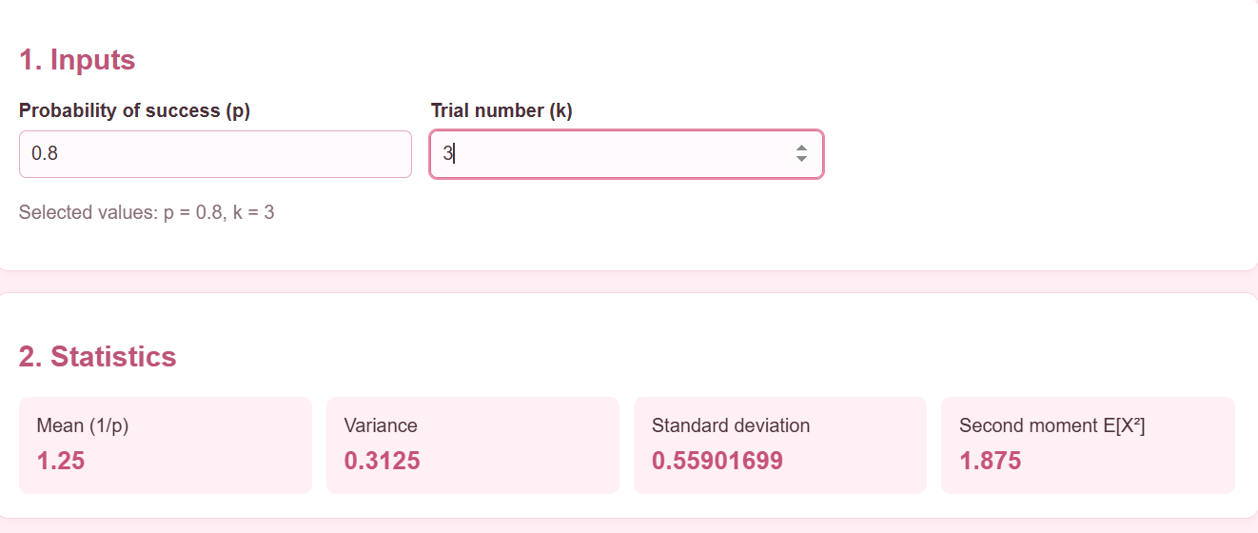
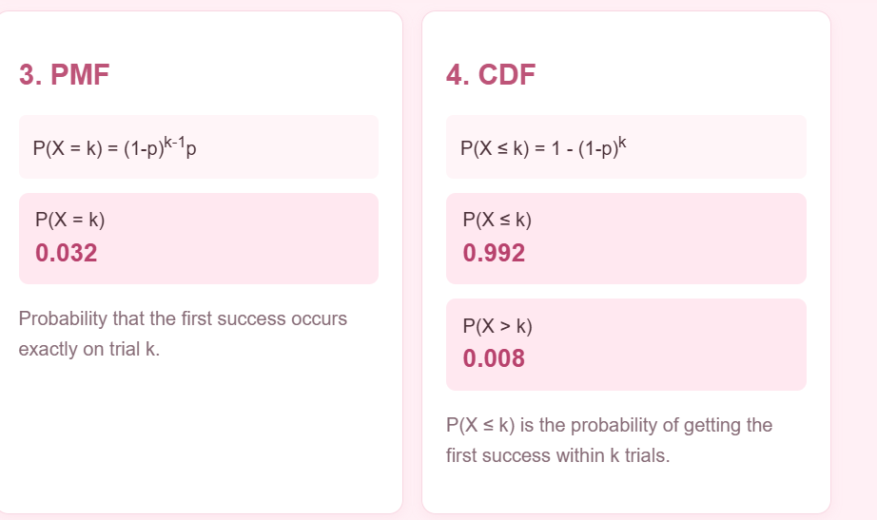
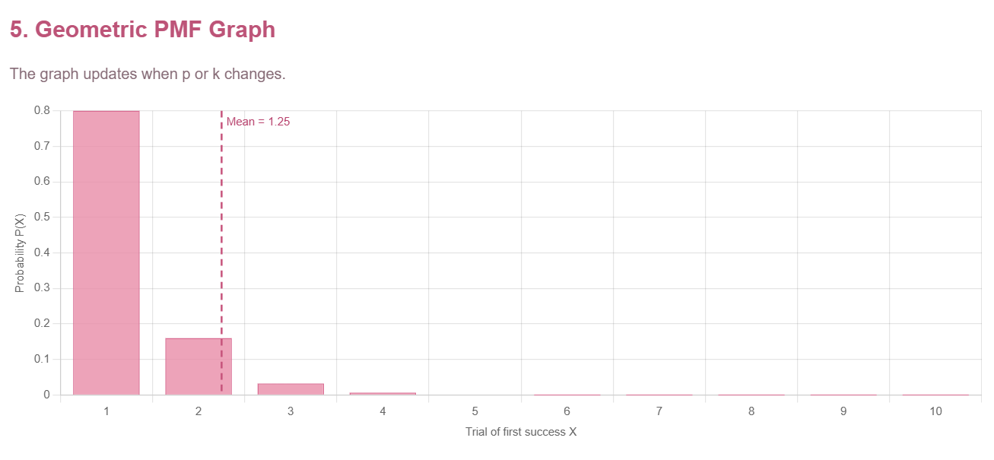Graph Observation: The graph shows the highest probability of success on the first attempt (80%). It decreases to 16% on the second attempt and 3.2% on the third attempt.
Inference: In cloud operations and cybersecurity monitoring, the geometric distribution indicates that an operation is most likely to succeed on the first attempt. If the first attempt fails, the probability of success on subsequent attempts decreases, helping the team evaluate retry policies and improve monitoring efficiency.
6.Interpret the Results
The calculated probabilities help the cloud operations and cybersecurity team predict system failures and monitor alert patterns. The Binomial distribution helps identify the likelihood of failures, the Poisson distribution helps set alert monitoring thresholds, and the Geometric distribution helps evaluate retry policies. These results support better decision-making and improve system reliability.
Overall Inference
The study of Binomial, Poisson, and Geometric distributions helps the cloud operations and cybersecurity team understand system failures, predict alert frequencies, and evaluate retry success probabilities. These results help establish suitable monitoring thresholds, detect unusual activity, and improve the reliability and efficiency of cloud operations.

