Unmanned Ground Vehicle (UGV)
Static Environment:
The battlefield is represented as a 70 × 70 grid where each cell can be free or contain an obstacle. Obstacles are generated randomly using different density levels. The start and goal positions are given by the user.
Dijkstra’s algorithm is used to find the shortest path from start to goal. Each cell is treated as a node, and movement is allowed in eight directions. Obstacle cells are avoided during traversal.
The algorithm keeps track of distances and parent nodes to reconstruct the final path. The result includes the shortest path, distance, nodes explored, and execution time, along with a visualization of the path on the grid.

Outputs:
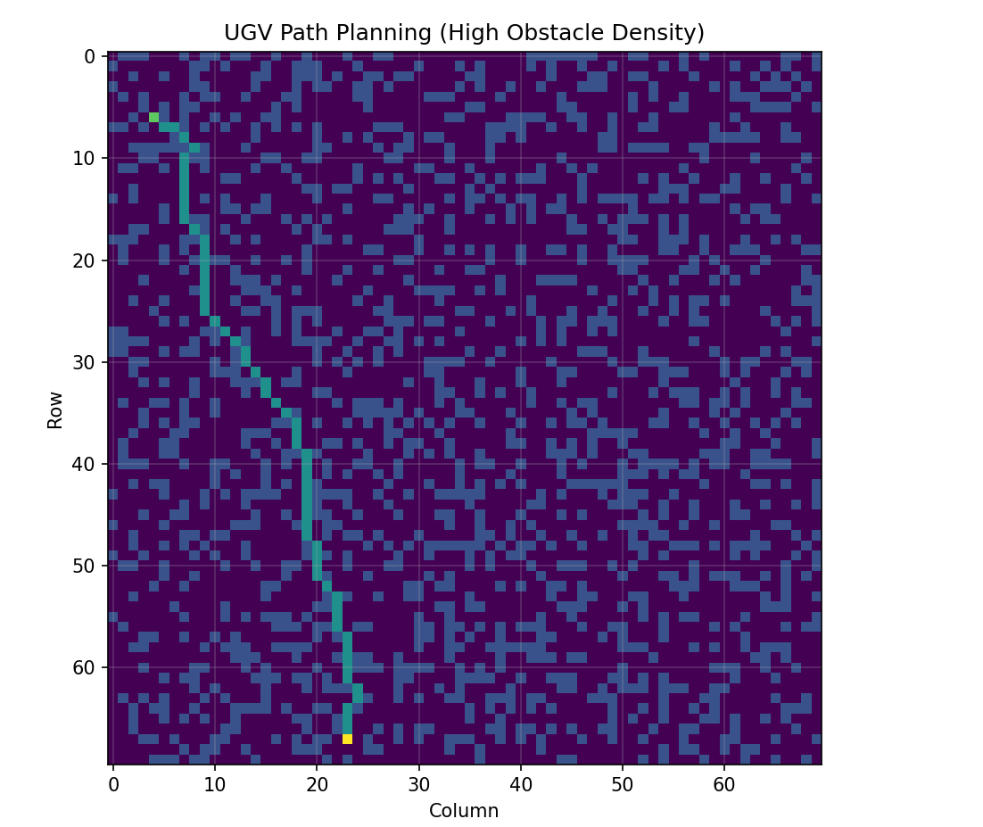

3.
Dynamic Environment:
It is true that in real-world scenarios, all the obstacles are dynamic and not known prior.
To make the UGV navigate and find an optimal path in such an environment:
Instead of planning once, it repeatedly replans the path from its current position to the goal using an efficient method like D* Lite, or repeated Dijkstra.
This allows the UGV to adapt in real time and safely reach the goal while avoiding moving or unknown obstacles.

