Pfizer Protocol Intelligence Platform | D2: Risk Profile Generator | Eval Report | C4891023

PFIZER PROTOCOL INTELLIGENCE PLATFORM
Risk Profile Generator — Eval Report
C4891023 — -- (PF-07850327) — PHASE PHASE I/II TRIAL ER+ advanced or metastatic breast cancer
Eval date: 2026-04-20 | Generator: v1.0 | Config: 1.0

DOCUMENT SCORE  Oncology / PHASE II — oncology_phase_ii | 33.3  / 100 | FAIL ✗  Threshold: 75  Target: 80

1. Summary Metrics
Metric | Score | Target | Pass/Fail | Source
M1 Risk name recall | 0% | 85% | FAIL ✗ | risk_profile_ground_truth.csv
M2 RPN tier (±1) | N/A | 90% | SKIP | risk_profile_ground_truth.csv
M3 Critical factor match | 100% | 80% | PASS ✓ | critical_factors_ground_truth.csv
M4 Provenance defects | 28 (semantic unmatched risks: 8) | 0 | FAIL ✗ | Risk existence gate + USDM / benchmark provenance rules

Overall Result
One or more requirements did not pass. Document score 33.3 (threshold 75, target 80). See eval JSON for details.
NO-GO ✗
Generator requires fixes before verify sign-off

2. Risk Scorecard
risk_profile_ground_truth.csv has no rows for this study_id: the benchmark specifies **zero** risks. The table lists risks the generator emitted anyway; each is scored as **hallucination / extra** (M1, M4).
Risk Name | Weight | Risk Score | Weighted | RPN ±1 | Controls | Status
Concomitant Medication Management (Study Risks) | 12.5% | 0.0 | 0.00 | N/A | 2 | Hallucination / extra
Samples incorrectly obtained, analyzed, stored or handled (inclusive of transportation and import/export) (Vendor Risks) | 12.5% | 0.0 | 0.00 | N/A | 0 | Hallucination / extra
Non-compliance with ICH or local country regulatory requirements (Vendor Risks) | 12.5% | 0.0 | 0.00 | N/A | 0 | Hallucination / extra
ICH Compliance (Study Site Risks) | 12.5% | 0.0 | 0.00 | N/A | 0 | Hallucination / extra
Investigator / Staff Conduct (Study Site Risks) | 12.5% | 0.0 | 0.00 | N/A | 0 | Hallucination / extra
Data / Data Reliability (Study Site Risks) | 12.5% | 0.0 | 0.00 | N/A | 0 | Hallucination / extra
Protocol Compliance (Study Site Risks) | 12.5% | 0.0 | 0.00 | N/A | 0 | Hallucination / extra
Informed Consent (Study Site Risks) | 12.5% | 0.0 | 0.00 | N/A | 0 | Hallucination / extra

Risk Score Bar Chart
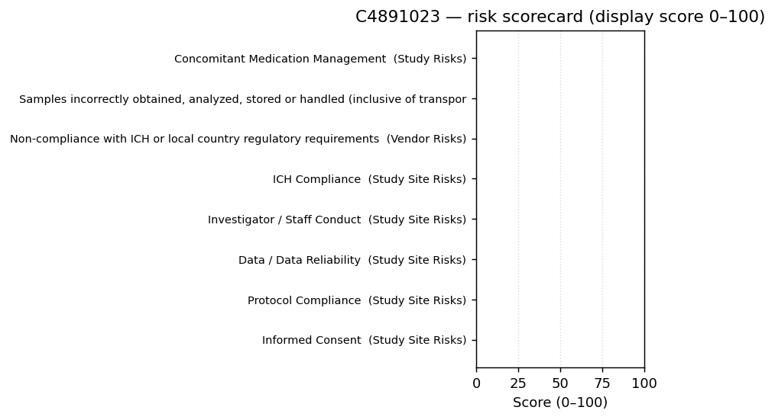

3. Risk Detail
Benchmark specifies zero risks for this study_id. Each section below is one generated risk with **no** authorized benchmark row (hallucination / extra under M1 and M4).

Risk 1 — Concomitant Medication Management [SR-PLACEHOLDER-001]

Risk match information
Field | Value
Risk Name Match | Concomitant Medication Management
Match Status | Normalized name match ✓ (not in M1 domain-matched set)
Ground Truth ID | —
Risk Domain | Study Risks

RPN components (generated vs ground truth)
Active RPN | Impact | Likelihood | Detectability
160 | 10 | 4 | 4

Attribute comparison
Attribute | Score | Match Type | Generated | Ground Truth
Risk name | 1.00 | verbatim | Concomitant Medication Management | Concomitant Medication Management
RPN | 0.00 | ±1 tier | 160 (Tier 2) | —
Risk domain | — | N/A | Study Risks | —
Primary control type | — | N/A | Edit Checks | —

Risk 2 — Samples incorrectly obtained, analyzed, stored or handled (inclusive of transportation and import/export) [VR-PLACEHOLDER-001]

Risk match information
Field | Value
Risk Name Match | Samples incorrectly obtained, analyzed, stored or handled (inclusive of transportation and import/export)
Match Status | Normalized name match ✓ (not in M1 domain-matched set)
Ground Truth ID | —
Risk Domain | —

RPN components (generated vs ground truth)
Active RPN | Impact | Likelihood | Detectability
280 | — | — | —

Attribute comparison
Attribute | Score | Match Type | Generated | Ground Truth
Risk name | 1.00 | verbatim | Samples incorrectly obtained, analyzed, stored or handled (inclusive of transportation and import/export) | Samples incorrectly obtained, analyzed, stored or handled (inclusive of transportation and import/export)
RPN | 0.00 | ±1 tier | 280 (Tier 4) | —
Risk domain | — | N/A | — | —
Primary control type | 0.00 | miss | — | —

Risk 3 — Non-compliance with ICH or local country regulatory requirements [VR-PLACEHOLDER-002]

Risk match information
Field | Value
Risk Name Match | Non-compliance with ICH or local country regulatory requirements
Match Status | Normalized name match ✓ (not in M1 domain-matched set)
Ground Truth ID | —
Risk Domain | —

RPN components (generated vs ground truth)
Active RPN | Impact | Likelihood | Detectability
196 | — | — | —

Attribute comparison
Attribute | Score | Match Type | Generated | Ground Truth
Risk name | 1.00 | verbatim | Non-compliance with ICH or local country regulatory requirements | Non-compliance with ICH or local country regulatory requirements
RPN | 0.00 | ±1 tier | 196 (Tier 3) | —
Risk domain | — | N/A | — | —
Primary control type | 0.00 | miss | — | —

Risk 4 — ICH Compliance [SSR-PLACEHOLDER-001]

Risk match information
Field | Value
Risk Name Match | ICH Compliance
Match Status | Normalized name match ✓ (not in M1 domain-matched set)
Ground Truth ID | —
Risk Domain | —

RPN components (generated vs ground truth)
Active RPN | Impact | Likelihood | Detectability
196 | — | — | —

Attribute comparison
Attribute | Score | Match Type | Generated | Ground Truth
Risk name | 1.00 | verbatim | ICH Compliance | ICH Compliance
RPN | 0.00 | ±1 tier | 196 (Tier 3) | —
Risk domain | — | N/A | — | —
Primary control type | 0.00 | miss | — | —

Risk 5 — Investigator / Staff Conduct [SSR-PLACEHOLDER-002]

Risk match information
Field | Value
Risk Name Match | Investigator / Staff Conduct
Match Status | Normalized name match ✓ (not in M1 domain-matched set)
Ground Truth ID | —
Risk Domain | —

RPN components (generated vs ground truth)
Active RPN | Impact | Likelihood | Detectability
196 | — | — | —

Attribute comparison
Attribute | Score | Match Type | Generated | Ground Truth
Risk name | 1.00 | verbatim | Investigator / Staff Conduct | Investigator / Staff Conduct
RPN | 0.00 | ±1 tier | 196 (Tier 3) | —
Risk domain | — | N/A | — | —
Primary control type | 0.00 | miss | — | —

Risk 6 — Data / Data Reliability [SSR-PLACEHOLDER-003]

Risk match information
Field | Value
Risk Name Match | Data / Data Reliability
Match Status | Normalized name match ✓ (not in M1 domain-matched set)
Ground Truth ID | —
Risk Domain | —

RPN components (generated vs ground truth)
Active RPN | Impact | Likelihood | Detectability
196 | — | — | —

Attribute comparison
Attribute | Score | Match Type | Generated | Ground Truth
Risk name | 1.00 | verbatim | Data / Data Reliability | Data / Data Reliability
RPN | 0.00 | ±1 tier | 196 (Tier 3) | —
Risk domain | — | N/A | — | —
Primary control type | 0.00 | miss | — | —

Risk 7 — Protocol Compliance [SSR-PLACEHOLDER-004]

Risk match information
Field | Value
Risk Name Match | Protocol Compliance
Match Status | Normalized name match ✓ (not in M1 domain-matched set)
Ground Truth ID | —
Risk Domain | —

RPN components (generated vs ground truth)
Active RPN | Impact | Likelihood | Detectability
280 | — | — | —

Attribute comparison
Attribute | Score | Match Type | Generated | Ground Truth
Risk name | 1.00 | verbatim | Protocol Compliance | Protocol Compliance
RPN | 0.00 | ±1 tier | 280 (Tier 4) | —
Risk domain | — | N/A | — | —
Primary control type | 0.00 | miss | — | —

Risk 8 — Informed Consent [SSR-PLACEHOLDER-005]

Risk match information
Field | Value
Risk Name Match | Informed Consent
Match Status | Normalized name match ✓ (not in M1 domain-matched set)
Ground Truth ID | —
Risk Domain | —

RPN components (generated vs ground truth)
Active RPN | Impact | Likelihood | Detectability
280 | — | — | —

Attribute comparison
Attribute | Score | Match Type | Generated | Ground Truth
Risk name | 1.00 | verbatim | Informed Consent | Informed Consent
RPN | 0.00 | ±1 tier | 280 (Tier 4) | —
Risk domain | — | N/A | — | —
Primary control type | 0.00 | miss | — | —

4. Critical Factors
4 critical factors expected for oncology_phase_ii bucket. 4 name matches; F1=0.8889, P=0.8, R=1.0. Content violations: 3. Extra (not in GT): ['Investigational Product Management'].

Critical Factor | Match | Critical Data | Critical Process
Endpoints | Yes ✓ | Primary endpoint data including DLTs during Cycle 1; Secondary efficacy data including ORR, DoR, CBR, PFS, and OS per RECIST v1.1; PK data (AUCtau, Cmax) for ARV-471, ARV-473, and ribociclib. | Accurate assessment and recording of DLTs during the observation period; Investigator-assessed tumor response per RECIST v1.1; Strict adherence to PK sampling timepoints for the DDI Assessment Cohorts
Adverse Event (AE) / Serious Adverse Event (SAE) | Yes ✓ | AE and SAE data characterized by severity (NCI CTCAE v5.0); Triplicate 12-lead ECG data (QTcF intervals); Clinical laboratory abnormalities (hepatic and hematologic). | Timely reporting of AEs/SAEs; Continuous monitoring of ECGs for QT prolongation and laboratory tests for hepatic/hematologic toxicities associated with the ribociclib and ARV-471 combination.
Data Integrity and Reliability of Trial Results | Yes ✓ | Dosing compliance data; Concomitant medication data (especially CYP3A inhibitors/inducers and QT-prolonging agents); Biomarker and ctDNA sample data. | Accurate documentation of concomitant medications to ensure DDI cohort validity; Proper collection, processing, and shipment of PK and biomarker samples; Adherence to visit windows for continuous and
Eligibility criteria | Yes ✓ | Inclusion/Exclusion criteria data including prior therapy lines (exactly 1 prior CDK4/6 inhibitor), ER+/HER2- status, and baseline hepatic/renal/hematologic function. | Verification of histological diagnosis and prior lines of therapy; Confirmation of washout periods for prior anticancer therapies and prohibited medications (CYP3A inhibitors/inducers) prior to enroll
Investigational Product Management | No ✗ | Dosing records for ARV-471 (continuous) and ribociclib (21 days on/7 days off); Dose modification, interruption, and reduction data. | Management of two different dosing schedules; Implementation of protocol-specified dose modifications for hematologic, hepatic, or ECG (QTcF) toxicities; IP accountability and dispensing.

5. Hallucination Check
PROVENANCE DEFECTS (field-level checks): 28
Semantic unmatched generated risks (M1; not summed into defect count above): 8. Extra critical factors when benchmark expects zero (M3): 0.

Check | Result
benchmark_source present | FAIL ✗
usdm_drivers non-empty | FAIL ✗
associated_cause usdm_trigger | FAIL ✗
critical_factor usdm critical_data | FAIL ✗

6. Near Misses
No near misses: the benchmark defines no risk names for this protocol, so name-distance logging is empty. Any generated risk is evaluated as hallucination / extra (M1, M4), not as a near miss.

7. Vendor / Site / Other Domain Risks
Domain | Generated | Ground Truth
Vendor risks | 2 | —
Study site risks | 5 | —
Other domain risks | 0 | —

Ground Truth counts are from risk_profile_ground_truth.csv for this study_id only. Vendor / site / other columns show how many benchmark rows fall in each domain when rows exist.
Risk existence: benchmark specifies zero risks for this protocol; generator emitted 8 risk object(s) (non-conformant — hallucination / extra).

Confidential | Hexaware Technologies

