Pfizer Protocol Intelligence Platform | D2: Risk Profile Generator | Eval Report | B7981027

PFIZER PROTOCOL INTELLIGENCE PLATFORM
Risk Profile Generator — Eval Report
B7981027 — Ritlecitinib (PF-06651600) — PHASE 3 Alopecia areata
Eval date: 2026-04-15 | Generator: v1.0 | Config: 1.0

DOCUMENT SCORE  Immunology / PHASE III — immunology_phase_iii | 79.2  / 100 | PASS ✓  Threshold: 75  Target: 80

1. Summary Metrics
Metric | Score | Target | Pass/Fail | Source
M1 Risk name recall | 67% | 85% | FAIL ✗ | risk_profile_ground_truth.csv
M2 RPN tier accuracy | 50% | 90% | FAIL ✗ | risk_profile_ground_truth.csv
M3 Critical factor match | 100% | 80% | PASS ✓ | critical_factors_ground_truth.csv
M4 Hallucination detection | 0 | 0 | PASS ✓ | USDM / benchmark provenance rules

Overall Result
One or more metrics did not pass. Document score 79.2 (threshold 75, target 80). See JSON for details.
NO-GO ✗
Generator requires fixes before verify sign-off

2. Risk Scorecard
Risk Name | Weight | Risk Score | Weighted | RPN Match | Controls | Status
Participant / Caregiver Trial Conduct | 33.3% | 88.0 | 29.33 | Yes | 2 | On Track
Concomitant Medication Management | 33.3% | 55.0 | 18.33 | No | 2 | Needs Work
Enrollment Criteria | 33.3% | 0.0 | 0.00 | No | 0 | Needs Work

Risk Score Bar Chart
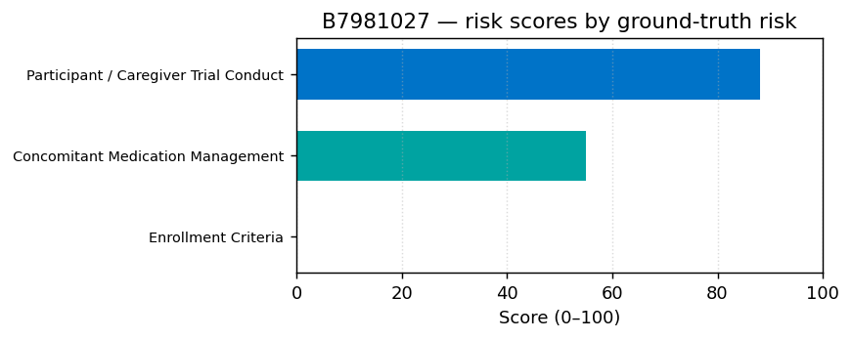

3. Risk Detail

Risk 1 — Participant / Caregiver Trial Conduct [SR-PLACEHOLDER-001]
Risk Name Match
Participant / Caregiver Trial Conduct
Match Status
Verbatim ✓ | Levenshtein: 0
Ground Truth ID
SR-02224
Risk Domain
Study Risks

Active RPN | Impact | Likelihood | Detectability
196 = 160 ✗ | 7 = 10 ✗ | 7 = 4 ✗ | 4 = 4 ✓

Attribute | Score | Match Type | Generated | Ground Truth
Risk name | 1.00 | verbatim | Participant / Caregiver Trial Conduct | Participant / Caregiver Trial Conduct
RPN | 1.00 | tier | 196 | 160
Risk domain | 1.00 | exact | Study Risks | Study Risks
Primary control type | 0.00 | miss | Routine Review and Remediation of metrics for loss to follow up (QTL/KRI) | Quality Tolerance Limit (QTL)

Intelligence block
Benchmark occurrence rate: 100% | Source: 2/2 studies
RPN confidence: LOW | USDM traceability: FULL

Risk 2 — Concomitant Medication Management [SR-PLACEHOLDER-005]
Risk Name Match
Concomitant Medication Management
Match Status
Verbatim ✓ | Levenshtein: 0
Ground Truth ID
SR-02216
Risk Domain
Study Risks

Active RPN | Impact | Likelihood | Detectability
196 = 112 ✗ | 7 = 7 ✓ | 7 = 4 ✗ | 4 = 4 ✓

Attribute | Score | Match Type | Generated | Ground Truth
Risk name | 1.00 | verbatim | Concomitant Medication Management | Concomitant Medication Management
RPN | 0.00 | tier | 196 | 112
Risk domain | 1.00 | exact | Study Risks | Study Risks
Primary control type | 0.00 | miss | Edit Checks | Quality Tolerance Limit (QTL)

Intelligence block
Benchmark occurrence rate: 50% | Source: 1/2 studies
RPN confidence: LOW | USDM traceability: FULL

Risk 3 — Enrollment Criteria [—]
Risk Name Match
— **MISS** — not generated under this name.
Match Status
Not generated (see M1 misses).
Ground Truth ID
SR-02218

4. Critical Factors
5 critical factors expected for immunology_phase_iii bucket. 5 matched exactly.

Critical Factor | Match | Critical Data | Critical Process
Endpoints | Yes ✓ | SALT response data; PGI-C data; PK plasma concentration data (dates and times); eCOA/ePRO secondary endpoint data (ELA, EBA, AAPPO, PROMIS Parent Proxy, BRIEF2, modified CDLQI, acceptability & palatab | Consistent rater training/certification/qualification and assessments for SALT, EBA, ELA, including proper Rater ID assignment/entry
Adverse Event (AE) / Serious Adverse Event (SAE) | Yes ✓ | AE/SAE data, death details, and vital signs and clinical lab values; Audiological and neurological AE assessment data; Medical history including menarchal status & history of AA treatment clinical res | Identification and assessment of potential audiologic and neurologic events; Routine contraception checks (if applicable), including regular review of menarchal status, contraception compliance, parti
Data Integrity and Reliability of Trial Results | Yes ✓ | Concomitant medication (prior or prohibited); Discontinuation data; Primary diagnosis - severe alopecia areata | Retaining the blind (double-blind design); eCOA/ePRO (SALT, ELA, EBA, AAPPO, PROMIS, BRIEF2, CDLQI) including device setup, data collection compliance & data transmission; Handling, collection, shipme
Eligibility criteria | Yes ✓ | Inclusion/exclusion criteria data (SALT score >= 50, age 6 to <12 years, history of AA treatment failure, TB/viral infection history) | Accurate compliance to protocol inclusion/exclusion criteria; Confirmation of a history of AA treatment clinical response failure; Verification of negative TB and viral hepatitis status.
Investigational Product Management | Yes ✓ | Dosing data (Ritlecitinib 50 mg, 30 mg, Placebo capsules) | IP management - Assigned IP kit numbers match between source documents and IRT; Participant/caregiver dosing diary compliance.

5. Hallucination Check
ZERO HALLUCINATIONS FOUND ✓

Check | Result
benchmark_source present | PASS ✓
usdm_drivers non-empty | PASS ✓
associated_cause usdm_trigger | PASS ✓
critical_factor usdm critical_data | PASS ✓

6. Near Misses
No near misses found. All 3 ground-truth risk names were either matched verbatim or missed outright (Levenshtein logging empty).

7. Vendor / Site / Other Domain Risks
Domain | Generated | Ground Truth
Vendor risks | 0 | 0
Study site risks | 0 | 0
Other domain risks | 0 | 0

If generated counts are zero for all three domains, this matches typical B7981027 ground truth (study risks only). Confirm against protocol-specific GT when available.

Confidential | Hexaware Technologies

