FASHION STORE (E-Commerce) Website

Color Palette & Typography Documentation

1. Primary Colors
Primary colors are the main brand colors used throughout the website.
Purpose | Color | HEX Code
Primary Brand Color | Pink | #FF3F6C
Primary Dark Color | Dark Blue | #1E293B
Primary Background | White | #FFFFFF

Usage:
- Navbar
- Buttons
- Highlights
- Links
- Active menu items

2. Secondary Colors
Secondary colors support the UI and improve visual hierarchy.
Purpose | Color | HEX Code
Light Gray Background | Light Gray | #F8FAFC
Border Color | Gray | #CBD5E1
Success Color | Green | #22C55E
Warning Color | Orange | #F59E0B
Error Color | Red | #EF4444
Text Secondary | Slate Gray | #64748B

Usage:
- Cards
- Product sections
- Alerts
- Notifications
- Footer background
- Input borders

3. Font Family
The project uses modern and clean Google Fonts for better readability.

Heading Font

Poppins
- Font Weight: 600 / 700
- Usage:
  - Headings
  - Titles
  - Hero Section

Body Font

Inter
- Font Weight: 400 / 500
- Usage:
  - Paragraphs
  - Product descriptions
  - Navigation links

Font Sizes
Element | Font Size
Main Heading | 36px
Section Heading | 28px
Sub Heading | 22px
Body Text | 16px
Small Text | 14px
Button Text | 15px

4. Button Styles
Buttons follow a clean and modern design system.

Primary Button
Property | Value
Background Color | #FF3F6C
Text Color | #FFFFFF
Border Radius | 10px
Padding | 12px 24px
Font Weight | 600
Hover Color | #E11D48

Usage:
- Add to Cart
- Buy Now
- Login
- Register

Secondary Button
Property | Value
Background Color | #FFFFFF
Border | 1px solid #CBD5E1
Text Color | #1E293B
Border Radius | 10px

Usage:
- Wishlist
- Cancel
- Back Buttons

Hover Effects
- Smooth transition: 0.3s ease
- Slight scale effect
- Background color change
- Shadow effect on hover
Example:
transition: all 0.3s ease;
transform: scale(1.02);

5. Spacing Rules
Consistent spacing improves UI quality and readability.

Margin & Padding Standards
Component | Spacing
Section Padding | 60px
Card Padding | 20px
Button Padding | 12px 24px
Input Padding | 12px
Grid Gap | 24px
Navbar Padding | 16px 40px

Layout Rules

Between Sections
- Maintain 60px vertical spacing

Between Cards
- Maintain 24px gap

Between Form Inputs
- Maintain 16px spacing

Inside Containers
- Use consistent padding for alignment

6. UI Design Guidelines
- Use clean and minimal layouts
- Maintain consistent spacing
- Use responsive grids
- Avoid excessive colors
- Use soft shadows for cards
- Keep typography readable
- Maintain mobile responsiveness

7. Design References
The design system is inspired by:
- Myntra → Fashion UI & Color Style
- Meesho → Simplicity & Mobile Layout
- Flipkart → Product Layout & Filters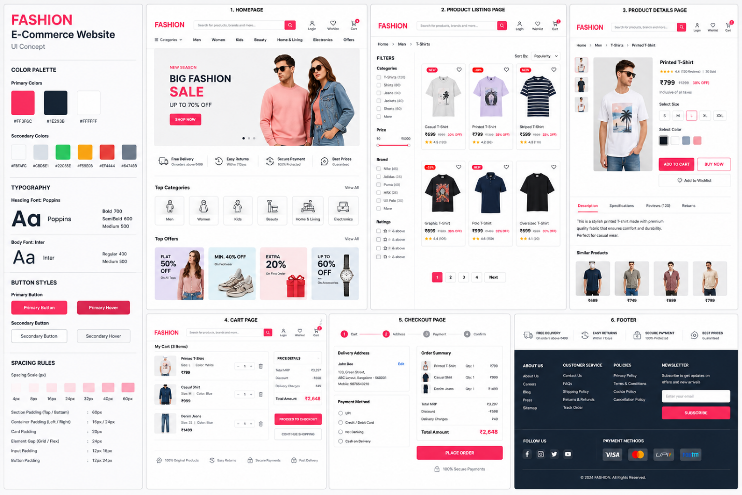

Conclusion
This Color Palette & Typography Documentation defines the design standards used in the Fashion E-Commerce Website project. It helps maintain UI consistency, responsive layouts, typography hierarchy, and modern frontend design practices throughout the application.

