**Problem Statement:**

Create 2 games. The first one is hangman, which is a ‘guess the word’ type of game. The user needs to be able to input letter guesses. A limit should also be set on how many guesses they can use.

The second game is tic-tac-toe. It’s just as how the original game goes.

**Input and Output:**

If they choose hangman, the user has to sign in. If they don’t have an existing username, they can sign up with a username(provided it does not already exist). They have to further input whether they choose the easy or the hard level.

A word is displayed with missing letters. The user is to input one letter which they think might fill the missing spaces.

If the letter is in the word, the word gets updated with the missing letter. If the user successfully inputs all letters without losing all their chances, they win.

If they type a wrong letter, a picture is displayed of a man who is about to be hanged. Depending on the number of wrong answers, the chances the man has of being saved varies.

If the player makes more wrong guesses than allotted, then the man is “hanged” according to the picture and the player loses and is awarded no points.



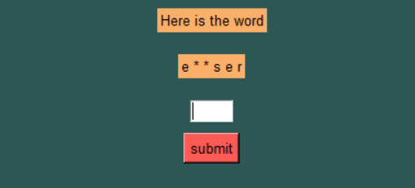

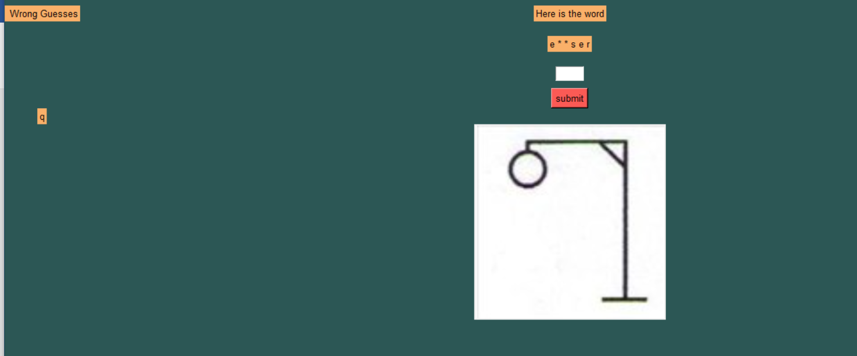

The program then asks the user whether they want to continue the game. If the user chooses yes, then they are again asked if they want the easy/hard level and they play the game again.

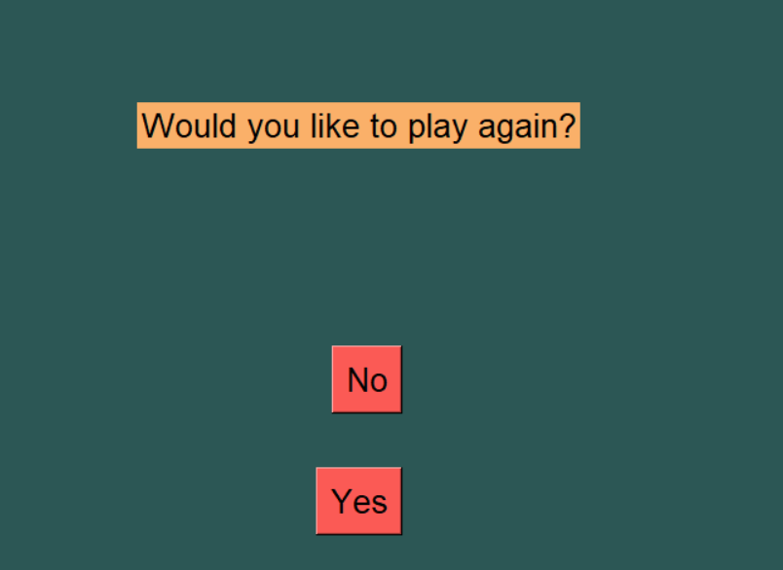

If the user chooses tictactoe in the starting, then a box of tictactoe is displayed, where the 1st player can click on any button to choose their place. X is seen where they click. Similarly, the 2nd player can click on any button in the grid to continue the game.

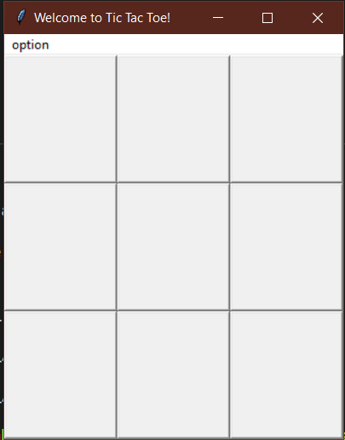 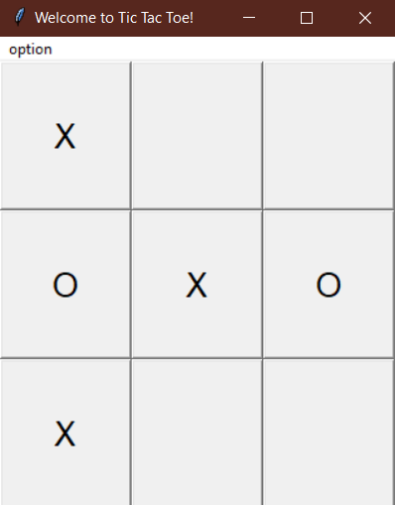

After the game is over, of the players would like to play the game again, they can clock option and click Reset Game.

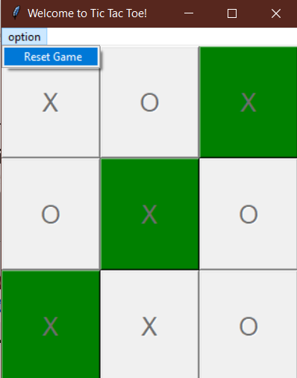 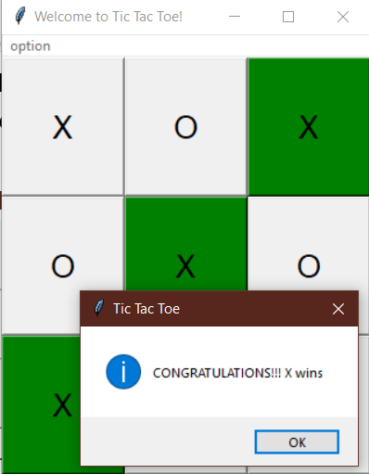

**Features**

Our program involves the usage of Tkinter for the whole program.

The main source code imports 2 files.

It involves usage of files, and the program remembers the scores of the previous players and usernames so that each player is unique and there is no mixing of players, and the player can continue playing and adding on to their high score.

The game of Hangman involves guessing of letters. If the same letter is missing more than once, guessing the correct letter will get inserted appropriately at all its missing places. Functions and lists are used. The word is chosen by random from a different file.

**Suitable GUI layout**

Tkinter is used for tictactoe. Grids and buttons are mainly used. Message box is also used to display the outcome of the game. Option is used for a new game.