Linux Basics Assignment

Name: Jahnavi Dasari

Course: Devops

# Task 1: Creating and Renaming Files/Directories

## Commands:

mkdir test_dir  
cd test_dir  
touch example.txt  
mv example.txt renamed_example.txt

## Explanation:

* `mkdir` creates a directory.
* `touch` creates an empty file.
* `mv` renames or moves files.

## Screenshot:

# Task 2: Viewing File Contents

## Commands:

cat sampel.py  
head -n 5 sample.py  
tail -n 5 sample.py

## Explanation:

* `cat` displays the entire file.
* `head -n 5` shows the first 5 lines.
* `tail -n 5` shows the last 5 lines.

## Screenshot:

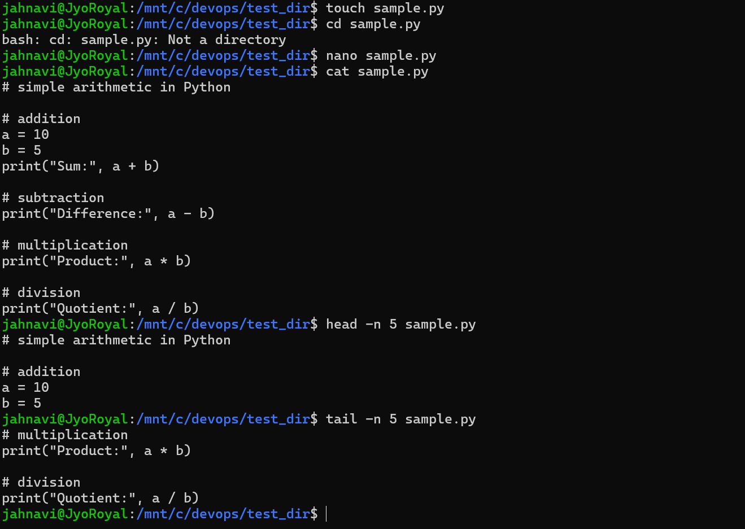

# Task 3: Searching for Patterns

## Commands:

grep print sample.py

## Explanation:

* `grep` searches for text in a file; here, it finds lines containing 'root'.

## Screenshot:

# 

# Task 4: Zipping and Unzipping

## Commands:

cd ..  
zip test_dir.zip sample.py  
unzip test_dir.zip

## Explanation:

* `zip -r` compresses a directory.
* `unzip -d` extracts into a new directory.

## Screenshot:

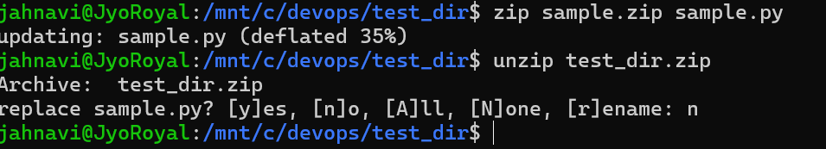

# Task 5: Downloading Files

## Commands:

wget https://example.com/sample.txt

## Explanation:

* `wget` downloads a file from the internet using its URL.

## Screenshot:

# Task 6: Changing Permissions

## Commands:

touch secure.txt  
chmod 444 secure.txt

## Explanation:

* `chmod 444` sets file permissions to read-only for everyone.

## Screenshot:

# Task 7: Working with Environment Variables

## Commands:

export MY_VAR="Hello, Linux!"  
echo $MY_VAR

## Explanation:

* `export` creates a new environment variable.
* `echo $MY_VAR` prints its value.

## Screenshot:

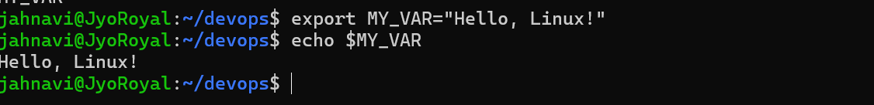

# Conclusion

This assignment helped me practice basic Linux commands like file handling, permissions, compression, searching, and environment variables. These are essential skills for system administration and DevOps tasks.