# Assignment Report

Name: Jahnavi

Course: DevOps

Title: Flask Application with MongoDB Integration

## 1. Objective

The objective of this assignment is to develop a simple Flask web application that demonstrates interaction between the frontend, backend, and a MongoDB database. The application includes an API endpoint that serves JSON data from a backend file, and a frontend form that allows users to submit data to MongoDB. Upon successful submission, a success message is displayed.

## 2. Prerequisites

The following tools and dependencies must be installed before running the assignment:

- Python 3.11 or later

- Flask (web framework)

- PyMongo (for MongoDB connection)

- MongoDB (local or Atlas cluster)

- Basic HTML knowledge for frontend creation

## 3. Steps and Explanation

### Step 1: Create Flask Application

A Flask app was created with an /api route that reads data from a JSON file and returns it as an API response. This demonstrates backend file handling and JSON response capability in Flask.

### Step 2: Create Frontend Form

An HTML form (form.html) was designed to take user input (Name and Email). When submitted, it sends the data to the Flask backend, which inserts the data into MongoDB.

### Step 3: Connect Flask with MongoDB

MongoDB Atlas (or local MongoDB) was used as the database. Flask connects to MongoDB through the PyMongo library. After successful data insertion, users are redirected to a success page.

### Step 4: Output Display

Once the user submits the form, if the operation is successful, a success message 'Data submitted successfully' is displayed. In case of an error, the same page displays an error message without redirection.

## 4. Output Screenshots

Below are the screenshots showing successful execution of the assignment:

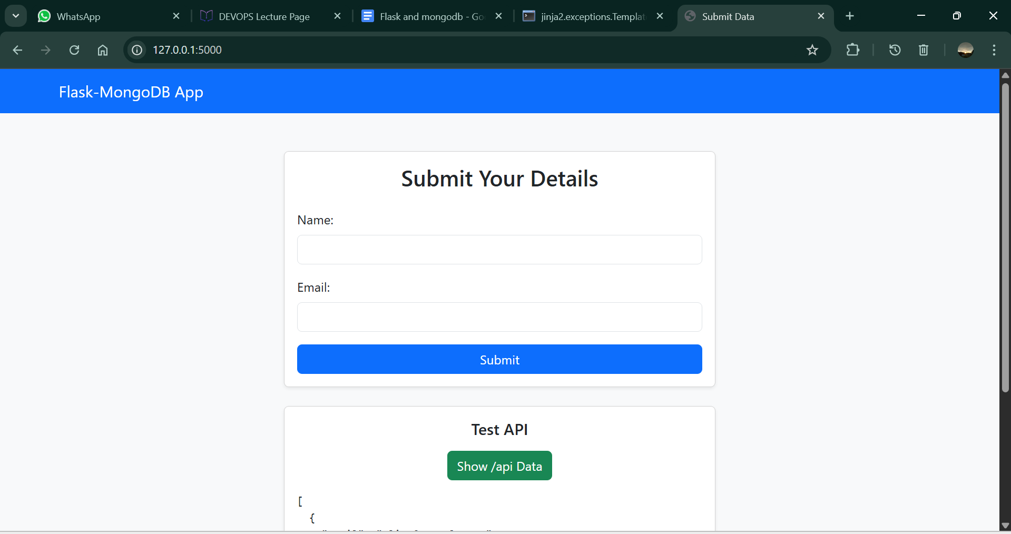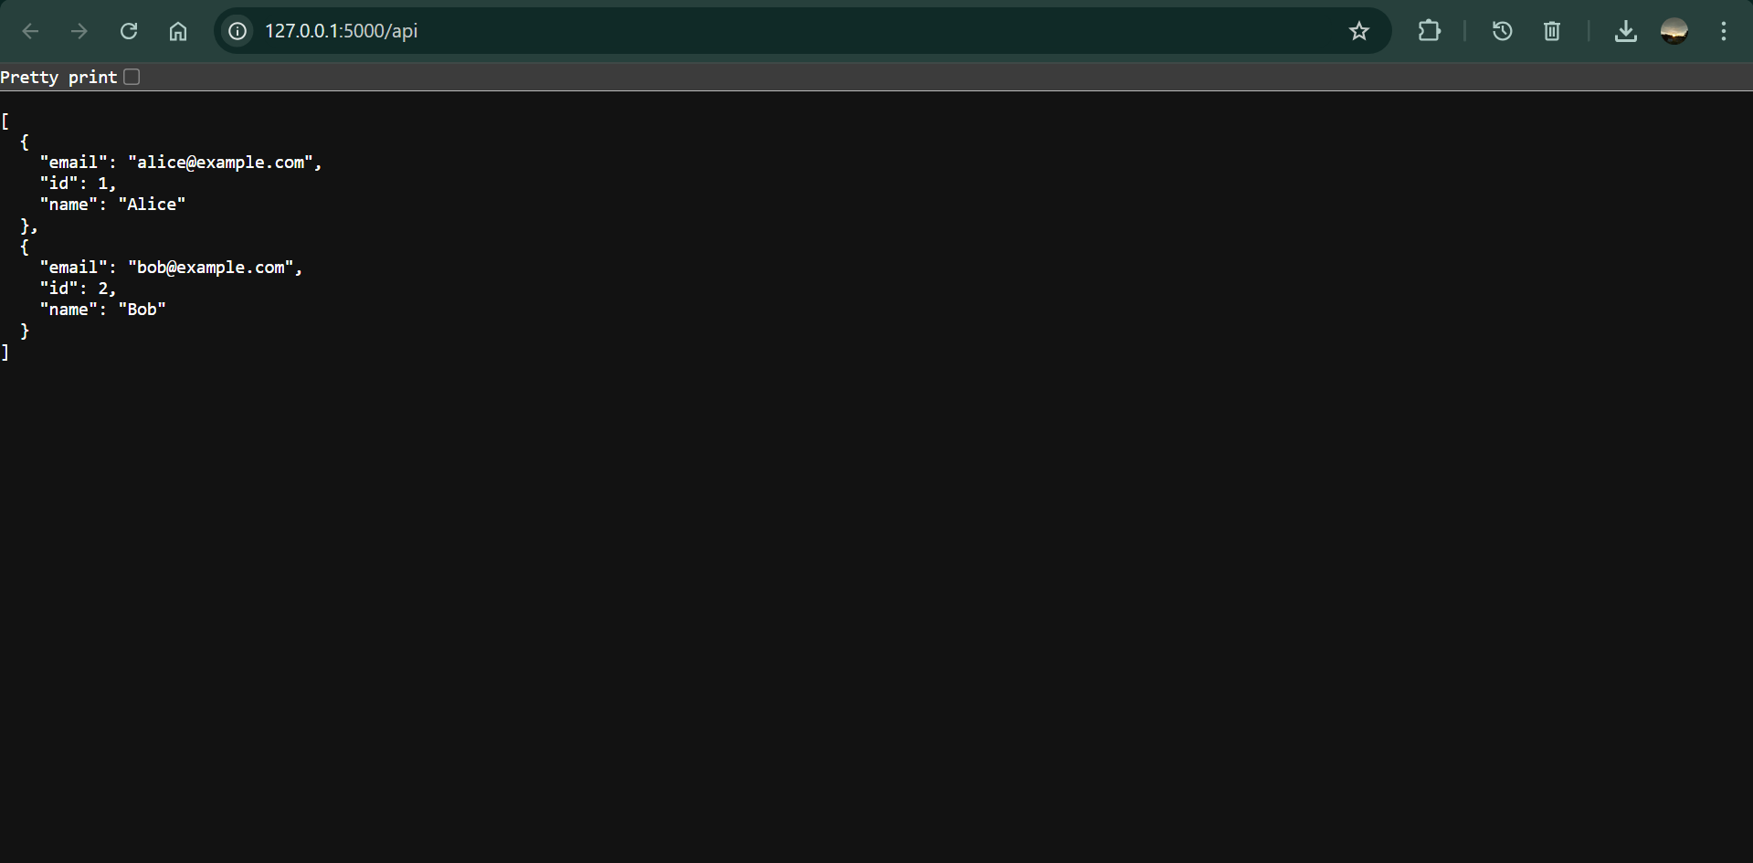

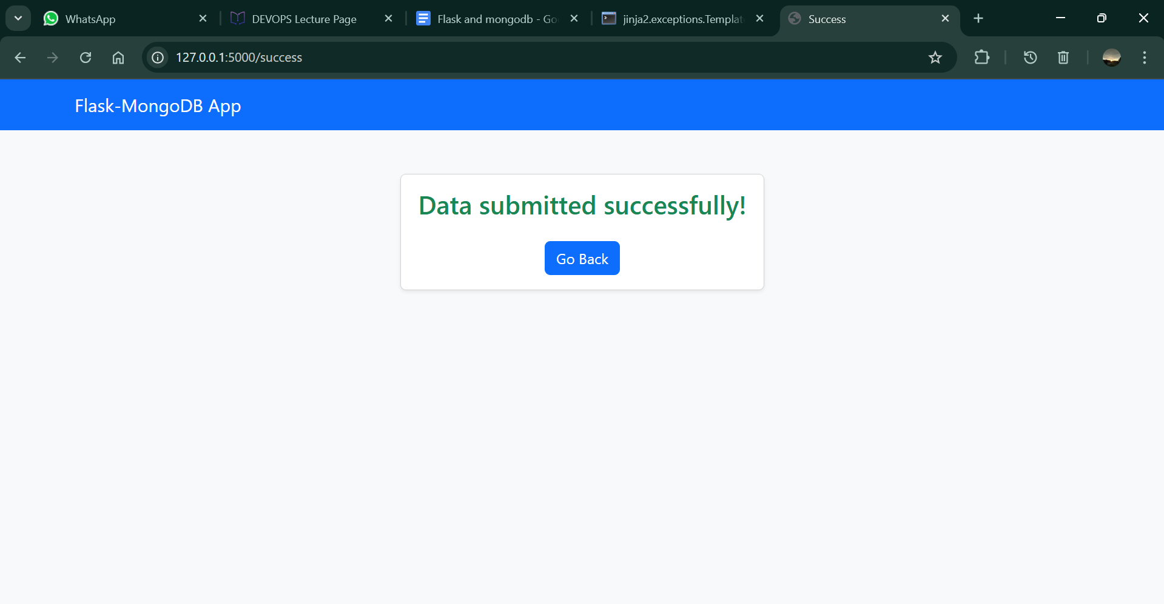

## 5. Conclusion

This assignment successfully demonstrates the integration of Flask with MongoDB and the use of RESTful API concepts. The system reads and returns JSON data, accepts user input via a web form, and stores it in MongoDB. This exercise provides a strong foundation for building full-stack applications using Python Flask and MongoDB.

***Giithub link :***