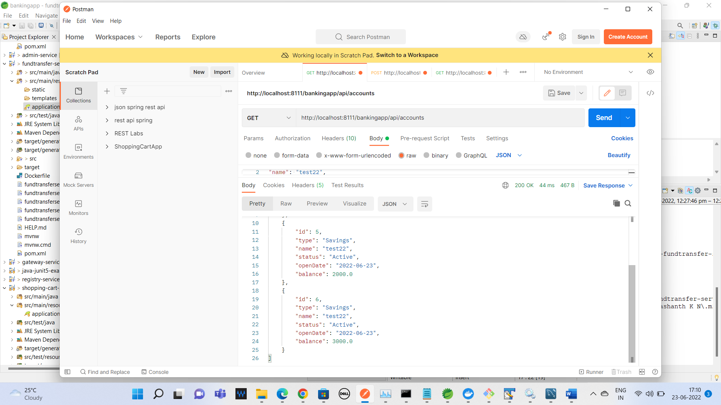

The above screen shot is for the account details before fundtransfer

FundTransfer for the account id 5 to 6 for 500 rs

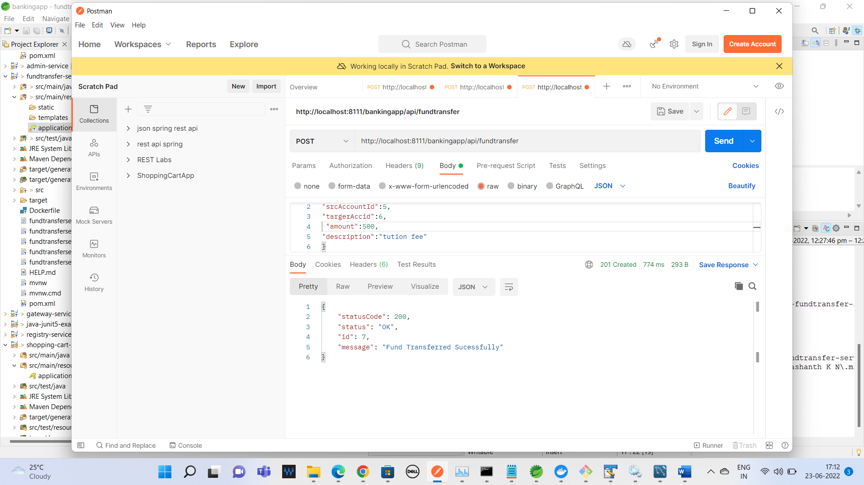

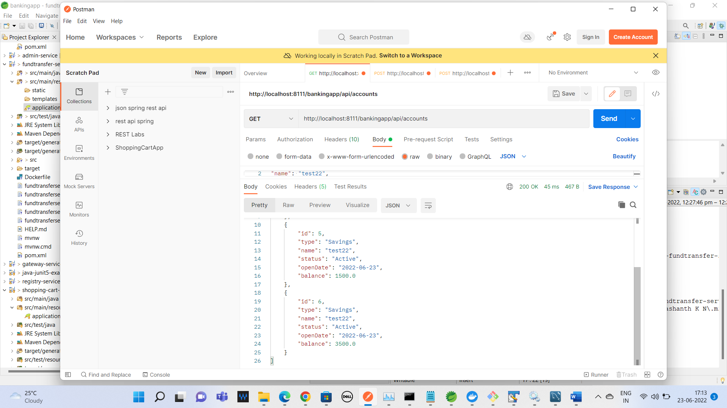

TWO TRANSACTIONS CREATED one for credit and debit

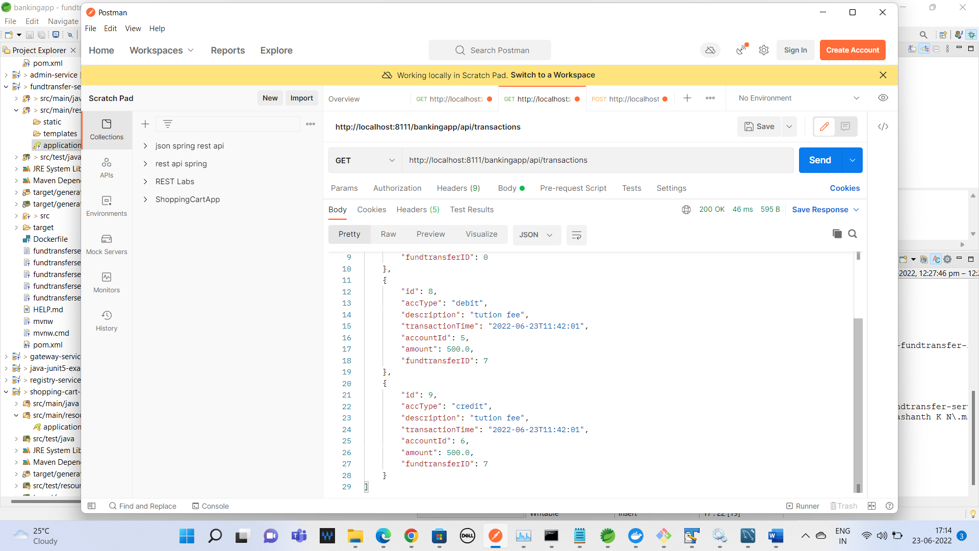

In Account table for the account 5 -500rs deducted and account 6 -500rs credited.

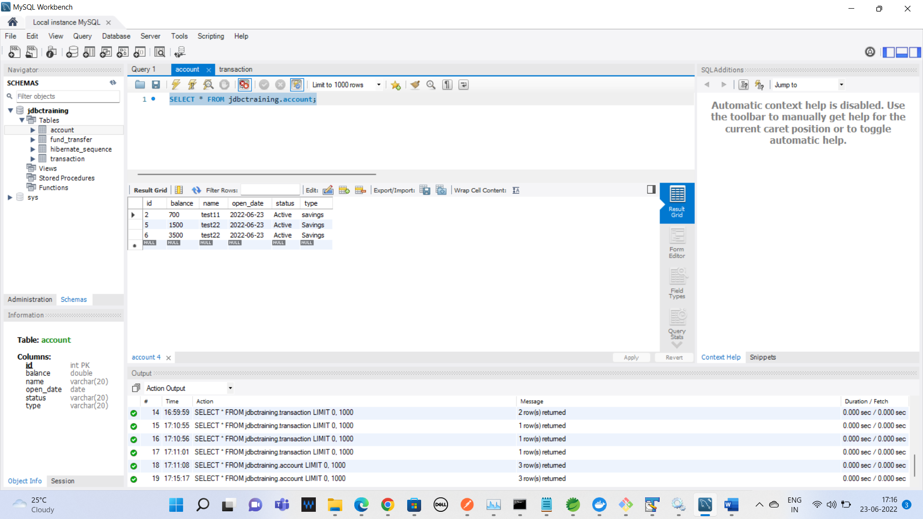

Transaction table:

Two records created with credit and debit.

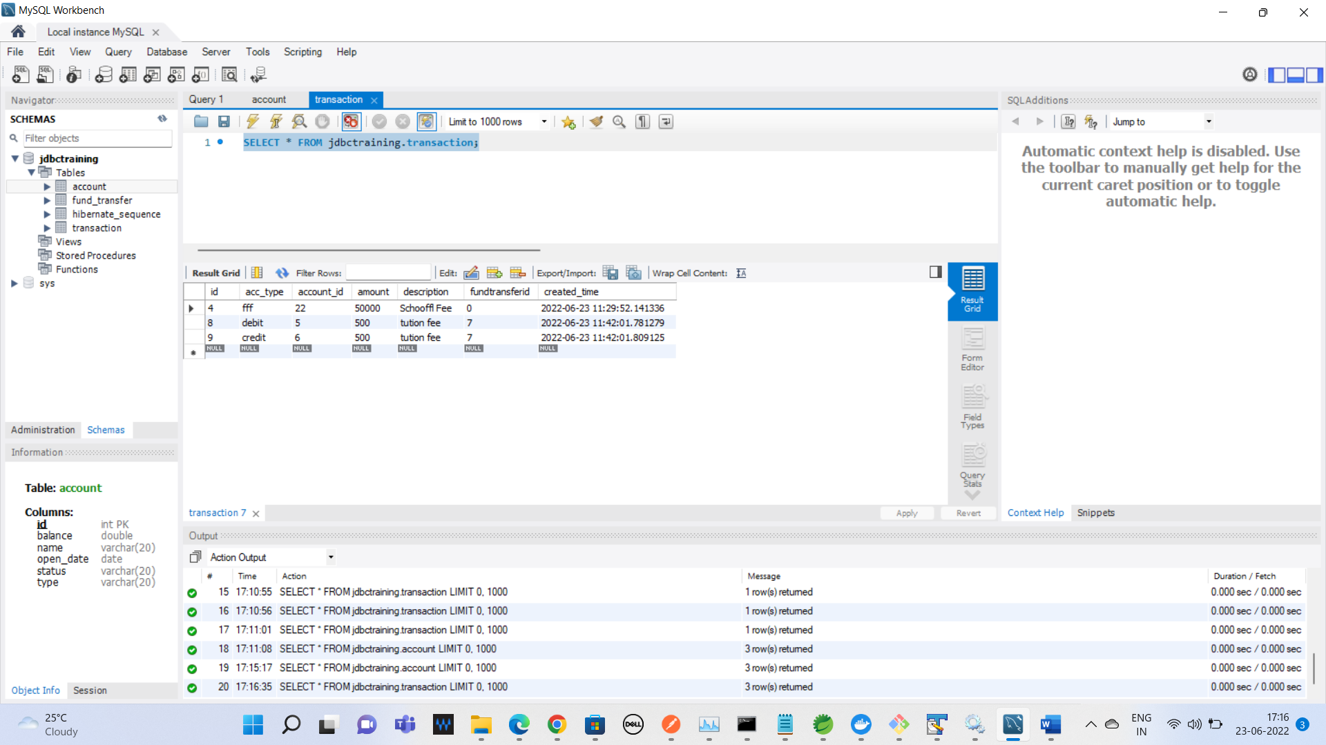

FUND_TRANFER table

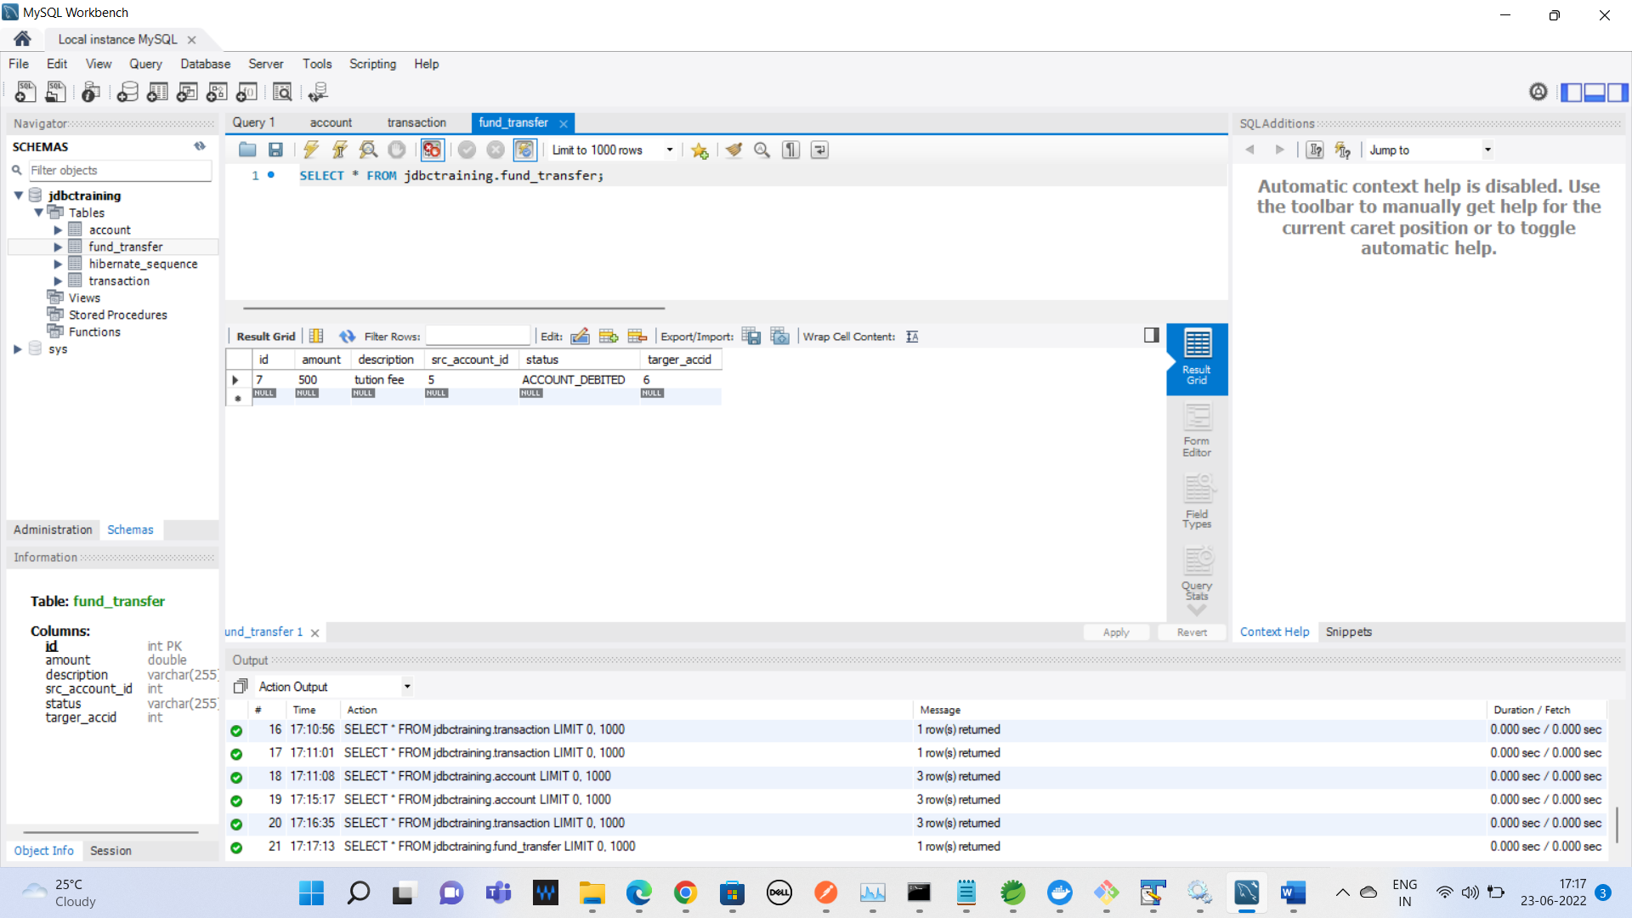

Fund transfer validation for transferring amount is more than balance

The account 5-has amount 1500 and fund transfer requested with 2000rs

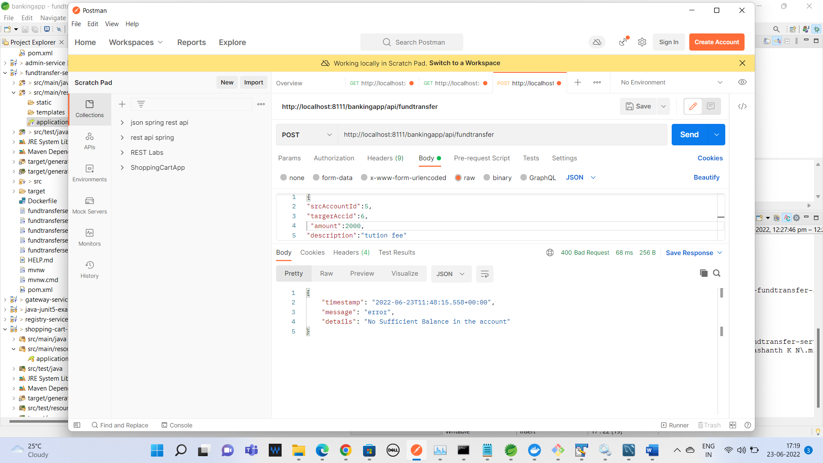

Validation for the mandatory fields:

