Add employee:

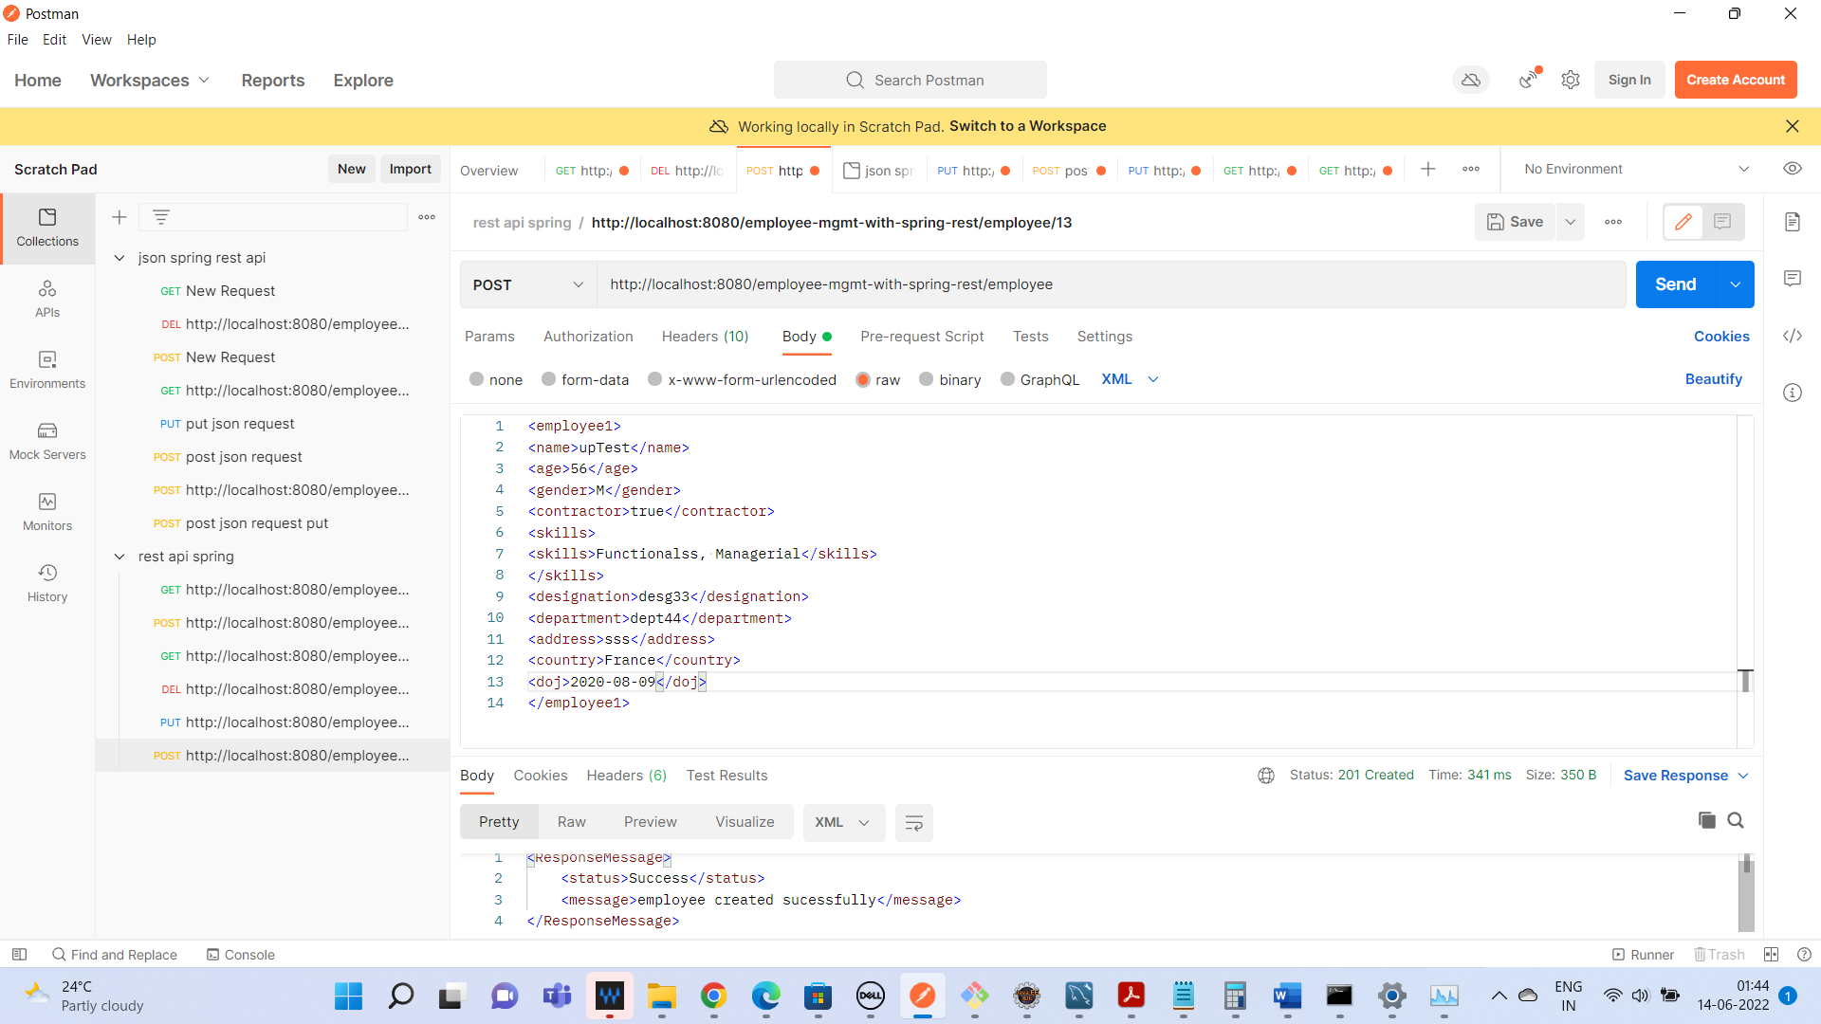

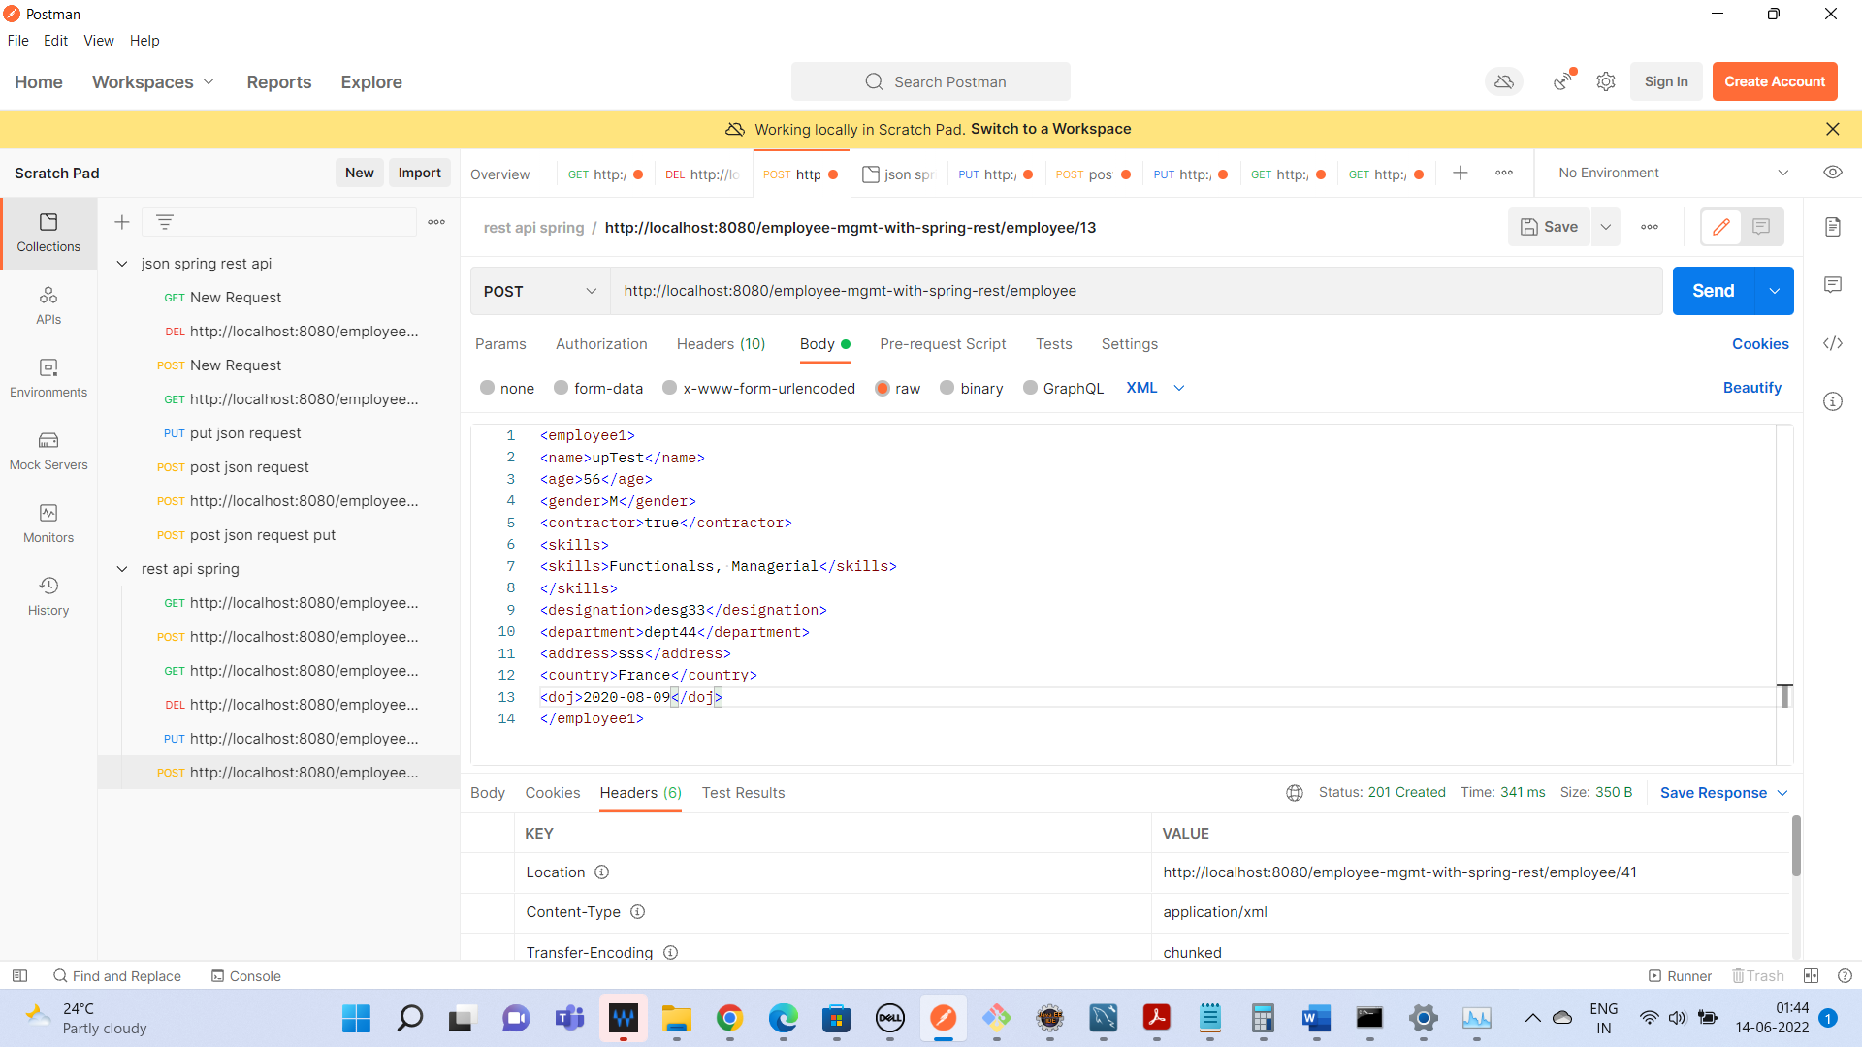

Add employee in JSON

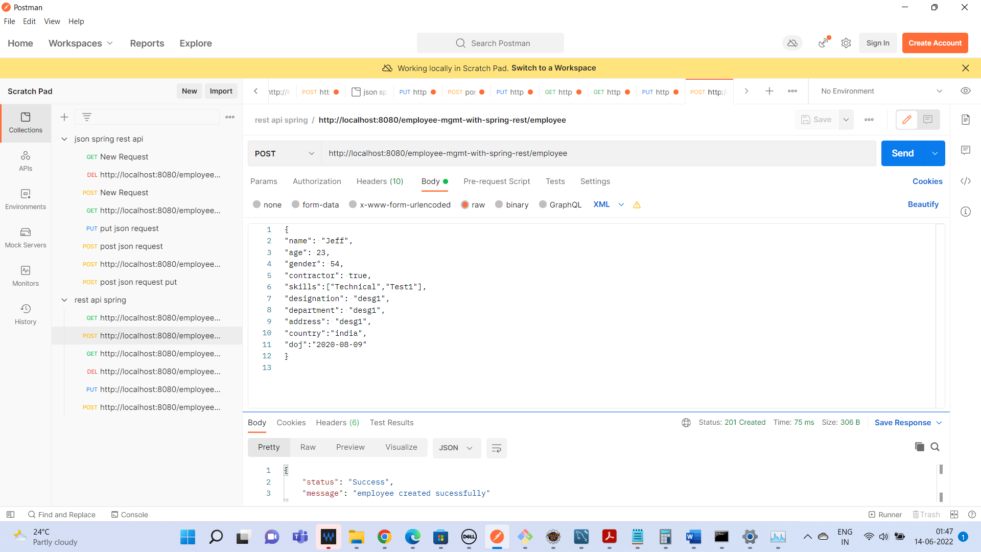

Get All employee

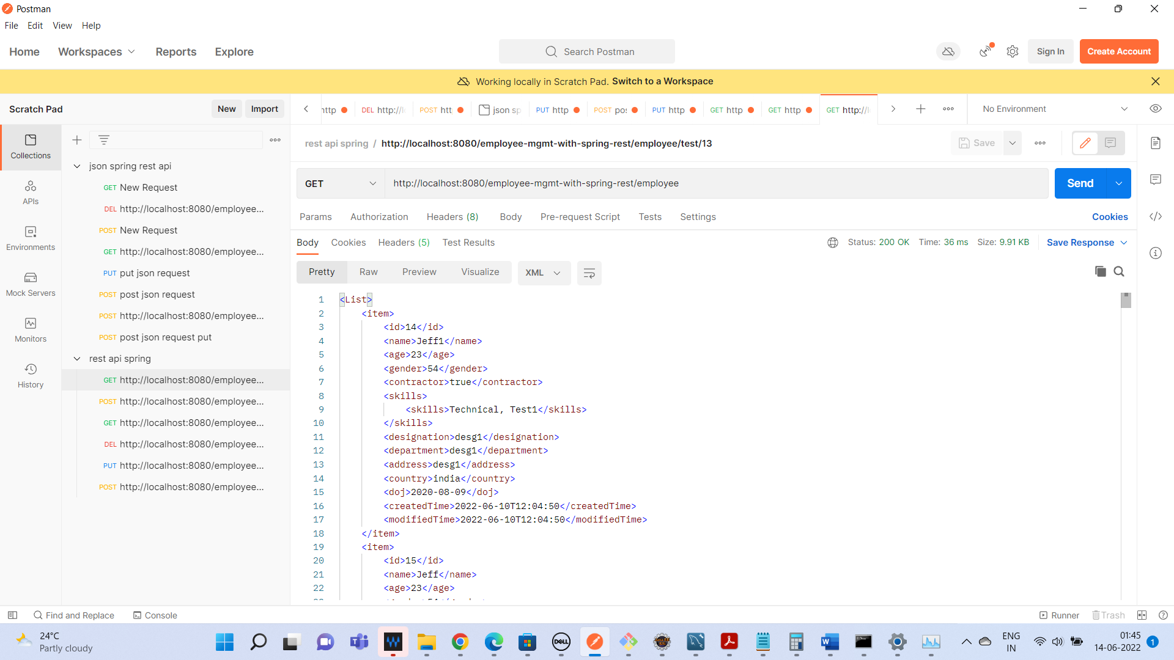

<item>

        <id>14</id>

        <name>Jeff1</name>

        <age>23</age>

        <gender>54</gender>

        <contractor>true</contractor>

        <skills>

            <skills>Technical, Test1</skills>

        </skills>

        <designation>desg1</designation>

        <department>desg1</department>

        <address>desg1</address>

        <country>india</country>

        <doj>2020-08-09</doj>

        <createdTime>2022-06-10T12:04:50</createdTime>

        <modifiedTime>2022-06-10T12:04:50</modifiedTime>

    </item>

    <item>

        <id>15</id>

        <name>Jeff</name>

        <age>23</age>

        <gender>54</gender>

        <contractor>true</contractor>

        <skills>

            <skills>Technkkical, Test1</skills>

        </skills>

        <designation>desg1</designation>

        <department>desg1</department>

        <address>desg133</address>

        <country>india</country>

        <doj>2020-08-09</doj>

        <createdTime>2022-06-10T12:30:09</createdTime>

        <modifiedTime>2022-06-11T20:57:02</modifiedTime>

    </item>

    <item>

        <id>16</id>

        <name>Test33</name>

        <age>34</age>

        <gender>M</gender>

        <contractor>true</contractor>

        <skills>

            <skills>Functional, Managerial</skills>

        </skills>

        <designation>desg33</designation>

        <department>dept44</department>

        <address>sadasd</address>

        <country>India</country>

        <doj>2020-08-09</doj>

        <createdTime>2022-06-10T12:31:36</createdTime>

        <modifiedTime>2022-06-10T12:31:36</modifiedTime>

    </item>

    <item>

        <id>17</id>

        <name>Test553</name>

        <age>34</age>

        <gender>M</gender>

        <contractor>true</contractor>

        <skills>

            <skills>Functional, Managerial</skills>

        </skills>

        <designation>desg33</designation>

        <department>dept44</department>

        <address>sadasd</address>

        <country>India</country>

        <doj>2020-08-09</doj>

        <createdTime>2022-06-10T12:32:10</createdTime>

        <modifiedTime>2022-06-10T12:32:10</modifiedTime>

    </item>

    <item>

        <id>18</id>

        <name>Test566</name>

        <age>34</age>

        <gender>M</gender>

        <contractor>true</contractor>

        <skills>

            <skills>Functional, Managerial</skills>

        </skills>

        <designation>desg33</designation>

        <department>dept44</department>

        <address>sadasd</address>

        <country>India</country>

        <doj>2020-08-09</doj>

        <createdTime>2022-06-11T09:59:24</createdTime>

        <modifiedTime>2022-06-11T09:59:24</modifiedTime>

    </item>

    <item>

        <id>19</id>

        <name>TestID</name>

        <age>34</age>

        <gender>M</gender>

        <contractor>true</contractor>

        <skills>

            <skills>Functional, Managerial</skills>

        </skills>

        <designation>desg33</designation>

        <department>dept44</department>

        <address>sadasd</address>

        <country>India</country>

        <doj>2020-08-09</doj>

        <createdTime>2022-06-11T11:15:34</createdTime>

        <modifiedTime>2022-06-11T11:15:34</modifiedTime>

    </item>

    <item>

        <id>20</id>

        <name>TestID1</name>

        <age>34</age>

        <gender>M</gender>

        <contractor>true</contractor>

        <skills>

            <skills>Functional, Managerial</skills>

        </skills>

        <designation>desg33</designation>

        <department>dept44</department>

        <address>sadasd</address>

        <country>India</country>

        <doj>2020-08-09</doj>

        <createdTime>2022-06-11T12:12:08</createdTime>

        <modifiedTime>2022-06-11T12:12:08</modifiedTime>

    </item>

    <item>

        <id>21</id>

        <name>TestID1</name>

        <age>34</age>

        <gender>M</gender>

        <contractor>true</contractor>

        <skills>

            <skills>Functional, Managerial</skills>

        </skills>

        <designation>desg33</designation>

        <department>dept44</department>

        <address>sadasd</address>

        <country>India</country>

        <doj>2020-08-09</doj>

        <createdTime>2022-06-11T12:18:58</createdTime>

        <modifiedTime>2022-06-11T12:18:58</modifiedTime>

    </item>

    <item>

        <id>22</id>

        <name>TestID1</name>

        <age>34</age>

        <gender>M</gender>

        <contractor>true</contractor>

        <skills>

            <skills>Functional, Managerial</skills>

        </skills>

        <designation>desg33</designation>

        <department>dept44</department>

        <address>sadasd</address>

        <country>India</country>

        <doj>2020-08-09</doj>

        <createdTime>2022-06-11T13:00:04</createdTime>

        <modifiedTime>2022-06-11T13:00:04</modifiedTime>

    </item>

    <item>

        <id>23</id>

        <name>TestID1</name>

        <age>34</age>

        <gender>M</gender>

        <contractor>true</contractor>

        <skills>

            <skills>Functional, Managerial</skills>

        </skills>

        <designation>desg33</designation>

        <department>dept44</department>

        <address>sadasd</address>

        <country>India</country>

        <doj>2020-08-09</doj>

        <createdTime>2022-06-11T13:02:25</createdTime>

        <modifiedTime>2022-06-11T13:02:25</modifiedTime>

    </item>

    <item>

        <id>24</id>

        <name>Jeff</name>

        <age>23</age>

        <gender>54</gender>

        <contractor>true</contractor>

        <skills>

            <skills>Technical, Test1</skills>

        </skills>

        <designation>desg1</designation>

        <department>desg1</department>

        <address>desg1</address>

        <country>india</country>

        <doj>2020-08-09</doj>

        <createdTime>2022-06-11T13:06:05</createdTime>

        <modifiedTime>2022-06-11T13:06:05</modifiedTime>

    </item>

    <item>

        <id>25</id>

        <name>Jeffdd</name>

        <age>23</age>

        <gender>54</gender>

        <contractor>true</contractor>

        <skills>

            <skills>Technical, Test1</skills>

        </skills>

        <designation>desgff1</designation>

        <department>desgff1</department>

        <address>desg1</address>

        <country>india</country>

        <doj>2020-12-09</doj>

        <createdTime>2022-06-11T13:19:11</createdTime>

        <modifiedTime>2022-06-11T13:19:11</modifiedTime>

    </item>

    <item>

        <id>28</id>

        <name>Jeffdd</name>

        <age>23</age>

        <gender>54</gender>

        <contractor>true</contractor>

        <skills>

            <skills>Technical, Test1</skills>

        </skills>

        <designation>desgff1</designation>

        <department>desgff1</department>

        <address>desg1</address>

        <country>india</country>

        <doj>2020-12-09</doj>

        <createdTime>2022-06-11T14:15:35</createdTime>

        <modifiedTime>2022-06-11T14:15:35</modifiedTime>

    </item>

    <item>

        <id>29</id>

        <name>Jeffdd</name>

        <age>23</age>

        <gender>54</gender>

        <contractor>true</contractor>

        <skills>

            <skills>Technical, Test1</skills>

        </skills>

        <designation>desgff1</designation>

        <department>desgff1</department>

        <address>desg1</address>

        <country>india</country>

        <doj>2020-12-09</doj>

        <createdTime>2022-06-11T14:19:08</createdTime>

        <modifiedTime>2022-06-11T14:19:08</modifiedTime>

    </item>

    <item>

        <id>30</id>

        <name>Jeffdd</name>

        <age>23</age>

        <gender>54</gender>

        <contractor>true</contractor>

        <skills>

            <skills>Technical, Test1</skills>

        </skills>

        <designation>desgff1</designation>

        <department>desgff1</department>

        <address>desg1</address>

        <country>india</country>

        <doj>2020-12-09</doj>

        <createdTime>2022-06-11T14:24:29</createdTime>

        <modifiedTime>2022-06-11T14:24:29</modifiedTime>

    </item>

    <item>

        <id>31</id>

        <name>Jeffdd</name>

        <age>23</age>

        <gender>54</gender>

        <contractor>true</contractor>

        <skills>

            <skills>Technical, Test1</skills>

        </skills>

        <designation>desgff1</designation>

        <department>desgff1</department>

        <address>desg1</address>

        <country>india</country>

        <doj>2020-12-09</doj>

        <createdTime>2022-06-11T14:27:56</createdTime>

        <modifiedTime>2022-06-11T14:27:56</modifiedTime>

    </item>

    <item>

        <id>32</id>

        <name>Jeffdd</name>

        <age>23</age>

        <gender>54</gender>

        <contractor>true</contractor>

        <skills>

            <skills>Technical, Test1</skills>

        </skills>

        <designation>desgff1</designation>

        <department>desgff1</department>

        <address>desg1</address>

        <country>india</country>

        <doj>2020-12-09</doj>

        <createdTime>2022-06-11T14:28:54</createdTime>

        <modifiedTime>2022-06-11T14:28:54</modifiedTime>

    </item>

    <item>

        <id>33</id>

        <name></name>

        <age>-2</age>

        <gender>54</gender>

        <contractor>true</contractor>

        <skills>

            <skills>Technical, Test1</skills>

        </skills>

        <designation>desgff1</designation>

        <department>desgff1</department>

        <address>desg1</address>

        <country>india</country>

        <doj>2020-12-09</doj>

        <createdTime>2022-06-11T16:03:02</createdTime>

        <modifiedTime>2022-06-11T16:03:02</modifiedTime>

    </item>

    <item>

        <id>34</id>

        <name>Jeff</name>

        <age>23</age>

        <gender>54</gender>

        <contractor>true</contractor>

        <skills>

            <skills>Technical, Test1</skills>

        </skills>

        <designation>desg1</designation>

        <department>desg1</department>

        <address>desg1</address>

        <country>india</country>

        <doj>2020-08-09</doj>

        <createdTime>2022-06-11T18:28:45</createdTime>

        <modifiedTime>2022-06-11T18:28:45</modifiedTime>

    </item>

    <item>

        <id>35</id>

        <name>Test553</name>

        <age>34</age>

        <gender>M</gender>

        <contractor>true</contractor>

        <skills>

            <skills>Functional, Managerial</skills>

        </skills>

        <designation>desg33</designation>

        <department>dept44</department>

        <address>sadasd</address>

        <country>India</country>

        <doj>2020-08-09</doj>

        <createdTime>2022-06-11T18:50:59</createdTime>

        <modifiedTime>2022-06-11T18:50:59</modifiedTime>

    </item>

    <item>

        <id>36</id>

        <name>Test553</name>

        <age>34</age>

        <gender>M</gender>

        <contractor>true</contractor>

        <skills>

            <skills>Functional, Managerial</skills>

        </skills>

        <designation>desg33</designation>

        <department>dept44</department>

        <address>sadasd</address>

        <country>India</country>

        <doj>2020-08-09</doj>

        <createdTime>2022-06-11T19:07:25</createdTime>

        <modifiedTime>2022-06-11T19:07:25</modifiedTime>

    </item>

    <item>

        <id>37</id>

        <name>Jeff</name>

        <age>23</age>

        <gender>54</gender>

        <contractor>true</contractor>

        <skills>

            <skills>Technical, Test1</skills>

        </skills>

        <designation>desg1</designation>

        <department>desg1</department>

        <address>desg1</address>

        <country>india</country>

        <doj>2020-08-09</doj>

        <createdTime>2022-06-11T20:03:24</createdTime>

        <modifiedTime>2022-06-11T20:03:24</modifiedTime>

    </item>

    <item>

        <id>38</id>

        <name>Jeff</name>

        <age>23</age>

        <gender>54</gender>

        <contractor>true</contractor>

        <skills>

            <skills>Technical, Test1</skills>

        </skills>

        <designation>desg1</designation>

        <department>desg1</department>

        <address>desg1</address>

        <country>india</country>

        <doj>2020-08-09</doj>

        <createdTime>2022-06-11T20:50:03</createdTime>

        <modifiedTime>2022-06-11T20:50:03</modifiedTime>

    </item>

    <item>

        <id>39</id>

        <name>Jeff</name>

        <age>23</age>

        <gender>54</gender>

        <contractor>true</contractor>

        <skills>

            <skills>Technical, Test1</skills>

        </skills>

        <designation>desg1</designation>

        <department>desg1</department>

        <address>desg1</address>

        <country>india</country>

        <doj>2020-08-09</doj>

        <createdTime>2022-06-11T20:51:38</createdTime>

        <modifiedTime>2022-06-11T20:51:38</modifiedTime>

    </item>

    <item>

        <id>40</id>

        <name>upTest</name>

        <age>56</age>

        <gender>M</gender>

        <contractor>true</contractor>

        <skills>

            <skills>Functionalss, Managerial</skills>

        </skills>

        <designation>desg33</designation>

        <department>dept44</department>

        <address>sss</address>

        <country>France</country>

        <doj>2020-08-09</doj>

        <createdTime>2022-06-11T20:59:53</createdTime>

        <modifiedTime>2022-06-11T20:59:53</modifiedTime>

    </item>

    <item>

        <id>41</id>

        <name>upTest</name>

        <age>56</age>

        <gender>M</gender>

        <contractor>true</contractor>

        <skills>

            <skills>Functionalss, Managerial</skills>

        </skills>

        <designation>desg33</designation>

        <department>dept44</department>

        <address>sss</address>

        <country>France</country>

        <doj>2020-08-09</doj>

        <createdTime>2022-06-14T01:43:51</createdTime>

        <modifiedTime>2022-06-14T01:43:51</modifiedTime>

    </item>

</List>

Get All employee details in JSON format:

        "id": 14,

        "name": "Jeff1",

        "age": 23,

        "gender": "54",

        "contractor": **true**,

        "skills": [

            "Technical, Test1"

        ],

        "designation": "desg1",

        "department": "desg1",

        "address": "desg1",

        "country": "india",

        "doj": "2020-08-09",

        "createdTime": "2022-06-10T12:04:50",

        "modifiedTime": "2022-06-10T12:04:50"

    },

    {

        "id": 15,

        "name": "Jeff",

        "age": 23,

        "gender": "54",

        "contractor": **true**,

        "skills": [

            "Technkkical, Test1"

        ],

        "designation": "desg1",

        "department": "desg1",

        "address": "desg133",

        "country": "india",

        "doj": "2020-08-09",

        "createdTime": "2022-06-10T12:30:09",

        "modifiedTime": "2022-06-11T20:57:02"

    },

    {

        "id": 16,

        "name": "Test33",

        "age": 34,

        "gender": "M",

        "contractor": **true**,

        "skills": [

            "Functional, Managerial"

        ],

        "designation": "desg33",

        "department": "dept44",

        "address": "sadasd",

        "country": "India",

        "doj": "2020-08-09",

        "createdTime": "2022-06-10T12:31:36",

        "modifiedTime": "2022-06-10T12:31:36"

    },

    {

        "id": 17,

        "name": "Test553",

        "age": 34,

        "gender": "M",

        "contractor": **true**,

        "skills": [

            "Functional, Managerial"

        ],

        "designation": "desg33",

        "department": "dept44",

        "address": "sadasd",

        "country": "India",

        "doj": "2020-08-09",

        "createdTime": "2022-06-10T12:32:10",

        "modifiedTime": "2022-06-10T12:32:10"

    },

    {

        "id": 18,

        "name": "Test566",

        "age": 34,

        "gender": "M",

        "contractor": **true**,

        "skills": [

            "Functional, Managerial"

        ],

        "designation": "desg33",

        "department": "dept44",

        "address": "sadasd",

        "country": "India",

        "doj": "2020-08-09",

        "createdTime": "2022-06-11T09:59:24",

        "modifiedTime": "2022-06-11T09:59:24"

    },

    {

        "id": 19,

        "name": "TestID",

        "age": 34,

        "gender": "M",

        "contractor": **true**,

        "skills": [

            "Functional, Managerial"

        ],

        "designation": "desg33",

        "department": "dept44",

        "address": "sadasd",

        "country": "India",

        "doj": "2020-08-09",

        "createdTime": "2022-06-11T11:15:34",

        "modifiedTime": "2022-06-11T11:15:34"

    },

    {

        "id": 20,

        "name": "TestID1",

        "age": 34,

        "gender": "M",

        "contractor": **true**,

        "skills": [

            "Functional, Managerial"

        ],

        "designation": "desg33",

        "department": "dept44",

        "address": "sadasd",

        "country": "India",

        "doj": "2020-08-09",

        "createdTime": "2022-06-11T12:12:08",

        "modifiedTime": "2022-06-11T12:12:08"

    },

    {

        "id": 21,

        "name": "TestID1",

        "age": 34,

        "gender": "M",

        "contractor": **true**,

        "skills": [

            "Functional, Managerial"

        ],

        "designation": "desg33",

        "department": "dept44",

        "address": "sadasd",

        "country": "India",

        "doj": "2020-08-09",

        "createdTime": "2022-06-11T12:18:58",

        "modifiedTime": "2022-06-11T12:18:58"

    },

    {

        "id": 22,

        "name": "TestID1",

        "age": 34,

        "gender": "M",

        "contractor": **true**,

        "skills": [

            "Functional, Managerial"

        ],

        "designation": "desg33",

        "department": "dept44",

        "address": "sadasd",

        "country": "India",

        "doj": "2020-08-09",

        "createdTime": "2022-06-11T13:00:04",

        "modifiedTime": "2022-06-11T13:00:04"

    },

    {

        "id": 23,

        "name": "TestID1",

        "age": 34,

        "gender": "M",

        "contractor": **true**,

        "skills": [

            "Functional, Managerial"

        ],

        "designation": "desg33",

        "department": "dept44",

        "address": "sadasd",

        "country": "India",

        "doj": "2020-08-09",

        "createdTime": "2022-06-11T13:02:25",

        "modifiedTime": "2022-06-11T13:02:25"

    },

    {

        "id": 24,

        "name": "Jeff",

        "age": 23,

        "gender": "54",

        "contractor": **true**,

        "skills": [

            "Technical, Test1"

        ],

        "designation": "desg1",

        "department": "desg1",

        "address": "desg1",

        "country": "india",

        "doj": "2020-08-09",

        "createdTime": "2022-06-11T13:06:05",

        "modifiedTime": "2022-06-11T13:06:05"

    },

    {

        "id": 25,

        "name": "Jeffdd",

        "age": 23,

        "gender": "54",

        "contractor": **true**,

        "skills": [

            "Technical, Test1"

        ],

        "designation": "desgff1",

        "department": "desgff1",

        "address": "desg1",

        "country": "india",

        "doj": "2020-12-09",

        "createdTime": "2022-06-11T13:19:11",

        "modifiedTime": "2022-06-11T13:19:11"

    },

    {

        "id": 28,

        "name": "Jeffdd",

        "age": 23,

        "gender": "54",

        "contractor": **true**,

        "skills": [

            "Technical, Test1"

        ],

        "designation": "desgff1",

        "department": "desgff1",

        "address": "desg1",

        "country": "india",

        "doj": "2020-12-09",

        "createdTime": "2022-06-11T14:15:35",

        "modifiedTime": "2022-06-11T14:15:35"

    },

    {

        "id": 29,

        "name": "Jeffdd",

        "age": 23,

        "gender": "54",

        "contractor": **true**,

        "skills": [

            "Technical, Test1"

        ],

        "designation": "desgff1",

        "department": "desgff1",

        "address": "desg1",

        "country": "india",

        "doj": "2020-12-09",

        "createdTime": "2022-06-11T14:19:08",

        "modifiedTime": "2022-06-11T14:19:08"

    },

    {

        "id": 30,

        "name": "Jeffdd",

        "age": 23,

        "gender": "54",

        "contractor": **true**,

        "skills": [

            "Technical, Test1"

        ],

        "designation": "desgff1",

        "department": "desgff1",

        "address": "desg1",

        "country": "india",

        "doj": "2020-12-09",

        "createdTime": "2022-06-11T14:24:29",

        "modifiedTime": "2022-06-11T14:24:29"

    },

    {

        "id": 31,

        "name": "Jeffdd",

        "age": 23,

        "gender": "54",

        "contractor": **true**,

        "skills": [

            "Technical, Test1"

        ],

        "designation": "desgff1",

        "department": "desgff1",

        "address": "desg1",

        "country": "india",

        "doj": "2020-12-09",

        "createdTime": "2022-06-11T14:27:56",

        "modifiedTime": "2022-06-11T14:27:56"

    },

    {

        "id": 32,

        "name": "Jeffdd",

        "age": 23,

        "gender": "54",

        "contractor": **true**,

        "skills": [

            "Technical, Test1"

        ],

        "designation": "desgff1",

        "department": "desgff1",

        "address": "desg1",

        "country": "india",

        "doj": "2020-12-09",

        "createdTime": "2022-06-11T14:28:54",

        "modifiedTime": "2022-06-11T14:28:54"

    },

    {

        "id": 33,

        "name": "",

        "age": -2,

        "gender": "54",

        "contractor": **true**,

        "skills": [

            "Technical, Test1"

        ],

        "designation": "desgff1",

        "department": "desgff1",

        "address": "desg1",

        "country": "india",

        "doj": "2020-12-09",

        "createdTime": "2022-06-11T16:03:02",

        "modifiedTime": "2022-06-11T16:03:02"

    },

    {

        "id": 34,

        "name": "Jeff",

        "age": 23,

        "gender": "54",

        "contractor": **true**,

        "skills": [

            "Technical, Test1"

        ],

        "designation": "desg1",

        "department": "desg1",

        "address": "desg1",

        "country": "india",

        "doj": "2020-08-09",

        "createdTime": "2022-06-11T18:28:45",

        "modifiedTime": "2022-06-11T18:28:45"

    },

    {

        "id": 35,

        "name": "Test553",

        "age": 34,

        "gender": "M",

        "contractor": **true**,

        "skills": [

            "Functional, Managerial"

        ],

        "designation": "desg33",

        "department": "dept44",

        "address": "sadasd",

        "country": "India",

        "doj": "2020-08-09",

        "createdTime": "2022-06-11T18:50:59",

        "modifiedTime": "2022-06-11T18:50:59"

    },

    {

        "id": 36,

        "name": "Test553",

        "age": 34,

        "gender": "M",

        "contractor": **true**,

        "skills": [

            "Functional, Managerial"

        ],

        "designation": "desg33",

        "department": "dept44",

        "address": "sadasd",

        "country": "India",

        "doj": "2020-08-09",

        "createdTime": "2022-06-11T19:07:25",

        "modifiedTime": "2022-06-11T19:07:25"

    },

    {

        "id": 37,

        "name": "Jeff",

        "age": 23,

        "gender": "54",

        "contractor": **true**,

        "skills": [

            "Technical, Test1"

        ],

        "designation": "desg1",

        "department": "desg1",

        "address": "desg1",

        "country": "india",

        "doj": "2020-08-09",

        "createdTime": "2022-06-11T20:03:24",

        "modifiedTime": "2022-06-11T20:03:24"

    },

    {

        "id": 38,

        "name": "Jeff",

        "age": 23,

        "gender": "54",

        "contractor": **true**,

        "skills": [

            "Technical, Test1"

        ],

        "designation": "desg1",

        "department": "desg1",

        "address": "desg1",

        "country": "india",

        "doj": "2020-08-09",

        "createdTime": "2022-06-11T20:50:03",

        "modifiedTime": "2022-06-11T20:50:03"

    },

    {

        "id": 39,

        "name": "Jeff",

        "age": 23,

        "gender": "54",

        "contractor": **true**,

        "skills": [

            "Technical, Test1"

        ],

        "designation": "desg1",

        "department": "desg1",

        "address": "desg1",

        "country": "india",

        "doj": "2020-08-09",

        "createdTime": "2022-06-11T20:51:38",

        "modifiedTime": "2022-06-11T20:51:38"

    },

    {

        "id": 40,

        "name": "upTest",

        "age": 56,

        "gender": "M",

        "contractor": **true**,

        "skills": [

            "Functionalss, Managerial"

        ],

        "designation": "desg33",

        "department": "dept44",

        "address": "sss",

        "country": "France",

        "doj": "2020-08-09",

        "createdTime": "2022-06-11T20:59:53",

        "modifiedTime": "2022-06-11T20:59:53"

    },

    {

        "id": 41,

        "name": "upTest",

        "age": 56,

        "gender": "M",

        "contractor": **true**,

        "skills": [

            "Functionalss, Managerial"

        ],

        "designation": "desg33",

        "department": "dept44",

        "address": "sss",

        "country": "France",

        "doj": "2020-08-09",

        "createdTime": "2022-06-14T01:43:51",

        "modifiedTime": "2022-06-14T01:43:51"

    },

    {

        "id": 42,

        "name": "Jeff",

        "age": 23,

        "gender": "54",

        "contractor": **true**,

        "skills": [

            "Technical, Test1"

        ],

        "designation": "desg1",

        "department": "desg1",

        "address": "desg1",

        "country": "india",

        "doj": "2020-08-09",

        "createdTime": "2022-06-14T01:47:35",

        "modifiedTime": "2022-06-14T01:47:35"

    }

]

GetEmployee By Id:

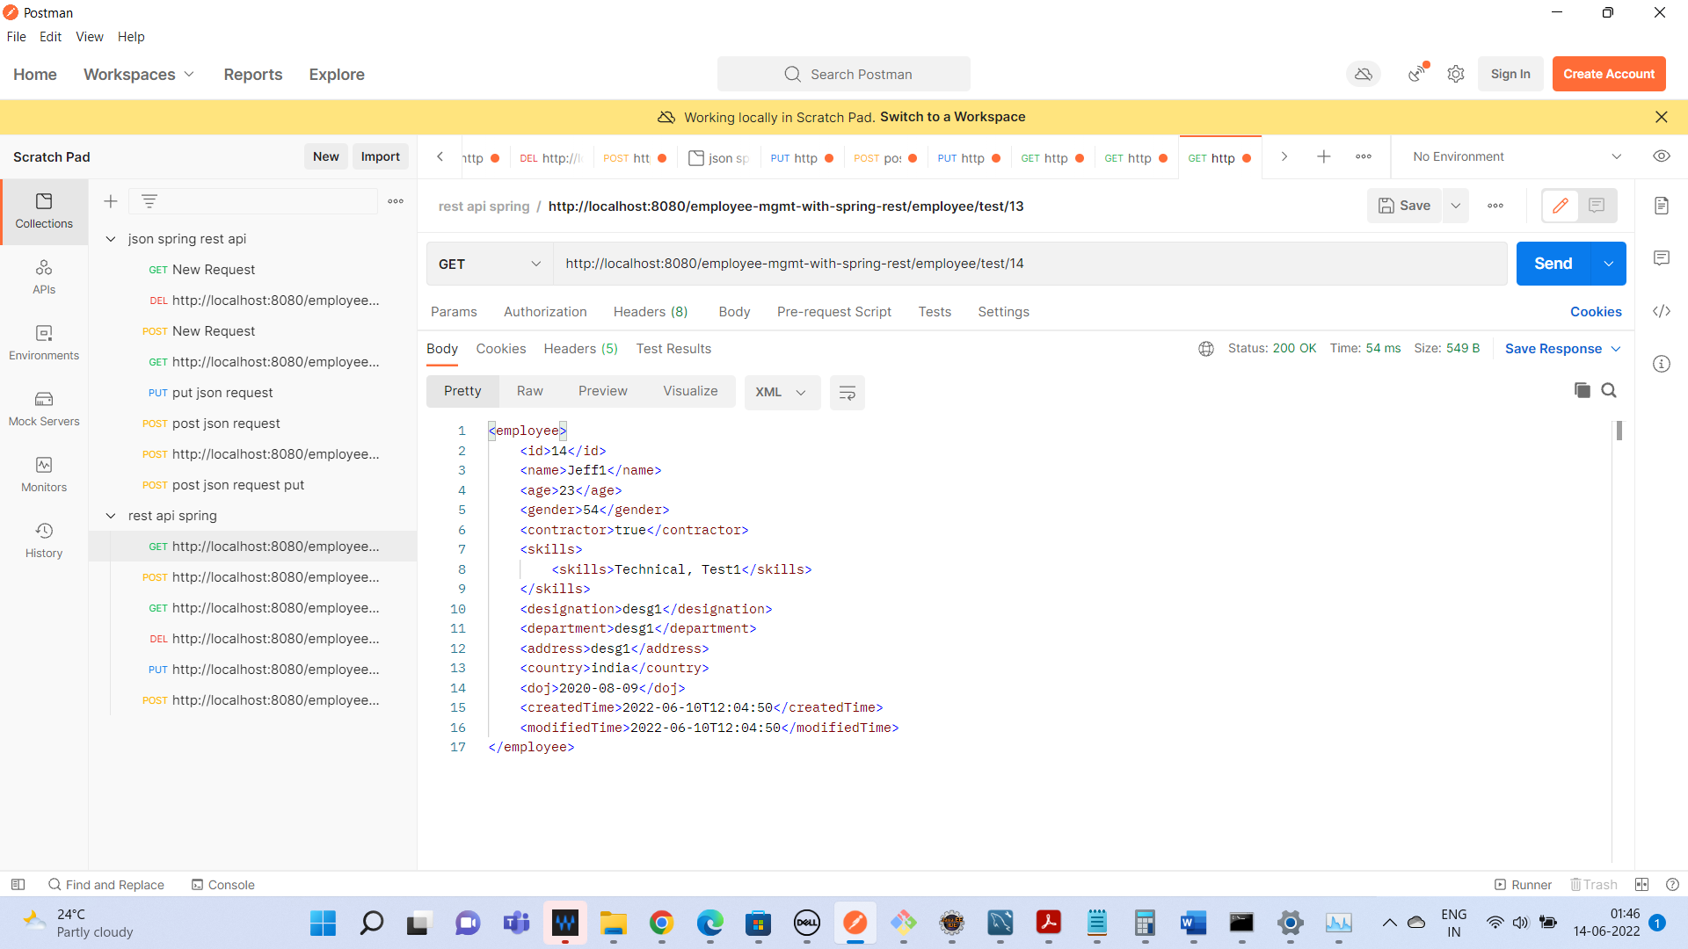

Update employee for record 13

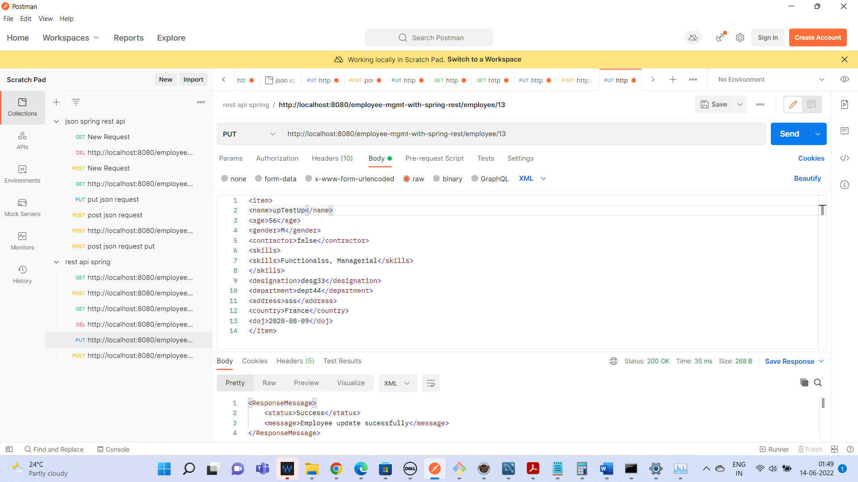

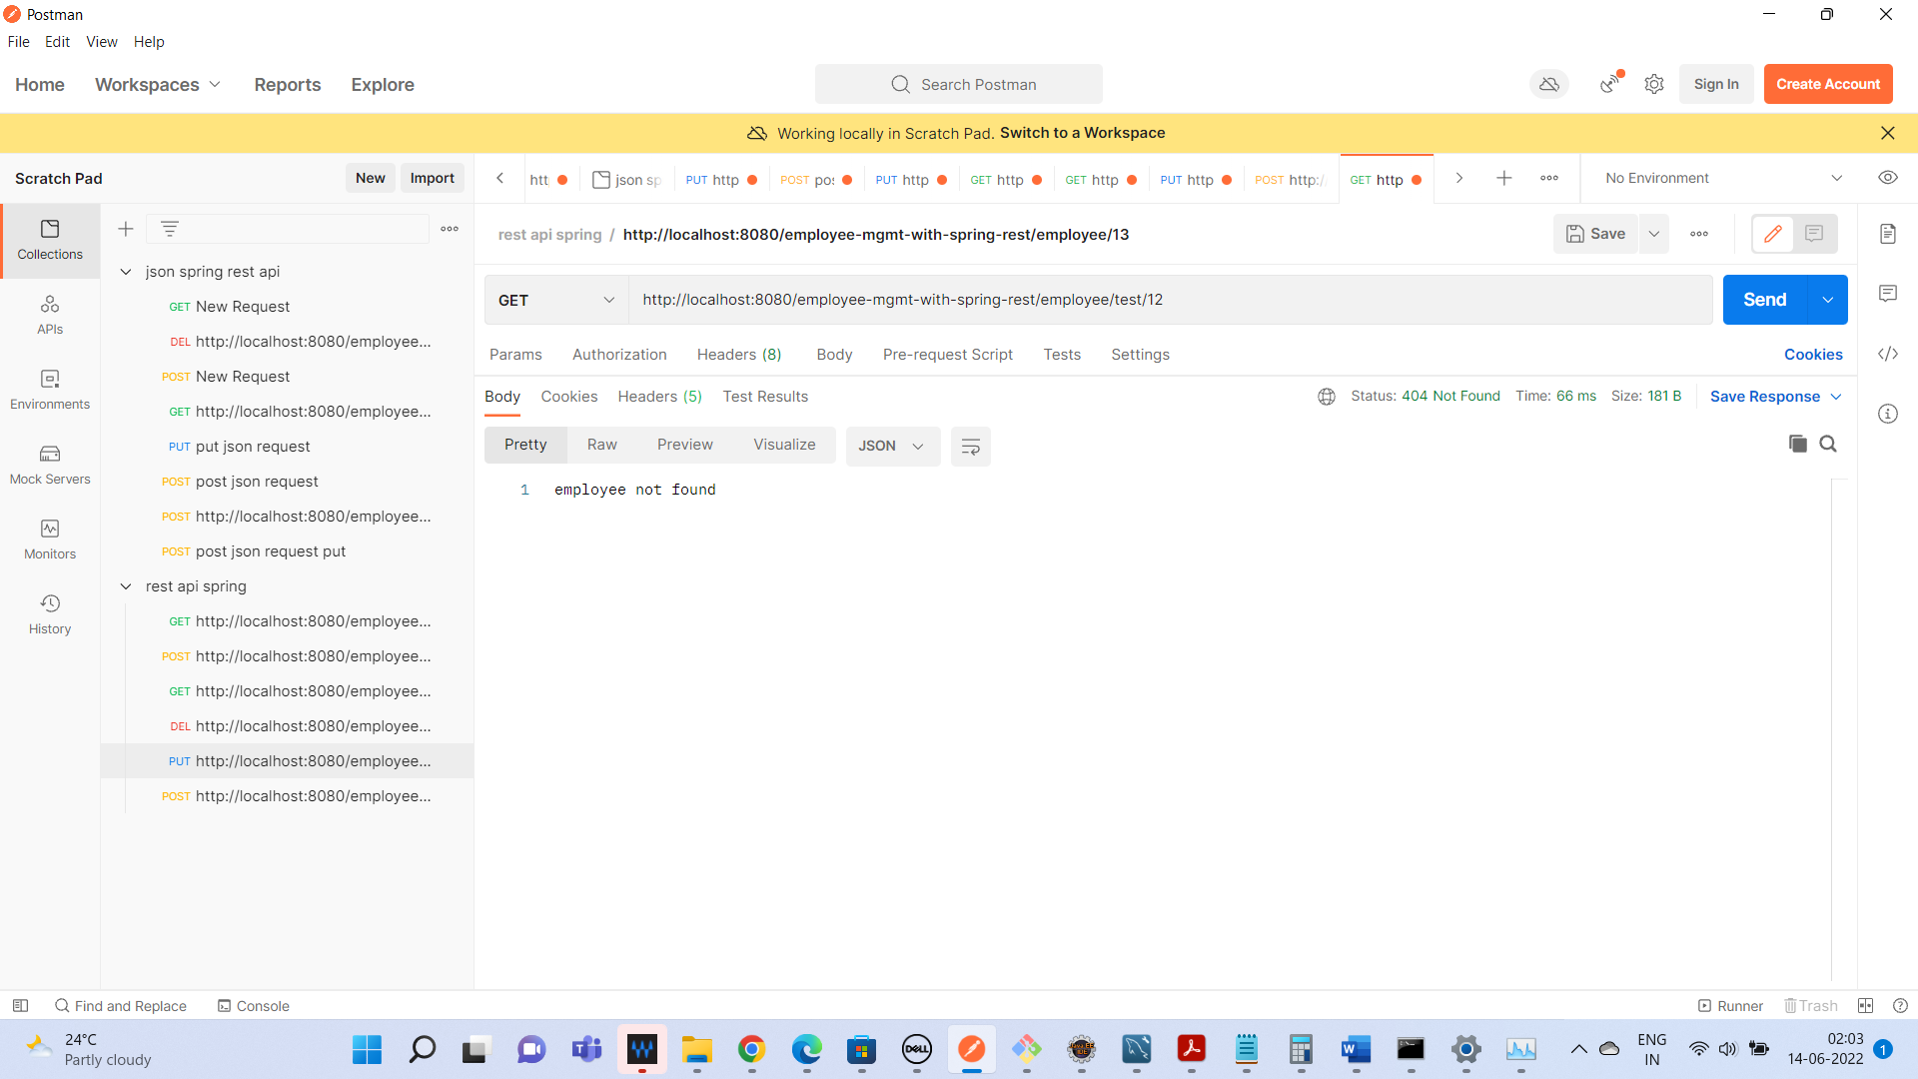

Age is changed from 54 to 20

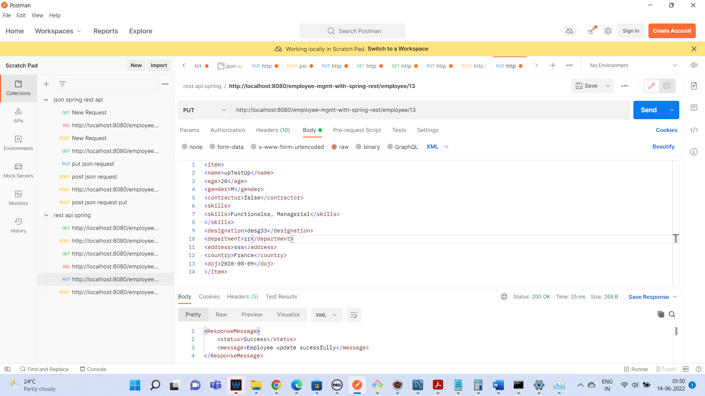

Deleting the employee 13

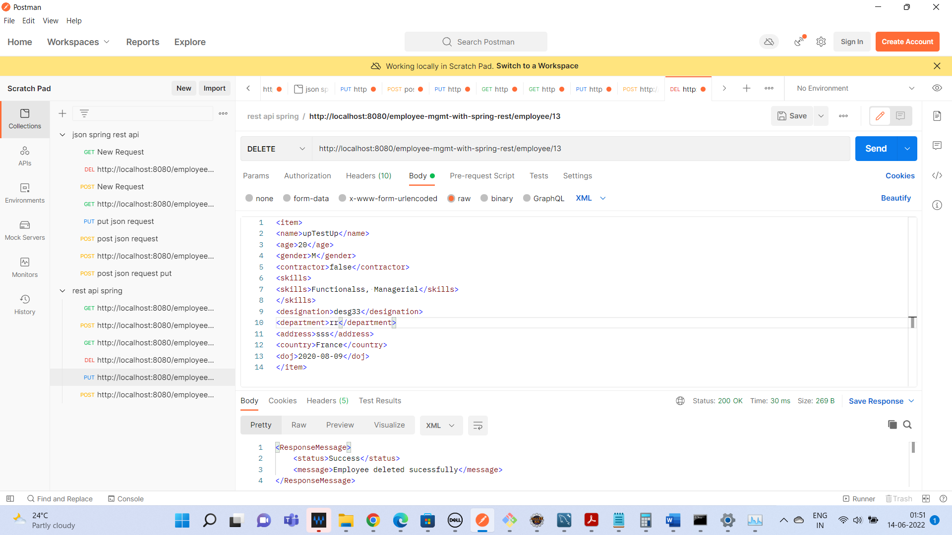

Validation failure:

