WEEK 3 INTERNSHIP REPORT

Advanced Data Analysis and
Visualization in Logistics
Exploratory Data Analysis using Python

Student Name | A. Jahnavi
Roll Number | 24471A4205
Course / Branch | CSM
Internship Task | Week 3 – Logistics Analysis and Visualization
This report uses a hypothetical dataset created for learning purposes. Results describe only this simulated sample.

1. Executive Summary
This report demonstrates exploratory data analysis (EDA) and visualization for logistics operations using a hypothetical dataset of 20 shipments. The analysis explores shipment distance, weight, delivery time, transport cost, transport mode, and on-time status. The simulated sample has an average delivery time of 3.84 days, a median of 2.30 days, an average transport cost of INR 7,625.00, and an overall on-time delivery rate of 80.0%. Charts and summary statistics are used to compare transport modes, examine delivery-time distribution, inspect cost relationships, and identify potential operational bottlenecks. Because the dataset is hypothetical and small, findings are illustrative rather than real-world claims.

2. Objectives
- Define a simulated logistics dataset and explain its fields.
- Perform EDA using descriptive statistics, distributions, and correlation analysis.
- Create visualizations for delivery performance, transport costs, and service reliability.
- Interpret the charts and recommend evidence-based operational improvements.
- Document Python code and explain how each visualization supports logistics decisions.

3. Dataset Simulation and Variables
A hypothetical dataset containing 20 shipment records was created to demonstrate the analysis process. It is not downloaded from a real logistics company and does not represent actual company performance. The records include a mix of road, rail, air, and sea transport, with deliberately varied distances, costs, delivery times, and on-time outcomes.
Variable | Type | Description
Shipment_ID | Text | Unique simulated shipment identifier
Transport_Mode | Categorical | Road, Rail, Air, or Sea
Distance_km | Numeric | Shipment travel distance in kilometres
Shipment_Weight_kg | Numeric | Shipment weight in kilograms
Delivery_Time_days | Numeric | Elapsed delivery time in days
Transport_Cost_INR | Numeric | Simulated transport cost in Indian rupees
On_Time | Categorical | Whether the shipment met its expected delivery time
Assumptions: each row represents one shipment; all values are simulated; ‘On_Time’ is a preassigned outcome for demonstration. In a real project, definitions and data sources must be verified.

4. Methodology
- Data preparation: construct the table in pandas and verify row count, column types, and missing values.
- Descriptive analysis: calculate count, mean, median, standard deviation, minimum, quartiles, and maximum.
- Group analysis: compare average delivery time, average cost, and on-time rate across transport modes.
- Relationship analysis: use Pearson correlation to check linear relationships between numeric variables.
- Visualization: use Matplotlib to generate bar charts, a histogram, a scatter plot, and a correlation matrix.
- Interpretation: connect chart patterns to possible service, cost, and planning decisions while noting limitations.

5. Exploratory Data Analysis (EDA)

5.1 Descriptive statistics
The mean delivery time is 3.84 days and the median is 2.30 days. The mean is higher than the median because several simulated sea shipments have much longer delivery times than other modes. The average transport cost is INR 7,625.00. These overall averages combine different transport modes and distances, so they should not be used alone to judge performance. Segment-level analysis provides a fairer comparison.
Metric | Mean | Median | Minimum | Maximum
Distance (km) | 804.50 | 640.00 | 120.00 | 2,400.00
Weight (kg) | 563.75 | 465.00 | 95.00 | 1,500.00
Delivery time (days) | 3.84 | 2.30 | 1.00 | 15.00
Cost (INR) | 7,625.00 | 5,000.00 | 1,800.00 | 22,500.00

5.2 Transport-mode comparison
The average delivery-time chart compares typical speed across modes. The on-time chart compares reliability. A mode can be fast on average but expensive, so mode selection should consider service requirements, shipment weight, distance, and budget together.
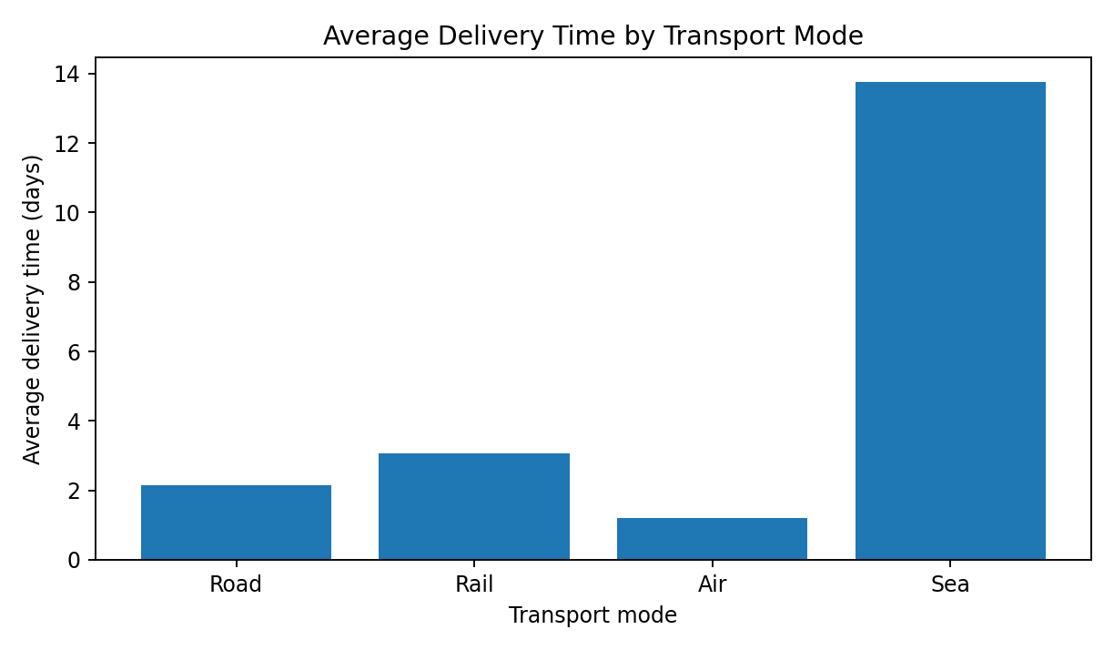
Interpretation: in this simulated sample, air and road shipments have shorter average delivery times than sea shipments. Sea shipments take longer, which may be expected for long-distance movement. This is not proof that one mode is universally better; the sample mixes different distances and is small.
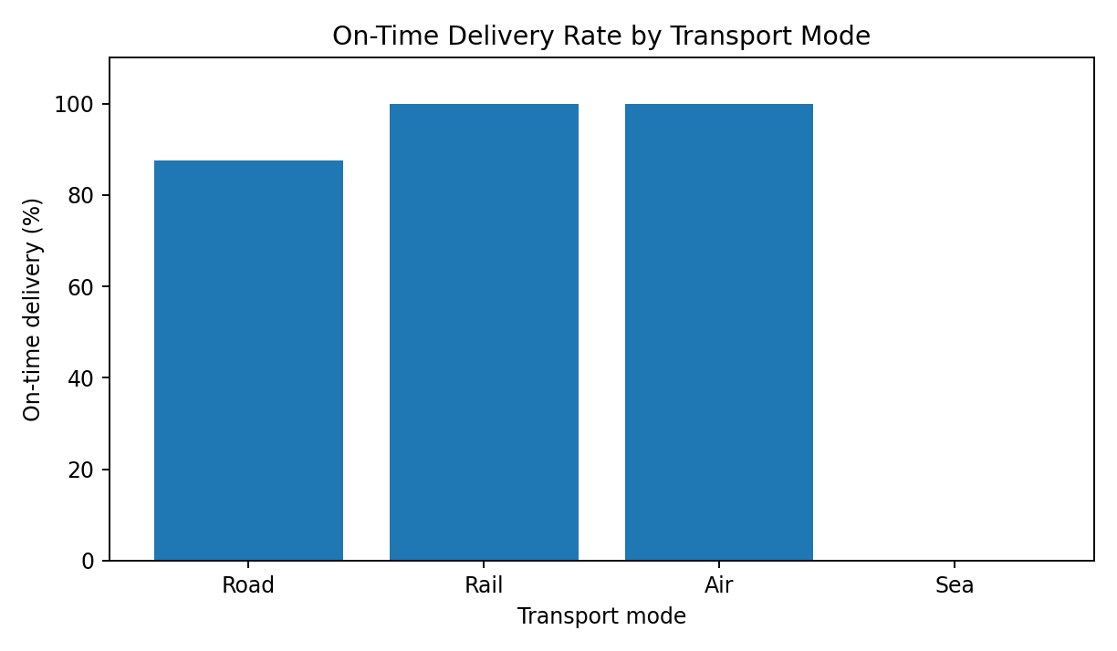
Interpretation: the overall simulated on-time rate is 80.0%. The mode-level chart highlights where delays appear in this sample. Managers should investigate the shipment routes, planned delivery windows, customs/handling stages, and tracking timestamps before making policy changes.

5.3 Delivery-time distribution
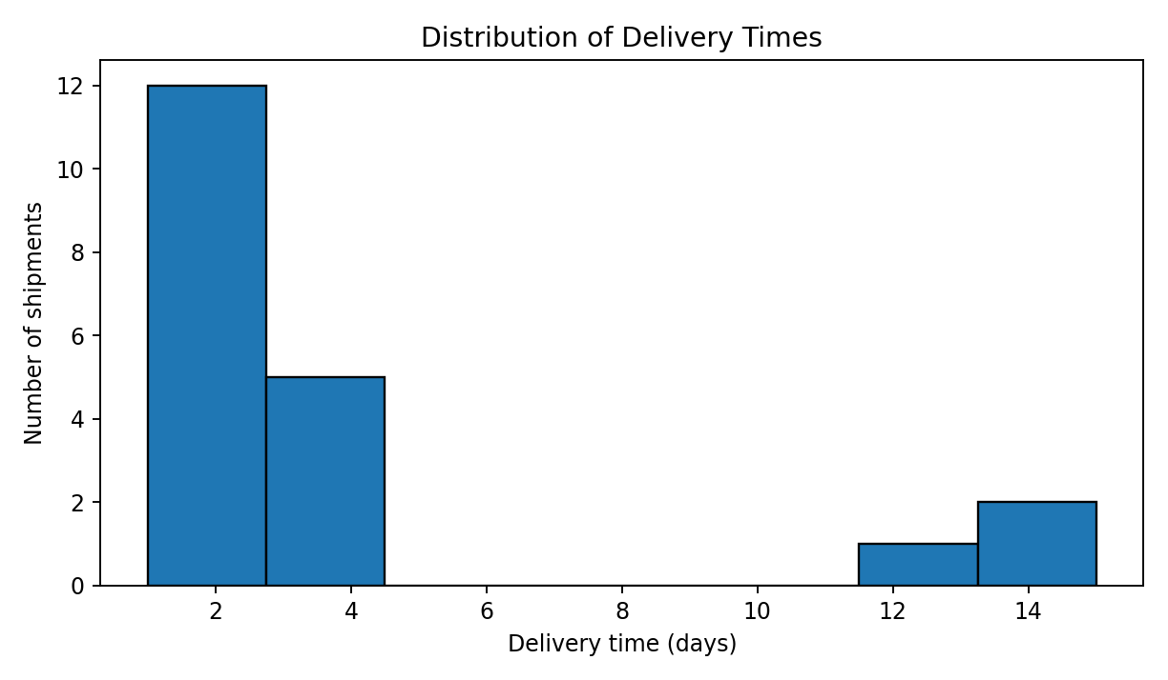
A histogram shows how frequently delivery times occur within intervals. Most simulated shipments cluster at shorter delivery times, while a smaller group of long-duration shipments forms a right tail. This suggests that the mean alone may hide a subset of slow deliveries. Median, percentiles, and the share delivered within the service-level target should also be monitored.

5.4 Relationship between distance and cost
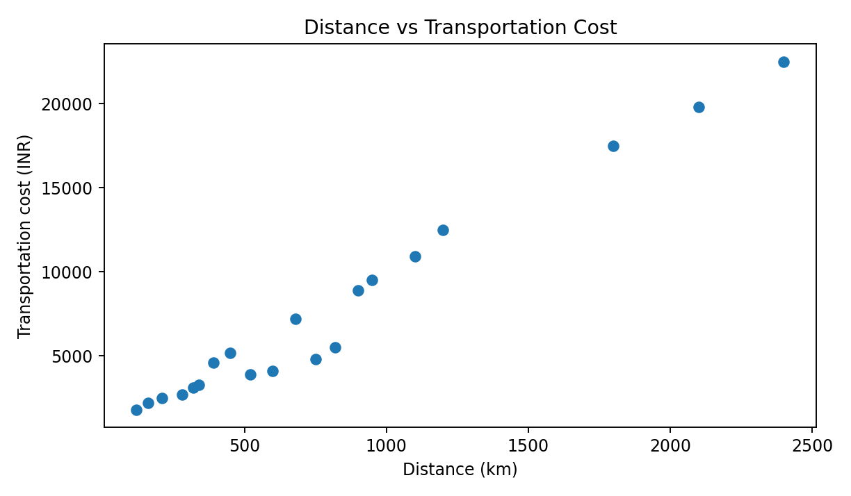
The distance–cost Pearson correlation in this simulated sample is 0.99. A positive relationship means longer routes tend to be associated with higher costs in this sample. However, mode, weight, fuel, handling, and service level can also affect cost. A scatter plot is useful because it shows individual shipments and can reveal unusual points that a single correlation value cannot explain.

5.5 Correlation analysis
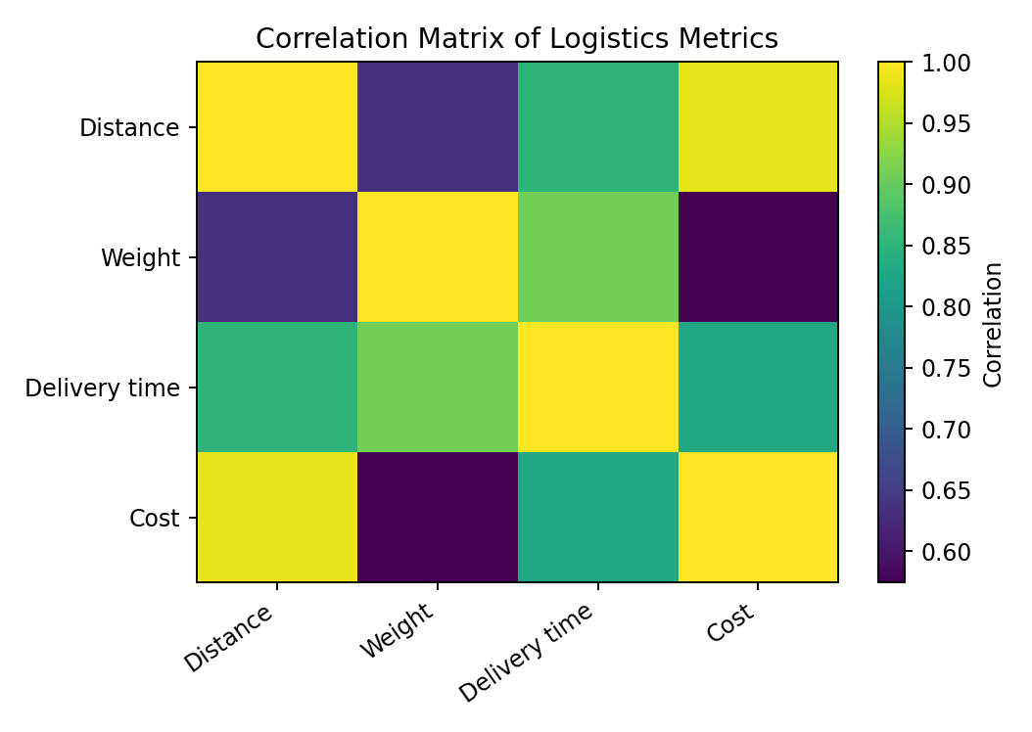
The correlation between distance and delivery time is 0.85, while the correlation between shipment weight and transport cost is 0.57. Correlation describes the strength and direction of a linear relationship; it does not establish causation. Since mode and route length are mixed in this small sample, correlations should be interpreted cautiously.

6. Python Code
The following code illustrates the main EDA and visualization steps. Install the required libraries with `pip install pandas matplotlib seaborn` if they are not already available. The example builds the hypothetical dataset in Python; replace it with a real CSV and use `pd.read_csv()` when working with actual data.
import pandas as pd
import matplotlib.pyplot as plt

# Load a real dataset when available:
# df = pd.read_csv("logistics_data.csv")

# Example analysis assumes df has these columns:
# Transport_Mode, Distance_km, Shipment_Weight_kg,
# Delivery_Time_days, Transport_Cost_INR, On_Time

print(df.head())
print(df.info())
print(df.isna().sum())
print(df[["Distance_km", "Shipment_Weight_kg",
"Delivery_Time_days", "Transport_Cost_INR"]].describe())

# Group-level metrics
mode_summary = df.groupby("Transport_Mode").agg(
shipments=("Shipment_ID", "count"),
avg_delivery_days=("Delivery_Time_days", "mean"),
avg_cost_inr=("Transport_Cost_INR", "mean"),
on_time_rate=("On_Time", lambda x: (x == "Yes").mean() * 100)
)
print(mode_summary.round(2))

# Histogram: distribution of delivery times
plt.hist(df["Delivery_Time_days"], bins=8, edgecolor="black")
plt.xlabel("Delivery time (days)")
plt.ylabel("Number of shipments")
plt.title("Distribution of Delivery Times")
plt.tight_layout()
plt.show()

# Scatter plot: distance versus cost
plt.scatter(df["Distance_km"], df["Transport_Cost_INR"])
plt.xlabel("Distance (km)")
plt.ylabel("Transport cost (INR)")
plt.title("Distance vs Transportation Cost")
plt.tight_layout()
plt.show()

# Correlation matrix
numeric_cols = ["Distance_km", "Shipment_Weight_kg",
"Delivery_Time_days", "Transport_Cost_INR"]
print(df[numeric_cols].corr().round(2))
Note: `df` must be created or loaded before running this excerpt. The full report’s figures were generated from the simulated 20-row dataset described above.

7. Key Findings
- The simulated overall on-time delivery rate is 80.0%, but performance differs by transport mode.
- Average delivery time (3.84 days) is greater than the median (2.30 days), indicating that a few long shipments raise the mean.
- Distance and transportation cost have a correlation of 0.99 in the simulated sample, suggesting distance is a useful cost-planning variable.
- The histogram and scatter plot reveal variation between shipments that cannot be captured by averages alone.
- These are illustrative findings from a hypothetical sample, not verified operational results.

8. Recommendations for Logistics Decision-Making
- Track on-time delivery rate, median delivery time, and 90th-percentile delivery time by route and transport mode.
- Investigate delayed shipments individually, focusing on route distance, handling stages, dispatch time, and any customs or transfer delays.
- Use distance, weight, transport mode, and service level together when comparing costs; avoid judging a mode from average cost alone.
- Build a recurring dashboard with weekly trends and clearly defined KPIs so managers can spot deterioration early.
- Increase the sample size and validate results with actual operational data before changing routes, suppliers, or transport policies.

9. Limitations
This is a small hypothetical dataset created for learning purposes. The results are sensitive to the selected example values, and the sample is not statistically representative of a real logistics network. The analysis does not account for seasonality, fuel-price changes, traffic, weather, warehouse capacity, route-specific conditions, or contractual service-level definitions. Correlation is not causation. Real decisions should be based on larger, validated datasets and operational context.

10. Conclusion
This task demonstrates how exploratory data analysis and visualizations can support logistics performance evaluation. Descriptive statistics summarize the dataset, bar charts compare modes, a histogram reveals delivery-time variation, a scatter plot examines cost drivers, and a correlation matrix summarizes relationships among numerical metrics. The analysis shows why multiple views are needed to identify possible bottlenecks and understand service-cost trade-offs. A disciplined EDA process helps turn raw shipment records into evidence that can guide further investigation and better decisions.

11. References
1. pandas documentation: https://pandas.pydata.org/docs/
2. Matplotlib documentation: https://matplotlib.org/stable/
3. Seaborn documentation: https://seaborn.pydata.org/
4. NumPy documentation: https://numpy.org/doc/
Dataset note: the report uses simulated values and does not claim to use an external real-world dataset.

