DSA 0601 - Data handling and visualization
Set 23 - Employee Performance Analysis
Name : B.Jahnavi
Reg.no: 192325043
1. Bar chart: distribution of employees across departments
Code:
library(ggplot2)

employees <- data.frame(
Employee_ID = 1:5,
Department = c("Sales","HR","Marketing","Sales","HR"),
Years_of_Service = c(5, 3, 7, 4, 2),
Performance_Score = c(85, 92, 78, 90, 76)
)

ggplot(employees, aes(x = Department, fill = Department)) +
geom_bar(color = "black") +
geom_text(stat = "count", aes(label = after_stat(count)), vjust = -0.5) +
labs(
title = "Number of Employees by Department",
x = "Department",
y = "Number of Employees"
) +
theme_minimal()
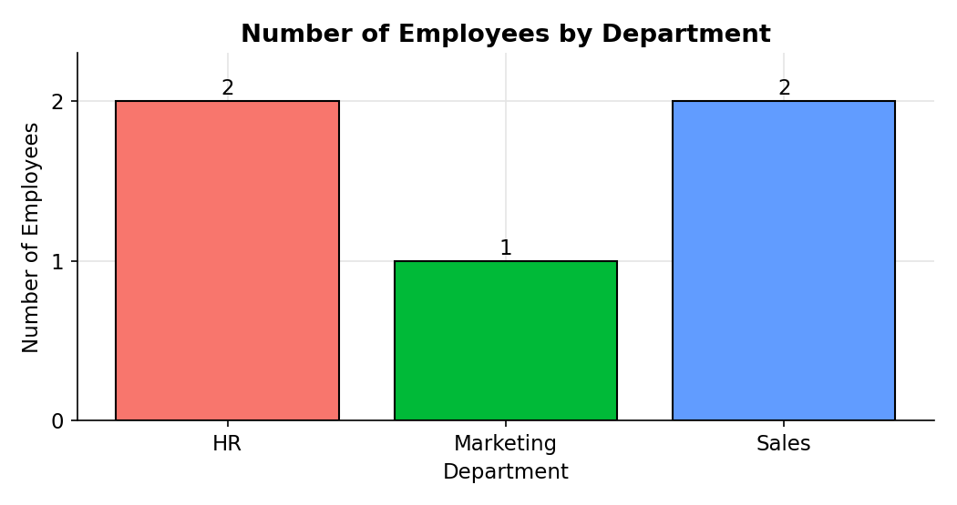
2. Line chart: performance trend over time
Code:
library(ggplot2)

ggplot(employees, aes(x = Years_of_Service, y = Performance_Score)) +
geom_line(color = "#2c7fb8", linewidth = 1) +
geom_point(size = 3, color = "#2c7fb8") +
geom_text(aes(label = paste("Emp", Employee_ID)), vjust = -1, size = 3) +
labs(
title = "Employee Performance Trend by Years of Service",
x = "Years of Service",
y = "Performance Score"
) +
theme_minimal()
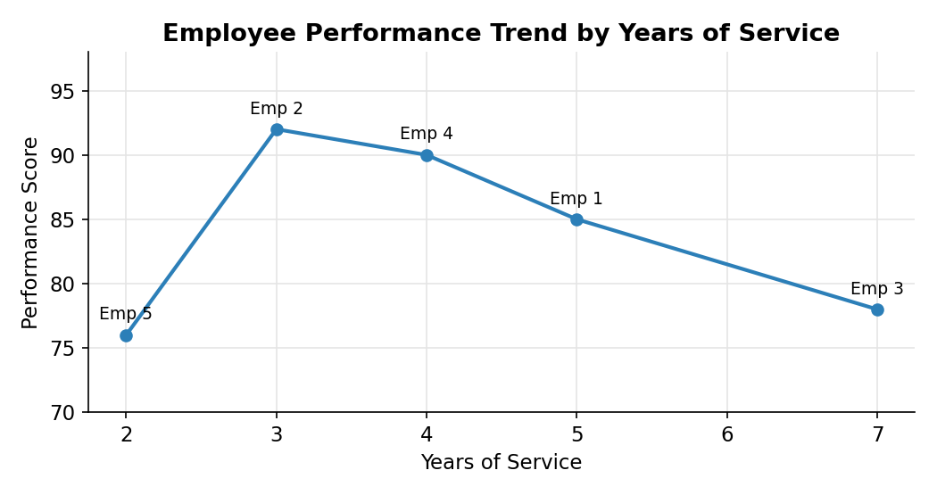
3. Tableau dashboard: department distribution and years of service vs performance
Code:
write.csv(employees, "Set23_Employee_Performance.csv", row.names = FALSE)
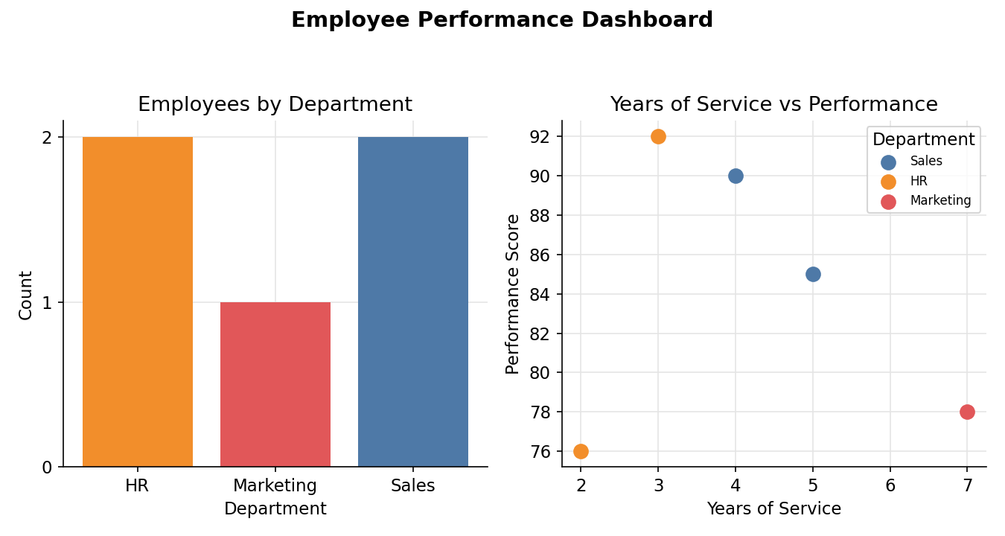
4. Table of performance data for each employee
Code:
library(gridExtra)
library(grid)

colnames(employees) <- c("Employee ID", "Department",
"Years of Service", "Performance Score")

grid.newpage()
grid.table(employees, rows = NULL)

# Alternative: print as a table in the console
print(employees)
