DSA 0601 - Data handling and visualization
Set 30 - Mobile App Usage Analysis
Name : B.Jahnavi
Reg.no: 192325043
1. Histogram and density plot of Screen_Time
Code:
library(ggplot2)

usage <- read.csv("Mobile_App_Usage.csv")

ggplot(usage, aes(x = Screen_Time)) +
geom_histogram(aes(y = after_stat(density)), bins = 5,
fill = "skyblue", color = "black", alpha = 0.8) +
geom_density(color = "red", linewidth = 1) +
labs(
title = "Histogram and Density Plot of Screen Time",
x = "Screen Time (hrs)",
y = "Density"
) +
theme_minimal()

summary(usage$Screen_Time)
sd(usage$Screen_Time)
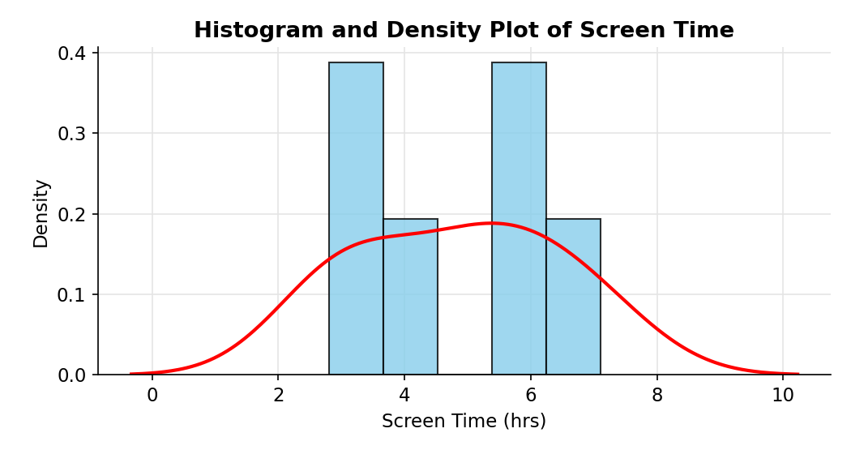
2. Scatter plot of Data_Used vs Screen_Time with correlation
Code:
ggplot(usage, aes(x = Data_Used, y = Screen_Time)) +
geom_point(size = 3, color = "#2c7fb8") +
geom_smooth(method = "lm", se = FALSE, color = "red") +
labs(
title = "Data Used vs Screen Time",
x = "Data Used (GB)",
y = "Screen Time (hrs)"
) +
theme_minimal()

cor(usage$Data_Used, usage$Screen_Time)
lm(Screen_Time ~ Data_Used, data = usage)
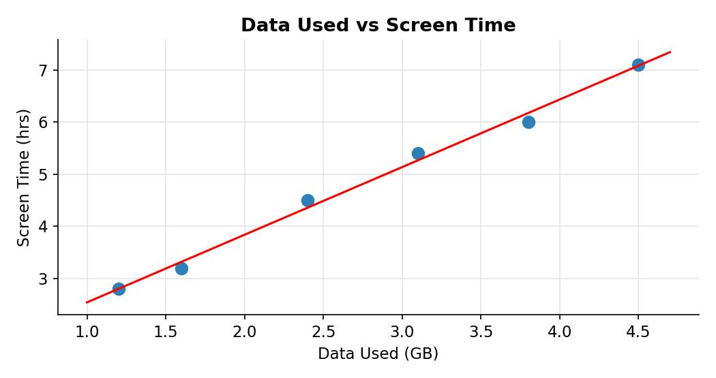
3. Average Satisfaction score by Gender
Code:
library(dplyr)
library(ggplot2)

sat_avg <- usage %>%
group_by(Gender) %>%
summarise(Avg_Satisfaction = mean(Satisfaction), .groups = "drop")

print(sat_avg)

ggplot(sat_avg, aes(x = Gender, y = Avg_Satisfaction, fill = Gender)) +
geom_col(color = "black", show.legend = FALSE) +
geom_text(aes(label = round(Avg_Satisfaction, 2)), vjust = -0.5) +
labs(
title = "Average Satisfaction Score by Gender",
x = "Gender",
y = "Average Satisfaction"
) +
ylim(0, 5.5) +
theme_minimal()
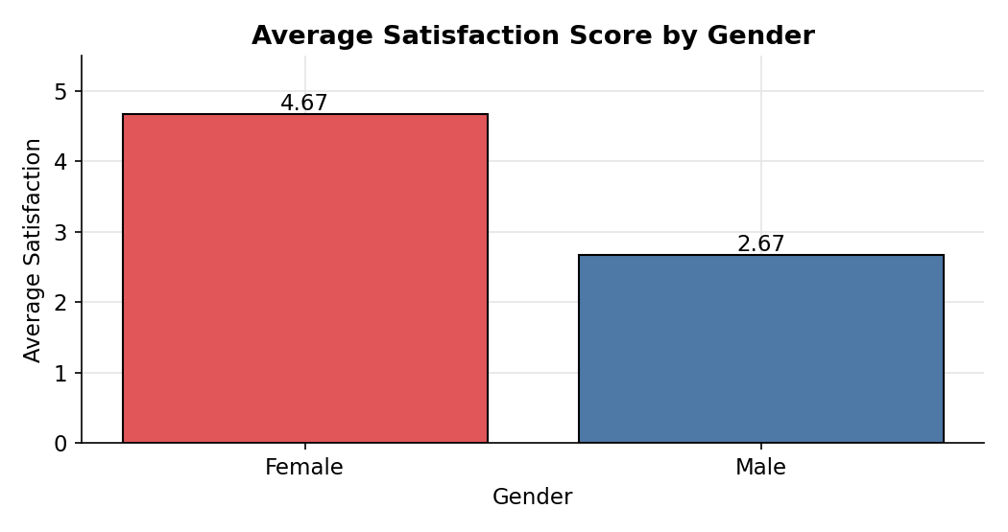
4. Tableau mini dashboard: bubble chart and usage trend
Code:
usage$Usage_Date <- as.Date(usage$Usage_Date)
write.csv(usage, "Mobile_App_Usage_Tableau.csv", row.names = FALSE)
