DSA 0601 - Data handling and visualization
Set 26 - Student Performance Analysis
Name : B.Jahnavi
Reg.no: 192325043
1. Histogram of Math_Score and boxplot of Science_Score by Gender
Code:
library(ggplot2)

students <- read.csv("Student_Mini_Data.csv")

# (a) Histogram of Math_Score
ggplot(students, aes(x = Math_Score)) +
geom_histogram(bins = 5, fill = "skyblue", color = "black") +
labs(
title = "Histogram of Math Score",
x = "Math Score",
y = "Frequency"
) +
theme_minimal()
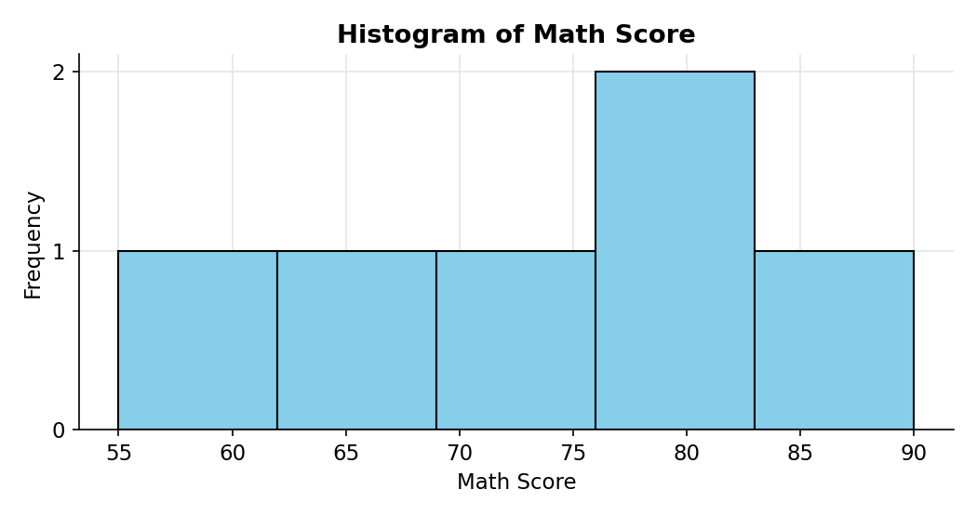
(b) Boxplot of Science_Score by Gender
Code:
ggplot(students, aes(x = Gender, y = Science_Score, fill = Gender)) +
geom_boxplot(alpha = 0.7) +
labs(
title = "Science Score by Gender",
x = "Gender",
y = "Science Score"
) +
theme_minimal()
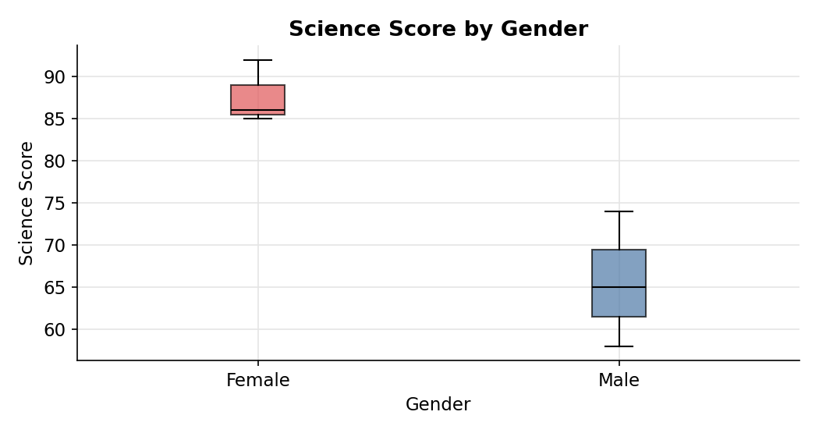
2. Scatter plot of Study_Hours vs Math_Score with regression line
Code:
ggplot(students, aes(x = Study_Hours, y = Math_Score, color = Gender)) +
geom_point(size = 3) +
geom_smooth(aes(group = 1), method = "lm", se = FALSE, color = "black") +
labs(
title = "Study Hours vs Math Score",
x = "Study Hours",
y = "Math Score"
) +
theme_minimal()

model <- lm(Math_Score ~ Study_Hours, data = students)
summary(model)
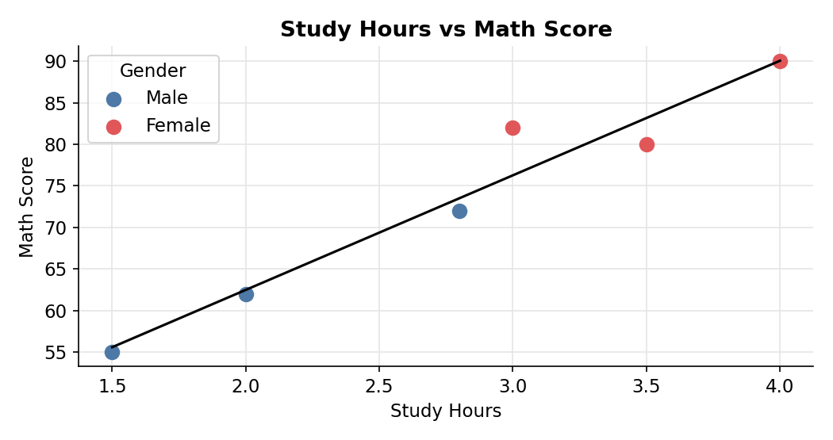
3. Monthly average Math score trend with moving average smoothing
Code:
library(dplyr)
library(ggplot2)
library(zoo)

students$Exam_Date <- as.Date(students$Exam_Date)
students$Month <- format(students$Exam_Date, "%Y-%m")

monthly <- students %>%
group_by(Month) %>%
summarise(Avg_Math = mean(Math_Score), .groups = "drop") %>%
mutate(Moving_Avg = rollmean(Avg_Math, k = 2, fill = NA, align = "right"))

print(monthly)

ggplot(monthly, aes(x = Month, group = 1)) +
geom_line(aes(y = Avg_Math, color = "Monthly average"), linewidth = 1) +
geom_point(aes(y = Avg_Math, color = "Monthly average"), size = 3) +
geom_line(aes(y = Moving_Avg, color = "2-month moving average"),
linetype = "dashed", linewidth = 1) +
labs(
title = "Monthly Average Math Score",
x = "Month",
y = "Average Math Score",
color = ""
) +
theme_minimal()
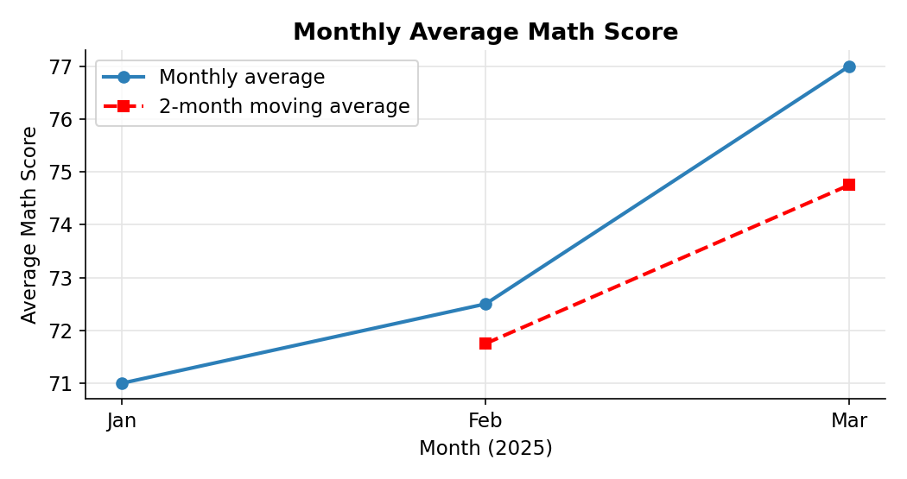
4. Tableau dashboard: average Math score by gender and score trend
Code:
write.csv(students[, c("Student_ID","Gender","Study_Hours","Attendance",
"Math_Score","Science_Score","Exam_Date")],
"Student_Mini_Data_Tableau.csv", row.names = FALSE)
