Task 1 – File Automation Script

1. Title Page
Task 1: File Automation Script
Submitted By: Jahnavi Bodapati
Internship: Python Internship
Date: 15 May 2026

2. Objective
To create an automation script using Python that performs file operations such as sorting, renaming, and deleting temporary files. The project uses the OS module, exception handling, logging, and user input support.

3. Technologies Used
• Python
• OS Module
• Logging Module
• Exception Handling
• VS Code / PyCharm

4. Source Code
import os
import shutil
import logging

# Configure logging
logging.basicConfig(
filename='automation.log',
level=logging.INFO,
format='%(asctime)s - %(levelname)s - %(message)s'
)

def sort_files(folder_path):
try:
if not os.path.exists(folder_path):
print("Folder does not exist!")
return

files = os.listdir(folder_path)

for file in files:
file_path = os.path.join(folder_path, file)

# Skip directories
if os.path.isdir(file_path):
continue

# Get file extension
extension = file.split('.')[-1]

# Create folder for extension
extension_folder = os.path.join(folder_path, extension.upper())

if not os.path.exists(extension_folder):
os.makedirs(extension_folder)

# Move file
shutil.move(file_path, os.path.join(extension_folder, file))

logging.info(f"Moved: {file} -> {extension_folder}")

print("Files sorted successfully!")

except Exception as e:
logging.error(f"Error occurred: {e}")
print("An error occurred:", e)

def rename_files(folder_path, prefix):
try:
files = os.listdir(folder_path)

count = 1

for file in files:
file_path = os.path.join(folder_path, file)

if os.path.isfile(file_path):
extension = file.split('.')[-1]
new_name = f"{prefix}_{count}.{extension}"

new_path = os.path.join(folder_path, new_name)

os.rename(file_path, new_path)

logging.info(f"Renamed: {file} -> {new_name}")

count += 1

print("Files renamed successfully!")

except Exception as e:
logging.error(f"Rename Error: {e}")
print("Error:", e)

def delete_temp_files(folder_path):
try:
files = os.listdir(folder_path)

for file in files:
if file.endswith('.tmp'):
file_path = os.path.join(folder_path, file)

os.remove(file_path)

logging.info(f"Deleted temp file: {file}")
print("Temporary files cleaned!")
except Exception as e:
logging.error(f"Cleaning Error: {e}")
print("Error:", e)

5. Input and Output

==== File Automation Script ====
Enter folder path: C:\Users\jahna\OneDrive\Documents
1. Sort Files
2. Rename Files
3. Delete Temp Files

Enter your choice: 1
Files sorted successfully!

6. Screenshots
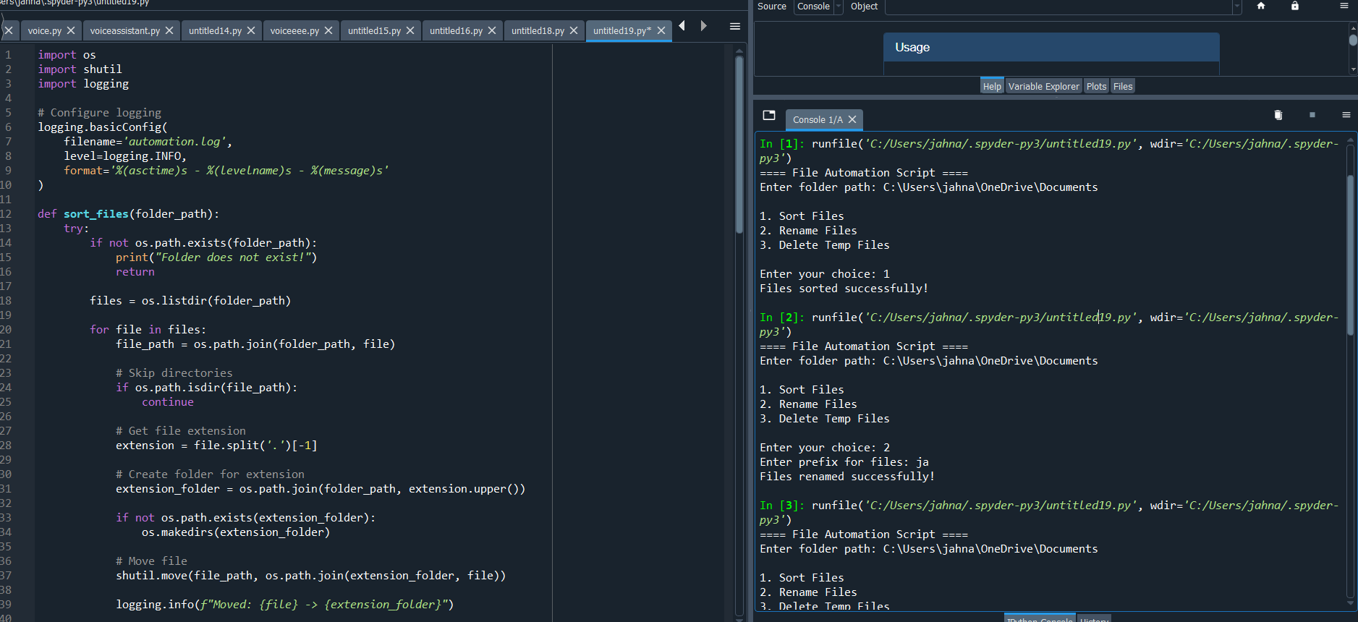

7. GitHub Repository Link
GitHub Repository: Git hub link

8. Conclusion
The project successfully automated file management tasks such as sorting, renaming, and cleaning files using Python. It improved understanding of file handling, OS operations, logging, and exception handling.

