VIT Bhopal University
CSE0001 – Digital Literacy

Digital Literacy Portfolio
Project Report

Name: Jahnavi Gautam
Registration No.: 25BCE10361
Branch: B.Tech – Computer Science and Engineering
Year: First Year
Course Code: CSE0001
Date: March 2026

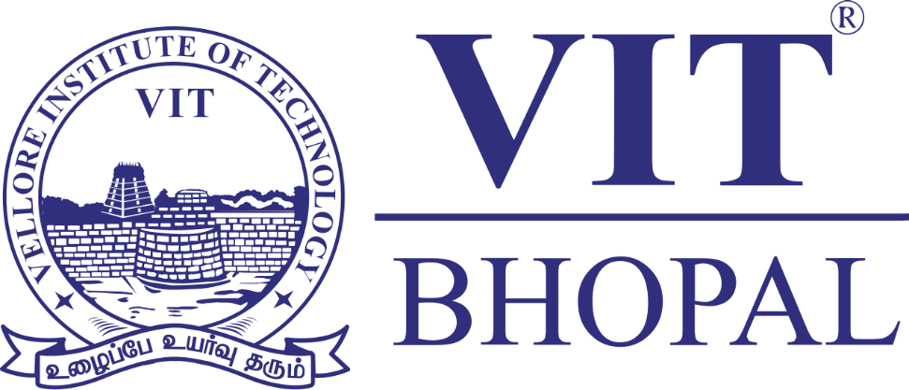

Introduction
This report documents my work as part of the CSE0001 – Digital Literacy project at VIT Bhopal University. As a first-year B.Tech student, I was assigned the role of a Student Digital Ambassador, tasked with building a comprehensive Digital Literacy Portfolio across five modules.
The project required me to create a digital literacy infographic, set up professional online profiles, explore coding and collaboration platforms, draft professional emails, and research cybercrime awareness. All tasks were completed using free, browser-based tools and organised in a public GitHub repository.
This report presents my work, observations, and reflections for each task, demonstrating my understanding of digital literacy concepts and their practical relevance to student life and future careers.

Task 1 – Digital Literacy Awareness Infographic
For Task 1, I created a one-page digital literacy awareness infographic using Canva, a free browser-based design tool. Canva offered a wide range of professionally designed templates, which made it easy to get started without any prior design experience.
My infographic covers three key topics: what digital literacy means in today’s world, safe internet practices for college students, and the importance of maintaining a professional online presence. I used a clean, colour-coded layout with icons and short text blocks to make the content visually engaging and easy to understand.
The most interesting part of the process was discovering how much thought goes into visual communication – choosing the right colours, fonts, and layout to convey information clearly without overwhelming the viewer. The most challenging aspect was fitting all the content onto a single page while keeping it readable and uncluttered. This task gave me a new appreciation for design thinking and how visuals can make complex information far more accessible than plain text.

Task 2 – Student Digital Portfolio
For Task 2, I set up my foundational professional digital presence across two platforms: GitHub and LinkedIn. These platforms are widely used by employers, internship coordinators, and the academic community to evaluate students and professionals.
On GitHub, I created my project repository and a profile README that introduces my name, branch, year, and learning goals. GitHub is primarily used for hosting code, collaborating on software projects, and showcasing technical work. On LinkedIn, I filled in my Education section with my current degree, institution, and expected graduation year. LinkedIn is the world’s largest professional networking platform, used for job searching, internship applications, and connecting with industry professionals.
Over the next four years, I plan to use GitHub to document all my coding projects and contribute to open-source work, building a visible portfolio for recruiters. I intend to use LinkedIn to connect with seniors, apply for internships, and stay updated with industry trends. These platforms will serve as my professional identity in the digital world throughout my academic journey and beyond.

Task 3 – Coding and Collaboration Platforms
For Task 3, I explored both a coding practice platform and a cloud collaboration tool. For the coding component, I created an account on HackerRank and completed a beginner-level challenge. HackerRank is a competitive programming platform that allows students to practise problem-solving skills across multiple programming languages and domains.
For the collaboration component, I created a five-question Digital Literacy Awareness Quiz using Google Forms. The quiz includes multiple choice questions on safe internet practices and a short answer question asking students to describe one responsible social media habit. The form is linked to a Google Sheet that automatically collects and organises responses, making it a practical tool for gathering feedback.
These platforms will be highly useful academically. HackerRank will help me practise coding consistently and prepare for technical interviews in the future. Google Forms and Google Workspace tools are essential for collaborative assignments, peer surveys, and group projects throughout my degree. Exploring these tools as part of this task has given me hands-on familiarity that I can build on immediately.

Task 4 – Professional Email and Etiquette Guide
For Task 4, I drafted two professional emails and created a social media Do’s and Don’ts checklist. The first email was addressed to a professor requesting an extension on an assignment deadline, and the second was addressed to an internship coordinator expressing interest in a summer internship opportunity.
This task highlighted how digital communication can significantly impact professional relationships. A poorly worded email – one that lacks a subject line, uses informal language, or fails to provide context – can create a negative impression even before a meeting takes place. For example, a student who emails a professor without a subject line or greeting may come across as disrespectful, potentially affecting how the professor responds. The key learning from this task is that professional emails must be concise, respectful, and clearly structured, regardless of how brief the message is.

Task 5 – Cybercrime Awareness Case Study
For Task 5, I researched UPI and online payment fraud – one of the most prevalent cybercrimes affecting college students in India. I wrote a realistic case study based on common fraud patterns reported by the National Cyber Crime Portal and RBI consumer alerts, and created a prevention checklist with actionable safety tips.
What surprised me most during this research was how sophisticated and convincing these scams can be. Fraudsters exploit people’s trust in familiar brand names and their urgency to recover money. The fact that something as simple as approving a collect request – which looks identical to receiving money – can result in financial loss is deeply alarming. One habit I will personally change as a result of this task is to never search for customer care numbers on Google. I will always find contact details within the official app or website, no matter how urgent the situation feels.

Conclusion
This project has been a valuable and practical introduction to digital literacy. Across the five tasks, I learned how to communicate professionally, maintain a safe and credible online presence, use industry-relevant tools, and protect myself from digital threats. The most significant takeaway is that digital literacy is not just a technical skill – it is a life skill that shapes how we learn, work, and interact in an increasingly digital world. I now feel more confident navigating professional platforms and more aware of the responsibilities that come with being an active digital citizen.

References
- Canva – canva.com
- GitHub – github.com
- LinkedIn – linkedin.com
- HackerRank – hackerrank.com
- Google Forms – forms.google.com
- National Cyber Crime Portal – cybercrime.gov.in
- Reserve Bank of India Consumer Alerts – rbi.org.in

