
Indian Institute of Technology Ropar
Department of Mechanical Engineering
Summer Internship Report, 2026 [course code, if any]
Title: Summer Internship at Connectify: Generative Engine Optimization, Market Research and Go-to-Market Strategy
Submitted by:
Jahnavi Sharma (2023MEB1349)
B.Tech Mechanical Engineering, 3rd Year
Faculty Supervisor: [Name, Designation]
Industry Supervisor: [Name, Designation, Connectify]
Internship Duration: 25 May – 25 July 2026
Organisation: Connectify | Role: GEO Intern, Go-to-Market Research

Certificate
This is to certify that the work presented in this internship report entitled "Summer Internship at Connectify: Generative Engine Optimization, Market Research and Go-to-Market Strategy" is a record of the work carried out by Jahnavi Sharma (2023MEB1349) at Connectify as a GEO Intern in Go-to-Market Research from 25 May 2026 to 25 July 2026, as part of the B.Tech Mechanical Engineering programme at the Department of Mechanical Engineering, Indian Institute of Technology Ropar. The material presented in this report has not been submitted elsewhere for the award of any other degree or diploma.
[Faculty Supervisor name]
Faculty Supervisor
Department of Mechanical Engineering
IIT Ropar
[Industry Supervisor name]
Industry Supervisor
Connectify
[Optional: attach the company internship certificate after this page.]

Acknowledgement
I would like to express my sincere gratitude to [Industry Supervisor name] and the team at Connectify for giving me the opportunity to work as a GEO Intern in Go-to-Market Research and for their guidance during the internship. I am also grateful to [Faculty Supervisor name] of the Department of Mechanical Engineering, IIT Ropar, for their support and for encouraging an interdisciplinary approach to the work.
I thank the Department of Mechanical Engineering and the Indian Institute of Technology Ropar for the academic foundation that made this experience possible, and my family and friends for their constant encouragement.
Jahnavi Sharma

Abstract
Search is shifting from ranked lists of links to AI-generated answers that mention, recommend and cite specific brands. Generative Engine Optimisation (GEO) is the emerging discipline concerned with how visible and well understood a brand's content is within such answers. This report documents a two-month summer internship at Connectify in which I worked as a GEO Intern in Go-to-Market Research, combining technical research with market analysis and go-to-market strategy for a product under development.
The technical research covered large language models and Transformers, vector embeddings and cosine similarity, vector databases, Retrieval-Augmented Generation (RAG), chunking strategies, re-ranking, query decomposition and fan-out, knowledge graphs and entity recognition, entity-based content optimisation, Schema.org markup with JSON-LD, and semantic HTML. These topics were synthesised into a single framework describing how content is organised, retrieved and selected by AI search systems. The market research analysed four leading GEO platforms (Peec AI, Profound, PromptWatch and LLM Pulse) and an Indian go-to-market strategy, leading to recommendations on customer segments, differentiation, pricing, acquisition channels and product priorities.
The analysis found that visibility tracking is becoming a standard feature, whereas the action layer, traffic attribution, agency tooling and local fit remain open, and that India offers a differentiation opportunity based on rupee pricing, regional-language tracking, WhatsApp-native alerts and agency distribution. The report also proposes, without claiming implementation, two potential industrial applications: using GEO concepts to improve the discoverability of industrial products, and using RAG to retrieve engineering knowledge in Industry 4.0 settings. The work was research and analysis; market figures are directional estimates and the recommendations are hypotheses to be validated.

Contents
1. Introduction 7
1.1 Background: From Search Results to AI-Generated Answers 7
1.2 The Organisation 7
1.3 The Business Problem 7
1.4 Duration and Role 8
1.5 Structure of the Report 8
2. Technical Background and Literature Review 9
2.1 Generative Engine Optimisation and Traditional SEO 9
2.2 Traditional versus Semantic Information Retrieval 9
2.3 Large Language Models, Transformers and Attention 10
2.4 Vector Embeddings and Cosine Similarity 10
2.5 Vector Databases 11
2.6 Retrieval-Augmented Generation (RAG) 12
2.7 Chunking Strategies 13
2.8 Re-ranking 13
2.9 Query Decomposition and Fan-Out 14
2.10 Knowledge Graphs and Entity Recognition 15
2.11 Knowledge Panels and Entity-Based Content Optimisation 16
2.12 Schema.org Markup and JSON-LD 16
2.13 Semantic HTML 17
3. Objectives of the Internship 18
4. Work Carried Out and Methodology 19
4.1 Overall Approach 19
4.2 Workstream A: Technical Research 19
4.3 Workstream B: Market and Strategy Research 20
4.4 Limitations of the Approach 20
5. Results and Discussion 21
5.1 Technical Findings: An Integrated Framework 21
5.2 Market Findings 21
5.3 Competitor Analysis 22
5.4 Capability Comparison 24
5.5 Go-to-Market Recommendations for India 24
5.6 Data Discrepancies in the Source Material 26
5.7 Synthesis 27
6. Mechanical Engineering Perspective: Potential Industrial Applications 28
6.1 GEO for Industrial Product Discoverability 28
6.2 RAG for Engineering Knowledge Retrieval (Future Scope in Industry 4.0) 29
6.3 The Role of a Mechanical Engineering Background 30
7. Learning Outcomes and Skills Acquired 31
8. Conclusion and Future Scope 32
8.1 Conclusion 32
8.2 Future Scope 32
References 33

List of Figures
Figure 2.1: Traditional SEO and AI-powered (GEO) search compared. 9
Figure 2.2: Schematic of an embedding space (two-dimensional projection). Related texts cluster together and the query lies near the semantically similar documents. 11
Figure 2.3: Architecture of a Retrieval-Augmented Generation (RAG) system. 12
Figure 2.4: Four chunking strategies applied to the same document. 13
Figure 2.5: Two-stage retrieval: fast vector search followed by precise re-ranking. 14
Figure 2.6: Query decomposition and fan-out retrieval. 15
Figure 2.7: From a sentence to a knowledge graph through entity recognition and linking. 16
Figure 4.1: Workflow of the internship from technical research to recommendations and potential applications. 19
Figure 5.1: Integrated framework connecting the technical research topics. 21
Figure 5.2: Estimated global GEO/AEO software market, 2025 and 2034 (estimate quoted in the source decks, not independently verified). 22
Figure 5.3: Schematic positioning of the four platforms by documented target segment. 23
Figure 5.4: Proposed phasing of customer segments (recommendation). 25
Figure 5.5: Estimated customer acquisition cost by channel (author's estimates from the India GTM research; to be validated with beta data). 26
Figure 6.1: Illustrative example of how structured, entity-rich product content could support discovery of industrial equipment by an AI assistant. 28
Figure 6.2: Illustrative RAG workflow for a maintenance query (potential future application; not implemented). 29

List of Tables
Table 2.1: Traditional (lexical) and semantic retrieval compared. 10
Table 2.2: Representative vector database and search solutions studied. 12
Table 4.1: Technical research topics studied in Workstream A. 19
Table 5.1: Summary of the four platforms analysed (figures as stated in each company deck). 23
Table 5.2: Selected capabilities as documented in the source decks. 24
Table 5.3: Discrepancies between source decks (reported as found, not reconciled). 26

1. Introduction

1.1 Background: From Search Results to AI-Generated Answers
For more than two decades, finding information online meant typing a query into a search engine and choosing from a ranked list of links. Businesses responded by investing in Search Engine Optimisation (SEO): the practice of structuring and promoting web content so that it ranks highly on a results page. Success was measured in positions, impressions and clicks.
This model is changing. Conversational AI systems such as ChatGPT, Gemini, Perplexity and Microsoft Copilot, together with AI features inside conventional search such as Google AI Overviews, now answer a user's question directly. Instead of ten links, the user receives one synthesised response that frequently names specific brands, recommends products and cites the sources it used. The material gathered during this internship points to rapid adoption of these tools, particularly in India, which one of the research decks describes as ChatGPT's second-largest market with roughly 100 million weekly users (an estimate quoted in the source material and not independently verified).
In this environment a brand can rank first on a conventional results page and still be absent from the AI-generated answer. The concepts of ranking and clicking are partly replaced by new questions: is the brand mentioned, is it recommended, and is its content cited as a source? The discipline that addresses these questions is called Generative Engine Optimisation (GEO), also referred to in the industry as Answer Engine Optimisation (AEO).

1.2 The Organisation
The internship was carried out at Connectify, which was developing a product in the GEO and AI-visibility space during the internship period. My role was GEO Intern in Go-to-Market Research. The work combined technical research into how AI-powered search and retrieval systems function with market research, competitor analysis and go-to-market (GTM) strategy for the product under development.
[Optional: add two or three sentences about Connectify (location, what it does, size) from your offer letter or the company website. The research material used for this report did not contain such details, so none have been added.]

1.3 The Business Problem
The central business problem that GEO addresses is a visibility blind spot. Marketing teams are increasingly asked whether their brand is visible on AI platforms, yet conventional SEO tools measure rank on a results page, a metric with no direct equivalent inside a conversational answer. Brands generally cannot see whether AI systems mention them, how they describe them, which competitors are recommended instead, or which sources shape the answer. Consequently, they also lack a systematic way to improve their standing.
A GEO product therefore has two broad functions: measurement (tracking brand visibility, sentiment and citations across AI platforms) and optimisation (recommending content and structural changes that make a brand's information easier for AI systems to retrieve and use). Understanding both functions required a grounding in the technology behind AI-powered search, which forms the first major part of this report.

1.4 Duration and Role
The internship ran from 25 May 2026 to 25 July 2026. My work was research and analysis; it did not involve building or deploying a GEO tool, a retrieval pipeline or any industrial AI system. Throughout this report, a clear distinction is maintained between (i) technical concepts I researched, (ii) market and competitor analysis I carried out, (iii) insights and recommendations I developed, and (iv) potential future applications I identified. Recommendations and proposed applications are presented as such and should not be read as implemented decisions or validated results.

1.5 Structure of the Report
Chapter 2 presents the technical background and literature on which the internship was based. Chapter 3 states the objectives. Chapter 4 describes the work carried out and the methodology. Chapter 5 presents the technical, market, competitor and go-to-market findings together with a synthesis. Chapter 6 discusses potential applications of the researched technologies in an industrial and Mechanical Engineering context. Chapter 7 summarises the learning outcomes and Chapter 8 concludes with future scope.

2. Technical Background and Literature Review
This chapter consolidates the technical research carried out in the first workstream of the internship. The topics are presented in the order in which they build on one another: from the difference between SEO and GEO, through the language models, embeddings and retrieval architectures that power AI search, to the techniques that improve how content is organised, interpreted and retrieved.

2.1 Generative Engine Optimisation and Traditional SEO
Generative Engine Optimisation is the practice of making content easy for AI systems to find, understand and use when they generate answers. Aggarwal et al. introduced GEO as a formal framework for optimising visibility in generative engine responses and showed that content-level changes can influence how prominently a source appears [1]. In practice, the industry uses GEO to describe work on discoverability, brand mentions, recommendations and citations in AI answers.
Traditional SEO and GEO share foundations, such as clear structure, authoritative content and technical accessibility, but differ in their target outcome. SEO aims to win a high position on a ranked page of links, after which the user decides whether to click. GEO aims to increase the likelihood that a system retrieves a piece of content, understands it correctly and includes or cites it in a synthesised answer (Figure 2.1). The word likelihood is deliberate: AI answers are generated by probabilistic systems whose behaviour varies between queries, platforms and time, so no optimisation technique can guarantee a citation or a recommendation.
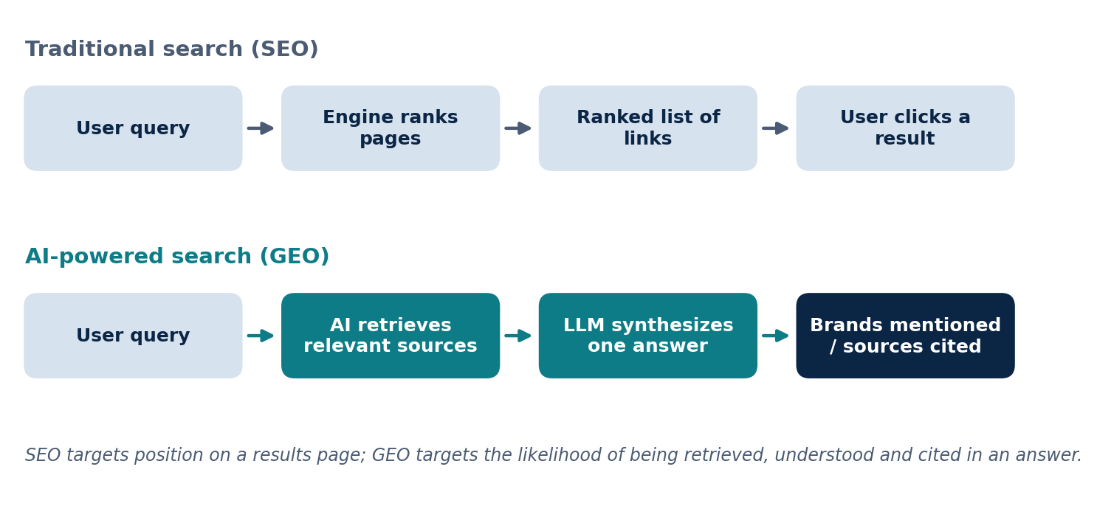
Figure 2.1: Traditional SEO and AI-powered (GEO) search compared.

2.2 Traditional versus Semantic Information Retrieval
Information retrieval (IR) is the task of finding documents relevant to a user query from a large collection. Traditional IR relies on lexical matching. A widely used ranking function is BM25, which scores a document according to how often the query terms appear in it, how informative those terms are across the collection, and how long the document is [2]. Lexical methods are fast, interpretable and computationally cheap, but they struggle when the same idea is expressed in different words. A search for “best budget laptop” may miss a page about an “affordable notebook” even though the two mean the same thing.
Semantic retrieval addresses this limitation by comparing meaning rather than words. Text is converted into numerical representations called embeddings, and similarity between embeddings is used to find conceptually related content. Table 2.1 summarises the contrast. In practice, modern systems often combine both approaches in a hybrid design, using lexical matching for exact terms and semantic matching for meaning.
Table 2.1: Traditional (lexical) and semantic retrieval compared.
Aspect | Traditional retrieval (e.g. BM25) | Semantic retrieval
Basis of matching | Shared words and their frequency | Similarity of meaning in vector space
Handles synonyms | Poorly; needs the same or similar words | Well; different words with similar meaning lie close together
Strengths | Fast, interpretable, exact-term precision | Context-aware, robust to phrasing
Limitations | Misses paraphrases and deeper intent | Needs embedding models and vector search infrastructure
Typical use | Classic search engines, keyword filters | RAG systems, AI search, recommendation

2.3 Large Language Models, Transformers and Attention
Large Language Models (LLMs) such as ChatGPT, Gemini, Claude, Llama and Mistral are the generative component of AI search. At their core, they are prediction engines: given a sequence of text, the model assigns probabilities to possible next tokens and selects one, repeating this process to produce a full response. Given “The capital of France is”, for instance, the model assigns a high probability to “Paris” based on patterns learned during training on very large text collections.
Most modern LLMs are built on the Transformer architecture introduced by Vaswani et al. in 2017 [3]. Text is first split into tokens, and each token is converted into an embedding vector. The central innovation of the Transformer is the self-attention mechanism, which allows every token in a sequence to weigh its relationship with every other token, so that long-range dependencies and context can be captured efficiently. This ability to interpret context is what makes LLMs effective at summarising and synthesising information.
LLMs also have two important limitations that motivate retrieval. First, their knowledge is static and limited to the data available at training time; new information is not available without expensive retraining. Second, they can generate plausible but incorrect statements, commonly called hallucinations. Both limitations can be reduced by supplying the model with relevant external information at the time of the query, which is the purpose of Retrieval-Augmented Generation (Section 2.6).

2.4 Vector Embeddings and Cosine Similarity
A vector embedding is a numerical representation of text that captures its meaning. An embedding model converts a word, sentence or paragraph into a vector of hundreds or thousands of numbers. Although the individual values are not interpretable by humans, together they encode semantic information so that texts with similar meanings produce vectors that lie close to one another in the high-dimensional space [4], [5]. For example, “car” and “automobile” produce nearby vectors, whereas “banana” and “quantum physics” produce distant ones (Figure 2.2).
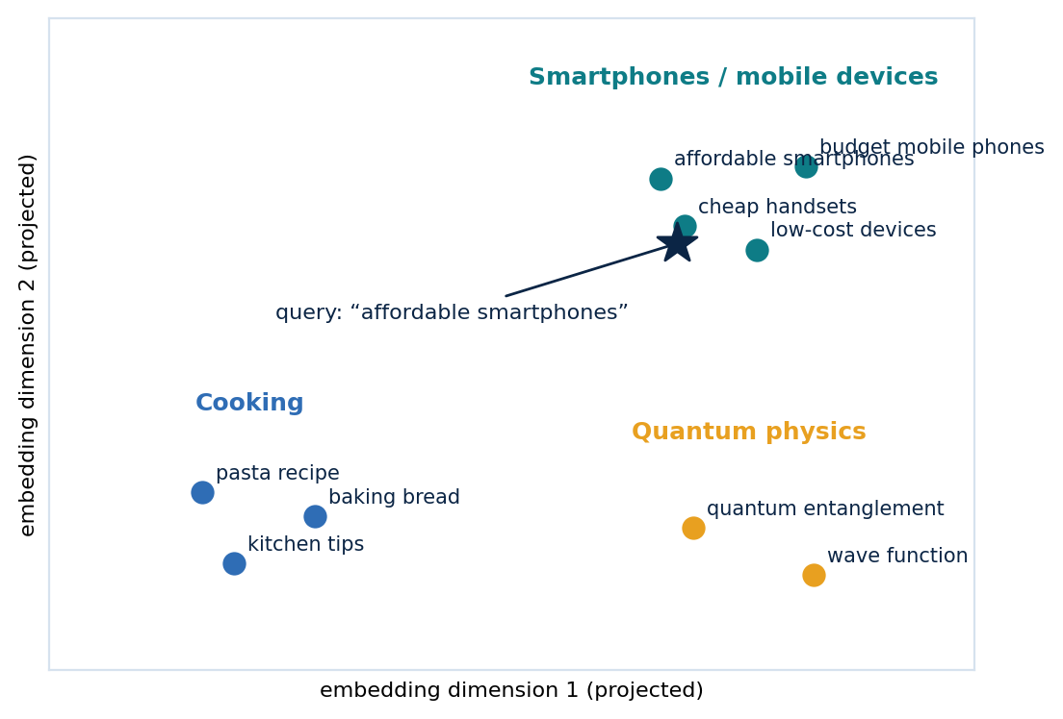
Figure 2.2: Schematic of an embedding space (two-dimensional projection). Related texts cluster together and the query lies near the semantically similar documents.
To measure how close two embeddings are, systems commonly use cosine similarity, which is the cosine of the angle between the two vectors. It ranges from -1 (opposite directions) through 0 (unrelated) to 1 (the same direction). Because it depends on direction rather than magnitude, it is insensitive to document length: two texts of very different sizes can still be judged similar if they discuss the same topic. Other measures such as Euclidean distance and dot product are also used. Together, embeddings and cosine similarity form the foundation of semantic search.

2.5 Vector Databases
Once documents are embedded, the resulting vectors must be stored and searched efficiently. Traditional relational databases are optimised for exact matches on structured fields, whereas vector databases are optimised for similarity search across millions or even billions of embeddings. Scanning every vector for every query would be impractical at scale, so vector databases build approximate nearest-neighbour (ANN) indexes, such as HNSW (Hierarchical Navigable Small World) [6], IVF (Inverted File) and Product Quantisation, that return close matches within milliseconds while accepting a small loss of exactness. Modern systems also support metadata filtering (for example by date, source or category) and hybrid search that combines vector similarity with keyword matching.
The research covered four representative solutions, summarised in Table 2.2. FAISS, developed by Meta AI, is a similarity-search library rather than a complete database [7]; the others are full database systems that differ mainly in their operating model and target scale.
Table 2.2: Representative vector database and search solutions studied.
Solution | Type | Strengths | Typical use
Pinecone | Fully managed, cloud-native | Low latency, automatic scaling, little operational overhead | Production enterprise RAG
Weaviate | Open-source, cloud-native | Hybrid search, rich metadata filtering, GraphQL API | Enterprise AI with complex requirements
ChromaDB | Lightweight, developer-friendly | Simple to start, minimal dependencies | Prototypes and small to medium applications
FAISS | Open-source search library | Very high performance on CPU and GPU | Custom, performance-critical systems

2.6 Retrieval-Augmented Generation (RAG)
Retrieval-Augmented Generation combines the retrieval capabilities of a search system with the language generation capabilities of an LLM [8]. Instead of answering only from what it learned in training, the system first retrieves relevant external content and supplies it to the model as context. A typical RAG system has two phases (Figure 2.3). In the indexing phase, content from websites, documents or databases is split into chunks, converted into embeddings and stored in a vector database. In the query phase, the user's question is converted into an embedding, the most similar chunks are retrieved, and the LLM generates a response using both the question and the retrieved context.
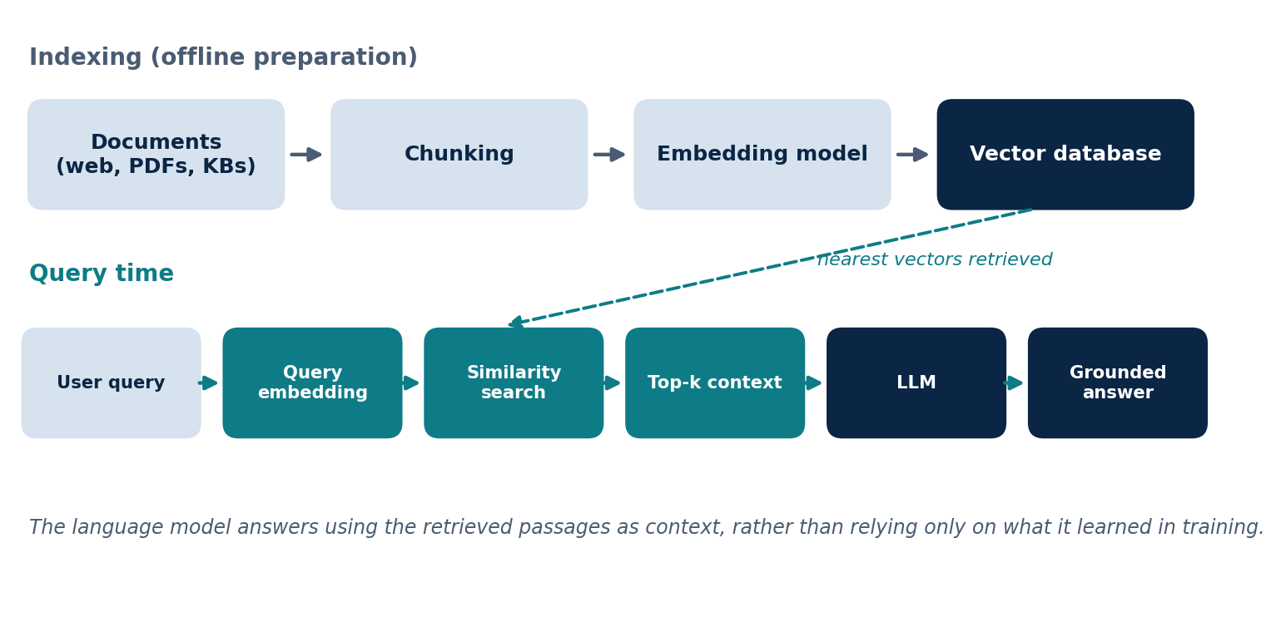
Figure 2.3: Architecture of a Retrieval-Augmented Generation (RAG) system.
RAG offers improved factual accuracy, access to current and proprietary information without retraining the model, and the ability to provide source references. Its challenges include retrieval errors (irrelevant or missing results leading to poor answers), added latency, the limited size of the LLM context window, vector database maintenance, and dependence on the quality of the underlying data. Because retrieval quality directly determines answer quality, the techniques in the following sections, which improve how content is chunked, retrieved and ranked, are central to the performance of the whole system.
RAG is also the mechanism through which many AI search engines discover and use web content. This is why it is central to GEO: content that is more retrievable, semantically rich and authoritative has a greater probability of being selected during retrieval and, consequently, of influencing the generated answer. It is important to distinguish the two terms. RAG is a technical architecture for grounding answers in retrieved information; GEO is a content and visibility discipline concerned with how well content is discovered by AI-driven search. A system can use RAG with no involvement of GEO, for example inside a company's private knowledge base.

2.7 Chunking Strategies
Chunking is the process of dividing large documents into smaller units before they are embedded and indexed. It is the bridge between raw content and efficient retrieval, because each chunk becomes an independent unit that can be indexed, searched and retrieved. Chunking is often regarded as one of the most important design decisions in a RAG pipeline. If chunks are too large, unrelated information dilutes the meaning of the embedding and adds noise. If they are too small, important context is fragmented across several chunks and complete answers are harder to assemble.
Four strategies were studied (Figure 2.4). Fixed-size chunking splits text after a set number of tokens; it is simple and predictable but may cut an idea in half. Overlapping chunking lets adjacent chunks share part of their content, which preserves context at boundaries and improves recall at the cost of extra storage and some duplicated results. Semantic chunking splits at natural topic changes so that each chunk holds a coherent idea, giving higher retrieval quality at greater processing cost. Hierarchical or structure-aware chunking follows the headings, sections and tables that many documents already contain. The choice among them balances retrieval precision, contextual completeness, storage requirements and inference cost.
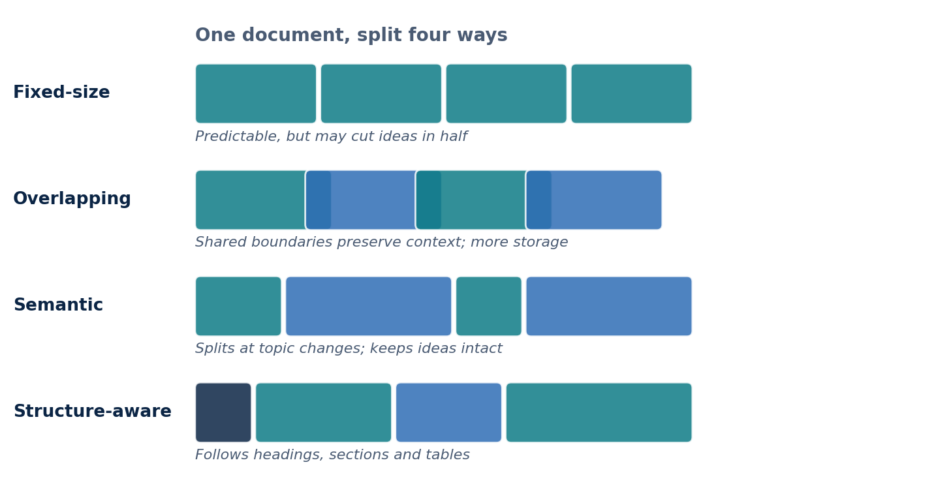
Figure 2.4: Four chunking strategies applied to the same document.

2.8 Re-ranking
Vector search provides a fast approximation of relevance, but documents with high embedding similarity are not always the most useful for answering a query, especially where terminology is domain-specific or the user's intent is subtle. Re-ranking is a post-retrieval step that reassesses the retrieved candidates and reorders them using a deeper comparison of query and document. Modern systems commonly use a two-stage architecture (Figure 2.5): the first stage performs approximate nearest-neighbour search over a very large collection to select a shortlist, and the second applies a computationally heavier model to that shortlist. Cross-encoder models, which read the query and a candidate together, are a widely used choice for this stage [9].
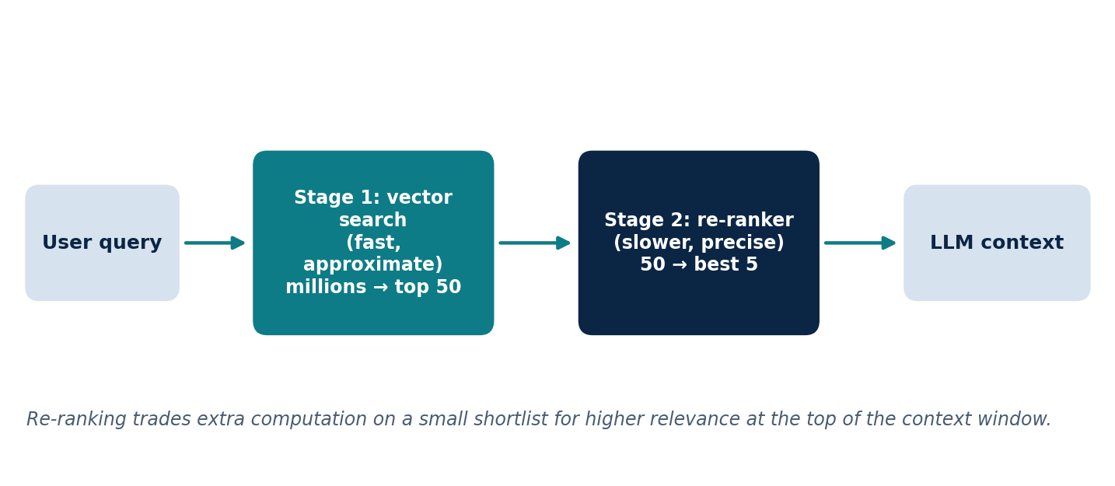
Figure 2.5: Two-stage retrieval: fast vector search followed by precise re-ranking.
The benefit is that the most useful information is placed at the top of the limited context window supplied to the LLM, improving answer accuracy and reducing hallucinations. For GEO, re-ranking illustrates that being retrieved is not enough: content must also be judged highly relevant at the precision stage.

2.9 Query Decomposition and Fan-Out
Real user queries often contain several information needs. A single retrieval operation tends to focus on the dominant theme of the query and may overlook the rest. For example, the question “How does GEO differ from SEO, and what role does RAG play in AI search?” contains at least three separate topics. Query decomposition addresses this by breaking a complex question into smaller, focused sub-queries, often with the help of an LLM. Fan-out retrieval then sends the sub-queries independently, and in parallel, to the vector database, search engine, knowledge graph or other data sources, after which the results are aggregated, de-duplicated and ranked before being passed to the LLM (Figure 2.6).
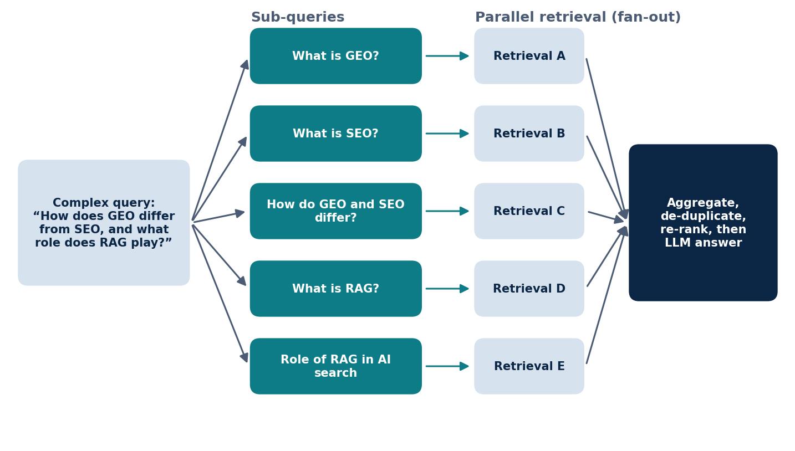
Figure 2.6: Query decomposition and fan-out retrieval.
The main advantage is improved recall and robustness: if one retrieval path returns incomplete information, others may compensate, and the language model works from a broader evidence base. The trade-offs are higher computational cost and latency, the risk of redundant sub-queries, and the need to merge results without overloading the context window. For GEO practitioners, the implication is that content should be optimised not only for broad topics but also for specific sub-topics, entities, comparisons, definitions and related questions, because content that addresses several aspects of a subject can be retrieved along several fan-out paths.

2.10 Knowledge Graphs and Entity Recognition
An entity is any uniquely identifiable real-world object or concept, such as a person, organisation, product, location, technology or event. Unlike a keyword, which is a text string, an entity has a distinct identity and defined relationships with other entities. A knowledge graph organises information as nodes (entities) connected by edges (relationships) rather than as rows in tables [10]. A company may, for example, develop products that belong to an industry that operates in a market.
Entity recognition and linking are the steps that turn raw text into such a graph (Figure 2.7). Named Entity Recognition (NER), a Natural Language Processing technique, detects mentions of entities in text and classifies them into categories. Entity linking then determines which real-world entity a mention refers to, resolving ambiguity: the word “Apple” may refer to a technology company or a fruit, and the surrounding context decides. Relationship extraction identifies how the entities are connected, and the results are stored in a graph database. Entity resolution merges duplicate entities as new information arrives.
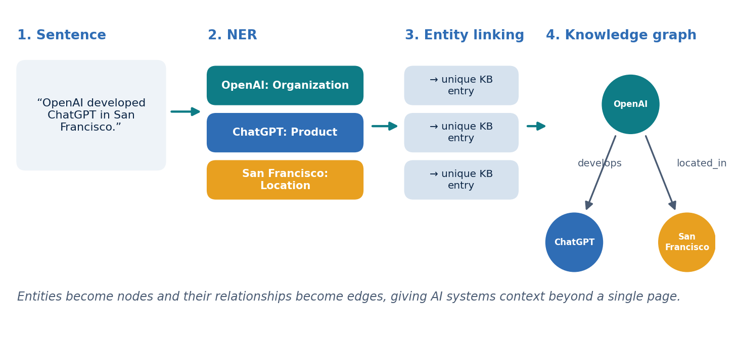
Figure 2.7: From a sentence to a knowledge graph through entity recognition and linking.
Knowledge graphs complement vector search in RAG. Vector search retrieves by semantic similarity but may miss relationships; a graph can be traversed from the entities in a query to related entities such as manufacturers, technologies and services, widening retrieval beyond direct embedding matches and improving answer completeness. For GEO, content that clearly defines entities, relationships and attributes is more likely to be interpreted accurately, retrieved and cited.

2.11 Knowledge Panels and Entity-Based Content Optimisation
Google's Knowledge Panel is an information box, shown beside search results, that summarises key facts about well-known entities by combining data from Google's Knowledge Graph with trusted external sources. Its accuracy depends on Google's ability to extract and link entities, using NLP together with contextual signals such as headings, semantic HTML, Schema.org markup and internal links. Panels are built from several authoritative sources, including official websites, structured data, public knowledge bases and business directories, and consistent information across these sources increases confidence in the entity. Structured data does not guarantee a Knowledge Panel, but it improves the chance that an entity is recognised and connected to existing graph entries.
Entity-based content optimisation applies the same ideas to content creation. Rather than repeating a keyword, content is organised around a primary entity, supported by related entities, attributes and explicit relationships such as ownership, function, location, industry and applications. Best practice is to identify the primary entity, add context, define relationships, apply structured data, publish, and then monitor and update so that entities and relationships stay accurate. Names, descriptions and contact details should be consistent across the website, social profiles and business listings. For GEO, this provides clear semantic signals that support entity recognition, retrieval precision and contextual reasoning.

2.12 Schema.org Markup and JSON-LD
Web pages are written for human readers, which makes it hard for machines to interpret context and relationships reliably. Schema.org is a shared vocabulary of hundreds of entity types and properties (for example Organization, Person, Product, Article, Event, FAQPage and LocalBusiness) used to describe page content explicitly [11]. JSON-LD (JavaScript Object Notation for Linked Data) is the most widely adopted format for implementing it. It places the structured data in a separate script block, leaving the visible HTML unchanged, which makes it simpler to maintain than Microdata or RDFa. A minimal example is shown below.
<script type="application/ld+json">
{
"@context": "https://schema.org",
"@type": "Article",
"headline": "Introduction to Schema.org and JSON-LD",
"author": { "@type": "Person", "name": "Your Name" },
"datePublished": "2025-05-20"
}
</script>

Search engines use such markup to generate rich results, and AI retrieval systems can use it for entity recognition, knowledge graph construction and contextual reasoning. Good practice is to choose the schema type that matches the content, complete the key properties, keep the markup consistent with the visible page, and validate it regularly.

2.13 Semantic HTML
Semantic HTML uses elements that describe the purpose of the content they contain, such as header, nav, main, section, article, aside and footer, instead of generic div and span containers. These elements give browsers, search engines, accessibility tools and AI systems clear structural cues, allowing crawlers to distinguish primary content from navigation, advertisements and sidebars. Semantic HTML complements structured data: Schema.org supplies explicit metadata, while semantic HTML establishes the logical framework of the page itself.
For retrieval systems, a logical heading hierarchy and clearly bounded sections make it easier to produce coherent chunks that preserve complete ideas rather than splitting information arbitrarily, which in turn supports higher retrieval precision. Semantic HTML also improves accessibility, since screen readers use the same landmarks to help users navigate. Best practice is to choose elements by purpose rather than appearance, maintain a clear heading hierarchy, and combine semantic markup with structured data, descriptive metadata and meaningful alternative text.

3. Objectives of the Internship
The internship brought together technology and business questions. A gap that the work set out to address is that GEO is often discussed either as a marketing technique or as a technical retrieval problem, rarely as both. To build a credible product and go-to-market plan in this space, one must understand how AI systems retrieve and use content as well as how the market and competitors are positioned. The objectives, which were pursued as a connected set, were as follows.
- Objective 1: to understand Generative Engine Optimisation and AI-driven search, including how it relates to and differs from traditional SEO.
- Objective 2: to research the technical foundations of information retrieval and AI-powered discovery, including RAG, embeddings, semantic search, vector databases, knowledge graphs and structured content.
- Objective 3: to analyse the GEO market and competing platforms, and to investigate customer segments, product positioning and market opportunities.
- Objective 4: to develop go-to-market insights and recommendations for Connectify's product.
- Objective 5: to explore potential applications of these technologies in Smart Manufacturing and Industry 4.0, as a forward-looking extension of the research.
The scope was research, analysis and recommendation. Product development, system implementation and testing, and primary market research such as customer interviews or surveys were outside the scope of the work documented in this report.

4. Work Carried Out and Methodology

4.1 Overall Approach
The work was organised into two workstreams, with the output of the first informing the second (Figure 4.1). Workstream A comprised technical research on GEO and the technologies underlying AI-powered search. Workstream B comprised market and strategy research: market trends, competitor analysis, customer segmentation, positioning and go-to-market recommendations. The approach was desk-based and secondary: the findings were consolidated from published material and documented in a series of structured presentations. No software system was built and no experiments or customer trials were conducted.
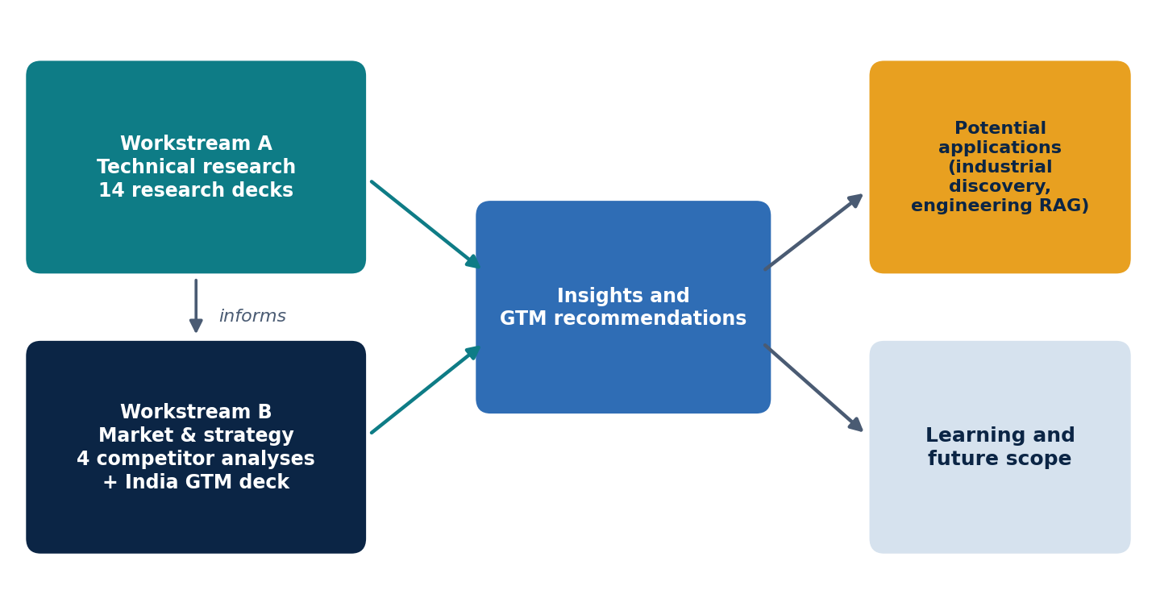
Figure 4.1: Workflow of the internship from technical research to recommendations and potential applications.
[Edit if needed: if you used specific sources, tools or discussions with your Connectify supervisor to carry out the research, add them here. The text above states only that the research was desk-based, which is what the research decks support.]

4.2 Workstream A: Technical Research
Fourteen technical research presentations were prepared. Each followed a consistent structure: a definition of the concept, an explanation of the underlying mechanism, supporting examples and diagrams, advantages and challenges, and an explicit statement of its relevance to GEO. The topics, grouped by theme, were as follows.
Table 4.1: Technical research topics studied in Workstream A.
Theme | Topics researched
AI language and retrieval foundations | Large Language Models, Transformers and attention; traditional versus semantic information retrieval (including BM25); vector embeddings; cosine similarity and semantic search
Retrieval infrastructure and architecture | Vector databases (Pinecone, Weaviate, ChromaDB, FAISS); Retrieval-Augmented Generation (RAG); chunking strategies; re-ranking; query decomposition and fan-out
Content understanding and structure | Knowledge graphs and entity recognition; knowledge panels and entity extraction; entity-based content optimisation; Schema.org markup and JSON-LD; semantic HTML

The topics were deliberately studied in an order that mirrors how an AI search system processes a query: how language models work, how text is represented numerically, how it is stored and compared, how retrieval is architected and refined, and finally how content can be structured so that these systems interpret it correctly. This ordering also made it possible to connect each technique to a content-level implication for GEO, which is summarised in Section 5.1.

4.3 Workstream B: Market and Strategy Research
Market research proceeded at two levels. First, the global GEO landscape was studied through four detailed analyses of leading platforms: Peec AI, Profound, PromptWatch and LLM Pulse. Each analysis used the same framework to allow comparison: company overview; industry overview; the problem the platform solves; product overview and features; target customers and segmentation; business model and pricing; competitor analysis; SWOT analysis; market opportunity; marketing and growth strategy; technology and innovation; challenges and risks; and conclusion.
Second, a go-to-market strategy for the Indian market was developed. It covered the problem and the reasons for acting now, the market opportunity, target customer segments, proposed solution and product features, the competitive landscape, differentiation, a business model with tiered pricing, customer acquisition channels with estimated costs, a phased roadmap, illustrative financial projections, and risks with mitigations.
The use of a common framework was important because several figures in the source material come from different decks and describe the same company differently. Where figures disagreed, the policy followed was to report each figure as stated, with its source, rather than silently reconciling them (see Section 5.6). Market sizes and projections were treated as directional estimates throughout.

4.4 Limitations of the Approach
- The research was desk-based; no customer interviews, surveys, product trials or experiments were conducted.
- Market figures such as market size, growth rates, user numbers and cost estimates are estimates quoted in the source material and were not independently verified.
- Competitor information reflects what was documented at the time of the research; pricing and features of fast-moving AI products change frequently.
- AI answers are non-deterministic, so even commercial visibility-tracking data is inherently noisy; this is a limitation of the category rather than of any one platform.
- The industrial applications discussed in Chapter 6 are proposals; no manufacturing market study or industrial pilot was carried out.

5. Results and Discussion

5.1 Technical Findings: An Integrated Framework
The principal technical outcome of Workstream A was to connect fourteen separate topics into a single framework describing how content travels from a web page to an AI-generated answer (Figure 5.1). The framework has three stages.
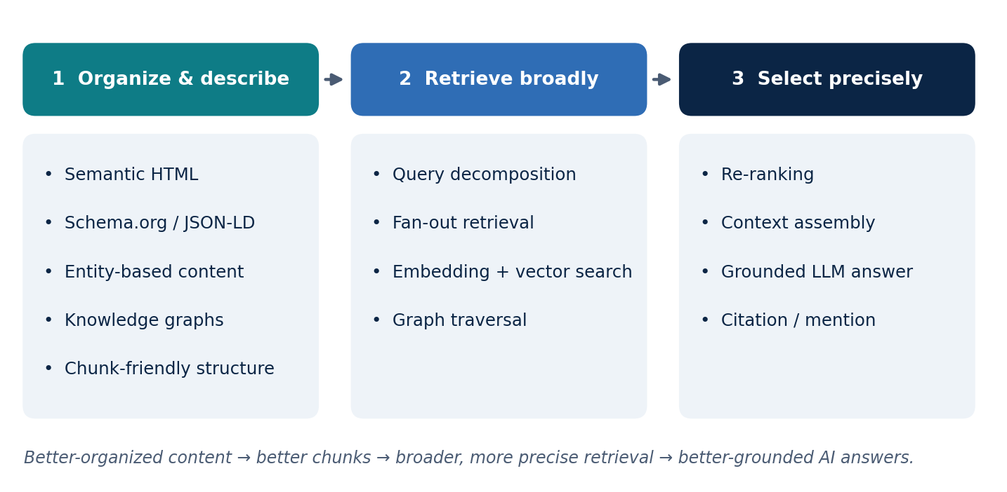
Figure 5.1: Integrated framework connecting the technical research topics.
The first stage is to organise and describe content. Semantic HTML provides the structure of the page, Schema.org markup in JSON-LD states explicitly what the page is about, entity-based content and knowledge graphs define the things discussed and how they relate, and a chunk-friendly layout ensures that ideas are not split arbitrarily when the page is indexed. The second stage is to retrieve broadly. Query decomposition and fan-out turn a complex question into many sub-queries, embedding-based vector search finds semantically related passages, and graph traversal brings in related entities. The third stage is to select precisely. Re-ranking reorders the candidates so that the best evidence reaches the language model, which then generates a grounded answer that may mention or cite its sources.
Several GEO-relevant conclusions follow from this framework. Content that is structured, entity-rich and complete across sub-topics is more likely to be retrieved along several fan-out paths. Retrieval is only the first hurdle, because precision-stage models decide which retrieved items are used. Structured data and consistent entity information reduce ambiguity, which helps AI systems attach content to the correct entity. Finally, because AI systems are probabilistic and platforms differ, these measures improve the likelihood of visibility but cannot guarantee it. This last point shaped how competitor tools were assessed: a tool that promises guaranteed citations would be making a claim the technology does not support.

5.2 Market Findings
Across the competitor analyses, the GEO and AEO software market is described as growing from approximately USD 1 billion in 2025 to approximately USD 17 billion by 2034, a compound annual growth rate of about 45 per cent (Figure 5.2). This is an estimate repeated across the source decks, and it is treated here as a directional indicator of category momentum rather than a verified forecast.
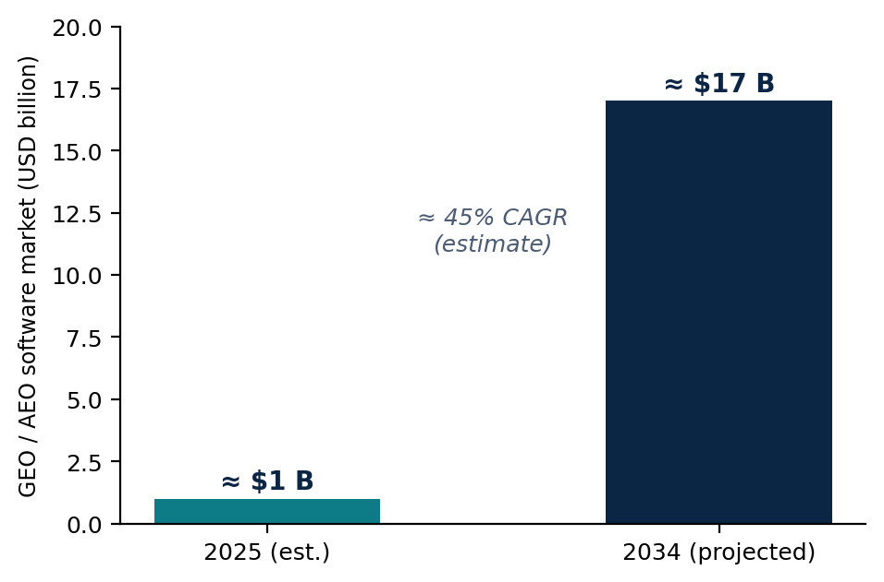
Figure 5.2: Estimated global GEO/AEO software market, 2025 and 2034 (estimate quoted in the source decks, not independently verified).
The decks identify several adoption drivers. Consumers increasingly use AI assistants to research purchases; zero-click search is eroding the value of rank-based SEO; enterprise marketing organisations are beginning to treat GEO as a distinct budget line; and investors have funded several GEO vendors within roughly eighteen months of launch, which the decks read as a sign that the category is durable. Customer problems were consistent across platforms: brands cannot tell whether AI mentions them, cannot see which competitors are recommended instead, cannot identify which sources shape AI answers, and lack a workflow to close content gaps.
For India, the go-to-market research framed the opportunity using three nested estimates: a total addressable market of over USD 7 billion in Indian digital marketing spend, a serviceable market of USD 450 to 600 million across mid-market companies, direct-to-consumer (D2C) brands, software-as-a-service (SaaS) companies and agencies, and a realistically obtainable market of USD 3 to 6 million in annual recurring revenue within three years, corresponding to about 3,000 to 6,000 customers. Supporting indicators quoted in the research include India's position as ChatGPT's second-largest market (about 100 million weekly users, growing about 41 per cent year on year) and an SEO software market in India described as growing at 18.2 per cent annually through 2030. All of these are planning estimates from the source material and carry the uncertainty that implies.

5.3 Competitor Analysis
The four platforms studied occupy different positions in the market (Figure 5.3), and their profiles are summarised in Table 5.1.
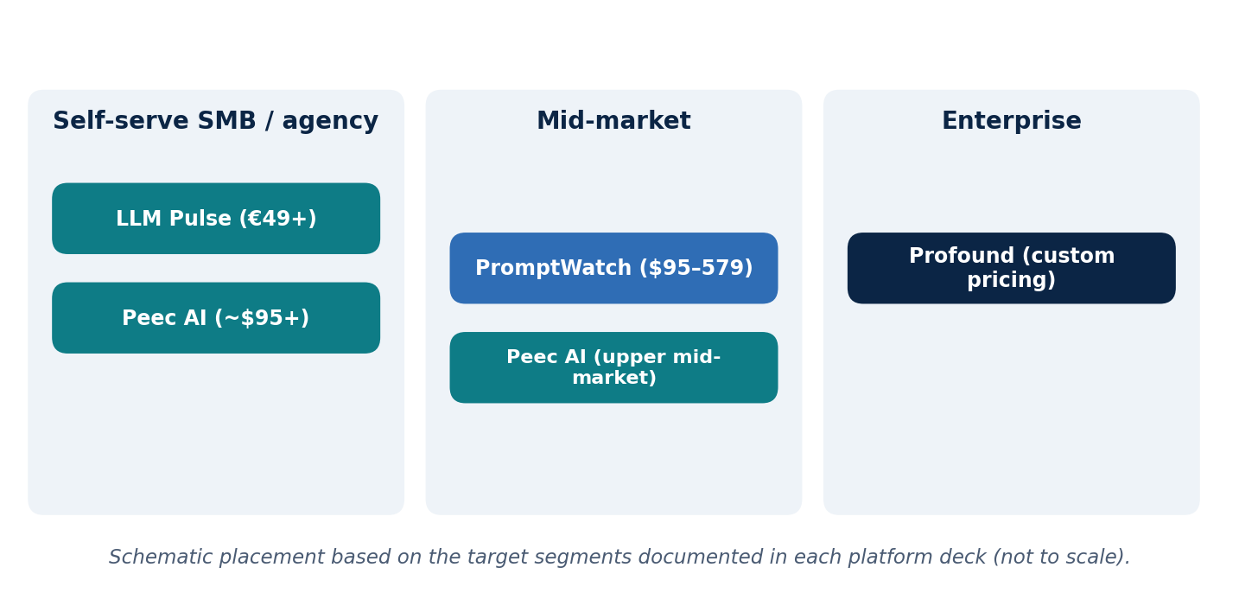
Figure 5.3: Schematic positioning of the four platforms by documented target segment.
Table 5.1: Summary of the four platforms analysed (figures as stated in each company deck).
Platform | Origin and model | Target customers | Positioning and key strengths | Key weaknesses noted
Peec AI | Berlin-founded, launched early 2025; self-serve SaaS; ~$95 to $495 per month tiers plus enterprise | SMB to upper mid-market; agencies | Simple, fast onboarding; per-prompt tracking of visibility, sentiment and sources; multilingual coverage; unlimited seats; UI-based data collection | Three engines per plan; Actions (recommendation) layer still in beta; early-stage maturity
Profound | New York-based, founded 2024; enterprise-led sales; custom pricing (earlier $99 and $399 tiers) | Large enterprise / Fortune 500; CMOs and large marketing teams | Deepest data layer: up to 10 engines, Prompt Volumes panel data, crawler analytics; SOC 2 Type II; Actions and Agents | No self-serve path at the top tier; no multi-client agency dashboard; no revenue attribution; US-only data hosting
PromptWatch | Amsterdam-based, launched April 2025; self-serve SaaS; $95 to $579 per month | Mid-market brands and agencies | Broad model coverage (9+); monitoring plus Content Agents that generate content; crawler detection; free trial | Newer brand with thin enterprise track record; small seed round; dependence on AI platform interfaces
LLM Pulse | Bootstrapped, launched July 2025; EUR 49 to EUR 1,086 per month plus enterprise | SMBs, cost-conscious teams, agencies | Up to 14 models; GA4 traffic and conversion attribution; hosted MCP server; GEO Writer and GEO Testing; white-label portals; unlimited seats | No disclosed SOC 2 or HIPAA; limits on prompts and projects raise costs at scale; EUR-first pricing

Rather than four separate company stories, the analyses reveal three patterns that matter for positioning. First, visibility tracking across AI engines is becoming a standard, commoditising feature; all four platforms monitor mentions, citations and sentiment, and differ mainly in engine coverage and price. Second, differentiation is moving to the action layer and to attribution. Platforms that offer content generation (PromptWatch), experimentation (LLM Pulse) or agent-based workflows (Profound) are positioned as measure-and-act systems, whereas monitoring-only products risk being seen as dashboards. Linking AI visibility to traffic or revenue, as LLM Pulse does through GA4, addresses a gap that several higher-priced competitors still leave open. Third, agencies are a key channel: features such as white-label portals, unlimited seats and multi-client dashboards recur wherever platforms target agencies, and their absence is cited as a blocker.
Each platform also reveals a strategic tension. Profound's retreat to enterprise-only pricing strengthens deal size and credibility but cedes the fast-growing SMB, mid-market and agency segment to others. Peec AI risks being squeezed between PromptWatch's richer execution layer and Profound's data depth. PromptWatch must compete with far better-funded rivals. LLM Pulse offers strong value for breadth but lacks the compliance certifications that win regulated and large enterprise accounts.

5.4 Capability Comparison
Table 5.2 compares the platforms on selected capabilities, using only what the source decks document. Where a deck does not mention a capability, the entry is shown as not documented, which should not be read as absent.
Table 5.2: Selected capabilities as documented in the source decks.
Capability | Peec AI | Profound | PromptWatch | LLM Pulse
Visibility, sentiment and citation tracking | Yes | Yes | Yes | Yes
Engine coverage | 3 per plan; 7+ overall | Up to 10 (Enterprise) | 9+ models | Up to 14 (5 core on self-serve)
Crawler / bot analytics | Not documented | Yes (Agent Analytics) | Yes (CDN integrations) | Yes
Content recommendations or generation | Actions (beta) | Actions / Agents | Content Agents | GEO Writer, GEO Testing
Traffic / revenue attribution | Not documented | Not available | Not documented | Yes (GA4, Plausible)
Agency features | Unlimited seats; Looker Studio | Agency plans; no multi-client dashboard | Agency / affiliate plans | White-label portals; unlimited seats
Compliance and data location | GDPR-first; EU data residency | SOC 2 Type II; US-only hosting | GDPR obligations noted | No SOC 2 / HIPAA disclosed
Free tier or trial | Not documented | No public free trial | Free trial and free tier | 14-day trial; no free tier

5.5 Go-to-Market Recommendations for India
The go-to-market work translated the technical and competitive findings into a set of recommendations for the Indian market. These are recommendations developed during the internship; they are not decisions made by Connectify and have not been validated with customers.
Target segments. A phased approach was recommended (Figure 5.4). The first phase targets D2C brands, SaaS companies and digital or SEO agencies, which make decisions quickly and have high exposure to AI search. D2C brands were proposed as the proof-of-value segment because they can see and act on visibility data fastest. Agencies were identified as the multiplier segment, since one agency partner may bring 10 to 30 client accounts. The second phase moves to mid-market companies (with revenue of roughly INR 50 to 500 crore), EdTech, FinTech and healthcare, which have larger budgets but longer sales cycles. The third phase addresses enterprise and banking, financial services and insurance (BFSI) clients, who require compliance readiness, and local businesses, who require ultra-low pricing.
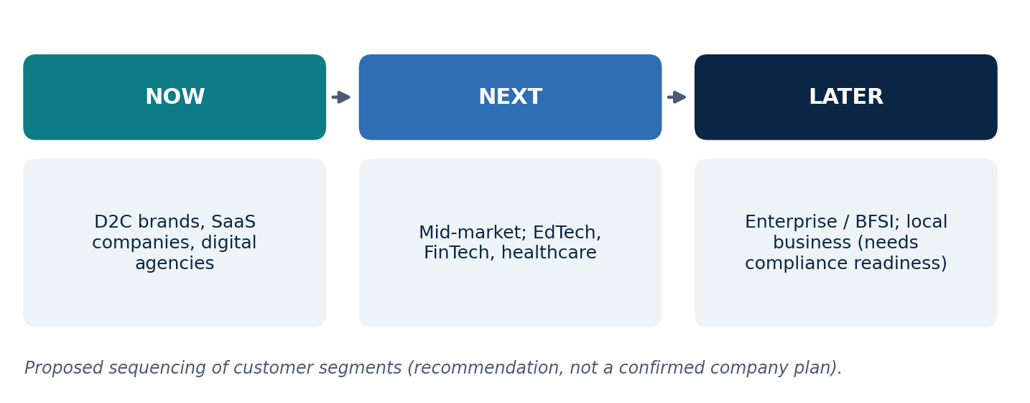
Figure 5.4: Proposed phasing of customer segments (recommendation).
Positioning and differentiation. The central insight was that existing global tools are not built for India, so the product should differentiate on fit rather than by trying to out-feature established platforms. In the comparison prepared during the research, none of the four platforms offered INR pricing, Indic-language tracking or WhatsApp-native alerts. The recommended differentiators were: INR-native pricing at roughly 30 to 50 per cent of global competitor cost; an agency-first, white-label design from the start; Hindi and regional-language visibility tracking; WhatsApp-native alerts and reports, reflecting the channel used daily by many Indian small businesses; and India data residency, which is a requirement for BFSI, healthcare and other regulated clients. Indirect competition from SEO agencies and from established suites such as Semrush and Ahrefs adding AI-visibility features was also noted.
Product priorities. The proposed solution is described as a three-step workflow: connect the brand, view a Visibility Score showing where it is cited and where it is missing, and act on content and structure recommendations whose effect is tracked weekly. Recommended features included a Visibility Score dashboard updated daily, competitor benchmarking, multi-engine coverage (ChatGPT, Gemini, Perplexity, Copilot and Google AI Overviews), Hindi and regional-language tracking, WhatsApp alerts, white-label reporting, API access and a content-gap engine that identifies what to publish to close a visibility gap. This reflects the competitor finding that the action layer is where products differ most.
Pricing. A simple tiered structure in Indian rupees was proposed: a free lead-generation tier for one brand, a Starter tier for D2C brands and start-ups, a Professional tier for growth teams, an Agency tier with white-label and multi-client features, and a custom Enterprise tier including single sign-on, data residency and dedicated support. Exact price points were left to be determined and are therefore not stated in this report.
Acquisition channels. Estimated customer acquisition cost (CAC) was compared across eight channels (Figure 5.5). Founder-led sales (about INR 2,500 per customer), community and webinars (INR 3,200), SEO and GEO content (INR 4,000) and partnerships or referrals (INR 4,500) were estimated as the lowest-cost routes, while paid advertising was estimated to be several times more expensive (LinkedIn ads about INR 12,000 and Google ads about INR 16,000). The recommendation was therefore to lead with trust-based, lower-cost channels, pair cold outreach with a free AI-visibility audit as the hook, and reserve paid channels for later phases once messaging is proven.
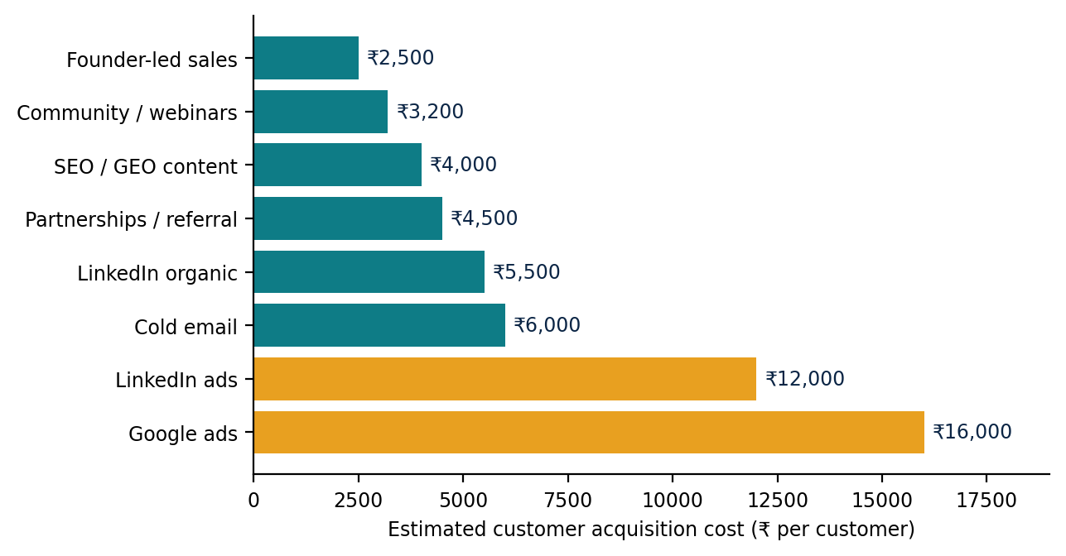
Figure 5.5: Estimated customer acquisition cost by channel (author's estimates from the India GTM research; to be validated with beta data).
Roadmap, projections and risks. The research outlined a 12-month plan with phases gated on customer and retention targets: a beta with 20 to 30 agencies and D2C brands, followed by a public self-serve launch, then growth with a formal agency partner programme and paid channels, and finally enterprise readiness (including SOC 2 and data residency). Illustrative three-year unit economics were also sketched; these were explicitly labelled in the source deck as directional planning estimates to be validated against actual data and are not reproduced as results here. The principal risks identified were dependence on AI platform interfaces and terms, global competitors localising for India, a market education gap, regulatory requirements such as the Digital Personal Data Protection Act and data localisation, and pricing pressure from free or do-it-yourself alternatives, together with a mitigation for each.

5.6 Data Discrepancies in the Source Material
A deliberate part of the methodology was to avoid silently reconciling conflicting statistics. Table 5.3 lists the main discrepancies identified. They illustrate a wider point about this category: it is young, fast-moving and poorly documented, and public figures for private companies should be treated with caution.
Table 5.3: Discrepancies between source decks (reported as found, not reconciled).
Item | Figure in one source | Figure in another source
Peec AI valuation | “$100M+” by November 2025 (Peec AI deck) | “near $200M” (PromptWatch deck)
Peec AI annual recurring revenue | “$4M+ (est., mid-2026)” (Peec AI deck) | “~$10M ARR / 16 months” (competitor tables in other decks)
Entry prices | Peec AI $89+, PromptWatch $99+, LLM Pulse $49+ (India GTM comparison table) | Peec AI ~$95, PromptWatch $95, LLM Pulse EUR 49 (company decks)
Profound self-serve | “No self-serve” (India GTM comparison table) | Earlier $99 and $399 self-serve tiers before moving to custom pricing (Profound deck)
Agency white-label | “No” for Peec AI and Profound (India GTM comparison table) | Peec AI cites unlimited seats and Looker Studio reporting; Profound lists agency plans but no multi-client dashboard

5.7 Synthesis
Bringing the technical and commercial strands together, four connected observations emerge. First, AI systems retrieve and interpret information through embeddings, structured content and entities, which means that visibility in AI answers is partly an engineering problem of how content is organised and described. Second, because AI answers can omit a brand that ranks well in conventional search, organisations need a way to see and improve their visibility; this is the need that GEO products address. Third, the competitor research shows that measurement is largely commoditising, while the action layer, attribution, agency tooling and local fit remain open. Fourth, these gaps shape positioning: for the Indian market, differentiating on price, language, channel and distribution is a more credible route than competing on raw feature breadth.
Three conclusions are supported by the work. GEO is a retrieval problem as much as a content problem. The opportunity lies in actionability and localisation rather than dashboards alone. And every market assumption in this report is a hypothesis to be validated with real data, for example through the proposed beta, before any strategic decision relies on it.

6. Mechanical Engineering Perspective: Potential Industrial Applications
The internship was primarily a software and business research experience. This chapter explores, as an interdisciplinary extension, how two of the researched technologies could connect to a Mechanical Engineering and manufacturing context. It is important to state clearly that both applications are proposals. I did not carry out a manufacturing market study, validate industrial demand, or develop, deploy or test any industrial AI system during the internship, and GEO does not control machines, perform predictive maintenance or improve equipment reliability.

6.1 GEO for Industrial Product Discoverability
Manufacturers sell technically complex products, for example CNC machines and machine tools, industrial sensors and automation equipment, together with specifications, product datasheets, engineering documentation and industrial solutions. Industrial buyers increasingly research suppliers online, and AI assistants are likely to become part of that process. A potential buyer might ask an AI assistant which CNC machine is suitable for a particular machining application and expect a shortlist with a comparison.
The GEO concepts studied in Chapter 2 suggest how a manufacturer's content could be made easier for AI systems to interpret (Figure 6.1). Entity-based content optimisation would describe each product as a clearly defined entity with its attributes (such as axes, spindle speed, workpiece materials and tolerance) and relationships (applications, accessories, compatible controllers). Schema.org Product markup in JSON-LD could state these attributes explicitly, semantic HTML would give datasheets and product pages a clear structure, and complete coverage of sub-topics such as comparisons and applications would help the content appear on several fan-out paths. Clearly structured and informative product documentation could then help the buyer discover and compare relevant equipment. As elsewhere in this report, this improves the likelihood of discovery but does not guarantee that any product is recommended.
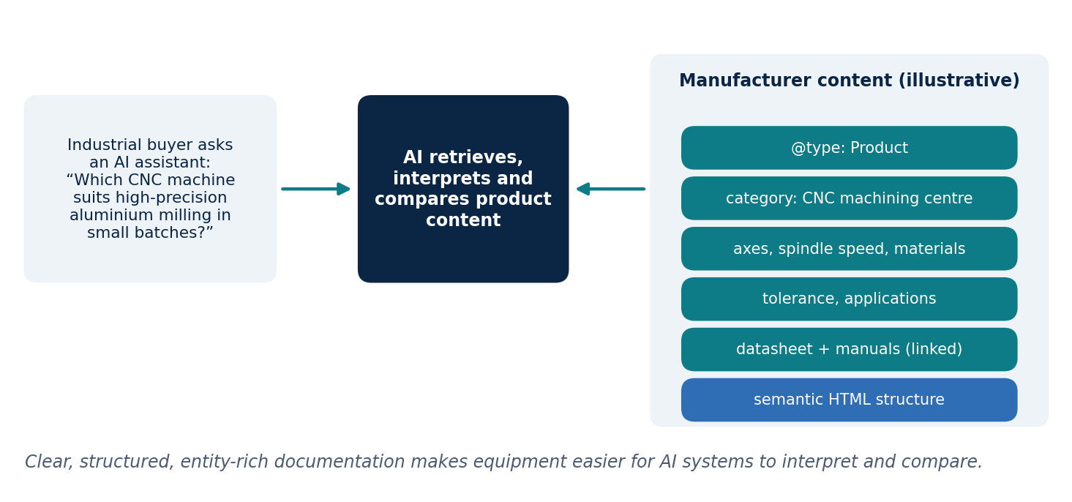
Figure 6.1: Illustrative example of how structured, entity-rich product content could support discovery of industrial equipment by an AI assistant.
This application connects to the go-to-market work. Industrial manufacturers could be a customer segment worth investigating for a GEO product, particularly because their products are specification-heavy and their buying decisions involve research. The research did not, however, test this segment, and no claim is made about its size, willingness to pay or readiness. It is offered as a hypothesis for future investigation, consistent with the principle that every market assumption should be validated.

6.2 RAG for Engineering Knowledge Retrieval (Future Scope in Industry 4.0)
The second application concerns a different technology. Retrieval-Augmented Generation is distinct from GEO: GEO concerns whether external AI search systems can discover an organisation's content, whereas RAG retrieves information from a knowledge base to ground an answer. In an industrial setting, the relevant knowledge base is the organisation's own technical documentation.
Consider a maintenance engineer who asks about excessive motor vibration (Figure 6.2). A RAG-based knowledge retrieval system could embed and index equipment manuals, maintenance records, troubleshooting documents and engineering guidelines. When the question arrives, it would retrieve the most relevant passages, possibly using query decomposition to cover causes such as imbalance, misalignment, bearing wear and looseness, and re-ranking to place the best evidence first, and then generate an answer grounded in those sources with references that the engineer can verify.
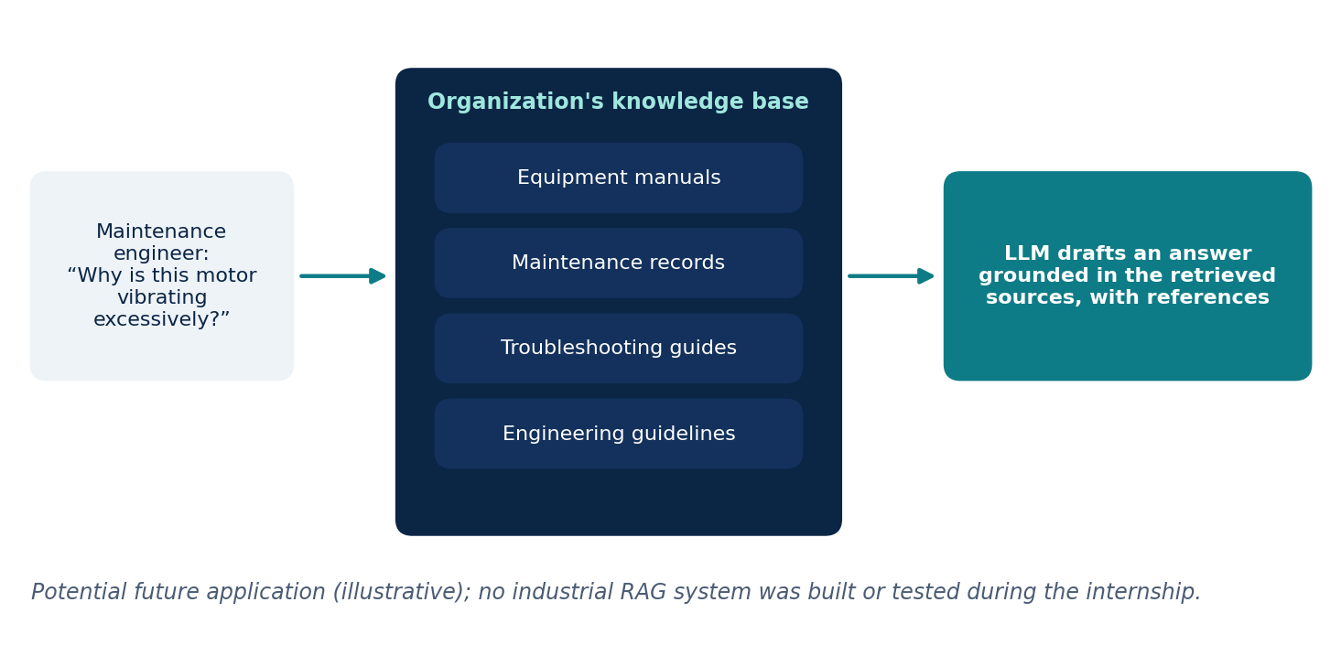
Figure 6.2: Illustrative RAG workflow for a maintenance query (potential future application; not implemented).
The potential value is more efficient access to technical documentation, reduced manual effort in searching engineering records, better use of organisational knowledge, and support for industrial troubleshooting workflows. This is relevant to Smart Manufacturing and Industry 4.0, where digital systems and industrial operations increasingly depend on information that is accessible and well organised. The challenges identified in Chapter 2 would also apply: retrieval errors, document quality, appropriate chunking of manuals and tables, latency, and the need to verify generated answers against their sources, which is especially important where safety is concerned.

6.3 The Role of a Mechanical Engineering Background
A Mechanical Engineering background does not make the internship a manufacturing project, but it provides a useful perspective when evaluating AI applications for industrial use. It helps in interpreting industrial terminology, understanding equipment documentation such as datasheets and maintenance manuals, and judging whether a proposed use case is realistic for engineers. It also helps in seeing where GEO and RAG could apply beyond marketing, and in recognising that engineering knowledge has particular structure, such as specifications, tolerances, procedures and failure modes, that retrieval systems must preserve.

7. Learning Outcomes and Skills Acquired
The internship contributed to my learning in the following areas.
- Technical understanding: a working understanding of GEO and AI-driven search, and familiarity with RAG, embeddings, semantic search, vector databases, chunking, re-ranking, query decomposition, knowledge graphs and structured content (Schema.org, JSON-LD and semantic HTML).
- Market and competitor research: experience in framing a market, comparing competing platforms using a consistent framework, and distinguishing documented facts from estimates.
- Product and strategy thinking: an understanding of product positioning, customer segmentation, differentiation, pricing structure and acquisition channels, and of how research can inform a go-to-market strategy.
- Analytical and research skills: synthesising many sources into a coherent narrative, noticing and documenting conflicting data, and qualifying conclusions appropriately.
- Communication: presenting technical and commercial material in structured presentations and explaining technical concepts to non-specialist audiences.
- Interdisciplinary perspective: relating AI retrieval technologies to possible industrial applications in the light of a Mechanical Engineering background.
The tangible outputs of the internship were fourteen technical research presentations, four competitor analyses, an India market and go-to-market strategy presentation, and the recommendations contained in them. No product deployment, customer outcome or quantified business impact is claimed.

8. Conclusion and Future Scope

8.1 Conclusion
The internship combined technical research into Generative Engine Optimisation and AI-driven search with market analysis and go-to-market strategy. On the technical side, the work showed how AI systems convert content into embeddings, store and search it in vector databases, widen and refine retrieval through query decomposition, knowledge graphs and re-ranking, and generate answers grounded in retrieved context, and how semantic HTML, Schema.org markup and entity-based content help these systems interpret information. On the commercial side, analysis of four leading platforms showed that tracking is becoming standard while the action layer, attribution, agency tooling and local fit remain open, and these gaps informed recommendations for positioning a GEO product in India. Together, the work demonstrates how emerging AI technologies, commercial research and structured information can contribute to new product opportunities, including potential applications in industrial environments.

8.2 Future Scope
- Validate the go-to-market assumptions with primary research and beta data, including customer interviews, willingness-to-pay testing and measured acquisition costs.
- Test the proposed differentiators (INR pricing, regional-language tracking, WhatsApp alerts, agency white-label) with target users before treating them as proven.
- Investigate industrial manufacturers as a potential customer segment, including how buyers use AI assistants during equipment selection.
- Prototype and evaluate an engineering knowledge retrieval system on a small set of maintenance documents, measuring retrieval quality and answer accuracy against the source documents.
- Track the evolution of AI search platforms, since changes in their retrieval behaviour and terms of use directly affect both GEO practice and the commercial viability of visibility-tracking products.

References
[1] P. Aggarwal, V. Murahari, T. Rajpurohit, A. Kalyan, K. Narasimhan, and A. Deshpande, "GEO: Generative engine optimization," in Proc. 30th ACM SIGKDD Conf. Knowledge Discovery and Data Mining, 2024.
[2] S. Robertson and H. Zaragoza, "The probabilistic relevance framework: BM25 and beyond," Foundations and Trends in Information Retrieval, vol. 3, no. 4, pp. 333-389, 2009.
[3] A. Vaswani et al., "Attention is all you need," in Advances in Neural Information Processing Systems, vol. 30, 2017.
[4] T. Mikolov, K. Chen, G. Corrado, and J. Dean, "Efficient estimation of word representations in vector space," arXiv:1301.3781, 2013.
[5] N. Reimers and I. Gurevych, "Sentence-BERT: Sentence embeddings using Siamese BERT-networks," in Proc. EMNLP-IJCNLP, 2019, pp. 3982-3992.
[6] Y. A. Malkov and D. A. Yashunin, "Efficient and robust approximate nearest neighbor search using hierarchical navigable small world graphs," IEEE Trans. Pattern Anal. Mach. Intell., vol. 42, no. 4, pp. 824-836, 2020.
[7] J. Johnson, M. Douze, and H. Jegou, "Billion-scale similarity search with GPUs," IEEE Trans. Big Data, vol. 7, no. 3, pp. 535-547, 2021.
[8] P. Lewis et al., "Retrieval-augmented generation for knowledge-intensive NLP tasks," in Advances in Neural Information Processing Systems, vol. 33, 2020.
[9] R. Nogueira and K. Cho, "Passage re-ranking with BERT," arXiv:1901.04085, 2019.
[10] A. Hogan et al., "Knowledge graphs," ACM Computing Surveys, vol. 54, no. 4, art. 71, 2021.
[11] R. V. Guha, D. Brickley, and S. Macbeth, "Schema.org: Evolution of structured data on the web," Communications of the ACM, vol. 59, no. 2, pp. 44-51, 2016.
[12] J. Sharma, "Technical research presentations on GEO and AI-powered search (14 presentations)," internal research material, Connectify, 2026.
[13] J. Sharma, "Market and strategy analyses of Peec AI, Profound, PromptWatch and LLM Pulse," internal research material, Connectify, 2026.
[14] J. Sharma, "GEO India go-to-market strategy," internal research material, Connectify, 2026.
[Check each reference against the original publication before submission and add or remove entries as needed.]

