SIMATS ENGINEERING (SAVEETHA SCHOOL OF ENGINEERING)
Department of Computer Science and Engineering
CO2 Assessment Tool 1 – Scenario-Based Requirement Analysis
Course Code: | CSA1007 | Course Title: | Software Engineering
CO Assessed: | CO2 | Assessment: | Assessment Tool 2 – Scenario-Based Requirement Analysis
Weightage: | 20% | Total Marks: | 25
Student Name: | Jahnavi Maddi | Reg. No.: | 192411196

Software Requirement Specification (SRS)
Project Title: Smart Mining Operations and Safety Management Platform

1. Introduction
Mining operations involve high-risk environments where worker safety, equipment reliability, and rapid emergency response are critical. This document presents the Software Requirement Specification (SRS) for a Smart Mining Operations and Safety Management Platform intended to digitize and automate the monitoring of workers, environmental conditions, and equipment health across a mine site, while enabling faster and better-coordinated safety responses.

2. Problem Description
Traditional mining operations largely depend on manual checks, radio communication, and periodic inspections to track worker safety and equipment condition. This approach is slow, error-prone, and reactive rather than preventive. Hazardous events such as toxic gas build-up, rockfall, or equipment breakdown may go undetected until an incident occurs, increasing the risk of accidents, production downtime, and regulatory non-compliance. There is a need for an integrated, real-time platform that combines worker tracking, environmental sensing, predictive maintenance, and emergency coordination into a single system.

2.1 Business Domain, Stakeholders, and Objectives
- Business Domain: Industrial safety and operations management for underground and open-pit mining.
- Stakeholders: Mine workers, safety officers, maintenance engineers, control room operators, emergency response teams, mine management, and regulatory bodies.
- Existing Challenges: Delayed hazard detection, lack of real-time worker visibility, reactive equipment maintenance, slow emergency coordination, and manual/inconsistent safety reporting.
- System Objectives: Track worker locations, monitor environmental conditions, detect hazards early, predict equipment failures, coordinate emergency response, and generate reliable safety reports.

3. Scope of the System
The platform will cover real-time worker location tracking, environmental sensor monitoring, automated hazard detection and alerting, predictive equipment maintenance, emergency response coordination, and safety report generation for a single mine site, with the architecture designed to scale to multiple sites. The scope excludes physical sensor/hardware manufacturing and heavy-equipment control automation, focusing instead on the software platform that consumes sensor data and coordinates people and processes.
Objectives and expected outcomes as provided in the assigned problem statement:
Objectives  - Track worker locations.  - Monitor environmental conditions.  - Detect safety hazards.  - Predict equipment failures.  - Coordinate emergency response.  - Generate safety reports. | Expected Outcomes  - Improved worker safety.  - Reduced accident rates.  - Faster emergency response.  - Lower equipment downtime.  - Better operational visibility.

4. Functional Requirements
ID | Functional Requirement
FR-1 | The system shall capture real-time location data of every worker underground/on-site using RFID, UWB, or GPS-enabled tags.
FR-2 | The system shall continuously monitor environmental parameters such as methane/CO gas concentration, temperature, humidity, and air quality.
FR-3 | The system shall automatically detect hazardous conditions (e.g., gas leaks, rockfall risk, high temperature) by comparing sensor readings against safety thresholds.
FR-4 | The system shall generate real-time alerts/notifications to workers, safety officers, and control room operators when a hazard is detected.
FR-5 | The system shall analyze equipment sensor data (vibration, temperature, usage hours) to predict probable equipment failures.
FR-6 | The system shall recommend/schedule preventive maintenance tasks based on failure predictions.
FR-7 | The system shall allow the control room to initiate and coordinate emergency response protocols, including worker evacuation routes.
FR-8 | The system shall maintain a live dashboard showing worker positions, environmental status, and equipment health.
FR-9 | The system shall generate periodic and on-demand safety compliance reports for management and regulatory bodies.
FR-10 | The system shall maintain an audit log of all alerts, responses, and safety incidents.
FR-11 | The system shall support role-based access control for workers, safety officers, engineers, and administrators.

5. Non-Functional Requirements
Category | Requirement
Performance | The system shall process sensor data and raise hazard alerts within 3–5 seconds of detection.
Reliability | The system shall operate with 99.5% uptime, given the safety-critical nature of mining operations.
Availability | Core monitoring and alert functions shall remain available even during partial network outages, using local caching/edge processing.
Security | All worker location and sensor data shall be encrypted in transit and at rest; access shall be authenticated and role-based.
Scalability | The system shall support scaling from a single mine site to multiple sites and thousands of concurrent sensor/worker devices.
Usability | Dashboards and mobile alerts shall be simple enough for use by workers with limited technical/digital literacy.
Maintainability | The system architecture shall be modular so that new sensor types or mine sites can be integrated with minimal rework.
Interoperability | The system shall integrate with existing mine SCADA/IoT sensor networks and third-party maintenance systems.

6. Actors and Use Case Descriptions
6.1 Actors
Actor | Type | Role Description
Mine Worker | Primary | Carries a tracking device/tag; receives hazard alerts and evacuation instructions.
Safety Officer | Primary | Monitors environmental dashboards, verifies hazard alerts, coordinates on-site safety response.
Maintenance Engineer | Primary | Reviews equipment health predictions and schedules preventive maintenance.
Control Room Operator | Primary | Monitors the central dashboard, tracks worker locations, triggers alerts.
Emergency Response Team | Secondary | Receives emergency notifications and executes rescue/evacuation procedures.
Mine Manager / Administrator | Secondary | Reviews safety reports, manages user access, oversees compliance.
External Regulatory Body | Secondary | Receives periodic compliance/safety reports (via export or API).

6.2 Use Case Descriptions
ID | Use Case | Actors Involved | Description
UC-1 | Track Worker Location | Mine Worker, Control Room Operator | Continuously records and displays the real-time position of each worker.
UC-2 | Monitor Environmental Conditions | Safety Officer, Control Room Operator | Displays live readings of gas levels, temperature, and air quality from sensors.
UC-3 | Detect Safety Hazards | System (automated), Safety Officer | Analyzes sensor data against thresholds to identify unsafe conditions.
UC-4 | Trigger Hazard Alerts | Safety Officer, Mine Worker | Sends real-time alerts to affected workers and supervisors.
UC-5 | Predict Equipment Failure | Maintenance Engineer | Uses historical/sensor data to forecast probable equipment breakdowns.
UC-6 | Schedule Preventive Maintenance | Maintenance Engineer | Creates maintenance tasks based on failure predictions.
UC-7 | Coordinate Emergency Response | Control Room Operator, Emergency Response Team | Activates evacuation plans and directs response teams during an incident.
UC-8 | Generate Safety Reports | Mine Manager, External Regulatory Body | Compiles incident, compliance, and operational safety data into reports.
UC-9 | Manage User & Device Access | Mine Manager / Administrator | Controls system login, roles, and registered tracking/sensor devices.

6.3 Use Case Diagram
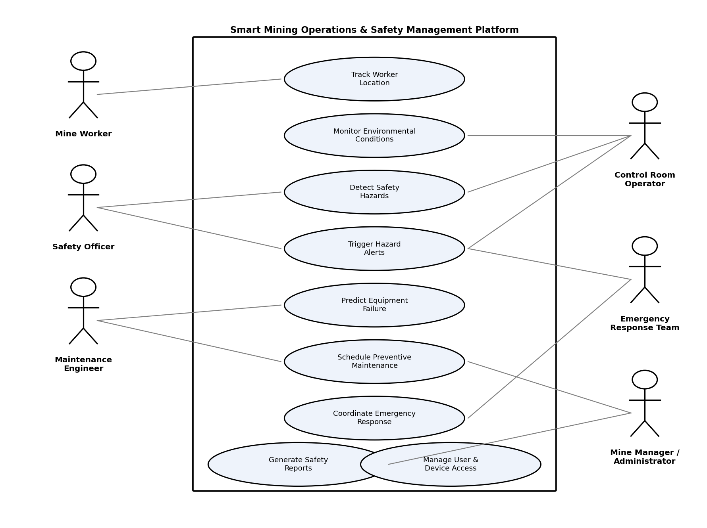
Figure 1: Use Case Diagram – Smart Mining Operations and Safety Management Platform

7. Data Requirements
- Worker Data: Worker ID, name, assigned zone, real-time location coordinates, shift timing.
- Sensor Data: Sensor ID, type (gas, temperature, humidity, vibration), reading value, timestamp, location.
- Equipment Data: Equipment ID, type, operating hours, maintenance history, health/failure prediction score.
- Incident/Alert Data: Alert ID, type, severity, timestamp, location, status (open/resolved), response actions taken.
- Report Data: Report period, incident summary, compliance status, generated by, date of generation.

8. External Interface Requirements
8.1 User Interfaces
- Web-based dashboard for control room operators and management showing live maps, sensor status, and alerts.
- Mobile application for workers and safety officers to receive alerts and report incidents.
8.2 Hardware Interfaces
- Integration with RFID/UWB/GPS worker tags, environmental IoT sensors, and equipment condition-monitoring sensors.
8.3 Software Interfaces
- Integration with existing mine SCADA systems, maintenance management software, and communication/notification services (SMS, email, push).
8.4 Communication Interfaces
- Wireless sensor network (Wi-Fi/LoRa/mesh) for underground data transmission; REST APIs for external system integration.

9. System Features
- Real-time worker location map with zone-based grouping.
- Automated hazard detection engine with configurable safety thresholds.
- Predictive maintenance module using historical equipment sensor trends.
- Emergency response coordination module with evacuation route guidance.
- Role-based dashboards and automated safety compliance report generation.

10. Assumptions and Constraints
10.1 Assumptions
- Workers and equipment are equipped with functioning tracking/sensor devices at all times.
- The mine site has a baseline wireless network infrastructure capable of supporting IoT data transmission.
- Safety threshold values for hazards are defined and approved by the mine's safety department.
10.2 Constraints
- Technical: Limited network connectivity in deep underground zones may affect real-time data transmission.
- Operational: The system must not disrupt existing manual safety procedures during initial rollout.
- Economic: Budget limits may restrict the number and type of sensors deployed initially.
- Legal: The system must comply with occupational mine safety regulations and data privacy laws for worker location tracking.
- Time-related: The platform must be piloted within one operational quarter before full-scale deployment.

11. Requirement Validation – Completeness and Consistency
11.1 Stakeholder Coverage Check
Requirements have been cross-checked against each stakeholder group (workers, safety officers, engineers, control room, management, regulators) to confirm that each group's core needs — safety awareness, operational monitoring, maintenance planning, and compliance reporting — are addressed by at least one functional requirement.
11.2 Ambiguity, Redundancy, and Missing Requirements
- Ambiguity: Terms such as "hazard" were clarified into specific measurable conditions (gas concentration limits, temperature thresholds) rather than left as vague statements.
- Redundancy: Alert-related requirements (FR-4) were consolidated into a single requirement covering all alert-triggering scenarios instead of separate duplicate entries.
- Missing Requirements Identified: An initial gap was found in offline/low-connectivity behavior; this was addressed by adding the Availability non-functional requirement covering local caching during network outages.
11.3 Suggested Improvements
- Introduce a requirements traceability matrix linking each functional requirement to its originating stakeholder need.
- Add specific, measurable acceptance criteria (e.g., exact alert response time in seconds) to each non-functional requirement during the design phase.
- Conduct a walkthrough review with safety officers and maintenance engineers to validate assumptions before finalizing the SRS.

