EV Charging Analytics – Project Summary
Project Title: EV Charging Analytics – Usage Trends, Peak Hours & Station Insights\
Author: Jahnavi Sharma
Date: 06-02-2026
Toolset Used: Python, Jupyter Notebook, Pandas, Matplotlib, Seaborn
Project Type: Data Analysis and Visualization (Notebook-based)

🔍 Objective
The objective of this project is to analyze electric vehicle (EV) charging station usage data and uncover:
- High-demand stations
- Peak usage hours
- Weekday vs weekend behavior
- Energy delivered trends over time
This analysis can help city planners, EV infrastructure companies, or product managers make better decisions around station placement, load management, and user demand forecasting.
📊 Data Used
- Type: Simulated EV charging session dat
- Columns included:
  - station_id – Unique ID of the charging station
  - start_time – Timestamp of when charging began
  - energy_kwh – Amount of energy delivered during session
- Additional Columns Derived:
  - hour – Hour of the day from start_time
  - is_weekend – Boolean indicating weekend vs weekday usage

✅ Key Analyses Performed

1. Station-Level Usage
- Grouped data by station_id
- Found top 10 stations by total energy delivered
- Created a bar chart to visualize the most utilized stations

2. Hourly Demand Pattern
- Extracted hour from session start times
- Created a line chart showing total energy delivered across 24 hours
- Morning (7–9 AM) and evening (5–7 PM) peak usage hours were highlighted

3. Weekday vs Weekend Trends
- Created a binary column to flag weekends
- Grouped data to compare energy usage on weekdays vs weekends
- Visualized using a side-by-side bar plot
📈 Visualizations Created
- Bar Chart: Top 10 High-Demand Stations
- Line Chart: Energy Usage by Hour of Day
- Bar Chart: Total Energy – Weekday vs Weekend
These visuals help highlight consumption spikes and infrastructure stress zones.
🧠 Insights
- Peak Hours Identified: Most charging happens during commute times (7–9 AM and 5–7 PM)
- Station Bottlenecks: A few stations account for disproportionately high energy consumption
- Weekday Preference: EV usage is significantly higher on weekdays compared to weekends

📁 Project Structure

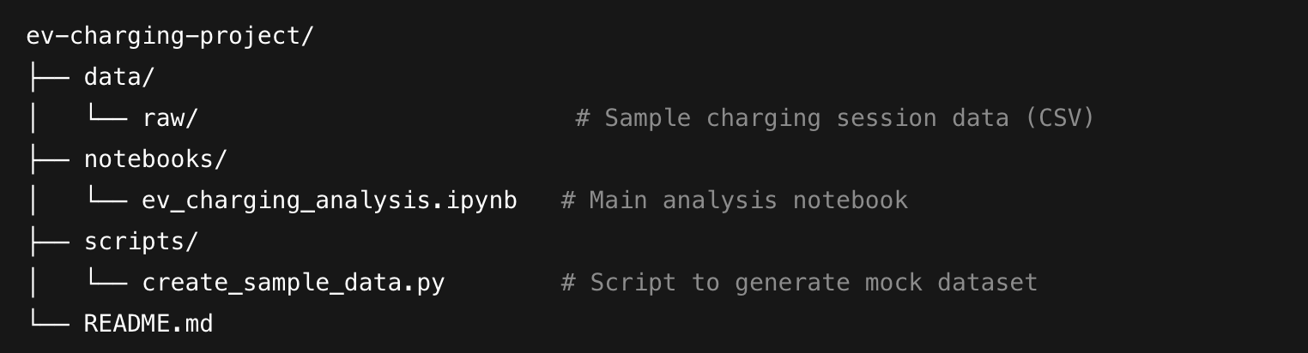

🛠️ Suggested Extensions (Future Work)
- Add real-world dataset integration (e.g. Open Charge Map API)
- Build a Streamlit dashboard for interactive analysis
- Cluster stations based on location and usage patterns
- Add anomaly detection for faulty sessions or outliers
📌 Conclusion
This project demonstrates strong skills in data preprocessing, visualization, time-series breakdown, and user demand interpretation. It’s suitable for showcasing analytical thinking, Python proficiency, and the ability to extract actionable insights from operational data, all of which are valuable for data science and product management roles.

