**Stock Market Trends**

**Abstract**

Investors face a variety of challenges when analyzing shares. An enormous flood of information makes it difficult to filter the most important data and make well-founded decisions about buying and selling shares. Extreme events in particular, such as natural disasters, can have a major impact on stock markets and are also difficult to predict. We have created a tool in which we correlate the most important data from natural catastrophes and stock markets and present them graphically. Our tool aims to demonstrate how major earthquakes (magnitude over 6) impact global markets, aiding investors, economists, and decision-makers in understanding market behavior changes due to such events.

By providing well-founded analyses and recommendations, the tool could help investors avoid emotional decisions and act based on data and could assess risks and opportunities in real-time, helping investors adjust their portfolios accordingly.

**Overview**

We received 16 datasets containing information about Stock market data (from 2008 to 2023) and Earthquake data (from 1990 to 2023). The key questions we want to solve are:

1. How is the impact of natural disasters on the stock market - in the short (one day) and long term (ten days)?
2. Are there specific sectors (e.g., energy, real estate, insurance, ...) or regions that are more sensitive to earthquakes in terms of market performance?

**Project Duration:** 9 weeks (13/01/2025 – 16/03/2025)

|  |  |  |  |
| --- | --- | --- | --- |
|  | **Description** | **Timeline** | **Completion Date** |
| 1 | Team and Project setup - Develop Key Questions and Project Goal | Week 1 | 19/01/2025 |
| 2 | Exploratory Data Analysis (EDA) | Week 2 | 26/01/2025 |
| 3 | Data Cleanup & Analysis | Week 3-4 | 09/02/2025 |
| 4 | Modelling & Evaluation | Week 5-6 | 23/02/2025 |
| 5 | Add two more Datasets to our Analysis | Week 7-8 | 09/03/2025 |
| 6 | Create Dashboard, Final Presentation & Blog Article | Week 9 | 16/03/2025 |

**Our Approach:**

1. Evaluate data availability:

We first checked the data sets provided for their format. All 16 datasets were in CSV format. 15 datasets contain the share prices, one dataset contains all data on natural catastrophes.

1. Exploratory data analysis (EDA) :

We were able to determine an identical structure in the data sets for the share prices. All CSV files contain the open and close prices of 12 stock indices per day. One file contains all data for one year. All 15 data sets could therefore be merged.

The dataset on natural disasters contains 25 different types of natural disasters, as well as their time, geodata (city, country, longitude, latitude) and information on their strength (magnitude and significance). We did not find any missing, duplicate or unrealistic values in any of the data sets. The data on natural disasters starts in 1990, the data on the stock markets in 2008. In order to link both data sets, the date could prove to be a suitable primary key.

1. Proof of Concept (PoC):

*3.1 Regression: Linear Results*

These are the results of our linear regression model. We used daily changes in each market as our dependent variable and these characteristics of earthquakes with a magnitude of 6 and above happening in the period between two consecutive market closes:

1. Number of earthquakes
2. Maximum magnitude of earthquakes
3. If the earthquake caused a Tsunami or not
4. Minimum distance of the earthquake from the town the market is located in.

*Findings:*

* National Stock Exchange of India (NSEI) and BSE Sensex Market (BSESN): Affected slightly by the maximum magnitude.
* Japanese Nikkei Stock Exchange (N225): Affected by both the number of earthquakes and the maximum magnitude. Number of earthquakes has a significant negative relationship with the change in the N225 index, and maximum magnitude has a tiny positive effect.

*3.2 Multinomial Logistic Results*

We measured the difference in change of a market compared to the average of all others and then assign 0, 1, 2, and 3 based on the difference of these two numbers. This method isolates the markets from other factors. Significant results were found for 7 markets:

*Findings:*

* IXIC: Number of earthquakes has a positive relationship with the range change minus 2 standard deviations, indicating more earthquakes increase the odds of a big negative change in IXIC.
* BESEN: Number of earthquakes has a negative relationship with effect 1 and positive with effect 2. Distance has the same relationship.
* N225: Higher number of earthquakes increases the odds of effect 2.
* 000001.SS: All three effects significant. Higher maximum significance increases the odds of effect 2 and 3, while closer distance increases the odds of effect 1 and decreases the odds of effect 3.
* N100: Higher number of earthquakes and maximum significance increase the odds of effect 1 and 2, while closer distance lowers these odds.
* DIJ and GSPC: Higher number of earthquakes lowers the odds of effect 1 happening, while higher maximum significance increases these odds. Closer distances lower the odds of effect 1.

*3.3 Market Analysis*

To expand our Analyses, we have not only focused on stock indexes, but also considered the stock values of individual companies and their industry. Regression analyses have shown that earthquakes can have significant impacts on stock markets, especially in Japan, Europe, China and India. Therefore, we have integrated datasets from all individual companies (including the industry) in the indexes with their open and close values on each day. Here are the results for Japan and the Nikkei Market as an Example:

1. Analysis of the impact of Earthquakes on Stock Prices by Industry.

False (average days that there is NO Earthquake), True (average days that there is Earthquake). The height of each bar represents the average percentage price change

* Negative Impact: If the 'earthquake=True' bar is lower (or negative), earthquakes may correlate with stock declines.
* Positive Impact: If the 'earthquake=True' bar is higher, industries might benefit
* No Impact: Bars of similar height suggest earthquakes have no measurable effect.
* **In this chart, all industries have Negative Impact (True > False)**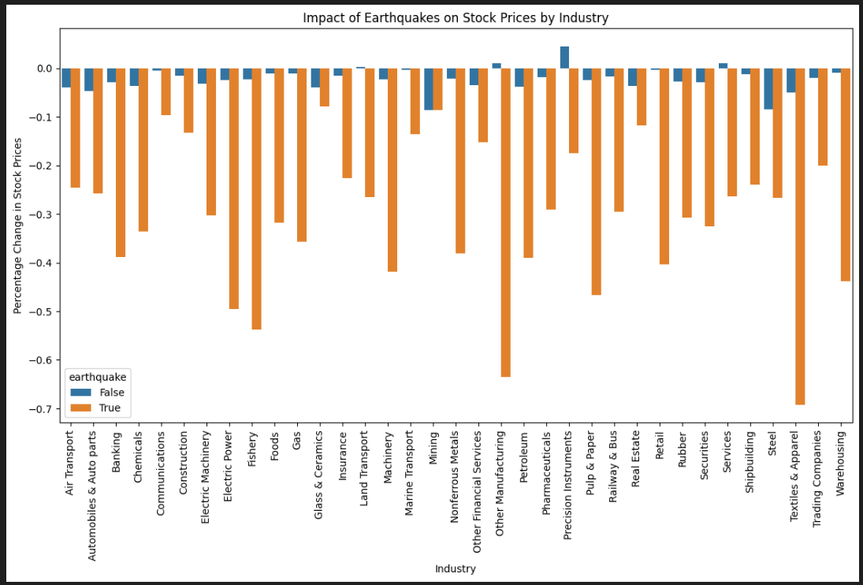

1. 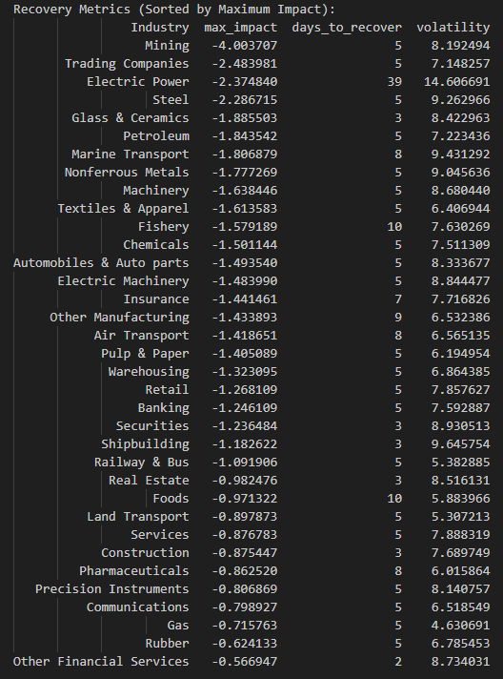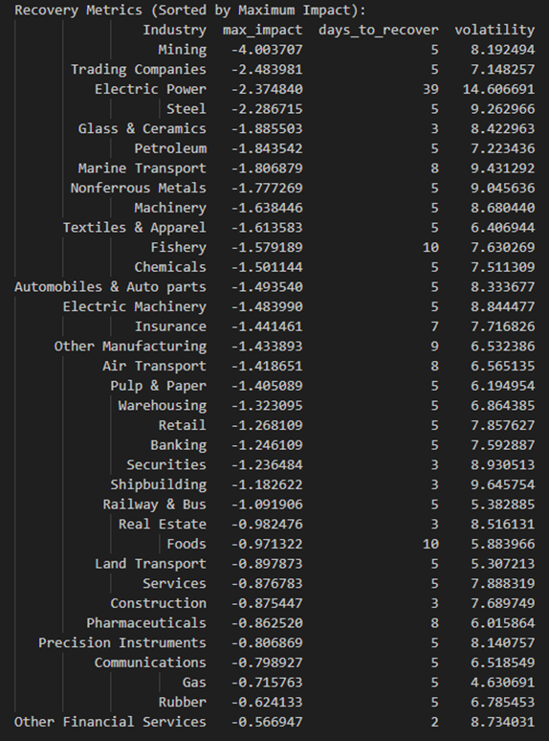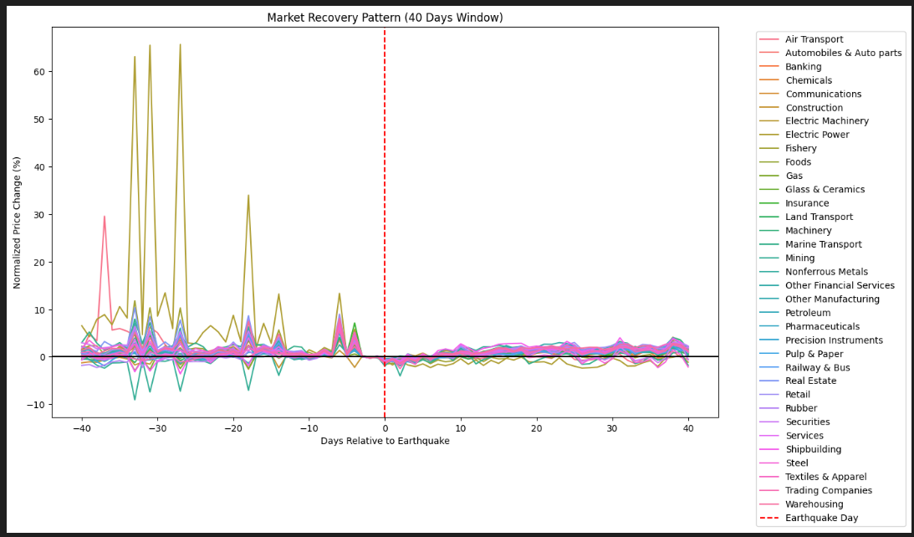Analysis of the Market Recovery Pattern in a 40 Days Window:

Metric Definitions:

* *max_impact:* The largest percentage drop in stock prices immediately after an earthquake.
* *days_to_recover:* Time (in days) for stock prices to return to pre-earthquake levels.
* *volatility:* Magnitude of price fluctuations during the recovery period (higher = more instability).

*Key Observations:*

1. All industries experienced negative stock price impacts (all max_impact values are negative), suggesting earthquakes generally correlate with short-term market declines.
2. Recovery times vary widely: Some industries rebounded in 2–5 days (e.g., Glass & Ceramics, Securities), while others took weeks (e.g., Electric Power: 39 days).
3. Volatility is highest in industries with prolonged recovery (e.g., Electric Power: 14.6 volatility), indicating prolonged uncertainty.

*Key Trends:*

1. Direct vs. Indirect Exposure:

* High Impact: Industries with physical assets (mining, power, marine transport) suffer most.
* Low Impact: Service-oriented sectors (financials, retail) are less affected.

1. Recovery Time vs. Volatility:

* Longer recovery periods correlate with higher volatility (e.g., Electric Power: 39 days, 14.6 volatility).
* Short recovery = lower uncertainty (e.g., Glass & Ceramics: 3 days, 8.42 volatility).

*Suggestion:*

* Investors: Avoid industries with high max_impact and slow recovery (e.g., Electric Power) during seismic activity. Consider short-term volatility in mining.
* Companies: High-impact industries (mining, power) should prioritize disaster resilience and investor communication.

1. Minimum Viable Product (MVP)

We have created a dashboard on which the corresponding analyses are displayed graphically in order to make the information collected available to the target group as required.

Depending on the filters set (year, region, industry), investors can identify the optimum time to buy or sell shares by looking at the development of share prices over time. The analyses are graphically supported by an interactive map on which the earthquakes and companies are displayed.

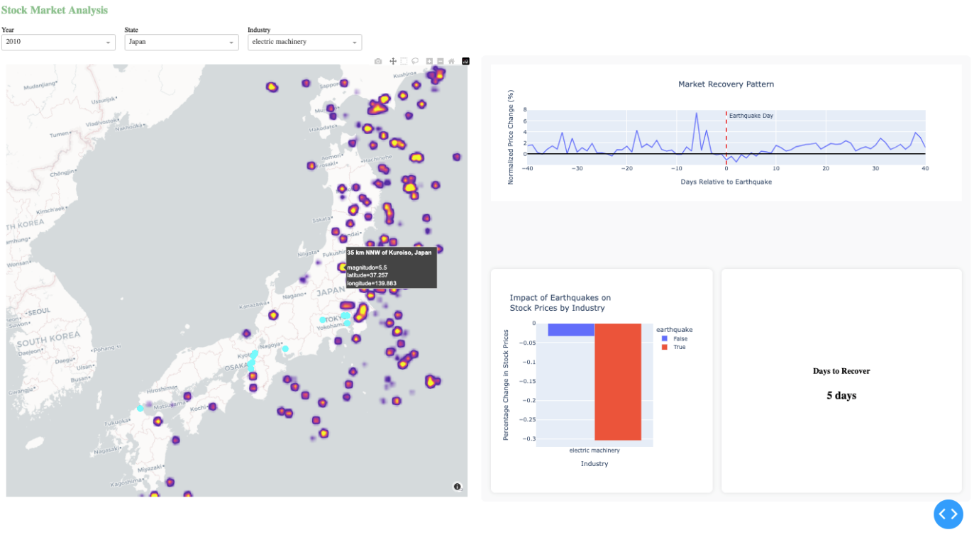

**Project Team**

* Anh Dong
* Sohail Jannessari
* Jan Hostmann

GitHub Repo: [**Techlabs_WS_Team3**](https://github.com/jahostm/Techlabs_WS_Team3)