Architecture Design

1. Overview and Goals
This system implements a personality-adaptive conversational agent that adjusts communication style based on real-time inference of user personality traits. The agent:
Estimates Big Five (OCEAN) personality traits from ongoing dialogue - Adapts tone, directness, pacing, and question-to-statement ratios accordingly - Operates without external knowledge bases, staying grounded in conversation context - Maintains therapeutic consistency for healthcare applications
Core Innovation: Real-time personality detection drives dynamic communication regulation through a deterministic, auditable pipeline.

2. Requirements Analysis

2.1 Functional Requirements
The system must perform accurate personality detection by inferring OCEAN traits with measurable accuracy and confidence levels. This detection operates in real-time with minimal latency impact while gracefully handling incomplete or ambiguous personality signals that commonly occur in natural conversation.
Adaptive regulation forms the core capability, translating detected personality traits into specific behavioral adaptations including tone adjustment, communication style modification, and pacing optimization. The system maintains consistency within individual conversations while allowing for natural personality evolution over extended interactions.
Quality assurance mechanisms ensure reliable operation through comprehensive verification of policy adherence, robust fallback systems for edge cases, and complete audit trails documenting all personality detection and regulation decisions.

2.2 Non-Functional Requirements
Performance requirements target P95 latencies of 2.5 seconds for standard responses and 5 seconds for refined responses. The system supports concurrent users through horizontal scaling capabilities while maintaining 99.9% availability with graceful degradation when components become unavailable.
Security and privacy protections include comprehensive data safeguards with configurable retention policies, full support for data minimization principles and privacy regulations, plus integrated PII redaction and consent management systems.

2.3 Success Metrics
- User Engagement: 25% improvement in conversation duration, 30% improvement in satisfaction - Detection Accuracy: 85% personality detection accuracy, 90% response consistency - System Performance: Meet latency targets with 99.9% availability

3. Framework Selection and Justification

3.1 Why Framework Selection Matters
Building personality-aware conversational AI requires sophisticated orchestration capabilities that extend far beyond simple prompt chaining. Modern agentic systems demand persistent state management, conditional control flow, comprehensive audit trails, and deterministic execution patterns—especially critical for healthcare applications where reproducibility and compliance are legally mandated.
Without appropriate frameworks, development teams inevitably re-implement brittle, custom orchestration pipelines that prove difficult to test, debug, and audit. The wrong framework choice can lead to: - Technical debt accumulation through ad-hoc state management solutions - Compliance failures due to inadequate audit trail capabilities - Scalability bottlenecks from poor orchestration patterns - Safety risks from insufficient error handling and recovery mechanisms
The framework selection process becomes particularly critical for personality-adaptive systems that must maintain conversation state, detect personality traits in real-time, and adapt behavior dynamically while ensuring clinical safety and regulatory compliance.

3.2 Framework Selection Criteria
Framework selection was driven by healthcare-specific requirements including stateful multi-turn conversations with persistent memory, comprehensive audit trails enabling deterministic behavior, and robust policy enforcement hooks with safety guardrails. The architecture must support both research experimentation and production deployment in clinical environments.
Healthcare-Specific Requirements: - Clinical Auditability: Every personality detection and regulation decision must be traceable - Deterministic Behavior: System responses must be reproducible for regulatory compliance - Safety Integration: Built-in hooks for content moderation, PII redaction, and escalation paths - Session Continuity: Persistent conversation state across interruptions and system restarts
Technical Requirements: - LLM-Native Integration: Seamless structured output handling and prompt management - State Management: Persistent checkpointing with conversation and personality state - Conditional Logic: Complex branching for personality detection confidence and safety policies - Observability: Step-level tracing, debugging tools, and comprehensive logging
Operational Requirements: - Production Readiness: Proven patterns for error handling, retry mechanisms, and scaling - Extensibility: Plugin architecture supporting future enhancements and tool integration - Community Support: Active development, documentation, and integration ecosystem

3.3 Framework Candidate Analysis
Six major platforms were systematically evaluated against personality-aware healthcare conversational AI requirements. Each platform was assessed across adaptability, compliance capabilities, modularity, production readiness, and healthcare-specific features.

LangGraph — Graph-Based Orchestration Excellence
Strengths: - Deterministic State Machines: Graph nodes and edges provide explicit, auditable execution flows - Built-in Checkpointing: Persistent state management with immutable checkpoint IDs for audit trails - Conditional Branching: Native support for complex decision logic (confidence gating, safety routing) - Healthcare Compliance: Pre/post-model hooks enable PII redaction, safety checks, and escalation protocols - Observability: Step-level tracing with LangSmith integration for comprehensive debugging
Healthcare Advantages: - Regulatory Compliance: Deterministic execution with complete audit trails meets clinical requirements - Safety Integration: Built-in safety hooks and escalation paths for high-risk scenarios - Session Recovery: Checkpoint-based state persistence enables reliable conversation continuity - Research Support: Graph visualization and debugging tools facilitate rapid development
Limitations: - Learning Curve: Graph-based paradigm requires architectural thinking shift - Newer Platform: Smaller community compared to established frameworks

LangChain — Modular Component Library
Strengths: - Rich Ecosystem: Extensive integrations with LLM providers, vector databases, and evaluation tools - Component Modularity: Well-tested building blocks for prompt management, memory, and chains - Production Proven: Mature codebase with established patterns and community support - Evaluation Tools: Built-in metrics and testing frameworks for personality detection accuracy
Limitations for Healthcare: - Orchestration Gaps: Limited stateful workflow capabilities for complex personality pipelines - Audit Trail Challenges: Custom implementation required for comprehensive audit logging - State Management: Basic memory modules insufficient for sophisticated personality tracking

Rasa — Intent-Driven Enterprise Platform
Strengths: - Enterprise Features: Mature analytics, governance, and deployment capabilities - Deterministic Flows: Story and rule-based conversation management with predictable behavior - Production Reliability: Proven enterprise deployment patterns and monitoring capabilities
Critical Limitations: - Limited LLM Integration: Traditional NLU approach poorly suited for personality detection - Flexibility Constraints: Rule-based system cannot handle dynamic personality adaptation - Development Overhead: Requires extensive training data and custom integration for LLM capabilities

Botpress/Dialogflow — Enterprise Platforms
Strengths: - Low-Code Development: Visual interfaces enable rapid prototyping and deployment - Enterprise Security: Built-in compliance features and access controls - Integration Capabilities: Native connections to business systems and databases
Critical Limitations: - Vendor Lock-in: Proprietary platforms with limited customization and export capabilities - LLM Constraints: Insufficient support for advanced personality detection and regulation - Research Limitations: Closed architectures prevent deep customization required for research

Dify — Emerging Open-Source Platform
Strengths: - Open Source Flexibility: Self-hosted deployment with full customization control - Visual Workflows: Intuitive interface for rapid prototype development - LLM Integration: Native support for modern language models
Limitations: - Maturity Concerns: Newer platform with evolving features and limited production track record - Limited State Management: Insufficient capabilities for complex personality tracking - Community Size: Smaller ecosystem compared to established alternatives

3.4 Framework Comparison Matrix
The comprehensive analysis revealed clear advantages for the LangGraph + LangChain orchestration stack, particularly for healthcare applications requiring personality-aware conversational AI. The following comparison matrix demonstrates the systematic evaluation process and provides quantitative justification for our framework selection:
Workflow Structure | Linear chains; DAGs | Graph nodes/edges; loops | Policies/stories/rules | Visual flows | Intent-based flows | Visual workflows
State Management | Basic memory | Persistent checkpoints | Tracker store | Built-in state | Context management | Limited state
LLM Integration | Native | Native | Limited | Limited | Limited | Native
Customization | High | High | Medium | Low | Low | Medium
Healthcare Compliance | Custom layers | Built-in hooks | Enterprise features | Enterprise | Enterprise | Limited
Research Suitability | Excellent | Excellent | Good | Limited | Limited | Good
Production Readiness | Strong | Strong | Mature | Mature | Mature | Emerging
Personality Adaptation | Good | Excellent | Limited | Poor | Poor | Limited
Clinical Auditability | Custom | Built-in | Good | Limited | Limited | Poor

Framework Selection Summary: - LangGraph: Primary choice for healthcare applications requiring personality-aware conversational AI - LangChain: Supporting framework providing component library and integration ecosystem - Rasa: Alternative option for structured healthcare interactions with limited LLM capabilities - Botpress/Dialogflow: Enterprise platforms with limited customization for research applications - Dify: Emerging platform with evolving features and limited production readiness

3.5 Decision Rationale: LangGraph + LangChain
The selected LangGraph + LangChain combination provides the optimal foundation for personality-regulated healthcare conversational AI. This decision was driven by three critical factors:

3.5.1 Healthcare Compliance Excellence
LangGraph's deterministic state machine architecture with built-in checkpointing directly addresses healthcare regulatory requirements. Every personality detection, regulation decision, and response generation step creates immutable audit trails with checkpoint IDs, enabling complete reproducibility essential for clinical applications. The framework's conditional edges naturally encode clinical policies including confidence gating, safety escalation, and graceful degradation paths.

3.5.2 Personality Adaptation Capabilities
The graph-based orchestration perfectly maps to the ingest → detect → smooth → regulate → generate → verify → checkpoint pipeline required for personality adaptation. Each node represents a discrete processing step with clear inputs, outputs, and state transitions. This explicit structure enables sophisticated personality tracking through persistent state while supporting real-time adaptation through conditional routing based on confidence levels and safety assessments.

3.5.3 Production-Ready Ecosystem
LangChain's mature component library provides battle-tested utilities for prompt management, LLM integration, and evaluation frameworks essential for production deployment. The combination offers immediate access to: - Proven Patterns: Established state management and error handling approaches - Extensive Integrations: Support for major LLM providers, databases, and monitoring tools - Future Extensibility: Plugin architecture enabling tool integration without architectural changes
Risk Mitigation Benefits: - Low Vendor Lock-in: Open-source stack with interface-based LLM abstraction - Deterministic Debugging: Graph visualization and step-level tracing for rapid issue resolution - Scalability Patterns: Stateless worker architecture with shared state storage - Safety Integration: Built-in hooks for content moderation, PII handling, and compliance monitoring
This combination uniquely satisfies the complex requirements of personality-aware healthcare conversational AI while providing the robustness, auditability, and extensibility required for both research development and clinical deployment.

4. System Architecture

4.1 High-Level Architecture
The system implements a three-tier architecture that provides clear separation of concerns while enabling seamless integration between components. This design addresses healthcare application requirements by ensuring each layer can be independently developed, tested, and validated while maintaining overall system integrity required for clinical deployment.
The client layer provides multiple interface options including web UI, mobile applications, and voice interfaces, ensuring accessibility across different patient populations and healthcare settings. The API gateway layer implements essential healthcare requirements including authentication, rate limiting, and comprehensive request validation to ensure data integrity and security.
The core processing layer contains the personality detection, regulation engine, and response generation components implementing the proven pipeline architecture. The data and infrastructure layer provides reliable operation through vector database storage, session management, and comprehensive observability capabilities.
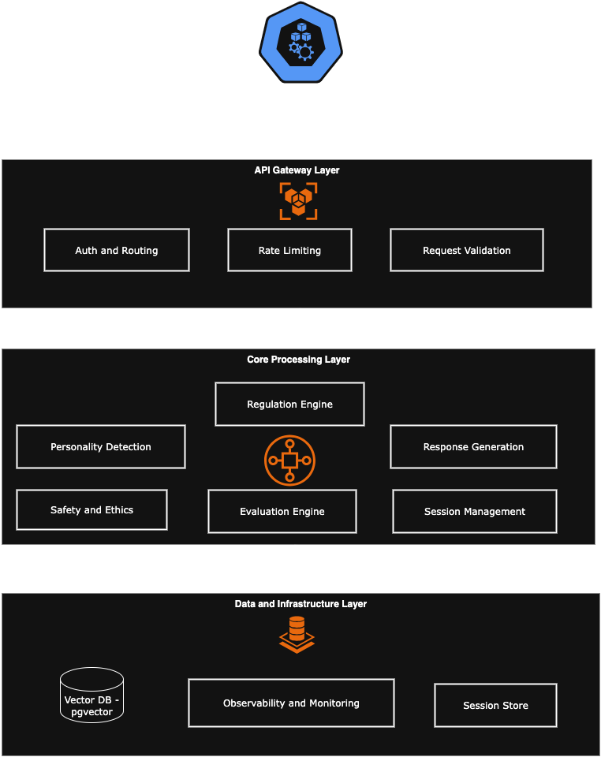

3.2 LangGraph Integration Architecture
The personality-adaptive pipeline implements a deterministic flow using LangGraph's state machine capabilities that ensures reproducible behavior essential for clinical applications. LangGraph orchestrates the entire conversation pipeline through explicit graph nodes and edges that mirror each processing step.

LangGraph State Management provides persistent checkpointing where each node maintains conversation state including personality estimates (`p̂_t`), conversation history, and policy configurations. This enables session recovery, debugging, and audit trail generation essential for healthcare compliance.
Conditional Edges encode clinical policies as decision points, implementing confidence gating, violation handling, and graceful degradation paths. When personality detection confidence is low, the system routes to neutral behavior paths. When safety violations are detected, explicit escalation edges trigger human oversight protocols.
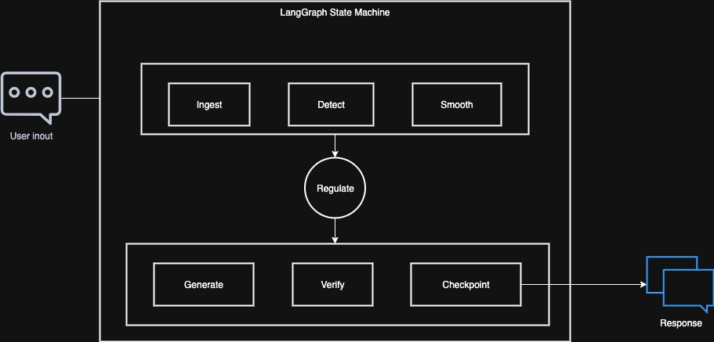

3.3 Frontend/Backend Architecture
The Next.js frontend implements a responsive chat interface with streaming response capabilities, session persistence, and accessibility features required for diverse patient populations. The client uses Server-Side Events (SSE) for real-time response streaming and maintains conversation state through React context
The FastAPI backend serves as the orchestration layer, exposing RESTful endpoints for chat interactions while managing LangGraph execution, session persistence, and comprehensive logging. The backend implements streaming response patterns for real-time user experience and maintains stateless operation for horizontal scalability.
Key Integration Points: - `/chat` endpoint receives user messages and triggers LangGraph pipeline execution - Session management persists conversation state and personality estimates across interactions - Checkpoint manager handles LangGraph state persistence and recovery - Observability layer captures detailed execution traces for debugging and compliance auditing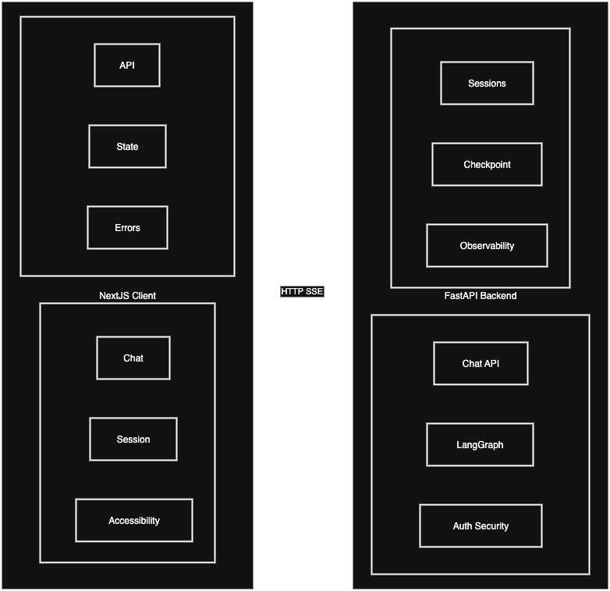

3.4 Pipeline Overview
The system operates through a 7-step deterministic pipeline:
ingest → detect → smooth → regulate → generate → verify → checkpoint
Each conversation turn follows this sequence: 1. Ingest: Normalize input, update conversation history 2. Detect: Assign OCEAN scores with confidence levels 3. Smooth: Stabilize personality estimates using exponential moving averages 4. Regulate: Convert traits into communication policies 5. Generate: Compose replies using dialog context and policy 6. Verify: Check policy adherence and dialog grounding 7. Checkpoint: Persist conversation state for continuity

3.2 Core Components
The detection component performs LLM-based personality assessment using conversation context to output per-trait scores with confidence levels. It gracefully handles contradictory signals and low-confidence scenarios that naturally arise during personality inference from limited conversational data.
Personality estimates are stabilized through the smoothing component, which applies exponential moving averages using the formula `p̂_t = (1 − α_t) · p̂{t−1} + α_t · ṗ_t`. Values are clipped to the [-1,1]^5 range while delta caps prevent abrupt personality changes that could disrupt conversation flow.
The regulation component maps detected personality traits to specific communication style controls through Zurich Model integration, enabling motivation-based behavioral adaptation. This component includes sophisticated conflict resolution mechanisms for handling competing personality indicators.
Response composition occurs through the generation component, which employs a "quote-and-bound" approach that stays strictly grounded in dialog history. This ensures all outputs avoid introducing novel factual claims while applying personality-guided style adaptations.

3.3 Mathematical Framework
Personality State: `p̂_t ∈ ℝ⁵` representing OCEAN traits at turn t
Style Controls: `s = clip(W·p̂_t + b)` across dimensions: - Empathy/warmth level - Formality vs. casualness - Directness vs. hedging - Assertiveness level - Verbosity and pacing - Question/statement ratio
Confidence Weighting: Higher confidence detections have greater influence on personality updates

5. Implementation Design

5.1 Technology Stack
Core Framework: - LangGraph: Orchestration and state management - LangChain: Component library and LLM integration - FastAPI: Backend services and API gateway - Next.js: Client UI with streaming support
Infrastructure: - PostgreSQL: Session storage and audit logs - Redis: Checkpointing and caching - LangSmith/OpenTelemetry: Observability and monitoring

5.2 Processing Pipeline
Per-Turn Flow: 1. Ingest: Normalize input, update conversation window (N turns + salient quotes) 2. Detect: LLM inference for personality traits with confidence scoring 3. Smooth: Apply EMA updates with stability flags and delta caps 4. Regulate: Map traits to style controls (warmth, directness, assertiveness, pacing) 5. Generate: Compose dialog-grounded replies using policy plans 6. Verify: Check policy adherence and grounding, trigger refinement if needed 7. Checkpoint: Persist state, policies, flags, and timing for audit
Configuration Parameters: - Stability thresholds (τ) for personality updates - Conversation history size limits - Per-turn delta caps for behavioral consistency - Refinement budgets and timeout controls

5.3 Performance and Safety
Performance Optimization: - Prompt caching and context compression - Parallel detection for sanity checking - Circuit breakers with neutral fallbacks - Bounded retries and timeout handling
Safety Mechanisms: - Misclassification Prevention: Self-consistency checks, confidence weighting - Style Oscillation Control: Delta caps, hysteresis on policy switches - Provider Resilience: Retry/backoff, circuit breakers, neutral fallbacks - Regression Prevention: Prompt versioning, canary deployments, scenario replays
Risk Mitigation: - Comprehensive content moderation and PII redaction - Evaluator-based refusals and escalation paths - Audit logging with access controls and retention policies - Graceful degradation maintaining conversation continuity

6. Deployment Strategy

6.1 Development Phases
Implementation follows a carefully planned four-phase approach prioritizing safety and validation. Phase 1 focuses on core pipeline implementation with basic personality detection and regulation capabilities, including comprehensive testing to ensure fundamental system reliability.
Phase 2 develops the client interface with streaming support and robust session management, ensuring users receive responses in accessible formats with proper conversation continuity. Phase 3 implements the evaluation framework and comprehensive safety guardrails, including quality metrics, safety monitoring, and compliance validation systems.
Phase 4 concentrates on performance optimization and production deployment readiness, ensuring the system operates reliably with appropriate monitoring, alerting, and maintenance capabilities required for healthcare environments.

6.2 Risk Mitigation
Technical risk mitigation addresses inherent challenges in personality inference and system reliability. Trait uncertainty is managed through confidence-weighted updates and neutral behavior maintenance until stability is achieved. Cultural variability concerns are addressed via stratified evaluations and culture-aware configuration options. Model updates are protected against through comprehensive regression testing, policy versioning, and drift detection mechanisms.
Operational risk management ensures safe deployment in healthcare environments. Safety drift prevention includes periodic red-team exercises and policy validation protocols. Human oversight capabilities provide clear escalation pathways for high-risk scenarios requiring clinical intervention. Compliance requirements are met through immutable audit logs, data minimization practices, and comprehensive consent management systems.

6.3 Operational Considerations
The system operates under strict healthcare constraints including dialog-only operation without external knowledge dependencies, ensuring all responses remain conversation-grounded. Priority is placed on stability and predictability over rapid style adaptation, maintaining therapeutic consistency essential for clinical applications.
Scalability design implements stateless workers with shared storage, enabling horizontal scaling based on queue depth while maintaining session continuity. Containerized deployment with centralized secrets management ensures secure, reliable operation that meets healthcare infrastructure requirements and supports regulatory compliance auditing.

