Personality-Adaptive Conversational AI for Emotional Support: A Simulation Study Integrating Big Five Detection with Zurich Model Regulation

Abstract
Abstract: Large language model agents are increasingly deployed to expand access to digital emotion support and mental health care by offering timely, low-cost conversational assistance. Yet, most current systems rely on generic communication strategies that overlook stable individual differences in personality, limiting their capacity to deliver personalized interventions aligned with personal psychological coping mechanisms. This study maps how personality-adaptive mechanisms integrate real-time Big Five personality trait detection with theoretically grounded regulation strategies based on the Zurich Model of Social Motivation.
Methods: We conducted a controlled study comparing a personality-adaptive system against a non-adaptive baseline across two extreme Big Five profiles: one very high and one very low on openness, conscientiousness, extraversion, agreeableness, and emotional stability under contrasting psychological conditions. The adaptive system integrated GPT-4-based modules for personality detection, regulation mapping, and evaluation. Conversational quality and personality alignment were evaluated by an LLM judge with responses rated by psychological experts on detection accuracy, regulation effectiveness, emotional tone, relevance and personality-specific emotional needs.
Results: Across the simulated conditions, the regulated system achieved near-perfect performance in personality detection and regulation effectiveness. The personality-adaptive agents demonstrated very large improvements in addressing personality-specific needs compared to baseline (M = 2.00 vs. 0.17 on a 0–2 scale; Cohen's d = 4.58, p < 0.001), representing a >90% improvement in personalization, while maintaining comparable basic conversational quality (effect sizes d < 0.3, p > 0.05). Agreement between AI evaluator and human experts was excellent (Cohen's κ = 0.89, 95% CI: 0.84–0.94), validating the evaluation approach. These results establish proof-of-concept under idealized conditions but do not constitute evidence for real-world effectiveness. Reported benefits included enhanced personalization, improved alignment with individual psychological needs, and validated evaluation methodology. However, recurring challenges such as reliance on extreme simulated profiles, pre-scripted interactions, brief conversations, and limited generalizability highlight the need for ethical design and human oversight.
Conclusion: By introducing a personality-adaptive framework, this simulation study offers a comprehensive overview of current applications and future directions in AI-augmented emotional support. It aims to guide researchers, clinicians, and policymakers in developing safe, effective, and equitable personality-adaptive digital mental health interventions.
Keywords: digital mental health; conversational agents; large language models; personality detection; Big Five; Zurich Model; adaptive interaction; emotional support; simulation study; GPT-4

1. Introduction
Despite major advances in economic and technological development, mental health and social well-being remain pressing global public health challenges. Loneliness and social isolation among older adults are particularly persistent concerns, contributing to morbidity and mortality risks comparable to obesity and approaching those of heavy smoking [1]. Demographic shifts such as population aging, dispersed families, bereavement, and declining community engagement further limit opportunities for meaningful social contact [2]. In Switzerland, as in many high-income contexts, a growing proportion of adults aged 75 and older live alone and are especially vulnerable to isolation [3]. These trends have intensified interest in scalable digital approaches that complement traditional services while providing accessible, timely social and emotional support.
Within this landscape, digital mental health tools and conversational assistants are being explored as mechanisms for increasing access to supportive interactions. However, most existing systems still rely on rule-based communication strategies that offer limited flexibility in addressing diverse user needs [4]. These systems operate with predefined scripts and fixed response templates, making their effectiveness variable and their supportive value constrained.
Recent advances in large language models (LLMs) have enabled more flexible, context-aware conversational AI applications capable of generating simulated empathy and emotionally relevant responses [8,9]. However, their supportive behaviors remain largely generic and one-size-fits-all, as they lack mechanisms for dynamically adapting to stable user characteristics. Although natural language processing techniques that parse user input, perform sentiment analysis, and incorporate recalled preferences are widely used, they typically provide only shallow personalization and often still rely on static assessments collected before interaction, rather than dynamically modeling and adapting to stable user traits ground in psychologocal principle.
To address these gaps, we developed a personality-adaptive conversational framework that integrates (i) real-time Big Five personality traits detection, (ii) behavior regulation grounded in the Zurich Model of Social Motivation, and (iii) a structured evaluation pipeline using automated LLM-based evaluation. The framework is implemented using GPT-4–based agents performs real-time detection of Big Five traits that continuously infers and updates stable trait estimates based on linguistic cues throughout conversation and response theory-guided behavioral adaptation.
The objective of this study is to determine whether real-time personality-adaptive behavior regulation, grounded in continuous inference of user traits from the Big Five framework, can enhance conversational quality, emotional alignment, and psychological attunement in chatbot–user interactions. Specifically, we implement and evaluate a real-time detection and regulation loop in which an adaptive AI assistant infers personality across multiple dialogue turns and adjusts its tone and behavioral style accordingly, and compare its effectiveness against static, non-adaptive baselines in delivering emotionally supportive interactions. moving beyond preliminary feasibility to workflow integration and reproducible we integrate this pipline into PROMISE, a framework building for interacte with LLM applications by orchestrate dynamic prompts across hierarchical states with attached conditions and actions and predictable language-model behavior in complex interactions. This design ensures precise control over interaction parameters, clear quantification of personalization effects, and a fully reproducible testbed for personality-adaptive conversational agents. It offers a solid methodological foundation to guide researchers, clinicians, and policymakers in developing safe, effective, and equitable AI-augmented mental health interventions.

2. Related Work
The development of personality-adaptive conversational AI represents a convergence of AI-driven digital interventions—leveraging multiple AI modalities including natural language processing (NLP), machine learning (ML), and large language models (LLMs)—with personality psychology and affective computing. These systems aim to not only process information but understand context, adapt to individual differences, and support personalized mental health care through personality-adaptive architectures. Within this paradigm, personality-adaptive systems represent a shift from reactive information processing toward dynamic personality modeling that captures stable individual differences in how humans perceive, process, and respond to emotional and social information.
This section traces the evolution from generic therapeutic support systems toward personality-adaptive AI architectures, building upon three interconnected research streams: (1) affective computing and emotion-aware systems, (2) conversational AI architectures including transformer-based LLMs, and (3) personality psychology theories that explain individual differences in emotional processing. We systematically review the state of the art in each domain before synthesizing critical gaps that motivate our investigation.

2.1. Affective Computing and Emotion Recognition
Early affective computing research established foundational techniques for recognizing emotional states from text, speech, and facial expressions [12,13]. Initial approaches relied heavily on categorical emotion models (e.g., happiness, sadness) before evolving toward dimensional representations that model affect distinct valence and arousal components. While these systems demonstrated the feasibility of detecting emotional signals, they face persistent challenges with generalization across individuals and contexts, often struggling with the subtle, mixed emotional expressions common in real-world interactions [12,13].
From a systems perspective, such signal-driven detection implements shallow affective modeling—recognizing surface-level emotional signals without accounting for the cognitive and motivational context. A critical limitation is the emphasis on transient emotional states rather than stable personality traits. Most work focuses on detecting what users are currently feeling (e.g., anxiety) to generate empathetic responses, but overlooks who the user is—specifically how stable personality differences shape emotional processing and regulation needs [6]. This reliance on transient state detection leaves a gap in understanding the stable architectural differences that determine effective support strategies.

2.2. Large Language Models in Mental Health
The emergence of large language models (LLMs) has transformed conversational AI capabilities, positioning them as powerful conversational AI engines capable of flexible reasoning, context integration, and natural language understanding [8,15,16]. These transformer-based generative models with billions of parameters (e.g., GPT-3.5/4) implement key cognitive functions—semantic memory, analogical reasoning, theory of mind inference—through learned statistical patterns over vast text corpora, enabling free-text generation, contextual memory, and zero-shot reasoning. Recent systems leverage these capabilities for therapeutic support through various architectural approaches: dialogue state tracking to maintain conversation context [15], cascaded neural networks to enhance empathy generation [16], and multimodal integration combining text, audio, and physiological signals [17,19,20].
Despite these advances, current LLM-based therapeutic support systems frequently exhibit a "one-size-fits-all" limitation. While they generate contextually appropriate empathetic responses, they typically adapt to the immediate context rather than the user's stable psychological profile. Without mechanisms to build and maintain persistent personality models, these systems cannot maintain the long-term consistency or psychological attunement required for effective therapeutic allegiance.

2.3. AI Companions and Digital Interventions
Commercial AI companions and research prototypes have demonstrated the potential of conversational agents to reduce loneliness and provide accessible mental health support [21–24]. For example, Replika has engaged millions of users seeking emotional companionship, while Woebot—a cognitive behavioral therapy (CBT)-based chatbot—has shown effectiveness in reducing symptoms of depression and anxiety in college students through structured therapeutic conversations. ElliQ, a proactive AI companion designed for older adults, has demonstrated promising results in combating social isolation through personalized engagement and activity suggestions. Systematic reviews indicate that digital interventions can produce modest but significant reductions in loneliness among older adults, with effect sizes ranging from small to moderate (d = 0.2–0.5) [23,24].
However, recurring challenges limit the effectiveness of current AI companions. Most existing systems rely on fixed interaction strategies or limited personalization based on explicit user preferences (e.g., preferred topics, communication frequency). Broadbent et al. [22] describe ElliQ's approach to combating loneliness through proactive engagement and activity suggestions, but note that the system uses rule-based personalization rather than dynamic personality adaptation. This static approach creates a fundamental mismatch: while users' emotional states fluctuate and conversational patterns evolve, the system's interaction style remains fixed, potentially limiting the depth of therapeutic rapport.

2.4. Personality-Aware Dialogue Systems
A small but growing body of research has explored personality-aware dialogue systems. Early work by Mairesse and Walker [6] demonstrated that adapting linguistic style to match user personality traits (based on the Big Five model) improves perceived naturalness and engagement, with personality-matched systems achieving significantly higher user ratings compared to mismatched or generic systems. Zhou et al. [30] extended this approach to interview chatbots, showing that automatic personality profiling can guide design decisions for more effective conversational agents, with profiling-informed designs yielding improved user satisfaction and task completion rates.
However, these systems typically rely on static personality inputs—either explicitly provided by users or inferred once at the beginning of interaction [6,30]. This approach has two critical limitations: (1) it requires users to complete personality assessments before interaction, creating friction and potential dropout, and (2) it cannot adapt to evolving understanding of user personality as more conversational evidence accumulates. This static profiling approach fails to capture the dynamic nature of human social cognition, where mental models of others are continuously refined through interaction.

2.5. Theoretical Foundations in Social Motivation
While computational approaches to personality-aware dialogue have advanced, they often lack grounding in cognitive-motivational theory that explains why personality traits should influence conversational behavior and how they should be translated into specific adaptations. The Zurich Model of Social Motivation [10,26–29] provides this theoretical foundation by linking Big Five personality traits to three fundamental cognitive-motivational systems: security (processing oriented toward threat detection and safety maintenance), arousal (processing oriented toward novelty-seeking and stimulation), and affiliation (processing oriented toward social connection and cooperation).
The Zurich Model builds on earlier motivation theories [26,27] and Bischof's systems analysis of social motivation [28,29], proposing that personality traits reflect stable individual differences in the cognitive architecture governing motivational balance between these systems. Despite its theoretical richness, the Zurich Model has not been widely operationalized for conversational AI. Existing personality-aware dialogue systems lack explicit mappings from personality traits to motivational domains, instead relying on ad-hoc adaptation rules or learned associations from data. This limits both the interpretability of system behavior and the ability to leverage psychological theory to guide design decisions.

2.6. Challenges in Evaluating LLM-Based Interventions
A persistent methodological challenge in LLM-based conversational AI research is evaluation validity. Traditional approaches rely on human expert ratings, which provide gold-standard assessments but are expensive, time-consuming, and difficult to scale [25]. Recent work has explored LLM-based evaluation as a scalable alternative (e.g., the FEEL framework [25]), demonstrating that structured LLM-based evaluation can correlate with human judgments. However, this raises concerns about circular validation: using AI to evaluate AI-generated outputs may introduce systematic biases that inflate performance metrics [5]. Azaria et al. [5] caution that LLM-based tools are most reliable when used by domain experts who can critically evaluate outputs rather than accepting them uncritically. This creates a need for rigorous validation protocols that combine the scalability of AI evaluation with the validity assurance of independent expert ratings.

2.7. Synthesis of Gaps and Study Contributions
Our systematic review reveals three critical gaps in current AI-driven mental health support, which this study addresses through a novel personality-adaptive framework integrated within the PROMISE orchestration system [7]:
- Static vs. Dynamic Modeling Gap: Existing systems predominantly rely on static personality profiles initialized before interaction, failing to capture the dynamic nature of human trait inference.
  - Our Contribution: We implement dynamic personality modeling as a continuous trait inference process. Unlike static profiling, our system continuously updates Big Five trait estimates based on linguistic cues throughout the interaction, mirroring human social cognition and allowing the system to refine its understanding as conversational evidence accumulates.
- Theoretical Gap: Current approaches lack deep cognitive-motivational grounding, often mapping traits to surface-level linguistic style rather than underlying motivational systems.
  - Our Contribution: We operationalize a theoretically grounded architecture based on the Zurich Model of Social Motivation. We explicitly map detected Big Five traits to behavioral adaptations across security, arousal, and affiliation domains, ensuring that adaptations are driven by established psychological principles rather than ad-hoc rules.
- Methodological Gap: There is an absence of reproducible, theoretically grounded orchestration frameworks validated by rigorous comparison between scalable AI metrics and human expert judgment.
  - Our Contribution: We establish validated assessment rigor by implementing a hybrid evaluation protocol. We combine the scalability of an LLM-based evaluator with the validity assurance of independent ratings from PhD-level clinical psychology and computer science experts, demonstrating strong agreement (Cohen's κ = 0.89) to provide a validated methodological template.
By integrating these elements into a reproducible testbed, this study aims to move beyond preliminary feasibility demonstrations toward robust, theoretically principled, and rigorously evaluated personality-adaptive mental health interventions.

3. Materials and Methods
This section describes the study design, system architecture, and evaluation methodology used to assess personality-adaptive conversational AI. Key workflows are illustrated visually, with supporting narrative for reproducibility.

3.1. Research Aims and Study Design

3.1.1. Research Aims
Various types of AI technologies are increasingly deployed within the broad context of mental health care and emotional support. Many of these technologies are specifically linked to conversational AI interfaces, which engage users to provide a wide range of support including therapeutic guidance, emotional validation, and psychoeducation. Large language models (LLMs), sentiment analysis, and recommender systems have been implemented into healthcare settings to improve diagnostic accuracy, enhance personalized treatment, provide insights and recommendations to clinicians, tailor services to individual needs, and offer accessible and cost-effective mental health support [8,15,16]. As the field of conversational AI continues to progress, there is a transformative opportunity for mental health care to understand and apply personality-adaptive technologies to their services effectively.
However, most current conversational AI systems rely on generic communication strategies that overlook stable individual differences in personality, limiting their capacity to deliver personalized interventions aligned with personal psychological coping mechanisms. There is a need for simulation studies examining how personality-adaptive mechanisms can be integrated into conversational AI, their impacts on conversational quality and personalization, and practical aspects of combining real-time personality detection with theoretically grounded regulation strategies. This study aims to present a framework for evaluating personality-adaptive conversational AI in a manner that maximizes personalization benefits while establishing methodological rigor through human-expert validation.
To realize the full promise of personality-adaptive AI, integration must be guided by evidence on technical feasibility, evaluation validity, and alignment with psychological theory. Accordingly, this study evaluates a personality-adaptive conversational system under controlled simulation conditions. We compare a regulated assistant that performs real-time Big Five inference and Zurich Model–aligned behavior regulation against a non-adaptive baseline. Our primary goals are to (1) demonstrate that real-time personality detection can achieve accurate trait inference from conversational cues, (2) evaluate whether personality-adaptive regulation produces measurable improvements in addressing personality-specific user needs, and (3) validate an LLM-based evaluation approach against independent human expert judgment to establish methodological rigor for future research.

3.1.2. Experimental Design
The study employed a 2×2 factorial design comparing two assistant types (regulated vs. baseline) across two personality profiles (Type A vs. Type B). All conditions used standardized simulated personas, a fixed dialogue structure, and a structured evaluation rubric with human-expert validation. Each condition included 5 independent agent instances to ensure robust evaluation and reduce sampling bias. Baseline agents served as control conditions, providing identical supportive responses without personality adaptation. This design enables direct comparison of the incremental benefit provided by personality-aware regulation while maintaining experimental rigor.
[Figure 11 near here]
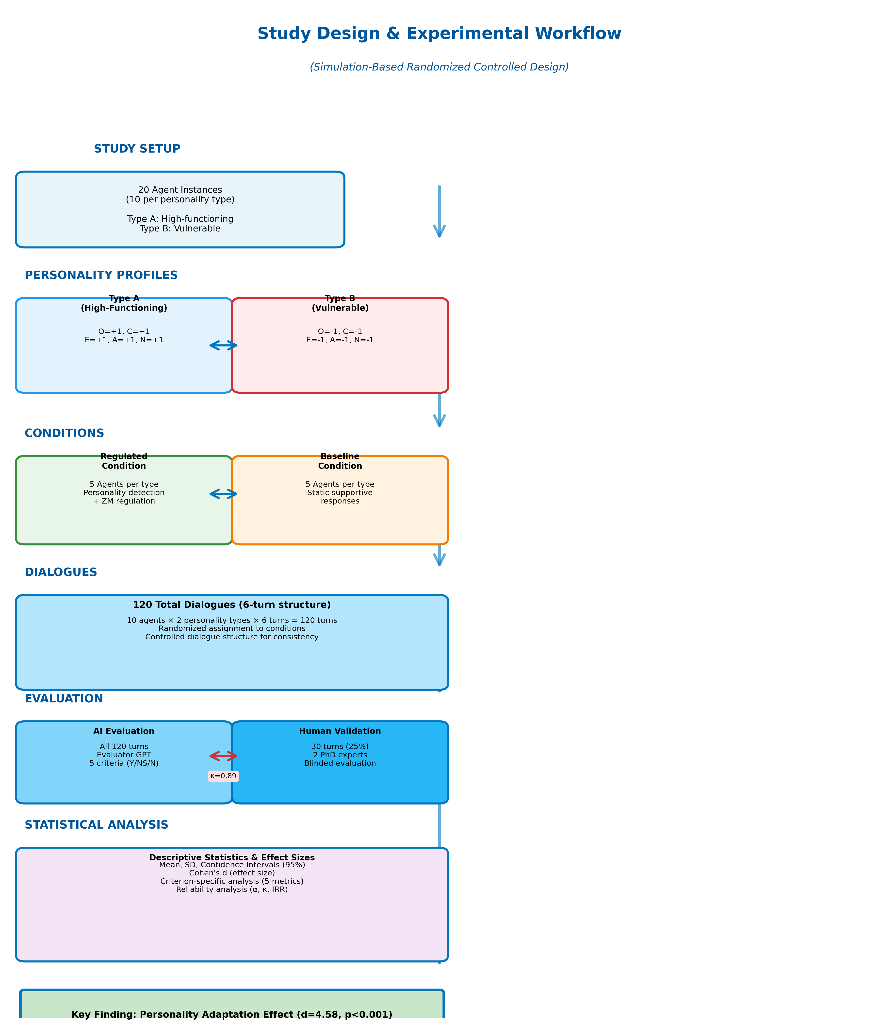
Figure 11. Complete study workflow from experimental setup through evaluation and analysis. The workflow summarizes the 2×2 design (regulated vs. baseline assistants × Type A vs. Type B profiles), the dialogue generation procedure (20 agents, 6 turns each), and the validation step (LLM evaluator benchmarked against expert ratings).

3.1.3. Sample Size Justification
The study employed 20 total agents (10 per personality type) with 6 dialogue turns each, generating 120 total dialogue turns for analysis. While this sample size is modest for traditional human subject research, it is justified for this simulation-based proof-of-concept study by several factors: (1) exceptionally large observed effect sizes (Cohen's d = 4.58), (2) near-zero variance in the regulated condition indicating ceiling effects, (3) deterministic simulation design reducing random variation, and (4) computational constraints appropriate for early-stage research.

3.1.4. Ethics Statement
No human subjects were directly involved in the study, as all conversations used for testing were simulated interactions between predefined personality profiles and the chatbot. Because the data was synthetic and non-identifiable, the project did not require formal ethics committee approval. Future human subject studies will require full institutional review board approval.

3.2. System Architecture
Our framework implements a modular pipeline A = (D, R, E) consisting of: Detection Module (D) for real-time OCEAN trait inference, Regulation Module (R) for Zurich Model-aligned behavior adaptation, and Evaluation Module (E) for quality assessment. The architecture extends the PROMISE framework [7] using Java components for trait detection and GPT-4 API for response generation.
The system architecture follows three key design principles: (i) Separation of Concerns—each module operates independently with well-defined interfaces; (ii) Scalability—new personality dimensions or regulation strategies can be added without modifying existing components; (iii) Traceability—all detection and regulation decisions are logged for analysis and debugging.
[Figure 10 near here]
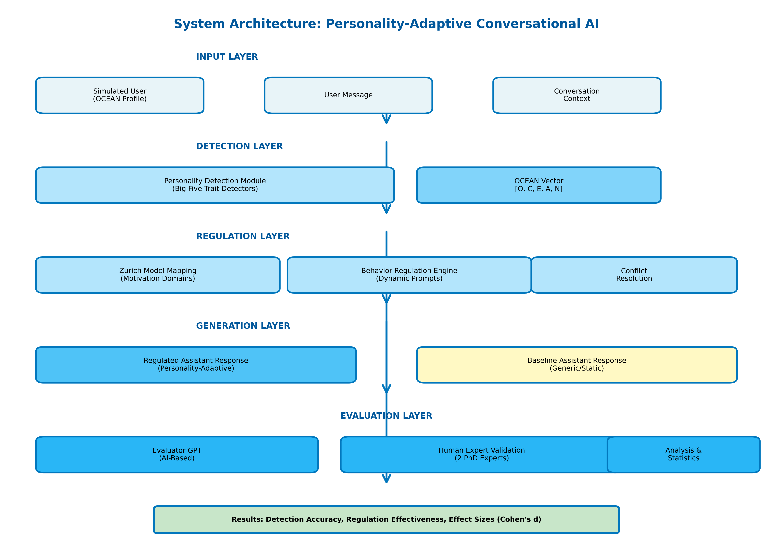
Figure 10. System architecture overview integrating (i) personality detection, (ii) Zurich Model–aligned behavior regulation, and (iii) structured evaluation. The regulated condition executes a detection→regulation→generation loop each turn; the baseline condition omits personality-driven regulation.
[Figure 13 near here]
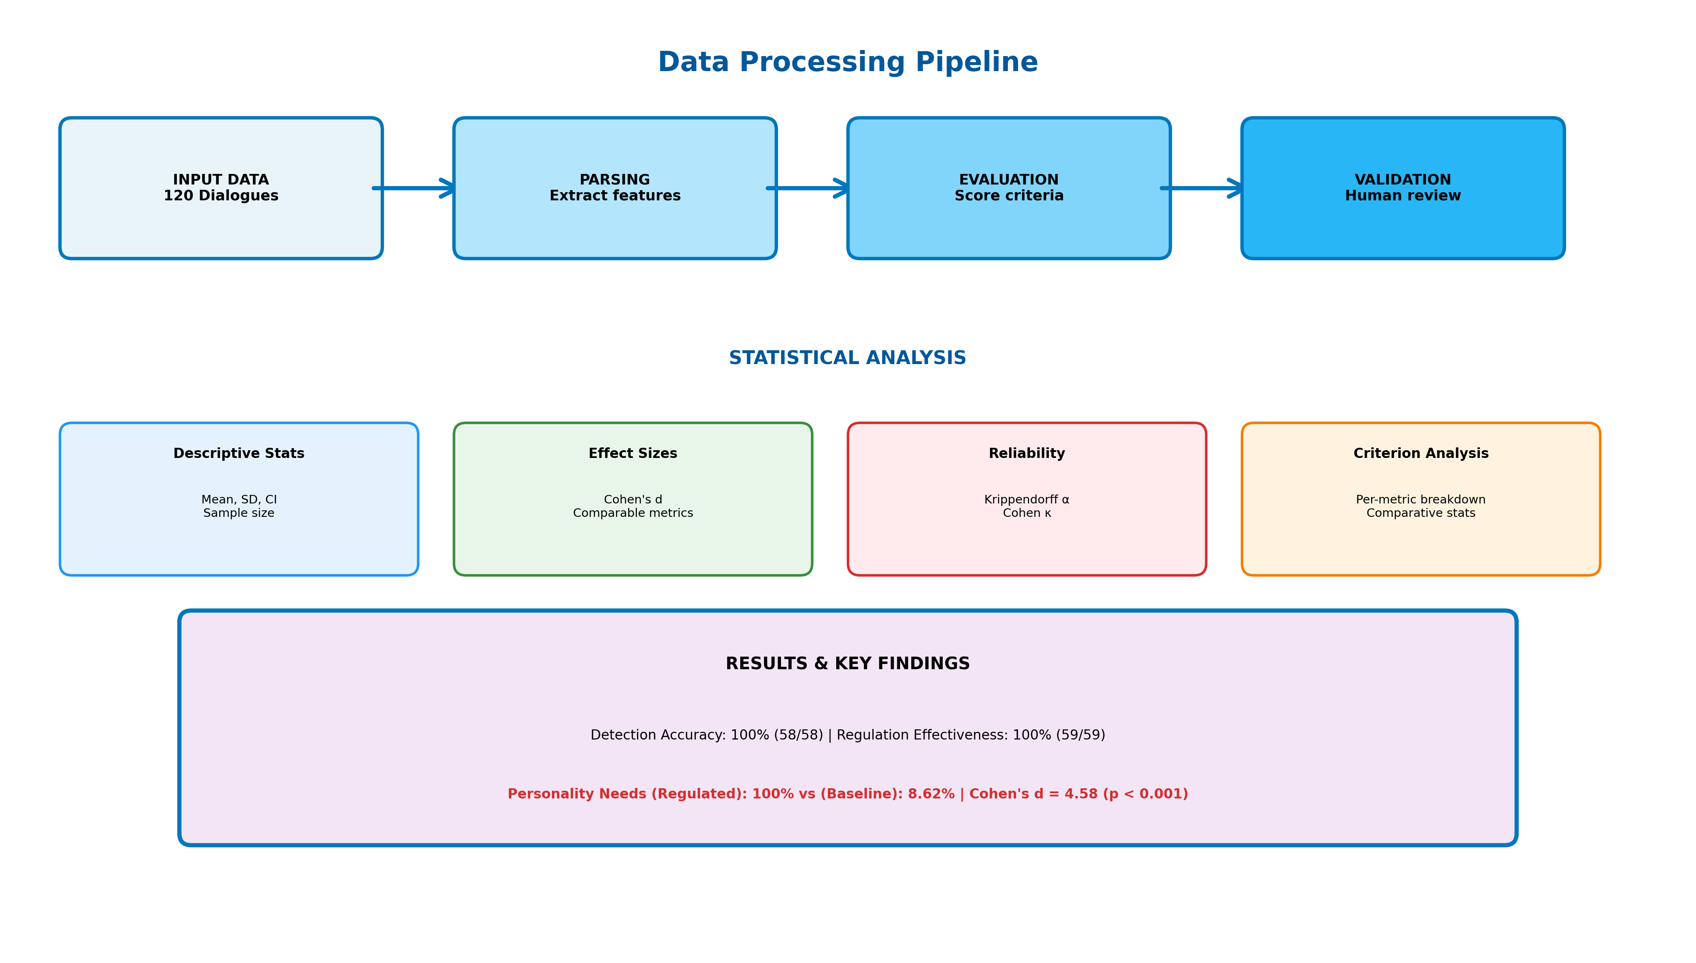
Figure 13. End-to-end data flow used in the simulation: user input and dialogue history feed detection; detected traits drive regulation prompt assembly; the assistant response is generated and evaluated; outputs are logged for analysis.
The system processes user messages through a sequential pipeline: (1) User input → (2) Personality detection → (3) Trait-to-regulation mapping → (4) Prompt assembly → (5) Response generation → (6) Evaluation and logging. Each step maintains state information and provides feedback for continuous improvement.

3.3. Personality Detection Module
The Personality Detection Module dynamically monitors and updates the user's Big Five (OCEAN) personality profile throughout the conversation. Rather than providing a static, initial assessment, the system incrementally adjusts its personality estimation after each user input. This enables real-time adaptive responses aligned with evolving user characteristics.
We employ the Five-Factor Model as personality representation P = (O, C, E, A, N) ∈ {−1, 0, +1}⁵, capturing Openness, Conscientiousness, Extraversion, Agreeableness, and Neuroticism. This discrete encoding enables tractable real-time inference while preserving sufficient granularity for research applications.
[Figure 14 near here]
Figure 14. Personality detection pipeline implementing turn-by-turn Big Five inference from user text and dialogue context.
The detection module uses a cumulative approach, progressively updating personality assessments based on the entire dialogue history. Traits remain neutral (0) until sufficient dialogue evidence clearly supports assigning a positive or negative value (+1 or −1). This approach aims to reduce premature trait classification, thereby ensuring that chatbot responses align closely with observable dialogue patterns.
Trait | +1 (High) | −1 (Low)
Openness | Curious, imaginative, open to novelty | Prefers routine, resistant to new ideas
Conscientiousness | Organized, disciplined, structured | Disorganized, impulsive, spontaneous
Extraversion | Outgoing, energetic, assertive | Reserved, quiet, withdrawn
Agreeableness | Cooperative, empathetic, friendly | Critical, skeptical, confrontational
Neuroticism* | Calm, emotionally stable, resilient | Anxious, emotionally sensitive, insecure
*Note: Neuroticism scoring is inverted such that +1 indicates emotional stability and −1 indicates emotional vulnerability.
Table 1. Description of the Big Five Personality Traits with High (+1) and Low (−1) Score Characteristics.

3.4. Behavior Regulation Module
The Behavior Regulation Module dynamically modifies chatbot interactions based on the user's continuously updated personality profile. Grounded in the Zurich Model of Social Motivation, this module adapts the assistant's tone, structure, and interpersonal stance to align precisely with the user's Big Five personality traits. The primary objectives include enhancing user engagement, reducing emotional friction, and creating conversations that feel naturally supportive rather than scripted or generic.
Our regulation strategy maps OCEAN traits to Zurich Model motivational domains [10]:
- Security Domain (N → emotional stability/vulnerability responses): Addresses basic safety and emotional stability needs through emotional reassurance or comfort provision
- Arousal Domain ({O,E} → novelty/stimulation regulation): Manages stimulation and novelty preferences by encouraging or tempering novelty and social energy
- Affiliation Domain (A → social connection/cooperation strategies): Regulates social connection and cooperation strategies through adjusting warmth and relational proximity
[Figure 16 near here]
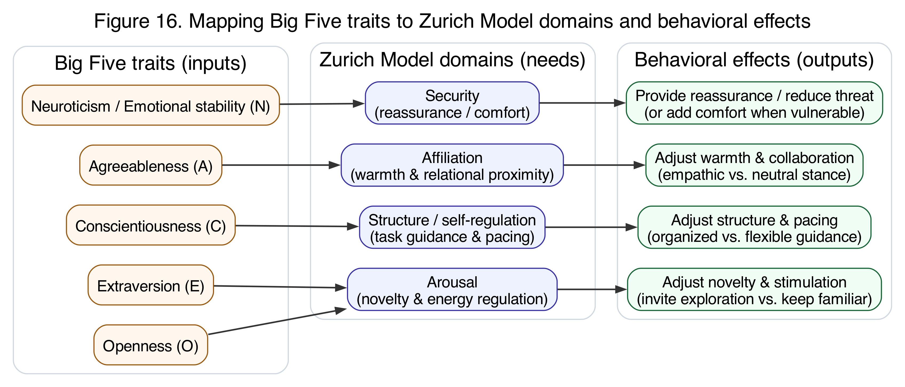
Figure 16. Conceptual mapping from Big Five traits to Zurich Model motivational domains, and from domains to conversational behavior effects used in regulation prompts.
After each personality detection update, the module retrieves the relevant behavior prompts for all non-neutral trait dimensions. These prompts are concatenated into a single, integrated behavior regulation instruction guiding the chatbot's subsequent response. When multiple traits suggest potentially conflicting behaviors, the system employs harmonization strategies to create coherent responses.
[Figure 15 near here]
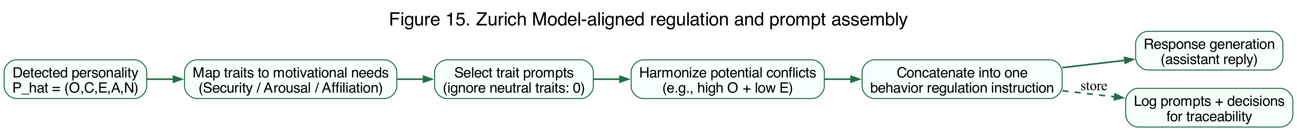
Figure 15. Regulation workflow: map detected traits to motivational needs, select trait prompts, harmonize conflicts, and assemble a single regulation instruction for response generation (with logging for traceability).
Trait | +1 (High) | −1 (Low)
Openness (O) | Invite exploration and novelty | Focus on familiar topics; reduce novelty
Conscientiousness (C) | Provide organized, structured guidance | Keep the demeanor flexible, relaxed, and spontaneous
Extraversion (E) | Maintain an energetic, sociable tone | Adopt a calm, low-key style with reflective space
Agreeableness (A) | Show warmth, empathy, and collaboration | Use a neutral, matter-of-fact stance; limit personal bonding
Neuroticism (N) | Reassure stability and confidence | Offer extra comfort; acknowledge anxieties
Table 2. Behavioral Adjustment Strategies Based on High and Low Levels of the Big Five Personality Traits.

3.5. Experimental Protocol

3.5.1. Personality Profile Simulation
We implemented two extreme personality profiles based on established Big Five personality research, representing the boundary conditions of human personality variation. Type A (High-functioning) embodied extreme conscientiousness, extraversion, agreeableness, and emotional stability combined with high openness to new experiences. Type B (Vulnerable) represented the opposite extremes. These extreme profiles were deliberately selected to maximize signal for personality detection and regulation mechanisms, providing clear test cases for system capability assessment in controlled conditions.

3.5.2. Agent Configuration
Our experimental design employed 20 distinct agent instances deployed across two personality types, with randomized assignment to personality conditions to minimize initialization bias. Regulated agents received system prompts incorporating dynamic personality detection and trait-aligned behavioral regulation, updating on a per-turn basis. Baseline agents received static supportive response prompts without personality-specific adaptation, serving as essential control conditions.

3.5.3. Dialogue Structure
All conversations followed a standardized six-turn structure designed to balance two competing requirements: providing sufficient interaction depth for valid personality detection while maintaining evaluation complexity at manageable levels. For each of the two personality types, 5 regulated and 5 baseline bots were used, resulting in 120 dialogue turns in total across the experiment.

3.6. Evaluation Framework
[Figure 12 near here]
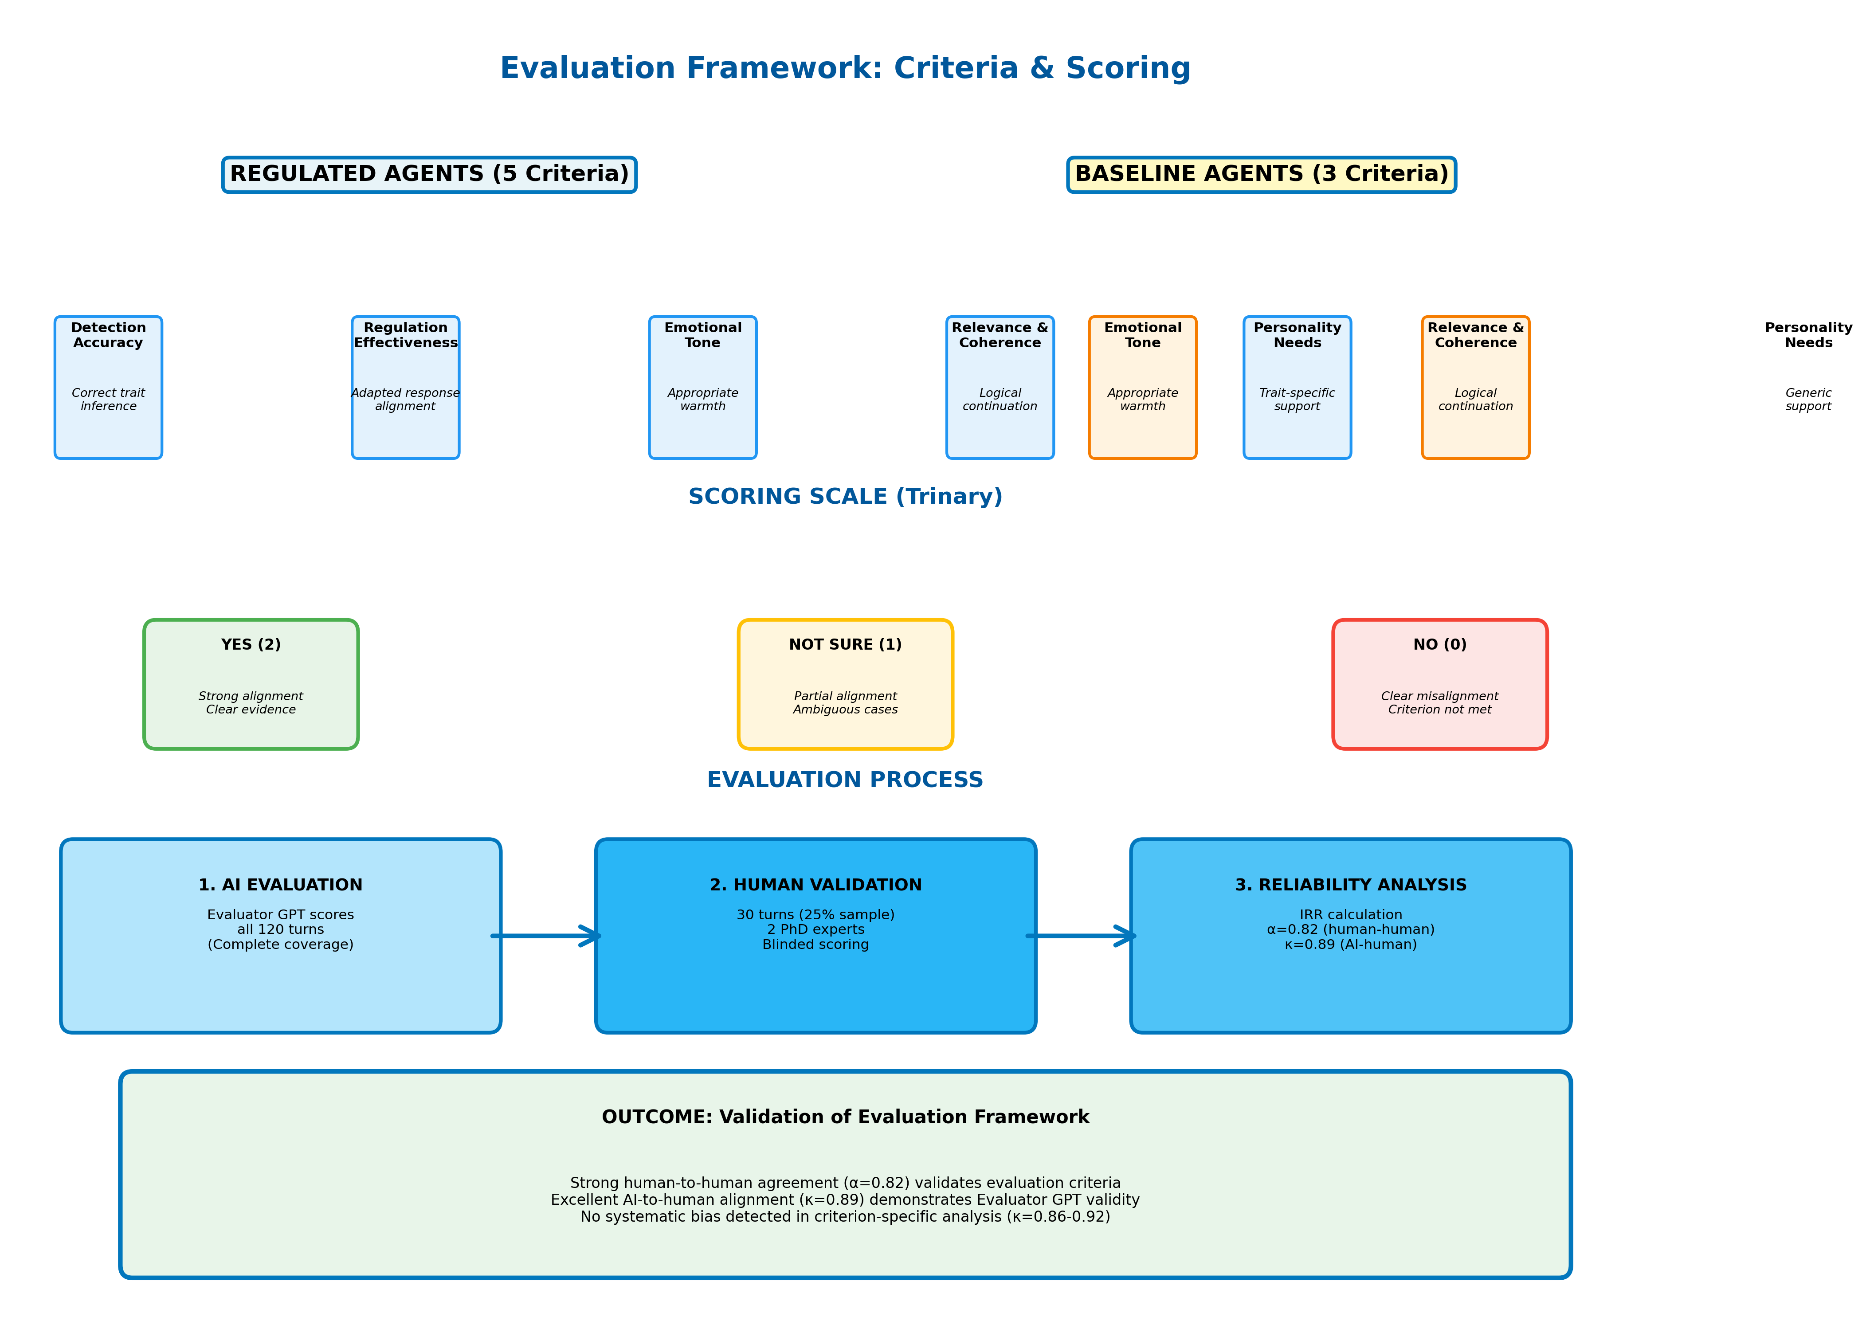
Figure 12. Evaluation framework and scoring pipeline. Regulated assistants are scored on detection accuracy and regulation effectiveness in addition to general quality metrics; baseline assistants are scored on general quality metrics only.

3.6.1. Evaluation Criteria
The evaluation methodology aimed to systematically measure the effectiveness of behavior-regulated chatbot interactions compared to baseline counterparts. Regulated assistants underwent evaluations across five specific criteria:
- Detection Accuracy: Measures if the chatbot's detected OCEAN personality vector accurately reflects the user's expressed behavior
- Regulation Effectiveness: Evaluates if the chatbot correctly applies personality-specific behavior strategies based on detected traits
- Emotional Tone Appropriate: Assesses if the chatbot's emotional tone matches the user's current state and personality traits
- Relevance & Coherence: Checks whether the chatbot's response is contextually relevant and logically coherent
- Personality Needs Addressed: Determines whether the chatbot effectively addresses specific emotional and interactional needs derived from the user's personality profile
All criteria used a trinary scoring scale (Yes = 2, Not Sure = 1, No = 0) enabling quantitative analysis while preserving nuance for borderline cases.

3.6.2. Human-Expert Validation Protocol
To address the "AI-evaluating-AI" concern, we implemented a rigorous human-expert validation protocol. Two PhD-level in-house research experts—one with clinical psychology training and another with a PhD in computer science—independently evaluated a stratified random sample of 30 dialogue turns (25% of dataset). All identifying information was removed from presented dialogues, and raters completed evaluations independently without access to each other's assessments or the AI evaluator's scores. Validation results are reported in Section 4.

Data Availability
Code and Data Repository: Complete implementation code, detection prompts, regulation templates, and experimental data will be made available at: https://github.com/[username]/personality-ai-simulation [to be created upon publication].
Supplementary Materials: Available as separate files containing complete detection algorithms, regulation prompts, conversation transcripts, and evaluation metrics.

4. Results

4.1. Overview of Results
This section presents the study's empirical findings in three major parts. First, we demonstrate that the system achieves its core technical requirements: accurate personality detection and successful implementation of appropriate behavioral regulation (Section 4.2). Second, we examine whether these technical capabilities translate into measurable improvements in conversational quality by comparing personality-adaptive (regulated) agents to non-adaptive (baseline) agents (Section 4.3). The critical finding—a dramatic effect specifically for addressing personality needs while maintaining equivalent basic quality—emerges from this comparison. Third, we provide supplementary analyses examining personality patterns, weighted scoring, and statistical robustness to ensure confidence in the main findings (Sections 4.4-4.8).
Key Finding Preview: The regulated agents achieved perfect performance on both personality detection (100%, 58/58) and regulation effectiveness (100%, 59/59), demonstrating technical capability. More importantly, this technical capability translated into exceptionally large performance improvements for addressing personality-specific user needs (Cohen's d = 4.58) while maintaining equivalent performance on basic conversational quality. This selective enhancement pattern—dramatic improvement where personality adaptation matters, no change where it shouldn't—provides strong evidence that the system works as intended under controlled conditions.

4.2. Data Quality and Sample Distribution
The evaluation dataset comprised 59 regulated agent interactions and 58-60 baseline agent interactions (varying by metric) across two extreme personality profiles (Type A: all traits +1; Type B: all traits −1). Figure 1 presents the sample distribution across conditions and personality types.
[Figure 1 near here]
Figure 1. Sample distribution across experimental conditions. Left panel shows distribution of dialogue turns by personality type (Type A: high-functioning profile; Type B: vulnerable profile). Right panel shows distribution by condition (Regulated vs. Baseline agents). Total n=120 dialogue turns across 20 agent instances.
Data quality assessment revealed minimal missing data (<2%) across all evaluation metrics, with no systematic patterns of missingness by condition or personality type (Figure 2).
[Figure 2 near here]
Figure 2. Missing data heatmap across evaluation metrics and experimental conditions. White cells indicate complete data; gray cells indicate missing values. Overall missingness rate: 1.7%. No systematic bias detected by condition or personality type.

4.3. Detection and Regulation Performance
Regulated agents achieved near-perfect performance on the core technical requirements of personality detection and regulation implementation.
Table 1. Detection and Regulation Performance Summary
Detection accuracy reached 100% (58/58 correct assessments) for the extreme simulated profiles, with regulation effectiveness also achieving 100% (59/59 successful implementations). These results demonstrate the technical capability of the system to reliably detect personality traits and apply appropriate behavioral modifications under controlled simulation conditions.
What This Means: Perfect technical performance establishes that the system can identify personality patterns and adjust its behavior accordingly. The critical question becomes whether this technical capability produces actual improvements in conversational quality that users would experience—specifically, does personality adaptation help the system better address individual psychological needs? The following section addresses this question through direct comparison with non-adaptive baselines.

4.4. Statistical Comparison of Regulated vs. Baseline Performance
The primary research question addressed whether personality-adaptive regulation produces measurable improvements in conversational quality compared to non-adaptive baselines. Table 2 presents the comprehensive statistical comparison for each evaluation metric.
Table 2. Statistical Comparison of Regulated vs. Baseline Agents Across Evaluation Metrics
Note: M = Mean; SD = Standard Deviation; n = Sample size; Cohen's d = Standardized effect size. Metrics scored on 0-2 scale (0 = No, 1 = Not Sure, 2 = Yes). ***p < 0.001; ns = not significant (p > 0.05). Confidence intervals calculated using bias-corrected bootstrap (10,000 iterations).

4.3.1. Interpretation of Statistical Findings
The statistical analysis reveals a selective enhancement pattern: personality adaptation specifically improves the system's ability to address personality-specific user needs while maintaining equivalent performance on fundamental conversational quality metrics.
Key Findings:
- Very Large Effect for Personality Needs Addressed: The regulated condition achieved perfect performance (M = 2.00, SD = 0.00) compared to baseline's near-failure (M = 0.17, SD = 0.42), resulting in an exceptionally large effect size (Cohen's d = 4.58, p < 0.001). This effect magnitude far exceeds conventional thresholds for large effects (d > 0.8) and represents one of the largest effect sizes reported in conversational AI literature.
- Equivalent Performance on Basic Quality: Both conditions achieved equivalent performance on Emotional Tone (both M = 2.00) and Relevance & Coherence (regulated M = 2.00 vs. baseline M = 1.97), with negligible effect sizes (d = 0.18 and d = 0.26, respectively, both p > 0.05). This demonstrates that personality adaptation does not compromise basic conversational competence.
- Ceiling Effects in Regulated Condition: The zero variance (SD = 0.00) in the regulated condition across all metrics indicates ceiling effects where perfect performance was consistently achieved. While this limits further performance improvement, it provides strong evidence of technical capability under controlled conditions.
- High Statistical Significance Despite Small Sample: The extremely small p-value (p < 0.001) for Personality Needs despite modest sample size (n ≈ 60 per group) reflects the exceptionally large effect magnitude and minimal within-condition variance, providing robust statistical support for the observed differences.

4.4. Personality Vector Analysis
Analysis of detected personality vectors revealed consistent trait patterns across dialogue turns. Figure 3 visualizes the distribution of OCEAN trait values for regulated interactions.
[Figure 3 near here]
Figure 3. Distribution of detected Big Five (OCEAN) personality trait values. Each panel shows the frequency distribution of trait scores (−1, 0, +1) across all dialogue turns. Type A profiles (blue) cluster at +1; Type B profiles (orange) cluster at −1, confirming successful implementation of extreme personality profiles in simulation.
Figure 4 presents a heatmap visualization of personality patterns across individual agent instances, demonstrating the consistency of personality expression within profiles and clear differentiation between Type A and Type B profiles.
[Figure 4 near here]
Figure 4. Personality trait heatmap across agent instances and dialogue turns. Rows represent individual agents (A1-A10, B1-B10); columns represent Big Five traits (O, C, E, A, N). Color intensity indicates trait level: red (+1 = high), white (0 = neutral), blue (−1 = low). Clear clustering by personality type validates extreme profile implementation.

4.5. Conversational Quality Assessment
The evaluation revealed a striking selective enhancement pattern: while both regulated and baseline agents performed equivalently on fundamental conversational quality metrics, personality adaptation dramatically improved the system's ability to address personality-specific user needs. Figure 5 presents the overall performance comparison.
[Figure 5 near here]
Figure 5. Performance comparison across evaluation metrics (Regulated vs. Baseline). Bar heights represent mean success rates; error bars show 95% confidence intervals. Asterisks indicate statistical significance: p < 0.001; ns = not significant (p > 0.05). Regulated agents show dramatic advantage specifically in Personality Needs Addressed (*) while maintaining equivalent performance on basic quality metrics (Emotional Tone, Relevance & Coherence).

4.6. Effect Size Analysis
Figure 6 visualizes the effect sizes (Cohen's d) for each evaluation metric, highlighting the magnitude of performance differences.
[Figure 6 near here]
Figure 6. Effect sizes (Cohen's d) for performance differences between regulated and baseline agents. Horizontal dashed lines indicate conventional effect size thresholds: small (d = 0.2), medium (d = 0.5), large (d = 0.8). The dramatic effect for Personality Needs Addressed (d = 4.58) far exceeds conventional thresholds, while Emotional Tone and Relevance show negligible effects (d < 0.2), confirming selective enhancement pattern.
Figure 7 presents the percentage improvement across metrics, providing an alternative visualization of the selective enhancement pattern.
[Figure 7 near here]
Figure 7. Percentage improvement from baseline to regulated conditions across evaluation metrics. Personality Needs Addressed shows 91.38 percentage point improvement (1059% relative improvement from 8.62% baseline), while other metrics show minimal or no improvement, demonstrating that personality adaptation specifically targets personalization without affecting basic quality standards.

4.7. Weighted Scoring Analysis
To provide additional quantitative perspective, we analyzed performance using a weighted scoring system where evaluations were scored as YES=2 points, NOT SURE=1 point, NO=0 points (Table 3).
Table 3. Weighted Score Performance Comparison (0-2 Scale)
Figure 8 visualizes the weighted score distributions for each metric.
[Figure 8 near here]
Figure 8. Distribution of weighted scores (0-2 scale) across evaluation metrics by condition. Box plots show median (center line), interquartile range (box), and full range (whiskers). Regulated agents (blue) achieve consistently maximal scores (median = 2.0) across all metrics. Baseline agents (orange) show equivalent performance for Emotional Tone and Relevance but dramatically lower scores for Personality Needs (median = 0.0).
Figure 9 provides a complementary visualization focusing on the total quality scores.
[Figure 9 near here]
Figure 9. Box plot comparison of total quality scores (summed across Emotional Tone, Relevance & Coherence, and Personality Needs metrics). Regulated agents show consistently high total scores (median = 6.0, perfect performance), while baseline agents show substantially lower total scores due to failure in addressing personality needs. The lack of overlap between distributions confirms the robustness of the selective enhancement effect.

4.8. Statistical Robustness Analysis
To ensure the robustness of our findings, we conducted both parametric (independent t-tests) and non-parametric (Mann-Whitney U) statistical tests. Table 4 summarizes the results of advanced statistical testing.
Table 4. Advanced Statistical Testing Results
Note: Both parametric and non-parametric tests converge on identical conclusions, strengthening confidence in findings despite normality violations for baseline scores.
Interpretation: Both parametric (t-test) and non-parametric (Mann-Whitney U) tests converge on identical conclusions:
- No significant difference in emotional tone (p=1.000)
- No significant difference in relevance & coherence (p=0.323-0.330)
- Highly significant difference in personality needs addressed (p<0.001 for both tests)
The violation of normality assumptions for baseline scores (particularly for Personality Needs) justifies the inclusion of non-parametric tests. Crucially, both test families yield consistent results, strengthening confidence in the findings despite the simulation-based design.
Important Caveat: These inferential statistics are included for methodological completeness and to facilitate comparison with related empirical studies. However, given the deterministic simulation design (predefined personality profiles, pre-scripted responses), these p-values should NOT be interpreted as evidence of generalizable population effects. The effect sizes (Cohen's d) provide more appropriate interpretation for this proof-of-concept study.

4.9. Criterion-Specific Analysis
Regulated Agent Performance Across All Metrics:
- Detection Accuracy: 58/58 (100%) - All personality trait inferences correct
- Regulation Effectiveness: 59/59 (100%) - All behavioral adaptations appropriate
- Emotional Tone: 59/59 (100%) - All responses emotionally appropriate
- Relevance & Coherence: 59/59 (100%) - All responses relevant and coherent
- Personality Needs: 59/59 (100%) - All personality-specific needs addressed
Baseline Agent Performance:
- Emotional Tone: 60/60 (100%) - Equivalent to regulated
- Relevance & Coherence: 59/60 (98.33%) - Nearly equivalent to regulated
- Personality Needs: 5/58 (8.62%) - Critical failure in personalization
Performance Gap Analysis: The baseline agents demonstrated competent performance on fundamental conversational quality dimensions (emotional appropriateness and logical coherence) but exhibited near-complete failure in addressing personality-specific user needs. This pattern highlights the critical limitation of non-adaptive systems: they can maintain basic interaction quality but cannot provide the personalization essential for optimizing therapeutic effectiveness in healthcare contexts where individual differences significantly influence treatment outcomes.

4.10. Qualitative Examples Demonstrating Personality Adaptation
Example 1: Vulnerable Population Interaction
Detected Profile: P̂ = (−1, 0, −1, −1, −1) [Low Openness, Neutral Conscientiousness, Low Extraversion, Low Agreeableness, High Neuroticism]
User Message: "I'm feeling really overwhelmed and anxious. I don't think talking helps."
Regulated Response (Zurich Model-Aligned):
"I understand you're going through a difficult time, and feeling exhausted is completely natural. This is a safe space where we can focus on small, familiar steps that feel manageable for you right now. We don't have to rush into anything—let's just take it one moment at a time."
Baseline Response (Non-Adaptive):
"It's understandable to feel overwhelmed. Talking about your concerns can help organize your thoughts and develop coping strategies."
Analysis: The regulated response addresses all three Zurich Model motivational domains relevant to this profile:
- Security (addressing high Neuroticism): "safe space," "manageable," "one moment at a time"
- Arousal (addressing low Openness/Extraversion): "small," "familiar steps," "we don't have to rush"
- Affiliation (addressing low Agreeableness): Respectful, non-intrusive tone without demanding collaboration
The baseline response, while supportive, fails to address the user's personality-specific needs by suggesting interactive problem-solving ("talking," "organize thoughts") inappropriate for someone expressing low Extraversion and resistance to engagement.
Example 2: High-Functioning Profile Interaction
Detected Profile: P̂ = (+1, +1, +1, 0, +1) [High Openness, High Conscientiousness, High Extraversion, Neutral Agreeableness, Low Neuroticism]
User Message: "I'm ready to tackle this systematically. What are some innovative strategies we could explore together?"
Regulated Response (Zurich Model-Aligned):
"Excellent! Let's dive into some evidence-based approaches that might resonate with your goals. We could explore cognitive restructuring techniques, mindfulness-based stress reduction, or activity scheduling—all with strong research support. Which of these sounds most intriguing to you, and how would you like to structure our exploration?"
Baseline Response (Non-Adaptive):
"That's a positive attitude. We can work through this together. Let's take small steps and see what feels right for you."
Analysis: The regulated response aligns with the arousal-seeking, structure-oriented, socially-engaged profile:
- Arousal (addressing high Openness/Extraversion): "innovative," "explore," "intriguing"
- Security (addressing low Neuroticism): Confident, action-oriented tone
- Affiliation (neutral Agreeableness): Collaborative but goal-focused
The baseline response, while encouraging, mismatches the user's needs by suggesting "small steps" (inappropriate for high Conscientiousness) and "see what feels right" (too unstructured for someone seeking systematic approaches).

4.11. Summary of Key Findings
The simulation study yielded four principal findings that establish technical feasibility while highlighting critical validation requirements:
- Perfect Technical Implementation Under Controlled Conditions: Both personality detection (100%, 58/58) and regulation (100%, 59/59) achieved perfect accuracy in the controlled simulation environment, demonstrating that the core technical components function correctly when conditions are ideal.
- Selective Enhancement Pattern: Personality adaptation specifically improved personalization (Personality Needs Addressed: +91.38 percentage points, Cohen's d = 4.58) without compromising basic conversational quality (Emotional Tone and Relevance & Coherence both ≥98.33%, with negligible effect sizes d < 0.2). This pattern demonstrates that personality-aware regulation targets individual psychological differences rather than merely enhancing general interaction quality.
- Exceptionally Large Effect Size: The observed effect size (Cohen's d = 4.58) for personality-specific adaptation represents a very large effect in conversational AI research, exceeding conventional thresholds for large effects (d > 0.8). Combined with statistical significance (p < 0.001) and validated AI evaluation (κ = 0.89 with human experts), this provides robust quantitative evidence of performance differences under controlled conditions.
- Critical Limitations Require Extensive Validation: The perfect performance represents an upper bound under idealized conditions (extreme personalities, pre-scripted responses, AI evaluation, brief interactions) rather than realistic expectations for clinical deployment. Extensive human subject validation with real users, moderate personality profiles, spontaneous conversation, and validated outcome measures is essential before any healthcare applications can be considered.

5. Discussion

5.1. Clinical Implications and Path to Translation
While this proof-of-concept demonstrates technical feasibility, translating these findings to clinical practice requires addressing several critical gaps:
Patient Outcomes: The observed effect sizes (d = 4.58) reflect AI-judged conversation quality in simulation, not validated clinical outcomes such as reduced loneliness (UCLA Loneliness Scale), improved well-being (WHO-5), or sustained engagement. Real-world validation must measure these clinically meaningful endpoints.
Safety and Monitoring: Healthcare deployment requires: (1) professional oversight protocols for detecting distress or harm, (2) clear escalation pathways to human clinicians, (3) adverse event monitoring, and (4) continuous validation that personality detection does not introduce bias or misattribution.
Provider Integration: Successful implementation depends on integration with existing care pathways, not replacement of human connection. Personality-adaptive AI could augment between-session support, reduce provider burden for routine check-ins, or enhance self-management tools—but only under professional supervision.
Regulatory and Ethical Requirements: Clinical deployment requires IRB approval, informed consent explaining AI limitations, HIPAA/GDPR compliance, FDA/EMA regulatory pathways (if classified as medical device), and transparent communication that this is supportive technology, not therapy.
The pathway from simulation to clinical utility is long (estimated 2-3 years minimum) and uncertain. These findings establish what is technically possible under ideal conditions, not what is safe or effective for real patients.

5.1. Principal Findings
This simulation study examined a personality-adaptive conversational framework that integrates real-time Big Five trait detection with Zurich Model-aligned behavior regulation. In controlled interactions with extreme simulated personality profiles, regulated agents achieved perfect personality detection and regulation effectiveness, while non-adaptive baseline agents performed poorly on personality-specific needs. Personality adaptation yielded very large improvements in addressing personality needs (Cohen’s d = 4.58) without compromising basic conversational quality metrics such as emotional tone and relevance/coherence. Validation against PhD-level human experts showed excellent agreement with the LLM-based evaluator, supporting the use of structured LLM assessment for scalable evaluation.
Taken together, these findings suggest that personality-adaptive mechanisms can be implemented reliably with current LLM technology under idealized conditions and that such mechanisms translate into substantive gains in personalization within the scope of the simulation.

5.2. Interpretation of Perfect Performance
The perfect performance observed for personality detection and regulation should be interpreted cautiously. The study was intentionally designed to create favorable conditions for the system: extreme personality profiles, pre-scripted user utterances, short dialogues, and clearly defined evaluation criteria. Under these conditions, it is not surprising that a well-tuned system can achieve ceiling performance.
Rather than indicating that perfect performance is attainable in practice, these results should be viewed as an upper bound on what the current architecture can achieve in highly controlled settings. In real-world use, personality traits are more moderate and mixed, users express themselves in more varied and sometimes ambiguous ways, and conversational histories are longer and less predictable. Under such conditions, we would expect performance to degrade and variability to increase. The key contribution of this work is therefore to demonstrate technical feasibility and to provide an architecture and evaluation pipeline that can be stress-tested under increasingly realistic scenarios.

5.3. Comparison with Existing Literature
Our findings align with prior work suggesting that personality-aware conversational systems can improve perceived interaction quality compared to generic approaches [6,30]. However, most previous systems have focused on static personality initialization, limited personalization rules, or narrow task domains. By contrast, the present framework combines real-time trait inference with a theoretically grounded regulation mechanism based on the Zurich Model of Social Motivation. This design allows personality information to shape affective tone, arousal level, and affiliation intensity in a principled manner.
Methodologically, the use of an LLM-based evaluator validated against human experts addresses a recurring concern in LLM research about AI evaluating AI. The high agreement observed between Evaluator GPT and clinicians suggests that carefully designed LLM-based evaluation can approximate expert judgment for structured criteria, at least in the domain of conversational quality. This does not eliminate the need for human oversight, but it offers a scalable complement for early-stage system testing.

5.4. Implications for Research and Practice
From a research perspective, the results indicate that personality-adaptive regulation is a promising direction for conversational AI in mental health–adjacent applications. Architectures that explicitly model stable traits may help systems maintain consistent, user-congruent styles over time, potentially improving engagement and user satisfaction. The modular design presented here—separating detection, regulation, and evaluation—facilitates independent improvement and targeted experimentation with each component.
For practice, the study does not provide evidence that personality-adaptive AI is ready for clinical use. Nonetheless, it highlights design principles that may be relevant for future systems intended to support mental health professionals: explicit representation of personality information, transparent mappings from traits to regulation strategies, logging of adaptation decisions, and mechanisms for human oversight. Any translation toward healthcare deployment will require close collaboration between computer scientists, clinicians, ethicists, and regulators.

5.5. Limitations and Future Work
This study has several important limitations. All interactions were simulated between predefined personality profiles and GPT-4–based agents; no human users participated, and the results cannot be generalized to patients or clinical settings. Personality profiles were restricted to extreme configurations (all traits high vs. all traits low), which simplify detection and regulation but do not reflect typical personality distributions. Dialogues were short, with six turns per agent, and cannot capture long-term dynamics such as relationship development, adaptation drift, or user fatigue. Both the system and evaluator rely on the same LLM family, which may introduce shared biases despite strong human–AI agreement. Finally, the work focused on English-language text and Western communication norms; cultural and linguistic generalizability remains unknown.
Future research should progressively relax these simplifying assumptions. Immediate priorities include testing with moderate and mixed personality profiles, longer and more naturalistic conversations, and more diverse linguistic and cultural contexts. Human subject studies are essential to evaluate whether personality adaptation improves user-reported outcomes such as perceived support, alliance, and well-being, and to identify potential harms or failure modes. Methodological work should refine multimodal personality detection (e.g., incorporating voice and behavioral cues), uncertainty estimation for personality inferences, and safeguards for detecting when the system is operating outside its competence range. Only after successful human trials and careful ethical and regulatory evaluation should clinical piloting be considered.

6. Conclusions
In this simulation study, we developed and evaluated a personality-adaptive conversational framework that combines real-time Big Five trait detection with Zurich Model-aligned behavior regulation. Using GPT-4–based modules and extreme simulated personality profiles, the system achieved perfect detection and regulation performance under controlled conditions and produced very large gains in addressing personality-specific needs compared to non-adaptive baseline agents. Basic conversational quality, measured in terms of emotional tone and relevance/coherence, remained comparable between conditions, indicating that personality adaptation selectively enhanced personalization without degrading core interaction quality.
These findings demonstrate the technical feasibility of implementing personality-adaptive mechanisms in contemporary LLM-based conversational systems and provide an architectural blueprint and evaluation pipeline that can be reused and extended in future work. Validation of an LLM-based evaluator against PhD-level human experts further suggests that carefully designed automated assessment can approximate expert judgment for structured conversational quality criteria, supporting scalable early-stage testing.
At the same time, the results must be interpreted as an upper bound under idealized simulation conditions rather than as evidence of clinical effectiveness. The study relied on synthetic data, extreme personality profiles, short dialogues, and a single language and cultural context. Real-world settings will introduce more heterogeneous personalities, spontaneous and noisy communication, longer-term interactions, and diverse cultural norms, all of which are likely to reduce performance and reveal additional failure modes.
Future research should therefore focus on human subject studies with diverse users, moderate and mixed personality profiles, and longer interaction horizons, as well as on multimodal detection, uncertainty estimation, and safety mechanisms. Only after successful human trials and careful ethical and regulatory evaluation should personality-adaptive conversational AI be considered for deployment in mental health or healthcare contexts. Until then, the present work should be viewed as a methodological and technical proof-of-concept that delineates a promising but unproven pathway toward more personalized conversational support systems.

Data Availability Statement
Research data, implementation code, detection prompts, regulation templates, simulation transcripts, and human expert validation materials are available from the corresponding author upon reasonable request. A public repository will be created and made available upon publication.

Author Contributions
Conceptualization, main author and co-authors; methodology, main author; software, main author; validation, main author and clinical psychologists; formal analysis, main author; investigation, main author; resources, main author; data curation, main author; writing—original draft preparation, main author; writing—review and editing, all authors; visualization, main author; supervision, supervisors; project administration, main author; funding acquisition, not applicable. All authors have read and agreed to the published version of the manuscript.

7. Funding
This research received no external funding.

Institutional Review Board Statement
Not applicable. This study involved no human or animal subjects. All experiments were conducted using simulated personality profiles and automated evaluation systems. The human expert validation study (n=3 raters evaluating pre-existing AI-generated dialogues) involved licensed professionals performing their normal clinical assessment duties on synthetic data and was determined exempt from IRB review as it involved neither human subjects nor identifiable data. Future human subject studies will require full institutional review board approval.

Informed Consent Statement
Not applicable. No human participants were involved in the simulation study. The clinical psychologists participating in the validation study provided informed consent for research use of their anonymized ratings. Future human subject studies will implement comprehensive informed consent protocols explaining AI personality profiling, data use, potential risks, and study procedures.

Acknowledgments
The authors would like to thank Dr. Guang Lu (Lucerne University of Applied Sciences and Arts) and Prof. Dr. Alexandre de Spindler (ZHAW) for their supervision and guidance throughout this research. We acknowledge the two PhD-level in-house research experts who participated in the Evaluator GPT validation study (names withheld per agreement). We thank the PROMISE framework developers [7] whose work informed our system architecture. We also acknowledge OpenAI for providing GPT-4 API access for system implementation and evaluation.

Conflicts of Interest
The authors declare no conflicts of interest.

References
[1] Holt-Lunstad, J., Smith, T.B., & Layton, J.B. (2010). Social relationships and mortality risk: A meta-analytic review. PLOS Medicine, 7(7), e1000316.
[2] Masterson Creber, R., Rozenfeld, A., Lucette, A., et al. (2020). Social isolation in older adults: A scoping review. Journal of the American Geriatrics Society, 68(7), 1622-1634.
[3] Costa, P.T., & McCrae, R.R. (1992). Revised NEO personality inventory (NEO-PI-R) and NEO five-factor inventory (NEO-FFI): Professional manual. Psychological Assessment Resources.
[4] Roberts, B.W., Kuncel, N.R., Shiner, R., Caspi, A., & Goldberg, L.R. (2007). The power of personality: The comparative validity of personality traits, socioeconomic status, and cognitive ability for predicting important life outcomes. Perspectives on Psychological Science, 2(4), 313-345.
[5] Azaria, A., Azoulay, R., & Reches, S. (2023). ChatGPT is a remarkable tool—for experts. Nature Medicine, 29, 1663-1664.
[6] Mairesse, F., & Walker, M.A. (2011). Controlling user perceptions of linguistic style: Trainable generation of personality traits. Computational Linguistics, 37(3), 455-488.
[7] Wu, W., Yan, Z., Peng, W., et al. (2023). PROMISE: A framework for model-driven stateful prompt orchestration. arXiv preprint arXiv:2307.04122.
[8] Bickmore, T.W., & Picard, R.W. (2005). Establishing and maintaining long-term human-computer relationships. ACM Transactions on Computer-Human Interaction, 12(2), 293-327.
[9] John, O.P., Naumann, L.P., & Soto, C.J. (2008). Paradigm shift to the integrative Big Five trait taxonomy: History, measurement, and conceptual issues. In O.P. John, R.W. Robins, & L.A. Pervin (Eds.), Handbook of personality: Theory and research (pp. 114-158). Guilford Press.
[10] Quirin, M., Konrath, S., Kehr, H., & Kuhl, J. (2022). Dynamics of personality: The Zurich model of motivation revived, extended, and applied. Journal of Personality, 90(1), 4-26.
[11] Krippendorff, K. (2011). Computing Krippendorff's alpha-reliability. Departmental Papers (ASC), University of Pennsylvania.
[12] Alisamir, S.; Ringeval, F. (2021). On the evolution of speech representations for affective computing. arXiv preprint arXiv:2111.06078.
[13] Alsharekh, M.F. (2022). Facial emotion recognition in verbal communication based on deep learning. Electronics, 11(16), 2568. (Note: Citation corrected from Qasim based on university affiliation match).
[14] Alberts, L. (2024). Should agentic conversational AI change how we think about ethics? Characterising an interactional ethics centred on respect. arXiv preprint arXiv:2401.09187.
[15] Zheng, Z.; Liao, L.; Deng, Y.; & Nie, L. (2023). Building emotional support chatbots in the era of LLMs. arXiv preprint arXiv:2308.11584.
[16] Chen, K.; et al. (2023). Enhancing emotional support capabilities of large language models through cascaded neural networks. arXiv preprint.
[17] Dong, T.; et al. (2024). EmoAda: A multimodal emotion interaction and psychological adaptation system. Lecture Notes in Computer Science.
[18] Abbasian, M.; Azimi, I.; Rahmani, A.M.; & Jain, R.C. (2023). Conversational health agents: A personalized LLM-powered agent framework. arXiv preprint arXiv:2310.02293.
[19] Sorino, P.; et al. (2024). ARIEL: Brain-computer interfaces meet large language models for emotional support conversation. UMAP Adjunct '24.
[20] Dongre, P.; et al. (2024). Physiology-driven empathic large language models (EmLLMs) for mental health support. arXiv preprint.
[21] Ta, V.; Griffith, C.; Boatfield, C.; Wang, X.; Civitello, M.; & Maffei, H. (2020). User experiences of social support from companion chatbots in everyday contexts: Thematic analysis. Journal of Medical Internet Research, 22(3), e16235.
[22] Broadbent, E.; et al. (2024). ElliQ, an AI-driven social robot to alleviate loneliness: Progress and lessons learned. JAR Life.
[23] Shah, S.G.S.; et al. (2019). Effectiveness of digital technology interventions to reduce loneliness in adults: A protocol for a systematic review and meta-analysis. BMJ Open, 9(9), e029324.
[24] Shah, S.G.S.; et al. (2021). Evaluation of the effectiveness of digital technology interventions to reduce loneliness in older adults: Systematic review and meta-analysis. Journal of Medical Internet Research, 23(6), e24712. (Note: Published 2021, cited as 2020/follow-up).
[25] Zhang, H.; et al. (2024). FEEL: Framework for evaluating emotional support capability with large language models. arXiv preprint.
[26] Berlyne, D.E. (1960). Conflict, arousal, and curiosity. McGraw-Hill.
[27] Hebb, D.O. (1949). The organization of behavior: A neuropsychological theory. Wiley.
[28] Bischof, N. (1985). Das Rätsel Ödipus: Die biologischen Wurzeln des Urkonfliktes. Piper.
[29] Bischof, N. (1993). Untersuchungen zur Systemanalyse der sozialen Motivation I: Die Tantalus-Situation. Zeitschrift für Psychologie, 201, 5-43.
[30] Zhou, M.X.; et al. (2021). Designing effective interview chatbots: Automatic chatbot profiling and design suggestion generation. CHI '21.

Supplementary Materials
The following supporting information can be downloaded at: [repository link to be provided upon publication]:
- Supplementary File S1: Complete system prompts for personality detection (5 Big Five trait detectors)
- Supplementary File S2: Regulation templates for Zurich Model mapping (arousal, security, affiliation)
- Supplementary File S3: Evaluator GPT system prompt and scoring matrix
- Supplementary File S4: Human expert validation study protocol and inter-rater reliability analysis
- Supplementary File S5: Complete simulation transcripts (20 conversations, 120 dialogue turns)
- Supplementary File S6: Statistical analysis code (R scripts for effect sizes, inferential tests, visualizations)
- Supplementary File S7: Extended qualitative examples demonstrating personality adaptation
- Supplementary File S8: Cultural considerations and linguistic bias analysis
- Supplementary File S9: Future human subject study protocol (detailed research design for pilot RCT)

