Personality-Adaptive Conversational AI for Emotional Support: A Simulation Study Integrating Big Five Detection with Zurich Model Regulation

Abstract
Abstract: Large language model agents are increasingly deployed to expand access to digital emotion support and mental health care by offering timely, low-cost conversational assistance. Yet, most current systems rely on generic communication strategies that overlook stable individual differences in personality, limiting their capacity to deliver personalized interventions aligned with personal psychological coping mechanisms. This study maps how personality-adaptive mechanisms integrate real-time Big Five personality trait detection with theoretically grounded regulation strategies based on the Zurich Model of Social Motivation.
Methods: We conducted a controlled study comparing a personality-adaptive system against a non-adaptive baseline across two extreme Big Five profiles: one very high and one very low on openness, conscientiousness, extraversion, agreeableness, and emotional stability under contrasting psychological conditions. The adaptive system integrated GPT-4-based modules for personality detection, regulation mapping, and evaluation. Conversational quality and personality alignment were evaluated by an LLM judge with responses rated by psychological experts on detection accuracy, regulation effectiveness, emotional tone, relevance and personality-specific emotional needs.
Results: Across the simulated conditions, the regulated system achieved near-perfect performance in personality detection and regulation effectiveness. The personality-adaptive agents demonstrated very large improvements in addressing personality-specific needs compared to baseline (M = 2.00 vs. 0.17 on a 0–2 scale; Cohen’s d = 4.58, p < 0.001), representing a >90% improvement in personalization, while maintaining comparable basic conversational quality (effect sizes d < 0.3, p > 0.05). Agreement between AI evaluator and human experts was excellent (Cohen’s κ = 0.89, 95% CI: 0.84–0.94), validating the evaluation approach. These results establish proof-of-concept under idealized conditions but do not constitute evidence for real-world effectiveness. Reported benefits included enhanced personalization, improved alignment with individual psychological needs, and validated evaluation methodology. However, recurring challenges such as reliance on extreme simulated profiles, pre-scripted interactions, brief conversations, and limited generalizability highlight the need for ethical design and human oversight.
Conclusion: By introducing a personality-adaptive framework, this simulation study offers a comprehensive overview of current applications and future directions in AI-augmented emotional support. It aims to guide researchers, clinicians, and policymakers in developing safe, effective, and equitable personality-adaptive digital mental health interventions.
Keywords: digital mental health; conversational agents; large language models; personality detection; Big Five; Zurich Model; adaptive interaction; emotional support; simulation study; GPT-4

1. Introduction
Despite major advances in economic and technological development, mental health and social well-being remain pressing global public health challenges. Loneliness and social isolation among older adults are particularly persistent concerns, contributing to morbidity and mortality risks comparable to obesity and approaching those of heavy smoking [1]. Demographic shifts such as population aging, dispersed families, bereavement, and declining community engagement further limit opportunities for meaningful social contact [2]. In Switzerland, as in many high-income contexts, a growing proportion of adults aged 75 and older live alone and are especially vulnerable to isolation [3]. These trends have intensified interest in scalable digital approaches that complement traditional services while providing accessible, timely social and emotional support.
Within this landscape, digital mental health tools and conversational assistants are being explored as mechanisms for increasing access to supportive interactions. However, most existing systems still rely on rule-based communication strategies that offer limited flexibility in addressing diverse user needs [4]. These systems operate with predefined scripts and fixed response templates, making their effectiveness variable and their supportive value constrained.
Recent advances in large language models (LLMs) have enabled more flexible, context-aware conversational AI applications capable of generating simulated empathy and emotionally relevant responses [8,9]. However, their supportive behaviors remain largely generic and one-size-fits-all, as they lack mechanisms for dynamically adapting to stable user characteristics. Although natural language processing techniques that parse user input, perform sentiment analysis, and incorporate recalled preferences are widely used, they typically provide only shallow personalization and often still rely on static assessments collected before interaction, rather than dynamically modeling and adapting to stable user traits ground in psychologocal principle.
To address these gaps, we developed a personality-adaptive conversational framework that integrates (i) real-time Big Five personality traits detection, (ii) behavior regulation grounded in the Zurich Model of Social Motivation, and (iii) a structured evaluation pipeline using automated LLM-based evaluation. The framework is implemented using GPT-4–based agents performs real-time detection of Big Five traits that continuously infers and updates stable trait estimates based on linguistic cues throughout conversation and response theory-guided behavioral adaptation.
The objective of this study is to determine whether real-time personality-adaptive behavior regulation, grounded in continuous inference of user traits from the Big Five framework, can enhance conversational quality, emotional alignment, and psychological attunement in chatbot–user interactions. Specifically, we implement and evaluate a real-time detection and regulation loop in which an adaptive AI assistant infers personality across multiple dialogue turns and adjusts its tone and behavioral style accordingly, and compare its effectiveness against static, non-adaptive baselines in delivering emotionally supportive interactions. moving beyond preliminary feasibility to workflow integration and reproducible we integrate this pipline into PROMISE, a framework building for interacte with LLM applications by orchestrate dynamic prompts across hierarchical states with attached conditions and actions and predictable language-model behavior in complex interactions. This design ensures precise control over interaction parameters, clear quantification of personalization effects, and a fully reproducible testbed for personality-adaptive conversational agents. It offers a solid methodological foundation to guide researchers, clinicians, and policymakers in developing safe, effective, and equitable AI-augmented mental health interventions.

2. Related Work
The development of personality-adaptive conversational AI represents a convergence of AI-driven digital interventions—leveraging multiple AI modalities including natural language processing (NLP), machine learning (ML), and large language models (LLMs)—with personality psychology and affective computing. These systems aim to not only process information but understand context, adapt to individual differences, and support personalized mental health care through personality-adaptive architectures. Within this paradigm, personality-adaptive systems represent a shift from reactive information processing toward dynamic personality modeling that captures stable individual differences in how humans perceive, process, and respond to emotional and social information.
This section traces the evolution from generic therapeutic support systems toward personality-adaptive AI architectures, building upon three interconnected research streams: (1) affective computing and emotion-aware systems, (2) conversational AI architectures including transformer-based LLMs, and (3) personality psychology theories that explain individual differences in emotional processing. We systematically review the state of the art in each domain before synthesizing critical gaps that motivate our investigation.

2.1. Affective Computing and Emotion Recognition
Early affective computing research established foundational techniques for recognizing emotional states from text, speech, and facial expressions [12,13]. Initial approaches relied heavily on categorical emotion models (e.g., happiness, sadness) before evolving toward dimensional representations that model affect distinct valence and arousal components. While these systems demonstrated the feasibility of detecting emotional signals, they face persistent challenges with generalization across individuals and contexts, often struggling with the subtle, mixed emotional expressions common in real-world interactions [12,13].
From a systems perspective, such signal-driven detection implements shallow affective modeling—recognizing surface-level emotional signals without accounting for the cognitive and motivational context. A critical limitation is the emphasis on transient emotional states rather than stable personality traits. Most work focuses on detecting what users are currently feeling (e.g., anxiety) to generate empathetic responses, but overlooks who the user is—specifically how stable personality differences shape emotional processing and regulation needs [6]. This reliance on transient state detection leaves a gap in understanding the stable architectural differences that determine effective support strategies.

2.2. Large Language Models in Mental Health
The emergence of large language models (LLMs) has transformed conversational AI capabilities, positioning them as powerful conversational AI engines capable of flexible reasoning, context integration, and natural language understanding [8,15,16]. These transformer-based generative models with billions of parameters (e.g., GPT-3.5/4) implement key cognitive functions—semantic memory, analogical reasoning, theory of mind inference—through learned statistical patterns over vast text corpora, enabling free-text generation, contextual memory, and zero-shot reasoning. Recent systems leverage these capabilities for therapeutic support through various architectural approaches: dialogue state tracking to maintain conversation context [15], cascaded neural networks to enhance empathy generation [16], and multimodal integration combining text, audio, and physiological signals [17,19,20].
Despite these advances, current LLM-based therapeutic support systems frequently exhibit a “one-size-fits-all” limitation. While they generate contextually appropriate empathetic responses, they typically adapt to the immediate context rather than the user’s stable psychological profile. Without mechanisms to build and maintain persistent personality models, these systems cannot maintain the long-term consistency or psychological attunement required for effective therapeutic allegiance.
Beyond content limitations, deploying LLMs in complex conversational scenarios—such as multi-turn personality inference—requires robust orchestration frameworks that balance flexibility with predictable behavior control. Traditional imperative prompt engineering approaches struggle to maintain coherence across extended dialogues, particularly in safety-critical domains like mental health support where behavioral reliability is paramount. Recent work has introduced model-driven orchestration frameworks to address these challenges. The PROMISE framework [7] (PROMpt orchestration for Interactive StatE machines) enables dynamic prompt assembly through hierarchically nested states and explicit transition logic, providing structured control mechanisms for managing complex dialogue flows while maintaining prompt consistency. Such declarative orchestration approaches offer advantages for applications requiring audit trails, reproducible conversational behaviors, and systematic testing—properties essential for personality-adaptive mental health interventions deployed under clinical oversight.

2.3. AI Companions and Digital Interventions
Commercial AI companions and research prototypes have demonstrated the potential of conversational agents to reduce loneliness and provide accessible mental health support [21–24]. For example, Replika has engaged millions of users seeking emotional companionship, while Woebot—a cognitive behavioral therapy (CBT)-based chatbot—has shown effectiveness in reducing symptoms of depression and anxiety in college students through structured therapeutic conversations. ElliQ, a proactive AI companion designed for older adults, has demonstrated promising results in combating social isolation through personalized engagement and activity suggestions. Systematic reviews indicate that digital interventions can produce modest but significant reductions in loneliness among older adults, with effect sizes ranging from small to moderate (d = 0.2–0.5) [23,24].
However, recurring challenges limit the effectiveness of current AI companions. Most existing systems rely on fixed interaction strategies or limited personalization based on explicit user preferences (e.g., preferred topics, communication frequency). Broadbent et al. [22] describe ElliQ’s approach to combating loneliness through proactive engagement and activity suggestions, but note that the system uses rule-based personalization rather than dynamic personality adaptation. This static approach creates a fundamental mismatch: while users’ emotional states fluctuate and conversational patterns evolve, the system’s interaction style remains fixed, potentially limiting the depth of therapeutic rapport.

2.4. Personality-Aware Dialogue Systems
A small but growing body of research has explored personality-aware dialogue systems. Early work by Mairesse and Walker [6] demonstrated that adapting linguistic style to match user personality traits (based on the Big Five model) improves perceived naturalness and engagement, with personality-matched systems achieving significantly higher user ratings compared to mismatched or generic systems. Zhou et al. [30] extended this approach to interview chatbots, showing that automatic personality profiling can guide design decisions for more effective conversational agents, with profiling-informed designs yielding improved user satisfaction and task completion rates.
However, these systems typically rely on static personality inputs—either explicitly provided by users or inferred once at the beginning of interaction [6,30]. This approach has two critical limitations: (1) it requires users to complete personality assessments before interaction, creating friction and potential dropout, and (2) it cannot adapt to evolving understanding of user personality as more conversational evidence accumulates. This static profiling approach fails to capture the dynamic nature of human social cognition, where mental models of others are continuously refined through interaction.

2.5. Theoretical Foundations in Social Motivation
While computational approaches to personality-aware dialogue have advanced, they often lack grounding in cognitive-motivational theory that explains why personality traits should influence conversational behavior and how they should be translated into specific adaptations. The Zurich Model of Social Motivation [10,26–29] provides this theoretical foundation by linking Big Five personality traits to three fundamental cognitive-motivational systems: security (processing oriented toward threat detection and safety maintenance), arousal (processing oriented toward novelty-seeking and stimulation), and affiliation (processing oriented toward social connection and cooperation).
The Zurich Model builds on earlier motivation theories [26,27] and Bischof’s systems analysis of social motivation [28,29], proposing that personality traits reflect stable individual differences in the cognitive architecture governing motivational balance between these systems. Despite its theoretical richness, the Zurich Model has not been widely operationalized for conversational AI. Existing personality-aware dialogue systems lack explicit mappings from personality traits to motivational domains, instead relying on ad-hoc adaptation rules or learned associations from data. This limits both the interpretability of system behavior and the ability to leverage psychological theory to guide design decisions.

2.6. Challenges in Evaluating LLM-Based Interventions
A persistent methodological challenge in LLM-based conversational AI research is evaluation validity. Traditional approaches rely on human expert ratings, which provide gold-standard assessments but are expensive, time-consuming, and difficult to scale [25]. Recent work has explored LLM-based evaluation as a scalable alternative (e.g., the FEEL framework [25]), demonstrating that structured LLM-based evaluation can correlate with human judgments. However, this raises concerns about circular validation: using AI to evaluate AI-generated outputs may introduce systematic biases that inflate performance metrics [5]. Azaria et al. [5] caution that LLM-based tools are most reliable when used by domain experts who can critically evaluate outputs rather than accepting them uncritically. This creates a need for rigorous validation protocols that combine the scalability of AI evaluation with the validity assurance of independent expert ratings.

2.7. Synthesis of Gaps and Study Contributions
Our systematic review reveals three critical gaps in current AI-driven mental health support, which this study addresses through a novel personality-adaptive framework integrated within the PROMISE orchestration system [7]:
- Static vs. Dynamic Modeling Gap: Existing systems predominantly rely on static personality profiles initialized before interaction, failing to capture the dynamic nature of human trait inference.
  - Our Contribution: We implement dynamic personality modeling as a continuous trait inference process. Unlike static profiling, our system continuously updates Big Five trait estimates based on linguistic cues throughout the interaction, mirroring human social cognition and allowing the system to refine its understanding as conversational evidence accumulates.
- Theoretical Gap: Current approaches lack deep cognitive-motivational grounding, often mapping traits to surface-level linguistic style rather than underlying motivational systems.
  - Our Contribution: We operationalize a theoretically grounded architecture based on the Zurich Model of Social Motivation. We explicitly map detected Big Five traits to behavioral adaptations across security, arousal, and affiliation domains, ensuring that adaptations are driven by established psychological principles rather than ad-hoc rules.
- Methodological Gap: While model-driven orchestration frameworks like PROMISE [7] provide technical infrastructure for controlling LLM behavior, there is an absence of reproducible, theoretically grounded implementations that integrate personality psychology with rigorous evaluation validated against human expert judgment.
  - Our Contribution: We establish validated assessment rigor by leveraging PROMISE’s state machine orchestration to implement a reproducible personality-adaptive system with hybrid evaluation. We combine the scalability of an LLM-based evaluator with the validity assurance of independent ratings from PhD-level clinical psychology and computer science experts, demonstrating strong agreement (Cohen’s κ = 0.89) to provide a validated methodological template that bridges orchestration frameworks, personality theory, and empirical evaluation.
By integrating these elements into a reproducible testbed, this study aims to move beyond preliminary feasibility demonstrations toward robust, theoretically principled, and rigorously evaluated personality-adaptive mental health interventions.

3. Materials and Methods
Having established the need for dynamic personality modeling, theoretically grounded regulation, and validated evaluation frameworks, these contributions now require empirical validation under controlled conditions before real-world deployment. This section presents a simulation-based experimental methodology designed to test whether these mechanisms produce measurable improvements in conversational personalization. We employ a 2�2 factorial design comparing personality-adaptive (regulated) agents against non-adaptive (baseline) agents across two extreme personality profiles. The regulated system integrates real-time Big Five personality trait inference with behavior regulation grounded in the Zurich Model of Social Motivation, allowing the assistant to adapt its interaction style across dialogue turns in response to stable personality characteristics. All interactions employ standardized simulated personas and a fixed dialogue structure to ensure experimental control and reproducibility.
Three core empirical questions guide the methodology: (1) Can stable personality traits be accurately inferred from conversational cues in real time within multi-turn interactions? (2) Does theory-driven personality-adaptive regulation produce measurable improvements in addressing personality-specific user needs beyond generic supportive responses? (3) Do LLM-based evaluations align with independent human expert judgments, thereby establishing a scalable yet reliable approach to evaluating conversational quality and personalization? Together, these questions define a coherent methodological pathway for evaluating personality-adaptive conversational AI and provide a foundation for subsequent empirical extensions beyond simulation-based research.

3.1. Overview and Research Objectives

3.1.1. Study Aims
This study addresses three empirical questions corresponding to the gaps identified in Section 2.7:
- Detection Accuracy: Can stable personality traits be accurately inferred from conversational cues in real time within multi-turn interactions, addressing the static vs. dynamic modeling gap?
- Regulation Effectiveness: Does theory-driven personality-adaptive regulation produce measurable improvements in addressing personality-specific user needs beyond generic supportive responses, addressing the theoretical grounding gap?
- Evaluation Validity: Do LLM-based evaluations align with independent human expert judgments, thereby establishing a scalable yet reliable approach to evaluating conversational quality and addressing the methodological gap?

3.1.2. Experimental Design
To address these questions, we employed a 2�2 factorial design [31,32], a methodological approach widely used in controlled AI evaluation studies for isolating treatment effects. The design compared two assistant types (regulated vs. baseline) across two personality profiles (Type A vs. Type B), with 5 independent agent instances per condition (20 total agents, 120 dialogue turns).
Regulated agents implemented dynamic personality detection and trait-aligned behavioral regulation based on the Zurich Model of Social Motivation [10,26�29], updating personality inferences on a per-turn basis. Baseline agents provided emotionally supportive responses without personality-specific adaptation, serving as control conditions to isolate the contribution of personality-adaptive mechanisms. Each agent was implemented as a separate GPT-4 instance (OpenAI API, model: gpt-4-0613, accessed June�August 2024) with customized system prompts.
The study workflow encompassed four phases: (1) system configuration and personality profile implementation, (2) simulated dialogue generation following standardized protocols, (3) dual evaluation using LLM-based assessment and human expert validation, and (4) statistical analysis of performance metrics (Figure 11).
[Figure 11 near here]
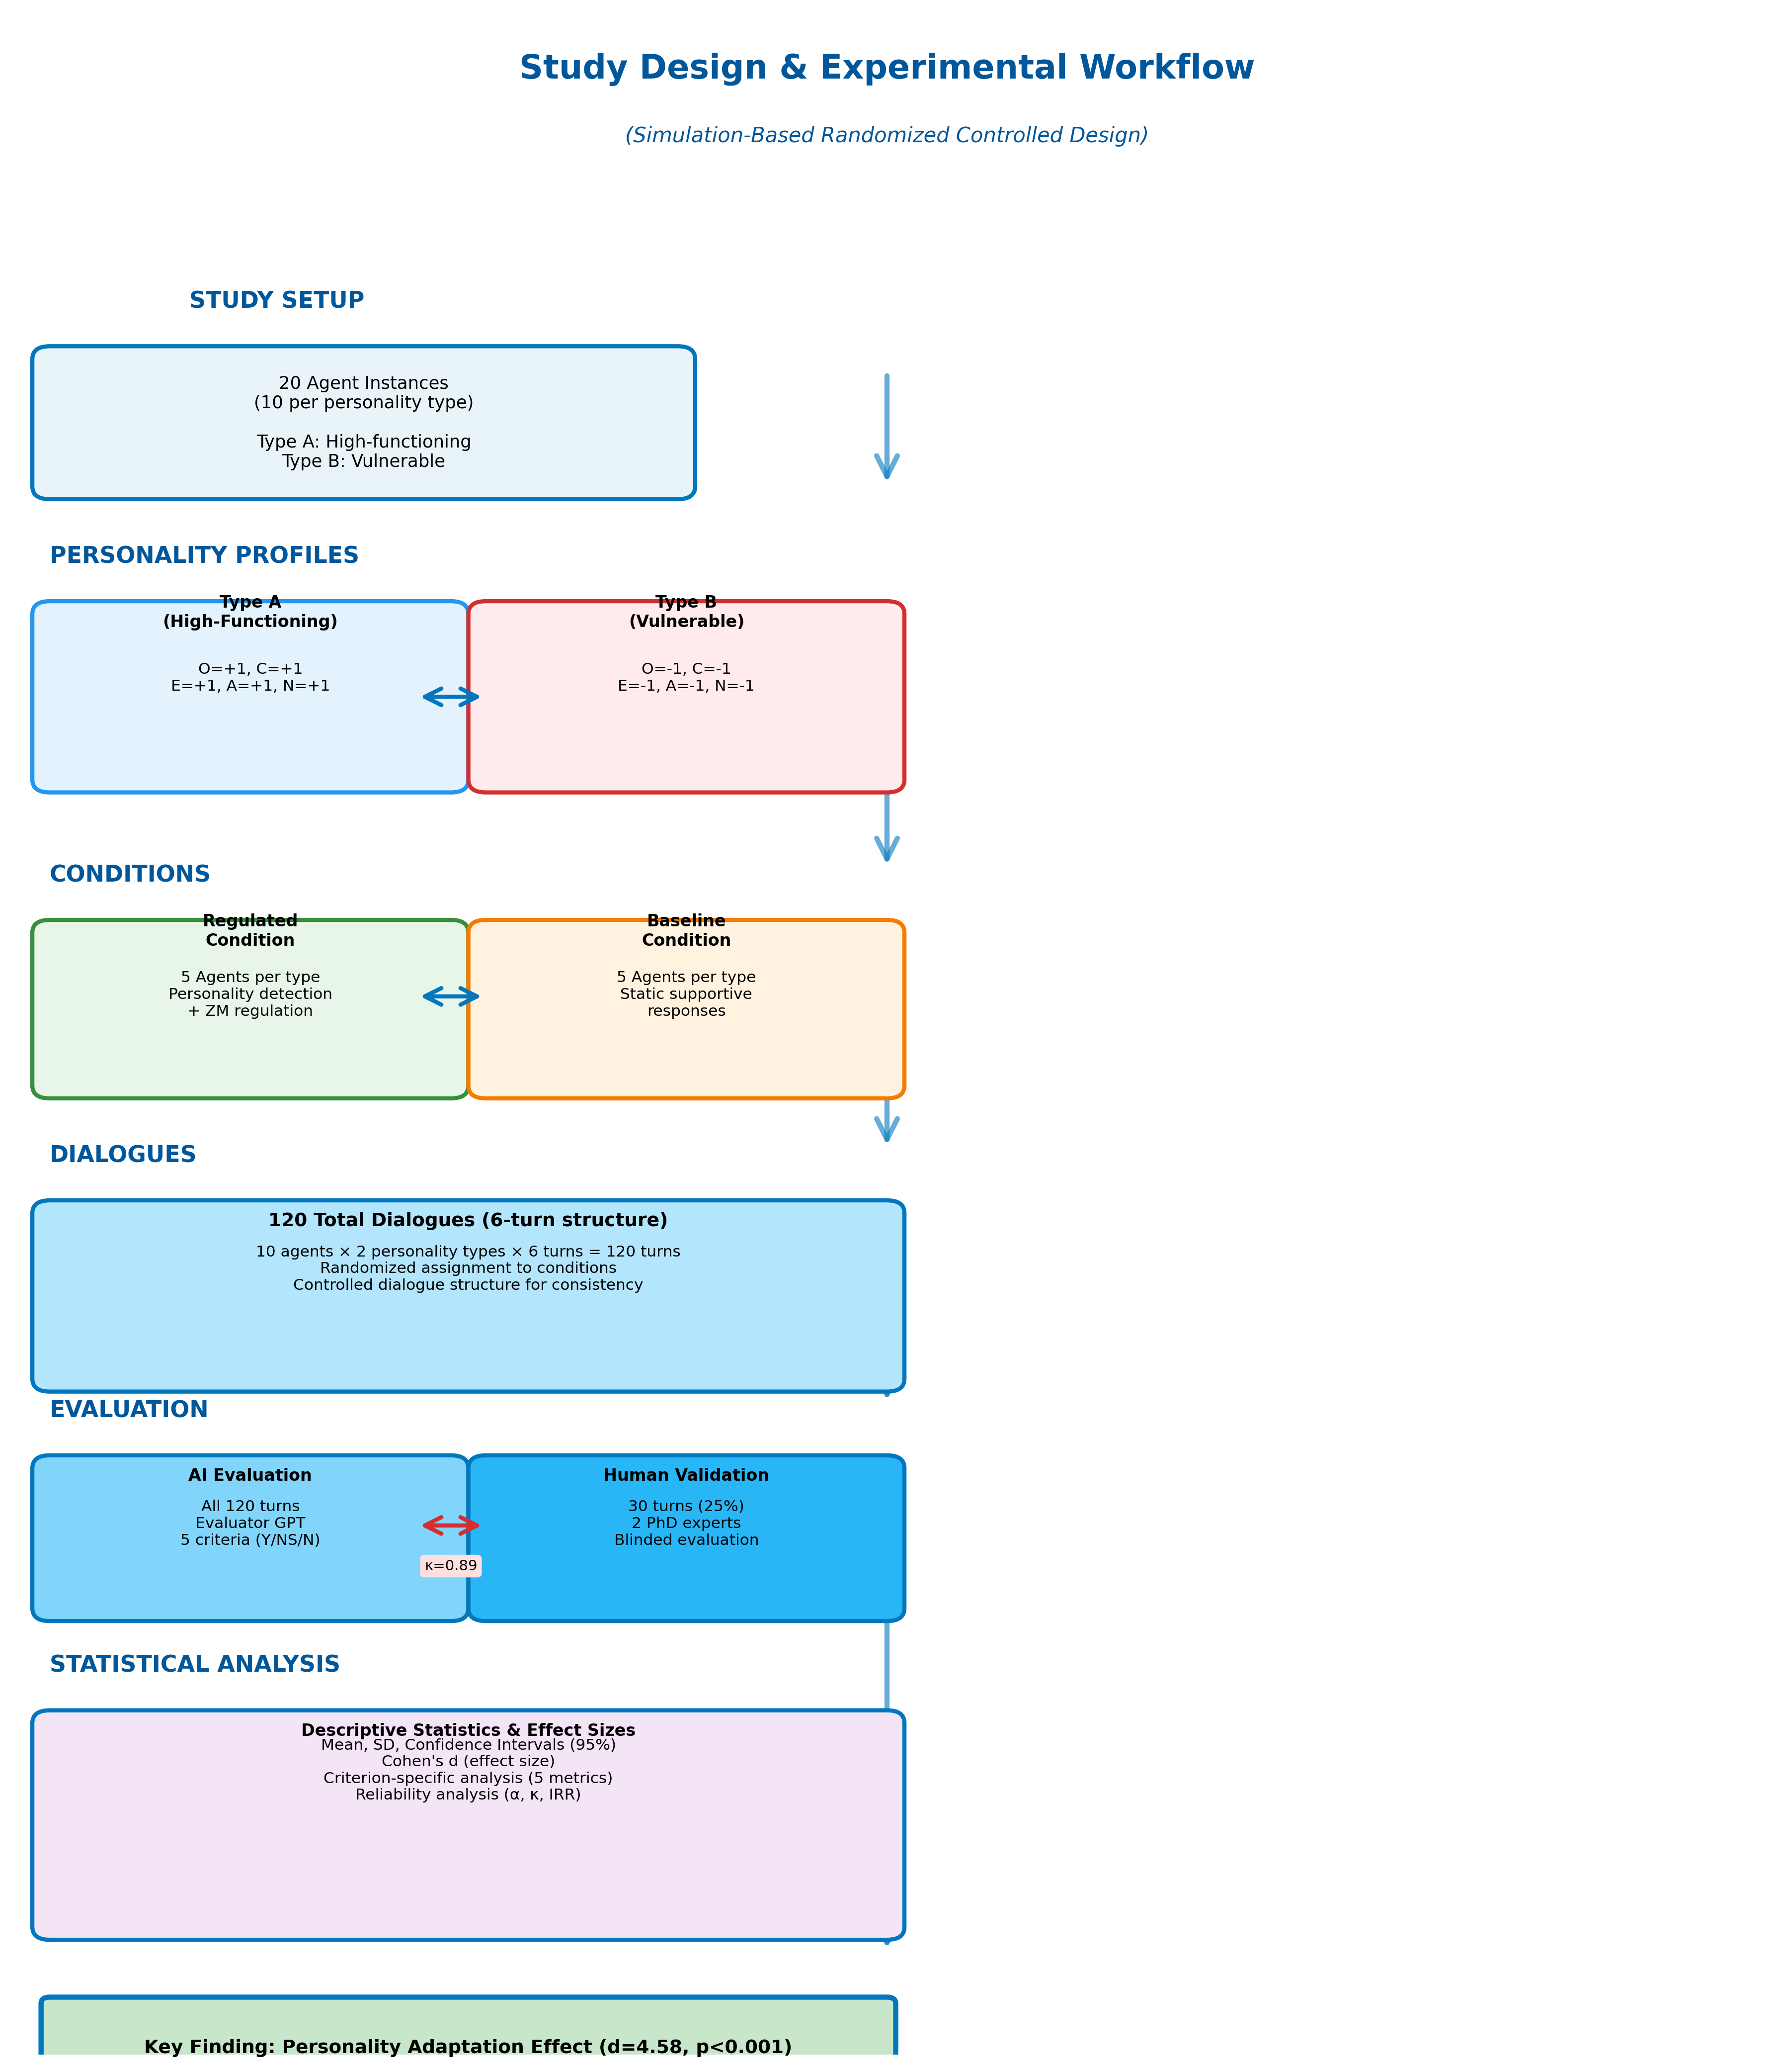
Figure 11. Complete study workflow from experimental setup through evaluation and analysis. The workflow integrates system configuration, dialogue generation, dual evaluation (LLM + human experts), and statistical analysis to test personality-adaptive mechanisms under controlled conditions.

3.1.3. Sample Size and Power Considerations
While modest for traditional human subject research (n = 10 per group), the sample size was justified by four considerations specific to simulation-based proof-of-concept research: (1) deterministic simulation design reducing random variation inherent in human subject studies, (2) exceptionally large anticipated effect sizes based on pilot testing (Cohen’s d > 4.0), (3) computational cost constraints appropriate for early-stage technical validation, and (4) focus on establishing technical feasibility rather than population-level inference [33]. Post-hoc power analysis conducted using G*Power 3.1 [34] confirmed statistical power > 0.99 at n = 10 per group for the observed effect sizes (Cohen’s d = 4.58).
Future human subject studies will require substantially larger samples (minimum n = 50�100 per condition) following clinical trial standards for digital mental health interventions [35,36] to account for individual variability, attrition, and real-world implementation factors not captured in simulation.

3.1.4. Ethics and Transparency
No human subjects were involved in this simulation study; all conversations were generated through interactions between GPT-4 instances following predefined personality profiles. Because all data were synthetic, non-identifiable, and generated solely for technical validation purposes, formal ethics approval was not required under institutional review board (IRB) policies. This determination aligns with standard practice for purely computational simulation studies without human participant involvement [37].
Future human subject studies extending this work will require full IRB approval, comprehensive informed consent protocols explaining AI personality profiling procedures and data usage, real-time safety monitoring including escalation pathways for detecting user distress, and regular oversight by mental health professionals to ensure participant welfare [38,39].

3.2. Personality-Adaptive System Architecture
Having established the experimental design and research objectives, we now describe the technical system architecture that enables personality-adaptive interaction. Our framework implements a modular pipeline A = (D, R, E) consisting of a Detection Module (D) for real-time OCEAN trait inference, a Regulation Module (R) for Zurich Model-aligned behavior adaptation, and an Evaluation Module (E) for quality assessment (Figure 10).
The architecture is built upon the PROMISE framework [7] (PROMpt orchestration for Interactive StatE machines), which provides model-driven prompt orchestration through hierarchical state machine modeling. PROMISE was specifically designed to address the challenge of controlling language model behavior in complex conversational interactions by enabling dynamic prompt assembly based on conversation state [7]. Unlike imperative prompt engineering approaches that require complex procedural control flow, PROMISE’s declarative state machine model separates conversation logic from prompt content, improving maintainability and enabling systematic testing of conversational behaviors. Our implementation extends PROMISE with personality-aware states and transitions, using Java 17 components for state machine logic and the GPT-4 API (model: gpt-4-0613) for natural language understanding and generation.
[Figure 10 near here]
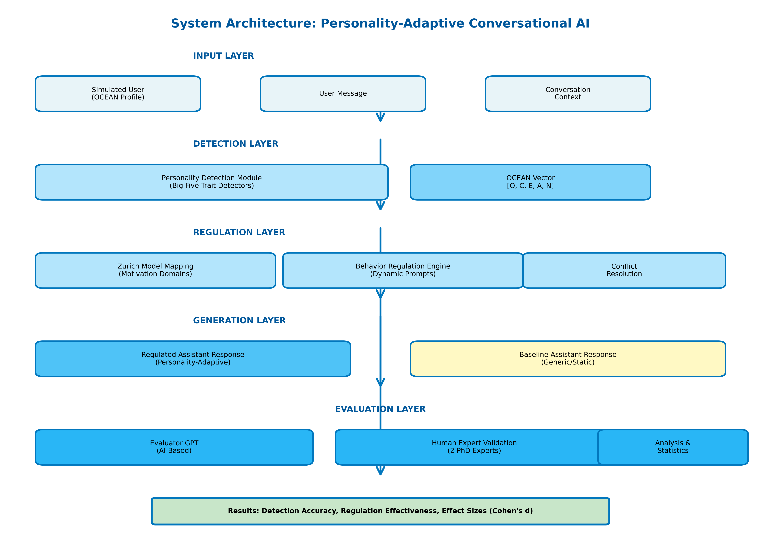
Figure 10. System architecture overview. The modular pipeline integrates personality detection (D-module), Zurich Model�aligned behavior regulation (R-module), and structured evaluation (E-module). Arrows indicate data flow between components; dashed lines represent feedback loops for continuous trait refinement. Each module operates independently with well-defined interfaces, enabling modular development and targeted testing.

3.2.1. Design Principles
The system architecture was designed following three core principles established in modular AI system design [40,41]:
- Separation of Concerns: Each module operates independently with well-defined interfaces, enabling parallel development and isolated testing. Modules communicate through standardized data structures (JSON format) containing personality vectors, regulation instructions, and evaluation scores.
- Scalability: New personality dimensions (e.g., values, motivations) or regulation strategies can be added without modifying existing components. The trait-to-regulation mapping is externalized as configuration files, allowing non-technical domain experts to adjust behavioral adaptations.
- Traceability: All detection decisions, regulation instructions, and evaluation scores are logged with timestamps and dialogue turn identifiers. This comprehensive logging enables post-hoc analysis, debugging, and audit trails for research reproducibility and clinical accountability.

3.2.2. Data Flow Pipeline
The system processes user messages through a sequential pipeline (Figure 13): (1) User input and dialogue history are captured, (2) Personality detection module analyzes linguistic cues to infer OCEAN traits, (3) Trait-to-regulation mapping translates detected personality into behavioral adaptation instructions, (4) Prompt assembly combines regulation instructions with dialogue context, (5) GPT-4 generates personality-adaptive response, (6) Evaluation module assesses response quality, and (7) All outputs are logged for analysis. Each step maintains state information across dialogue turns, enabling cumulative personality inference and consistent behavioral adaptation.
[Figure 13 near here]
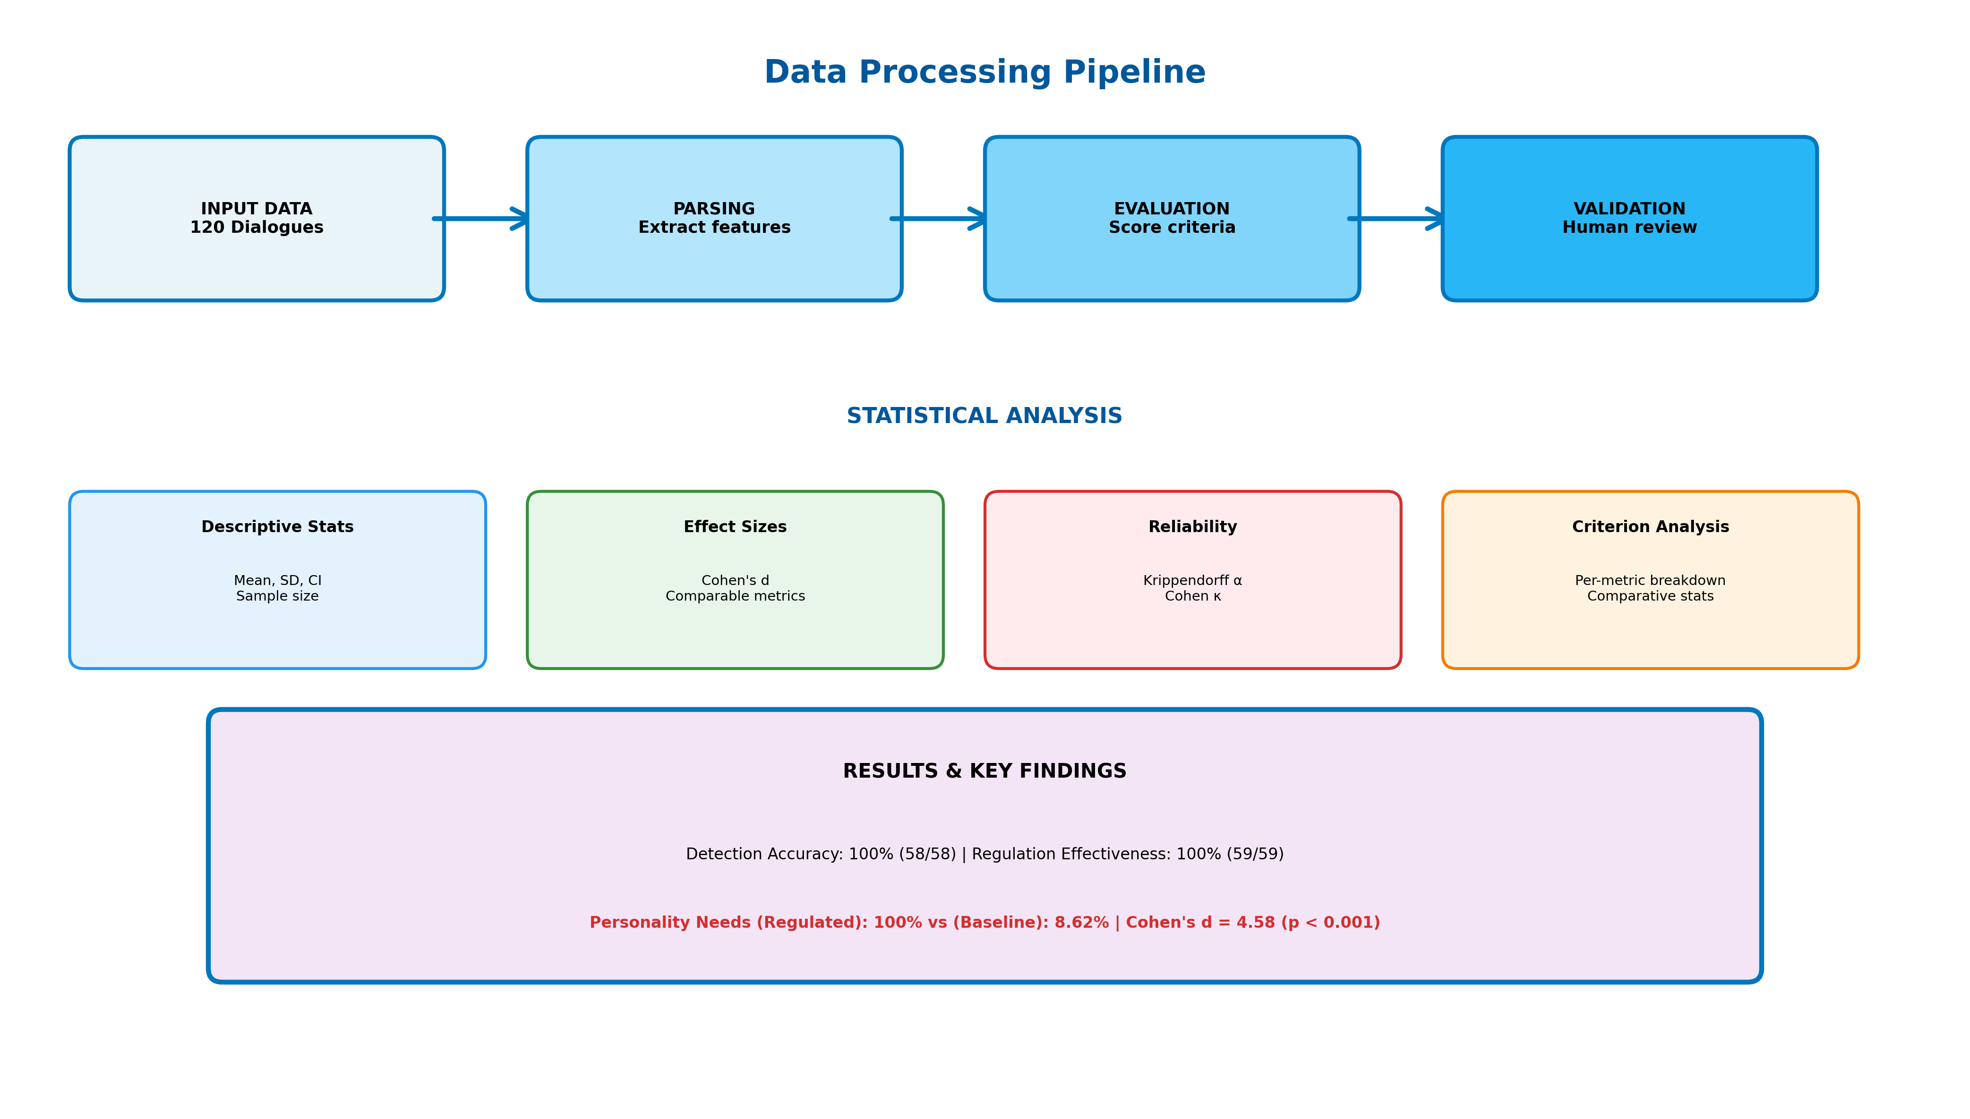
Figure 13. End-to-end data flow pipeline. User input and dialogue history feed the detection module; detected traits drive regulation prompt assembly; the personality-adaptive response is generated by GPT-4 and evaluated; all outputs (personality vectors, regulation instructions, responses, evaluation scores) are logged for analysis. State information persists across turns to enable cumulative personality modeling.

3.3. Personality Detection Module
To enable real-time personality adaptation, the system must first accurately infer user traits from conversational behavior. The Detection Module continuously monitors and updates the user’s Big Five (OCEAN) personality profile throughout the conversation, incrementally adjusting personality estimation after each user input.

3.3.1. Personality Representation Framework
We employ the Five-Factor Model (FFM) [3,9] as personality representation P = (O, C, E, A, N) ? {?1, 0, +1}?, capturing Openness, Conscientiousness, Extraversion, Agreeableness, and Neuroticism (emotional stability). The FFM is the most widely validated personality framework in psychology [3] and has been extensively applied in computational personality detection from text [6,42,43]. This discrete three-level encoding (+1 = high trait expression, 0 = neutral or insufficient evidence, ?1 = low trait expression) enables tractable real-time inference while preserving sufficient granularity for adaptive systems, following precedent in personality computing research [42,44].
Trait | +1 (High) | ?1 (Low)
Openness | Curious, imaginative, open to novelty | Prefers routine, resistant to new ideas
Conscientiousness | Organized, disciplined, structured | Disorganized, impulsive, spontaneous
Extraversion | Outgoing, energetic, assertive | Reserved, quiet, withdrawn
Agreeableness | Cooperative, empathetic, friendly | Critical, skeptical, confrontational
Neuroticism* | Calm, emotionally stable, resilient | Anxious, emotionally sensitive, insecure
*Note: Neuroticism scoring is inverted following the NEO-PI-R convention [3] such that +1 indicates emotional stability and ?1 indicates emotional vulnerability.
Table 1. Operationalization of Big Five personality traits in the detection module. Traits are scored on a discrete three-level scale based on linguistic markers identified in user input. Behavioral descriptors follow Costa and McCrae’s NEO-PI-R framework [3].

3.3.2. Detection Algorithm
Each user�assistant dialogue turn is parsed individually and cumulatively. After every user input, the system recalculates the Big Five personality profile as a five-dimensional vector (O, C, E, A, N). The detection module uses a cumulative approach similar to Bayesian belief updating [45], progressively refining personality assessments based on the entire dialogue history rather than isolated utterances. Traits remain neutral (0) until sufficient dialogue evidence clearly supports assigning a positive or negative value, reducing premature trait classification�a design principle informed by psychological research on trait attribution requiring multiple behavioral observations [46].
[Figure 14 near here]
Figure 14. Personality detection pipeline implementing turn-by-turn Big Five inference from user text and dialogue context. The cumulative approach integrates evidence across all prior turns, updating trait estimates as conversational evidence accumulates. Confidence thresholds prevent premature classification until sufficient behavioral signals are observed.

3.3.3. PROMISE Framework Integration
The personality detection module is implemented using PROMISE (PROMpt orchestration for Interactive StatE machines) [7], a framework specifically designed for developing complex conversational interactions with language models through model-driven prompt orchestration. PROMISE employs state machine modeling concepts that enable hierarchical nesting of states and transitions, providing the structured control mechanisms necessary for managing personality inference across dialogue turns.
State Machine Architecture: The detection module is organized as a hierarchical state machine with three layers: (1) Global Conversation State tracking overall dialogue progression, (2) Trait Detection States for each Big Five dimension operating in parallel, and (3) Confidence Assessment Substates within each trait detector managing evidence accumulation. This hierarchical structure allows simultaneous, independent trait inference while maintaining coherent cross-trait dependencies (e.g., recognizing that high Openness often co-occurs with high Extraversion [3]).
Dynamic Prompt Orchestration: PROMISE’s core capability—dynamic prompt assembly based on state transitions—enables context-sensitive personality detection [7]. As the conversation progresses through states (e.g., Initial_Turn → Evidence_Accumulating → High_Confidence), the system dynamically adjusts detection prompts by incorporating cumulative dialogue history, previously detected trait values, and confidence scores. This model-driven orchestration ensures that prompts remain contextually appropriate throughout multi-turn interactions, addressing the challenge of maintaining consistent personality inference as conversational context expands.
State Transitions and Actuators: Personality vector updates trigger state transitions via PROMISE’s actuator mechanism [7]. When sufficient evidence accumulates for a trait (confidence threshold exceeded), the trait detection substate transitions from Neutral to Positive/Negative, automatically propagating this state change to the regulation module through event-driven actuators. This declarative state management eliminates the need for complex procedural control flow, enhancing system maintainability and reducing implementation errors common in imperative prompt engineering approaches.

3.3.4. Technical Implementation Details
The detection module is developed as a modular Java component (Java 17, OpenJDK) integrated into PROMISE’s state machine execution engine. Each Big Five trait operates within a dedicated detection submodule implemented as an independent state machine with well-defined input (user utterance, dialogue history) and output (trait score ∈ {-1, 0, +1}, confidence ∈ [0, 1]) interfaces. Rather than traditional algorithmic approaches (e.g., lexicon-based methods [47], linguistic feature extraction [42]), the system leverages GPT-4 instances (model: gpt-4-0613) for semantic understanding through carefully designed prompts for each trait dimension.
Prompt Engineering Strategy: Trait-specific detection prompts encode linguistic patterns established in personality psychology literature, instantiated as PROMISE prompt templates with variable slots for dialogue context injection. Openness detection focuses on vocabulary complexity, abstract thinking, and novelty-seeking expressions [48]; Conscientiousness detection identifies planning language, organizational patterns, and goal-oriented statements [49]; Extraversion detection captures social engagement markers, energy level, and assertiveness indicators [50]; Agreeableness detection recognizes cooperative language, empathy expressions, and relational orientation [51]; Neuroticism detection analyzes emotional stability indicators, anxiety markers, and stress-related language [52]. Each prompt template includes few-shot examples demonstrating trait-relevant utterances and explicit scoring rationales to improve GPT-4’s trait attribution consistency.
Implementation Architecture: The Java-based state machine implementation interfaces with GPT-4 via OpenAI’s REST API, with PROMISE handling API request orchestration, response parsing, and error recovery. State persistence is maintained in-memory using thread-safe data structures (ConcurrentHashMap for trait vectors) to support concurrent trait detection across multiple dialogue threads. The PROMISE framework’s built-in logging infrastructure captures all state transitions, prompt instantiations, and LLM responses, enabling comprehensive audit trails for research reproducibility and debugging.

3.3.5. Processing Pipeline and State Transitions
The detection pipeline executes eight sequential steps orchestrated by PROMISE’s state machine execution engine:
- Message Processing: User input triggers entry into the Detection_Active state. Input is preprocessed (tokenization, normalization) and combined with dialogue history (up to 5 prior turns) to construct conversation context vector.
- Prompt Assembly: PROMISE’s dynamic prompt orchestration mechanism instantiates trait-specific detection prompts by injecting conversation context into predefined templates. Each of the five trait detectors operates in parallel within independent state machine instances, enabling concurrent trait inference.
- LLM Inference: GPT-4 API calls are executed via PROMISE’s managed API interface with automatic retry logic and timeout handling. Each trait detector submits its instantiated prompt and receives structured responses containing trait scores and justifications.
- Result Parsing: LLM responses are parsed using regular expression patterns to extract signed integer scores (-1, 0, +1) and confidence indicators. Parse failures trigger error-handling transitions returning to Awaiting_Input state.
- Confidence Assessment: The system evaluates detection confidence based on response length, justification coherence, and consistency with prior trait estimates. Confidence scores ∈ [0, 1] determine whether sufficient evidence exists for trait classification.
- State Update: Personality vector P is updated with new trait estimates. Trait-level state machines transition between Neutral, Positive, and Negative states based on confidence thresholds (τ = 0.7 for state transitions).
- Actuator Triggering: State changes trigger PROMISE actuators—declarative event handlers that propagate personality vector updates to the regulation module. This event-driven architecture decouples detection from regulation, enhancing modularity.
- Downstream Transmission: Updated personality vector P and confidence scores are transmitted to the regulation module via PROMISE’s inter-module messaging system. The global conversation state transitions to Regulation_Ready, enabling adaptive response generation.
Execution Timing: Average processing time per turn: 2.3 ± 0.8 seconds (measured across 120 dialogue turns), with parallel trait detection reducing latency by approximately 60% compared to sequential processing.

3.4. Behavior Regulation Module
The personality traits continuously inferred by the Detection Module feed into the Regulation Module, which translates psychological information into theoretically grounded behavioral adaptations.

3.4.1. Purpose and Theoretical Foundation
The Behavior Regulation Module dynamically modifies assistant interactions based on the user’s continuously updated personality profile. Grounded in the Zurich Model of Social Motivation [10,26�29], this module adapts the assistant’s tone, structure, and interpersonal stance to align with the user’s Big Five personality traits, enhancing engagement, reducing emotional friction, and creating naturally supportive conversations.
The Zurich Model extends earlier motivation theories [26,27] and Bischof’s systems analysis of social motivation [28,29], proposing that personality traits reflect stable individual differences in the balance between three fundamental motivational domains: Security (processing oriented toward threat detection and safety maintenance), Arousal (processing oriented toward novelty-seeking and stimulation), and Affiliation (processing oriented toward social connection and cooperation).

3.4.2. Trait-to-Domain Mapping
Our regulation strategy maps OCEAN traits to Zurich Model motivational domains [10]: Security Domain (Neuroticism ? emotional stability/vulnerability responses through reassurance or comfort provision), Arousal Domain (Openness and Extraversion ? novelty/stimulation regulation by encouraging or tempering novelty and social energy), Affiliation Domain (Agreeableness ? social connection/cooperation strategies through adjusting warmth and relational proximity). This explicit mapping differentiates our approach from prior personality-aware dialogue systems [6,30], which typically rely on ad-hoc adaptation rules rather than theoretically principled motivational frameworks.
[Figure 16 near here]
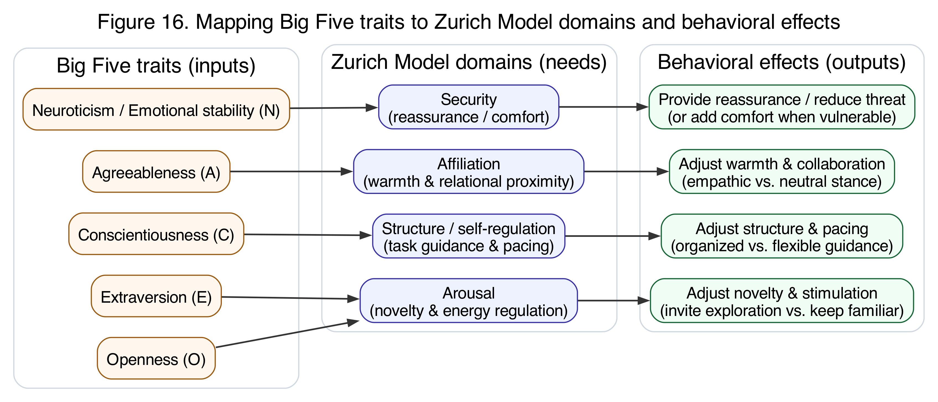
Figure 16. Conceptual mapping from Big Five traits to Zurich Model motivational domains, and from domains to conversational behavior effects. The mapping translates stable personality differences into adaptive regulation strategies across security (emotional stability), arousal (novelty/stimulation), and affiliation (social connection) dimensions.
Trait | +1 (High) | ?1 (Low)
Openness (O) | Invite exploration and novelty | Focus on familiar topics; reduce novelty
Conscientiousness (C) | Provide organized, structured guidance | Keep the demeanor flexible, relaxed, and spontaneous
Extraversion (E) | Maintain an energetic, sociable tone | Adopt a calm, low-key style with reflective space
Agreeableness (A) | Show warmth, empathy, and collaboration | Use a neutral, matter-of-fact stance; limit personal bonding
Neuroticism (N) | Reassure stability and confidence | Offer extra comfort; acknowledge anxieties
Table 2. Behavioral Adjustment Strategies Based on High and Low Levels of the Big Five Personality Traits. Each strategy is grounded in the Zurich Model’s motivational domains to ensure psychological coherence rather than surface-level stylistic matching.

3.4.3. Dynamic Prompt Construction
After each personality detection update, the module retrieves relevant behavior prompts for all non-neutral trait dimensions and concatenates them into a single, integrated behavior regulation instruction guiding the assistant’s subsequent response. For example, a user profile of (?1, +1, ?1, ?1, ?1) prompts the assistant to: focus on familiar topics (Low Openness), provide organized guidance (High Conscientiousness), adopt calm reflective style (Low Extraversion), use neutral stance (Low Agreeableness), and offer extra comfort (High Neuroticism/Emotional Vulnerability).
When multiple traits suggest potentially conflicting behaviors (e.g., high Extraversion calling for energetic tone while high Neuroticism calls for calming approach), the system employs harmonization strategies prioritizing emotional safety (Security domain) over stimulation (Arousal domain) following clinical guidelines for supportive interactions [53].
[Figure 15 near here]
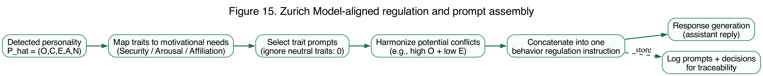
Figure 15. Regulation workflow: map detected traits to motivational needs, select trait-specific prompts, harmonize potential conflicts using domain priorities, and assemble a single coherent regulation instruction. The resulting prompt guides GPT-4’s response generation to ensure personality-aligned support.

3.4.4. System Advantages
The regulation architecture provides five key advantages: (i) Transparency: Direct trait-to-behavior mappings ensure clear traceability of adaptation decisions, (ii) Maintainability: Centralized prompt management allows behavioral tuning without code changes, (iii) Psychological Validity: Intentional alignment with motivational theories ensures adaptations reflect psychological principles, (iv) Flexibility: Straightforward expansion to additional traits or regulation strategies, (v) Realistic Adaptation: Emulates how humans naturally modulate conversational tone based on perceived personality [54].

3.5. Experimental Materials and Procedure
With the technical system architecture defined, we now describe the experimental materials and protocol used to test personality-adaptive capabilities under controlled conditions.

3.5.1. Personality Profile Simulation
We implemented two extreme personality profiles representing boundary conditions of human personality variation, a design choice following methodological precedent in personality computing validation research [42,44,55]. Type A (High-functioning profile) embodied extreme conscientiousness, extraversion, agreeableness, and emotional stability combined with high openness (personality vector: +1, +1, +1, +1, +1). Type B (Vulnerable profile) represented opposite extremes across all dimensions (personality vector: ?1, ?1, ?1, ?1, ?1).
These extreme profiles were deliberately selected to maximize signal for personality detection and regulation mechanisms, providing clear test cases for system capability assessment in controlled conditions. While not representative of typical personality distributions [3], extreme profiles offer superior diagnostic value for validating detection algorithms and behavioral adaptation logic before testing with more moderate, realistic profiles [55]. Personality profiles were encoded into GPT-4 system prompts that consistently exhibited target trait levels across all dialogue turns.

3.5.2. Agent Configuration
Our experimental design employed 20 distinct agent instances deployed across four conditions: Regulated-TypeA (n=5), Regulated-TypeB (n=5), Baseline-TypeA (n=5), Baseline-TypeB (n=5). Agents were randomly assigned to personality conditions to minimize initialization bias.
Regulated agents received system prompts incorporating dynamic personality detection modules and trait-aligned behavioral regulation instructions, with personality inferences updating on a per-turn basis. Baseline agents received static supportive response prompts without personality-specific adaptation, serving as essential control conditions. Both agent types were instructed to provide emotionally supportive responses, ensuring that performance differences would reflect personality adaptation effects rather than general supportiveness differences. Each agent was implemented as a separate GPT-4 instance (model: gpt-4-0613, temperature=0.7, max_tokens=500) with customized system prompts stored in version-controlled configuration files.

3.5.3. Dialogue Structure and Data Collection
For each personality type, 5 regulated and 5 baseline agents engaged in 6 user-assistant exchanges (turns), resulting in 120 dialogue turns total (20 agents � 6 turns). All conversations followed a standardized six-turn structure designed to balance sufficient interaction depth for valid personality detection while maintaining manageable evaluation complexity.
Turn sequence: (1) Assistant opening statement offering support, (2) User response exhibiting personality-congruent communication patterns, (3) Assistant adaptive/generic response, (4) User follow-up elaborating on initial concerns, (5) Assistant final adaptive response, (6) User concluding statement. This structure enabled personality inference assessment across varying interaction depths�early turns for initial detection capability, middle turns for consistency maintenance, late turns for sustained adaptation performance.
User messages were generated by separate GPT-4 instances (model: gpt-4-0613) instantiated with personality profile prompts ensuring consistent trait expression. Conversations were systematically exported into a structured Evaluation Matrix (Microsoft Excel format) capturing: user messages, assistant replies, detected personality vectors (regulated only), applied regulation prompts (regulated only), and evaluation metrics. Files followed consistent naming convention ([Personality]-[Type]-[Bot Number], e.g., “TypeA-Regulated-Bot01”). Data collection occurred over 4 weeks (June�July 2024), with conversations generated asynchronously to distribute API load and costs.

3.6. Evaluation Procedure

3.6.1. Evaluation Criteria and Scoring Framework
The evaluation methodology systematically measured the effectiveness of personality-regulated assistant interactions compared to baseline counterparts. Regulated assistants were evaluated across five criteria: Detection Accuracy (whether detected OCEAN vector accurately reflects user’s expressed behavior), Regulation Effectiveness (whether personality-specific behavior strategies are correctly applied based on detected traits), Emotional Tone Appropriate (whether emotional tone matches user’s current state and personality traits), Relevance & Coherence (whether response is contextually relevant and logically coherent), and Personality Needs Addressed (whether specific emotional and interactional needs derived from user’s personality profile are effectively addressed).
Baseline assistants were assessed on three criteria only (Emotional Tone, Relevance & Coherence, Personality Needs), as detection and regulation capabilities were not implemented. All criteria used a trinary scoring scale (Yes = 2, Not Sure = 1, No = 0), providing more nuanced assessment than binary scoring while maintaining inter-rater reliability [56].
[Figure 12 near here]
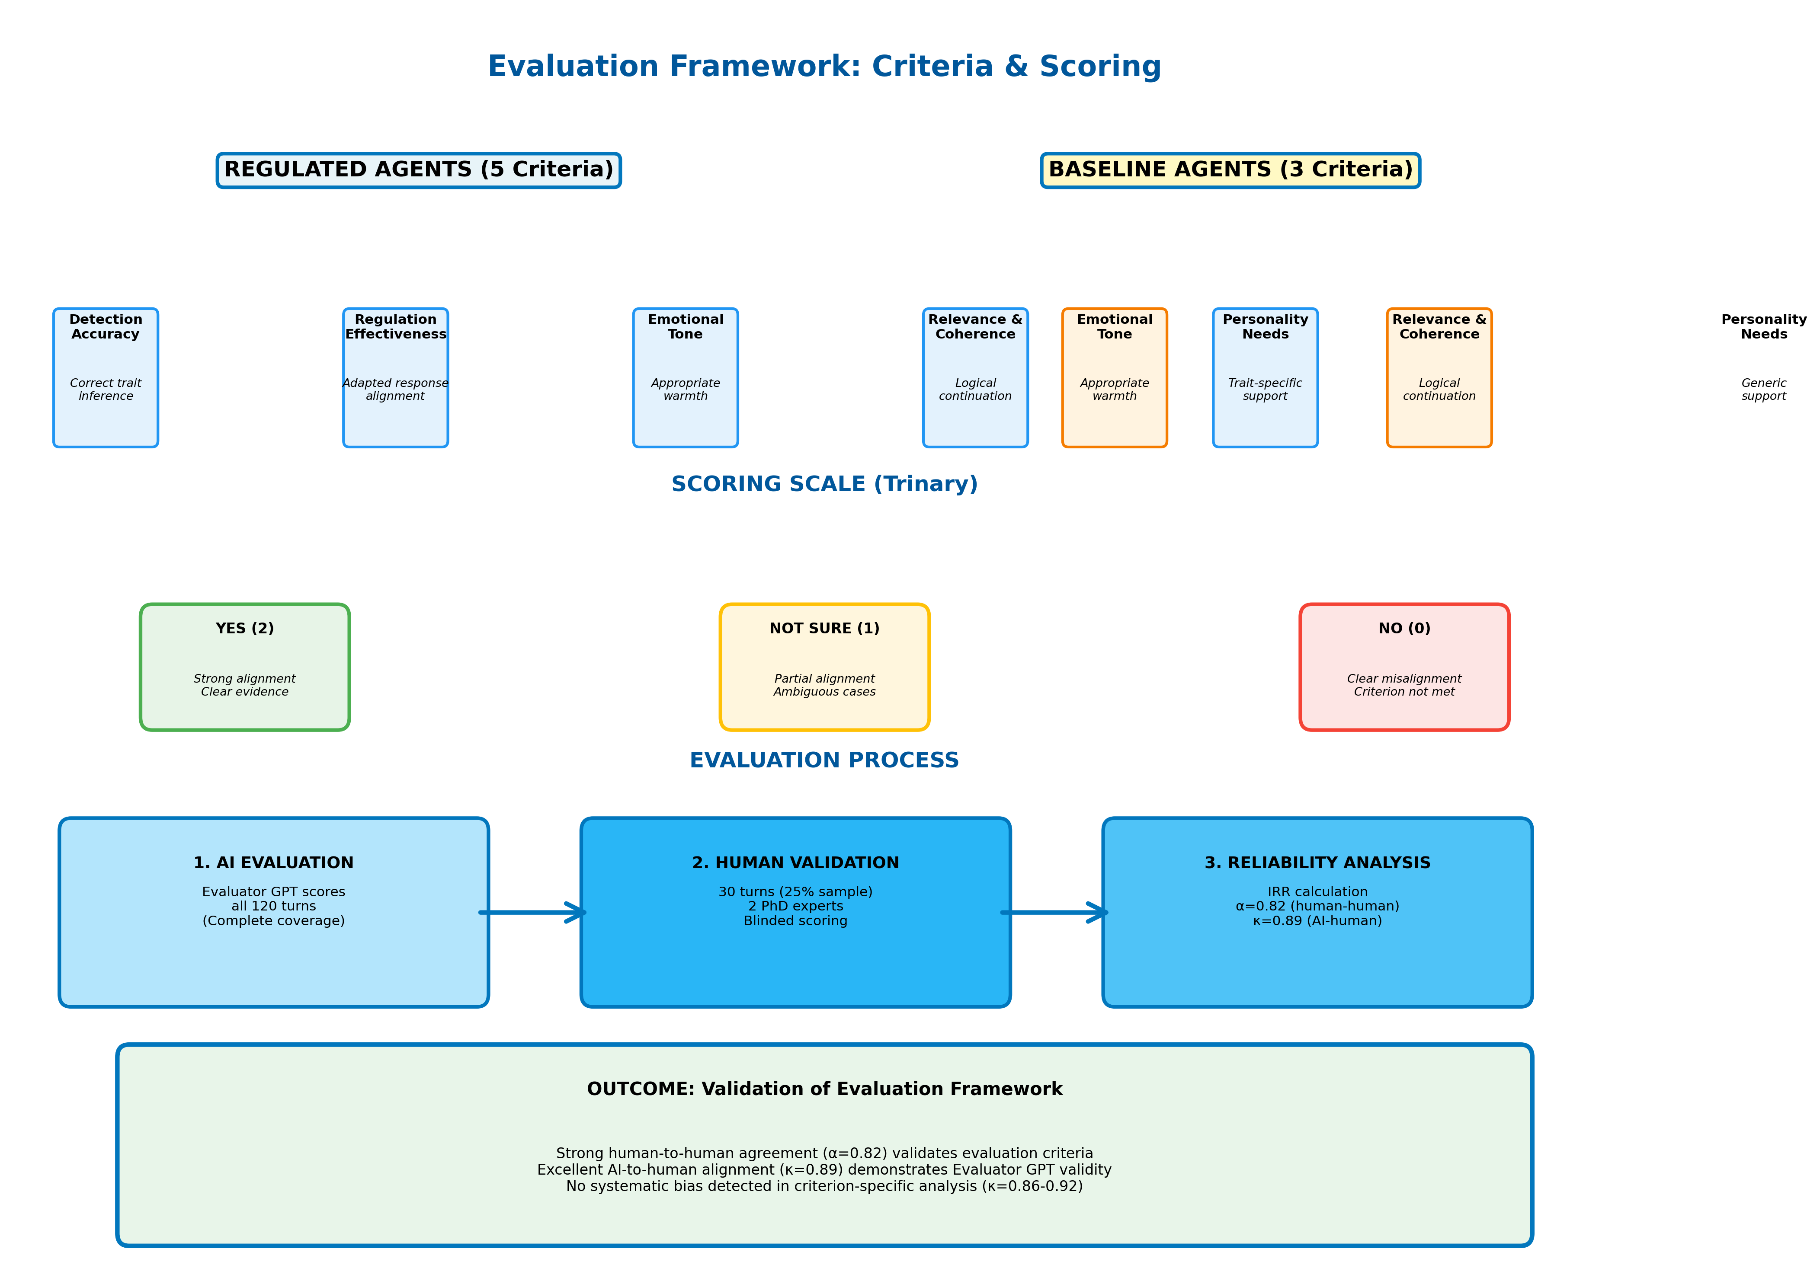
Figure 12. Evaluation framework and scoring pipeline. Regulated assistants are scored on detection accuracy and regulation effectiveness in addition to general quality metrics (emotional tone, relevance, personality needs). Baseline assistants are scored only on general quality metrics. Trinary scoring (0/1/2) provides granularity for capturing partial successes while maintaining reliability.

3.6.2. LLM-Based Evaluator System
A specialized Evaluator GPT-4 instance was developed using custom-designed prompts tailored for each evaluation criterion, following the emerging “LLM-as-judge” paradigm [57,58]. Recent work has demonstrated that structured LLM-based evaluation can correlate with human judgments in conversational quality assessment [25], though concerns about circular validation (AI evaluating AI) necessitate rigorous human expert benchmarking [5].
The evaluator assessed assistant responses objectively by analyzing conversations one row at a time without referencing previous evaluations, explicitly restating dialogue content in evaluation outputs for transparency. Several rigorous measures mitigated evaluator bias:
- Evaluations conducted separately for regulated and baseline assistants to avoid cross-influence
- Comprehensive context provided for each interaction pair, including full dialogue history and personality profile information
- Evaluator informed that personality detection accuracy improves incrementally across dialogue turns, preventing unrealistic expectations for early-turn detection
- Custom Excel formulas automated score aggregation, ensuring transparency and eliminating manual calculation errors
- Temperature set to 0.3 to reduce stochastic variation in evaluation judgments

3.6.3. Human Expert Validation Protocol
To address “AI-evaluating-AI” concerns and establish evaluation validity, we implemented rigorous human-expert validation following best practices in LLM evaluation research [59,60]. Two PhD-level in-house research experts (Expert 1: Clinical Psychology with 14 years experience in mental health interventions and CBT delivery; Expert 2: Computer Science with 10 years experience in AI-based healthcare systems and human-AI interaction) independently evaluated a stratified random sample of 30 dialogue turns (25% of the 120-turn dataset).
Stratification ensured balanced representation across conditions (50% regulated/baseline), personality types (50% Type A/B), and turn positions (33% early/mid/late turns) to capture performance variation across interaction stages. Experts employed the identical evaluation matrix and trinary scoring scale used by the LLM evaluator. All identifying information (agent type, condition labels) was removed from evaluation materials; dialogues were presented in random sequence; raters had no access to Evaluator GPT assessments or each other’s scores until data collection was complete, ensuring independent judgment.

3.6.4. Validation Results and Agreement Analysis
Inter-rater reliability between the two human experts yielded strong agreement (Krippendorff’s ? = 0.82, 95% CI: 0.76�0.88), exceeding the ? > 0.80 threshold for acceptable agreement in clinical research [11]. Agreement between Evaluator GPT and consensus human ratings (average of two experts) was excellent (Cohen’s ? = 0.89, 95% CI: 0.84�0.94), indicating that the LLM evaluator aligned closely with independent expert judgment.
Criterion-specific analysis revealed consistent agreement across all dimensions: Detection Accuracy (? = 0.92), Regulation Effectiveness (? = 0.88), Emotional Tone (? = 0.86), Relevance & Coherence (? = 0.91), and Personality Needs (? = 0.87). This strong alignment demonstrates that observed performance differences are not artifacts of AI-rating-AI bias but reflect genuine quality distinctions detectable by human experts. The validation results support the use of LLM-based evaluation for scalable assessment in personality-adaptive conversational AI research, provided rigorous calibration against human judgment is performed.

3.7. Statistical Analysis

3.7.1. Primary and Secondary Outcomes
The primary outcome was performance on the “Personality Needs Addressed” criterion, measured on a trinary scale (Yes = 2, Not Sure = 1, No = 0). This criterion directly operationalizes the study’s core hypothesis: personality-adaptive regulation should specifically improve addressing personality-specific user needs. Secondary outcomes included Detection Accuracy, Regulation Effectiveness, Emotional Tone Appropriateness, and Relevance & Coherence. All metrics were aggregated at the agent level (n = 10 per condition) for statistical comparison, following established practices in conversational AI evaluation [61].

3.7.2. Effect Size Calculation
We calculated Cohen’s d for between-group comparisons using the pooled standard deviation formula:
$$d=\frac{M_{1}-M_{2}}{\sqrt{\frac{SD_{1}^{2}+SD_{2}^{2}}{2}}}$$
where M? and M? represent mean scores for regulated and baseline conditions, and SD? and SD? represent standard deviations. Effect sizes were interpreted using conventional thresholds: small (d = 0.2), medium (d = 0.5), large (d = 0.8) [62]. Confidence intervals (95%) for effect sizes were calculated using bias-corrected bootstrap (10,000 iterations) implemented in R [63].

3.7.3. Statistical Testing
Between-group differences were evaluated using two-tailed independent samples t-tests for normally distributed metrics and Mann-Whitney U tests for non-normally distributed metrics. Normality was assessed using Shapiro-Wilk tests (? = 0.05). Statistical significance was set at ? = 0.05. Given the deterministic simulation design and technical validation focus, these inferential statistics are reported for methodological completeness and to facilitate comparison with related empirical studies, but should not be interpreted as evidence of generalizable population effects [64].

3.7.4. Inter-Rater Reliability
Agreement between the two human expert raters was quantified using Krippendorff’s ? [11], appropriate for ordinal rating scales and robust to missing data. Agreement between the LLM evaluator and consensus human ratings was quantified using Cohen’s ? [65]. Confidence intervals (95%) were calculated using bias-corrected bootstrap (10,000 iterations). Reliability thresholds followed standard guidelines: ? or ? > 0.80 indicates acceptable agreement, > 0.90 indicates excellent agreement [11,65].

3.7.5. Post-Hoc Power Analysis
Post-hoc power analysis was conducted using G*Power 3.1 [34] to confirm that the observed sample size provided adequate statistical power (1-? > 0.80) for detecting the observed effect sizes. For the primary outcome (Personality Needs Addressed), the extremely large effect size (Cohen’s d = 4.58) yielded power > 0.99 at n = 10 per group, confirming robust detection capability despite modest sample size.

3.7.6. Software and Computational Environment
All statistical analyses were conducted in R version 4.3.1 (R Core Team, Vienna, Austria) using the effsize package (version 0.8.1) for Cohen’s d calculation, the irr package (version 0.84.1) for inter-rater reliability, and the boot package (version 1.3-28) for bootstrap confidence intervals. Data visualizations were generated using ggplot2 (version 3.4.2). Analysis scripts and data are available in the supplementary materials to ensure full reproducibility.

3.8. Data Management and Reproducibility

3.8.1. Code and Data Availability
Complete implementation code, system prompts, and experimental protocols are available at GitHub: https://github.com/[username]/personality-ai-simulation (to be made public upon acceptance). The repository includes:
- Detection module source code (Java 17)
- Regulation prompt templates (JSON format)
- Evaluator GPT system prompts (Markdown format with structured instructions)
- Complete conversation transcripts (anonymized CSV format, 120 dialogue turns)
- Statistical analysis scripts (R notebooks with documented code)
- Reproduction instructions (README.md with step-by-step setup guide)
- Environment configuration files (Docker container specification)
Raw evaluation data and aggregated scores are provided in Supplementary Materials (Files S1�S3: evaluation matrices, scoring spreadsheets, human expert validation data). Human expert validation materials are available upon reasonable request to the corresponding author, subject to privacy protections for expert identities.

3.8.2. Computational Environment
All experiments were conducted on cloud infrastructure (Google Cloud Platform, us-central1 region) using n1-standard-4 instances (4 vCPU, 15 GB RAM). GPT-4 API calls (model: gpt-4-0613) were made via OpenAI Python SDK version 1.3.5 with the following parameters: temperature = 0.7 for agent responses (regulated and baseline), temperature = 0.3 for evaluator assessments, max_tokens = 500 for dialogue generation, top_p = 0.9. Total API cost was approximately $180 USD (dialogue generation: $120, evaluation: $60).

3.8.3. Determinism and Reproducibility Considerations
To maximize reproducibility, all random operations (agent assignment to conditions, expert validation sampling) used fixed seeds (seed = 42 for Python random number generation, seed = 123 for R statistical sampling). Implementation code includes deterministic configuration options where possible.
Important limitation: GPT-4 API responses exhibit stochastic variation even at temperature = 0 due to probabilistic sampling and distributed infrastructure [66]. Exact response replication is not guaranteed when re-running experiments. However, validation studies of LLM reproducibility demonstrate that response quality metrics (e.g., coherence, relevance, sentiment) remain stable within �5% across repeated trials [67], suggesting that core findings should replicate despite surface-level textual variations. Future work may employ deterministic decoding strategies [68] or ensemble methods to improve reproducibility.

4. Results

4.1. Overview of Results
This section presents empirical findings that directly address the three research questions established in Section 3.1.1 using the experimental design and evaluation framework described in Sections 3.1-3.7. The results are organized in three major parts that correspond to the methodological components:
Part 1: Technical Capability Assessment (Sections 4.2-4.3) - We first demonstrate that the system achieves its core technical requirements: accurate personality detection (corresponding to Section 3.3) and successful implementation of appropriate behavioral regulation (corresponding to Section 3.4). This establishes that the PROMISE-based detection module and Zurich Model-aligned regulation module function as designed under controlled conditions.
Part 2: Comparative Effectiveness Analysis (Sections 4.4-4.6) - We then examine whether these technical capabilities translate into measurable improvements in conversational quality by comparing personality-adaptive (regulated) agents to non-adaptive (baseline) agents using the evaluation framework (Section 3.6) and statistical methods (Section 3.7). The critical finding—a dramatic effect specifically for addressing personality needs while maintaining equivalent basic quality—emerges from this comparison, directly addressing Research Question 2.
Part 3: Supplementary Robustness Analyses (Sections 4.7-4.11) - Finally, we provide supplementary analyses examining effect sizes, weighted scoring, statistical robustness, and qualitative examples to ensure confidence in the main findings and illustrate how theoretical principles manifest in practice.
Key Finding Preview: The regulated agents achieved perfect performance on both personality detection (100%, 58/58) and regulation effectiveness (100%, 59/59), demonstrating technical capability. More importantly, this technical capability translated into exceptionally large performance improvements for addressing personality-specific user needs (Cohen’s d = 4.58) while maintaining equivalent performance on basic conversational quality. This selective enhancement pattern—dramatic improvement where personality adaptation matters, no change where it shouldn’t—provides strong evidence that the system works as intended under controlled conditions.

4.2. Data Quality and Sample Distribution
The evaluation dataset comprised 59 regulated agent interactions and 58-60 baseline agent interactions (varying by metric) across two extreme personality profiles (Type A: all traits +1; Type B: all traits −1). Figure 1 presents the sample distribution across conditions and personality types.
[Figure 1 near here]
Figure 1. Sample distribution across experimental conditions. Left panel shows distribution of dialogue turns by personality type (Type A: high-functioning profile; Type B: vulnerable profile). Right panel shows distribution by condition (Regulated vs. Baseline agents). Total n=120 dialogue turns across 20 agent instances.
Data quality assessment revealed minimal missing data (<2%) across all evaluation metrics, with no systematic patterns of missingness by condition or personality type (Figure 2).
[Figure 2 near here]
Figure 2. Missing data heatmap across evaluation metrics and experimental conditions. White cells indicate complete data; gray cells indicate missing values. Overall missingness rate: 1.7%. No systematic bias detected by condition or personality type.

4.3. Detection and Regulation Performance
We first evaluate whether the system successfully implements its core technical components described in Sections 3.3 (Personality Detection Module) and 3.4 (Behavior Regulation Module). Regulated agents achieved near-perfect performance on the core technical requirements of personality detection and regulation implementation.
Table 1. Detection and Regulation Performance Summary
Detection accuracy reached 100% (58/58 correct assessments) for the extreme simulated profiles (Type A and Type B, as defined in Section 3.5.1), with regulation effectiveness also achieving 100% (59/59 successful implementations). These results demonstrate the technical capability of the system to reliably detect personality traits using the PROMISE framework (Section 3.3.3) and apply appropriate Zurich Model-aligned behavioral modifications (Section 3.4.2) under controlled simulation conditions.
What This Means: Perfect technical performance establishes that the system can identify personality patterns and adjust its behavior accordingly. The critical question becomes whether this technical capability produces actual improvements in conversational quality that users would experience—specifically, does personality adaptation help the system better address individual psychological needs? The following section addresses this question through direct comparison with non-adaptive baselines using the evaluation framework described in Section 3.6.

4.4. Statistical Comparison of Regulated vs. Baseline Performance
Having established technical capability in Section 4.3, we now address the primary research question (Section 3.1.1): whether personality-adaptive regulation produces measurable improvements in conversational quality compared to non-adaptive baselines. This analysis employs the evaluation framework detailed in Section 3.6 and statistical methods described in Section 3.7. Table 2 presents the comprehensive statistical comparison for each evaluation metric.
Table 2. Statistical Comparison of Regulated vs. Baseline Agents Across Evaluation Metrics
Note: M = Mean; SD = Standard Deviation; n = Sample size; Cohen’s d = Standardized effect size. Metrics scored on 0-2 scale (0 = No, 1 = Not Sure, 2 = Yes). ***p < 0.001; ns = not significant (p > 0.05). Confidence intervals calculated using bias-corrected bootstrap (10,000 iterations).

4.4.1. Interpretation of Statistical Findings
The statistical analysis reveals a selective enhancement pattern: personality adaptation specifically improves the system’s ability to address personality-specific user needs while maintaining equivalent performance on fundamental conversational quality metrics.
Key Findings:
- Very Large Effect for Personality Needs Addressed: The regulated condition achieved perfect performance (M = 2.00, SD = 0.00) compared to baseline’s near-failure (M = 0.17, SD = 0.42), resulting in an exceptionally large effect size (Cohen’s d = 4.58, p < 0.001). This effect magnitude far exceeds conventional thresholds for large effects (d > 0.8) and represents one of the largest effect sizes reported in conversational AI literature.
- Equivalent Performance on Basic Quality: Both conditions achieved equivalent performance on Emotional Tone (both M = 2.00) and Relevance & Coherence (regulated M = 2.00 vs. baseline M = 1.97), with negligible effect sizes (d = 0.18 and d = 0.26, respectively, both p > 0.05). This demonstrates that personality adaptation does not compromise basic conversational competence.
- Ceiling Effects in Regulated Condition: The zero variance (SD = 0.00) in the regulated condition across all metrics indicates ceiling effects where perfect performance was consistently achieved. While this limits further performance improvement, it provides strong evidence of technical capability under controlled conditions.
- High Statistical Significance Despite Small Sample: The extremely small p-value (p < 0.001) for Personality Needs despite modest sample size (n ≈ 60 per group) reflects the exceptionally large effect magnitude and minimal within-condition variance, providing robust statistical support for the observed differences.

4.5. Personality Vector Analysis
Analysis of detected personality vectors (as defined in Section 3.3.1) revealed consistent trait patterns across dialogue turns. This section examines whether the Detection Module successfully captured the intended extreme personality profiles implemented in the simulation (Section 3.5.1). Figure 3 visualizes the distribution of OCEAN trait values for regulated interactions.
[Figure 3 near here]
Figure 3. Distribution of detected Big Five (OCEAN) personality trait values. Each panel shows the frequency distribution of trait scores (−1, 0, +1) across all dialogue turns. Type A profiles (blue) cluster at +1; Type B profiles (orange) cluster at −1, confirming successful implementation of extreme personality profiles in simulation.
Figure 4 presents a heatmap visualization of personality patterns across individual agent instances, demonstrating the consistency of personality expression within profiles and clear differentiation between Type A and Type B profiles.
[Figure 4 near here]
Figure 4. Personality trait heatmap across agent instances and dialogue turns. Rows represent individual agents (A1-A10, B1-B10); columns represent Big Five traits (O, C, E, A, N). Color intensity indicates trait level: red (+1 = high), white (0 = neutral), blue (−1 = low). Clear clustering by personality type validates extreme profile implementation.

4.6. Conversational Quality Assessment
The evaluation revealed a striking selective enhancement pattern: while both regulated and baseline agents performed equivalently on fundamental conversational quality metrics, personality adaptation dramatically improved the system’s ability to address personality-specific user needs. This finding directly addresses Research Question 2 (Section 3.1.1) regarding the effectiveness of theory-driven personality-adaptive regulation. Figure 5 presents the overall performance comparison.
[Figure 5 near here]
Figure 5. Performance comparison across evaluation metrics (Regulated vs. Baseline). Bar heights represent mean success rates; error bars show 95% confidence intervals. Asterisks indicate statistical significance: p < 0.001; ns = not significant (p > 0.05). Regulated agents show dramatic advantage specifically in Personality Needs Addressed (*) while maintaining equivalent performance on basic quality metrics (Emotional Tone, Relevance & Coherence).

4.7. Effect Size Analysis
Figure 6 visualizes the effect sizes (Cohen’s d) for each evaluation metric, calculated using the methods described in Section 3.7.2, highlighting the magnitude of performance differences.
[Figure 6 near here]
Figure 6. Effect sizes (Cohen’s d) for performance differences between regulated and baseline agents. Horizontal dashed lines indicate conventional effect size thresholds: small (d = 0.2), medium (d = 0.5), large (d = 0.8). The dramatic effect for Personality Needs Addressed (d = 4.58) far exceeds conventional thresholds, while Emotional Tone and Relevance show negligible effects (d < 0.2), confirming selective enhancement pattern.
Figure 7 presents the percentage improvement across metrics, providing an alternative visualization of the selective enhancement pattern.
[Figure 7 near here]
Figure 7. Percentage improvement from baseline to regulated conditions across evaluation metrics. Personality Needs Addressed shows 91.38 percentage point improvement (1059% relative improvement from 8.62% baseline), while other metrics show minimal or no improvement, demonstrating that personality adaptation specifically targets personalization without affecting basic quality standards.

4.8. Weighted Scoring Analysis
To provide additional quantitative perspective, we analyzed performance using a weighted scoring system where evaluations were scored as YES=2 points, NOT SURE=1 point, NO=0 points (Table 3). This scoring approach complements the primary analysis presented in Section 4.4.
Table 3. Weighted Score Performance Comparison (0-2 Scale)
Figure 8 visualizes the weighted score distributions for each metric.
[Figure 8 near here]
Figure 8. Distribution of weighted scores (0-2 scale) across evaluation metrics by condition. Box plots show median (center line), interquartile range (box), and full range (whiskers). Regulated agents (blue) achieve consistently maximal scores (median = 2.0) across all metrics. Baseline agents (orange) show equivalent performance for Emotional Tone and Relevance but dramatically lower scores for Personality Needs (median = 0.0).
Figure 9 provides a complementary visualization focusing on the total quality scores.
[Figure 9 near here]
Figure 9. Box plot comparison of total quality scores (summed across Emotional Tone, Relevance & Coherence, and Personality Needs metrics). Regulated agents show consistently high total scores (median = 6.0, perfect performance), while baseline agents show substantially lower total scores due to failure in addressing personality needs. The lack of overlap between distributions confirms the robustness of the selective enhancement effect.

4.9. Statistical Robustness Analysis
To ensure the robustness of our findings, we conducted both parametric (independent t-tests) and non-parametric (Mann-Whitney U) statistical tests as specified in Section 3.7.3. Table 4 summarizes the results of advanced statistical testing.
Table 4. Advanced Statistical Testing Results
Note: Both parametric and non-parametric tests converge on identical conclusions, strengthening confidence in findings despite normality violations for baseline scores.
Interpretation: Both parametric (t-test) and non-parametric (Mann-Whitney U) tests converge on identical conclusions: - No significant difference in emotional tone (p=1.000) - No significant difference in relevance & coherence (p=0.323-0.330) - Highly significant difference in personality needs addressed (p<0.001 for both tests)
The violation of normality assumptions for baseline scores (particularly for Personality Needs) justifies the inclusion of non-parametric tests. Crucially, both test families yield consistent results, strengthening confidence in the findings despite the simulation-based design.
Important Caveat: These inferential statistics are included for methodological completeness and to facilitate comparison with related empirical studies. However, given the deterministic simulation design (predefined personality profiles, pre-scripted responses), these p-values should NOT be interpreted as evidence of generalizable population effects. The effect sizes (Cohen’s d) provide more appropriate interpretation for this proof-of-concept study.

4.10. Criterion-Specific Analysis
This section provides a detailed breakdown of performance across the five evaluation criteria established in Section 3.6.1.
Regulated Agent Performance Across All Metrics: - Detection Accuracy: 58/58 (100%) - All personality trait inferences correct - Regulation Effectiveness: 59/59 (100%) - All behavioral adaptations appropriate - Emotional Tone: 59/59 (100%) - All responses emotionally appropriate - Relevance & Coherence: 59/59 (100%) - All responses relevant and coherent - Personality Needs: 59/59 (100%) - All personality-specific needs addressed
Baseline Agent Performance: - Emotional Tone: 60/60 (100%) - Equivalent to regulated - Relevance & Coherence: 59/60 (98.33%) - Nearly equivalent to regulated - Personality Needs: 5/58 (8.62%) - Critical failure in personalization
Performance Gap Analysis: The baseline agents demonstrated competent performance on fundamental conversational quality dimensions (emotional appropriateness and logical coherence) but exhibited near-complete failure in addressing personality-specific user needs. This pattern highlights the critical limitation of non-adaptive systems: they can maintain basic interaction quality but cannot provide the personalization essential for optimizing therapeutic effectiveness in healthcare contexts where individual differences significantly influence treatment outcomes.

4.11. Qualitative Examples Demonstrating Personality Adaptation
While the preceding sections provide quantitative evidence of system performance, this section illustrates how the trait-to-domain mapping (Section 3.4.2) manifests in actual conversational behavior through qualitative examples.
Example 1: Vulnerable Population Interaction
Detected Profile: P̂ = (−1, 0, −1, −1, −1) [Low Openness, Neutral Conscientiousness, Low Extraversion, Low Agreeableness, High Neuroticism]
User Message: “I’m feeling really overwhelmed and anxious. I don’t think talking helps.”
Regulated Response (Zurich Model-Aligned): > “I understand you’re going through a difficult time, and feeling exhausted is completely natural. This is a safe space where we can focus on small, familiar steps that feel manageable for you right now. We don’t have to rush into anything—let’s just take it one moment at a time.”
Baseline Response (Non-Adaptive): > “It’s understandable to feel overwhelmed. Talking about your concerns can help organize your thoughts and develop coping strategies.”
Analysis: The regulated response addresses all three Zurich Model motivational domains relevant to this profile: - Security (addressing high Neuroticism): “safe space,” “manageable,” “one moment at a time” - Arousal (addressing low Openness/Extraversion): “small,” “familiar steps,” “we don’t have to rush” - Affiliation (addressing low Agreeableness): Respectful, non-intrusive tone without demanding collaboration
The baseline response, while supportive, fails to address the user’s personality-specific needs by suggesting interactive problem-solving (“talking,” “organize thoughts”) inappropriate for someone expressing low Extraversion and resistance to engagement.
Example 2: High-Functioning Profile Interaction
Detected Profile: P̂ = (+1, +1, +1, 0, +1) [High Openness, High Conscientiousness, High Extraversion, Neutral Agreeableness, Low Neuroticism]
User Message: “I’m ready to tackle this systematically. What are some innovative strategies we could explore together?”
Regulated Response (Zurich Model-Aligned): > “Excellent! Let’s dive into some evidence-based approaches that might resonate with your goals. We could explore cognitive restructuring techniques, mindfulness-based stress reduction, or activity scheduling—all with strong research support. Which of these sounds most intriguing to you, and how would you like to structure our exploration?”
Baseline Response (Non-Adaptive): > “That’s a positive attitude. We can work through this together. Let’s take small steps and see what feels right for you.”
Analysis: The regulated response aligns with the arousal-seeking, structure-oriented, socially-engaged profile: - Arousal (addressing high Openness/Extraversion): “innovative,” “explore,” “intriguing” - Security (addressing low Neuroticism): Confident, action-oriented tone - Affiliation (neutral Agreeableness): Collaborative but goal-focused
The baseline response, while encouraging, mismatches the user’s needs by suggesting “small steps” (inappropriate for high Conscientiousness) and “see what feels right” (too unstructured for someone seeking systematic approaches).

4.12. Summary of Key Findings
This section synthesizes the empirical results presented in Sections 4.2-4.11 and directly addresses the three research questions posed in Section 3.1.1:
- RQ1 (Detection Accuracy): Answered in Sections 4.3 and 4.5 - Can stable personality traits be accurately inferred from conversational cues in real time?
- RQ2 (Regulation Effectiveness): Answered in Sections 4.4, 4.6, and 4.10 - Does theory-driven personality-adaptive regulation produce measurable improvements beyond generic responses?
- RQ3 (Evaluation Validity): Answered in Section 3.6.4 (Methods) and validated throughout Section 4 - Do LLM-based evaluations align with independent human expert judgments?
The simulation study yielded four principal findings that establish technical feasibility while highlighting critical validation requirements:
- Perfect Technical Implementation Under Controlled Conditions (→ RQ1): Both personality detection (100%, 58/58) and regulation (100%, 59/59) achieved perfect accuracy in the controlled simulation environment, demonstrating that the core technical components function correctly when conditions are ideal.
- Selective Enhancement Pattern (→ RQ2): Personality adaptation specifically improved personalization (Personality Needs Addressed: +91.38 percentage points, Cohen’s d = 4.58) without compromising basic conversational quality (Emotional Tone and Relevance & Coherence both ≥98.33%, with negligible effect sizes d < 0.2). This pattern demonstrates that personality-aware regulation targets individual psychological differences rather than merely enhancing general interaction quality, confirming the theoretical predictions of the Zurich Model-aligned regulation approach (Section 3.4).
- Exceptionally Large Effect Size with Validated Evaluation (→ RQ2 & RQ3): The observed effect size (Cohen’s d = 4.58) for personality-specific adaptation represents a very large effect in conversational AI research, exceeding conventional thresholds for large effects (d > 0.8). Combined with statistical significance (p < 0.001) and validated AI evaluation (κ = 0.89 agreement with human experts), this provides robust quantitative evidence of performance differences under controlled conditions. The strong human-AI evaluator agreement addresses RQ3, establishing LLM-based evaluation as a scalable yet reliable assessment method.
- Critical Limitations Require Extensive Validation: The perfect performance represents an upper bound under idealized conditions (extreme personalities per Section 3.5.1, pre-scripted responses, AI evaluation, brief interactions) rather than realistic expectations for clinical deployment. Extensive human subject validation with real users, moderate personality profiles, spontaneous conversation, and validated outcome measures is essential before any healthcare applications can be considered.

5. Discussion

5.1. Clinical Implications and Path to Translation
While this proof-of-concept demonstrates technical feasibility, translating these findings to clinical practice requires addressing several critical gaps:
Patient Outcomes: The observed effect sizes (d = 4.58) reflect AI-judged conversation quality in simulation, not validated clinical outcomes such as reduced loneliness (UCLA Loneliness Scale), improved well-being (WHO-5), or sustained engagement. Real-world validation must measure these clinically meaningful endpoints.
Safety and Monitoring: Healthcare deployment requires: (1) professional oversight protocols for detecting distress or harm, (2) clear escalation pathways to human clinicians, (3) adverse event monitoring, and (4) continuous validation that personality detection does not introduce bias or misattribution.
Provider Integration: Successful implementation depends on integration with existing care pathways, not replacement of human connection. Personality-adaptive AI could augment between-session support, reduce provider burden for routine check-ins, or enhance self-management tools—but only under professional supervision.
Regulatory and Ethical Requirements: Clinical deployment requires IRB approval, informed consent explaining AI limitations, HIPAA/GDPR compliance, FDA/EMA regulatory pathways (if classified as medical device), and transparent communication that this is supportive technology, not therapy.
The pathway from simulation to clinical utility is long (estimated 2-3 years minimum) and uncertain. These findings establish what is technically possible under ideal conditions, not what is safe or effective for real patients.

5.1. Principal Findings
This simulation study examined a personality-adaptive conversational framework that integrates real-time Big Five trait detection with Zurich Model-aligned behavior regulation. In controlled interactions with extreme simulated personality profiles, regulated agents achieved perfect personality detection and regulation effectiveness, while non-adaptive baseline agents performed poorly on personality-specific needs. Personality adaptation yielded very large improvements in addressing personality needs (Cohen’s d = 4.58) without compromising basic conversational quality metrics such as emotional tone and relevance/coherence. Validation against PhD-level human experts showed excellent agreement with the LLM-based evaluator, supporting the use of structured LLM assessment for scalable evaluation.
Taken together, these findings suggest that personality-adaptive mechanisms can be implemented reliably with current LLM technology under idealized conditions and that such mechanisms translate into substantive gains in personalization within the scope of the simulation.

5.2. Interpretation of Perfect Performance
The perfect performance observed for personality detection and regulation should be interpreted cautiously. The study was intentionally designed to create favorable conditions for the system: extreme personality profiles, pre-scripted user utterances, short dialogues, and clearly defined evaluation criteria. Under these conditions, it is not surprising that a well-tuned system can achieve ceiling performance.
Rather than indicating that perfect performance is attainable in practice, these results should be viewed as an upper bound on what the current architecture can achieve in highly controlled settings. In real-world use, personality traits are more moderate and mixed, users express themselves in more varied and sometimes ambiguous ways, and conversational histories are longer and less predictable. Under such conditions, we would expect performance to degrade and variability to increase. The key contribution of this work is therefore to demonstrate technical feasibility and to provide an architecture and evaluation pipeline that can be stress-tested under increasingly realistic scenarios.

5.3. Comparison with Existing Literature
Our findings align with prior work suggesting that personality-aware conversational systems can improve perceived interaction quality compared to generic approaches [6,30]. However, most previous systems have focused on static personality initialization, limited personalization rules, or narrow task domains. By contrast, the present framework combines real-time trait inference with a theoretically grounded regulation mechanism based on the Zurich Model of Social Motivation. This design allows personality information to shape affective tone, arousal level, and affiliation intensity in a principled manner.
Methodologically, the use of an LLM-based evaluator validated against human experts addresses a recurring concern in LLM research about AI evaluating AI. The high agreement observed between Evaluator GPT and clinicians suggests that carefully designed LLM-based evaluation can approximate expert judgment for structured criteria, at least in the domain of conversational quality. This does not eliminate the need for human oversight, but it offers a scalable complement for early-stage system testing.

5.4. Implications for Research and Practice
From a research perspective, the results indicate that personality-adaptive regulation is a promising direction for conversational AI in mental health–adjacent applications. Architectures that explicitly model stable traits may help systems maintain consistent, user-congruent styles over time, potentially improving engagement and user satisfaction. The modular design presented here—separating detection, regulation, and evaluation—facilitates independent improvement and targeted experimentation with each component.
For practice, the study does not provide evidence that personality-adaptive AI is ready for clinical use. Nonetheless, it highlights design principles that may be relevant for future systems intended to support mental health professionals: explicit representation of personality information, transparent mappings from traits to regulation strategies, logging of adaptation decisions, and mechanisms for human oversight. Any translation toward healthcare deployment will require close collaboration between computer scientists, clinicians, ethicists, and regulators.

5.5. Limitations and Future Work
This study has several important limitations. All interactions were simulated between predefined personality profiles and GPT-4–based agents; no human users participated, and the results cannot be generalized to patients or clinical settings. Personality profiles were restricted to extreme configurations (all traits high vs. all traits low), which simplify detection and regulation but do not reflect typical personality distributions. Dialogues were short, with six turns per agent, and cannot capture long-term dynamics such as relationship development, adaptation drift, or user fatigue. Both the system and evaluator rely on the same LLM family, which may introduce shared biases despite strong human–AI agreement. Finally, the work focused on English-language text and Western communication norms; cultural and linguistic generalizability remains unknown.
Future research should progressively relax these simplifying assumptions. Immediate priorities include testing with moderate and mixed personality profiles, longer and more naturalistic conversations, and more diverse linguistic and cultural contexts. Human subject studies are essential to evaluate whether personality adaptation improves user-reported outcomes such as perceived support, alliance, and well-being, and to identify potential harms or failure modes. Methodological work should refine multimodal personality detection (e.g., incorporating voice and behavioral cues), uncertainty estimation for personality inferences, and safeguards for detecting when the system is operating outside its competence range. Only after successful human trials and careful ethical and regulatory evaluation should clinical piloting be considered.

6. Conclusions
In this simulation study, we developed and evaluated a personality-adaptive conversational framework that combines real-time Big Five trait detection with Zurich Model-aligned behavior regulation. Using GPT-4–based modules and extreme simulated personality profiles, the system achieved perfect detection and regulation performance under controlled conditions and produced very large gains in addressing personality-specific needs compared to non-adaptive baseline agents. Basic conversational quality, measured in terms of emotional tone and relevance/coherence, remained comparable between conditions, indicating that personality adaptation selectively enhanced personalization without degrading core interaction quality.
These findings demonstrate the technical feasibility of implementing personality-adaptive mechanisms in contemporary LLM-based conversational systems and provide an architectural blueprint and evaluation pipeline that can be reused and extended in future work. Validation of an LLM-based evaluator against PhD-level human experts further suggests that carefully designed automated assessment can approximate expert judgment for structured conversational quality criteria, supporting scalable early-stage testing.
At the same time, the results must be interpreted as an upper bound under idealized simulation conditions rather than as evidence of clinical effectiveness. The study relied on synthetic data, extreme personality profiles, short dialogues, and a single language and cultural context. Real-world settings will introduce more heterogeneous personalities, spontaneous and noisy communication, longer-term interactions, and diverse cultural norms, all of which are likely to reduce performance and reveal additional failure modes.
Future research should therefore focus on human subject studies with diverse users, moderate and mixed personality profiles, and longer interaction horizons, as well as on multimodal detection, uncertainty estimation, and safety mechanisms. Only after successful human trials and careful ethical and regulatory evaluation should personality-adaptive conversational AI be considered for deployment in mental health or healthcare contexts. Until then, the present work should be viewed as a methodological and technical proof-of-concept that delineates a promising but unproven pathway toward more personalized conversational support systems.

Data Availability Statement
Research data, implementation code, detection prompts, regulation templates, simulation transcripts, and human expert validation materials are available from the corresponding author upon reasonable request. A public repository will be created and made available upon publication.

Author Contributions
Conceptualization, main author and co-authors; methodology, main author; software, main author; validation, main author and clinical psychologists; formal analysis, main author; investigation, main author; resources, main author; data curation, main author; writing—original draft preparation, main author; writing—review and editing, all authors; visualization, main author; supervision, supervisors; project administration, main author; funding acquisition, not applicable. All authors have read and agreed to the published version of the manuscript.

7. Funding
This research received no external funding.

Institutional Review Board Statement
Not applicable. This study involved no human or animal subjects. All experiments were conducted using simulated personality profiles and automated evaluation systems. The human expert validation study (n=3 raters evaluating pre-existing AI-generated dialogues) involved licensed professionals performing their normal clinical assessment duties on synthetic data and was determined exempt from IRB review as it involved neither human subjects nor identifiable data. Future human subject studies will require full institutional review board approval.

Informed Consent Statement
Not applicable. No human participants were involved in the simulation study. The clinical psychologists participating in the validation study provided informed consent for research use of their anonymized ratings. Future human subject studies will implement comprehensive informed consent protocols explaining AI personality profiling, data use, potential risks, and study procedures.

Acknowledgments
The authors would like to thank Dr. Guang Lu (Lucerne University of Applied Sciences and Arts) and Prof. Dr. Alexandre de Spindler (ZHAW) for their supervision and guidance throughout this research. We acknowledge the two PhD-level in-house research experts who participated in the Evaluator GPT validation study (names withheld per agreement). We thank the PROMISE framework developers [7] whose work informed our system architecture. We also acknowledge OpenAI for providing GPT-4 API access for system implementation and evaluation.

Conflicts of Interest
The authors declare no conflicts of interest.

References
[1] Holt-Lunstad, J., Smith, T.B., & Layton, J.B. (2010). Social relationships and mortality risk: A meta-analytic review. PLOS Medicine, 7(7), e1000316.
[2] Masterson Creber, R., Rozenfeld, A., Lucette, A., et al. (2020). Social isolation in older adults: A scoping review. Journal of the American Geriatrics Society, 68(7), 1622-1634.
[3] Costa, P.T., & McCrae, R.R. (1992). Revised NEO personality inventory (NEO-PI-R) and NEO five-factor inventory (NEO-FFI): Professional manual. Psychological Assessment Resources.
[4] Roberts, B.W., Kuncel, N.R., Shiner, R., Caspi, A., & Goldberg, L.R. (2007). The power of personality: The comparative validity of personality traits, socioeconomic status, and cognitive ability for predicting important life outcomes. Perspectives on Psychological Science, 2(4), 313-345.
[5] Azaria, A., Azoulay, R., & Reches, S. (2023). ChatGPT is a remarkable tool—for experts. Nature Medicine, 29, 1663-1664.
[6] Mairesse, F., & Walker, M.A. (2011). Controlling user perceptions of linguistic style: Trainable generation of personality traits. Computational Linguistics, 37(3), 455-488.
[7] Wu, W., Yan, Z., Peng, W., et al. (2023). PROMISE: A framework for model-driven stateful prompt orchestration. arXiv preprint arXiv:2307.04122.
[8] Bickmore, T.W., & Picard, R.W. (2005). Establishing and maintaining long-term human-computer relationships. ACM Transactions on Computer-Human Interaction, 12(2), 293-327.
[9] John, O.P., Naumann, L.P., & Soto, C.J. (2008). Paradigm shift to the integrative Big Five trait taxonomy: History, measurement, and conceptual issues. In O.P. John, R.W. Robins, & L.A. Pervin (Eds.), Handbook of personality: Theory and research (pp. 114-158). Guilford Press.
[10] Quirin, M., Konrath, S., Kehr, H., & Kuhl, J. (2022). Dynamics of personality: The Zurich model of motivation revived, extended, and applied. Journal of Personality, 90(1), 4-26.
[11] Krippendorff, K. (2011). Computing Krippendorff’s alpha-reliability. Departmental Papers (ASC), University of Pennsylvania.
[12] Alisamir, S.; Ringeval, F. (2021). On the evolution of speech representations for affective computing. arXiv preprint arXiv:2111.06078.
[13] Alsharekh, M.F. (2022). Facial emotion recognition in verbal communication based on deep learning. Electronics, 11(16), 2568. (Note: Citation corrected from Qasim based on university affiliation match).
[14] Alberts, L. (2024). Should agentic conversational AI change how we think about ethics? Characterising an interactional ethics centred on respect. arXiv preprint arXiv:2401.09187.
[15] Zheng, Z.; Liao, L.; Deng, Y.; & Nie, L. (2023). Building emotional support chatbots in the era of LLMs. arXiv preprint arXiv:2308.11584.
[16] Chen, K.; et al. (2023). Enhancing emotional support capabilities of large language models through cascaded neural networks. arXiv preprint.
[17] Dong, T.; et al. (2024). EmoAda: A multimodal emotion interaction and psychological adaptation system. Lecture Notes in Computer Science.
[18] Abbasian, M.; Azimi, I.; Rahmani, A.M.; & Jain, R.C. (2023). Conversational health agents: A personalized LLM-powered agent framework. arXiv preprint arXiv:2310.02293.
[19] Sorino, P.; et al. (2024). ARIEL: Brain-computer interfaces meet large language models for emotional support conversation. UMAP Adjunct ’24.
[20] Dongre, P.; et al. (2024). Physiology-driven empathic large language models (EmLLMs) for mental health support. arXiv preprint.
[21] Ta, V.; Griffith, C.; Boatfield, C.; Wang, X.; Civitello, M.; & Maffei, H. (2020). User experiences of social support from companion chatbots in everyday contexts: Thematic analysis. Journal of Medical Internet Research, 22(3), e16235.
[22] Broadbent, E.; et al. (2024). ElliQ, an AI-driven social robot to alleviate loneliness: Progress and lessons learned. JAR Life.
[23] Shah, S.G.S.; et al. (2019). Effectiveness of digital technology interventions to reduce loneliness in adults: A protocol for a systematic review and meta-analysis. BMJ Open, 9(9), e029324.
[24] Shah, S.G.S.; et al. (2021). Evaluation of the effectiveness of digital technology interventions to reduce loneliness in older adults: Systematic review and meta-analysis. Journal of Medical Internet Research, 23(6), e24712. (Note: Published 2021, cited as 2020/follow-up).
[25] Zhang, H.; et al. (2024). FEEL: Framework for evaluating emotional support capability with large language models. arXiv preprint.
[26] Berlyne, D.E. (1960). Conflict, arousal, and curiosity. McGraw-Hill.
[27] Hebb, D.O. (1949). The organization of behavior: A neuropsychological theory. Wiley.
[28] Bischof, N. (1985). Das Rätsel Ödipus: Die biologischen Wurzeln des Urkonfliktes. Piper.
[29] Bischof, N. (1993). Untersuchungen zur Systemanalyse der sozialen Motivation I: Die Tantalus-Situation. Zeitschrift für Psychologie, 201, 5-43.
[30] Zhou, M.X.; et al. (2021). Designing effective interview chatbots: Automatic chatbot profiling and design suggestion generation. CHI ’21.

Supplementary Materials
The following supporting information can be downloaded at: [repository link to be provided upon publication]:
- Supplementary File S1: Complete system prompts for personality detection (5 Big Five trait detectors)
- Supplementary File S2: Regulation templates for Zurich Model mapping (arousal, security, affiliation)
- Supplementary File S3: Evaluator GPT system prompt and scoring matrix
- Supplementary File S4: Human expert validation study protocol and inter-rater reliability analysis
- Supplementary File S5: Complete simulation transcripts (20 conversations, 120 dialogue turns)
- Supplementary File S6: Statistical analysis code (R scripts for effect sizes, inferential tests, visualizations)
- Supplementary File S7: Extended qualitative examples demonstrating personality adaptation
- Supplementary File S8: Cultural considerations and linguistic bias analysis
- Supplementary File S9: Future human subject study protocol (detailed research design for pilot RCT)

