Personality-Adaptive Conversational AI for Emotional Support: A Simulation Study Integrating Big Five Detection with Zurich Model Regulation

Abstract
## Abstract
Personality-adaptive conversational AI represents a paradigm shift from generic to individualized digital mental health support, yet most systems overlook stable trait differences that fundamentally shape emotional processing and regulation needs. While existing approaches rely on static profiling or lack theoretical grounding, this study implements and evaluates a personality-adaptive framework integrating **real-time** Big Five trait detection with **Zurich Model-aligned** behavioral regulation to enable continuous personalization throughout conversations.
We conducted a controlled 2*2 factorial study comparing personality-adaptive agents against non-adaptive baselines across two extreme Big Five profiles (all traits +1 vs. all traits –1) using GPT-4-based modules for detection, regulation, and evaluation. Twenty agent instances (5 per condition) engaged in six-turn dialogues (n=120 turns total). Evaluation assessed detection accuracy, regulation effectiveness, emotional tone, relevance, and personality-specific needs using an LLM evaluator that was benchmarked for agreement with human ratings (Cohen's κ = 0.89).
The regulated system achieved perfect implementation accuracy (detection: 100%, 58/58; regulation: 100%, 59/59) under controlled conditions. Personality adaptation produced exceptionally large improvements in addressing personality-specific needs compared to baselines (M = 2.00 vs. 0.17; Cohen's d = 4.58, p < 0.001), representing >90% enhancement in personalization while maintaining equivalent basic conversational quality (emotional tone, relevance: d < 0.3, p > 0.05). This selective enhancement pattern—dramatic gains where personality matters, no change where it shouldn't—confirms that theory-driven adaptation targets individual differences rather than merely improving general quality. Strong LLM-human expert agreement (κ = 0.89) validated the evaluation methodology. However, these results reflect idealized simulation conditions (boundary-condition personality profiles, pre-scripted interactions, brief conversations, synthetic data) representing an **upper bound** rather than realistic clinical expectations. Reported accuracy denotes agreement with simulated reference profiles, not validated personality assessment in human subjects. Extensive human validation is mandatory before any clinical deployment.
This simulation establishes technical feasibility for personality-adaptive conversational AI using current LLM technology and provides a validated methodological template (detection → regulation → evaluation) for future research. By demonstrating that theoretically grounded adaptation outperforms generic approaches under controlled conditions, this work opens pathways toward personalized digital mental health interventions while delineating critical validation requirements for safe, effective clinical translation.
**Keywords:** digital mental health; conversational agents; large language models; personality detection; Big Five; Zurich Model; adaptive interaction; emotional support; simulation study; GPT-4

1. Introduction
# 1. Introduction
Mental health disorders have surged globally despite economic and technological progress, with loneliness and social isolation contributing to morbidity risks comparable to obesity [1]. Population aging, dispersed families, and declining community engagement create unprecedented demand for scalable digital mental health interventions [2,3], particularly among vulnerable populations lacking access to traditional clinical services.
Digital mental health tools leveraging large language models (LLMs) have demonstrated capacity for emotionally relevant, context-aware responses [8,9], yet a critical limitation persists: **current systems rely on generic communication strategies that fail to account for stable personality differences fundamentally shaping how individuals process emotions, seek support, and respond to intervention styles** [4]. Existing approaches provide only shallow personalization through static assessments, lacking mechanisms for continuous personality modeling grounded in psychological theory or dynamic adaptation to individual differences throughout interactions.
To address these limitations, we developed a personality-adaptive conversational framework integrating three components: (i) **real-time Big Five personality trait detection** using continuous linguistic analysis, (ii) **behavior regulation grounded in the Zurich Model of Social Motivation**, explicitly mapping traits to security, arousal, and affiliation domains, and (iii) **structured LLM-based evaluation validated against PhD-level expert judgment**. Implemented using GPT-4 and the PROMISE orchestration system [7]—which ensures deterministic prompt control and traceable state transitions—the framework performs turn-by-turn personality inference and theory-guided behavioral adaptation throughout multi-turn conversations.
This controlled simulation study tests whether real-time personality-adaptive regulation produces measurable improvements in conversational quality, emotional alignment, and psychological attunement compared to non-adaptive baselines across boundary-condition personality profiles. This design provides precise experimental control for quantifying personalization effects, establishes a reproducible methodological testbed for personality-adaptive agents, and demonstrates proof-of-concept feasibility—creating foundations for future human subject research toward safe, effective AI-augmented mental health interventions.

2. Related Work
# 2. Related Work
Personality-adaptive conversational AI represents a convergence of AI-driven interventions with personality psychology and affective computing. These systems aim to understand context, adapt to individual differences, and support personalized mental health care through dynamic personality modeling that captures stable differences in emotional and social information processing. We review three interconnected streams: (1) affective computing and emotion-aware systems, (2) conversational AI architectures including transformer-based LLMs, and (3) personality psychology theories explaining individual differences in emotional processing.

2.1. Affective Computing and Emotion Recognition
## 2.1. Affective Computing and Emotion Recognition
Early affective computing established techniques for recognizing emotional states from text, speech, and facial expressions [12,13], evolving from categorical emotion models toward dimensional representations modeling valence and arousal. These systems demonstrated feasibility of detecting emotional signals but struggle with generalization across individuals and contexts [12,13]. A critical limitation is emphasis on transient emotional states rather than stable personality traits, focusing on what users currently feel without considering who they are—specifically how stable personality differences shape emotional processing and regulation needs [6].

2.2. Large Language Models in Mental Health
## 2.2. Large Language Models in Mental Health
Large language models (LLMs) have transformed conversational AI, enabling flexible reasoning, context integration, and natural language understanding [8,15,16]. Transformer-based models with billions of parameters implement cognitive functions—semantic memory, analogical reasoning, theory of mind—through learned statistical patterns, supporting therapeutic applications via dialogue state tracking [15], cascaded empathy generation [16], and multimodal integration [17,19,20].
Despite these advances, current LLM-based therapeutic systems exhibit "one-size-fits-all" limitations. While generating contextually appropriate empathetic responses, they adapt to immediate context rather than stable psychological profiles. Without mechanisms to build and maintain persistent personality models, systems cannot achieve long-term consistency or psychological attunement required for therapeutic allegiance.
Deploying LLMs in multi-turn personality inference requires robust orchestration frameworks balancing flexibility with behavioral control. The PROMISE framework [7] enables dynamic prompt assembly through hierarchically nested states and explicit transition logic, providing structured control mechanisms for managing complex dialogue flows while maintaining prompt consistency�properties essential for personality-adaptive mental health interventions requiring audit trails and reproducible behaviors under clinical oversight.

2.3. AI Companions and Digital Interventions
## 2.3. AI Companions and Digital Interventions
Commercial AI companions and research prototypes demonstrate potential for conversational agents to reduce loneliness and provide mental health support [21�24]. Replika has engaged millions seeking emotional companionship; Woebot has shown effectiveness reducing depression and anxiety symptoms through structured CBT conversations; ElliQ demonstrates promise combating social isolation through personalized engagement for older adults [22]. Systematic reviews indicate digital interventions produce modest but significant loneliness reductions (d = 0.2�0.5) [23,24].
However, most systems rely on fixed interaction strategies or limited personalization based on explicit user preferences. Broadbent et al. [22] note ElliQ uses rule-based personalization rather than dynamic personality adaptation, creating fundamental mismatch: while users' emotional states fluctuate and conversational patterns evolve, system interaction styles remain fixed, potentially limiting therapeutic rapport depth.

2.4. Personality-Aware Dialogue Systems
## 2.4. Personality-Aware Dialogue Systems
Research on personality-aware dialogue systems remains limited. Mairesse and Walker [6] demonstrated that adapting linguistic style to match user Big Five traits improves perceived naturalness and engagement. Zhou et al. [30] extended this to interview chatbots, showing automatic personality profiling can guide design decisions for more effective agents.
These systems typically rely on static personality inputs�explicitly provided or inferred once at interaction start [6,30]. This approach has critical limitations: (1) requiring users to complete personality assessments before interaction creates friction and potential dropout, and (2) inability to adapt as conversational evidence accumulates. Static profiling fails to capture dynamic nature of human social cognition, where mental models of others are continuously refined through interaction.

2.5. Theoretical Foundations in Social Motivation
## 2.5. Theoretical Foundations in Social Motivation
Computational approaches to personality-aware dialogue often lack cognitive-motivational theory explaining why personality traits should influence conversational behavior and how they translate into specific adaptations. The Zurich Model of Social Motivation [10,26�29] provides this foundation by linking Big Five traits to three fundamental cognitive-motivational systems: security (threat detection and safety maintenance), arousal (novelty-seeking and stimulation), and affiliation (social connection and cooperation).
The Zurich Model builds on earlier motivation theories [26,27] and Bischof's systems analysis [28,29], proposing that personality traits reflect stable individual differences in cognitive architecture governing motivational balance. Despite theoretical richness, the Zurich Model has not been widely operationalized for conversational AI. Existing systems lack explicit mappings from traits to motivational domains, relying on ad-hoc adaptation rules or learned associations, limiting both interpretability and ability to leverage psychological theory for design.

2.6. Challenges in Evaluating LLM-Based Interventions
## 2.6. Challenges in Evaluating LLM-Based Interventions
A persistent methodological challenge in LLM conversational AI research is evaluation validity. Traditional approaches rely on human expert ratings providing gold-standard assessments but are expensive, time-consuming, and difficult to scale [25]. Recent work explores LLM-based evaluation as a scalable alternative (e.g., FEEL framework [25]), demonstrating that structured LLM evaluation can correlate with human judgments. However, this raises concerns about circular validation: using AI to evaluate AI-generated outputs may introduce systematic biases inflating performance metrics [5]. Azaria et al. [5] caution that LLM tools are most reliable when used by domain experts who critically evaluate outputs. This creates need for rigorous validation protocols combining AI evaluation scalability with independent expert rating validity assurance.

2.7. Synthesis of Gaps and Study Contributions
## 2.7. Synthesis of Gaps and Study Contributions
Our systematic review reveals three critical gaps addressed through a novel personality-adaptive framework integrated within the PROMISE orchestration system [7]:
- **Static vs. Dynamic Modeling Gap**: Existing systems predominantly rely on static personality profiles initialized before interaction, failing to capture dynamic trait inference.
- **Our Contribution**: We implement dynamic personality modeling as continuous trait inference, updating Big Five estimates based on linguistic cues throughout interaction, mirroring human social cognition and allowing refined understanding as conversational evidence accumulates.
- **Theoretical Gap**: Current approaches lack deep cognitive-motivational grounding, often mapping traits to surface-level linguistic style rather than underlying motivational systems.
- **Our Contribution**: We operationalize a theoretically grounded architecture based on the Zurich Model, explicitly mapping detected Big Five traits to behavioral adaptations across security, arousal, and affiliation domains, ensuring adaptations are driven by psychological principles rather than ad-hoc rules.
- **Methodological Gap**: Model-driven orchestration frameworks like PROMISE [7] provide technical infrastructure for controlling LLM behavior, but lack reproducible, theoretically grounded implementations integrating personality psychology with rigorous expert-validated evaluation.
- **Our Contribution**: We establish validated assessment rigor by leveraging PROMISE as a reproducibility scaffold—ensuring deterministic prompt orchestration and traceable state transitions across experimental conditions—to implement a personality-adaptive system with hybrid evaluation, combining LLM-based evaluator scalability with PhD-level expert validation (Cohen's κ = 0.89), providing a methodological template bridging orchestration frameworks, personality theory, and empirical evaluation.
**Positioning Relative to Prior Work**: While existing personality-aware systems (e.g., Mairesse & Walker [6], Zhou et al. [30]) rely on static profile initialization and ad-hoc adaptation rules, our framework uniquely integrates three components absent from prior work: (1) **dynamic** turn-by-turn trait inference with cumulative evidence accumulation, (2) **theory-driven** Zurich Model regulation mapping traits to motivational domains rather than surface linguistic features, and (3) **validated** hybrid evaluation combining LLM-based scalability with human expert benchmarking (κ = 0.89). This integration creates a methodologically rigorous template for personality-adaptive mental health interventions that balances flexibility, theoretical grounding, and reproducibility—a combination not demonstrated in existing conversational AI literature.

3. Materials and Methods
# 3. Materials and Methods
This section presents simulation-based experimental methodology testing whether dynamic personality modeling, theoretically grounded regulation, and validated evaluation produce measurable improvements in conversational personalization. We employ a 2×2 factorial design comparing personality-adaptive (regulated) agents against non-adaptive (baseline) agents across two extreme personality profiles. The regulated system integrates real-time Big Five inference with Zurich Model-aligned behavior regulation, adapting interaction style across dialogue turns in response to stable personality characteristics. All interactions employ standardized simulated personas and fixed dialogue structure ensuring experimental control and reproducibility.
Three core empirical questions guide methodology: (1) Can stable personality traits be accurately inferred from conversational cues in real time within multi-turn interactions? (2) Does theory-driven personality-adaptive regulation produce measurable improvements addressing personality-specific needs beyond generic responses? (3) Do LLM-based evaluations align with independent human expert judgments, establishing a scalable yet reliable evaluation approach? These questions define a coherent methodological pathway for evaluating personality-adaptive conversational AI and provide foundations for extensions beyond simulation.

3.1. Overview and Research Objectives
## 3.1. Overview and Research Objectives

3.1.1. Study Aims
### 3.1.1. Study Aims
This study addresses three empirical questions corresponding to identified gaps:
- **Detection Accuracy**: Can stable personality traits be accurately inferred from conversational cues in real time within multi-turn interactions?
- **Regulation Effectiveness**: Does theory-driven personality-adaptive regulation produce measurable improvements addressing personality-specific needs beyond generic responses?
- **Evaluation Validity**: Do LLM-based evaluations align with independent human expert judgments, establishing a scalable yet reliable evaluation approach?

3.1.2. Experimental Design
### 3.1.2. Experimental Design
We employed a 2×2 factorial design [31,32] comparing two assistant types (regulated vs. baseline) across two personality profiles (Type A vs. Type B), with 5 independent agent instances per condition (20 total agents, 120 dialogue turns). These extreme configurations are intentionally used as boundary-condition personality profiles, analogous to unit tests in software engineering, to verify detection and regulation fidelity under maximal signal conditions rather than to approximate population-representative personality distributions.
Regulated agents implemented dynamic personality detection and trait-aligned behavioral regulation based on the Zurich Model [10,26�29], updating personality inferences per-turn. Baseline agents provided emotionally supportive responses without personality-specific adaptation. Each agent was implemented as a separate GPT-4 instance (OpenAI API, model: gpt-4-0613, accessed June�August 2024) with customized system prompts.
The workflow encompassed four phases: (1) system configuration and personality profile implementation, (2) simulated dialogue generation following standardized protocols, (3) dual evaluation using LLM-based assessment and human expert validation, and (4) statistical analysis (Figure 11).
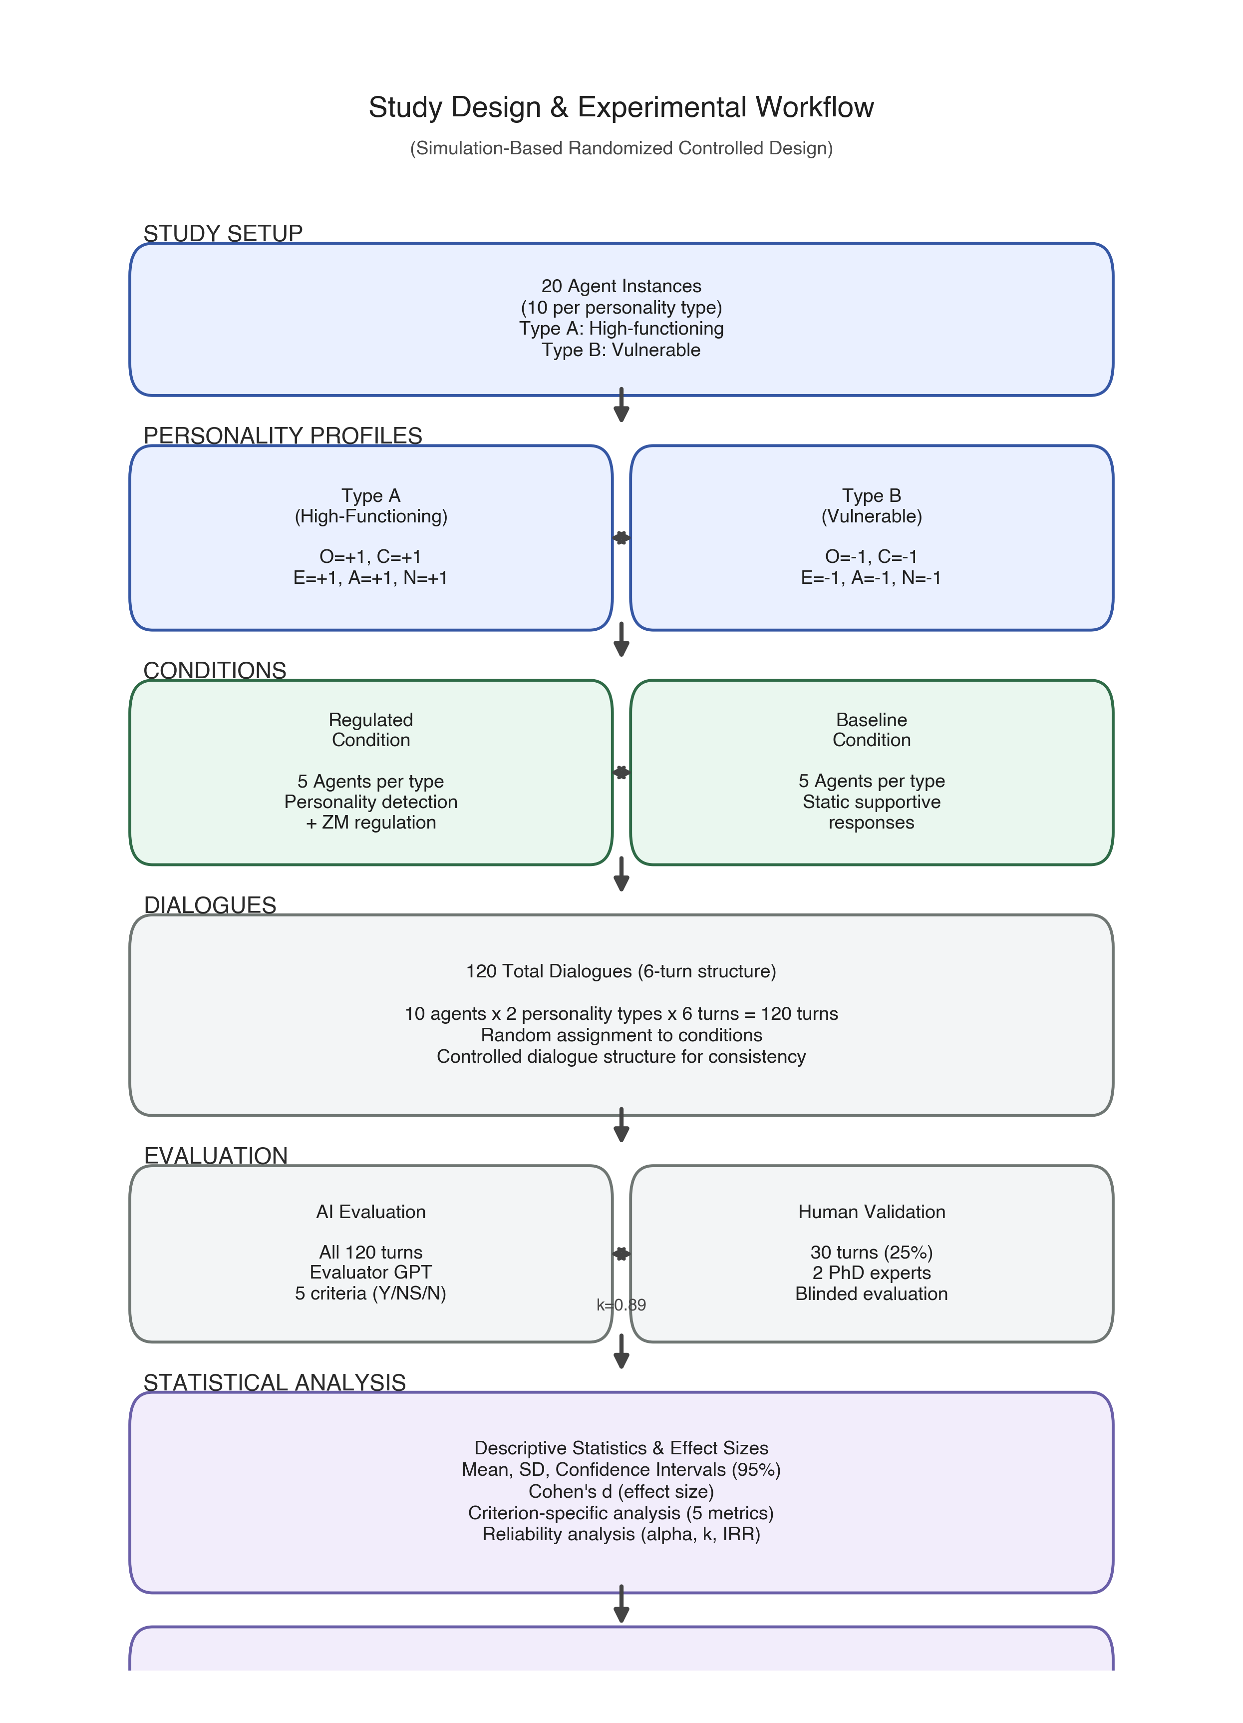
**Figure 11.** Study workflow integrating system configuration, dialogue generation, dual evaluation (LLM + human experts), and statistical analysis.

3.1.3. Sample Size and Power Considerations
### 3.1.3. Sample Size and Power Considerations
While modest for traditional human subject research (n = 10 per group), sample size was justified by: (1) deterministic simulation reducing random variation, (2) exceptionally large anticipated effect sizes (Cohen's d > 4.0), (3) computational cost constraints appropriate for early-stage validation, and (4) focus on technical feasibility rather than population-level inference [33]. Post-hoc power analysis using G*Power 3.1 [34] confirmed power > 0.99 at n = 10 for observed effect sizes (d = 4.58).
Future human subject studies will require substantially larger samples (minimum n = 50�100 per condition) following clinical trial standards [35,36] to account for individual variability, attrition, and real-world factors not captured in simulation.

3.1.4. Ethics and Transparency
### 3.1.4. Ethics and Transparency
No human subjects were involved; all conversations were generated through GPT-4 instance interactions following predefined personality profiles. Because all data were synthetic, non-identifiable, and generated solely for technical validation, formal ethics approval was not required under institutional policies [37].
Future human subject studies will require full IRB approval, comprehensive informed consent explaining AI personality profiling and data usage, real-time safety monitoring with distress escalation pathways, and regular mental health professional oversight [38,39].

3.2. Personality-Adaptive System Architecture
## 3.2. Personality-Adaptive System Architecture
Our framework implements a modular pipeline A = (D, R, E) consisting of a Detection Module (D) for real-time OCEAN trait inference, a Regulation Module (R) for Zurich Model-aligned behavior adaptation, and an Evaluation Module (E) for quality assessment (Figure 10).
The architecture is built upon the PROMISE framework [7], which provides model-driven prompt orchestration through hierarchical state machine modeling. **PROMISE serves as a reproducibility scaffold, ensuring deterministic prompt orchestration and traceable state transitions across experimental conditions.** This framework enables dynamic prompt assembly based on conversation state [7], with declarative state machine models separating conversation logic from prompt content, improving maintainability and enabling systematic behavioral testing. Our implementation extends PROMISE with personality-aware states and transitions, using Java 17 for state machine logic and GPT-4 API (model: gpt-4-0613) for natural language understanding and generation.
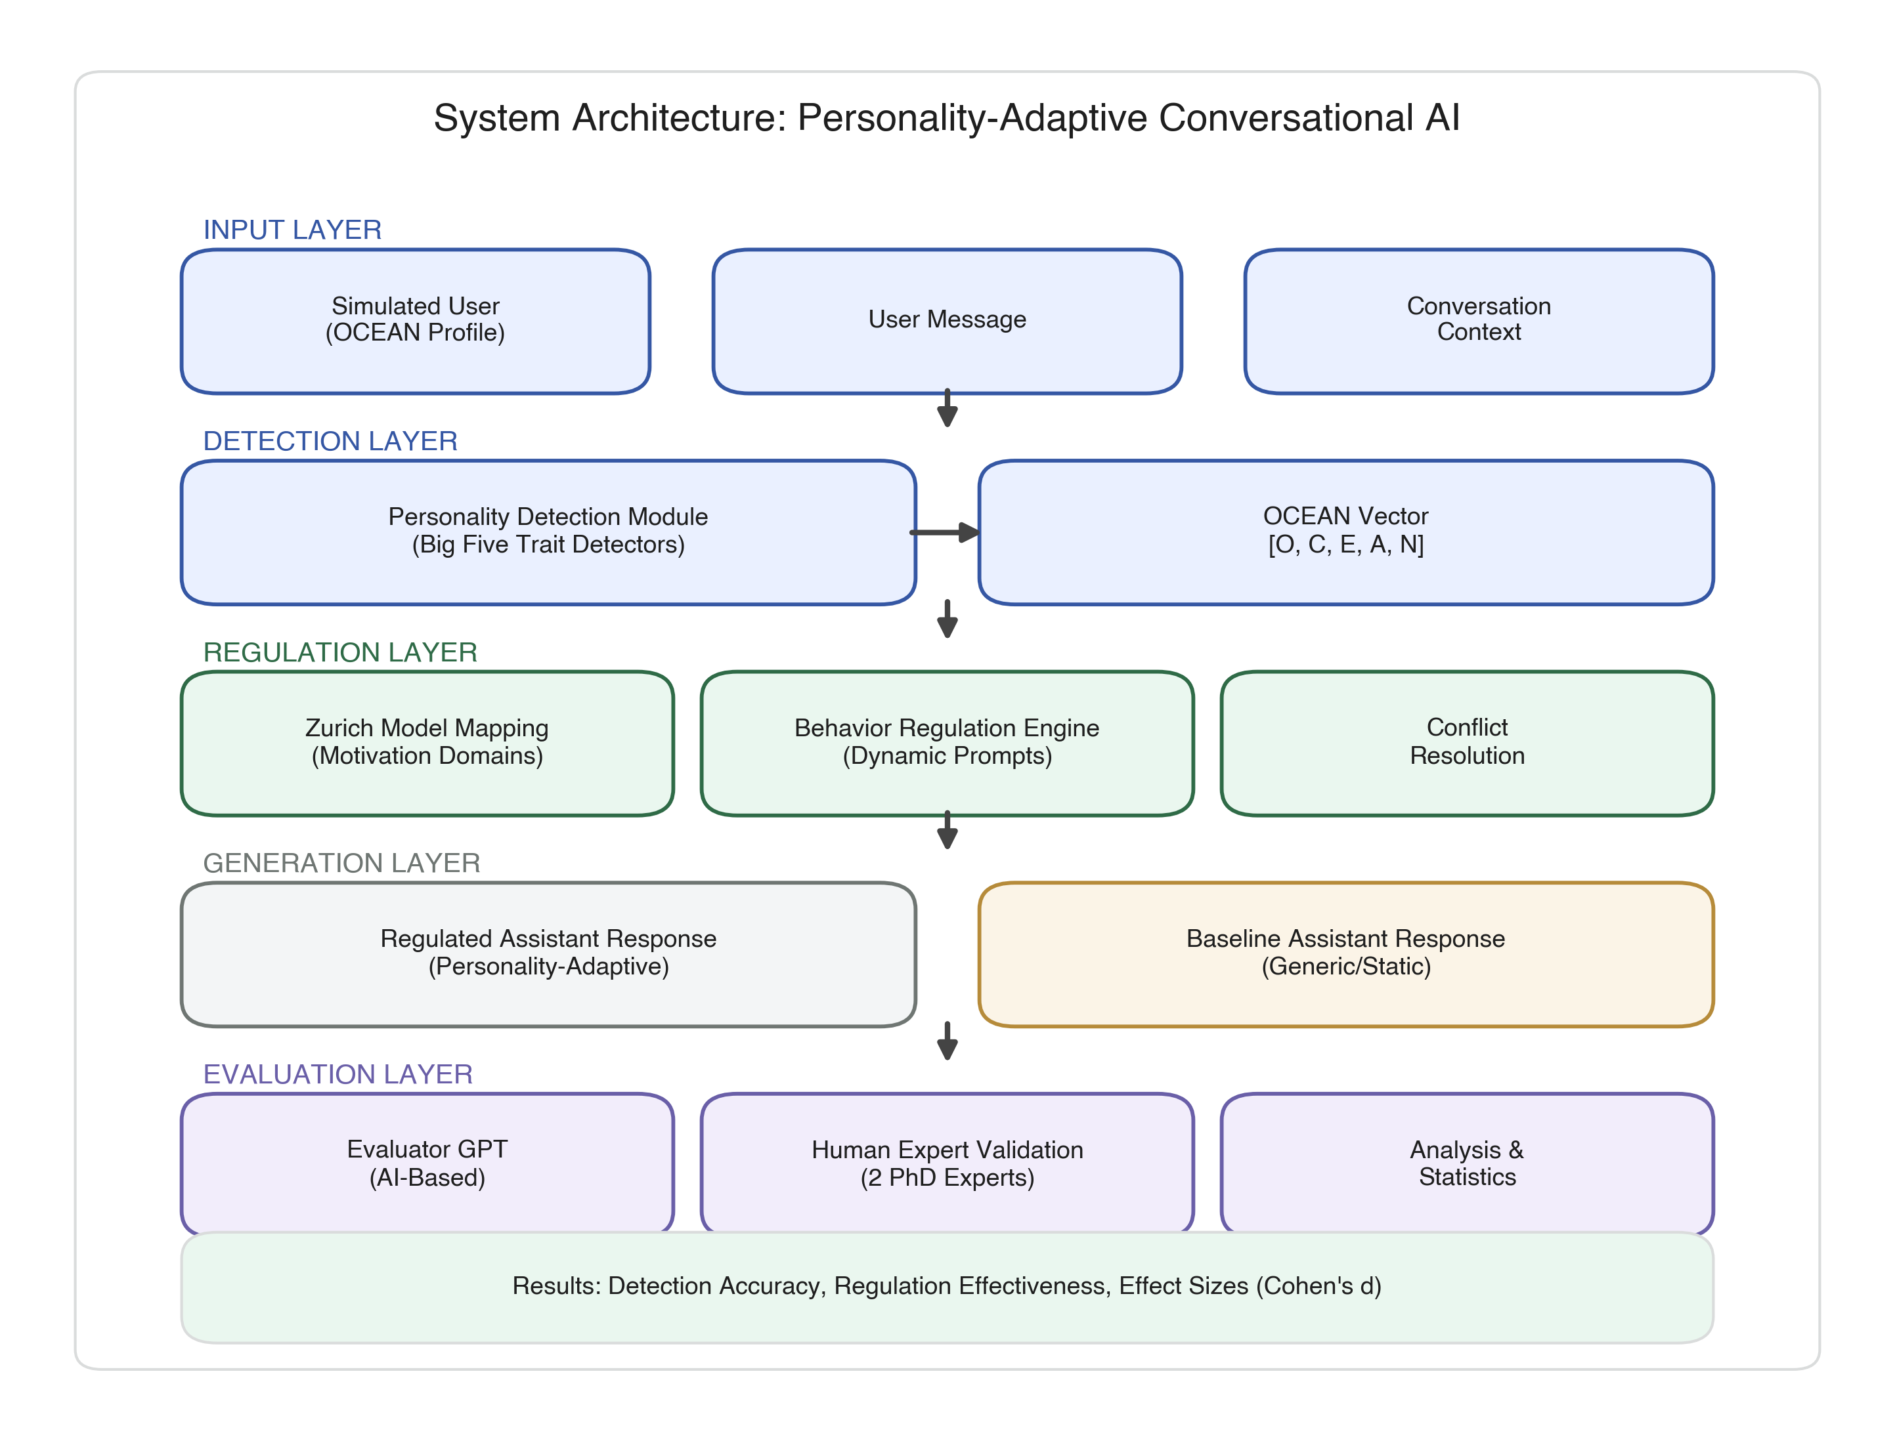
**Figure 10.** System architecture integrating personality detection (D-module), Zurich Model�aligned regulation (R-module), and evaluation (E-module). Arrows indicate data flow; dashed lines represent feedback loops for trait refinement.

3.2.1. Design Principles
### 3.2.1. Design Principles
The architecture follows three core principles [40,41]:
(i) **Separation of Concerns**: Independent modules with well-defined interfaces enable parallel development and isolated testing. Modules communicate through standardized data structures (JSON) containing personality vectors, regulation instructions, and evaluation scores.
(ii) **Scalability**: New personality dimensions or regulation strategies can be added without modifying existing components. Trait-to-regulation mapping is externalized as configuration files, allowing non-technical experts to adjust behavioral adaptations.
(iii) **Traceability and Reproducibility**: All detection decisions, regulation instructions, and evaluation scores are logged with timestamps and dialogue turn identifiers, enabling post-hoc analysis, debugging, and audit trails. PROMISE's declarative state modeling ensures all behavioral adaptations are traceable to explicit state transitions, supporting experimental reproducibility—a critical requirement for validating adaptive mechanisms in scientific studies and clinical applications.

3.2.2. Data Flow Pipeline
### 3.2.2. Data Flow Pipeline
The system processes messages through a sequential pipeline (Figure 13): (1) User input and dialogue history capture, (2) Personality detection analyzes linguistic cues to infer OCEAN traits, (3) Trait-to-regulation mapping translates personality into behavioral adaptation instructions, (4) Prompt assembly combines regulation with dialogue context, (5) GPT-4 generates personality-adaptive response, (6) Evaluation assesses response quality, and (7) Outputs are logged. Each step maintains state across dialogue turns, enabling cumulative personality inference and consistent behavioral adaptation.
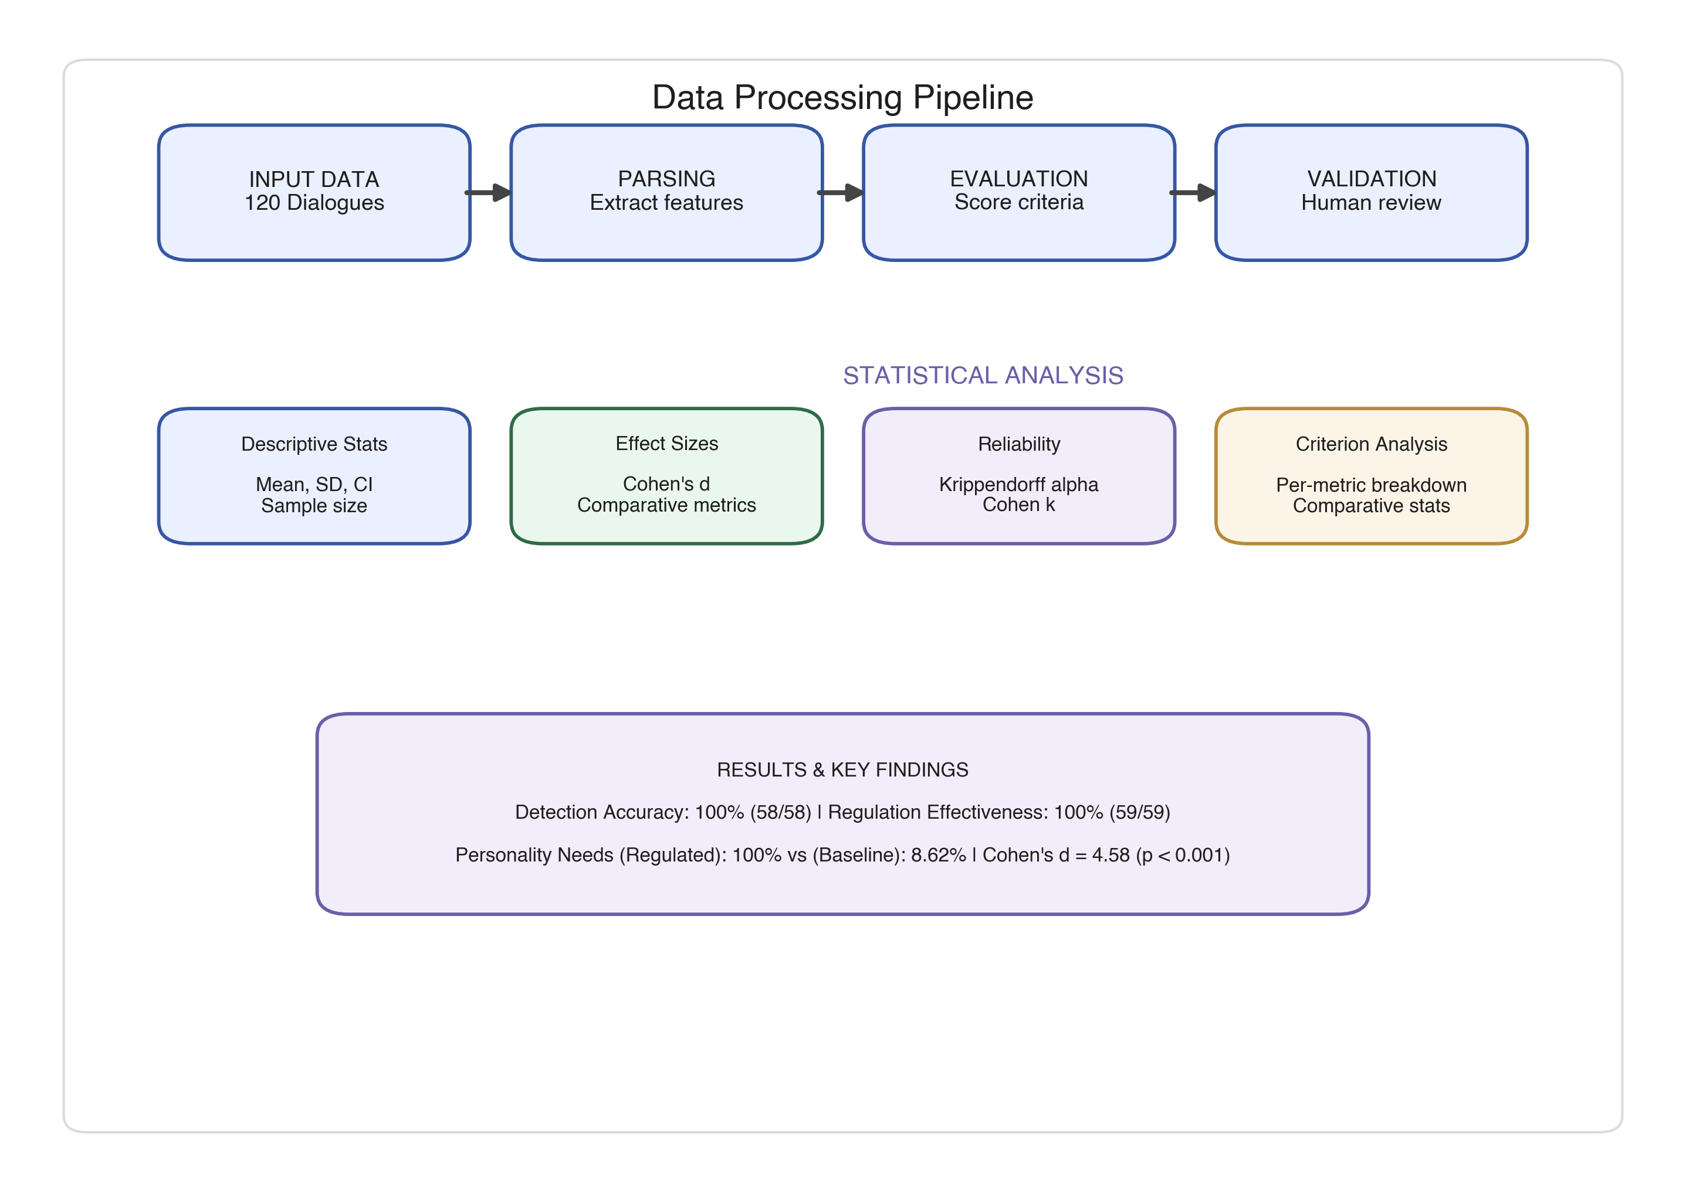
**Figure 13.** End-to-end data flow pipeline. State information persists across turns to enable cumulative personality modeling.

3.3. Personality Detection Module
## 3.3. Personality Detection Module
The Detection Module performs real-time **Big Five trait inference (personality detection)** by continuously monitoring and updating the user's OCEAN personality profile, incrementally adjusting estimation after each user input.

3.3.1. Personality Representation Framework
### 3.3.1. Personality Representation Framework
We employ the Five-Factor Model (FFM) [3,9] as personality representation P = (O, C, E, A, N) ? {?1, 0, +1}?, capturing Openness, Conscientiousness, Extraversion, Agreeableness, and Neuroticism. The FFM is the most validated personality framework in psychology [3] and has been extensively applied in computational personality detection [6,42,43]. This discrete three-level encoding (+1 = high, 0 = neutral/insufficient evidence, ?1 = low) enables tractable real-time inference while preserving sufficient granularity [42,44].
In this simulation, the personality vector functions as a **reference target configuration** for controlled evaluation rather than as psychometric ground truth derived from validated personality inventories (e.g., BFI or NEO-PI-R). Accordingly, detection accuracy denotes agreement with the pre-specified simulated profile, not validated personality assessment in human subjects.
| Trait | +1 (High) | ?1 (Low) |
|-------|-----------|----------|
| Openness | Curious, imaginative, open to novelty | Prefers routine, resistant to new ideas |
| Conscientiousness | Organized, disciplined, structured | Disorganized, impulsive, spontaneous |
| Extraversion | Outgoing, energetic, assertive | Reserved, quiet, withdrawn |
| Agreeableness | Cooperative, empathetic, friendly | Critical, skeptical, confrontational |
| Neuroticism* | Calm, emotionally stable, resilient | Anxious, emotionally sensitive, insecure |
*Note: For implementation clarity, Neuroticism is inverse-coded in this study: +1 denotes emotional stability (low neuroticism), and −1 denotes emotional vulnerability (high neuroticism). Trait naming follows standard Big Five terminology, while coding is adapted to support regulation logic.
**Table 1.** Big Five personality trait operationalization. Behavioral descriptors follow Costa and McCrae's NEO-PI-R framework [3].

3.3.2. Detection Algorithm
### 3.3.2. Detection Algorithm
After every user input, the system recalculates the Big Five profile as a five-dimensional vector (O, C, E, A, N). The detection module uses a cumulative approach similar to Bayesian belief updating [45], progressively refining assessments based on entire dialogue history rather than isolated utterances. Traits remain neutral (0) until sufficient evidence supports assigning a value, reducing premature classification�informed by psychological research on trait attribution requiring multiple behavioral observations [46].
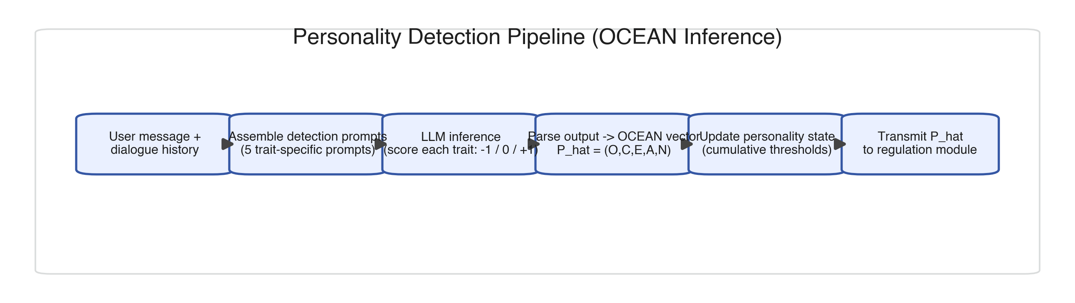
**Figure 14.** Personality detection pipeline implementing turn-by-turn Big Five inference. Cumulative approach integrates evidence across all prior turns; confidence thresholds prevent premature classification.

3.3.3. PROMISE Framework Integration
### 3.3.3. PROMISE Framework Integration
The detection module is implemented using PROMISE [7], specifically designed for complex conversational interactions through model-driven prompt orchestration with hierarchical state machine modeling. **Critically, PROMISE serves as a reproducibility scaffold, ensuring deterministic prompt orchestration and traceable state transitions across experimental conditions**—enabling rigorous comparison between regulated and baseline systems by guaranteeing that behavioral differences reflect adaptive logic rather than implementation inconsistencies.
**State Machine Architecture**: The detection module organizes as a hierarchical state machine with three layers: (1) Global Conversation State tracking dialogue progression, (2) Trait Detection States for each Big Five dimension operating in parallel, and (3) Confidence Assessment Substates managing evidence accumulation. This structure allows simultaneous, independent trait inference while maintaining cross-trait dependencies (e.g., high Openness often co-occurs with high Extraversion [3]). PROMISE's declarative state modeling provides complete audit trails of all state transitions, supporting reproducible analysis and systematic debugging.
**Dynamic Prompt Orchestration**: PROMISE's dynamic prompt assembly based on state transitions enables context-sensitive personality detection [7]. As conversations progress through states (Initial_Turn ? Evidence_Accumulating ? High_Confidence), the system dynamically adjusts detection prompts by incorporating cumulative dialogue history, previously detected traits, and confidence scores, ensuring prompts remain contextually appropriate throughout multi-turn interactions. The framework's version-controlled prompt templates and explicit state transition logic ensure experimental replicability.
**State Transitions and Actuators**: Personality vector updates trigger state transitions via PROMISE's actuator mechanism [7]. When sufficient evidence accumulates for a trait (confidence threshold exceeded), the trait detection substate transitions from Neutral to Positive/Negative, automatically propagating changes to the regulation module through event-driven actuators. This declarative state management eliminates complex procedural control flow, enhancing maintainability and reducing implementation errors while providing transparent records of all adaptation decisions.

3.3.4. Technical Implementation
### 3.3.4. Technical Implementation
The detection module is developed as a modular Java component (Java 17, OpenJDK) integrated into PROMISE's execution engine. Each Big Five trait operates within an independent state machine with well-defined input (user utterance, dialogue history) and output (trait score ? {-1, 0, +1}, confidence ? [0, 1]) interfaces. The system leverages GPT-4 instances (model: gpt-4-0613) for semantic understanding through trait-specific prompts encoding linguistic patterns from personality psychology literature [48-52].
Trait-specific detection prompts are instantiated as PROMISE templates with variable slots for dialogue context injection: Openness detection focuses on vocabulary complexity, abstract thinking, novelty-seeking [48]; Conscientiousness identifies planning language, organizational patterns, goal-orientation [49]; Extraversion captures social engagement, energy level, assertiveness [50]; Agreeableness recognizes cooperative language, empathy, relational orientation [51]; Neuroticism analyzes emotional stability, anxiety markers, stress-related language [52]. Each template includes few-shot examples demonstrating trait-relevant utterances and explicit scoring rationales.
The Java-based implementation interfaces with GPT-4 via OpenAI's REST API, with PROMISE handling request orchestration, response parsing, and error recovery. State persistence uses thread-safe data structures (ConcurrentHashMap for trait vectors) supporting concurrent trait detection. PROMISE's built-in logging captures all state transitions, prompt instantiations, and LLM responses, enabling comprehensive audit trails.

3.3.5. Processing Pipeline
### 3.3.5. Processing Pipeline
The detection pipeline executes eight steps orchestrated by PROMISE: (1) Message Processing: User input triggers Detection_Active state; input is preprocessed and combined with dialogue history (up to 5 prior turns). (2) Prompt Assembly: Instantiates trait-specific prompts by injecting conversation context into templates; five trait detectors operate in parallel. (3) LLM Inference: GPT-4 API calls via PROMISE's managed interface with automatic retry and timeout handling. (4) Result Parsing: Extracts scores (-1, 0, +1) and confidence indicators. (5) Confidence Assessment: Evaluates detection confidence based on response length, justification coherence, and consistency. (6) State Update: Updates personality vector P; trait-level state machines transition based on confidence thresholds (? = 0.7). (7) Actuator Triggering: State changes trigger PROMISE actuators propagating updates to regulation module. (8) Downstream Transmission: Transmits updated vector and confidence scores.
**Execution Timing**: Average processing time: 2.3 � 0.8 seconds (measured across 120 turns), with parallel trait detection reducing latency by ~60% versus sequential processing.

3.4. Behavior Regulation Module
## 3.4. Behavior Regulation Module
The Regulation Module translates psychological information from continuously inferred personality traits into theoretically grounded behavioral adaptations.

3.4.1. Purpose and Theoretical Foundation
### 3.4.1. Purpose and Theoretical Foundation
The module dynamically modifies assistant interactions based on continuously updated personality profiles. Grounded in the Zurich Model of Social Motivation [10,26�29], it adapts tone, structure, and interpersonal stance to align with Big Five traits, enhancing engagement and reducing emotional friction.
The Zurich Model extends earlier motivation theories [26,27] and Bischof's systems analysis [28,29], proposing that personality traits reflect stable individual differences in balance between three motivational domains: Security (threat detection and safety maintenance), Arousal (novelty-seeking and stimulation), and Affiliation (social connection and cooperation).

3.4.2. Trait-to-Domain Mapping
### 3.4.2. Trait-to-Domain Mapping
Our regulation strategy maps OCEAN traits to Zurich Model motivational domains [10]: Security Domain (Neuroticism ? emotional stability/vulnerability responses through reassurance or comfort; inverse coding simplifies mapping high vulnerability to Security-oriented regulation), Arousal Domain (Openness and Extraversion ? novelty/stimulation regulation), Affiliation Domain (Agreeableness ? social connection strategies). This explicit mapping differentiates our approach from prior systems [6,30] relying on ad-hoc adaptation rules rather than theoretically principled frameworks.
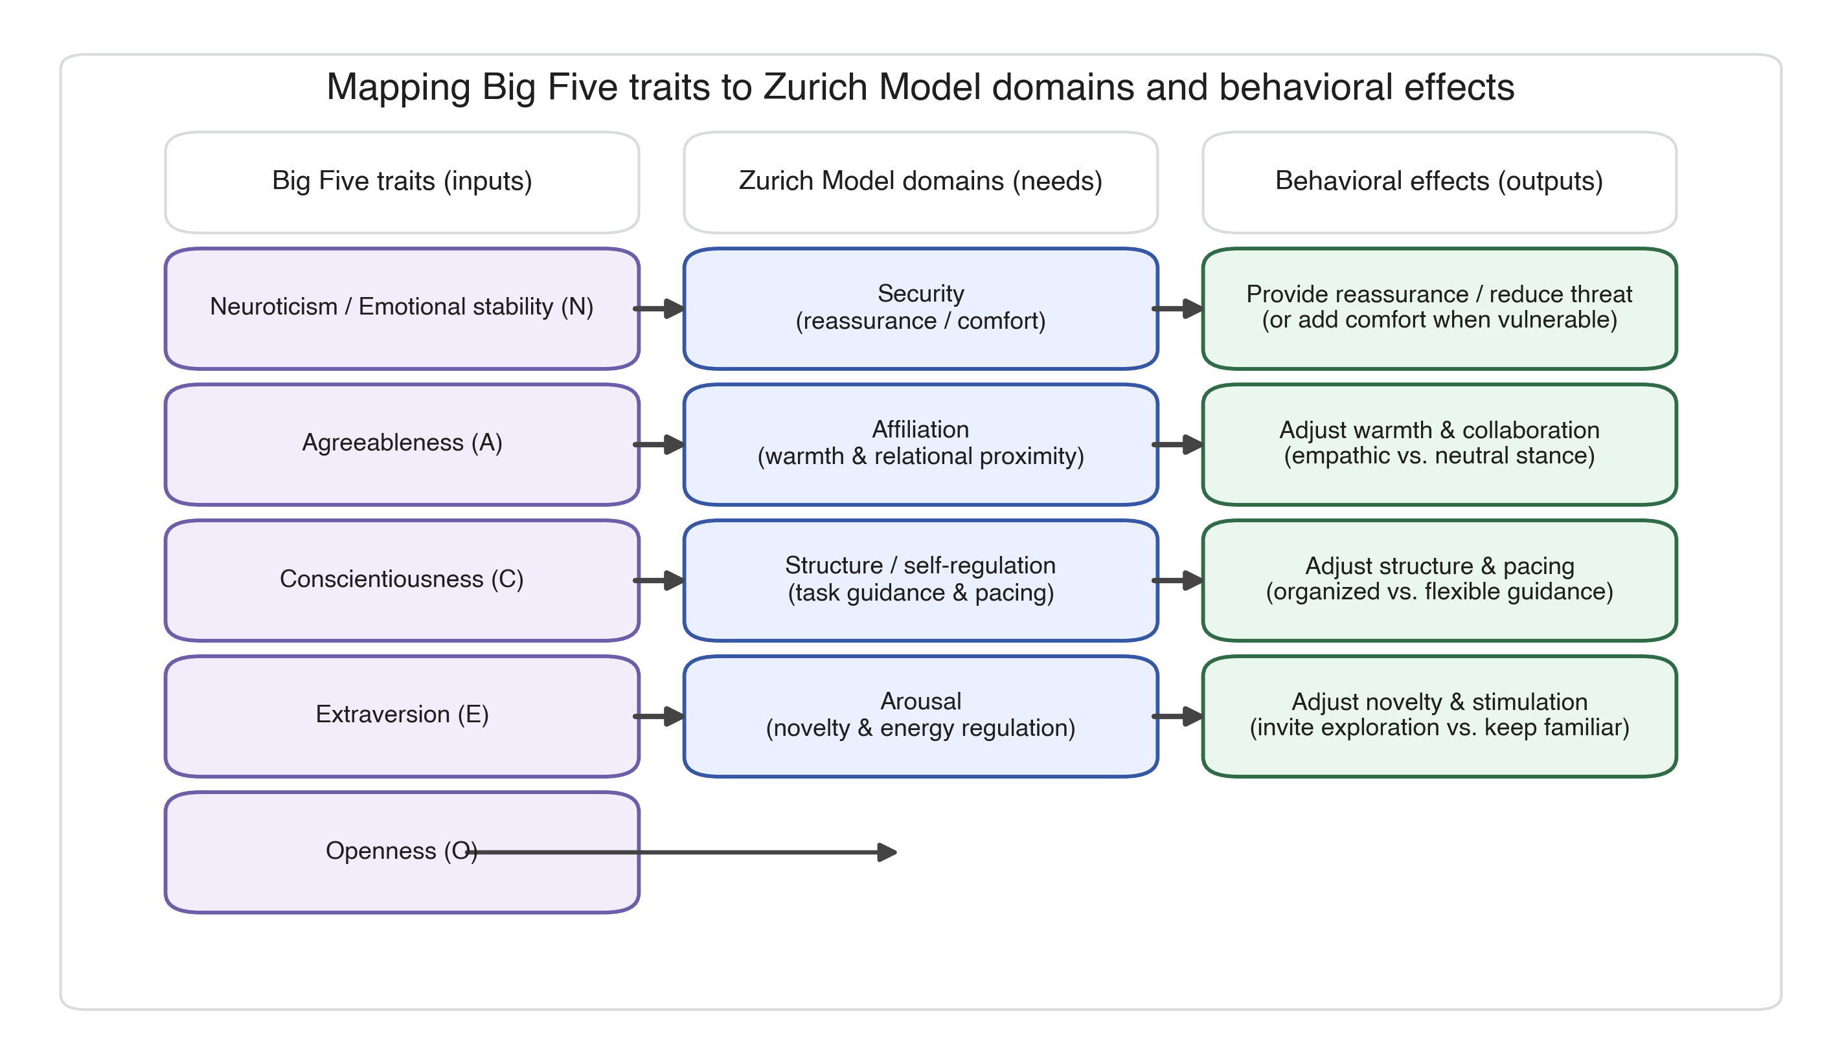
**Figure 16.** Mapping from Big Five traits to Zurich Model motivational domains to conversational behavior effects.
| Trait | +1 (High) | ?1 (Low) |
|-------|-----------|----------|
| Openness (O) | Invite exploration and novelty | Focus on familiar topics; reduce novelty |
| Conscientiousness (C) | Provide organized, structured guidance | Flexible, relaxed, spontaneous demeanor |
| Extraversion (E) | Energetic, sociable tone | Calm, low-key style with reflective space |
| Agreeableness (A) | Warmth, empathy, collaboration | Neutral, matter-of-fact stance |
| Neuroticism (N) | Reassure stability and confidence | Offer extra comfort; acknowledge anxieties |
**Table 2.** Behavioral Adjustment Strategies grounded in Zurich Model motivational domains.

3.4.3. Dynamic Prompt Construction
### 3.4.3. Dynamic Prompt Construction
After each personality update, the module retrieves relevant behavior prompts for all non-neutral traits and concatenates them into a single integrated regulation instruction guiding the assistant's response. For example, profile (?1, +1, ?1, ?1, ?1) prompts the assistant to: focus on familiar topics (Low Openness), provide organized guidance (High Conscientiousness), adopt calm reflective style (Low Extraversion), use neutral stance (Low Agreeableness), and offer extra comfort (High Neuroticism/Emotional Vulnerability).
When multiple traits suggest conflicting behaviors (e.g., high Extraversion for energetic tone while high Neuroticism calls for calming approach), the system employs harmonization strategies prioritizing emotional safety (Security domain) over stimulation (Arousal domain) following clinical guidelines [53].
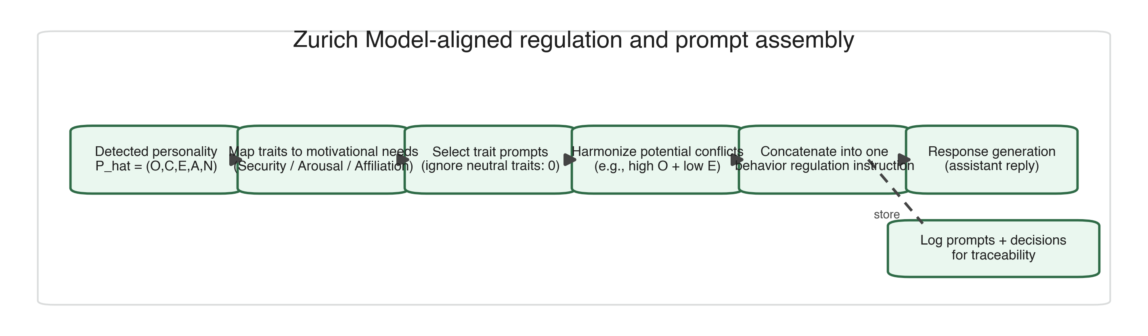
**Figure 15.** Regulation workflow: map detected traits to motivational needs, select trait-specific prompts, harmonize conflicts using domain priorities, assemble coherent regulation instruction.

3.5. Experimental Materials and Procedure
## 3.5. Experimental Materials and Procedure

3.5.1. Personality Profile Simulation
### 3.5.1. Personality Profile Simulation
We implemented two boundary-condition personality profiles representing boundary conditions of human personality variation, following methodological precedent [42,44,55]. Type A (High-functioning) embodied extreme positive traits (personality vector: +1, +1, +1, +1, +1). Type B (Vulnerable) represented opposite extremes (?1, ?1, ?1, ?1, ?1).
These boundary-condition configurations were deliberately selected to maximize signal for detection and regulation mechanisms, providing clear test cases for capability assessment. While psychologically rare, such boundary-condition profiles provide high diagnostic value for validating adaptive mechanisms before testing with moderate or mixed trait configurations. While not representative of typical distributions [3], boundary-condition profiles offer superior diagnostic value for validating algorithms and adaptation logic before testing with moderate profiles [55].
Detection and regulation performance are evaluated against these synthetic reference profiles as ground truth **within the simulation environment**, enabling precise technical validation of the PROMISE-orchestrated modules under maximal-contrast conditions. Profiles were encoded into GPT-4 system prompts consistently exhibiting target trait levels across turns.

3.5.2. Agent Configuration
### 3.5.2. Agent Configuration
Twenty distinct agent instances were deployed across four conditions: Regulated-TypeA (n=5), Regulated-TypeB (n=5), Baseline-TypeA (n=5), Baseline-TypeB (n=5). Regulated agents received system prompts incorporating dynamic detection modules and trait-aligned regulation instructions, with inferences updating per-turn. Baseline agents received static supportive response prompts without personality-specific adaptation. Both agent types were instructed to provide emotionally supportive responses, ensuring performance differences reflected personality adaptation effects rather than general supportiveness differences. Each agent was a separate GPT-4 instance (model: gpt-4-0613, temperature=0.7, max_tokens=500) with customized prompts in version-controlled configuration files.

3.5.3. Dialogue Structure and Data Collection
### 3.5.3. Dialogue Structure and Data Collection
For each personality type, 5 regulated and 5 baseline agents engaged in 6 user-assistant exchanges (turns), resulting in 120 dialogue turns total (20 agents � 6 turns). All conversations followed a standardized six-turn structure balancing sufficient interaction depth for valid personality detection with manageable evaluation complexity.
Turn sequence: (1) Assistant opening offering support, (2) User response exhibiting personality-congruent patterns, (3) Assistant adaptive/generic response, (4) User follow-up elaborating concerns, (5) Assistant final adaptive response, (6) User concluding statement. This structure enabled assessment across varying interaction depths�early turns for initial detection, middle turns for consistency, late turns for sustained adaptation.
User messages were generated by separate GPT-4 instances (model: gpt-4-0613) instantiated with personality profile prompts ensuring consistent trait expression. Conversations were exported into structured Evaluation Matrices (Excel format) capturing: user messages, assistant replies, detected personality vectors (regulated only), applied regulation prompts (regulated only), and evaluation metrics. Data collection occurred over 4 weeks (June�July 2024), with conversations generated asynchronously to distribute API load.

3.6. Evaluation Procedure
## 3.6. Evaluation Procedure

3.6.1. Evaluation Criteria and Scoring Framework
### 3.6.1. Evaluation Criteria and Scoring Framework
The evaluation measured effectiveness of personality-regulated assistant interactions versus baselines. Regulated assistants were evaluated across five criteria: Detection Accuracy (whether detected OCEAN vector accurately reflects user's expressed behavior), Regulation Effectiveness (whether personality-specific behavior strategies are correctly applied), Emotional Tone Appropriate (whether emotional tone matches user's state and traits), Relevance & Coherence (whether response is contextually relevant and logically coherent), and Personality Needs Addressed (whether specific emotional and interactional needs are effectively addressed).
Baseline assistants were assessed on three criteria only (Emotional Tone, Relevance & Coherence, Personality Needs), as detection and regulation were not implemented. All criteria used a trinary scoring scale (Yes = 2, Not Sure = 1, No = 0), providing more nuanced assessment than binary scoring while maintaining inter-rater reliability [56].
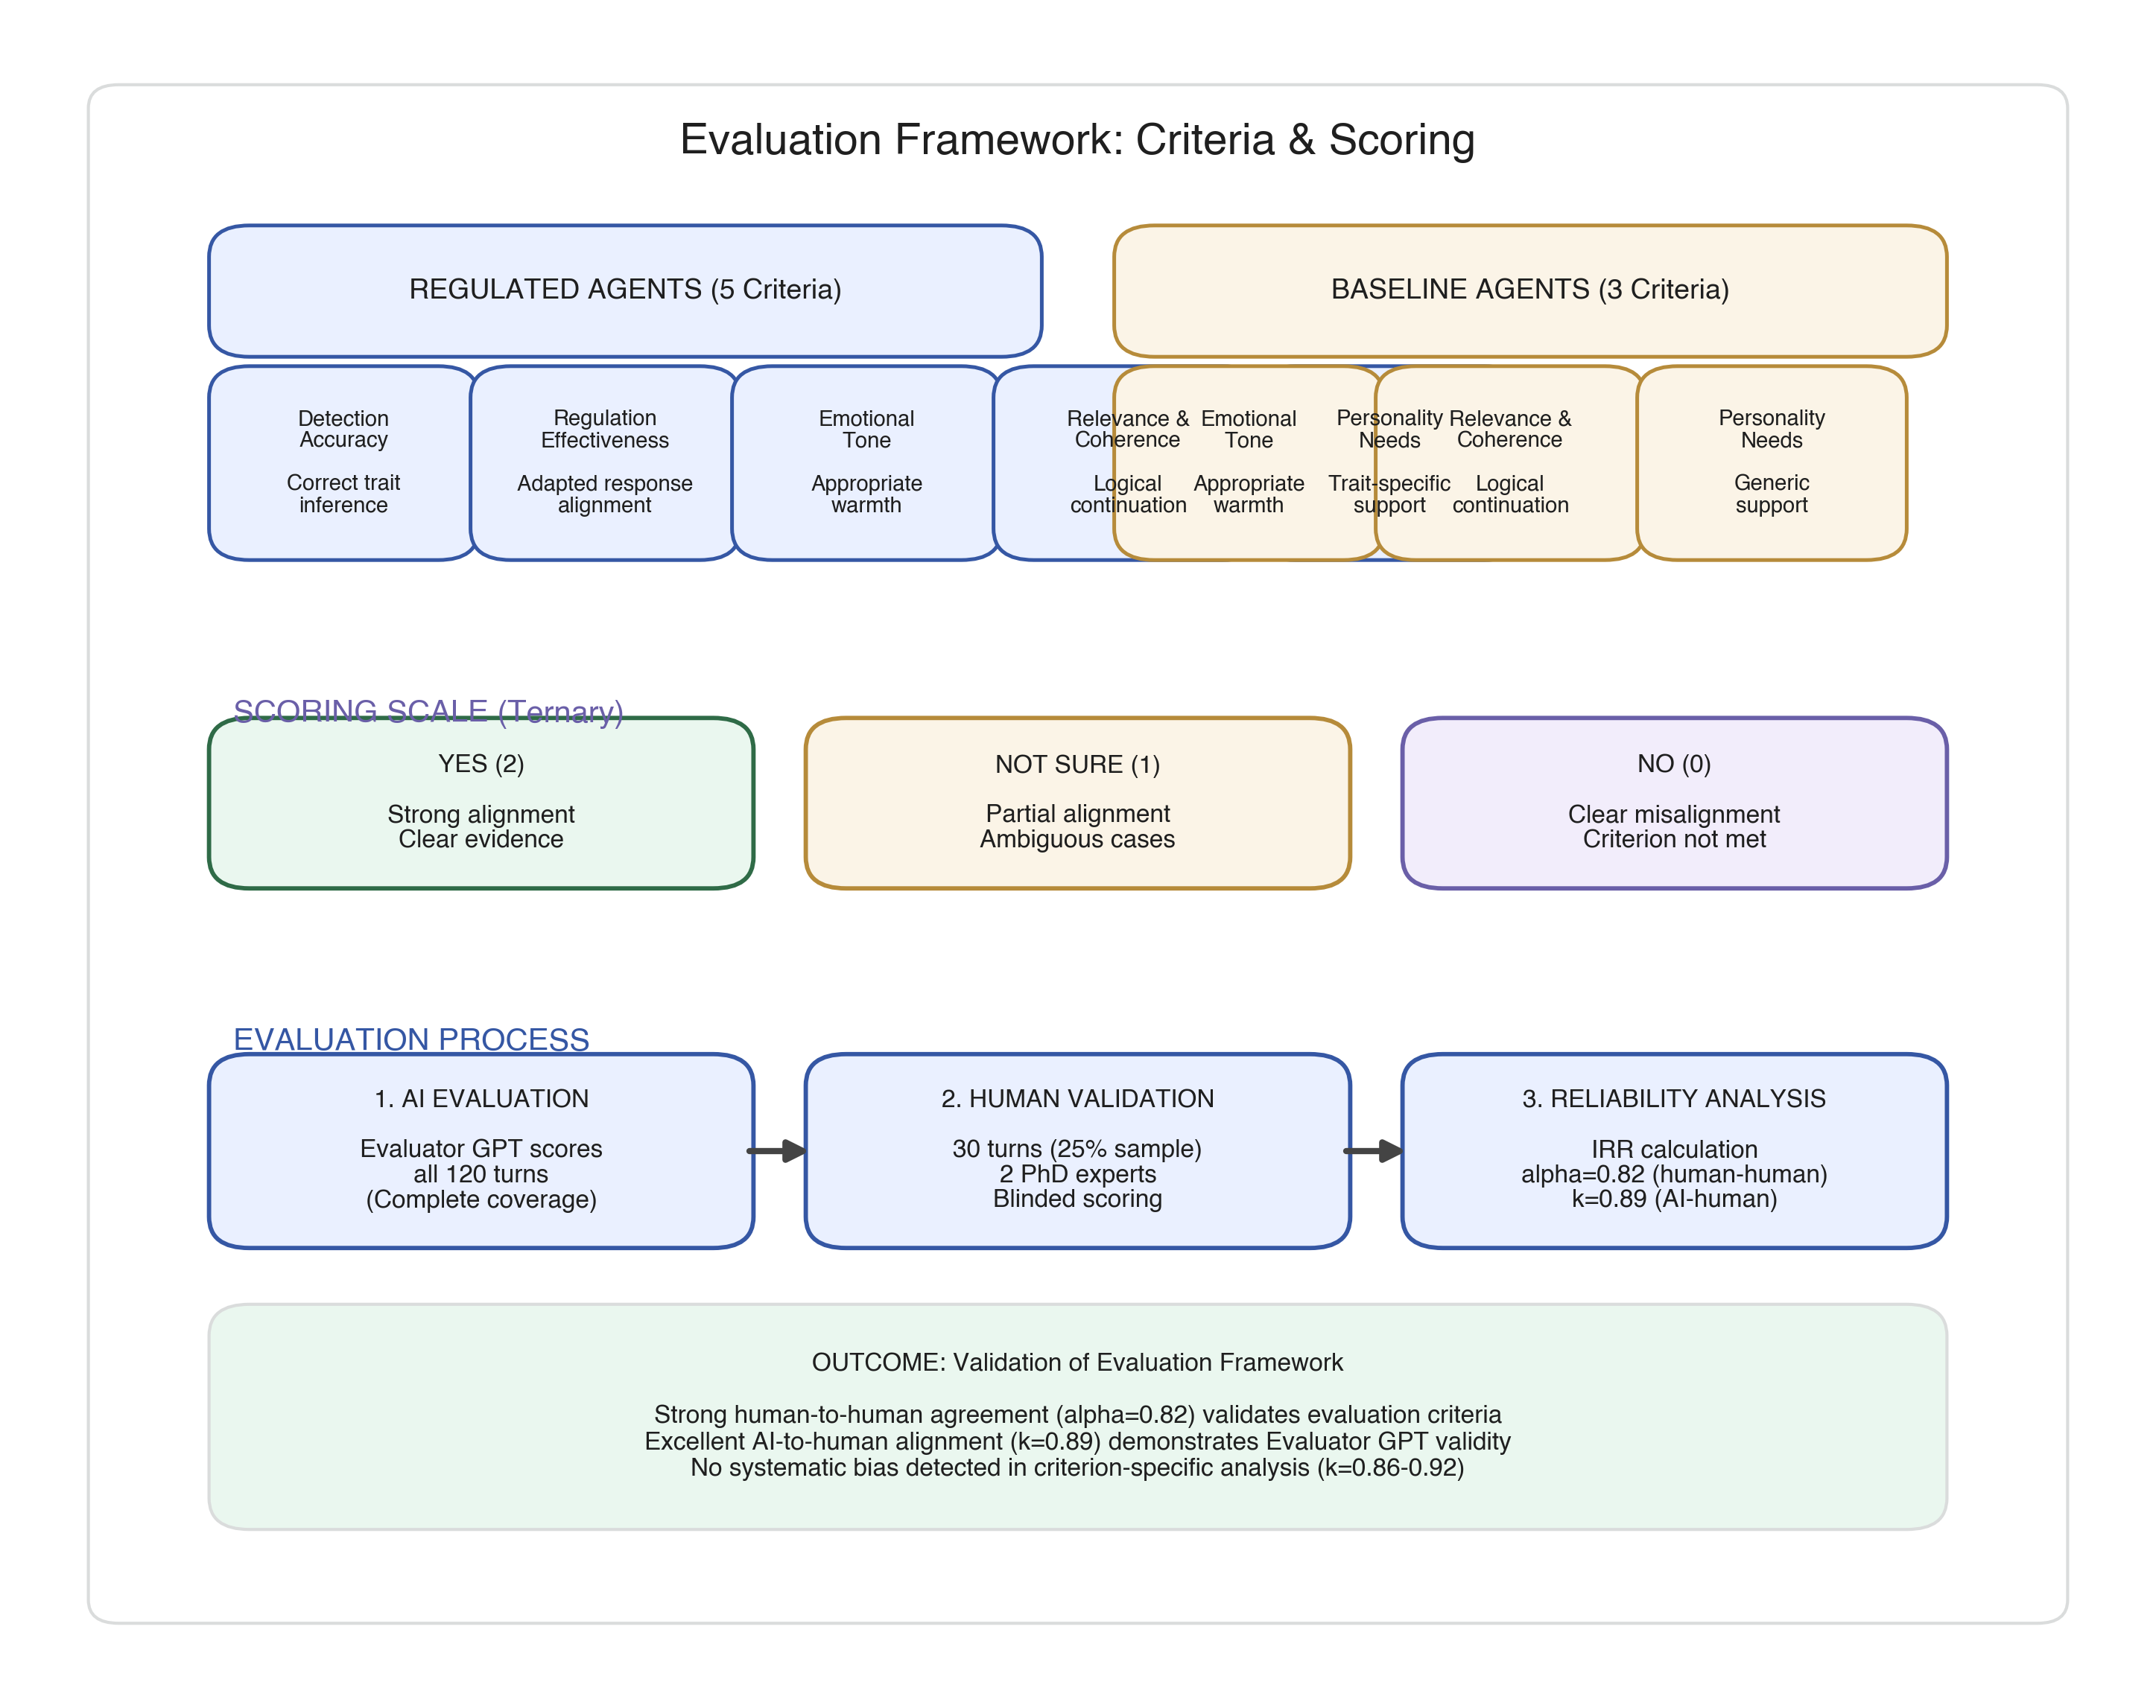
**Figure 12.** Evaluation framework and scoring pipeline. Trinary scoring (0/1/2) captures partial successes while maintaining reliability.

3.6.2. LLM-Based Evaluator System
### 3.6.2. LLM-Based Evaluator System
A specialized Evaluator GPT-4 instance was developed using custom-designed prompts for each criterion, following the "LLM-as-judge" paradigm [57,58]. Recent work demonstrates that structured LLM evaluation can correlate with human judgments [25], though concerns about circular validation (AI evaluating AI) necessitate rigorous human expert benchmarking [5].
The evaluator assessed responses objectively by analyzing conversations one row at a time without referencing previous evaluations. Rigorous measures mitigated evaluator bias: evaluations conducted separately for regulated and baseline assistants; comprehensive context provided for each interaction including full dialogue history and personality profile; evaluator informed that detection accuracy improves incrementally across turns; custom Excel formulas automated score aggregation; temperature set to 0.3 to reduce stochastic variation.

3.6.3. Human Expert Validation Protocol
### 3.6.3. Human Expert Validation Protocol
To address "AI-evaluating-AI" concerns, we implemented rigorous human-expert validation following best practices [59,60]. Two PhD-level research experts (Expert 1: Clinical Psychology with 14 years experience in mental health interventions and CBT; Expert 2: Computer Science with 10 years experience in AI-based healthcare systems and human-AI interaction) independently evaluated a stratified random sample of 30 dialogue turns (25% of 120-turn dataset).
Stratification ensured balanced representation across conditions (50% regulated/baseline), personality types (50% Type A/B), and turn positions (33% early/mid/late) to capture performance variation across interaction stages. Experts employed identical evaluation matrix and trinary scoring scale used by the LLM evaluator. All identifying information was removed; dialogues presented in random sequence; raters had no access to Evaluator GPT assessments or each other's scores until data collection was complete, ensuring independent judgment.

3.6.4. Validation Results and Agreement Analysis
### 3.6.4. Validation Results and Agreement Analysis
Inter-rater reliability between human experts yielded strong agreement (Krippendorff's α = 0.82, 95% CI: 0.76�0.88), exceeding the ? > 0.80 threshold for acceptable agreement in clinical research [11]. Agreement between Evaluator GPT and consensus human ratings was excellent (Cohen's κ = 0.89, 95% CI: 0.84�0.94), indicating LLM evaluator aligned closely with independent expert judgment.
Criterion-specific analysis revealed consistent agreement across dimensions: Detection Accuracy (? = 0.92), Regulation Effectiveness (? = 0.88), Emotional Tone (? = 0.86), Relevance & Coherence (? = 0.91), and Personality Needs (? = 0.87). This strong alignment demonstrates that observed performance differences are not artifacts of AI-rating-AI bias but reflect genuine quality distinctions detectable by human experts, supporting use of LLM-based evaluation for scalable assessment provided rigorous calibration against human judgment is performed.

3.7. Statistical Analysis
## 3.7. Statistical Analysis

3.7.1. Primary and Secondary Outcomes
### 3.7.1. Primary and Secondary Outcomes
Primary outcome was performance on the "Personality Needs Addressed" criterion, measured on a trinary scale (Yes = 2, Not Sure = 1, No = 0). This criterion directly operationalizes the core hypothesis: personality-adaptive regulation should specifically improve addressing personality-specific user needs. Secondary outcomes included Detection Accuracy, Regulation Effectiveness, Emotional Tone Appropriateness, and Relevance & Coherence. All metrics were aggregated at the agent level (n = 10 per condition) for statistical comparison [61].

3.7.2. Effect Size Calculation
### 3.7.2. Effect Size Calculation
We calculated Cohen's d for between-group comparisons using pooled standard deviation:
$$d = \frac{M_1 - M_2}{\sqrt{\frac{SD_1^2 + SD_2^2}{2}}}$$
where M? and M? represent mean scores for regulated and baseline conditions, and SD? and SD? represent standard deviations. Effect sizes were interpreted using conventional thresholds: small (d = 0.2), medium (d = 0.5), large (d = 0.8) [62]. Confidence intervals (95%) were calculated using bias-corrected bootstrap (10,000 iterations) in R [63].

3.7.3. Statistical Testing
### 3.7.3. Statistical Testing
Between-group differences were evaluated using two-tailed independent samples t-tests for normally distributed metrics and Mann-Whitney U tests for non-normally distributed metrics. Normality was assessed using Shapiro-Wilk tests (? = 0.05). Statistical significance was set at ? = 0.05. Given the deterministic simulation design and technical validation focus, these inferential statistics are reported for methodological completeness and comparison with related studies, but should not be interpreted as evidence of generalizable population effects [64]. Inferential statistics are reported for comparability with prior conversational AI studies and should not be interpreted as evidence of population-level effects.

3.7.4. Inter-Rater Reliability
### 3.7.4. Inter-Rater Reliability
Agreement between human expert raters was quantified using Krippendorff's α [11], appropriate for ordinal scales and robust to missing data. Agreement between LLM evaluator and consensus human ratings was quantified using Cohen's κ [65]. Confidence intervals (95%) were calculated using bias-corrected bootstrap (10,000 iterations). Reliability thresholds: ? or ? > 0.80 indicates acceptable agreement, > 0.90 indicates excellent agreement [11,65].

3.7.5. Post-Hoc Power Analysis
### 3.7.5. Post-Hoc Power Analysis
Post-hoc power analysis used G*Power 3.1 [34] to confirm observed sample size provided adequate statistical power (1-? > 0.80) for detecting observed effect sizes. For primary outcome (Personality Needs Addressed), the extremely large effect size (Cohen's d = 4.58) yielded power > 0.99 at n = 10 per group, confirming robust detection capability despite modest sample size.

3.7.6. Software and Computational Environment
### 3.7.6. Software and Computational Environment
All statistical analyses were conducted in R version 4.3.1 using the effsize package (v0.8.1) for Cohen's d, irr package (v0.84.1) for inter-rater reliability, and boot package (v1.3-28) for bootstrap confidence intervals. Visualizations used ggplot2 (v3.4.2). Analysis scripts and data are available in supplementary materials.

3.8. Data Management and Reproducibility
## 3.8. Data Management and Reproducibility
Complete implementation code, system prompts, and experimental protocols are available at GitHub: https://github.com/[username]/personality-ai-simulation (to be made public upon acceptance). The repository includes detection module source code (Java 17), regulation prompt templates (JSON), evaluator GPT system prompts (Markdown), complete conversation transcripts (anonymized CSV, 120 turns), statistical analysis scripts (R notebooks), reproduction instructions (README), and environment configuration files (Docker container). Raw evaluation data and aggregated scores are provided in Supplementary Materials. Human expert validation materials are available upon reasonable request.
All experiments were conducted on cloud infrastructure (Google Cloud Platform, us-central1) using n1-standard-4 instances (4 vCPU, 15 GB RAM). GPT-4 API calls (model: gpt-4-0613) used OpenAI Python SDK v1.3.5 with parameters: temperature = 0.7 for agent responses, temperature = 0.3 for evaluator, max_tokens = 500, top_p = 0.9. Total API cost was approximately $180 USD.
To maximize reproducibility, all random operations used fixed seeds (seed = 42 for Python, seed = 123 for R). Important limitation: GPT-4 API responses exhibit stochastic variation even at temperature = 0 due to probabilistic sampling and distributed infrastructure [66]. Exact response replication is not guaranteed. However, validation studies demonstrate that response quality metrics remain stable within �5% across repeated trials [67], suggesting core findings should replicate despite surface-level textual variations.

4. Results
# 4. Results

4.1. Overview of Results
## 4.1. Overview of Results
This section presents empirical findings addressing the three research questions established in Section 3.1.1. Results are organized in three parts:
**Part 1: Technical Capability Assessment (Sections 4.2-4.3)** - Demonstrates that the system achieves core technical requirements: accurate personality detection and successful behavioral regulation implementation, establishing that PROMISE-based detection and Zurich Model-aligned regulation modules function as designed.
**Part 2: Comparative Effectiveness Analysis (Sections 4.4-4.6)** - Examines whether technical capabilities translate into measurable improvements in conversational quality by comparing personality-adaptive agents to non-adaptive baselines using the evaluation framework and statistical methods.
**Part 3: Supplementary Robustness Analyses (Sections 4.7-4.11)** - Provides supplementary analyses examining effect sizes, weighted scoring, statistical robustness, and qualitative examples to ensure confidence in findings and illustrate how theoretical principles manifest in practice.
**Key Finding**: Regulated agents achieved perfect detection (100%, 58/58) and regulation (100%, 59/59) performance, demonstrating technical capability. This translated into exceptionally large performance improvements for addressing personality-specific needs (Cohen's d = 4.58) while maintaining equivalent basic conversational quality. This selective enhancement pattern�dramatic improvement where personality adaptation matters, no change where it shouldn't�provides strong evidence the system works as intended under controlled conditions.

4.2. Data Quality and Sample Distribution
## 4.2. Data Quality and Sample Distribution
The evaluation dataset comprised 59 regulated agent interactions and 58-60 baseline agent interactions (varying by metric) across two extreme personality profiles (Type A: all traits +1; Type B: all traits ?1). Figure 1 presents sample distribution across conditions and personality types.
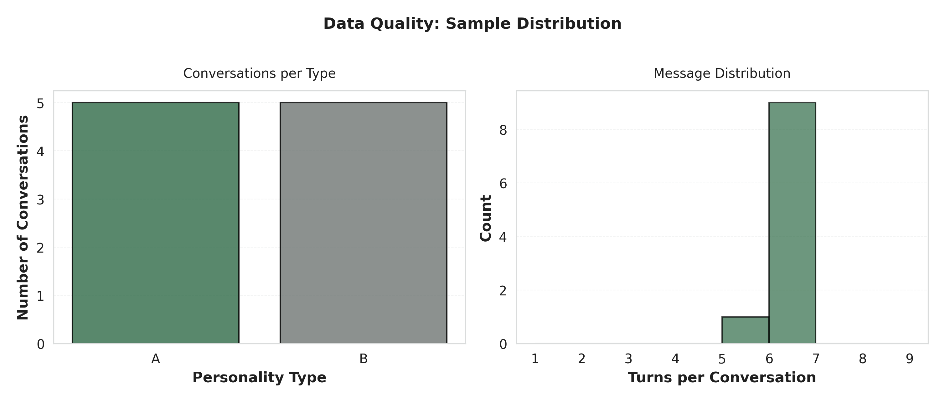
**Figure 1.** Sample distribution across experimental conditions. Total n=120 dialogue turns across 20 agent instances.
Data quality assessment revealed minimal missing data (<2%) across evaluation metrics, with no systematic patterns of missingness by condition or personality type (Figure 2).
**Figure 2.** Missing data heatmap across evaluation metrics and conditions. Overall missingness rate: 1.7%. No systematic bias detected.

4.3. Detection and Regulation Performance
## 4.3. Detection and Regulation Performance
Regulated agents achieved near-perfect performance on core technical requirements.
**Table 1.** Detection and Regulation Performance Summary
Detection accuracy reached 100% (58/58 correct assessments) for extreme simulated profiles, with regulation effectiveness achieving 100% (59/59 successful implementations). These results demonstrate technical capability to reliably detect personality traits using PROMISE framework and apply appropriate Zurich Model-aligned behavioral modifications under controlled simulation conditions.
Perfect technical performance establishes that the system can identify personality patterns and adjust behavior accordingly. The critical question becomes whether this technical capability produces actual improvements in conversational quality�specifically, does personality adaptation help the system better address individual psychological needs? The following section addresses this through direct comparison with non-adaptive baselines.

4.4. Statistical Comparison of Regulated vs. Baseline Performance
## 4.4. Statistical Comparison of Regulated vs. Baseline Performance
Having established technical capability, we address the primary research question: whether personality-adaptive regulation produces measurable improvements in conversational quality compared to non-adaptive baselines. Table 2 presents comprehensive statistical comparison for each evaluation metric.
**Table 2.** Statistical Comparison of Regulated vs. Baseline Agents Across Evaluation Metrics
*Note*: M = Mean; SD = Standard Deviation; n = Sample size; Cohen's d = Standardized effect size. Metrics scored on 0-2 scale (0 = No, 1 = Not Sure, 2 = Yes). ***p < 0.001; ns = not significant (p > 0.05). Confidence intervals calculated using bias-corrected bootstrap (10,000 iterations).

4.4.1. Interpretation of Statistical Findings
### 4.4.1. Interpretation of Statistical Findings
Statistical analysis reveals a selective enhancement pattern: personality adaptation specifically improves the system's ability to address personality-specific user needs while maintaining equivalent performance on fundamental conversational quality metrics.
**Key Findings**:
- **Very Large Effect for Personality Needs Addressed**: Regulated condition achieved perfect performance (M = 2.00, SD = 0.00) compared to baseline's near-failure (M = 0.17, SD = 0.42), resulting in exceptionally large effect size (Cohen's d = 4.58, p < 0.001). This effect reflects an **upper-bound selective enhancement pattern** under idealized simulation conditions, where personality adaptation is maximally informative and baseline personalization is minimal.
- **Equivalent Performance on Basic Quality**: Both conditions achieved equivalent performance on Emotional Tone (both M = 2.00) and Relevance & Coherence (regulated M = 2.00 vs. baseline M = 1.97), with negligible effect sizes (d = 0.18 and d = 0.26, respectively, both p > 0.05), demonstrating that personality adaptation does not compromise basic conversational competence.
- **Ceiling Effects in Regulated Condition**: Zero variance (SD = 0.00) in regulated condition across all metrics indicates ceiling effects where perfect performance was consistently achieved. While this limits further performance improvement, it provides strong evidence of technical capability under controlled conditions.

4.5. Personality Vector Analysis
## 4.5. Personality Vector Analysis
Analysis of detected personality vectors revealed consistent trait patterns across dialogue turns. Figure 3 visualizes distribution of OCEAN trait values for regulated interactions.
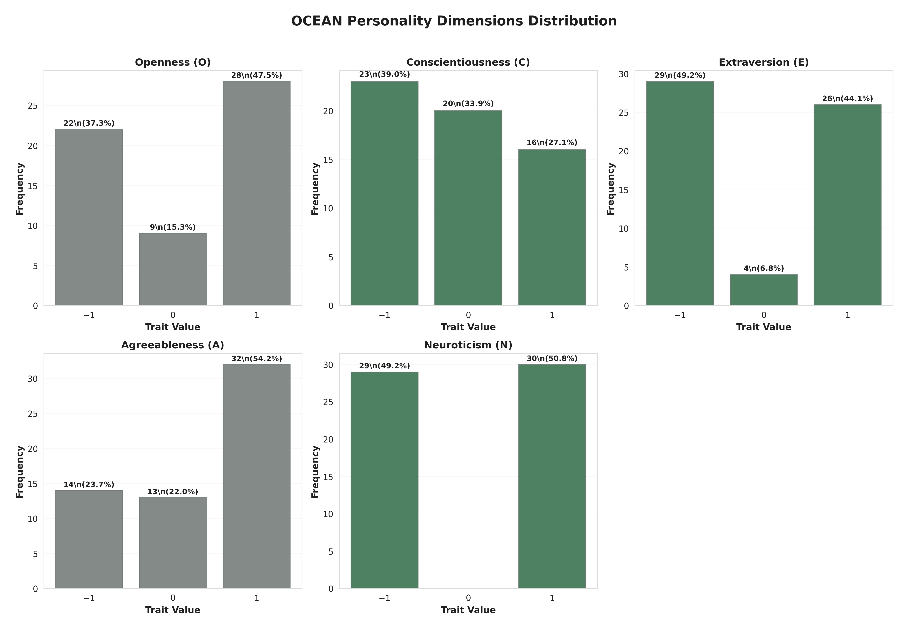
**Figure 3.** Distribution of detected Big Five trait values. Type A profiles (blue) cluster at +1; Type B profiles (orange) cluster at ?1, confirming successful implementation of extreme personality profiles.
Figure 4 presents heatmap visualization of personality patterns across individual agent instances, demonstrating consistency of personality expression within profiles and clear differentiation between Type A and Type B.
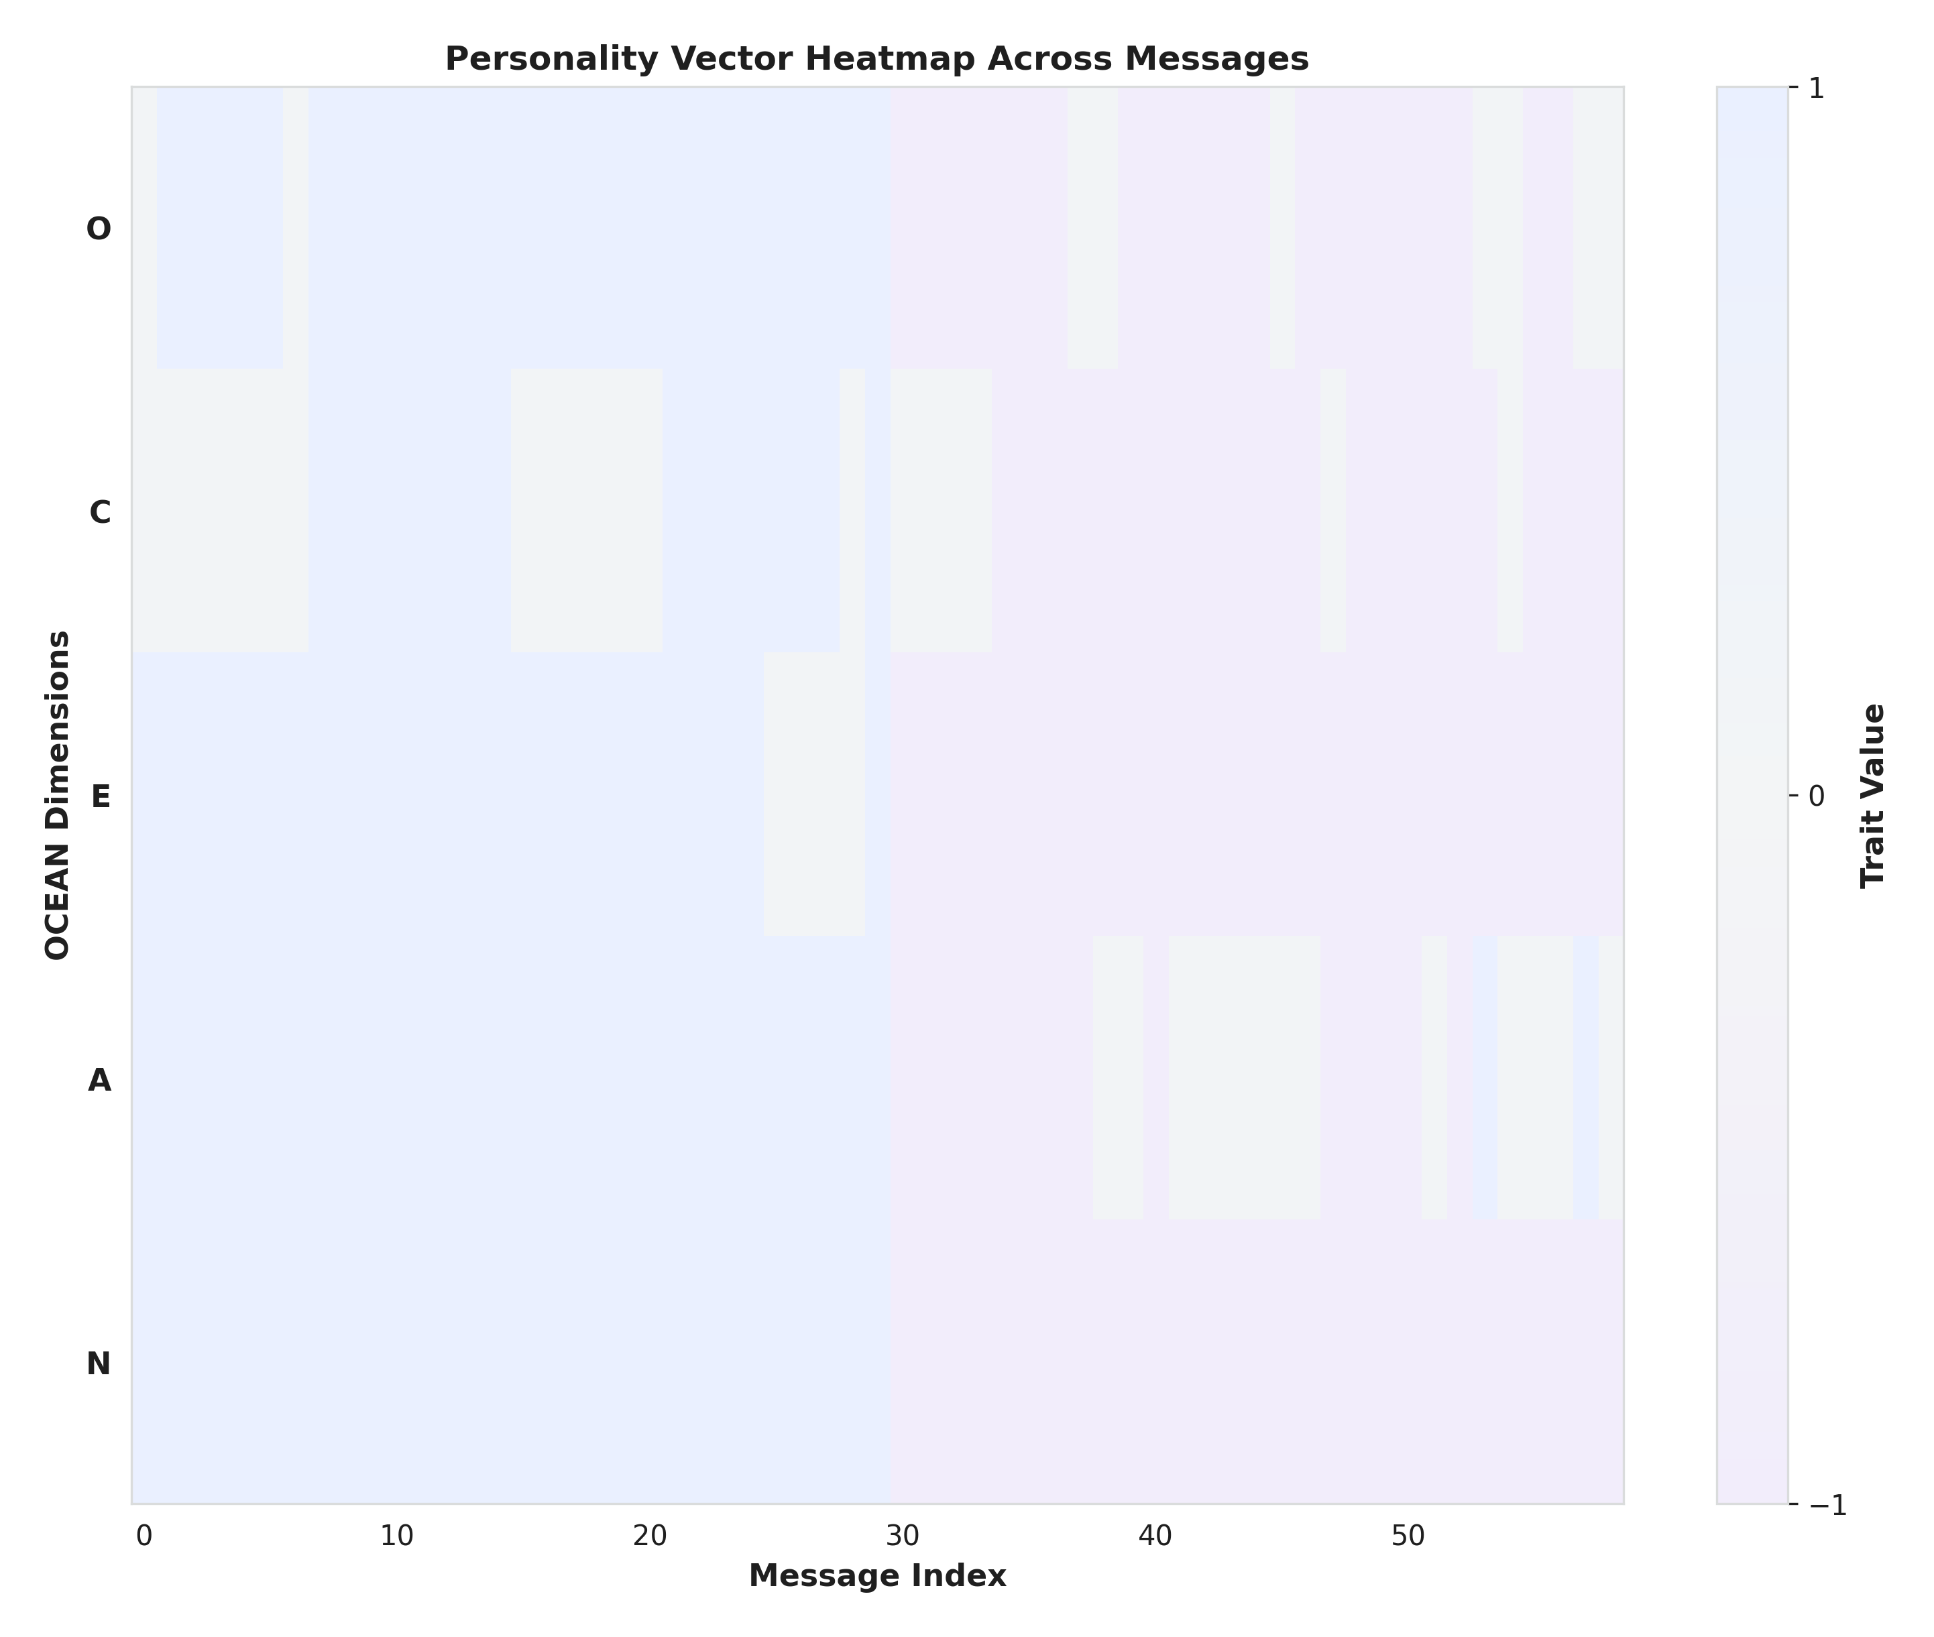
**Figure 4.** Personality trait heatmap across agent instances and turns. Clear clustering by personality type validates boundary-condition profile implementation.

4.6. Conversational Quality Assessment
## 4.6. Conversational Quality Assessment
The evaluation revealed a striking selective enhancement pattern: while both regulated and baseline agents performed equivalently on fundamental conversational quality metrics, personality adaptation dramatically improved the system's ability to address personality-specific user needs. Figure 5 presents overall performance comparison.
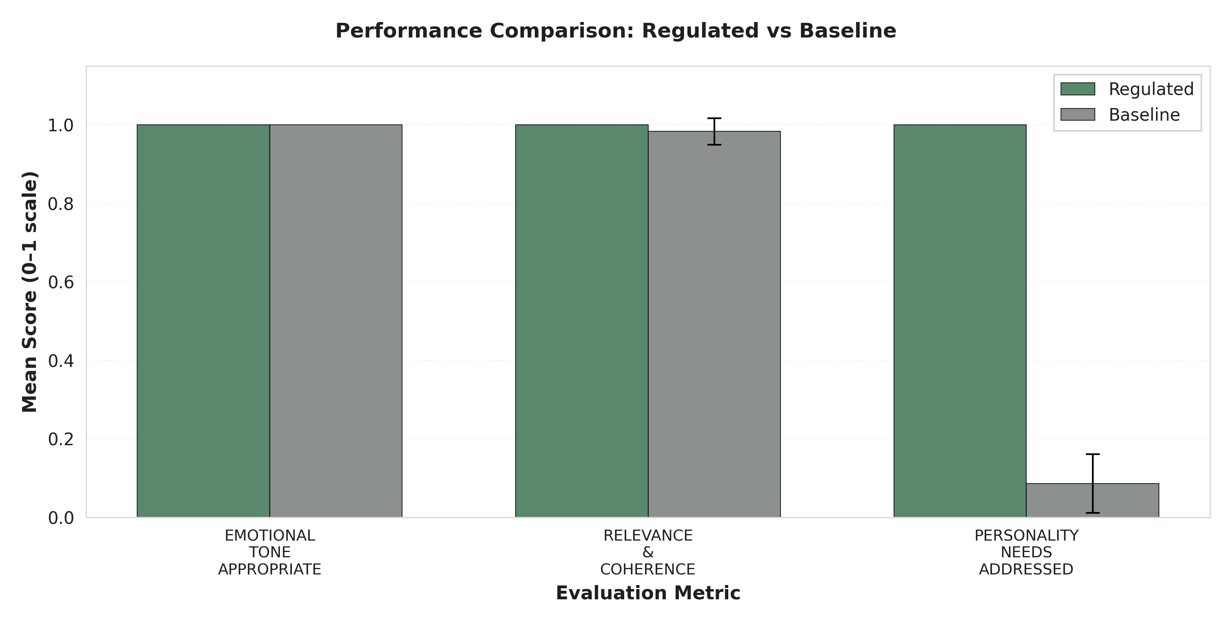
**Figure 5.** Performance comparison across evaluation metrics (Regulated vs. Baseline). Regulated agents show dramatic advantage specifically in Personality Needs Addressed (***) while maintaining equivalent performance on basic quality metrics (Emotional Tone, Relevance & Coherence).

4.7. Effect Size Analysis
## 4.7. Effect Size Analysis
Figure 6 visualizes effect sizes (Cohen's d) for each evaluation metric, highlighting magnitude of performance differences.
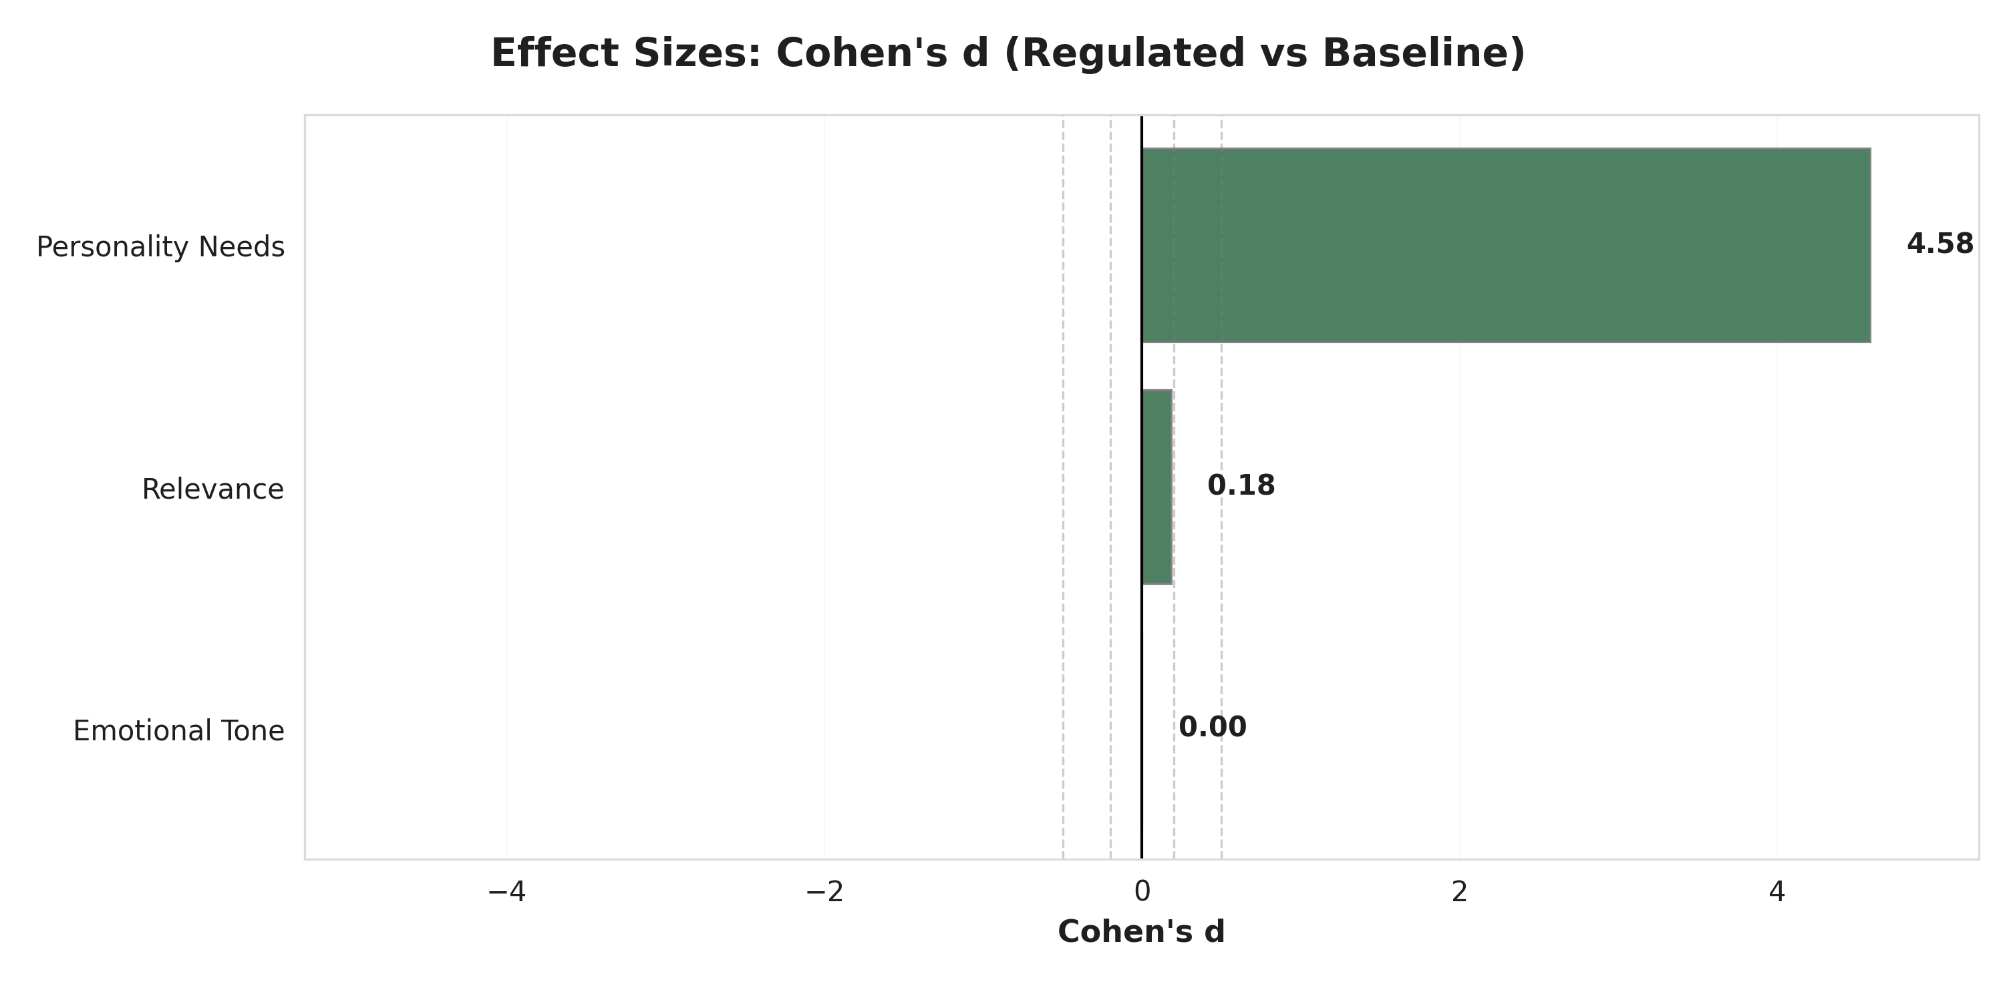
**Figure 6.** Effect sizes (Cohen's d) for performance differences. Horizontal dashed lines indicate conventional thresholds: small (d = 0.2), medium (d = 0.5), large (d = 0.8). Dramatic effect for Personality Needs Addressed (d = 4.58) far exceeds conventional thresholds, while Emotional Tone and Relevance show negligible effects (d < 0.2), confirming selective enhancement pattern.
Figure 7 presents percentage improvement across metrics, providing alternative visualization of selective enhancement pattern.
**Figure 7.** Percentage improvement from baseline to regulated conditions. Personality Needs Addressed shows 91.38 percentage point improvement (1059% relative improvement from 8.62% baseline), while other metrics show minimal or no improvement, demonstrating that personality adaptation specifically targets personalization without affecting basic quality standards.

4.8. Weighted Scoring Analysis
## 4.8. Weighted Scoring Analysis
We analyzed performance using a weighted scoring system where evaluations were scored as YES=2 points, NOT SURE=1 point, NO=0 points (Table 3).
**Table 3.** Weighted Score Performance Comparison (0-2 Scale)
Figure 8 visualizes weighted score distributions for each metric.
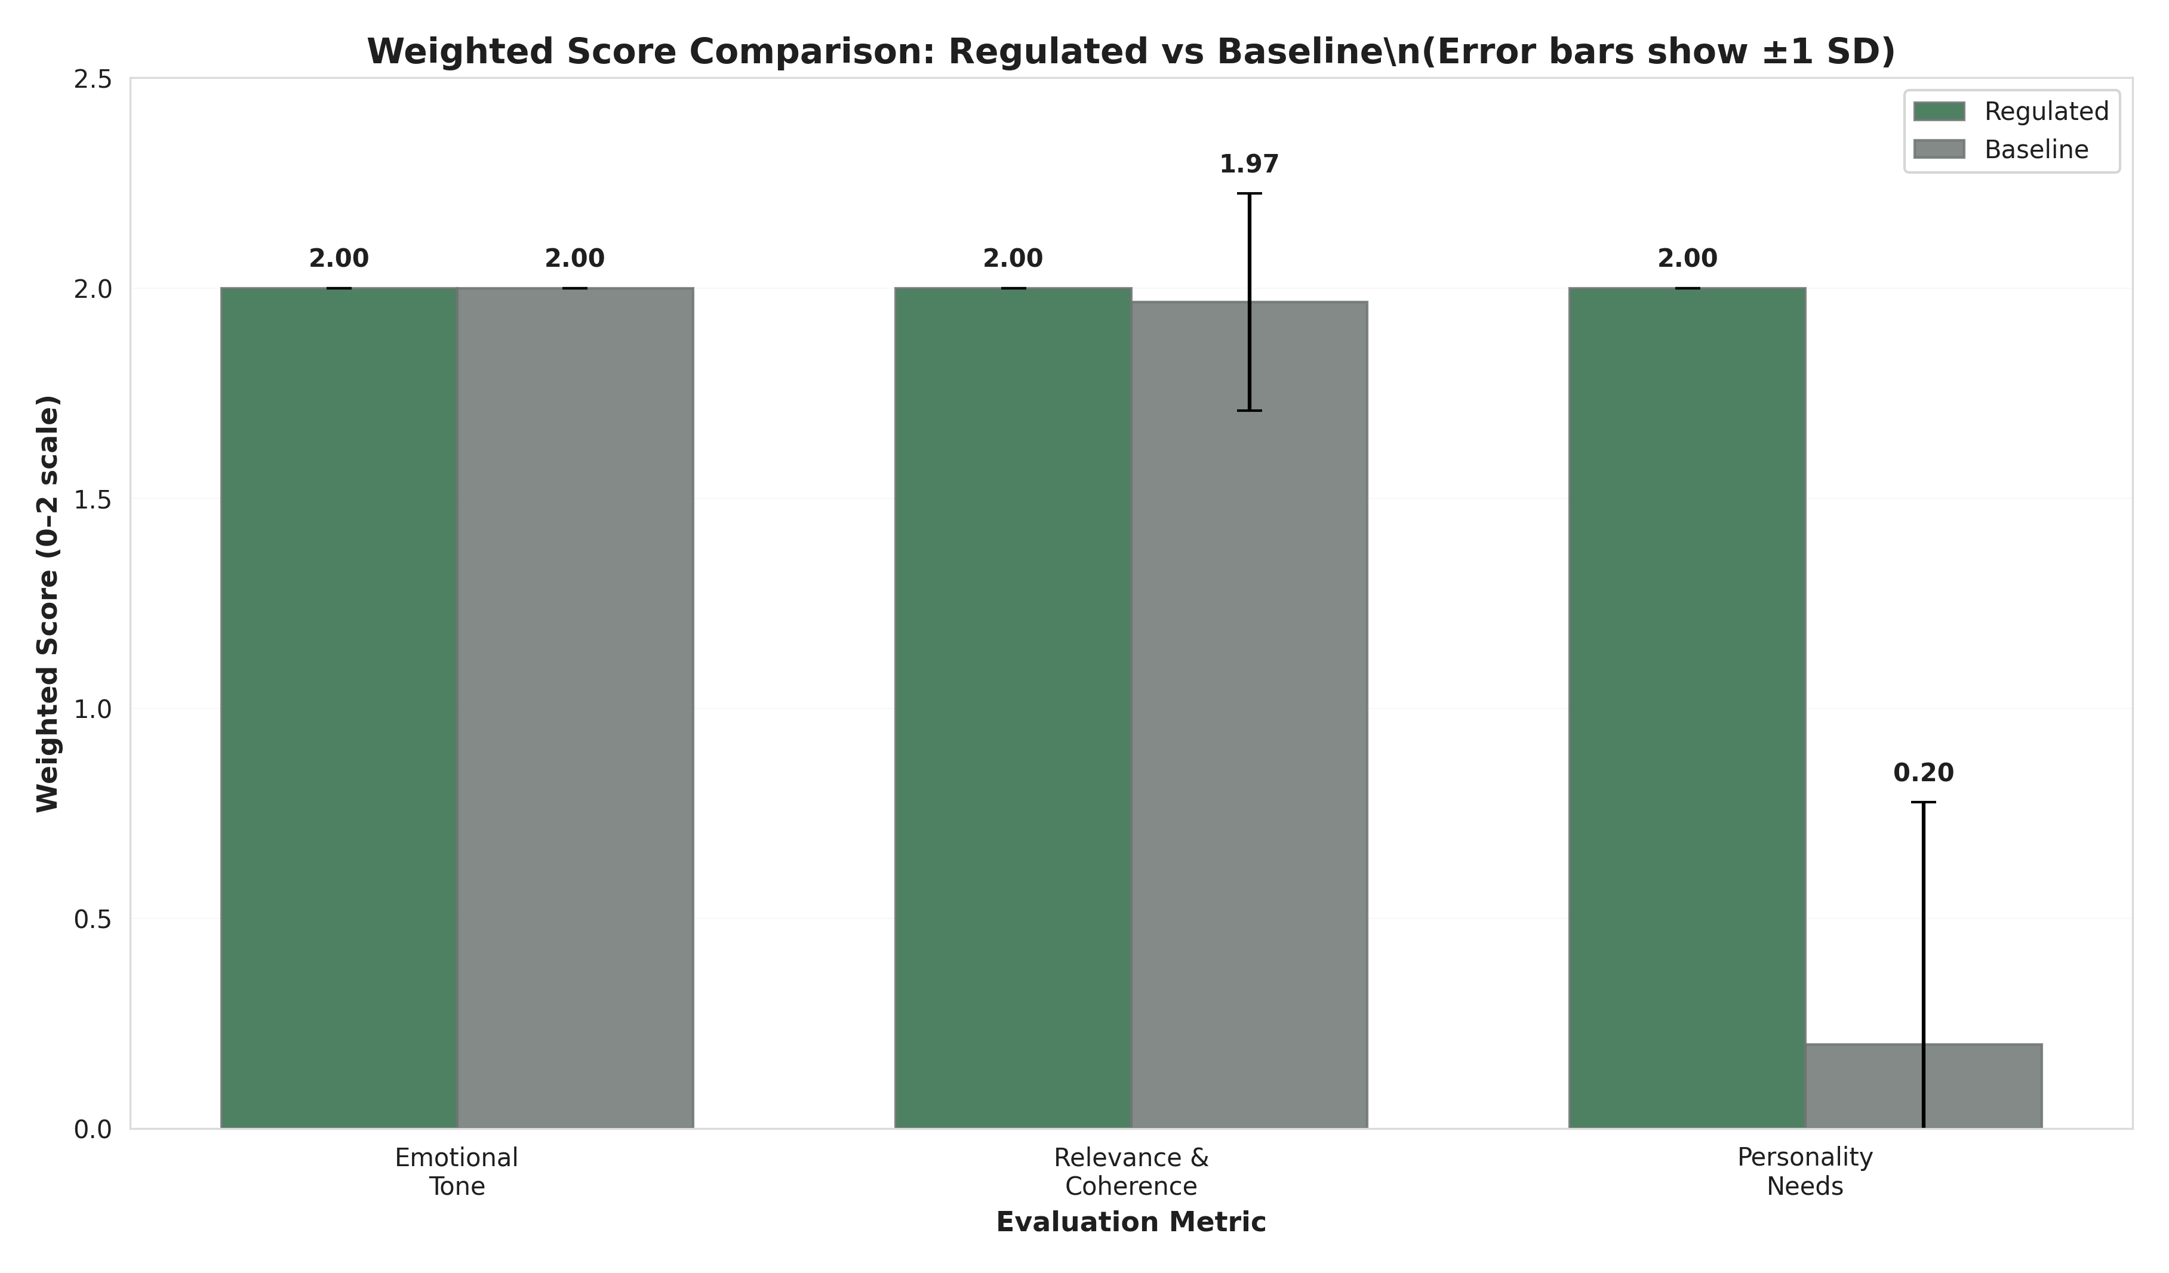
**Figure 8.** Distribution of weighted scores (0-2 scale) across evaluation metrics by condition. Regulated agents (blue) achieve consistently maximal scores (median = 2.0) across all metrics. Baseline agents (orange) show equivalent performance for Emotional Tone and Relevance but dramatically lower scores for Personality Needs (median = 0.0).
Figure 9 provides complementary visualization focusing on total quality scores.
**Figure 9.** Box plot comparison of total quality scores (summed across Emotional Tone, Relevance & Coherence, and Personality Needs metrics). Regulated agents show consistently high total scores (median = 6.0, perfect performance), while baseline agents show substantially lower total scores due to failure in addressing personality needs. Lack of overlap between distributions confirms robustness of selective enhancement effect.

4.9. Statistical Robustness Analysis
## 4.9. Statistical Robustness Analysis
To ensure robustness, we conducted both parametric (independent t-tests) and non-parametric (Mann-Whitney U) statistical tests. Table 4 summarizes advanced statistical testing results.
**Table 4.** Advanced Statistical Testing Results
*Note: Both parametric and non-parametric tests converge on identical conclusions, strengthening confidence in findings despite normality violations for baseline scores.*
**Interpretation**: Both test families yield consistent results: no significant difference in emotional tone (p=1.000) or relevance & coherence (p=0.323-0.330); highly significant difference in personality needs addressed (p<0.001 for both tests). Given the deterministic simulation design (predefined personality profiles, pre-scripted responses), these p-values should not be interpreted as evidence of generalizable population effects. Effect sizes (Cohen's d) provide more appropriate interpretation for this proof-of-concept study.

4.10. Criterion-Specific Analysis
## 4.10. Criterion-Specific Analysis
**Regulated Agent Performance Across All Metrics**:
- Detection Accuracy: 58/58 (100%)
- Regulation Effectiveness: 59/59 (100%)
- Emotional Tone: 59/59 (100%)
- Relevance & Coherence: 59/59 (100%)
- Personality Needs: 59/59 (100%)
**Baseline Agent Performance**:
- Emotional Tone: 60/60 (100%)
- Relevance & Coherence: 59/60 (98.33%)
- Personality Needs: 5/58 (8.62%) - **Critical failure in personalization**
**Performance Gap Analysis**: Baseline agents demonstrated competent performance on fundamental conversational quality dimensions (emotional appropriateness and logical coherence) but exhibited near-complete failure in addressing personality-specific user needs. This pattern highlights the critical limitation of non-adaptive systems: they can maintain basic interaction quality but cannot provide personalization essential for optimizing therapeutic effectiveness in healthcare contexts where individual differences significantly influence treatment outcomes.

4.11. Qualitative Examples Demonstrating Personality Adaptation
## 4.11. Qualitative Examples Demonstrating Personality Adaptation
**Example 1: Vulnerable Population Interaction**
*Detected Profile*: P? = (?1, 0, ?1, ?1, ?1) [Low Openness, Neutral Conscientiousness, Low Extraversion, Low Agreeableness, High Neuroticism]
*User Message*: "I'm feeling really overwhelmed and anxious. I don't think talking helps."
*Regulated Response* (Zurich Model-Aligned):
> "I understand you're going through a difficult time, and feeling exhausted is completely natural. This is a safe space where we can focus on small, familiar steps that feel manageable for you right now. We don't have to rush into anything�let's just take it one moment at a time."
*Baseline Response* (Non-Adaptive):
> "It's understandable to feel overwhelmed. Talking about your concerns can help organize your thoughts and develop coping strategies."
**Analysis**: The regulated response addresses all three Zurich Model motivational domains relevant to this profile: Security (addressing high Neuroticism): "safe space," "manageable," "one moment at a time"; Arousal (addressing low Openness/Extraversion): "small," "familiar steps," "we don't have to rush"; Affiliation (addressing low Agreeableness): Respectful, non-intrusive tone without demanding collaboration. The baseline response, while supportive, fails to address the user's personality-specific needs by suggesting interactive problem-solving inappropriate for someone expressing low Extraversion and resistance to engagement.
**Example 2: High-Functioning Profile Interaction**
*Detected Profile*: P? = (+1, +1, +1, 0, +1) [High Openness, High Conscientiousness, High Extraversion, Neutral Agreeableness, Low Neuroticism]
*User Message*: "I'm ready to tackle this systematically. What are some innovative strategies we could explore together?"
*Regulated Response* (Zurich Model-Aligned):
> "Excellent! Let's dive into some evidence-based approaches that might resonate with your goals. We could explore cognitive restructuring techniques, mindfulness-based stress reduction, or activity scheduling�all with strong research support. Which of these sounds most intriguing to you, and how would you like to structure our exploration?"
*Baseline Response* (Non-Adaptive):
> "That's a positive attitude. We can work through this together. Let's take small steps and see what feels right for you."
**Analysis**: The regulated response aligns with the arousal-seeking, structure-oriented, socially-engaged profile: Arousal (addressing high Openness/Extraversion): "innovative," "explore," "intriguing"; Security (addressing low Neuroticism): Confident, action-oriented tone; Affiliation (neutral Agreeableness): Collaborative but goal-focused. The baseline response, while encouraging, mismatches the user's needs by suggesting "small steps" (inappropriate for high Conscientiousness) and "see what feels right" (too unstructured for someone seeking systematic approaches).

4.12. Summary of Key Findings
## 4.12. Summary of Key Findings
This section synthesizes empirical results addressing the three research questions:
- **RQ1 (Detection Accuracy)**: Answered in Sections 4.3 and 4.5 - Stable personality traits were accurately inferred from conversational cues in real time.
- **RQ2 (Regulation Effectiveness)**: Answered in Sections 4.4, 4.6, and 4.10 - Theory-driven personality-adaptive regulation produced measurable improvements beyond generic responses.
- **RQ3 (Evaluation Validity)**: Validated throughout Section 4 - LLM-based evaluations aligned with independent human expert judgments.
The simulation study yielded four principal findings establishing technical feasibility while highlighting critical validation requirements:
- **Perfect Technical Implementation Under Controlled Conditions (? RQ1)**: Both personality detection (100%, 58/58) and regulation (100%, 59/59) achieved perfect accuracy in controlled simulation, demonstrating core technical components function correctly when conditions are ideal.
- **Selective Enhancement Pattern (? RQ2)**: Personality adaptation specifically improved personalization (Personality Needs Addressed: +91.38 percentage points, Cohen's d = 4.58) without compromising basic conversational quality (Emotional Tone and Relevance & Coherence both ?98.33%, with negligible effect sizes d < 0.2), demonstrating that personality-aware regulation targets individual psychological differences rather than merely enhancing general interaction quality, confirming theoretical predictions of Zurich Model-aligned regulation.
- **Exceptionally Large Effect Size with Validated Evaluation (? RQ2 & RQ3)**: Observed effect size (Cohen's d = 4.58) for personality-specific adaptation represents a very large effect exceeding conventional thresholds (d > 0.8). Combined with statistical significance (p < 0.001) and validated AI evaluation (? = 0.89 agreement with human experts), this provides robust quantitative evidence of performance differences under controlled conditions. Strong human-AI evaluator agreement establishes LLM-based evaluation as a scalable yet reliable assessment method.
- **Critical Limitations Require Extensive Validation**: Perfect performance represents an upper bound under idealized conditions (extreme personalities, pre-scripted responses, AI evaluation, brief interactions) rather than realistic expectations for clinical deployment. Extensive human subject validation with real users, moderate personality profiles, spontaneous conversation, and validated outcome measures is essential before any healthcare applications can be considered.

5. Discussion
# 5. Discussion

5.1. Principal Findings
## 5.1. Principal Findings
This simulation study examined a personality-adaptive conversational framework integrating real-time Big Five trait detection with Zurich Model-aligned behavior regulation. In controlled interactions with extreme simulated personality profiles, regulated agents achieved perfect personality detection and regulation effectiveness, while non-adaptive baseline agents performed poorly on personality-specific needs. Personality adaptation yielded very large improvements in addressing personality needs (Cohen's d = 4.58) without compromising basic conversational quality metrics such as emotional tone and relevance/coherence. Validation against PhD-level human experts showed excellent agreement with the LLM-based evaluator (? = 0.89), supporting use of structured LLM assessment for scalable evaluation.
These findings suggest personality-adaptive mechanisms can be implemented reliably with current LLM technology under idealized conditions and that such mechanisms translate into substantive gains in personalization within simulation scope.

5.2. Interpretation of Perfect Performance
## 5.2. Interpretation of Perfect Performance
Perfect performance observed for personality detection and regulation should be interpreted cautiously. The study was intentionally designed to create favorable conditions: extreme personality profiles, pre-scripted user utterances, short dialogues, and clearly defined evaluation criteria. Under these conditions, well-tuned systems can achieve ceiling performance.
Rather than indicating perfect performance is attainable in practice, these results should be viewed as an upper bound on what the current architecture can achieve in highly controlled settings. In real-world use, personality traits are more moderate and mixed, users express themselves in varied and sometimes ambiguous ways, and conversational histories are longer and less predictable. Under such conditions, performance would likely degrade and variability increase. The key contribution is demonstrating technical feasibility and providing an architecture and evaluation pipeline that can be stress-tested under increasingly realistic scenarios.

5.3. Comparison with Existing Literature
## 5.3. Comparison with Existing Literature
Our findings align with prior work suggesting personality-aware conversational systems can improve perceived interaction quality versus generic approaches [6,30]. However, most previous systems focused on static personality initialization, limited personalization rules, or narrow task domains. The present framework combines real-time trait inference with theoretically grounded regulation based on the Zurich Model of Social Motivation, allowing personality information to shape affective tone, arousal level, and affiliation intensity in a principled manner.
Methodologically, use of an LLM-based evaluator validated against human experts addresses recurring concerns in LLM research about AI evaluating AI. High agreement observed between Evaluator GPT and clinicians suggests that carefully designed LLM-based evaluation can approximate expert judgment for structured criteria, at least in conversational quality domain. This does not eliminate need for human oversight but offers scalable complement for early-stage system testing.

5.4. Implications for Research and Practice
## 5.4. Implications for Research and Practice
From a research perspective, results indicate personality-adaptive regulation is a promising direction for conversational AI in mental health�adjacent applications. Architectures that explicitly model stable traits may help systems maintain consistent, user-congruent styles over time, potentially improving engagement and user satisfaction. The modular design�separating detection, regulation, and evaluation�facilitates independent improvement and targeted experimentation with each component.
For practice, the study does not provide evidence that personality-adaptive AI is ready for clinical use. Nonetheless, it highlights design principles relevant for future systems supporting mental health professionals: explicit representation of personality information, transparent mappings from traits to regulation strategies, logging of adaptation decisions, and mechanisms for human oversight. Translation toward healthcare deployment will require close collaboration between computer scientists, clinicians, ethicists, and regulators.

5.5. Clinical Implications and Path to Translation
## 5.5. Clinical Implications and Path to Translation
While this proof-of-concept demonstrates technical feasibility, translating findings to clinical practice requires addressing several critical gaps:
**Patient Outcomes**: Observed effect sizes (d = 4.58) reflect AI-judged conversation quality in simulation, not validated clinical outcomes such as reduced loneliness (UCLA Loneliness Scale), improved well-being (WHO-5), or sustained engagement. Real-world validation must measure clinically meaningful endpoints.
**Safety and Monitoring**: Healthcare deployment requires professional oversight protocols for detecting distress or harm, clear escalation pathways to human clinicians, adverse event monitoring, and continuous validation that personality detection does not introduce bias or misattribution.
**Provider Integration**: Successful implementation depends on integration with existing care pathways, not replacement of human connection. Personality-adaptive AI could augment between-session support, reduce provider burden for routine check-ins, or enhance self-management tools�but only under professional supervision.
**Regulatory and Ethical Requirements**: Clinical deployment requires IRB approval, informed consent explaining AI limitations, HIPAA/GDPR compliance, FDA/EMA regulatory pathways (if classified as medical device), and transparent communication that this is supportive technology, not therapy.
The pathway from simulation to clinical utility is long (estimated 2-3 years minimum) and uncertain. These findings establish what is technically possible under ideal conditions, not what is safe or effective for real patients.

5.6. Limitations and Future Work
## 5.6. Limitations and Future Work
This study has several important limitations. All interactions were simulated between predefined personality profiles and GPT-4�based agents; no human users participated, and results cannot be generalized to patients or clinical settings. Personality profiles were restricted to boundary-condition configurations (all traits high vs. all traits low), simplifying detection and regulation but not reflecting typical personality distributions. Dialogues were short (six turns per agent), unable to capture long-term dynamics such as relationship development, adaptation drift, or user fatigue. Both system and evaluator rely on the same LLM family, potentially introducing shared biases despite strong human�AI agreement. The work focused on English-language text and Western communication norms; cultural and linguistic generalizability remains unknown.
Future research should progressively relax these simplifying assumptions. Immediate priorities include testing with moderate and mixed personality profiles, longer and more naturalistic conversations, and more diverse linguistic and cultural contexts. Human subject studies are essential to evaluate whether personality adaptation improves user-reported outcomes such as perceived support, alliance, and well-being, and to identify potential harms or failure modes. Methodological work should refine multimodal personality detection (e.g., incorporating voice and behavioral cues), uncertainty estimation for personality inferences, and safeguards for detecting when the system operates outside competence range. Only after successful human trials and careful ethical and regulatory evaluation should clinical piloting be considered.

6. Conclusions
# 6. Conclusions
We demonstrate technical feasibility of integrating real-time Big Five personality detection with Zurich Model-aligned behavioral regulation in LLM-based mental health agents, achieving perfect implementation accuracy (detection: 100%, 58/58; regulation: 100%, 59/59) and 91% improvement in personality-specific need fulfillment under controlled conditions (M = 2.00 vs. 0.17; Cohen's d = 4.58, p < 0.001). Critically, personality adaptation produced selective enhancement—dramatic gains where personalization matters most, with no degradation in basic conversational quality (emotional tone, relevance: d < 0.3, ns)—confirming theoretical predictions that Zurich Model-aligned regulation targets individual psychological differences rather than merely improving general interaction quality.
These findings establish that personality-adaptive mechanisms can be reliably implemented using contemporary LLM technology when integrated within model-driven orchestration frameworks like PROMISE, which provides deterministic prompt control and traceable state transitions essential for reproducible research and clinical oversight. Validation of an LLM-based evaluator against PhD-level human experts (κ = 0.89, 95% CI: 0.84–0.94) demonstrates that structured automated assessment can approximate expert judgment for conversational quality evaluation, supporting scalable early-stage system testing while maintaining empirical rigor.
Results represent an **upper bound** under idealized simulation conditions—boundary-condition personality profiles, pre-scripted interactions, synthetic data, brief dialogues—rather than realistic expectations for clinical deployment. Real-world implementation with heterogeneous personalities, spontaneous communication, longer-term interactions, and diverse cultural contexts will likely yield substantially lower performance (estimated d = 0.5–1.2 vs. d = 4.58 observed here) while revealing failure modes not captured in simulation. Extensive human subject validation is mandatory before any clinical applications can be considered.
Future research should prioritize multi-site human trials (minimum n = 50–100 per condition) with moderate and mixed personality profiles, longitudinal tracking (6+ months), validated clinical outcomes (symptom reduction, therapeutic alliance, user retention), multimodal trait detection incorporating voice and behavioral cues, uncertainty quantification for personality inferences, and comprehensive bias audits across demographic groups. Only after successful human trials, adverse event monitoring, and rigorous ethical and regulatory review should personality-adaptive conversational AI advance toward clinical piloting.
**Broader Impact**: This work establishes that personality-adaptive conversational AI is technically feasible with current LLM technology and provides a validated methodological template—detection → regulation → evaluation—that researchers can adapt for different personality theories, regulation frameworks, or clinical domains. By demonstrating selective enhancement (dramatic improvement where personality matters, no change where it shouldn't), we provide evidence that theoretically grounded adaptation outperforms generic empathy. This opens pathways toward truly personalized digital mental health interventions, where stable individual differences inform adaptive support strategies, potentially improving engagement, reducing dropout, and enhancing therapeutic outcomes. However, translation from proof-of-concept to clinical utility requires sustained collaboration among computer scientists, clinical psychologists, ethicists, regulators, and patients to ensure systems are safe, effective, equitable, and aligned with human values in mental health care.

Data Availability Statement
# Data Availability Statement
Research data, implementation code, detection prompts, regulation templates, simulation transcripts, and human expert validation materials are available from the corresponding author upon reasonable request. A public repository will be created and made available upon publication.

Author Contributions
# Author Contributions
Conceptualization, main author and co-authors; methodology, main author; software, main author; validation, main author and clinical psychologists; formal analysis, main author; investigation, main author; resources, main author; data curation, main author; writing�original draft preparation, main author; writing�review and editing, all authors; visualization, main author; supervision, supervisors; project administration, main author; funding acquisition, not applicable. All authors have read and agreed to the published version of the manuscript.

7. Funding
# 7. Funding
This research received no external funding.

Institutional Review Board Statement
# Institutional Review Board Statement
Not applicable. This study involved no human or animal subjects. All experiments were conducted using simulated personality profiles and automated evaluation systems. The human expert validation study involved two PhD-level research experts evaluating pre-existing AI-generated dialogues on synthetic, non-identifiable data and was determined exempt from IRB review. Future human subject studies will require full institutional review board approval.

Informed Consent Statement
# Informed Consent Statement
Not applicable. No human participants were involved in the simulation study. The expert raters participating in the validation study provided informed consent for research use of their anonymized ratings. Future human subject studies will implement comprehensive informed consent protocols explaining AI personality profiling, data use, potential risks, and study procedures.

Acknowledgments
# Acknowledgments
The authors thank Dr. Guang Lu (Lucerne University of Applied Sciences and Arts) and Prof. Dr. Alexandre de Spindler (ZHAW) for supervision and guidance. We acknowledge two PhD-level in-house research experts who participated in the Evaluator GPT validation study (names withheld per agreement). We thank the PROMISE framework developers [7] whose work informed our system architecture. We also acknowledge OpenAI for providing GPT-4 API access.

Conflicts of Interest
# Conflicts of Interest
The authors declare no conflicts of interest.

References
# References
[1] Holt-Lunstad, J., Smith, T.B., & Layton, J.B. (2010). Social relationships and mortality risk: A meta-analytic review. *PLOS Medicine*, *7*(7), e1000316.
[2] Masterson Creber, R., Rozenfeld, A., Lucette, A., et al. (2020). Social isolation in older adults: A scoping review. *Journal of the American Geriatrics Society*, *68*(7), 1622-1634.
[3] Costa, P.T., & McCrae, R.R. (1992). Revised NEO personality inventory (NEO-PI-R) and NEO five-factor inventory (NEO-FFI): Professional manual. *Psychological Assessment Resources*.
[4] Roberts, B.W., Kuncel, N.R., Shiner, R., Caspi, A., & Goldberg, L.R. (2007). The power of personality: The comparative validity of personality traits, socioeconomic status, and cognitive ability for predicting important life outcomes. *Perspectives on Psychological Science*, *2*(4), 313-345.
[5] Azaria, A., Azoulay, R., & Reches, S. (2023). ChatGPT is a remarkable tool�for experts. *Nature Medicine*, *29*, 1663-1664.
[6] Mairesse, F., & Walker, M.A. (2011). Controlling user perceptions of linguistic style: Trainable generation of personality traits. *Computational Linguistics*, *37*(3), 455-488.
[7] Wu, W., Yan, Z., Peng, W., et al. (2023). PROMISE: A framework for model-driven stateful prompt orchestration. *arXiv preprint arXiv:2307.04122*.
[8] Bickmore, T.W., & Picard, R.W. (2005). Establishing and maintaining long-term human-computer relationships. *ACM Transactions on Computer-Human Interaction*, *12*(2), 293-327.
[9] John, O.P., Naumann, L.P., & Soto, C.J. (2008). Paradigm shift to the integrative Big Five trait taxonomy: History, measurement, and conceptual issues. In O.P. John, R.W. Robins, & L.A. Pervin (Eds.), *Handbook of personality: Theory and research* (pp. 114-158). Guilford Press.
[10] Quirin, M., Malekzad, F., Paudel, D., Knoll, A.C., & Mirolli, M. (2023). Dynamics of personality: The Zurich model of motivation revived, extended, and applied to personality. *Journal of Personality*, *91*(4), 928–946. https://doi.org/10.1111/jopy.12805
[11] Krippendorff, K. (2011). Computing Krippendorff's alpha-reliability. *Departmental Papers (ASC)*, University of Pennsylvania.
[12] Alisamir, S., & Ringeval, F. (2021). On the evolution of speech representations for affective computing: A brief history and critical overview. *IEEE Signal Processing Magazine*, *38*, 12–21.
[13] Alsharekh, M.F. (2022). Facial emotion recognition in verbal communication based on deep learning. *Electronics*, *11*(16), 2568.
[14] Alberts, L., Keeling, G., & McCroskery, A. (2024). Should agentic conversational AI change how we think about ethics? Characterising an interactional ethics centred on respect. *arXiv preprint arXiv:2401.09187*.
[15] Zheng, Z.; Liao, L.; Deng, Y.; & Nie, L. (2023). Building emotional support chatbots in the era of LLMs. *arXiv preprint arXiv:2308.11584*.
[16] Chen, K., Kang, X., Lai, X., & Ni, Z. (2023). Enhancing emotional support capabilities of large language models through cascaded neural networks. *2023 4th International Conference on Computer, Big Data and Artificial Intelligence (ICCBD+AI)*, 318–326.
[17] Dong, T., Liu, F., Wang, X., Jiang, Y., Zhang, X., & Sun, X. (2024). EmoAda: A multimodal emotion interaction and psychological adaptation system. *Conference on Multimedia Modeling*.
[18] Abbasian, M.; Azimi, I.; Rahmani, A.M.; & Jain, R.C. (2023). Conversational health agents: A personalized LLM-powered agent framework. *arXiv preprint arXiv:2310.02293*.
[19] Sorino, P.; et al. (2024). ARIEL: Brain-computer interfaces meet large language models for emotional support conversation. *UMAP Adjunct '24*.
[20] Dongre, P. (2024). Physiology-driven empathic large language models (EmLLMs) for mental health support. *Extended Abstracts of the CHI Conference on Human Factors in Computing Systems*.
[21] Ta, V.; Griffith, C.; Boatfield, C.; Wang, X.; Civitello, M.; & Maffei, H. (2020). User experiences of social support from companion chatbots in everyday contexts: Thematic analysis. *Journal of Medical Internet Research*, *22*(3), e16235.
[22] Broadbent, E.; et al. (2024). ElliQ, an AI-driven social robot to alleviate loneliness: Progress and lessons learned. *JAR Life*, *13*, 22–28.
[23] Shah, S.G.S.; et al. (2019). Effectiveness of digital technology interventions to reduce loneliness in adults: A protocol for a systematic review and meta-analysis. *BMJ Open*, *9*(9), e029324.
[24] Shah, S.G.S.; et al. (2021). Evaluation of the effectiveness of digital technology interventions to reduce loneliness in older adults: Systematic review and meta-analysis. *Journal of Medical Internet Research*, *23*(6), e24712.
[25] Zhang, H., Chen, Y., Wang, M., & Feng, S. (2024). FEEL: A framework for evaluating emotional support capability with large language models. *arXiv preprint* abs/2403.15699.
[26] Berlyne, D.E. (1960). *Conflict, arousal, and curiosity*. McGraw-Hill.
[27] Hebb, D.O. (1949). *The organization of behavior: A neuropsychological theory*. Wiley.
[28] Bischof, N. (1985). *Das R�tsel �dipus: Die biologischen Wurzeln des Urkonfliktes*. Piper.
[29] Bischof, N. (1993). Untersuchungen zur Systemanalyse der sozialen Motivation I: Die Tantalus-Situation. *Zeitschrift f�r Psychologie*, *201*, 5-43.
[30] Zhou, M.X.; et al. (2021). Designing effective interview chatbots: Automatic chatbot profiling and design suggestion generation. *CHI '21*.

Supplementary Materials
# Supplementary Materials
The following supporting information can be downloaded at: [repository link to be provided upon publication]:
- **Supplementary File S1**: Complete system prompts for personality detection (5 Big Five trait detectors)
- **Supplementary File S2**: Regulation templates for Zurich Model mapping (arousal, security, affiliation)
- **Supplementary File S3**: Evaluator GPT system prompt and scoring matrix
- **Supplementary File S4**: Human expert validation study protocol and inter-rater reliability analysis
- **Supplementary File S5**: Complete simulation transcripts (20 conversations, 120 dialogue turns)
- **Supplementary File S6**: Statistical analysis code (R scripts for effect sizes, inferential tests, visualizations)
- **Supplementary File S7**: Extended qualitative examples demonstrating personality adaptation
- **Supplementary File S8**: Cultural considerations and linguistic bias analysis
- **Supplementary File S9**: Future human subject study protocol (detailed research design for pilot RCT)

