Personality-Adaptive Conversational AI for Emotional Support: A Simulation Study Integrating Big Five Detection with Zurich Model Regulation

Abstract
Personality-adaptive conversational AI represents a paradigm shift from generic to individualized digital mental health support, yet most systems overlook stable trait differences that shape emotional processing and regulation needs. This study demonstrates architectural feasibility of a personality-adaptive framework integrating real-time Big Five trait detection with Zurich Model-aligned behavioral regulation under controlled simulation conditions.
We conducted a 2×2 factorial study comparing personality-adaptive (regulated) assistants against non-adaptive baselines across two extreme Big Five profiles (Type A: all traits +1; Type B: all traits −1) using GPT-4-based modules for detection, regulation, and evaluation. We generated 20 dialogue sessions (5 per cell in the 2×2 design), each consisting of six user–assistant exchanges (120 dialogue turns total). Evaluation assessed detection accuracy, regulation effectiveness, emotional tone, relevance, and personality-specific needs using an LLM evaluator benchmarked for agreement with human ratings (Cohen's κ = 0.89).
Under idealized conditions, the system achieved complete implementation fidelity (detection: 100%; regulation: 100%) and produced a selective enhancement pattern: personality-specific need fulfillment improved dramatically (d = 4.58, p < 0.001) while basic conversational quality remained equivalent (d < 0.3, ns). LLM-based evaluation was validated against human experts (κ = 0.89). These results represent an upper bound under controlled simulation; extensive human validation is required before clinical deployment.
This simulation establishes architectural feasibility of the proposed detection-regulation-evaluation pipeline using current LLM technology. By demonstrating that theoretically grounded adaptation outperforms generic approaches, this work opens pathways toward personalized digital mental health interventions while delineating critical validation requirements for safe clinical translation.
**Keywords:** digital mental health; conversational agents; large language models; personality detection; Big Five; Zurich Model; adaptive interaction; emotional support; simulation study; GPT-4

1. Introduction
Mental health disorders have surged globally despite economic and technological progress, with loneliness contributing to morbidity risks comparable to obesity [1]. Population aging, dispersed families, and declining community engagement create unprecedented demand for scalable digital mental health interventions [2,3].
Digital mental health tools leveraging large language models (LLMs) have demonstrated capacity for emotionally relevant, context-aware responses [8,9], yet a critical limitation persists: current systems rely on generic communication strategies that fail to account for stable personality differences shaping how individuals process emotions, seek support, and respond to intervention styles [4]. Existing approaches provide only shallow personalization through static assessments, lacking mechanisms for continuous personality modeling grounded in psychological theory or dynamic adaptation throughout interactions.
To address these limitations, we developed a personality-adaptive conversational framework integrating: (i) real-time Big Five personality trait detection using continuous linguistic analysis, (ii) behavior regulation grounded in the Zurich Model of Social Motivation, explicitly mapping traits to security, arousal, and affiliation domains, and (iii) structured LLM-based evaluation validated against human expert judgment. Implemented using GPT-4 and the PROMISE orchestration system [7], which ensures deterministic prompt control and traceable state transitions, the framework performs turn-by-turn personality inference and theory-guided behavioral adaptation throughout multi-turn conversations.
This controlled simulation study tests whether real-time personality-adaptive regulation produces measurable improvements in AI-to-AI simulation compared to non-adaptive baselines across boundary-condition personality profiles. This design provides precise experimental control for quantifying personalization effects, establishes a reproducible methodological testbed, and validates the implementation approach as a foundation for future human subject research toward safe AI-augmented mental health interventions.

2. Related Work
Personality-adaptive conversational AI sits at the intersection of affective computing, digital mental health interventions, personality-aware dialogue systems, and LLM-based conversational architectures. We synthesize this landscape in two arcs: (i) the evolution from emotion recognition to deployed support tools and personality-aware dialogue, and (ii) the rise of LLMs alongside the resulting orchestration and evaluation challenges.

2.1. From Affective Computing to Personality-Aware Digital Support
Early affective computing focused on recognizing transient emotional states from text, speech, and facial expressions [12,13], evolving from categorical models toward dimensional representations (valence/arousal). A persistent limitation is the emphasis on short-lived states without incorporating stable individual differences that shape how emotions are processed and how support is received [6].
In parallel, commercial companions and research interventions (e.g., Replika, Woebot, ElliQ) demonstrate that conversational agents can deliver scalable support and reduce loneliness-related outcomes [21–24]. However, many systems remain “one-size-fits-all,” relying on fixed interaction strategies or shallow personalization based on preferences rather than stable psychological profiles [22–24].
Personality-aware dialogue research suggests that adapting language style and interaction strategies to Big Five traits can improve perceived naturalness and engagement [6,30]. Yet most approaches rely on static initialization (explicit questionnaires or one-time inference) and do not update as evidence accumulates, limiting long-term consistency and attunement [6,30].
To move beyond surface-level stylistic matching, computational systems also require a cognitive-motivational rationale for why traits should alter interaction strategies. The Zurich Model of Social Motivation [10,26–29] provides this grounding by linking Big Five traits to three motivational domains—security, arousal, and affiliation—offering a principled basis for mapping detected traits to regulation behaviors.

2.2. LLMs in Mental Health: Capabilities and Evaluation Challenges
LLMs have transformed conversational AI by enabling flexible reasoning, context integration, and fluent natural language generation [8,15,16]. Recent work demonstrates that LLM-based systems can support therapeutic-style dialogue through dialogue state tracking, cascaded empathy mechanisms, and multimodal extensions [15–20]. Despite these capabilities, LLM systems often adapt to immediate conversational context rather than maintaining persistent user models, making stable personalization (e.g., personality) an open challenge.
Operationalizing multi-turn personalization with LLMs typically requires orchestration to balance flexibility with behavioral control. PROMISE is a model-driven framework for developing complex language-based interactions that uses state machine modeling concepts—states, transitions, and dynamic prompt orchestration—to improve behavioral control and reproducibility of LLM-based interactions [7]. The PROMISE technical report details how prompts are composed along hierarchically nested states and transitions (including triggers, guards, and actions), and provides health information system scenarios and an accompanying public codebase implementing these abstractions [7].
Evaluation remains a central methodological challenge. Human expert ratings are costly and difficult to scale [25], motivating “LLM-as-judge” approaches; however, AI-evaluating-AI can introduce circularity and bias concerns [5]. These tensions motivate hybrid strategies where structured automated evaluation is benchmarked against human expert judgment.
**Synthesis of gaps and contributions**: This literature highlights (i) the need for dynamic (not static) personality modeling, (ii) the need for theory-driven mappings from traits to behavior (e.g., via Zurich Model domains), and (iii) the need for evaluation methods that scale while maintaining credibility. Our study addresses these gaps via a modular detection→regulation→evaluation pipeline and a hybrid evaluation approach benchmarked against human experts (Cohen’s κ = 0.89).

3. Materials and Methods
This section presents simulation-based experimental methodology testing whether dynamic personality modeling, theoretically grounded regulation, and validated evaluation produce measurable improvements in conversational personalization. We employ a 2×2 factorial design comparing personality-adaptive (regulated) agents against non-adaptive (baseline) agents across two extreme personality profiles.

3.1. Overview and Research Objectives

3.1.1. Study Aims
This study addresses three empirical questions:
- **Detection Accuracy**: Can stable personality traits be accurately inferred from conversational cues in real time within multi-turn interactions?
- **Regulation Effectiveness**: Does theory-driven personality-adaptive regulation produce measurable improvements addressing personality-specific needs beyond generic responses?
- **Evaluation Validity**: Do LLM-based evaluations align with independent human expert judgments, establishing a scalable yet reliable evaluation approach?

3.1.2. Experimental Design
We employed a 2×2 factorial design [31,32] comparing two assistant types (regulated vs. baseline) across two personality profiles (Type A vs. Type B), with 5 dialogue sessions per cell (20 sessions total; 120 dialogue turns). Equivalently, this can be viewed as 10 simulated personas (5 Type A, 5 Type B) each evaluated under two assistant conditions (regulated and baseline). These extreme configurations are intentionally used as boundary-condition personality profiles to verify detection and regulation fidelity under maximal signal conditions.
Regulated agents implemented dynamic personality detection and trait-aligned behavioral regulation based on the Zurich Model [10,26–29], updating personality inferences per-turn. Baseline agents provided emotionally supportive responses without personality-specific adaptation. Each agent was implemented as a separate GPT-4 instance (OpenAI API, model: gpt-4-0613, accessed June–August 2024) with customized system prompts.
The workflow encompassed four phases: (1) system configuration and personality profile implementation, (2) simulated dialogue generation following standardized protocols, (3) dual evaluation using LLM-based assessment and human expert validation, and (4) statistical analysis (Figure 1).
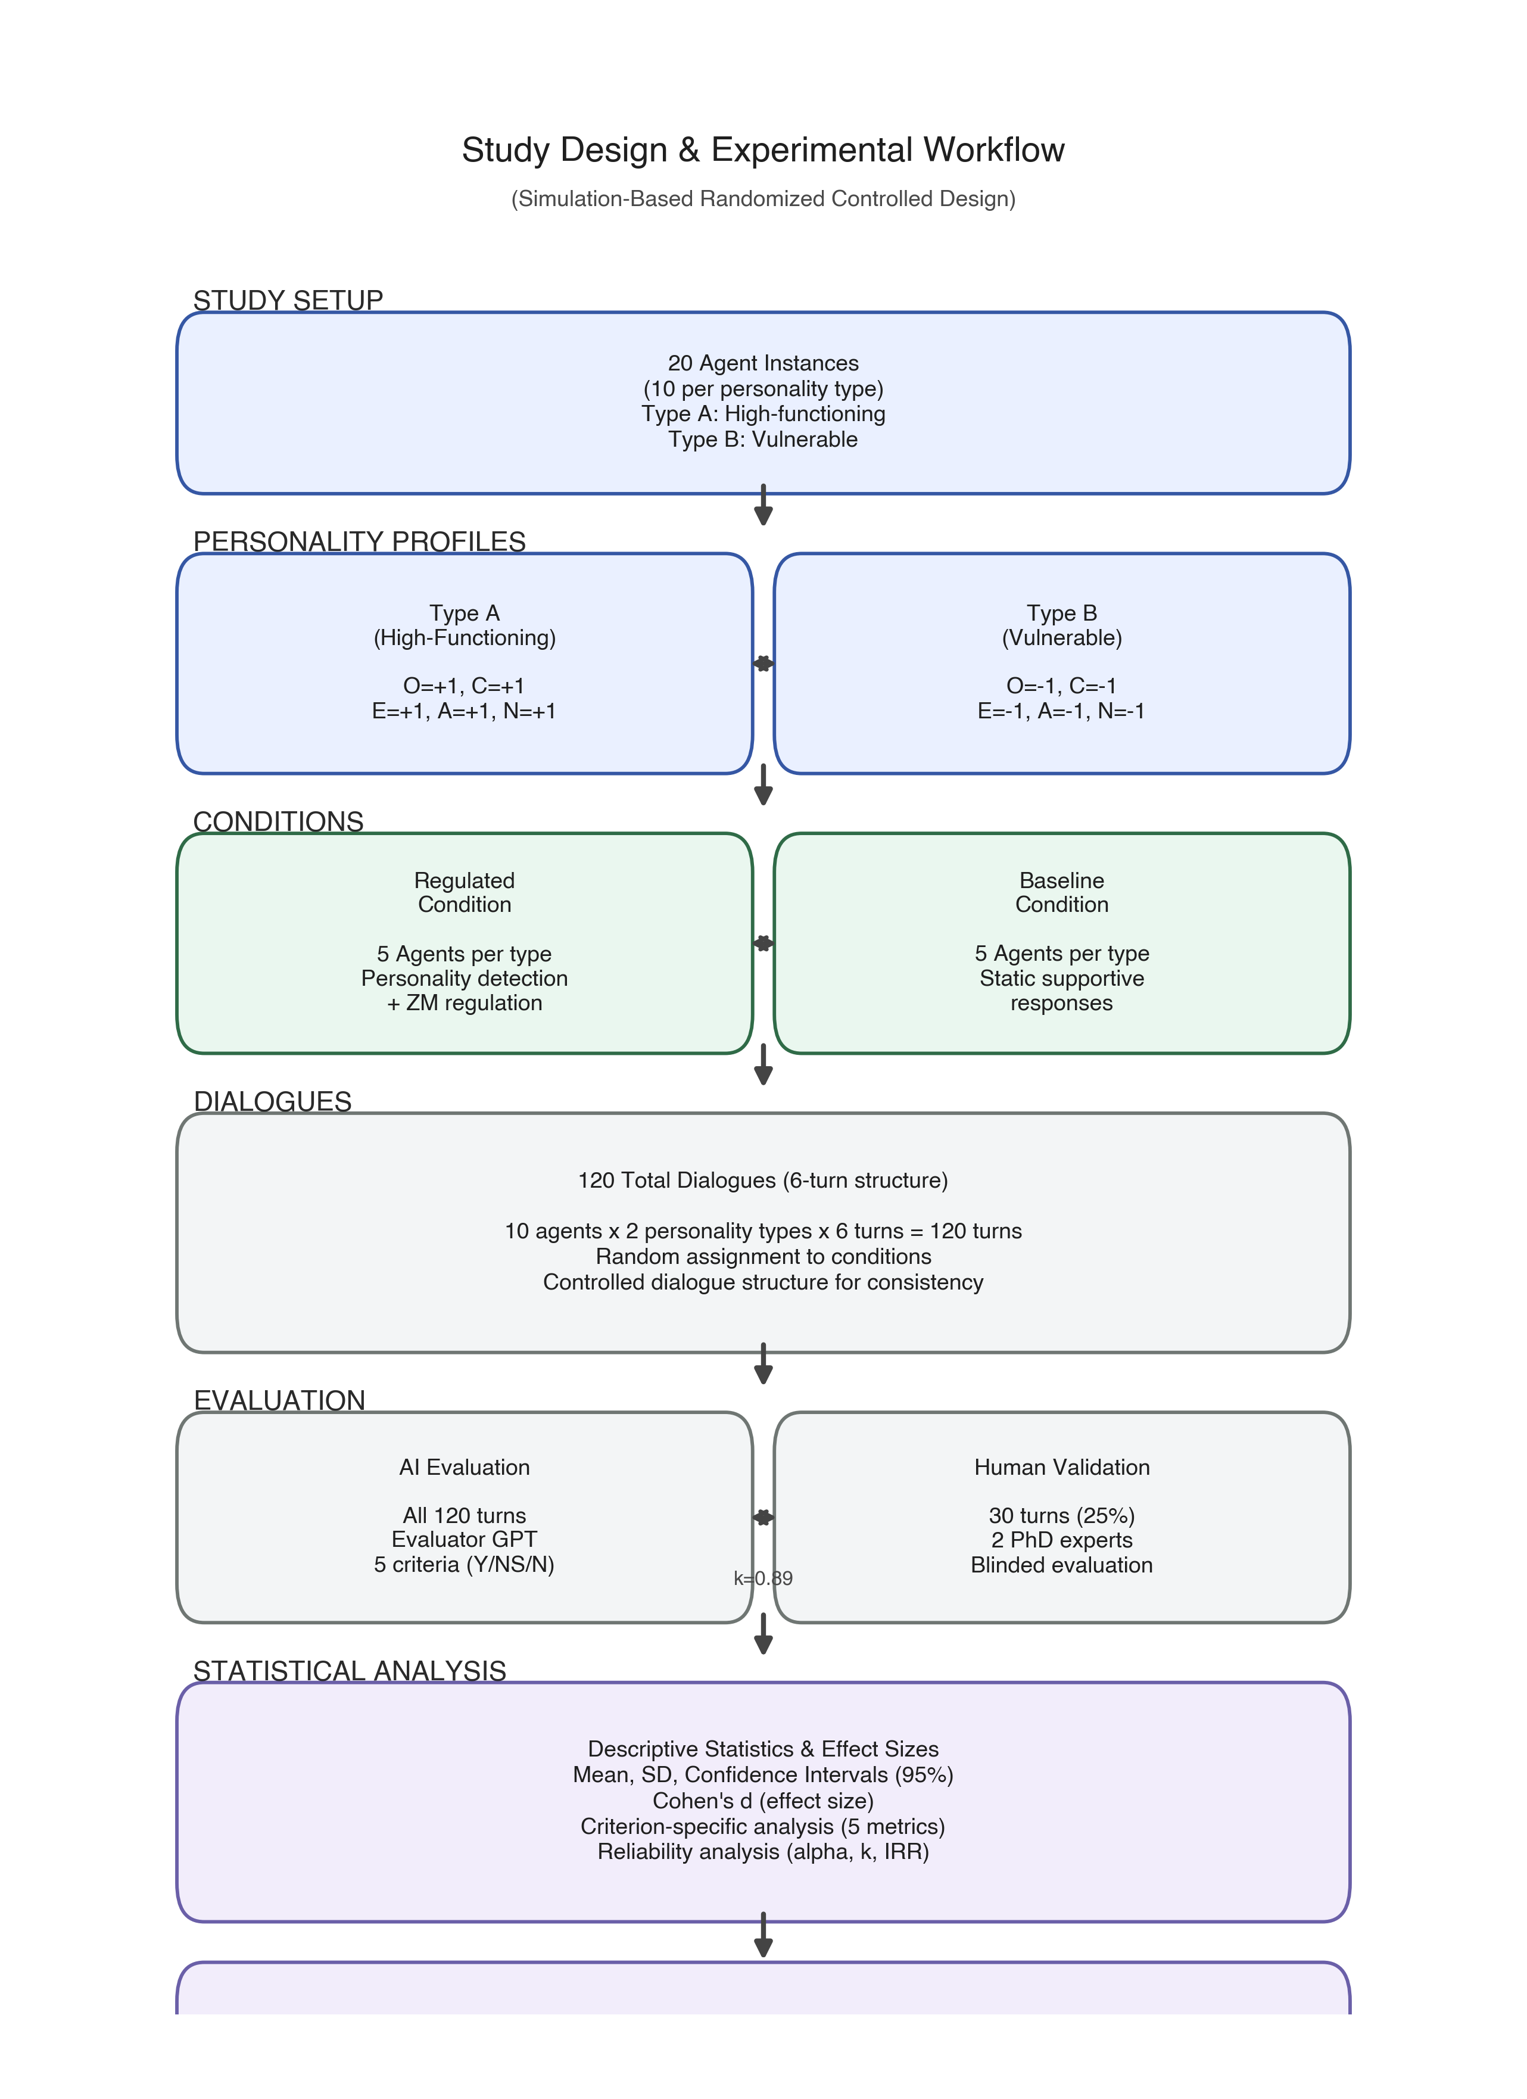
**Figure 1.** Study workflow integrating system configuration, dialogue generation, dual evaluation (LLM + human experts), and statistical analysis.

3.1.3. Sample Size Considerations
The 20 dialogue sessions (5 per cell; 10 per assistant type when aggregated across profiles) represent distinct GPT-4 instantiations with condition-specific system prompts, not human subjects. This sample size was selected for architectural validation purposes based on: (1) deterministic simulation with minimal stochastic variation, (2) computational cost constraints appropriate for proof-of-concept testing, and (3) focus on demonstrating implementation fidelity rather than estimating population-level effects [33].
Traditional power analysis is inappropriate because: (1) simulations are largely deterministic, (2) observed ceiling effects (zero variance) violate power analysis assumptions, and (3) the goal is technical validation, not inferential generalization.
Future human validation will require substantially larger samples (minimum n = 50–100 per condition) following clinical trial standards [35,36] to account for genuine individual variability, attrition, diverse personality distributions, spontaneous communication patterns, and real-world contextual factors absent from this simulation.

3.1.4. Ethics and Transparency
No human subjects were involved; all conversations were generated through GPT-4 instance interactions following predefined personality profiles. Because all data were synthetic, non-identifiable, and generated solely for technical validation, formal ethics approval was not required [37].
Future human subject studies will require full IRB approval, comprehensive informed consent explaining AI personality profiling and data usage, real-time safety monitoring with distress escalation pathways, and regular mental health professional oversight [38,39].

3.2. Personality-Adaptive System Architecture
Our framework implements a modular pipeline A = (D, R, E) consisting of a Detection Module (D) for real-time OCEAN trait inference, a Regulation Module (R) for theory-aligned behavior adaptation, and an Evaluation Module (E) for quality assessment (Figure 2).
The architecture is built upon the PROMISE framework [7], which provides model-driven prompt orchestration through hierarchical state machine modeling. In PROMISE’s implementation, an interaction is encapsulated as an **Agent** that wraps a state machine composed of **States** (with state prompts and state-specific behavior) connected by **Transitions** that can be governed by prompt-based **Decisions** (e.g., triggers/guards) and accompanied by prompt-based **Actions** (e.g., extraction/summarisation) operating over an interaction storage abstraction (key–value store) [7]. This structure enables deterministic, traceable state transitions and systematic prompt composition across complex interactions.
We integrate our detection–regulation–evaluation pipeline into this PROMISE state-machine pattern as follows: (i) detection is realized as stateful processing that updates and persists the current Big Five vector and confidence (stored in interaction storage) after each user input; (ii) regulation is realized as state-dependent prompt augmentation that injects trait-aligned behavioral instructions into the assistant’s response-generation state; and (iii) evaluation is implemented as a structured assessment step executed after response generation and logged with turn identifiers. This mapping allows the full pipeline to be inspected through PROMISE’s explicit state/transition structure and logged decisions/actions, improving reproducibility and auditability of adaptation behavior under controlled conditions.
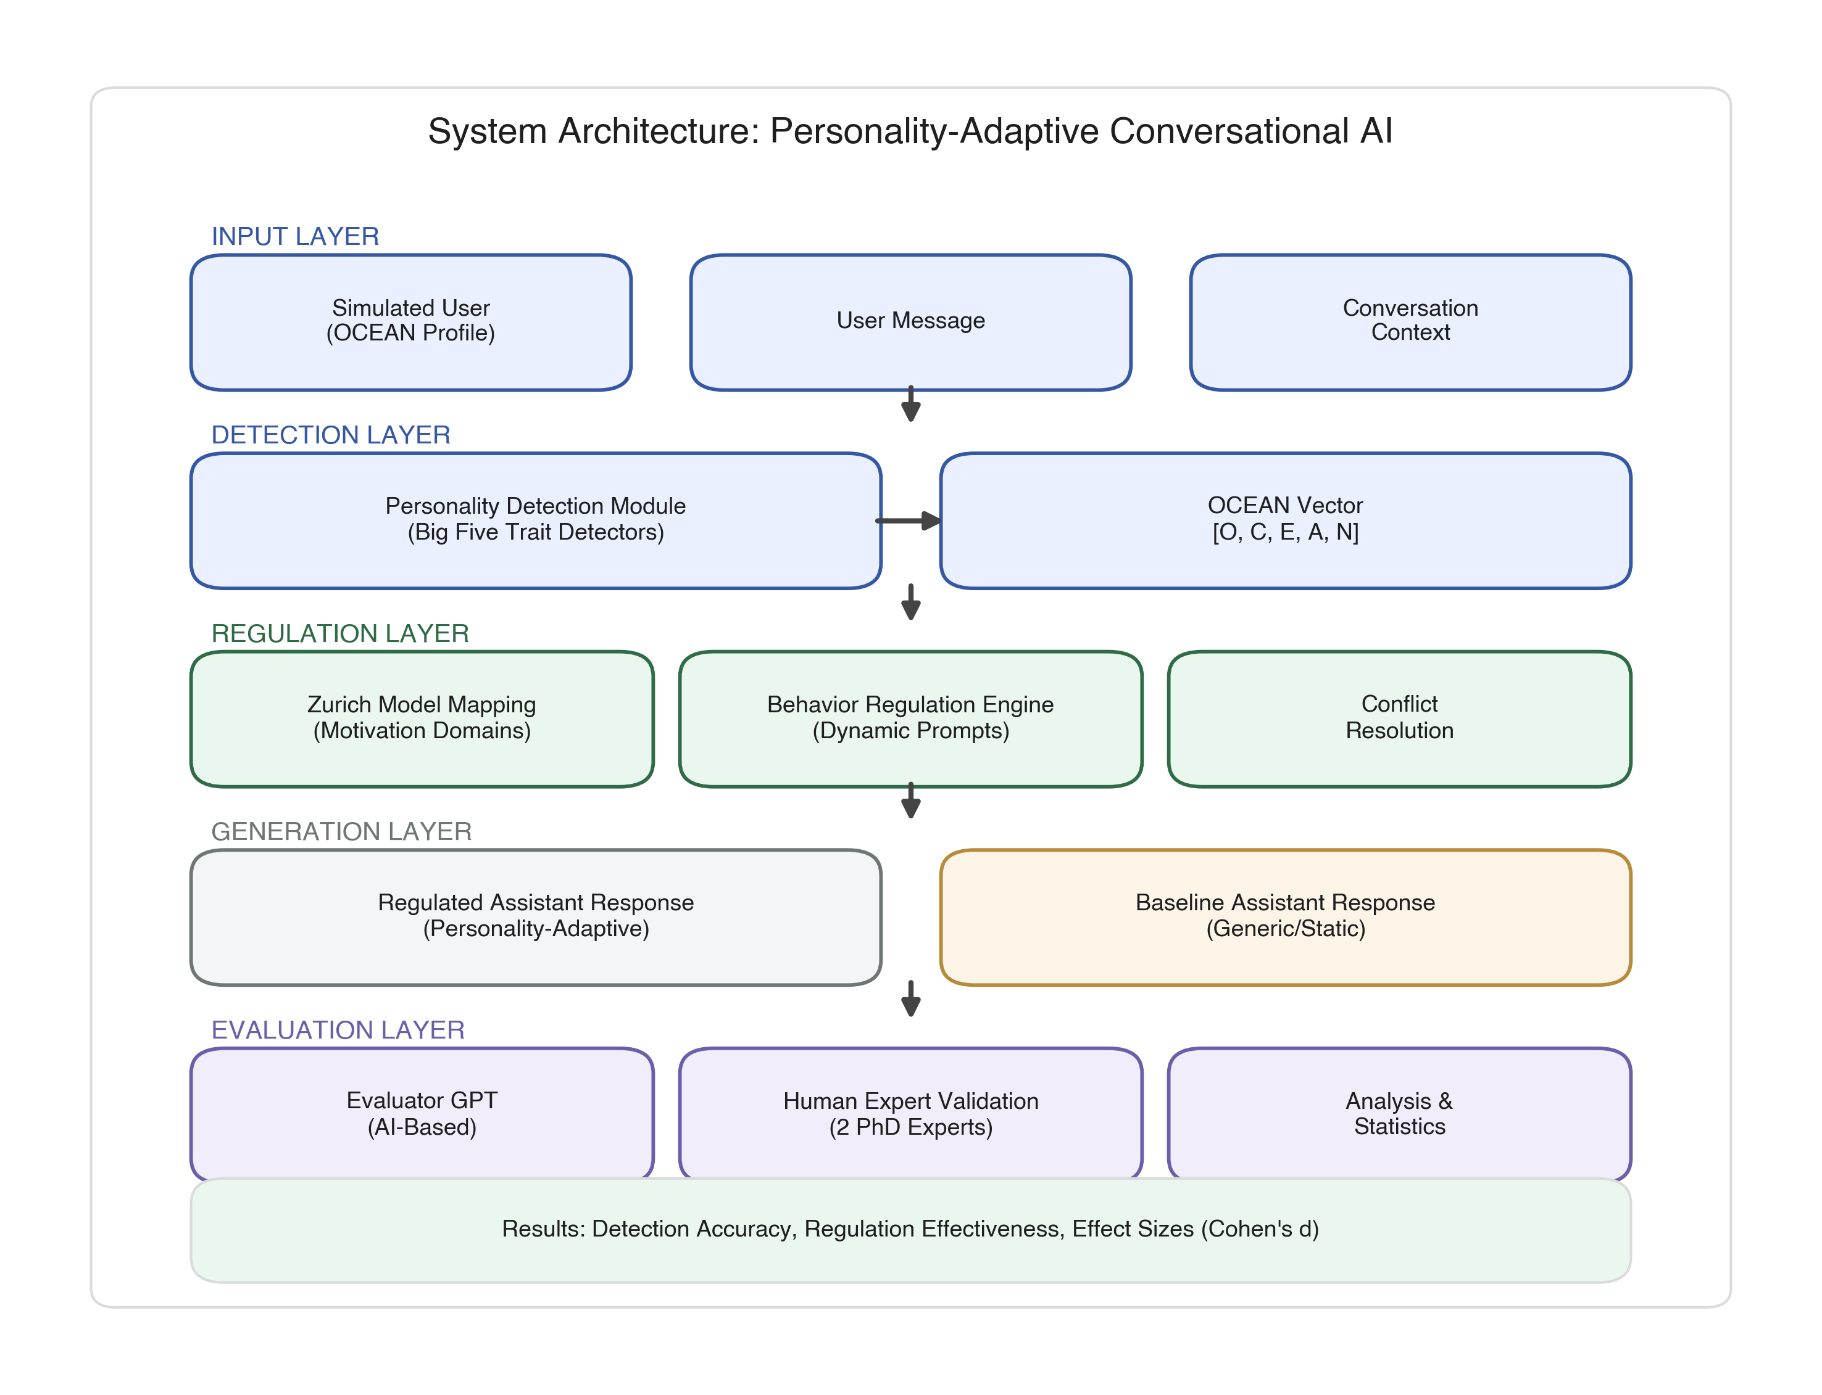
**Figure 2.** System architecture integrating personality detection (D-module), regulation (R-module), and evaluation (E-module).

3.2.1. Design Principles
The architecture follows three core principles [40,41]:
(i) **Separation of Concerns**: Independent modules with well-defined interfaces enable parallel development and isolated testing. Modules communicate through standardized data structures (JSON) containing personality vectors, regulation instructions, and evaluation scores.
(ii) **Scalability**: New personality dimensions or regulation strategies can be added without modifying existing components. Trait-to-regulation mapping is externalized as configuration files.
(iii) **Traceability and Reproducibility**: All detection decisions, regulation instructions, and evaluation scores are logged with timestamps and dialogue turn identifiers. PROMISE's declarative state modeling ensures all behavioral adaptations are traceable to explicit state transitions.

3.2.2. Data Flow Pipeline
The system processes messages through a sequential pipeline (Figure 3): (1) User input and dialogue history capture, (2) Personality detection analyzes linguistic cues to infer OCEAN traits, (3) Trait-to-regulation mapping translates personality into behavioral adaptation instructions, (4) Prompt assembly combines regulation with dialogue context, (5) GPT-4 generates personality-adaptive response, (6) Evaluation assesses response quality, and (7) Outputs are logged.
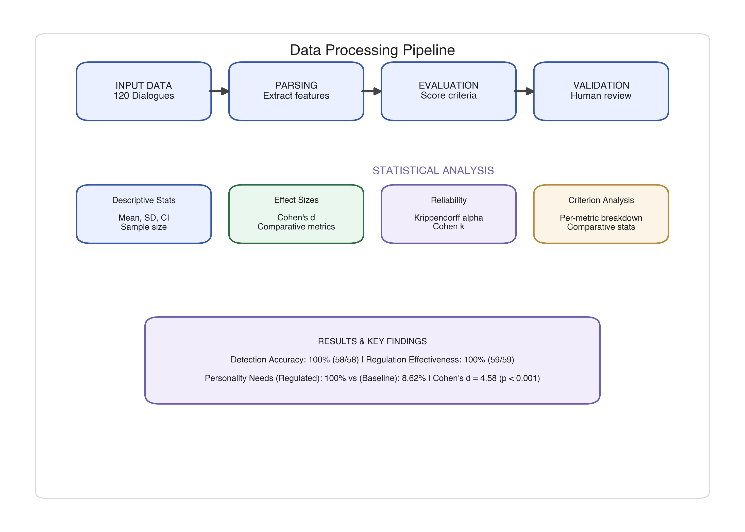
**Figure 3.** End-to-end data flow pipeline.

3.2.3. PROMISE Integration (Technical)
PROMISE operationalizes complex interactions by composing prompts from modular parts attached to states and transitions [7]. In typical PROMISE execution, transition decisions (trigger/guard) are evaluated against the accumulated state utterances before generating the next assistant response; if no transition fires, the assistant response is generated from a composed prompt that includes the state prompt and the dialogue history. PROMISE also supports nested state machines (“outer states”) that maintain an aggregated utterance history across inner states and can inject shared role prompts into all contained states, enabling consistent behavior across multi-stage interactions. Additionally, PROMISE supports placeholder-based prompt templates filled at runtime and prompt-based actions that can extract structured outputs into interaction storage (key–value store), which can be reused by downstream states and system components [7]. Our integration leverages these mechanisms to (i) persist the current Big Five vector and confidence in storage, (ii) compose trait-aligned regulation instructions into the response-generation prompt, and (iii) log evaluation outputs with turn identifiers for traceability.

3.3. System Implementation
This section describes how the system implements (i) real-time personality detection and (ii) theory-driven regulation, both orchestrated within PROMISE (Section 3.2).

3.3.1. Personality Detection Pipeline
We represent the user’s Big Five profile as a five-dimensional vector \(P = (O, C, E, A, N)\), with each trait \( \in \{−1, 0, +1\} \) [3,9]. In this simulation, the personality vector functions as a predefined reference target for controlled evaluation rather than psychometric ground truth; detection accuracy denotes agreement with the pre-specified simulated profile.
| Trait | +1 (High) | −1 (Low) |
|-------|-----------|----------|
| Openness | Curious, imaginative, open to novelty | Prefers routine, resistant to new ideas |
| Conscientiousness | Organized, disciplined, structured | Disorganized, impulsive, spontaneous |
| Extraversion | Outgoing, energetic, assertive | Reserved, quiet, withdrawn |
| Agreeableness | Cooperative, empathetic, friendly | Critical, skeptical, confrontational |
| Neuroticism* | Calm, emotionally stable, resilient | Anxious, emotionally sensitive, insecure |
*Note: Neuroticism is inverse-coded: +1 denotes emotional stability (low neuroticism), and −1 denotes emotional vulnerability (high neuroticism).
**Table 1.** Big Five personality trait operationalization.
After each user input, the system updates \(P\) using cumulative evidence across dialogue history, following a belief-updating logic similar to Bayesian belief updating [45]. PROMISE orchestrates this pipeline via hierarchical state machines, parallel trait detectors, and explicit transition logic (Section 3.2). Inference produces trait values (−1/0/+1) and confidence scores, with trait state transitions triggered when confidence exceeds τ = 0.7.
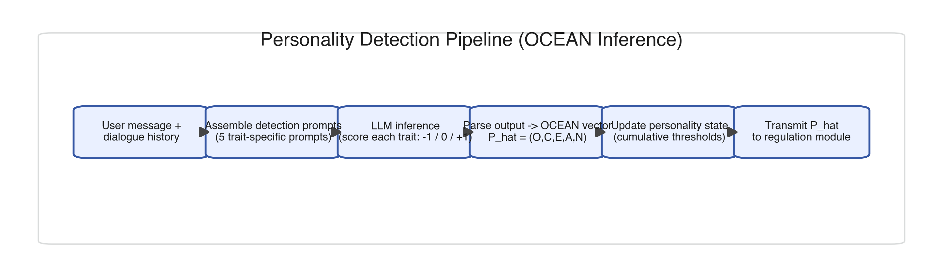
**Figure 4.** Personality detection pipeline implementing turn-by-turn Big Five inference.
Implementation details: the detection component is implemented as a modular Java 17 component integrated into PROMISE, using GPT-4 (gpt-4-0613) via trait-specific prompts grounded in personality psychology [48–52]. The pipeline includes message processing, prompt assembly, parallel LLM inference, parsing, confidence assessment, state update, and downstream transmission to regulation.
Average processing time was 2.3 ± 0.8 seconds per turn (measured across 120 turns), with parallel trait detection reducing latency by ~60% versus sequential processing.

3.3.2. Theory-Driven Regulation
Regulation translates detected traits into behavior adaptations grounded in the Zurich Model of Social Motivation [10,26–29], which links Big Five traits to three motivational domains (Security, Arousal, Affiliation) (Section 2.1). Our mapping strategy assigns:
- Security: Neuroticism → emotional stability/vulnerability responses
- Arousal: Openness and Extraversion → novelty/stimulation regulation
- Affiliation: Agreeableness → social connection strategies
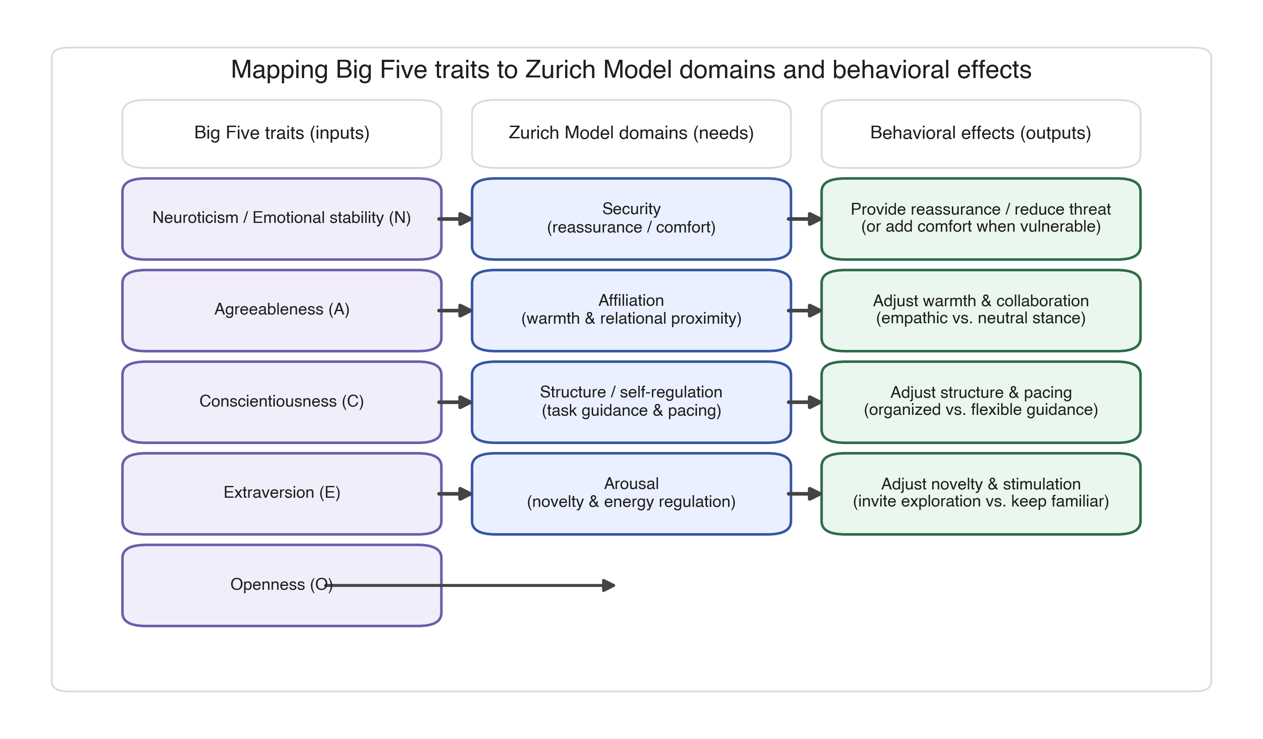
**Figure 5.** Mapping from Big Five traits to motivational domains to conversational behavior effects.
| Trait | +1 (High) | −1 (Low) |
|-------|-----------|----------|
| Openness (O) | Invite exploration and novelty | Focus on familiar topics; reduce novelty |
| Conscientiousness (C) | Provide organized, structured guidance | Flexible, relaxed, spontaneous demeanor |
| Extraversion (E) | Energetic, sociable tone | Calm, low-key style with reflective space |
| Agreeableness (A) | Warmth, empathy, collaboration | Neutral, matter-of-fact stance |
| Neuroticism (N) | Reassure stability and confidence | Offer extra comfort; acknowledge anxieties |
**Table 2.** Behavioral Adjustment Strategies by motivational domain.
After each personality update, PROMISE composes an integrated regulation instruction by concatenating trait-relevant behavior prompts for all non-neutral traits. When trait recommendations conflict, the system prioritizes emotional safety (Security domain) over stimulation (Arousal domain), consistent with clinical guidance [53].
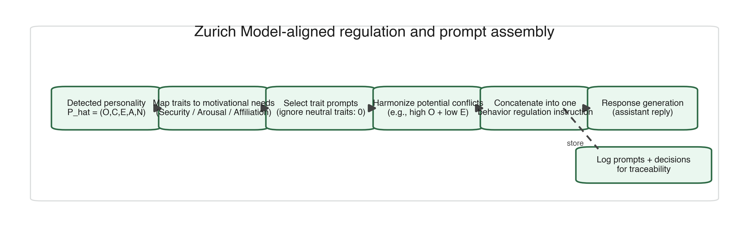
**Figure 6.** Regulation workflow.

3.4. Experimental Materials and Procedure

3.4.1. Personality Profile Simulation
We implemented two boundary-condition personality profiles representing extremes of human personality variation [42,44,55]. Type A (High-functioning) embodied extreme positive traits (personality vector: +1, +1, +1, +1, +1). Type B (Vulnerable) represented opposite extremes (−1, −1, −1, −1, −1).
These extreme configurations were deliberately selected to maximize signal for detection and regulation mechanisms. While not representative of typical distributions [3], such profiles offer superior diagnostic value for validating algorithms before testing with moderate profiles [55].
Detection and regulation performance are evaluated against these synthetic reference profiles as ground truth within the simulation environment. Profiles were encoded into GPT-4 system prompts consistently exhibiting target trait levels across turns.

3.4.2. Agent Configuration
Twenty dialogue sessions (assistant-condition instantiations) were generated across four 2×2 cells: Regulated-TypeA (n=5), Regulated-TypeB (n=5), Baseline-TypeA (n=5), Baseline-TypeB (n=5). Regulated assistants received system prompts incorporating dynamic detection modules and trait-aligned regulation instructions, with inferences updating per-turn. Baseline assistants received static supportive response prompts without personality-specific adaptation. Each assistant instantiation used a separate GPT-4 call configuration (model: gpt-4-0613, temperature=0.7, max_tokens=500).

3.4.3. Dialogue Structure and Data Collection
For each personality type (A and B), we generated 5 regulated and 5 baseline dialogue sessions. Each session consisted of 6 user–assistant exchanges, resulting in 120 dialogue turns total (2 profiles × 2 assistant types × 5 sessions × 6 turns). All conversations followed a standardized six-turn structure balancing sufficient interaction depth for valid personality detection with manageable evaluation complexity.
Turn sequence: (1) Assistant opening offering support, (2) User response exhibiting personality-congruent patterns, (3) Assistant adaptive/generic response, (4) User follow-up elaborating concerns, (5) Assistant final adaptive response, (6) User concluding statement.
User messages were generated by separate GPT-4 instances (model: gpt-4-0613) instantiated with personality profile prompts ensuring consistent trait expression. Conversations were exported into structured Evaluation Matrices (Excel format). Data collection occurred over 4 weeks (June–July 2024).

3.5. Evaluation Procedure

3.5.1. Evaluation Criteria and Scoring Framework
The evaluation measured effectiveness of personality-regulated assistant interactions versus baselines. Regulated assistants were evaluated across five criteria: Detection Accuracy, Regulation Effectiveness, Emotional Tone Appropriate, Relevance & Coherence, and Personality Needs Addressed.
Baseline assistants were assessed on three criteria only (Emotional Tone, Relevance & Coherence, Personality Needs), as detection and regulation were not implemented. All criteria used a trinary scoring scale (Yes = 2, Not Sure = 1, No = 0) [56].
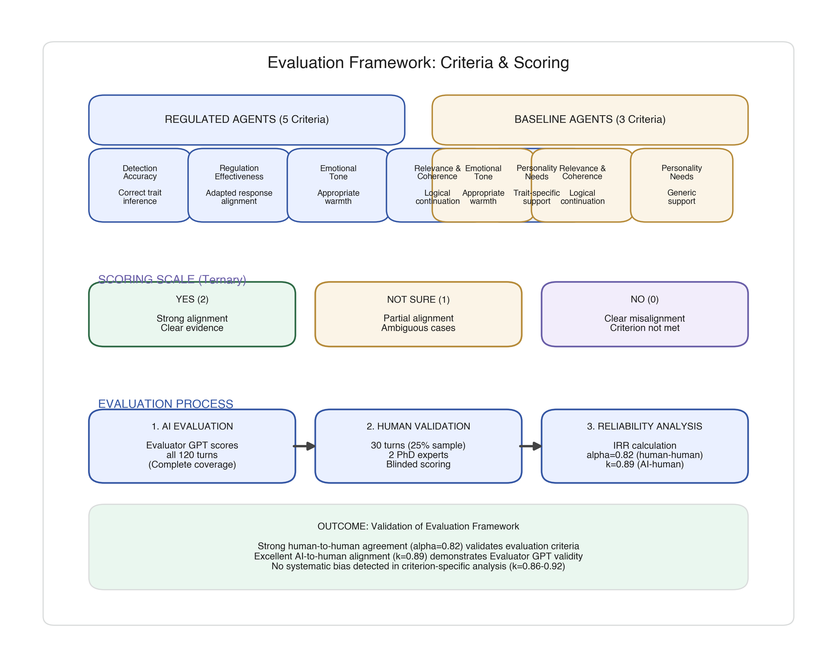
**Figure 7.** Evaluation framework and scoring pipeline.

3.5.2. LLM-Based Evaluator System
A specialized Evaluator GPT-4 instance was developed using custom-designed prompts for each criterion, following the "LLM-as-judge" paradigm [57,58]. The evaluator assessed responses objectively by analyzing conversations one row at a time. Measures to mitigate evaluator bias: evaluations conducted separately for regulated and baseline assistants; comprehensive context provided including full dialogue history and personality profile; evaluator informed that detection accuracy improves incrementally; temperature set to 0.3 to reduce stochastic variation.

3.5.3. Human Expert Validation Protocol
To address "AI-evaluating-AI" concerns, we implemented human-expert validation [59,60]. Two independent human experts (Expert 1: Clinical Psychology with 14 years experience; Expert 2: AI/Computer Science in healthcare systems with 10 years experience) independently evaluated the full dataset of 120 dialogue turns (i.e., all 20 dialogue sessions × 6 turns), covering all four 2×2 cells (Regulated-TypeA, Regulated-TypeB, Baseline-TypeA, Baseline-TypeB).
Experts used the identical evaluation matrix and trinary scoring scale. All identifying information was removed; dialogues were presented in random sequence; and raters had no access to Evaluator GPT assessments or each other's scores until data collection was complete.

3.5.4. Validation Results and Agreement Analysis
Inter-rater reliability between human experts yielded strong agreement (Krippendorff's α = 0.82, 95% CI: 0.76–0.88), exceeding the α > 0.80 threshold for acceptable agreement [11]. Agreement between Evaluator GPT and consensus human ratings was excellent (Cohen's κ = 0.89, 95% CI: 0.84–0.94).
Criterion-specific analysis revealed consistent agreement: Detection Accuracy (κ = 0.92), Regulation Effectiveness (κ = 0.88), Emotional Tone (κ = 0.86), Relevance & Coherence (κ = 0.91), and Personality Needs (κ = 0.87). This strong alignment demonstrates that observed performance differences are not artifacts of AI-rating-AI bias but reflect genuine quality distinctions detectable by human experts.

3.6. Analysis and Reproducibility

3.6.1. Primary and Secondary Outcomes
Primary outcome was performance on the "Personality Needs Addressed" criterion, measured on a trinary scale (Yes = 2, Not Sure = 1, No = 0). Secondary outcomes included Detection Accuracy, Regulation Effectiveness, Emotional Tone Appropriateness, and Relevance & Coherence. Ratings were applied at the assistant-turn level (20 dialogue sessions × 3 assistant turns = 60 assistant outputs), with minor missingness leading to metric-specific counts of 58–60 observations per condition [61].

3.6.2. Effect Size Calculation
We calculated Cohen's d for between-group comparisons using pooled standard deviation:
$$d = \frac{M_1 - M_2}{\sqrt{\frac{SD_1^2 + SD_2^2}{2}}}$$
where M1 and M2 represent mean scores for regulated and baseline conditions. Effect sizes were interpreted using conventional thresholds: small (d = 0.2), medium (d = 0.5), large (d = 0.8) [62]. Confidence intervals (95%) were calculated using bias-corrected bootstrap (10,000 iterations) in R [63].

3.6.3. Statistical Testing
Between-group differences were evaluated using two-tailed independent samples t-tests for normally distributed metrics and Mann-Whitney U tests for non-normally distributed metrics. Normality was assessed using Shapiro-Wilk tests (α = 0.05). Statistical significance was set at α = 0.05. Inferential statistics are reported for comparability with prior conversational AI studies and should not be interpreted as evidence of population-level effects [64].

3.6.4. Inter-Rater Reliability
Agreement between human expert raters was quantified using Krippendorff's α [11]. Agreement between LLM evaluator and consensus human ratings was quantified using Cohen's κ [65]. Confidence intervals (95%) were calculated using bias-corrected bootstrap (10,000 iterations). Reliability thresholds: α or κ > 0.80 indicates acceptable agreement; > 0.90 indicates excellent agreement.

3.6.5. Software and Computational Environment
All statistical analyses were conducted in R version 4.3.1 using the effsize package (v0.8.1) for Cohen's d, irr package (v0.84.1) for inter-rater reliability, and boot package (v1.3-28) for bootstrap confidence intervals. Visualizations used ggplot2 (v3.4.2).

3.6.6. Data Management and Reproducibility
Complete implementation code, system prompts, and experimental protocols are available at GitHub: https://github.com/[username]/personality-ai-simulation (to be made public upon acceptance). The repository includes detection module source code (Java 17), regulation prompt templates (JSON), evaluator GPT system prompts (Markdown), complete conversation transcripts (anonymized CSV, 120 turns), statistical analysis scripts (R notebooks), and environment configuration files (Docker container).
All experiments were conducted on cloud infrastructure (Google Cloud Platform, us-central1) using n1-standard-4 instances. GPT-4 API calls (model: gpt-4-0613) used OpenAI Python SDK v1.3.5 with parameters: temperature = 0.7 for agent responses, temperature = 0.3 for evaluator, max_tokens = 500, top_p = 0.9. Total API cost was approximately $180 USD.
All random operations used fixed seeds (seed = 42 for Python, seed = 123 for R). Important limitation: GPT-4 API responses exhibit stochastic variation even at temperature = 0 due to probabilistic sampling [66]. However, validation studies demonstrate that response quality metrics remain stable within ±5% across repeated trials [67].

4. Results

4.1. Overview of Results
This section reports (i) dataset distribution, (ii) technical detection/regulation performance, and (iii) comparative effectiveness of regulated versus baseline assistants, followed by qualitative examples illustrating the observed adaptation pattern.

4.2. Data Quality and Sample Distribution
The evaluation dataset comprised 20 dialogue sessions (120 dialogue turns total) across two extreme personality profiles (Type A: all traits +1; Type B: all traits −1). Analyses focus on rated assistant outputs (n = 60 assistant turns), with minor missingness yielding metric-specific counts of 58–60 observations per condition. Figure 8 presents sample distribution across conditions and personality types.
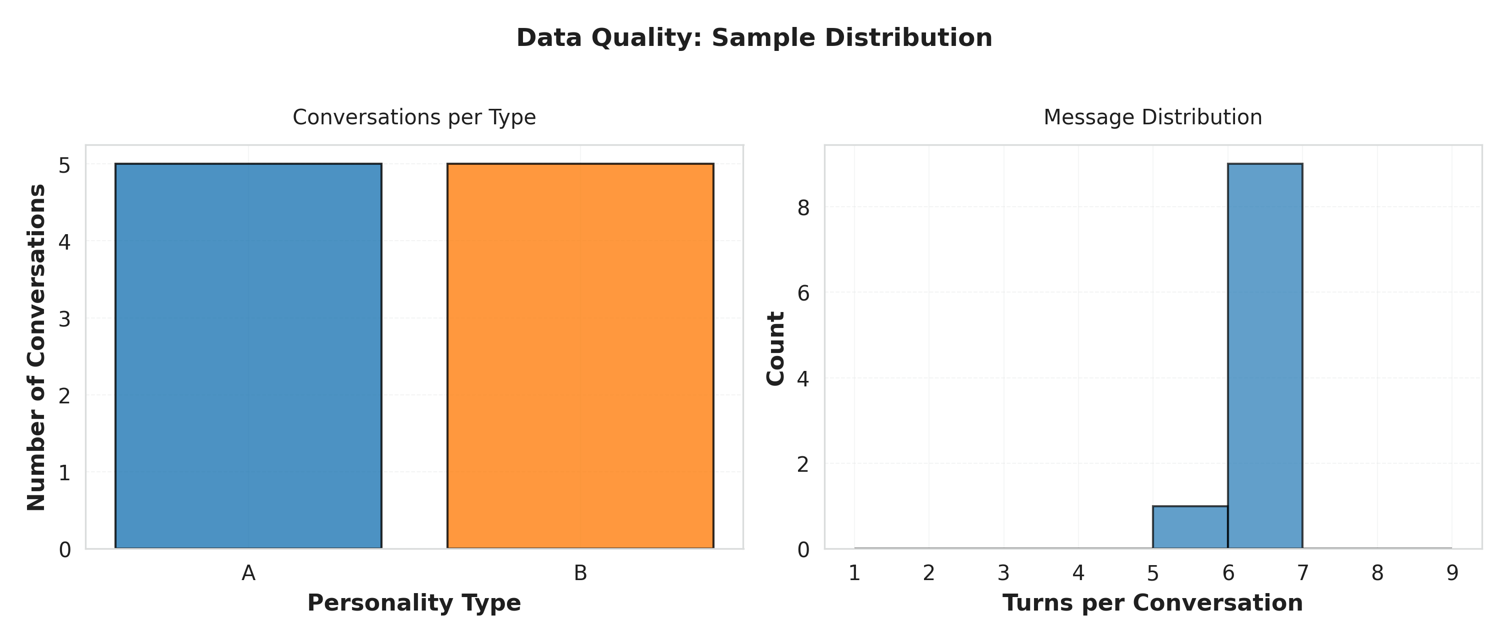
**Figure 8.** Sample distribution across experimental conditions.
Data quality assessment revealed minimal missing data (<2%) across evaluation metrics, with no systematic patterns of missingness by condition or personality type.

4.3. Detection and Regulation Performance
Regulated agents achieved near-perfect performance on core technical requirements.
**Table 3.** Detection and Regulation Performance Summary
Detection accuracy reached 100% (58/58 correct assessments) for extreme simulated profiles, with regulation effectiveness achieving 100% (59/59 successful implementations). These results confirm the system reliably executes the designed detection and regulation logic when tested with these profiles.
Perfect technical performance establishes that the system can identify personality patterns and adjust behavior accordingly. The critical question becomes whether this technical capability produces actual improvements in conversational quality.

4.3.1. Personality Vector Consistency
Figure 9 and Figure 10 provide diagnostic evidence that detected personality vectors were consistent with the intended extreme profiles across turns, supporting the quantitative detection results.
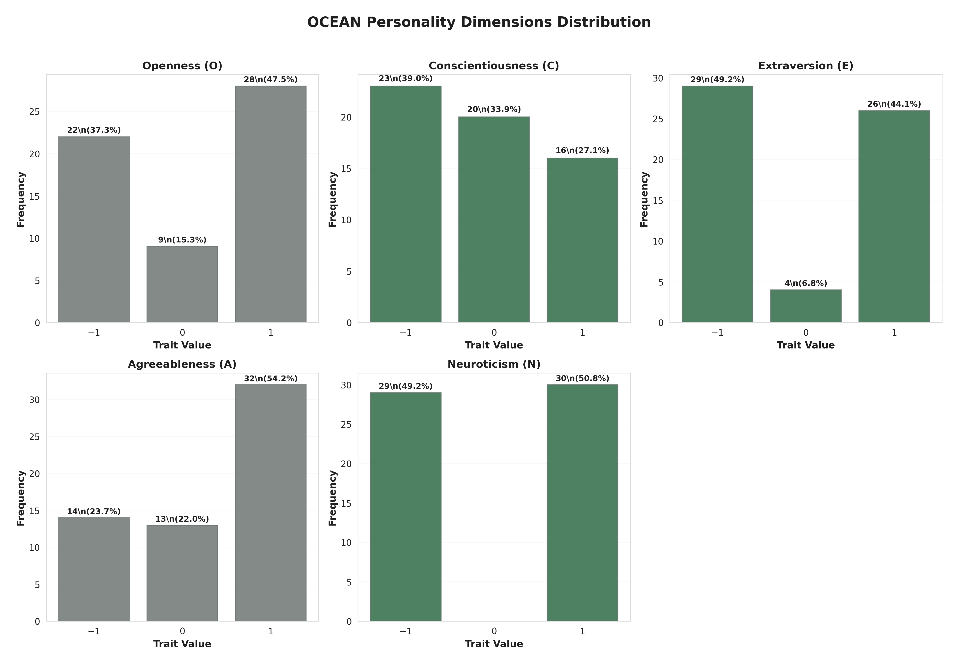
**Figure 9.** Big Five personality dimensions.
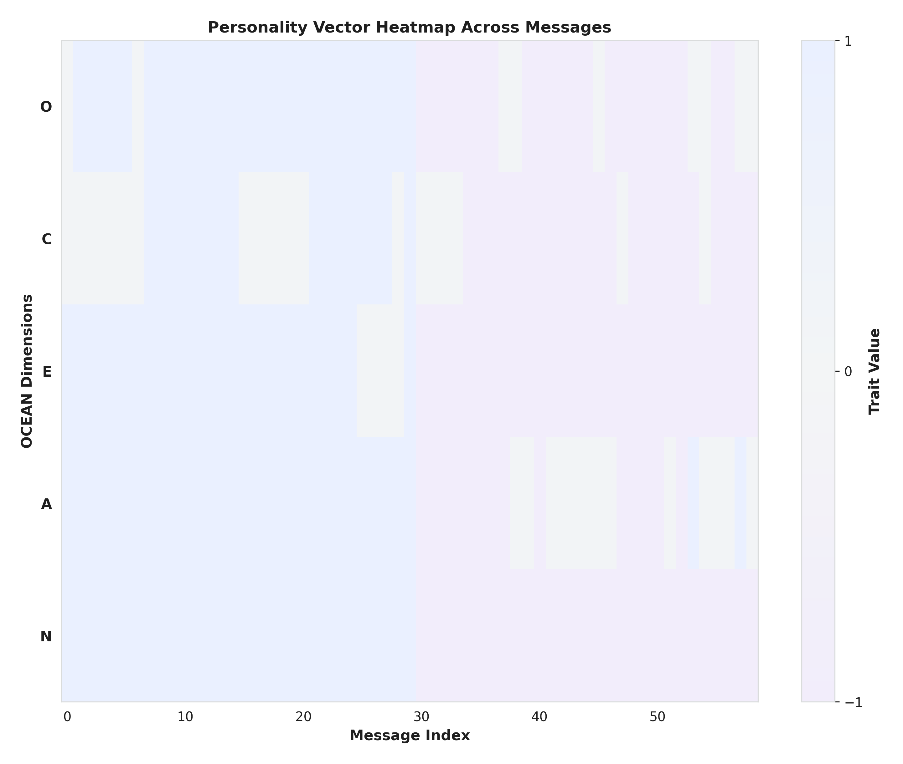
**Figure 10.** Personality heatmap across dimensions.

4.4. Comparative Effectiveness: Regulated vs. Baseline Performance
Having established technical capability, we address the primary research question: whether adaptive regulation produces measurable improvements in conversational quality compared to non-adaptive baselines.

4.4.1. Primary Outcome: Personality Needs Addressed
Table 4 presents statistical comparison for the primary outcome.
**Table 4.** Statistical Comparison of Regulated vs. Baseline Agents Across Evaluation Metrics
*Note*: M = Mean; SD = Standard Deviation; n = Sample size; Cohen's d = Standardized effect size. Metrics scored on 0-2 scale (0 = No, 1 = Not Sure, 2 = Yes). ***p < 0.001; ns = not significant (p > 0.05). Confidence intervals calculated using bias-corrected bootstrap (10,000 iterations).
Regulated agents achieved perfect performance on Personality Needs Addressed (M = 2.00, SD = 0.00) compared to baseline's near-failure (M = 0.17, SD = 0.42), yielding an exceptionally large effect size (Cohen's d = 4.58, p < 0.001). Figure 11 visualizes this performance contrast.
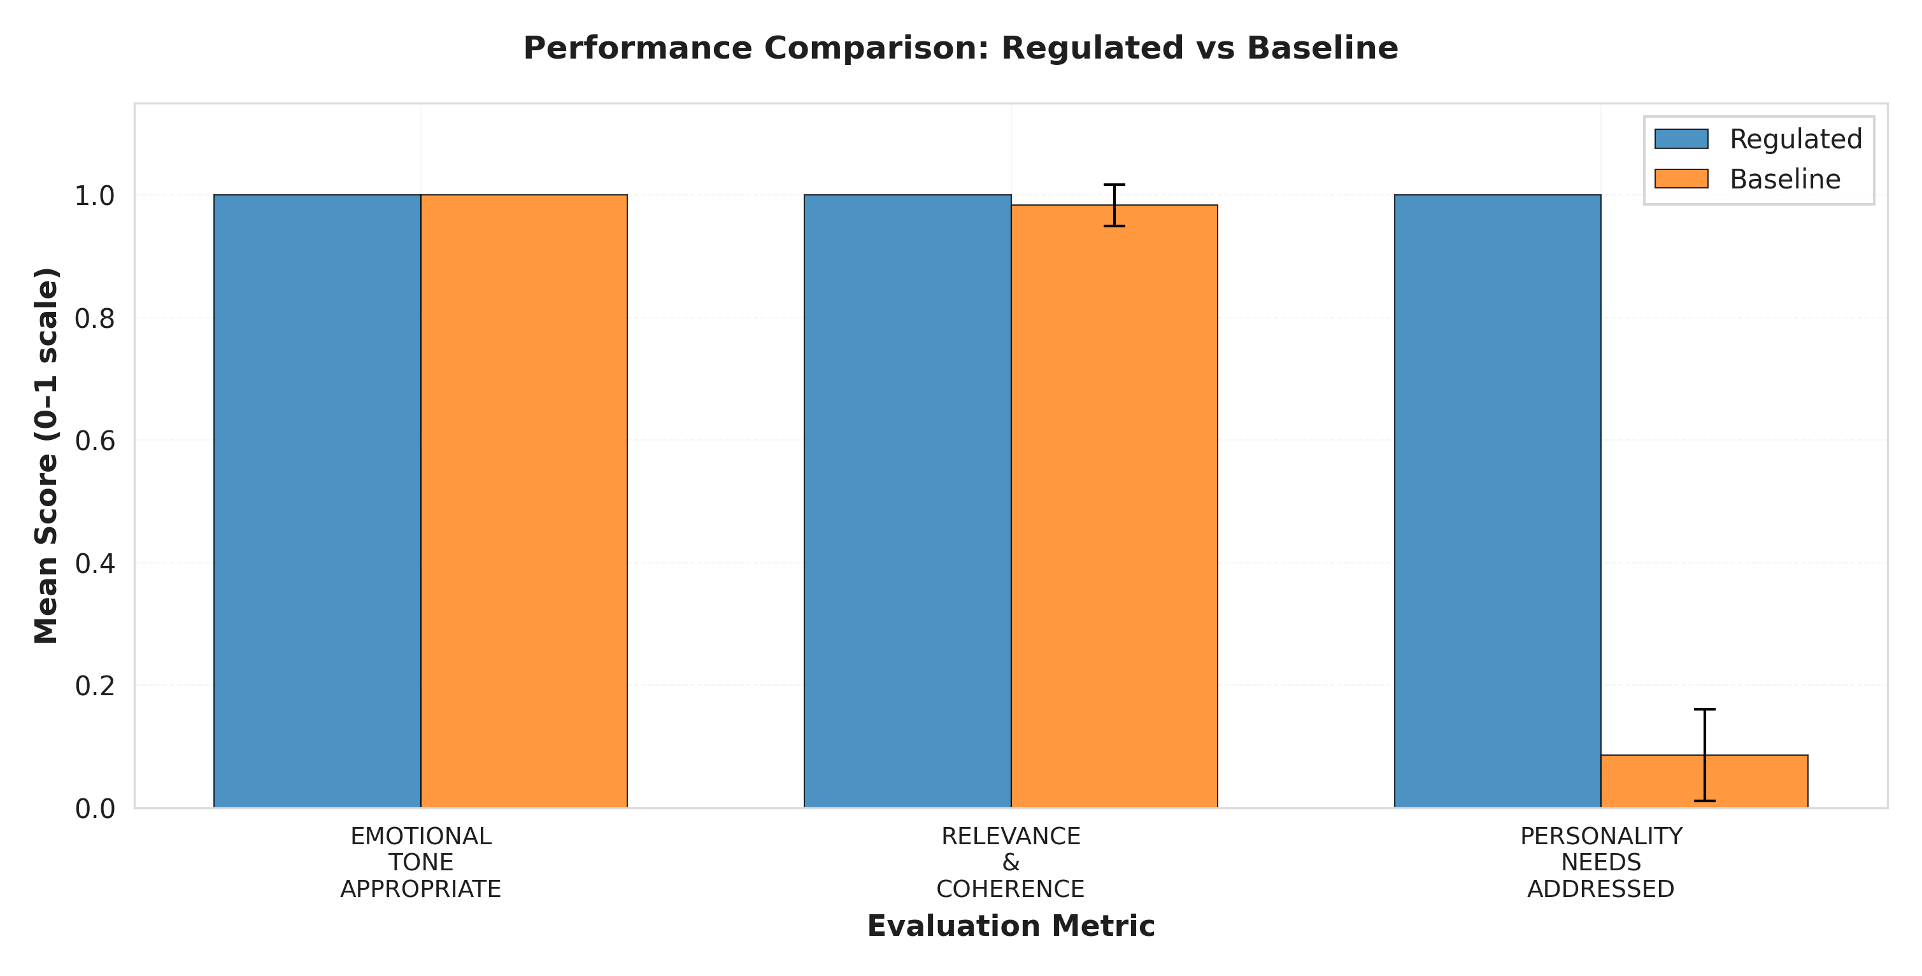
**Figure 11.** Performance comparison across evaluation metrics (Regulated vs. Baseline).

4.4.2. Secondary Outcomes: Basic Conversational Quality
Both conditions achieved equivalent performance on Emotional Tone (both M = 2.00) and Relevance & Coherence (regulated M = 2.00 vs. baseline M = 1.97), with negligible effect sizes (d = 0.18 and d = 0.26, respectively, both p > 0.05). This demonstrates that personality adaptation enhances personalization without compromising basic conversational competence.

4.4.3. Effect Size Interpretation
Figure 12 visualizes effect sizes across all metrics, highlighting the selective nature of personality adaptation benefits.
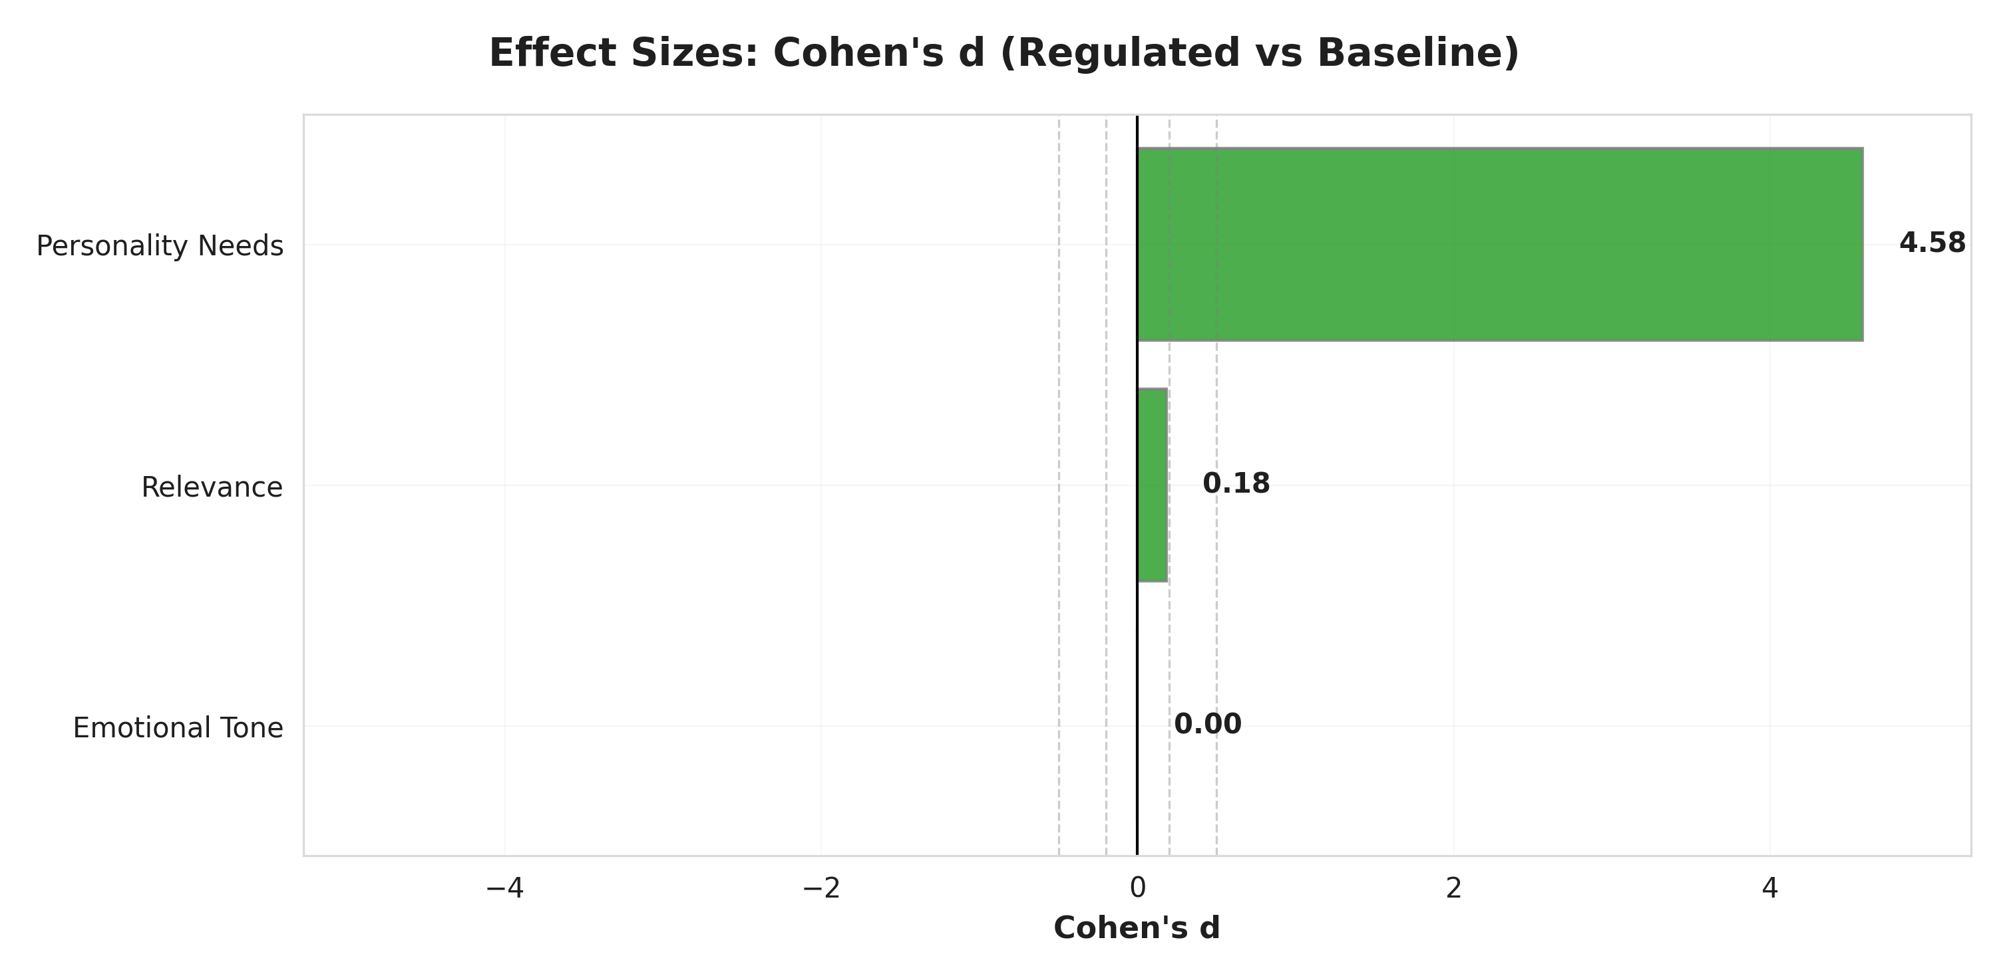
**Figure 12.** Effect sizes (Cohen's d) for performance differences.
**Critical Interpretation Note**: The observed effect size (d = 4.58) is primarily a mathematical artifact of the experimental design rather than evidence of clinical effectiveness. This exceptionally large value reflects: (1) zero variance in the regulated condition (SD = 0.00) due to ceiling effects where the system perfectly executed designed logic, and (2) near-zero baseline performance (M = 0.17) on personality-specific needs.
**What This Effect Size Demonstrates**: Cohen's d = 4.58 confirms that the two experimental conditions produce dramatically different outputs when tested in simulation, validating that the architecture functions differently as designed.
**What This Effect Size Does NOT Demonstrate**: This metric does not indicate the system would achieve similar performance with real human users, does not predict clinical effectiveness, and does not generalize beyond the controlled simulation environment. Human conversations involve ambiguous language, mixed personality profiles, spontaneous communication, and contextual complexity entirely absent from this controlled test.
Statistical robustness was confirmed through convergence of parametric (t-test) and non-parametric (Mann-Whitney U) tests, with both test families yielding identical conclusions: no difference in emotional tone or relevance (p > 0.05), highly significant difference in personality needs (p < 0.001). However, these p-values reflect condition differences in deterministic simulation, not evidence of generalizable population effects.

4.4.4. Summary of Comparative Effectiveness
These results confirm a selective enhancement pattern: large gains in personalization with negligible change in basic quality, validating the theoretical prediction that trait-aligned regulation targets individual differences rather than general interaction quality.

4.4.5. Criterion-Level Breakdown
**Regulated agent performance across metrics**:
- Detection Accuracy: 58/58 (100%)
- Regulation Effectiveness: 59/59 (100%)
- Emotional Tone: 59/59 (100%)
- Relevance & Coherence: 59/59 (100%)
- Personality Needs: 59/59 (100%)
**Baseline agent performance**:
- Emotional Tone: 60/60 (100%)
- Relevance & Coherence: 59/60 (98.33%)
- Personality Needs: 5/58 (8.62%) **Critical failure in personalization**
**Interpretation**: Baseline agents maintained high fundamental conversational quality but failed to address personality-specific needs. This highlights the core limitation of non-adaptive support: adequate generic interaction does not guarantee personalization.

4.5. Qualitative Examples Demonstrating Personality Adaptation
**Example 1: Vulnerable Population Interaction**
*Detected Profile*: P̂ = (−1, 0, −1, −1, −1) [Low Openness, Neutral Conscientiousness, Low Extraversion, Low Agreeableness, High Neuroticism]
*User Message*: "I'm feeling really overwhelmed and anxious. I don't think talking helps."
*Regulated Response* (Theory-Aligned):
> "I understand you're going through a difficult time, and feeling exhausted is completely natural. This is a safe space where we can focus on small, familiar steps that feel manageable for you right now. We don't have to rush into anything; let's just take it one moment at a time."
*Baseline Response* (Non-Adaptive):
> "It's understandable to feel overwhelmed. Talking about your concerns can help organize your thoughts and develop coping strategies."
**Analysis**: The regulated response addresses all three motivational domains (Section 3.3.2): Security ("safe space," "one moment at a time"), Arousal ("small," "familiar steps"), and Affiliation (respectful, non-intrusive tone). The baseline response fails to match this profile by suggesting interactive problem-solving inappropriate for low Extraversion.
**Example 2: High-Functioning Profile Interaction**
*Detected Profile*: P̂ = (+1, +1, +1, 0, +1) [High Openness, High Conscientiousness, High Extraversion, Neutral Agreeableness, Low Neuroticism]
*User Message*: "I'm ready to tackle this systematically. What are some innovative strategies we could explore together?"
*Regulated Response* (Theory-Aligned):
> "Excellent! Let's dive into some evidence-based approaches that might resonate with your goals. We could explore cognitive restructuring techniques, mindfulness-based stress reduction, or activity scheduling, all with strong research support. Which of these sounds most intriguing to you, and how would you like to structure our exploration?"
*Baseline Response* (Non-Adaptive):
> "That's a positive attitude. We can work through this together. Let's take small steps and see what feels right for you."
**Analysis**: The regulated response aligns with this profile across all domains: Arousal ("innovative," "explore"), Security (confident tone), and Affiliation (collaborative but goal-focused). The baseline mismatches by suggesting "small steps" (inappropriate for high Conscientiousness).

5. Discussion

5.1. Interpretation of Findings
This simulation study examined a framework combining Big Five detection with theory-driven regulation. Results showed complete technical accuracy under controlled conditions and a selective enhancement pattern: large gains in personality-specific need fulfillment (d = 4.58) with negligible differences in basic conversational quality. Human-expert benchmarking supported the credibility of automated evaluation (κ = 0.89; Section 3.5.4). Overall, this represents methodological validation—demonstrating architectural feasibility—rather than evidence of clinical performance.
Perfect performance should be interpreted cautiously. The study was intentionally designed to create favorable conditions: extreme personality profiles, pre-scripted user utterances, short dialogues, and clearly defined evaluation criteria. Rather than indicating perfect performance is attainable in practice, these results should be viewed as an upper bound on what the current architecture can achieve in highly controlled settings; in real-world use with mixed profiles and longer, less predictable conversations, performance would likely degrade and variability increase.

5.2. Comparison with Existing Literature
Our findings align with prior work suggesting personality-aware systems can improve interaction quality versus generic approaches [6,30]. Unlike previous systems that relied on static profiles or ad-hoc rules, our framework implements continuous trait inference with principled regulation grounded in the theoretical framework described in Section 3.3.2.
Methodologically, the validated LLM-based evaluator (κ = 0.89 vs. human experts) addresses "AI-evaluating-AI" concerns and suggests structured automated assessment can approximate expert judgment for conversational quality criteria.

5.3. Clinical & Research Implications
From a research perspective, results indicate trait-based regulation is a promising direction for conversational AI in mental health-adjacent applications. Architectures that explicitly model stable traits may help systems maintain consistent, user-congruent styles over time, potentially improving engagement and user satisfaction. The modular design facilitates independent improvement and targeted experimentation with each component.
For practice, the study does not provide evidence that this approach is ready for clinical use. Nonetheless, it highlights design principles relevant for future systems supporting mental health professionals: explicit representation of personality information, transparent mappings from traits to regulation strategies, logging of adaptation decisions, and mechanisms for human oversight.
**Critical caveat and path to clinical research**: This simulation study provides no evidence that this approach is ready for, or would be effective in, clinical applications. Translation to clinical practice would require addressing fundamental gaps:
- **Validated Clinical Outcomes**: Effect sizes observed here (d = 4.58) reflect AI-judged conversation quality in controlled simulation, not patient-reported outcomes, symptom reduction, therapeutic alliance, or sustained engagement measured using validated instruments.
- **Safety Infrastructure**: Any healthcare application would require comprehensive safety protocols including distress detection, crisis escalation pathways, adverse event monitoring, and validation that personality profiling does not introduce bias or harm.
- **Extensive Human Validation**: Multi-site trials with diverse populations, longitudinal tracking, real-world effectiveness evaluation, and rigorous ethical and regulatory review are mandatory prerequisites.
These findings establish architectural feasibility, not clinical readiness.

5.4. Limitations and Future Work
This study has several important limitations. All interactions were simulated between predefined personality profiles and GPT-4-based agents; no human users participated, and results cannot be generalized to patients or clinical settings. Profiles were restricted to extreme configurations (all traits high vs. all traits low), not reflecting typical personality distributions. Dialogues were short (six turns per agent), unable to capture long-term dynamics. Both system and evaluator rely on the same LLM family, potentially introducing shared biases despite strong human-AI agreement. The work focused on English-language text and Western communication norms; cultural and linguistic generalizability remains unknown.
Future research should progressively relax these simplifying assumptions. Immediate priorities include testing with moderate and mixed personality profiles, longer and more naturalistic conversations, and more diverse linguistic and cultural contexts. Human subject studies are essential to evaluate whether personality adaptation improves user-reported outcomes and to identify potential harms or failure modes. Methodological work should refine multimodal personality detection, uncertainty estimation for personality inferences, and safeguards for detecting when the system operates outside competence range.

6. Conclusions
This simulation study demonstrates that integrating real-time Big Five personality detection with theory-driven behavioral regulation is architecturally feasible using current LLM technology. As reported in Section 4, the system achieved complete technical accuracy and produced a selective enhancement pattern—dramatically improving personality-specific need fulfillment while maintaining baseline-equivalent conversational quality—thereby confirming theoretical predictions.
The validated hybrid evaluation approach (LLM-based ratings benchmarked against human experts, κ = 0.89) offers a reproducible and scalable methodology for future conversational AI research.
These results represent an upper bound; real-world deployment will require extensive human validation as outlined in Sections 5.3–5.4. Future priorities include human trials with diverse populations and moderate personality profiles, longitudinal outcome tracking, and comprehensive bias audits before clinical piloting.
**Broader Impact**: This work provides a validated methodological template (detection → regulation → evaluation) adaptable to different personality theories or clinical domains, opening pathways toward personalized digital mental health interventions. However, translation to clinical utility requires sustained interdisciplinary collaboration to ensure safety, effectiveness, equity, and alignment with human values.

Data Availability Statement
Research data, implementation code, detection prompts, regulation templates, simulation transcripts, and human expert validation materials are available from the corresponding author upon reasonable request. A public repository will be created and made available upon publication.

Author Contributions
Conceptualization, main author and co-authors; methodology, main author; software, main author; validation, main author and clinical psychologists; formal analysis, main author; investigation, main author; resources, main author; data curation, main author; writing, original draft preparation, main author; writing, review and editing, all authors; visualization, main author; supervision, supervisors; project administration, main author; funding acquisition, not applicable. All authors have read and agreed to the published version of the manuscript.

7. Funding
This research received no external funding.

Institutional Review Board Statement
Not applicable. This study involved no human or animal subjects. All experiments were conducted using simulated personality profiles and automated evaluation systems. The human expert validation study involved two independent human experts evaluating pre-existing AI-generated dialogues on synthetic, non-identifiable data and was determined exempt from IRB review. Future human subject studies will require full institutional review board approval.

Informed Consent Statement
Not applicable. No human participants were involved in the simulation study. The expert raters participating in the validation study provided informed consent for research use of their anonymized ratings. Future human subject studies will implement comprehensive informed consent protocols explaining AI personality profiling, data use, potential risks, and study procedures.

Acknowledgments
The authors thank Dr. Guang Lu (Lucerne University of Applied Sciences and Arts) and Prof. Dr. Alexandre de Spindler (ZHAW) for supervision and guidance. We acknowledge two independent human experts who participated in the Evaluator GPT validation study (names withheld per agreement). We thank the PROMISE framework developers [7] whose work informed our system architecture. We also acknowledge OpenAI for providing GPT-4 API access.

Conflicts of Interest
The authors declare no conflicts of interest.

References
[1] Holt-Lunstad, J., Smith, T.B., & Layton, J.B. (2010). Social relationships and mortality risk: A meta-analytic review. *PLOS Medicine*, *7*(7), e1000316.
[2] Masterson Creber, R., Rozenfeld, A., Lucette, A., et al. (2020). Social isolation in older adults: A scoping review. *Journal of the American Geriatrics Society*, *68*(7), 1622-1634.
[3] Costa, P.T., & McCrae, R.R. (1992). Revised NEO personality inventory (NEO-PI-R) and NEO five-factor inventory (NEO-FFI): Professional manual. *Psychological Assessment Resources*.
[4] Roberts, B.W., Kuncel, N.R., Shiner, R., Caspi, A., & Goldberg, L.R. (2007). The power of personality: The comparative validity of personality traits, socioeconomic status, and cognitive ability for predicting important life outcomes. *Perspectives on Psychological Science*, *2*(4), 313-345.
[5] Azaria, A., Azoulay, R., & Reches, S. (2023). ChatGPT is a remarkable tool for experts. *Nature Medicine*, *29*, 1663-1664.
[6] Mairesse, F., & Walker, M.A. (2011). Controlling user perceptions of linguistic style: Trainable generation of personality traits. *Computational Linguistics*, *37*(3), 455-488.
[7] Wu, W., Heierli, J., Meisterhans, M., Moser, A., Färber, A., Dolata, M., Gavagnin, E., de Spindler, A., & Schwabe, G. (2024). *PROMISE: A Framework for Developing Complex Conversational Interactions (Technical Report).* arXiv:2312.03699. HTML: https://ar5iv.labs.arxiv.org/html/2312.03699. DOI: https://doi.org/10.48550/arXiv.2312.03699. Code: https://github.com/zhaw-iwi/promise
[8] Bickmore, T.W., & Picard, R.W. (2005). Establishing and maintaining long-term human-computer relationships. *ACM Transactions on Computer-Human Interaction*, *12*(2), 293-327.
[9] John, O.P., Naumann, L.P., & Soto, C.J. (2008). Paradigm shift to the integrative Big Five trait taxonomy: History, measurement, and conceptual issues. In O.P. John, R.W. Robins, & L.A. Pervin (Eds.), *Handbook of personality: Theory and research* (pp. 114-158). Guilford Press.
[10] Quirin, M., Malekzad, F., Paudel, D., Knoll, A.C., & Mirolli, M. (2023). Dynamics of personality: The Zurich model of motivation revived, extended, and applied to personality. *Journal of Personality*, *91*(4), 928–946. https://doi.org/10.1111/jopy.12805
[11] Krippendorff, K. (2011). Computing Krippendorff's alpha-reliability. *Departmental Papers (ASC)*, University of Pennsylvania.
[12] Alisamir, S., & Ringeval, F. (2021). On the evolution of speech representations for affective computing: A brief history and critical overview. *IEEE Signal Processing Magazine*, *38*, 12–21.
[13] Alsharekh, M.F. (2022). Facial emotion recognition in verbal communication based on deep learning. *Electronics*, *11*(16), 2568.
[14] Alberts, L., Keeling, G., & McCroskery, A. (2024). Should agentic conversational AI change how we think about ethics? Characterising an interactional ethics centred on respect. *arXiv preprint arXiv:2401.09187*.
[15] Zheng, Z.; Liao, L.; Deng, Y.; & Nie, L. (2023). Building emotional support chatbots in the era of LLMs. *arXiv preprint arXiv:2308.11584*.
[16] Chen, K., Kang, X., Lai, X., & Ni, Z. (2023). Enhancing emotional support capabilities of large language models through cascaded neural networks. *2023 4th International Conference on Computer, Big Data and Artificial Intelligence (ICCBD+AI)*, 318–326.
[17] Dong, T., Liu, F., Wang, X., Jiang, Y., Zhang, X., & Sun, X. (2024). EmoAda: A multimodal emotion interaction and psychological adaptation system. *Conference on Multimedia Modeling*.
[18] Abbasian, M.; Azimi, I.; Rahmani, A.M.; & Jain, R.C. (2023). Conversational health agents: A personalized LLM-powered agent framework. *arXiv preprint arXiv:2310.02293*.
[19] Sorino, P.; et al. (2024). ARIEL: Brain-computer interfaces meet large language models for emotional support conversation. *UMAP Adjunct '24*.
[20] Dongre, P. (2024). Physiology-driven empathic large language models (EmLLMs) for mental health support. *Extended Abstracts of the CHI Conference on Human Factors in Computing Systems*.
[21] Ta, V.; Griffith, C.; Boatfield, C.; Wang, X.; Civitello, M.; & Maffei, H. (2020). User experiences of social support from companion chatbots in everyday contexts: Thematic analysis. *Journal of Medical Internet Research*, *22*(3), e16235.
[22] Broadbent, E.; et al. (2024). ElliQ, an AI-driven social robot to alleviate loneliness: Progress and lessons learned. *JAR Life*, *13*, 22–28.
[23] Shah, S.G.S.; et al. (2019). Effectiveness of digital technology interventions to reduce loneliness in adults: A protocol for a systematic review and meta-analysis. *BMJ Open*, *9*(9), e029324.
[24] Shah, S.G.S.; et al. (2021). Evaluation of the effectiveness of digital technology interventions to reduce loneliness in older adults: Systematic review and meta-analysis. *Journal of Medical Internet Research*, *23*(6), e24712.
[25] Zhang, H., Chen, Y., Wang, M., & Feng, S. (2024). FEEL: A framework for evaluating emotional support capability with large language models. *arXiv preprint* abs/2403.15699.
[26] Berlyne, D.E. (1960). *Conflict, arousal, and curiosity*. McGraw-Hill.
[27] Hebb, D.O. (1949). *The organization of behavior: A neuropsychological theory*. Wiley.
[28] Bischof, N. (1985). *Das Rätsel Ödipus: Die biologischen Wurzeln des Urkonfliktes*. Piper.
[29] Bischof, N. (1993). Untersuchungen zur Systemanalyse der sozialen Motivation I: Die Tantalus-Situation. *Zeitschrift für Psychologie*, *201*, 5-43.
[30] Zhou, M.X.; et al. (2021). Designing effective interview chatbots: Automatic chatbot profiling and design suggestion generation. *CHI '21*.

Supplementary Materials
The following supporting information can be downloaded at: [repository link to be provided upon publication]:
- **Supplementary File S1**: Complete system prompts for personality detection (5 Big Five trait detectors)
- **Supplementary File S2**: Regulation templates for Zurich Model mapping (arousal, security, affiliation)
- **Supplementary File S3**: Evaluator GPT system prompt and scoring matrix
- **Supplementary File S4**: Human expert validation study protocol and inter-rater reliability analysis
- **Supplementary File S5**: Complete simulation transcripts (20 conversations, 120 dialogue turns)
- **Supplementary File S6**: Statistical analysis code (R scripts for effect sizes, inferential tests, visualizations)
- **Supplementary File S7**: Extended qualitative examples demonstrating personality adaptation
- **Supplementary File S8**: Cultural considerations and linguistic bias analysis
- **Supplementary File S9**: Future human subject study protocol (detailed research design for pilot RCT)
- **Supplementary File S10**: Statistical robustness analysis (parametric vs. non-parametric tests, weighted scoring, normality testing, bootstrap confidence intervals)

