**Please record the below log files while reproducing the reported Issue**

* Please download the **ICESDPTool** on the affected computer.

**ICESDPTool**:<http://aka.ms/icesdptool> (Screenshots can be found **here**)

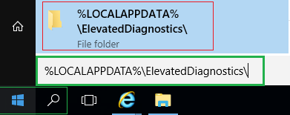***Run this tool and collect diagnostic information while you reproduce the issue.*** *\*\* Install the certificate when prompted.**Please send the recorded data afterwards, these are available at:*

**%LOCALAPPDATA%\ElevatedDiagnostics\  
 *C:\Users\****LOGIN_NAME****\AppData\Local*\ElevatedDiagnostics\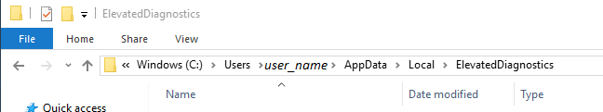  
*** NOTE, the logs will not appear until the end, when you have finished the program. \*\*\***  
  
**Instructions for the detailed steps:**\*

* When the first dialog box appears, click **Next**.
* On the description screen, click **Next**.
* You will be prompted to install Fiddler certificates. Click **Yes**.
* In the 'Logging starts with Next' window, click **next**.
* The assistant attempts to close all open Office applications and processes.
* In case of any open application you will be notified and have time to save your work.
* Otherwise, the process will end after a certain amount of time.

When you see the window "**Logging in process**", you can now **reproduce the reported issue / error message.**Do **not** click [Stop Recording] **until the reproduction of the error is complete.  
  
After** reproduction your scenario, please return to the above dialog box and click **Stop**.The assistent will then try to remove the previously installed Fiddler Certificate.  
Please click **Yes** to confirm.  
  
The assistent will then ask you to enter a password to protect your recorded files.  
  
Please enter a **password**, you can enter "**1234**" as the password (“**default password”**).  
  
However, if you choose to enter a **different password** for personal reasons, please make sure that you **inform the backend team** separately.  
  
When you go to the last dialog box, select **Close** the troubleshooter to complete the SDP diagnostic process correctly.  
  
**Note**: The **ICESDPTool** collects the following information according to  
[3093873-Office Sign-in and Authentication Diagnostic:](https://support.microsoft.com/en-us/help/3093873/sdp-3-c6406ad7-cdd8-406e-a409-a7f0c676ccb3-office-sign-in-and-authenti)

* **Windows Step Recorder (.mht)**
* **Fiddler Trace (.saz)**
* **Event Trace Logs (.etl)**
* **Registry Dump, Before and After (.reg)**
* **Windows CredManager Cache (.txt)**

**Please save the collected diagnostic information**  
(these also contain the Fiddler-Recording) **stored in the following folder**:

%LOCALAPPDATA%\ElevatedDiagnostics\ (short)Full Path**: C:\Users\***USER_NAME***\AppData\Local\ElevatedDiagnostics***\* The* ***Appdata*** *directory by default is a* ***hidden folder***  
*\*\** *in* ***the file manager > on top > view > view hidden files****.***\*\*\* Attention, the logs will NOT appear until the END when you have finished the program.\*\*\***  
Best to upload in ticket at **Admin Center > Support > Service Requests**(or as **an attachment in an e-mail** in the **ticket**).

* Following the above steps with **screenshots**:

1. **Start installation**

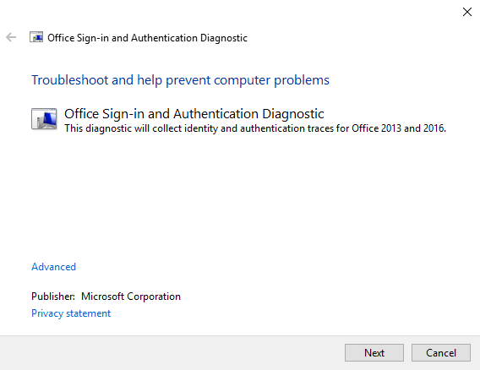

1. **Install certificate**

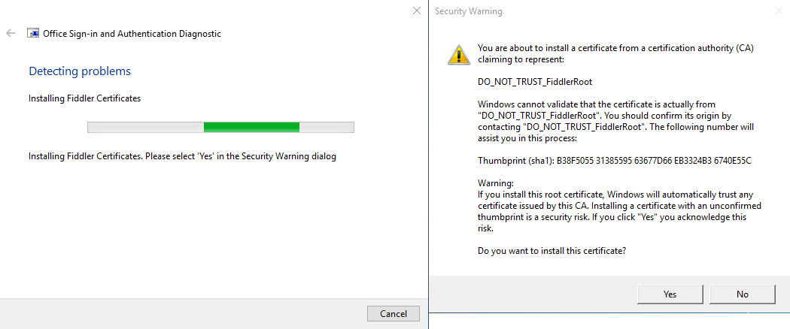

1. **Start recording – confirm with [Next]**

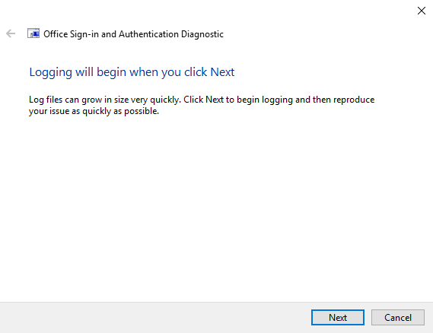

1. **Recording - logs in progress**

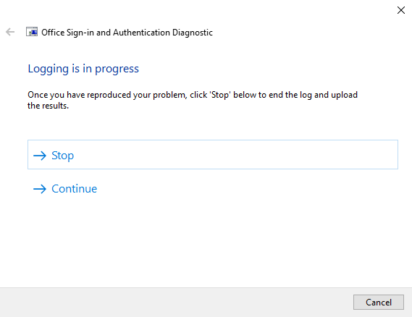

1. **End the recording**

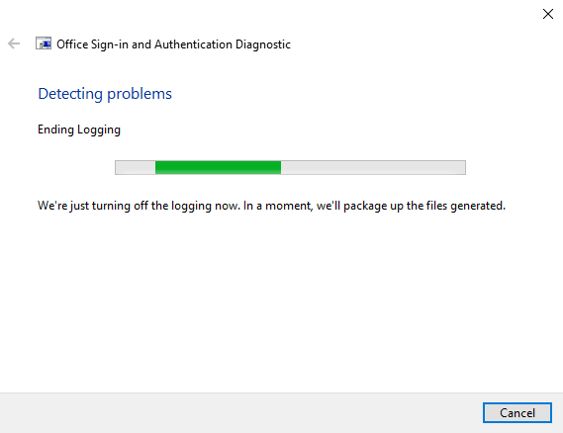

1. **Remove the certificate (Fiddler) of the recording application**

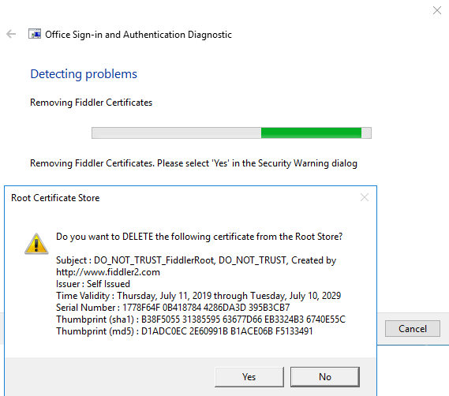

1. **Set password**, e.g. default password **"1234"**

***If you enter a personal password, please provide it separately***

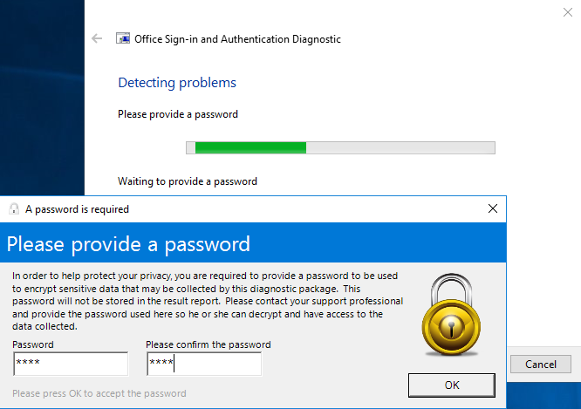

*Please send the recorded data afterwards, these are located under:*

****%LOCALAPPDATA%\ElevatedDiagnostics\**

Which automatically opens the corresponding folder below

***C:\Users\****LOGIN_NAME****\AppData\Local*\ElevatedDiagnostics\**

 *\*in case of* ***multiple*** *recordings please check* ***last created folder date*   
Please Note:**- the **logs will not appear** until you confirmed **to complete the recording** (see above).  
- Please double-check and *compress as* ***ZIP*** */ send / attach* ***in the ticket****- Kindly* inform us about the **password** which you have used above. ***We very much appreciate your efforts in order to resolve the issue – Thank You!***