1. We should confirm that they are following our guidelines for syncing contacts (Save Contacts) on Outlook for iOS to multiple iOS devices as outlined below.

[Outlook Support (osupportweb.com)](https://nam06.safelinks.protection.outlook.com/?url=https%3A%2F%2Fwww.osupportweb.com%2Fa%2Foutlook-mobile%2F%3Fp%3Dall%26s%3Dpeople%26f%3Dhow-do-i-save-my-outlook-contacts-to-my-ios-contacts-app&data=04%7C01%7CDaniel.Laughlin%40microsoft.com%7Cb5714eabd57c4d92c1fe08d8d29c3bb1%7C72f988bf86f141af91ab2d7cd011db47%7C1%7C0%7C637490915758092171%7CUnknown%7CTWFpbGZsb3d8eyJWIjoiMC4wLjAwMDAiLCJQIjoiV2luMzIiLCJBTiI6Ik1haWwiLCJXVCI6Mn0%3D%7C1000&sdata=P1lDzCX6QHY7BFbU9MKP1jm3IcLGozsnh6LkEIack9I%3D&reserved=0)

How do I save my Outlook contacts to my iOS contacts app?

To save Outlook contacts to your native address book:

First go to Device Settings > Contacts and confirm that the “Default Account” is set to “iCloud”. If you do not see this setting that is OK, the setting should only be available if you have more than one account added to your device. If there is no account connected to the device, then your Outlook contacts will be saved locally but will not be synced to other devices.

Second, open Outlook for iOS and in the left nav view open the Settings gear > Select your account > Toggle ON the “Save Contacts” toggle.

Saved contacts will be added under the contacts in your iCloud account. These contacts will sync to all devices which are signed in with the same iCloud account. Note: You can only export contacts from one device at a time.

If a user has contact-export turned on both their iPad and iPhone one will need to be disabled so that we are able to manage conflicts. Duplicates can take up 24 hours to be reconciliated.

2. Also with iOS there are limitations imposed on our app since iOS 11.3 when the device is MDM managed. These restrictions can cause either no contacts to sync or duplications to occur if the MDM controls are not being applied properly. These restrictions can be found in the following articles along with the steps to address that with both Intune and other MDM’s.

**Limit access to contacts on managed devices:**

[https://support.apple.com/en-us/HT208749](https://nam06.safelinks.protection.outlook.com/?url=https%3A%2F%2Fsupport.apple.com%2Fen-us%2FHT208749&data=04%7C01%7CDaniel.Laughlin%40microsoft.com%7Cb5714eabd57c4d92c1fe08d8d29c3bb1%7C72f988bf86f141af91ab2d7cd011db47%7C1%7C0%7C637490915758102168%7CUnknown%7CTWFpbGZsb3d8eyJWIjoiMC4wLjAwMDAiLCJQIjoiV2luMzIiLCJBTiI6Ik1haWwiLCJXVCI6Mn0%3D%7C1000&sdata=sKeHj%2FvNPrNR4AjPzTjXGji0cMRlJW2DpLoBMaGGld0%3D&reserved=0)

In iOS 11.3 and later, use MDM to prevent unmanaged destinations from accessing contacts associated with managed sources. The following restrictions apply to contacts:

• Documents from managed sources appear in unmanaged destinations

• Documents from unmanaged sources appear in managed destinations

As a result of this change, these restrictions prevent unmanaged apps from accessing contacts from managed accounts, and prevent managed apps from saving contacts to the local Contacts app.

**Support Tip: Enabling Outlook iOS Contact Sync with iOS12 MDM Controls**

[iOS12 Intune (microsoft.com)](https://nam06.safelinks.protection.outlook.com/?url=https%3A%2F%2Ftechcommunity.microsoft.com%2Ft5%2Fintune-customer-success%2Fsupport-tip-enabling-outlook-ios-contact-sync-with-ios12-mdm%2Fba-p%2F298453&data=04%7C01%7CDaniel.Laughlin%40microsoft.com%7Cb5714eabd57c4d92c1fe08d8d29c3bb1%7C72f988bf86f141af91ab2d7cd011db47%7C1%7C0%7C637490915758102168%7CUnknown%7CTWFpbGZsb3d8eyJWIjoiMC4wLjAwMDAiLCJQIjoiV2luMzIiLCJBTiI6Ik1haWwiLCJXVCI6Mn0%3D%7C1000&sdata=MLsgJZCjCmbZa4csEWQBgGUuNPWIW1A32CMUsWj6VXc%3D&reserved=0)

[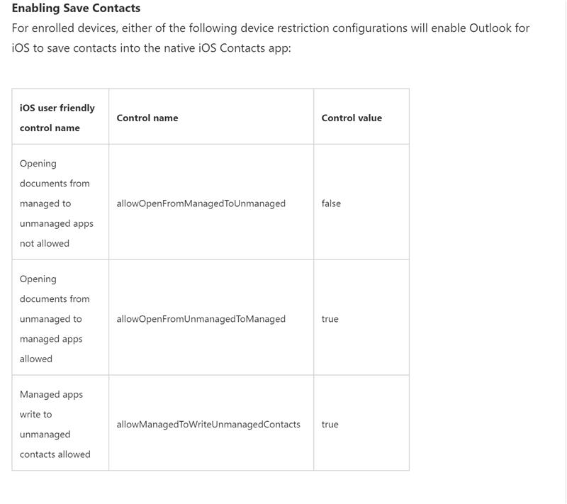](https://us-prod.asyncgw.teams.microsoft.com/v1/objects/0-eus-d14-a33201cf89282a5f9b831ac554ecb3f6/views/imgo)

If they are using Intune as their MDM, Intune will allow this via an iOS Device Configuration with the following in the policy.

[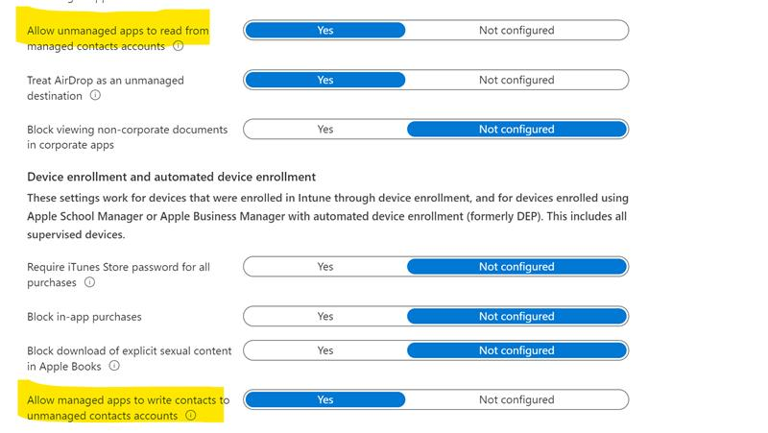](https://us-prod.asyncgw.teams.microsoft.com/v1/objects/0-eus-d17-73b49d931efd5e9170588dac1d58ca8e/views/imgo)

An easy way to check is to tap the export button when viewing an attachment (top right) and see if non-Microsoft apps are hidden from the app suggestions. The MDM config to block sharing disables all data export on the device (including save contacts).