**Contents:**

* **(1) Outlook App - per user**
* **(2) OWA - addon + Edge browser**
* **(3) OWA tenant wide - recommended**

**------------------------------------------------------------------------------------------------------------------------------------------**

* **(1) Outlook App**[https://www.ssl.com/how-to/installing-s-mime-certificate-sending-secure-email-outlook-windows-10/](https://nam06.safelinks.protection.outlook.com/?url=https%3A%2F%2Fwww.ssl.com%2Fhow-to%2Finstalling-s-mime-certificate-sending-secure-email-outlook-windows-10%2F&data=04%7C01%7Cv-jahube%40microsoft.com%7C61464c9c967c4ccc8f5708d91aef7a70%7C72f988bf86f141af91ab2d7cd011db47%7C1%7C0%7C637570438165306660%7CUnknown%7CTWFpbGZsb3d8eyJWIjoiMC4wLjAwMDAiLCJQIjoiV2luMzIiLCJBTiI6Ik1haWwiLCJXVCI6Mn0%3D%7C1000&sdata=uHS05MhyZD1Pr%2FwDj72tYh9qF95N%2FkvmGdTc7RFnyKU%3D&reserved=0)  
  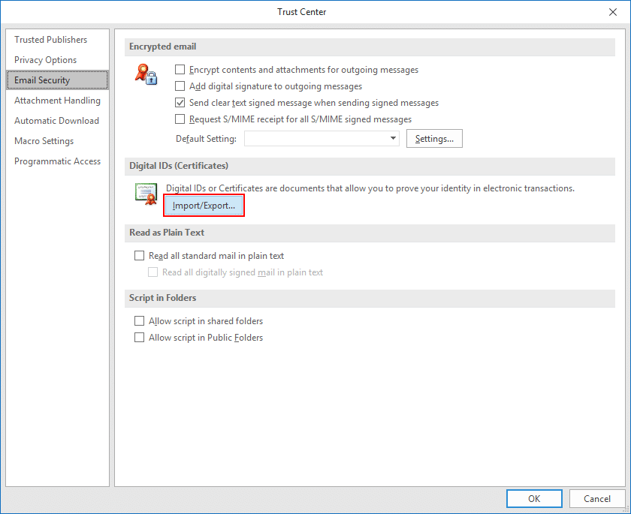  
    
  **--------------------------------------------------------------------------------------------------------------------------------**
* **Outlook on the Web**
  + **(2)  using [S/****MIME control Addon]  - easier but with below limitations**  
    *-  works only  with* ***Edge Browser***  *- requires installation on every PC to be used  
    - does not work in Outlook Mobile*  
    [**Encrypt messages by using S/MIME in Outlook on the web - Outlook (microsoft.com)**](https://nam06.safelinks.protection.outlook.com/?url=https%3A%2F%2Fsupport.microsoft.com%2Fen-us%2Foffice%2Fencrypt-messages-by-using-s-mime-in-outlook-on-the-web-878c79fc-7088-4b39-966f-14512658f480&data=04%7C01%7Cv-jahube%40microsoft.com%7C61464c9c967c4ccc8f5708d91aef7a70%7C72f988bf86f141af91ab2d7cd011db47%7C1%7C0%7C637570438165306660%7CUnknown%7CTWFpbGZsb3d8eyJWIjoiMC4wLjAwMDAiLCJQIjoiV2luMzIiLCJBTiI6Ik1haWwiLCJXVCI6Mn0%3D%7C1000&sdata=IevurBBRqvdYCZB5eSwKTTBdXcW2Y5g2grQVJ5KkKcg%3D&reserved=0)  
    -------------------------------------------------------------------------------------------------------
  + **(3) Recommended way:  
     export the** **Root CA Certificate Chain, and setting via Powershell   
    Advantage - works for all users + eventually outlook mobile**  
     **official documentation**[https://techcommunity.microsoft.com/t5/exchange-team-blog/how-to-configure-s-mime-in-office-365/ba-p/584516](https://nam06.safelinks.protection.outlook.com/?url=https%3A%2F%2Ftechcommunity.microsoft.com%2Ft5%2Fexchange-team-blog%2Fhow-to-configure-s-mime-in-office-365%2Fba-p%2F584516&data=04%7C01%7Cv-jahube%40microsoft.com%7C61464c9c967c4ccc8f5708d91aef7a70%7C72f988bf86f141af91ab2d7cd011db47%7C1%7C0%7C637570438165316619%7CUnknown%7CTWFpbGZsb3d8eyJWIjoiMC4wLjAwMDAiLCJQIjoiV2luMzIiLCJBTiI6Ik1haWwiLCJXVCI6Mn0%3D%7C1000&sdata=PkRbPtM01%2FwSQhrdCFs4thfB1tbVto420mXoKkav6Bg%3D&reserved=0)
* **IN DETAIL**
* **example article** *(Disclaimer:**third party / used as a reference only*[https://www.ishir.com/blog/3707/cant-keep-step-step-easy-configuration-guide-smime-office-365.htm](https://nam06.safelinks.protection.outlook.com/?url=https%3A%2F%2Fwww.ishir.com%2Fblog%2F3707%2Fcant-keep-step-step-easy-configuration-guide-smime-office-365.htm&data=04%7C01%7Cv-jahube%40microsoft.com%7C61464c9c967c4ccc8f5708d91aef7a70%7C72f988bf86f141af91ab2d7cd011db47%7C1%7C0%7C637570438165326571%7CUnknown%7CTWFpbGZsb3d8eyJWIjoiMC4wLjAwMDAiLCJQIjoiV2luMzIiLCJBTiI6Ik1haWwiLCJXVCI6Mn0%3D%7C1000&sdata=k4M1Ks1vgViwH1ZoJSCmpxVCph2gnyJGW5%2BR8YuwTkU%3D&reserved=0)
* **How To start MMC with Certificate Snap-in (required for next step)**

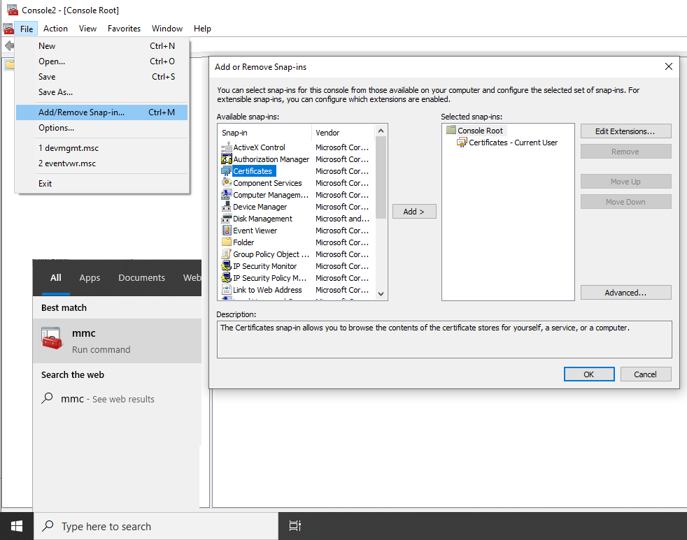  
  
------------------------------------------------------------------------------------------------------------------------------------------

* **How to Export the Certificate chain**

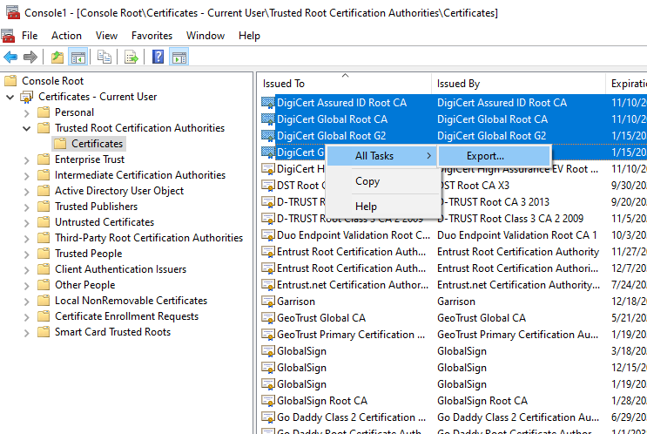  
  
------------------------------------------------------------------------------------------------------------------------------------------

* **Steps how to configure the Certificate Change for use in Exchange Online with Powershell  
    
  Set-SmimeConfig -SMIMECertificateIssuingCA (Get-Content "C:\Path\Filename.sst" -Encoding Byte)**[**https://docs.microsoft.com/en-us/microsoft-365/security/office-365-security/set-up-virtual-certificate-collection-to-validate-s-mime**](https://nam06.safelinks.protection.outlook.com/?url=https%3A%2F%2Fdocs.microsoft.com%2Fen-us%2Fmicrosoft-365%2Fsecurity%2Foffice-365-security%2Fset-up-virtual-certificate-collection-to-validate-s-mime&data=04%7C01%7Cv-jahube%40microsoft.com%7C61464c9c967c4ccc8f5708d91aef7a70%7C72f988bf86f141af91ab2d7cd011db47%7C1%7C0%7C637570438165326571%7CUnknown%7CTWFpbGZsb3d8eyJWIjoiMC4wLjAwMDAiLCJQIjoiV2luMzIiLCJBTiI6Ik1haWwiLCJXVCI6Mn0%3D%7C1000&sdata=mfnWJoOw0hLzXxdAjJNUnELQvAQDQOTNfNczEDTUnnc%3D&reserved=0)

[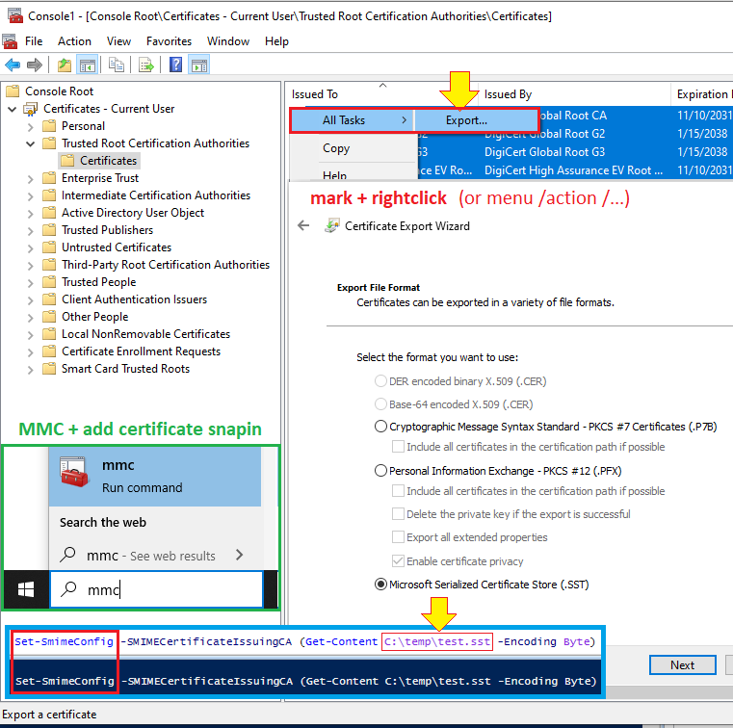](https://nam06.safelinks.protection.outlook.com/?url=https%3A%2F%2Fraw.githubusercontent.com%2Fjahube%2FScreenshots%2Fmaster%2FOWA%2FOWA-S-MIME-SetMimeconfig-MMC-Cert.png&data=04%7C01%7Cv-jahube%40microsoft.com%7C61464c9c967c4ccc8f5708d91aef7a70%7C72f988bf86f141af91ab2d7cd011db47%7C1%7C0%7C637570438165326571%7CUnknown%7CTWFpbGZsb3d8eyJWIjoiMC4wLjAwMDAiLCJQIjoiV2luMzIiLCJBTiI6Ik1haWwiLCJXVCI6Mn0%3D%7C1000&sdata=Av%2BQ6DclULqL121B8V8fu1v%2B%2BqYi%2BAHMPHIdDPTHsLI%3D&reserved=0)

* **export from certificate store via Powershell (advanced / for reference only)**

[https://knowledge.digicert.com/quovadis/ssl-certificates/ssl-general-topics/how-do-trust-s-mime-certificate-in-office-365.html](https://nam06.safelinks.protection.outlook.com/?url=https%3A%2F%2Fknowledge.digicert.com%2Fquovadis%2Fssl-certificates%2Fssl-general-topics%2Fhow-do-trust-s-mime-certificate-in-office-365.html&data=04%7C01%7Cv-jahube%40microsoft.com%7C61464c9c967c4ccc8f5708d91aef7a70%7C72f988bf86f141af91ab2d7cd011db47%7C1%7C0%7C637570438165336533%7CUnknown%7CTWFpbGZsb3d8eyJWIjoiMC4wLjAwMDAiLCJQIjoiV2luMzIiLCJBTiI6Ik1haWwiLCJXVCI6Mn0%3D%7C1000&sdata=FWusF%2BYw0EucQOSO5WpvCc%2FsGWoTFAP1dvgJLyaBsr8%3D&reserved=0)

* **distribute Certificates via GPO**  
  <https://docs.microsoft.com/en-us/windows-server/identity/ad-fs/deployment/distribute-certificates-to-client-computers-by-using-group-policy#main>
* **missing encrypt button**  
  <https://docs.microsoft.com/en-us/outlook/troubleshoot/security/no-buttons-to-sign-or-encrypt-emails>  
  <https://support.microsoft.com/en-us/topic/0172c8ec-8e11-1df2-33ec-e285309c79ca>