**Import - Export - Recovery  
  
PST Import**

1. **Required Permissions** **(page2)**
2. **Import-Job** **(below)**
3. **AZCopy**
4. **Mapping.CSV**  **(FILENAME.PST > NEWUSER)**

**Export**

1. PST **Export** (Exchange/**eDiscovery**)
2. Content search
3. Backup+Upload OneDrive - link existing to new account

**E-Mail Recovery**

1. Restore-Recoverableitems

**Mailbox Recovery**

1. softdeleted mailboxes / on-prem disconnected mailboxes
2. **Required Permissions**

* **Powershell / Powershell** (ISE)

[Net.ServicePointManager]::SecurityProtocol = [Net.SecurityProtocolType]::Tls12

Set-ExecutionPolicy RemoteSigned

Install-Module -Name ExchangeOnlineManagement -Scope currentuser # INSTALLATION

$ADMIN = "Global@Admin.com" # PLEASE CHANGE ADMIN

Connect-ExchangeOnline -UserPrincipalName $ADMIN -ShowProgress $true # CONNECT

New-ManagementRoleAssignment -Role "Mailbox Import Export" -User $ADMIN # REQUIRED

New-ManagementRoleAssignment -Role "Mailbox Search" -User $ADMIN

Add-RoleGroupMember "Organization Management" -Member $ADMIN

Add-RoleGroupMember "Discovery Management" -Member $ADMIN

Add-RoleGroupMember "Compliance Management" -Member $ADMIN   
  
#if customization not enabled yet, run the below first (takes **1-2 minutes**)  
  
**Enable**-Organization**Customization** -confirm:$false

* **SCREENSHOT Powershell (ISE)**

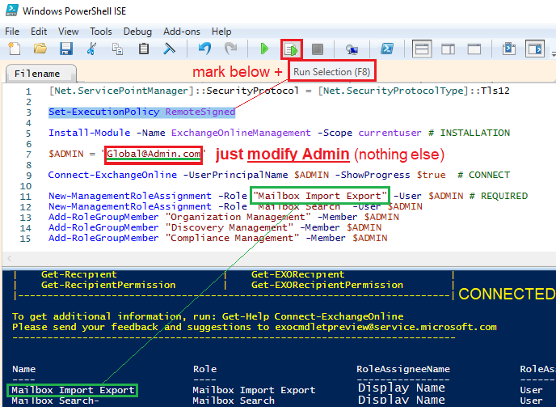

1. **Create Import-Job**

* **OLD View ( Security and Compliance)**

**URL: <https://protection.office.com/import>**

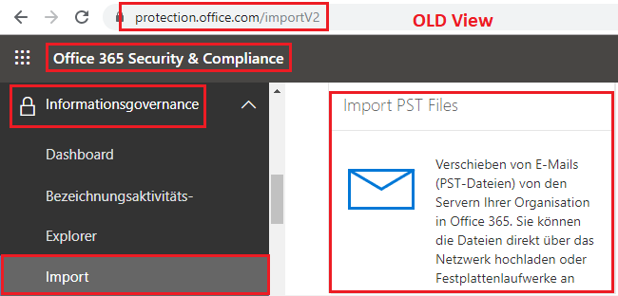

* **New View (Compliance)**

**URL: <https://compliance.microsoft.com/informationgovernance?viewid=import>**

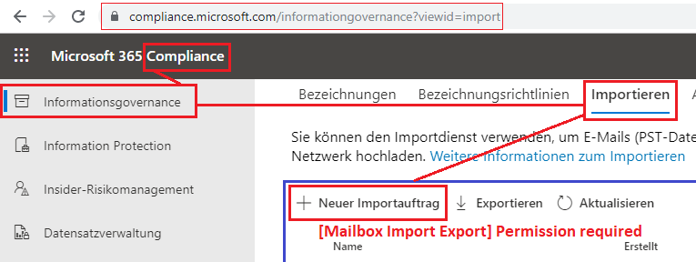

1. 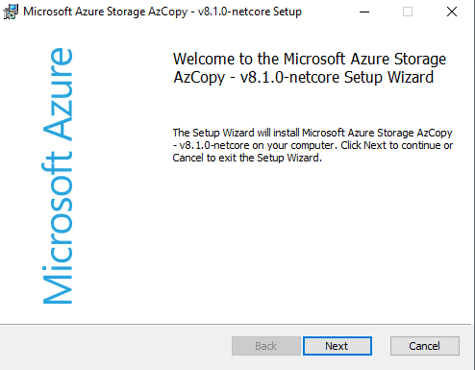**Download + Install AZCopy**

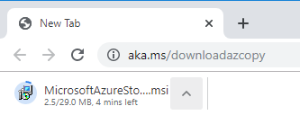

* **Open CMD**
* **Change Directory**

**CD "C:\Program Files (x86)\Microsoft SDKs\Azure\AzCopy\”**

* **Edit below in NotePad - insert the SAS-URL copied in Step** **(2) Create Import-Job**
* **Modify PST-Folder - put only the PST-Files inside**
* **Run below from Notepad**

**.\AzCopy.exe /Source:"C:\PSTFOLDER\" /Dest:"SAS-URL" /V:"C:\AzCopy1.log" /Y**

* Upload with ca. **700 kb/s Speed**
* Able to **automatically resume** (for example if internet connection is reset)  
    
    
    
    
    
    
    
    
    
    
  **[When Upload is finished, continue below]**

1. **Create Mapping.CSV** (FILENAME.PST > NEWUSER)*

**Reference:**<https://docs.microsoft.com/en-gb/office365/securitycompliance/use-network-upload-to-import-pst-files>

* **Copy Below to NotePad**

Workload,FilePath,Name,Mailbox,IsArchive,TargetRootFolder,ContentCodePage,SPFileContainer,SPManifestContainer,SPSiteUrl  
Exchange,,user1backup.pst,target1@mailbox.com,FALSE,/,,,,  
Exchange,,user2backup.pst,target2@mailbox.com,FALSE,/,,,,

* **save as** All Files (*.*) **🡪 .CSV**

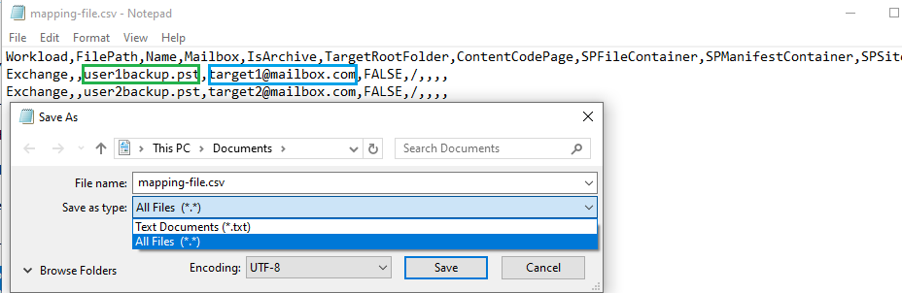

* **Excel View for Comparison**

|  |  |  |  |  |  |  |  |  |  |  |
| --- | --- | --- | --- | --- | --- | --- | --- | --- | --- | --- |
| Workload | FilePath | Name | Mailbox |  | IsArchive | TargetRootFolder | ContentCodePage | SPFileContainer | SPManifestContainer | SPSiteUrl |
| Exchange |  | **user1backup.pst** | **target1@mailbox.com** |  | FALSE | / |  |  |  |  |
| Exchange |  | **user2backup.pst** | **target2@mailbox.com** |  | FALSE | / |  |  |  |  |

* Excel-CSV

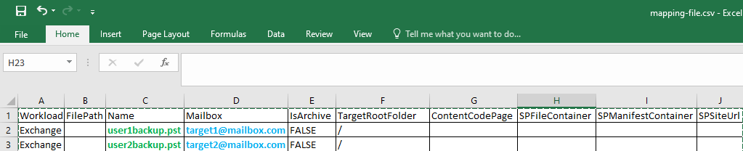

1. PST **Export** (Exchange/**eDiscovery**)

Exchange Admincenter > Compliance Management > [+] > [+] > one user > [ADD] > [OK] > Run

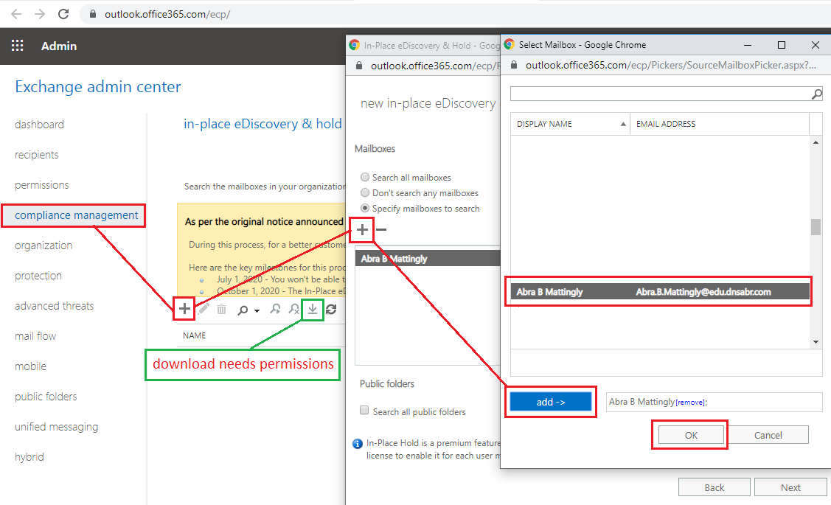

* **Download only in Internet Explorer (Arrow-Down)**
* **Alternative: Chrome + [Clickonce Chrome] Plugin**

1. **Content Search (also for Data-Recovery + Sharepoint + other Data)**

* **Assign Permissions**[**https://docs.microsoft.com/en-us/microsoft-365/compliance/assign-ediscovery-permissions**](https://docs.microsoft.com/en-us/microsoft-365/compliance/assign-ediscovery-permissions)[**https://protection.office.com/permissions**](https://protection.office.com/permissions) **🡪 "eDiscovery Manager"**
* **Alternative: Assign Permissions in Powershell  
  [Net.ServicePointManager]::SecurityProtocol = [Net.SecurityProtocolType]::Tls12  
  Install-Module MSOnline ; Connect-MsolService  
  Add-MsolRoleMember -RoleName "eDiscovery Manager" -RoleMemberEmailAddress “admin@domain.com”**
* **Start a New Search**[**https://protection.office.com/contentsearchbeta**](https://protection.office.com/contentsearchbeta)[**https://docs.microsoft.com/en-gb/microsoft-365/compliance/content-search**](https://docs.microsoft.com/en-gb/microsoft-365/compliance/content-search)

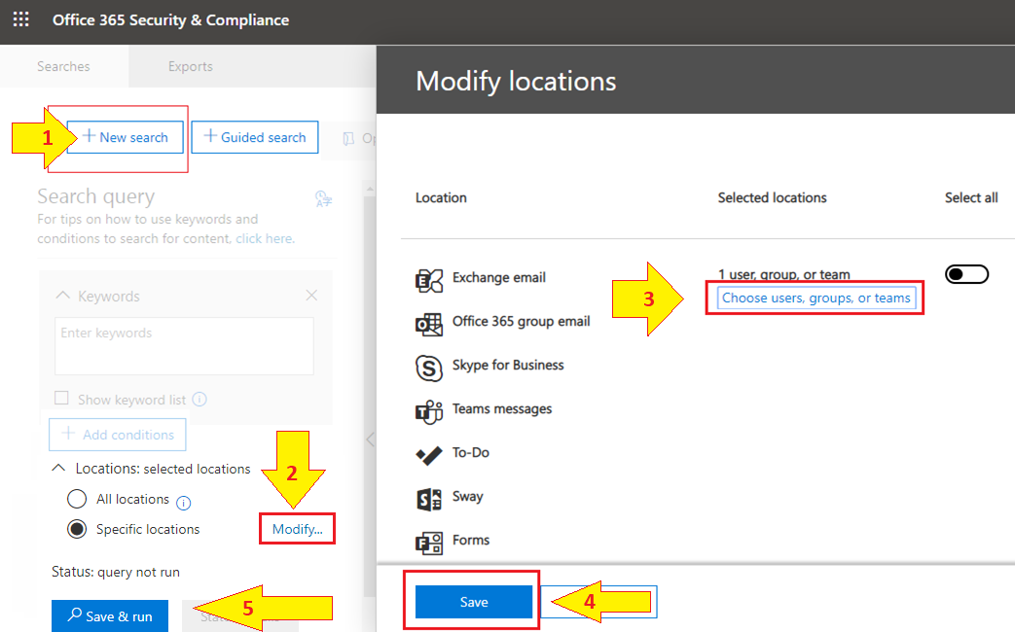

* **Also Specify the User (“Search Locations”)**
* **Start Search ( Save > Save & Run )**
* **Prepare the Export PST – One PST for each Mailbox**
* **when finished you can download the PST under Export (see permissions required)**
* **eDiscovery Export Tool only works in IExplorer or Chrome +** [**Click-Once**](https://chrome.google.com/webstore/detail/clickonce-for-google-chro/kekahkplibinaibelipdcikofmedafmb) **Extension!**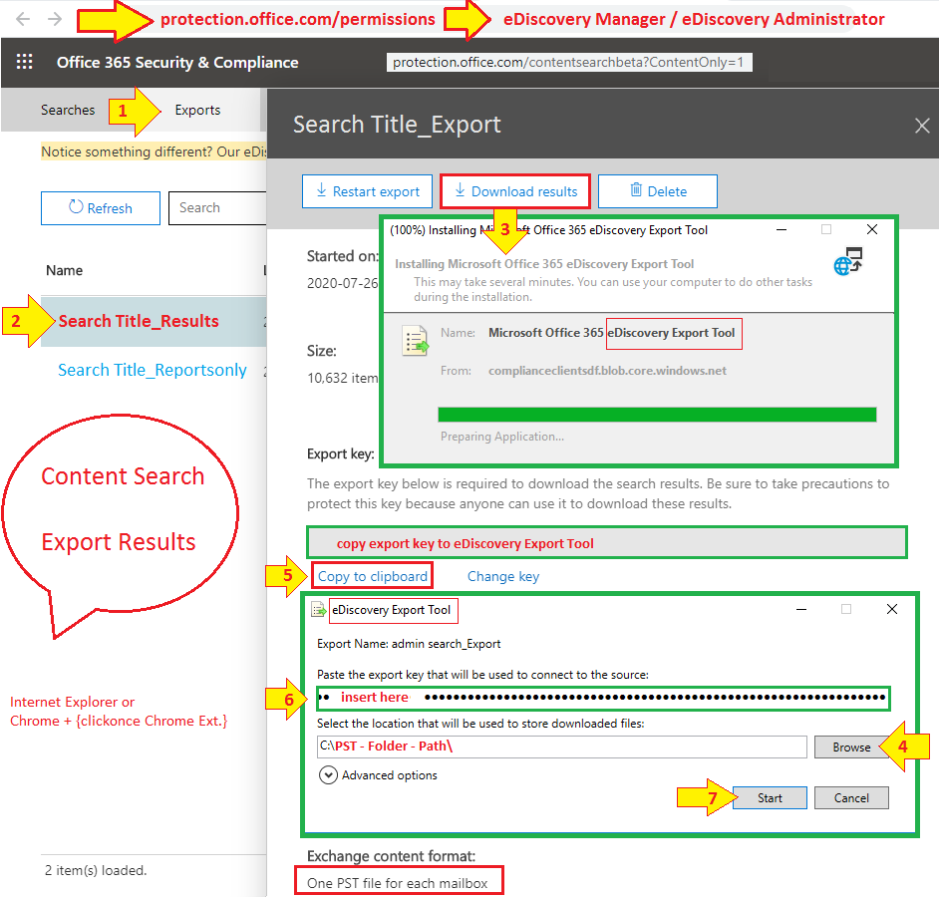

1. 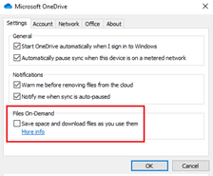**Backup + Upload OneDrive** (linking old Folder to new Account)  
   **Get your Personal Onedrive Link**🡪 **[Onedrive – view online)  
   Alternative: Go to Onedrive / Settings  
   - unselect [ files on demand / save space]   
   - to download your complete Onedrive (compare size)  
   - link/sync NEW Onedrive account to that folder with all files  
   - can be used for Onedrive and for Sharepoint document lists**
2. **Restore-Recoverableitems (**[**Link**](https://docs.microsoft.com/en-us/powershell/module/exchange/get-recoverableitems)**)**

* **Connect**

Set-**ExecutionPolicy** RemoteSigned  
[Net.ServicePointManager]::SecurityProtocol = [Net.SecurityProtocolType]::Tls12  
**Install**-Module -Name ExchangeOnlineManagement  
  
$admin = “[*GLOBAL@ADMIN.com*](mailto:GLOBAL@ADMIN.com)*”* ***#*** *Global Admin please Modify***Connect**-ExchangeOnline -UserPrincipalName **$admin** -ShowProgress $true  
  
New-ManagementRoleAssignment -Role "**Mailbox Import Export**" -User $ADMIN  
  
**#reconnect to have new permissions**Get-PSSession | remove-PSSession  
**Connect**-ExchangeOnline -UserPrincipalName **$admin** -ShowProgress $true

* **GET-RECOVERABLE ITEMS**

$user = “[***AFFECTED@USER.com***](mailto:AFFECTED@USER.com)***” # Affected User –*** *please Modify*

$start **= Get-Date -date $(Get-Date).AddDays(-90) # past -90 days**$end = **Get-Date -date $(Get-Date)**$search = **Get**-**recoverableitems** **-Identity $user -FilterStartTime** $start **-FilterEndTime** $end

$search | **FL** **subject**,**SourceFolder**,**ItemClass # see results**

$search | **restore**-**recoverableitems # recover results**

* **OPTIONAL PARAMETERS to filter Types**-**SourceFolder** *PARAMETER* **PurgedItems / DeletedItems / RecoverableItems   
    
  -FilterItemType** IPM.**Appointment** **# calendar items  
  -FilterItemType** IPM.Contact  
  **-FilterItemType** IPM.**File  
  -FilterItemType** IPM.**Note # E-mails  
  -FilterItemType** IPM.**Task**

1. **softdeleted mailboxes (disconnected/inactive)**

**ONPREM** disconnected/softdeleted

<https://docs.microsoft.com/en-us/exchange/disconnected-mailboxes-exchange-2013-help>  
  
$dbs = Get-MailboxDatabase

$dbs|%{Get-MailboxStatistics -Database $_.DistinguishedName }|?{$_.DisconnectReason -ne $Null } | Format-Table DisplayName,Database,DisconnectDate

**ONCLOUD** * (**softdeleted**) 🡪 (**New Mailbox**) **\* new-mailboxrestorerequest  
  
$Source = get-mailbox** -**InactiveMailboxOnly “**[INACTIVE@Mailbox.com](mailto:INACTIVE@Mailbox.com)”  
**$target = get-mailbox** “[NEW@Mailbox.com](mailto:NEW@Mailbox.com)”  
$S = $Source.ExchangeGUID.GUID  
$T = $target.ExchangeGUID.GUID  
**write-host “Deleted NAME: $($source.**displayname**) + GUID: $($S)” –foregroundcolor yellow  
write-host “Target NAME: $($target.**displayname**) + GUID: $($S)” –foregroundcolor green**

**new-mailboxrestorerequest -SourceMailbox $S -TargetMailbox $T -AllowlegacyDNmismatch**

* **Check**

get-mailboxrestorerequest  
Get-MailboxRestoreRequest -Status **Failed** | Get-MailboxRestoreRequestStatistics –IncludeReport

* **create PST** (only **onprem**)

New-**MailboxExportRequest** -Mailbox MAILBOXUSER –FilePath \\192.168.250.2\PSTFileShare\USER.pst"

**DUPLICATE mailbox (1) onprem and (2) oncloud (please escalate with below logs) (Ref.-**[**Link**](https://docs.microsoft.com/en-us/exchange/troubleshoot/move-mailboxes/mailbox-exists-exo-onpremises)**)**

* **CMD / local AD** :

ldifde -f **c:\BadUser1.txt** -r "(UserPrincipalName=**User1@domain.com**)"  
ldifde -f **c:\GoodUser1.txt** -r "(UserPrincipalName=**User2@domain.com**)"

* **Exchange management** shell (**on-prem**)

get-remotemailbox -identity **user1@domain.com** | fl | out-file C:\**BadRemoteuser.txt**get-remotemailbox -identity **user2@domain.com** | fl | out-file C:\**GoodRemoteuser.txt**

* **Exchange Online** (**Cloud**)

$FormatEnumerationLimit=-1  
get-mailbox -identity **user1@domain.com** | fl | out-file C:\**BadEXOuser.txt**get-mailbox -identity **user2@domain.com** | fl | out-file C:\**GoodEXOuser.txt**  [© Jan Hübener](mailto:v-jahube@microsoft.com)  
  
  
if (!($value = Read-Host "Value [$default]")) { $value = $default }