## Business Process Flow and Overall Use-Case

Customer visits the welcome page and selects a product category. Customer browses products within the selected category page, then adds a product to his or her shopping cart. Customer continues shopping and selects a different category. Customer adds several products from this category to shopping cart. Customer selects 'view cart' option and updates quantities for cart products in the cart page. Customer verifies shopping cart contents and proceeds to checkout. In the checkout page, customer views the cost of the order and other information, fills in personal data, then submits his or her details. The order is processed and customer is taken to a confirmation page. The confirmation page provides a unique reference number for tracking the customer order, as well as a summary of the order.

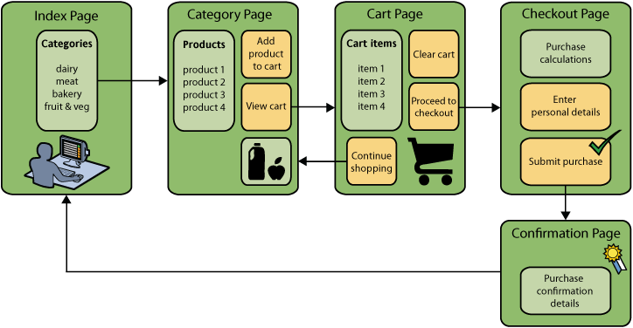

### Online Catalog – Homepage

**Description and Priority**

The homepage is the entry point for the application. It introduces the business and the service to the customers and allows the users to shop through this online representation of the product categories that are available in the physical store. There are four categories and they are Dairy, Meats, Bakery, Fruits and Vegetables. The user can browse through the products available in a category by clicking on the category image in this catalog page. This feature is of high priority and the user cannot browse products to shop without navigating through the category. Not able to navigate to the product page is high risk as it hampers the completion of the base use case of shopping for products.

**Stimulus/Response Sequences**

Typing in the web address of the affable bean brings the user to this page. The user can select a category by clicking on the image of the category or the name of the category in the catalog section. The user is navigated to the product page once the category is selected.

**Functional Requirements**

REQ-1: Load Category name and relevant category images in the category catalog

REQ-2: Allows the user to browse through categories in the catalog

REQ-3: Navigate to the product catalog for the selected category

REQ-4: Clicking on the Logo image should reload the homepage.

REQ-5: Language support for both English and Czech.

**User Interface Specifications:**

## 

## Online Catalog – Category View

**Description and Priority**

The category page populates the listing of products available in the store that belong the selected category. The user can view all product information in this page and can add items into their shopping cart. The user can also navigate to another category and view the listed products in that category. The use can shop products from multiple categories in one session. This feature is also of high priority and the user cannot shop products without being able to browse through and add to cart. As in the case of the homepage, not able to navigate to the product page and adding to cart is of high risk as it hampers the completion of the base use case of shopping for products.

**Stimulus/Response Sequences**

Clicking on a category in the homepage navigates the user to this page. Selecting a category from the category tab, loads the relevant product listing. Clicking on the “add to cart” button adds the selected product to the cart and enables the view cart and proceed to check out buttons. The user can continue navigating through categories and adding products to the cart or can proceed to view cart or checkout.

**Functional Requirements**

REQ-1: List product information and relevant information of the selected category

REQ-2: Add selected product to cart

REQ-3: Enable view cart and proceed to check out when cart isn’t empty

REQ-4: Clicking on the Logo image should reload the homepage.

REQ-5: Language support for both English and Czech.

**User Interface Specifications:**

[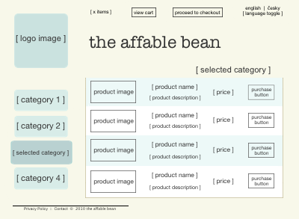](https://netbeans.org/images_www/articles/73/javaee/ecommerce/design/mockup-category.png)

## Cart Page

**Description and Priority**

The cart page lists all items held in the user's shopping cart. It displays product details for each item, and tallies the subtotal for the items in the cart. The user could clear all items in the cart which would disable the view cart and proceed checkout button, update the quantity of items in the cart or remove a product by setting quantity to 0, continue shopping by returning to the catalog or proceed to checkout. The cart is also a feature of high priority as it supports the base case.

**Stimulus/Response Sequences**

* Clicking on the view cart button from the category view navigates the user to this page.
* Clicking clear cart, removes all items in the cart. The 'proceed to checkout' buttons and shopping cart table to disappear.
* On updating the quantity for any listed item, the price and quantity are updated and the subtotal is recalculated. If user sets quantity to '0', the product table row is removed.
* Clicking on 'continue shopping' navigates the user back to the previous category that they were in before they viewed the cart.
* Clicking on ‘Proceed to checkout’ navigates the user to the checkout page

**Functional Requirements**

REQ-1: Populate cart with added items and prices of items

REQ-2: Allow quantity updates and product removal

REQ-3: recalculate subtotal on edits to cart

REQ-4: Navigate the user back to previous category on click on ‘continue shopping’ button

REQ-5: Navigate the user to the checkout page on click of ‘proceed to checkout’

REQ-6: Clicking on the Logo image should reload the homepage.

REQ-7: Language support for both English and Czech.

**User Interface Specifications:**

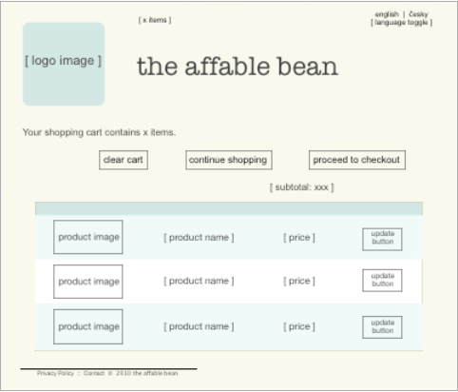

## Checkout Page

**Description and Priority:**

The checkout page collects information from the customer using a form. This page also displays purchase conditions, and summarizes the order by providing calculations for the total cost.The user is able to send personal details over a secure channel.

**Stimulus/Response Sequences:**

Clicking on the ‘procced to checkout’ button from the cart page or from the category page navigates the user to this page. The user enters his or her details to complete the order. Details such as name, address, phone number and credit card details are collected here.

**Functional Requirements:**

REQ-1: Gather customer details in a form

REQ-2: Calculate subtotal and delivery charge and display the same

REQ-3: Validate field information such as credit card number

REQ-4: Allow user to submit the purchase

REQ-5: Clicking on the Logo image should reload the homepage.

REQ-6: Language support for both English and Czech.

**User Interface Specifications**:

[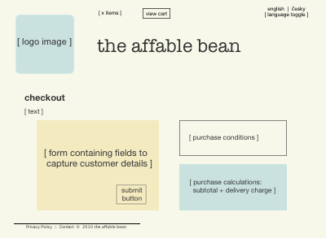](https://netbeans.org/images_www/articles/73/javaee/ecommerce/design/mockup-checkout.png)

## Confirmation Page

**Description and Priority:**

The confirmation page returns a message to the customer confirming that the order was successfully recorded. An order reference number is provided to the customer, as well as a summary listing order details.Order summary and customer personal details are returned over a secure channel.

**Stimulus/Response Sequences:**

Clicking on the confirm order button in the checkout page navigates the user to this page.This page is just a view and has not task associated but clicking on the image icon to navigate to the homepage.

**Functional Requirements:**

REQ-1: Display order summary

REQ-2: Display customer details that were gathered in the form (previous page)

REQ-3: Clicking on the Logo image should reload the homepage.

**User Interface Specifications:**

[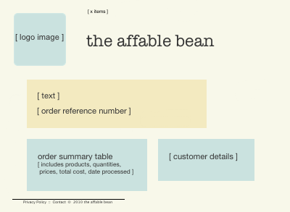](https://netbeans.org/images_www/articles/73/javaee/ecommerce/design/mockup-confirmation.png)

**General Business Rules:**

These general rules apply to multiple pages:

* The user is able to proceed to checkout from any page, provided that:
  + - The shopping cart is not empty
    - The user is not already on the checkout page
    - The user has not already checked out (i.e., is on the confirmation page)
* From all pages, the user is able to:
  + - View the status of his or her shopping cart (if it is not empty)
    - Return to the welcome page by clicking the logo image
* The user is able to select the language (English or Czech) to view the page in for all pages except the confirmation page.