NovaCRM Onboarding Automation
Part 1: Requirements & Workflow Analysis
Forward Deployed Engineer take-home, Rocketlane | 11 November 2026 (updated 13 November 2026)

1. Summary
I will automate NovaCRM's onboarding setup: a deal email arrives, an agent confirms the plan tier with the AE by phone, creates the right Rocketlane project, and opens a personalized Slack channel. Overdue tasks are escalated by Rocketlane's own automation.
Core principle: the Customer Success team owns the onboarding process (templates, phases, tasks, deadlines, owners). The AI system executes that process under the rules CS defines.
The LLM is used to read unstructured input: the deal email and the call transcript. When information is missing or unclear, the system pauses and asks a human.

2. Current workflow
Every step today is manual. NovaCRM has about 200 customers on two plans: Enterprise (30-day onboarding, dedicated CSM) and Growth (14-day onboarding, pooled CSM). Each project follows one template of about 15 tasks across 4 phases: Kickoff, Data Migration, Configuration and Go-Live.
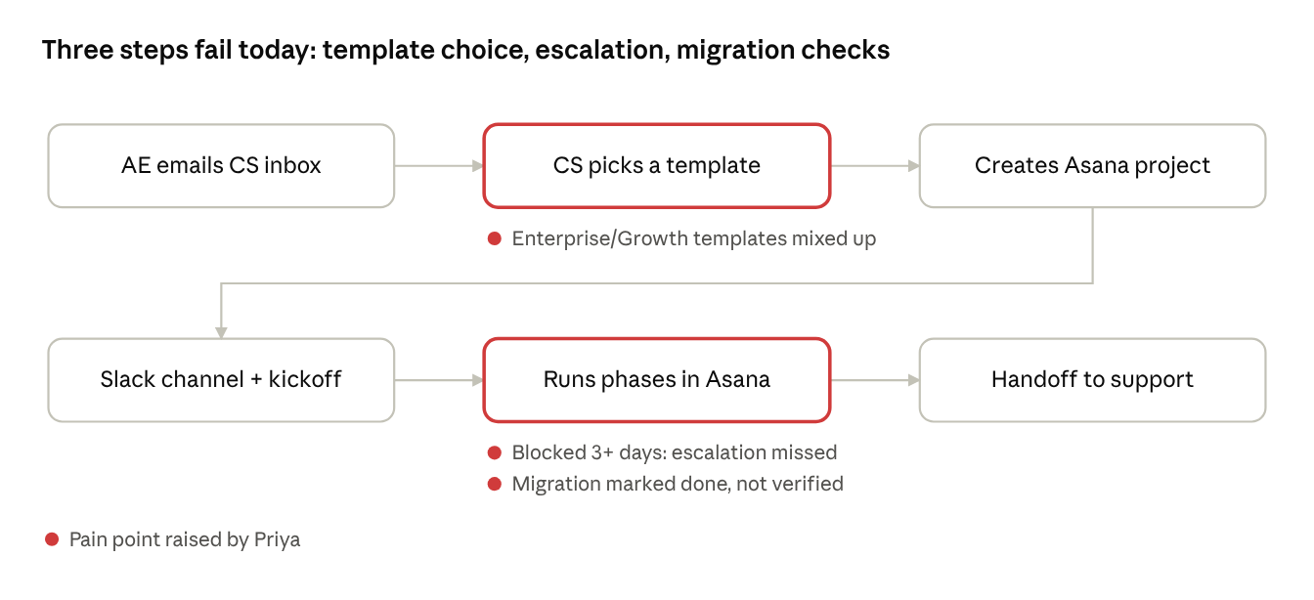
Figure 1. Current manual workflow and the three pain points Priya raised
All three issues depend on someone remembering to check. The proposed workflow adds automated checks at each of these points.

3. Proposed agentic workflow
One orchestrated workflow (LangGraph, state checkpointed in PostgreSQL) with two agents, plus one native Rocketlane automation:
- Intake & Routing Agent: receives new emails through a Gmail Pub/Sub webhook, extracts and validates fields, looks up the AE, calls them to confirm the tier, then creates the Rocketlane project from the matching template.
- Communication Agent: creates the Slack channel with a tier-specific name, topic and welcome message.
- Rocketlane automation: escalates overdue tasks. It's configured in Rocketlane, not coded.
Enterprise maps to the 30-day template with a dedicated CSM. Growth maps to the 14-day template with a pooled CSM.
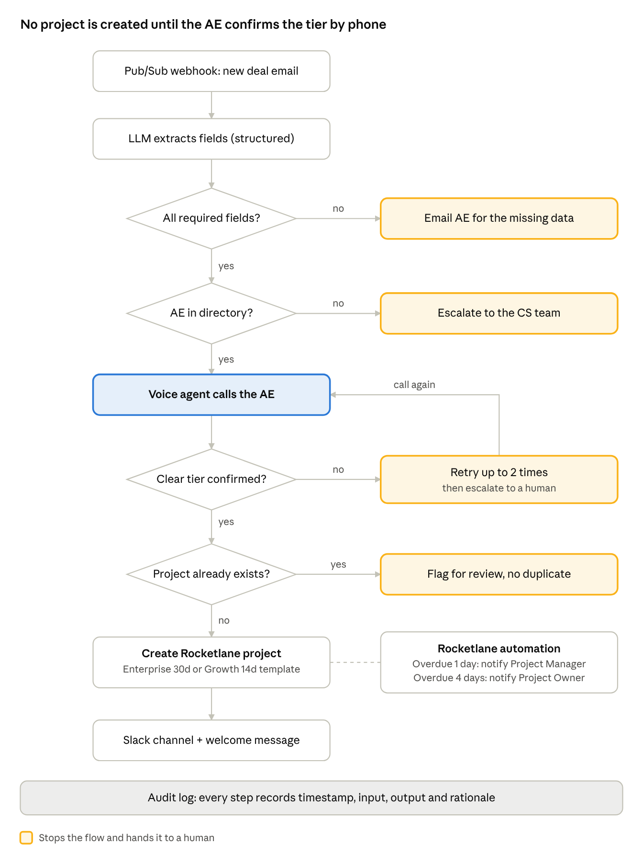
Figure 2. Proposed workflow: four checks before anything is created
The workflow pauses during the phone call, with its state saved in PostgreSQL, and resumes when the voice provider's webhook returns the result.

4. Guardrails
A Rocketlane project is created only after the AE has confirmed the plan tier.
Situation | What the system does
Required field missing or invalid (customer name, contact email, AE) | Pauses and replies to the AE asking for the missing data.
AE not in the AE directory, or no phone number | Escalates to the CS inbox. No call is placed.
AE doesn't answer, or the call fails | Retries up to 2 more times, 15 minutes apart, then escalates to a human.
Ambiguous answer ("I think Enterprise?", "not sure") | Asks once more on the call. If still unclear, escalates to a human.
Existing project for the same customer or opportunity | Does not create a duplicate. Flags it for review.
Duplicate Gmail notification or voice webhook | Ignored, using the stored message ID or call ID.
Rocketlane API down or timing out | Retries with backoff, keeps the workflow state, escalates if it still fails.
Slack channel creation fails | Retries, then escalates. The Rocketlane project is kept.
Data migration marked done | Validation checks must pass before the "Migration verified" task can close. Go-Live depends on it.

Audit log. Every step writes one record: timestamp, step name, input, output and decision rationale (why it continued, paused or escalated). Secrets are never logged and personal data is kept to the minimum.
Least privilege. The agent can create a project from a template but cannot edit templates, change deadlines, or reassign owners.

5. Data migration validation
Priya's worst escalations came from migration tasks marked done without checking the data. I will run a simple validation checklist between two simulated PostgreSQL databases: a source (the customer's old system) and a destination (NovaCRM).
Check | Passes when
Record count | Source and destination row counts match
Primary keys | Every source ID exists in the destination
Duplicates | No duplicate IDs in the destination
Required fields | No empty values in required columns (for example name, email)

Each run stores its counts, failures and timestamp as evidence. Any failed check keeps the "Migration verified" task open and alerts the CSM. The checklist is intentionally basic for this build.

6. Scope: initial plan vs what I am building
My first design covered the full onboarding lifecycle. I cut it down to the assignment's core plus three parts worth building properly (Pub/Sub intake, durable workflow state, migration validation) and kept the rest as a production roadmap.
Area | Initially planned | Building now | Production path
Gmail intake | Push notifications via Google Pub/Sub | Pub/Sub push to a webhook, de-duplicated by message ID | Same, plus automatic watch renewal and alerting
Salesforce | REST API: Opportunity, Account, Contact, Closed Won check, reconciliation | Parse the Opportunity ID from the link only | Full REST enrichment and Closed Won check
AE phone number | Pulled from Salesforce | AE directory table in PostgreSQL (email, name, phone) | Synced from Salesforce Users or the HR system
Voice call | Real call (Vapi or Retell) | Real call (unchanged) | Same
Workflow engine | LangGraph + PostgreSQL checkpointer | Same, PostgreSQL in a Docker or Podman container | Managed PostgreSQL
LLM | Gemini plus Ollama behind a provider layer | One hosted model with structured output | Same, plus evals
Rocketlane | Templates, role mapping, duplicate check | Same | Same
Slack | Real API, Slack Connect, live progress updates | Channel, topic, welcome message, Slack Connect invite to the customer (developer sandbox or Pro trial) | Same on a paid plan, plus event-driven progress updates
Overdue escalation | Native Rocketlane automation | Same | Same
Migration validation | 11 automated checks on simulated databases | 4 basic checks between two simulated PostgreSQL databases | Full check suite against real customer systems
Configuration (AD, SSO) | Optional technical tasks | Excluded | Added per customer by CS in the template
Kickoff calendar invite, handoff sign-off | Calendar integration, automatic handoff | Excluded | Calendar invite and LLM-drafted handoff for CS review

7. Exclusions
I have deliberately left these out of this build:
- Calendar invitations for the kickoff call.
- The final handoff summary and sign-off to the support team.
- Salesforce API enrichment and AD/SSO configuration tasks.

8. Assumptions
# | Assumption | Initially | Now
1 | AE phone number. The email doesn't contain it. | Fetch from the Salesforce User record | A dedicated AE directory table in PostgreSQL maps AE email to name and phone. I seed it. Unknown AE: escalate, no call.
2 | Enterprise and Growth templates exist in Rocketlane with the 4 phases. | Templates already set up in Rocketlane by CS | I configure both: Enterprise 30 days with a dedicated CSM, Growth 14 days with a pooled CSM.
3 | CSM, Project Manager and Project Owner users exist in Rocketlane. | Users already exist in Rocketlane | I create them in the trial and map roles to users in config.
4 | Task lists inside each template are owned by CS. | Same | I use a ~15-task draft for the demo, labelled as a placeholder for CS to replace.
5 | Salesforce API access. | Integrate via Developer Edition | Out of scope. I only parse the Opportunity ID from the link.
6 | Required email fields: customer name, customer contact email, AE name, AE email. | Same | Same. The Salesforce link is optional for the build.
7 | Slack Connect is available for the demo. | Slack Connect with the customer | Real Slack Connect using a free developer sandbox or Pro trial. Fallback: a single internal channel.
8 | Data migration validation. | 11 automated checks | 4 basic checks between two simulated PostgreSQL databases.
9 | Kickoff calendar invitation and final handoff sign-off. | Calendar integration and automatic handoff | Excluded from this build.
10 | Infrastructure for the demo. | Not decided | PostgreSQL in a Docker or Podman container; webhooks exposed through a tunnel such as ngrok.
11 | One email = one deal. | Same | Same. Emails with several customers are escalated.

9. Clarifying questions
I sent these questions to karthikr@rocketlane.com on 11 November 2026, with my default next to each one. No reply had arrived by the submission date, so I built on the defaults. The last column shows what I built.
# | Question | Default (no reply, so used) | What I built
1 | AE phone number: the deal email doesn't include it. Is it acceptable to keep an AE directory (email, name, phone) in my own database, or should it come from Salesforce? | AE directory table in PostgreSQL | AE directory in PostgreSQL. CS can add and edit AEs from the dashboard, and the changes are audited.
2 | Voice call: I plan to place the call from the voice provider's number (likely US) to my own Indian mobile, acting as the AE. Is that fine? | Provider number calling my own phone | A Retell voice agent calls my mobile. Recordings and transcripts are shown in the dashboard.
3 | Salesforce: I plan to keep this lightweight and only parse the Opportunity ID from the link, without a full CRM integration. Do you expect the agent to fetch data from Salesforce? | Parse the link only | Only the Opportunity ID is parsed, from both classic and Lightning links.
4 | Templates: should I assume the Enterprise and Growth templates already exist in Rocketlane, or should I create them? | I create them | Both templates were created in Rocketlane: Enterprise (30 days) and Growth (14 days), with 4 phases each.
5 | Users: should CSMs, Project Managers and Project Owners already exist as Rocketlane users? | I create and map them | The users were created in the trial. Roles are mapped by tier in configuration (TIER_RULES), never by the LLM.
6 | Data migration: the brief mentions migration tasks marked complete without verification. Would a verification checklist and an explicit completion gate within the Rocketlane workflow be sufficient? | A verification checklist, with evidence required before the migration task is marked complete | Five code checks run against the customer's database through a read-only user. If “Migration verified” is ticked without a passing check, Agent 3 reopens it.
7 | Slack: I plan to show a real Slack Connect channel shared with the customer, using a free Slack developer sandbox or Pro trial. Is that acceptable? | Real Slack Connect channel, with a single internal channel as fallback | The fallback was used. Slack Connect needs a paid plan, so each customer gets a real internal channel, and the customer invite is flagged as a manual step.
8 | Rocketlane trial: should I expect the trial to include API access for creating projects from templates and configuring overdue-task automations? | I verify on the trial | Verified. The API creates projects from templates, and the overdue automation is configured natively in Rocketlane.
9 | Submission format: would you like a GitHub repository (public or private, and whom should I give access to) along with the Loom link? Is there a length limit for the video? | Private GitHub repo shared with the panel, video under 10 minutes | A public GitHub repository, and a Drive folder with two videos: a 10-minute presentation and a 16-minute live demo.

10. What changed during the build
I wrote this document before the build. These things changed while I built and tested the system:
Topic | This document planned | Final build
Agents | Two agents plus a Rocketlane automation | Three agents. Project Tracking (Agent 3) watches Rocketlane after setup.
Handoff to support | Excluded (section 7) | Built. Agent 3 writes the handoff summary when Go-Live is complete.
Migration checks | 4 basic checks between simulated databases | 5 checks, including schema, against a customer database connected from the dashboard
Call retries | 15 minutes apart | 3 attempts in total, about 30 seconds apart for the demo. The interval is a configuration setting.
Sender check | AE directory lookup | AE directory plus Gmail's DMARC verdict, so a forged sender cannot trigger a call
Infrastructure | Local Docker and a tunnel | Deployed on AWS EC2 with Docker Compose and HTTPS

