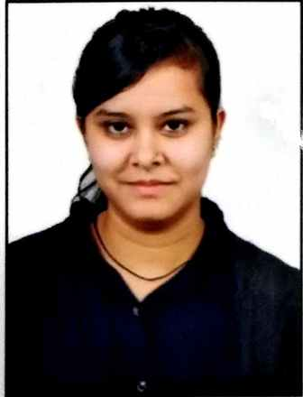**SAKSHI WAGHMARE**

[E-mail-](mailto:Email-aman007rj@gmail.com) sakshiwaghmare44@gmail.com

Contact-+91-8871451285

Address- 203/A, Pooja Girls Hostel, Indrapuri

Bhopal, M.P. - 462021

**CAREER OBJECTIVE**

To succeed in an environment of growth and excellence and earn a job which provides me with satisfaction and helps me achieve personal as well as organizational goals.

**EDUCATIONAL QUALIFICATIONS**

|  |  |  |  |  |
| --- | --- | --- | --- | --- |
| **DEGREE** | **INSTITUTION** | **BOARD/UNIVERSITY** | **PERCENTAGE** | **YEAR** |
| B.E (CSE) | VIDHYAPEETH INSTITUTE OF SCIENCE & TECHNOLOGY, BHOPAL | R.G.P.V, BHOPAL | 8.05 CGPA  (Till 7th Sem) | 2019 |
| HSC | H.D.MEMORIAL.HR.SEC SCHOOL , KATNI | M.P BOARD | 48.6% | 2015 |
| SSC | H.D.MEMORIAL.HR.SEC SCHOOL , KATNI | M.P BOARD | 73.83% | 2013 |

**TECHNICAL EXPOSURE :**

|  |  |
| --- | --- |
| **INDUSTRIAL TRAINING** | * **Training on J2SE(Duration 1 month)**   Key learning:-   * Learned about basic java concept * Learned how to make project using Net Beans * Training on android Through Internshala (Duration 1 month)   Key learning:-   * Create an android app by making your own android player * Learn how to make a new project in android studio |
| **PROJECT** | * **Online Test Management System**   **Tools used : Back End (Database) oracle**  : Front End (Java) Swing  Design (JAVA SWING) Net Beans |

**TECHNICAL SKILLS & SUBJECTIVE LEARNINGS**

* Beginner of J2SE
* Basic knowledge of C and C++
* Ms-Office ( Ms-Word, Ms- PowerPoint, Ms- Excel)

**PERSONAL TRAITS & HOBBIES**

* Quick learner
* Good at decision making
* Good to make traditional Rangolies
* Listening music

**PERSONAL DETAILS**

**Name** : Sakshi Waghmare

**Date of Birth** :02 FEB 1997

**Father’s Name** : Sanjay Waghmare

**Mother’s Name**  : Surbhi Waghmare

**Permanent Address** : Shastri colony, Katni,M.P.- 483501

**Languages Known** : English, Hindi, Marathi

**Nationality** : Indian

**PLACE:**

**DATE: SAKSHI WAGHMARE**