**Naman Vijayvargiya**

**181IT129**

**Crowdfunding Smartcontract**

**Compile**

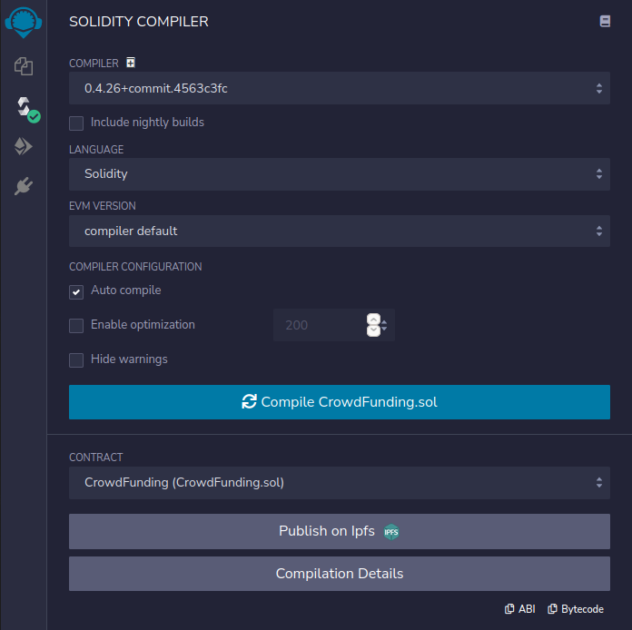

**4]Send transaction to create the contract,on account1(owner).(When creating the contract,set**

**_duration to 300(5min) and _goalAmount(target amount) to 25ETH)**

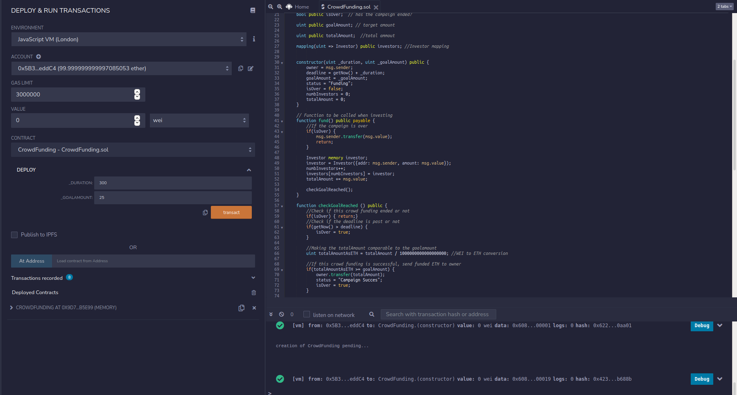

**5]Check deadline and end state.**

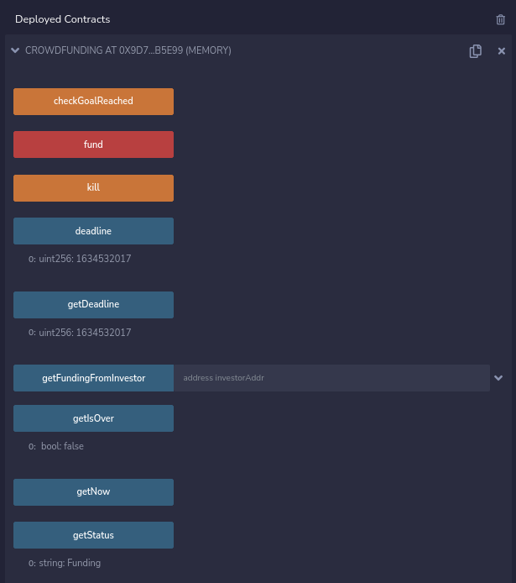

**6]** 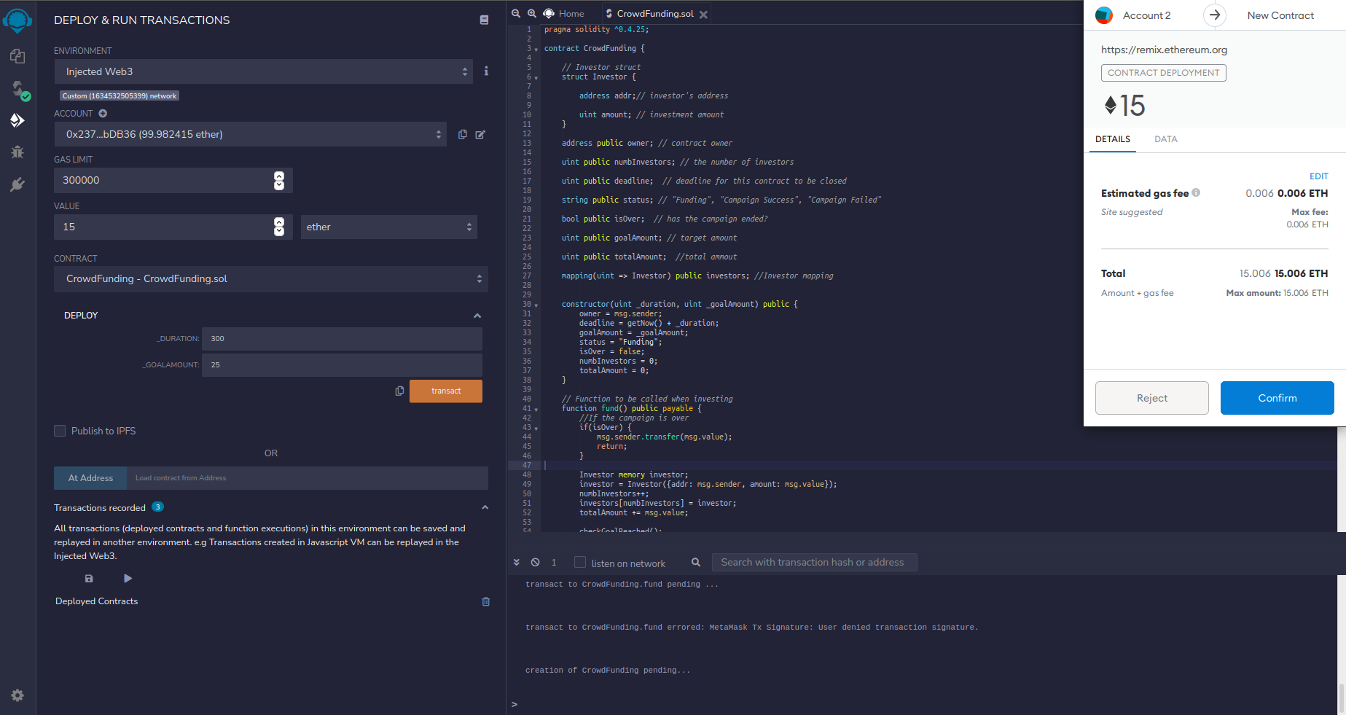

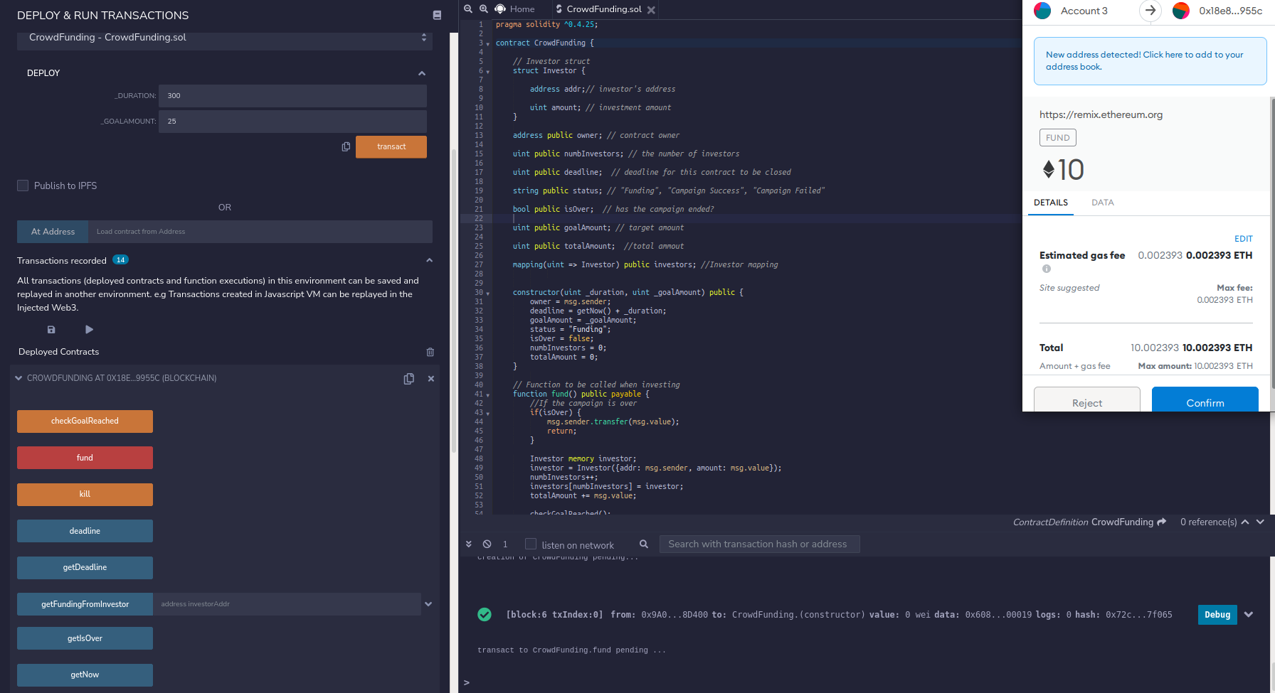

**7]**

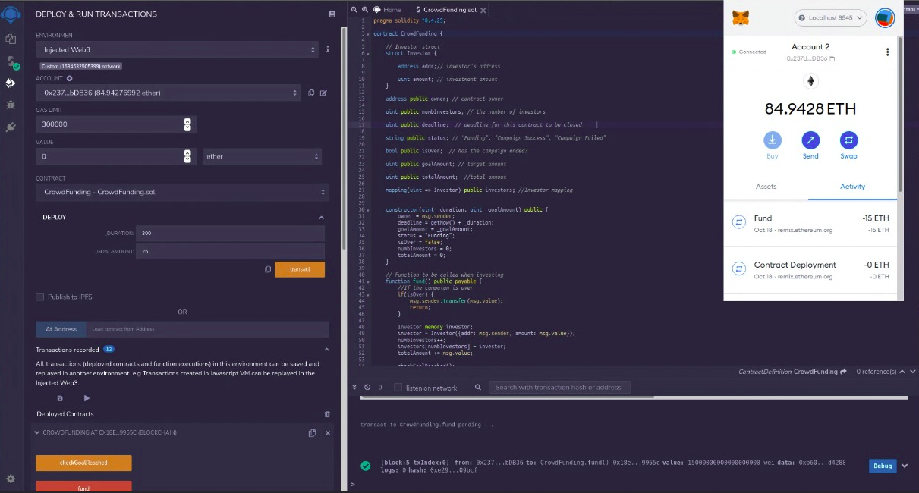

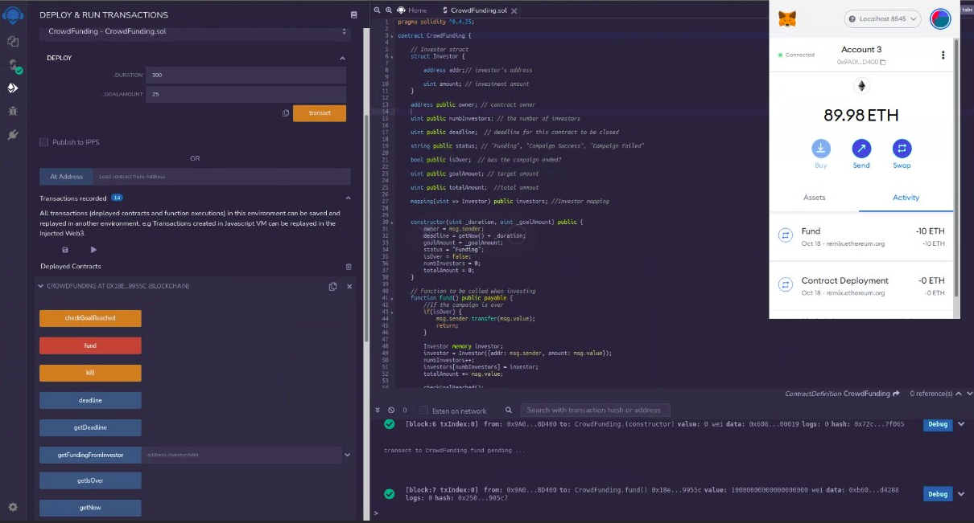

**8]**

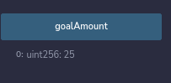

**9]**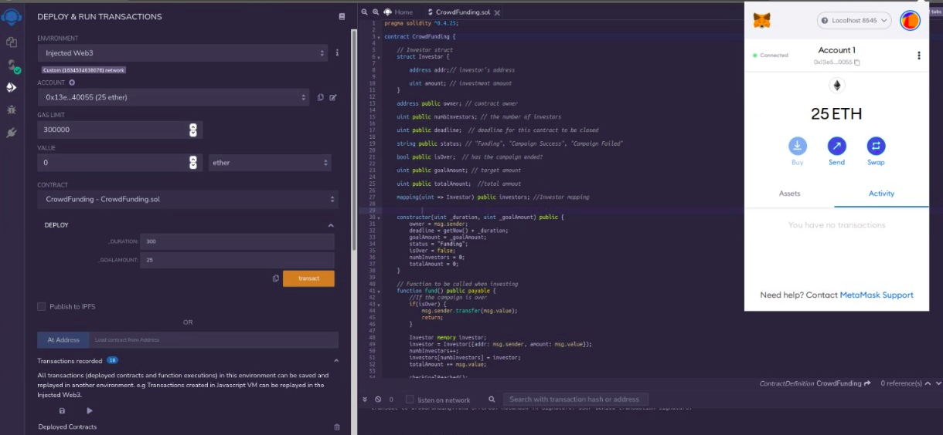

**10]**

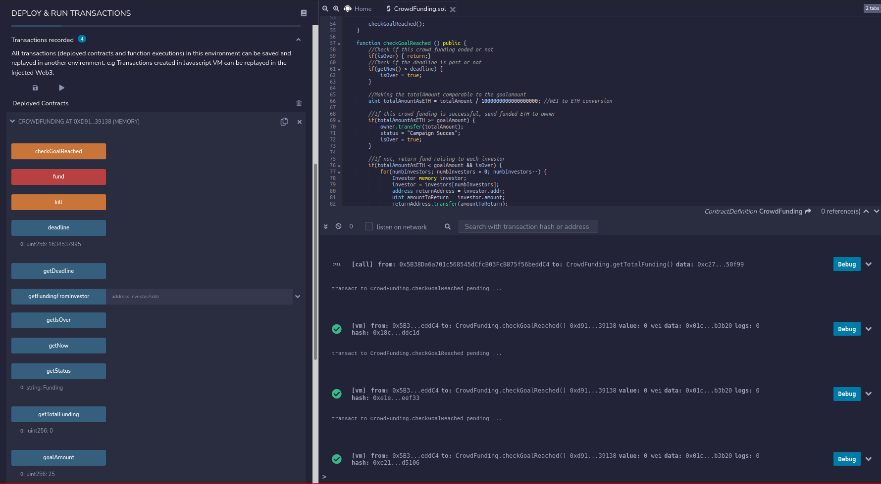

**11]**



**12]**

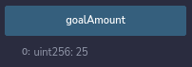



**13]**





**14]**

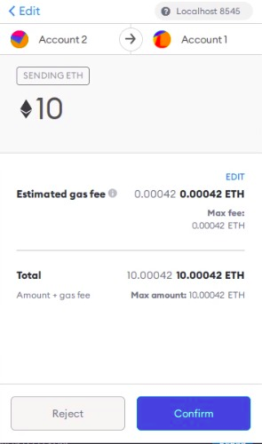

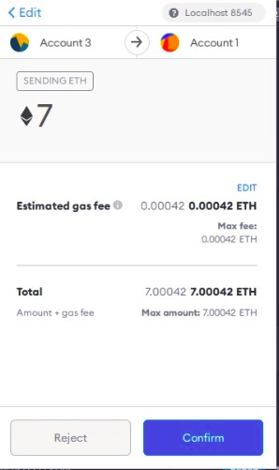

**15]**

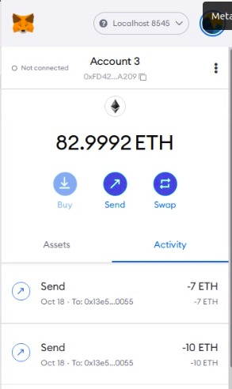

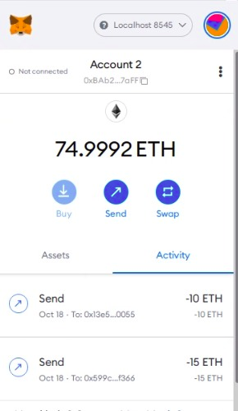

**16]**

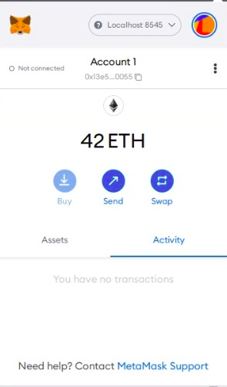

**17]**





**18]**



**19]**

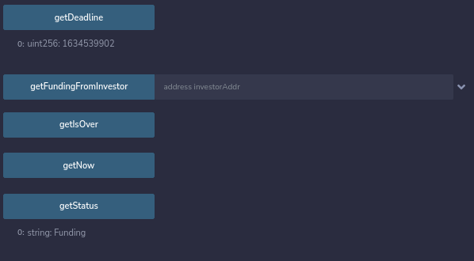

**20]**



**21]**





**2) CryptoFlight and its smart contract**

**compiler is set to at least 0.5.8 and Compilation Successful**

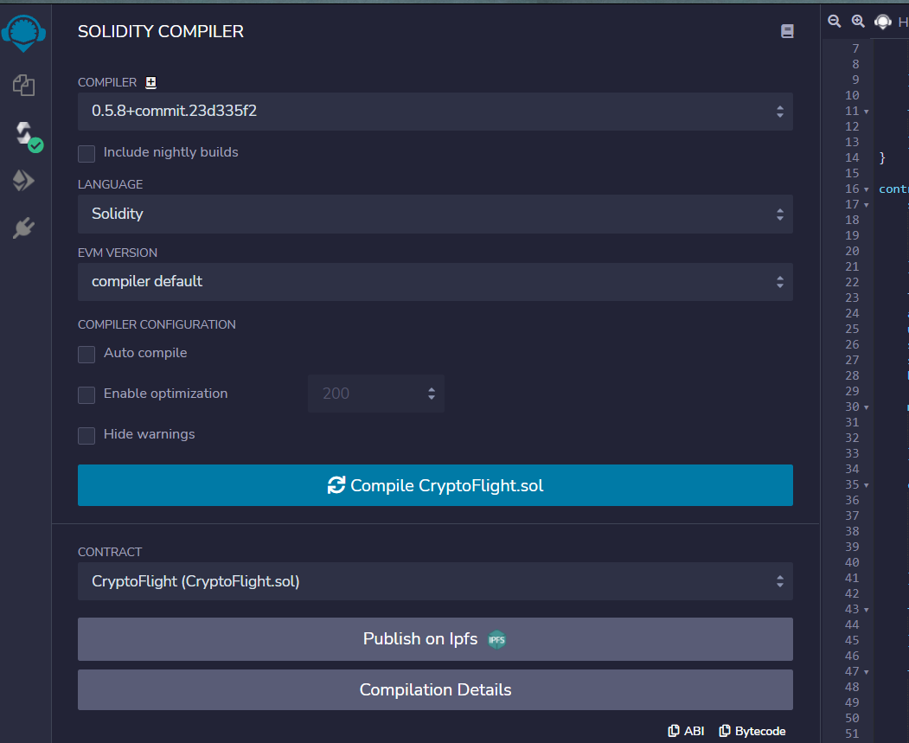

**Deployed successfully  
  
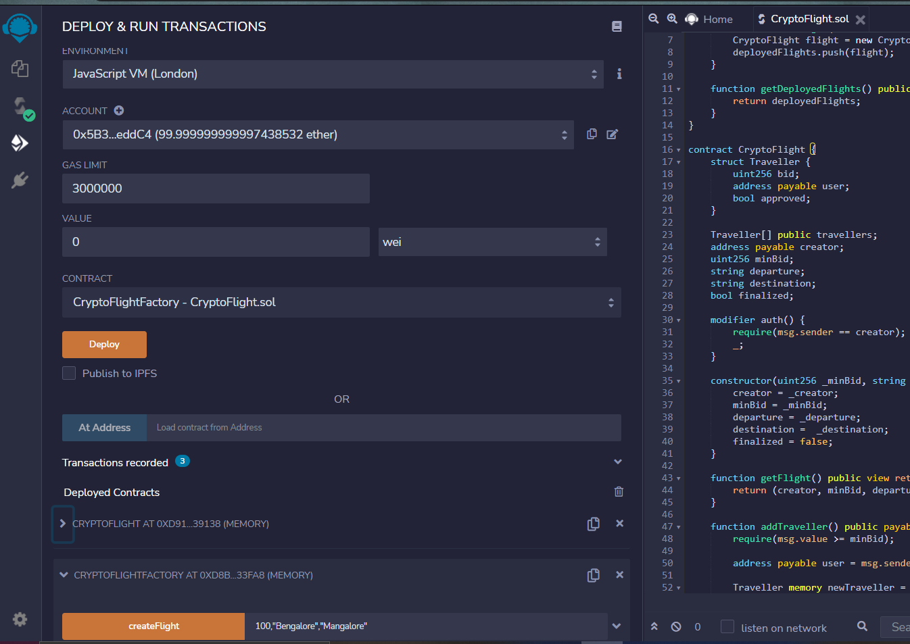**

**Deployed Contracts**

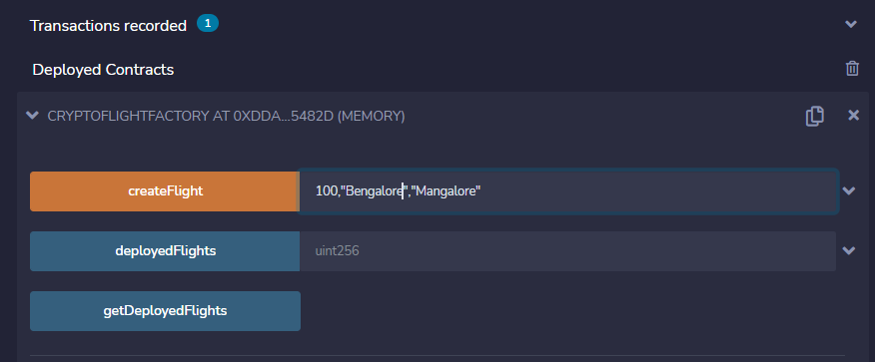

**output in the debug-log after successful deployment**

