Blockchain empowers the IoT devices to enhance security and bring transparency in IoT ecosystems.

Blockchain offers a scalable and decentralized environment to IoT devices, platforms, and applications.  
Banks and Financial institutes like ING, Deutsche Bank, and HSBC are doing PoC to validate the blockchain technology. Apart from financial institutes, a wide range of companies have planned to experience the blockchain’s potential.

On the other hand, the Internet of Things (IoT) opens up countless opportunities for businesses to run smart operations. Every device around us is now equipped with sensors, sending data to the cloud. Therefore, combining these two technologies can make the systems efficient.

Here are a few ***Blockchain Enterprise use cases*** on how combining IoT with Blockchain can have a significant impact across multiple industries:

* [Supply Chain and Logistics](https://www.leewayhertz.com/blockchain-iot-use-cases-real-world-products/#supply)
* [Automotive Industry](https://www.leewayhertz.com/blockchain-iot-use-cases-real-world-products/#auto)
* [Smart Homes](https://www.leewayhertz.com/blockchain-iot-use-cases-real-world-products/#smart)
* [Sharing Economy](https://www.leewayhertz.com/blockchain-iot-use-cases-real-world-products/#sharing)
* [Pharmacy Industry](https://www.leewayhertz.com/blockchain-iot-use-cases-real-world-products/#pharma)
* [Agriculture](https://www.leewayhertz.com/blockchain-iot-use-cases-real-world-products/#agri)
* [Water Management](https://www.leewayhertz.com/blockchain-iot-use-cases-real-world-products/#water_management)

**1. Supply Chain and Logistics**

A global supply chain network involves many stakeholders, such as:

* Brokers raw material providers, etc.

It complicates the end-to-end visibility. The supply chain can also extend over months of time and consist of many payments and invoices. Due to the involvement of multiple stakeholders, delivery delays have become the biggest challenge.

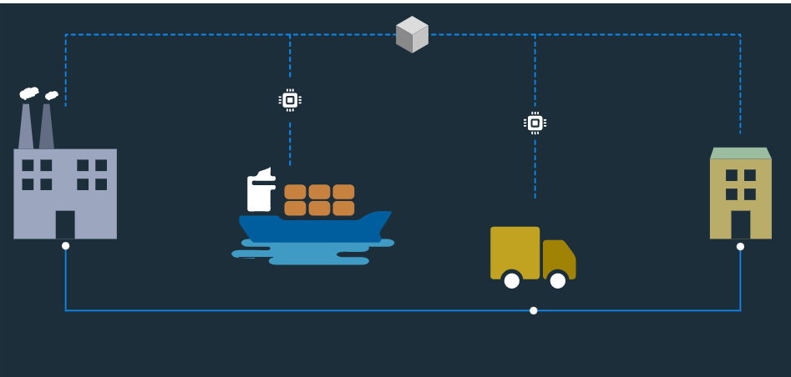

Therefore, companies are working on making the vehicles IoT-enabled to track the movement throughout the shipment process. Due to the lack of transparency and complications in the current supply chain and logistics, Blockchain and IoT combined can enhance the network’s reliability and traceability.

Crisp details about shipments’ status can be provided by IoT sensors, like:

* motion sensors
* GPS
* temperature sensors
* vehicle information
* connected devices, etc.

Sensor information is then stored in the blockchain. Once the data is saved on the Blockchain, stakeholders listed in the Smart Contracts get access to the information in real-time. Supply chain participants can accordingly prepare for transshipment and run cross-border transactions.

***How is “Golden State Foods” disrupting the Supply Chain and Logistics Industry?***

Golden State Foods(GSF) is a diversified supplier, well-known for manufacturing and distributing food products. Serving more than 125,000 restaurants, GSF is aimed at producing and delivering high-quality products.

GSF is working with IBM to optimize business processes using Blockchain and IoT. Sensors data collected on the blockchain ensure the issues are addressed and reported automatically before they create serious problems.

With blockchain’s help, GSF can create a secure, immutable, and visible ledger accessible by different stakeholders to improve:

* accountability
* transparency

**2. Automotive Industry**

Nowadays, digitization is a competitive demand. Automotive industries are using IoT-enabled sensors to develop fully automated vehicles.

Connecting[Industrial IoT solutions](https://www.leewayhertz.com/industrial-iot-solutions/) in the automotive sector with the decentralized network enables multiple users to exchange crucial information easily and quickly.

The automotive industry is an exciting blockchain IoT use case, where the combined technology can disrupt:

* automated fuel payment
* autonomous cars
* smart parking
* automated traffic control

***How is NetObjex reshaping the automotive industry?***

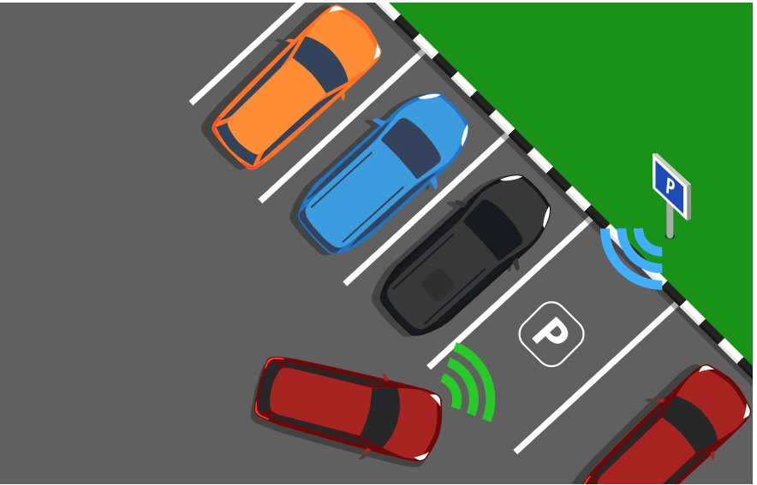

NetObjex has demonstrated the smart parking solution using blockchain and IoT. The integration eases the process of finding a vacant space in the parking lot and automates the payments using crypto-wallets.

The company has collaborated with a parking sensor company “PNI” for real-time vehicle detection and finding the parking area’s availability.

IoT sensors calculate the parking duration charges, and the billing takes place directly through the crypto-wallet.

**3. Smart Homes**

Smart IoT-enabled devices play a crucial role in our day-to-day lives. IoT blockchain enables the home security system to be managed remotely from the smartphone.

But the traditional centralized approach to exchange information generated by IoT devices lacks the security standards and ownership of data.

Blockchain could elevate the smart home to the next level by:

* solving security issues
* removing centralized infrastructure

***How is Telstra trying to improve the security of smart homes?***

Telstra, an Australian telecommunication and media company, provides smart home solutions. The company has implemented blockchain and biometric security to ensure no one can manipulate the data captured from smart devices.

Sensitive user data is stored on the blockchain for improved security, such as:

* biometrics
* voice recognition
* facial recognition

Once the data is saved on the blockchain, it cannot be modified, and the access is only provided to the right person.

**Get unified blockchain solutions for your business needs**

**LeewayHertz Blockchain Development Services**

[Contact Us](https://www.leewayhertz.com/blockchain-development-company/?utm_source=blockchain-iot-use-cases-real-world-products-Insight&utm_medium=CTA)

**4. Sharing Economy**

The sharing economy has become a widely adopted concept around the world. Blockchain could help create decentralized, shared economy applications to earn considerable revenue by sharing the goods seamlessly.

Can you imagine an Airbnb apartment that leases itself? [Slock.it](http://slock.it/" \t "_blank) is doing it precisely by using Blockchain IoT.

***How is [Slock.it](http://slock.it/" \t "_blank) transforming the Sharing Economy business?***

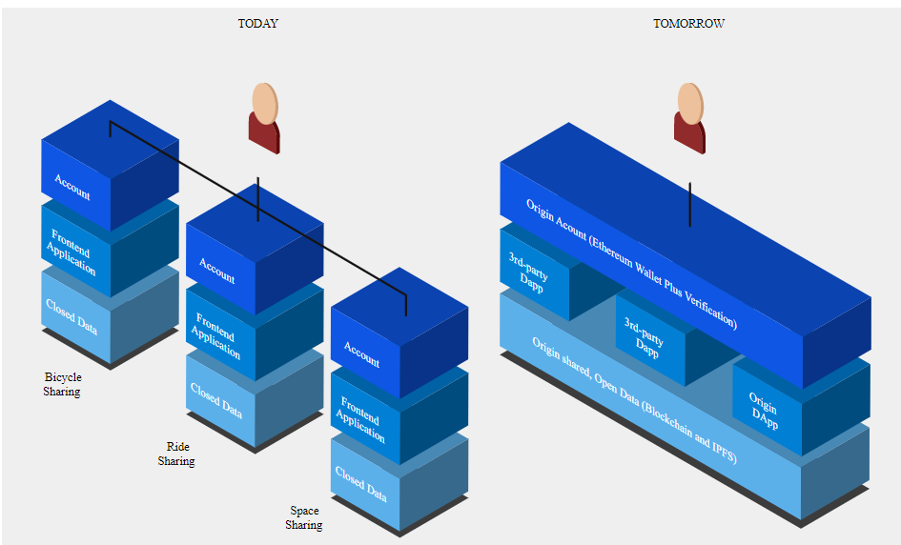

[Slock.it](http://slock.it/)is using blockchain technology for sharing IoT-enabled objects or devices.

They have planned to develop a Universal Sharing Network (USN) to create a secure online market of connected things. With USN, any object can be rented, sold, or shared securely without requiring intermediaries.

It could be possible for third-parties like manufacturers to onboard any object to the USN without seeking permission. Smart contracts ensure data privacy and transparency by controlling access to information.

**5. Pharmacy Industry**

The issue of counterfeit medicines in the pharmaceutical sector is increasing with every passing day. The pharmacy industry is responsible for:

* developing drugs
* manufacturing drugs
* distributing drugs

Therefore, tracking drugs’ complete journey is difficult.

The blockchain technology’s transparent and traceable nature can help monitor the shipment of drugs from its origin to the supply chain destination.

Let’s discuss one potential IoT blockchain application based on the healthcare industry.

***How can Mediledger be the game-changer for the pharmacy industry?***

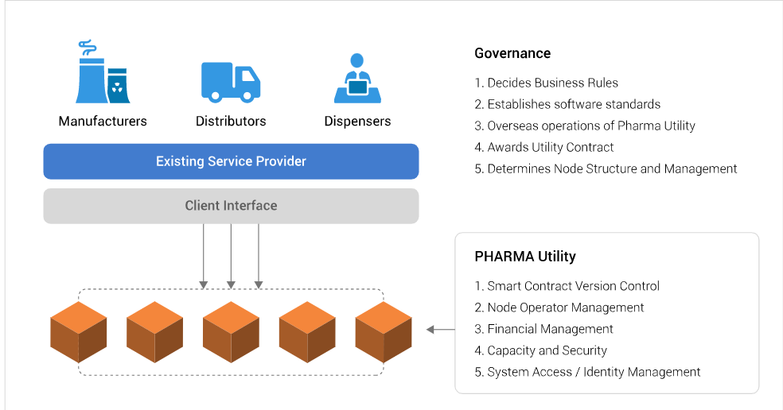

Mediledger is a blockchain IoT use case designed to track the legal change of prescription medicines’ ownership. Transparency and traceability are essential when it comes to monitoring sensitive healthcare products.

The data stored on the distributed ledger is immutable and timestamped, accessible to:

* manufacturers
* wholesalers
* dispensers
* end-customers

Mediledger is a blockchain based platform, offering:

* simplified payment processes
* controlling users access
* stopping counterfeit drugs from invading the supply chain

**6. Agriculture**

For maximum customer satisfaction, it is essential to grow more food for the increased population while:

* minimizing environmental footprints
* ensuring transparency across the supply chain

Blockchain, coupled with IoT, has the potential to reshape the food production industry- from farm to grocery to home. Installing IoT sensors in the farms and sending its data directly to the blockchain can help enhance the food supply chain to a greater extent.

Let us explore one application that is using IoT blockchain to improve the agricultural supply chain.

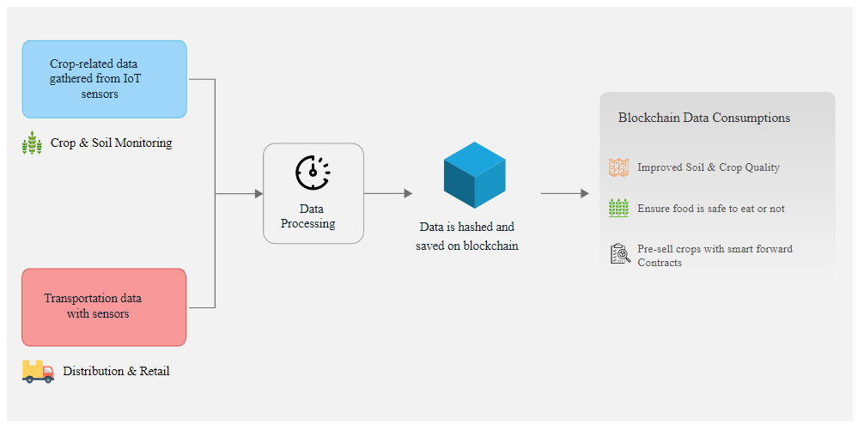

***How can Pavo transform agriculture with blockchain and IoT?***

Offering a new and smart farming approach to farmers, Pavo is a blockchain IoT use case that brings unparalleled transparency. The information collected from Pavo’s IoT hardware device installed on farms gets saved on the blockchain. It enables farmers to enhance farming techniques by looking at the captured data. It also allows distributors, retailers and consumers to make informed decisions about buying a specific crop or food item.

The Pavo marketplace also allows farmers to presell crops through smart contracts to prevent farmers from waiting for payment after harvest.

**7. Water Management**

Leaking water fixtures can result in one trillion gallons of wasted water per year in the USA. Aquai has built Puck, a smart water sensor that can:

* track how much water you use
* automate water shutdown if any leak is detected

Using NetObjex’s IoT and blockchain services, it can monitor and store the data.

There’s one more project that has been proposed to measure river contamination via blockchain and IoT. Two companies, Libelium and Airalab, have teamed up to create a project, “Drone on the Volga.” It uses a drone equipped with IoT sensors and blockchain technology to gather water contamination levels autonomously. The drone collects water readings of the Kuybyshev Reservoir in the Volga River and publishes the Ethereum Blockchain data in real-time.

Using IoT, the drone can understand where and when readings were taken, helping scientists discover where contamination has come from.