**AKASH JAISWAL**

B. Tech - Civil Engineering (Minor in Computer Applications)

Gender: Male

Date of Birth: 16/03/2003

E-mail: akashjaiswal3846@gmail.com

Contact: +91 96706 64115

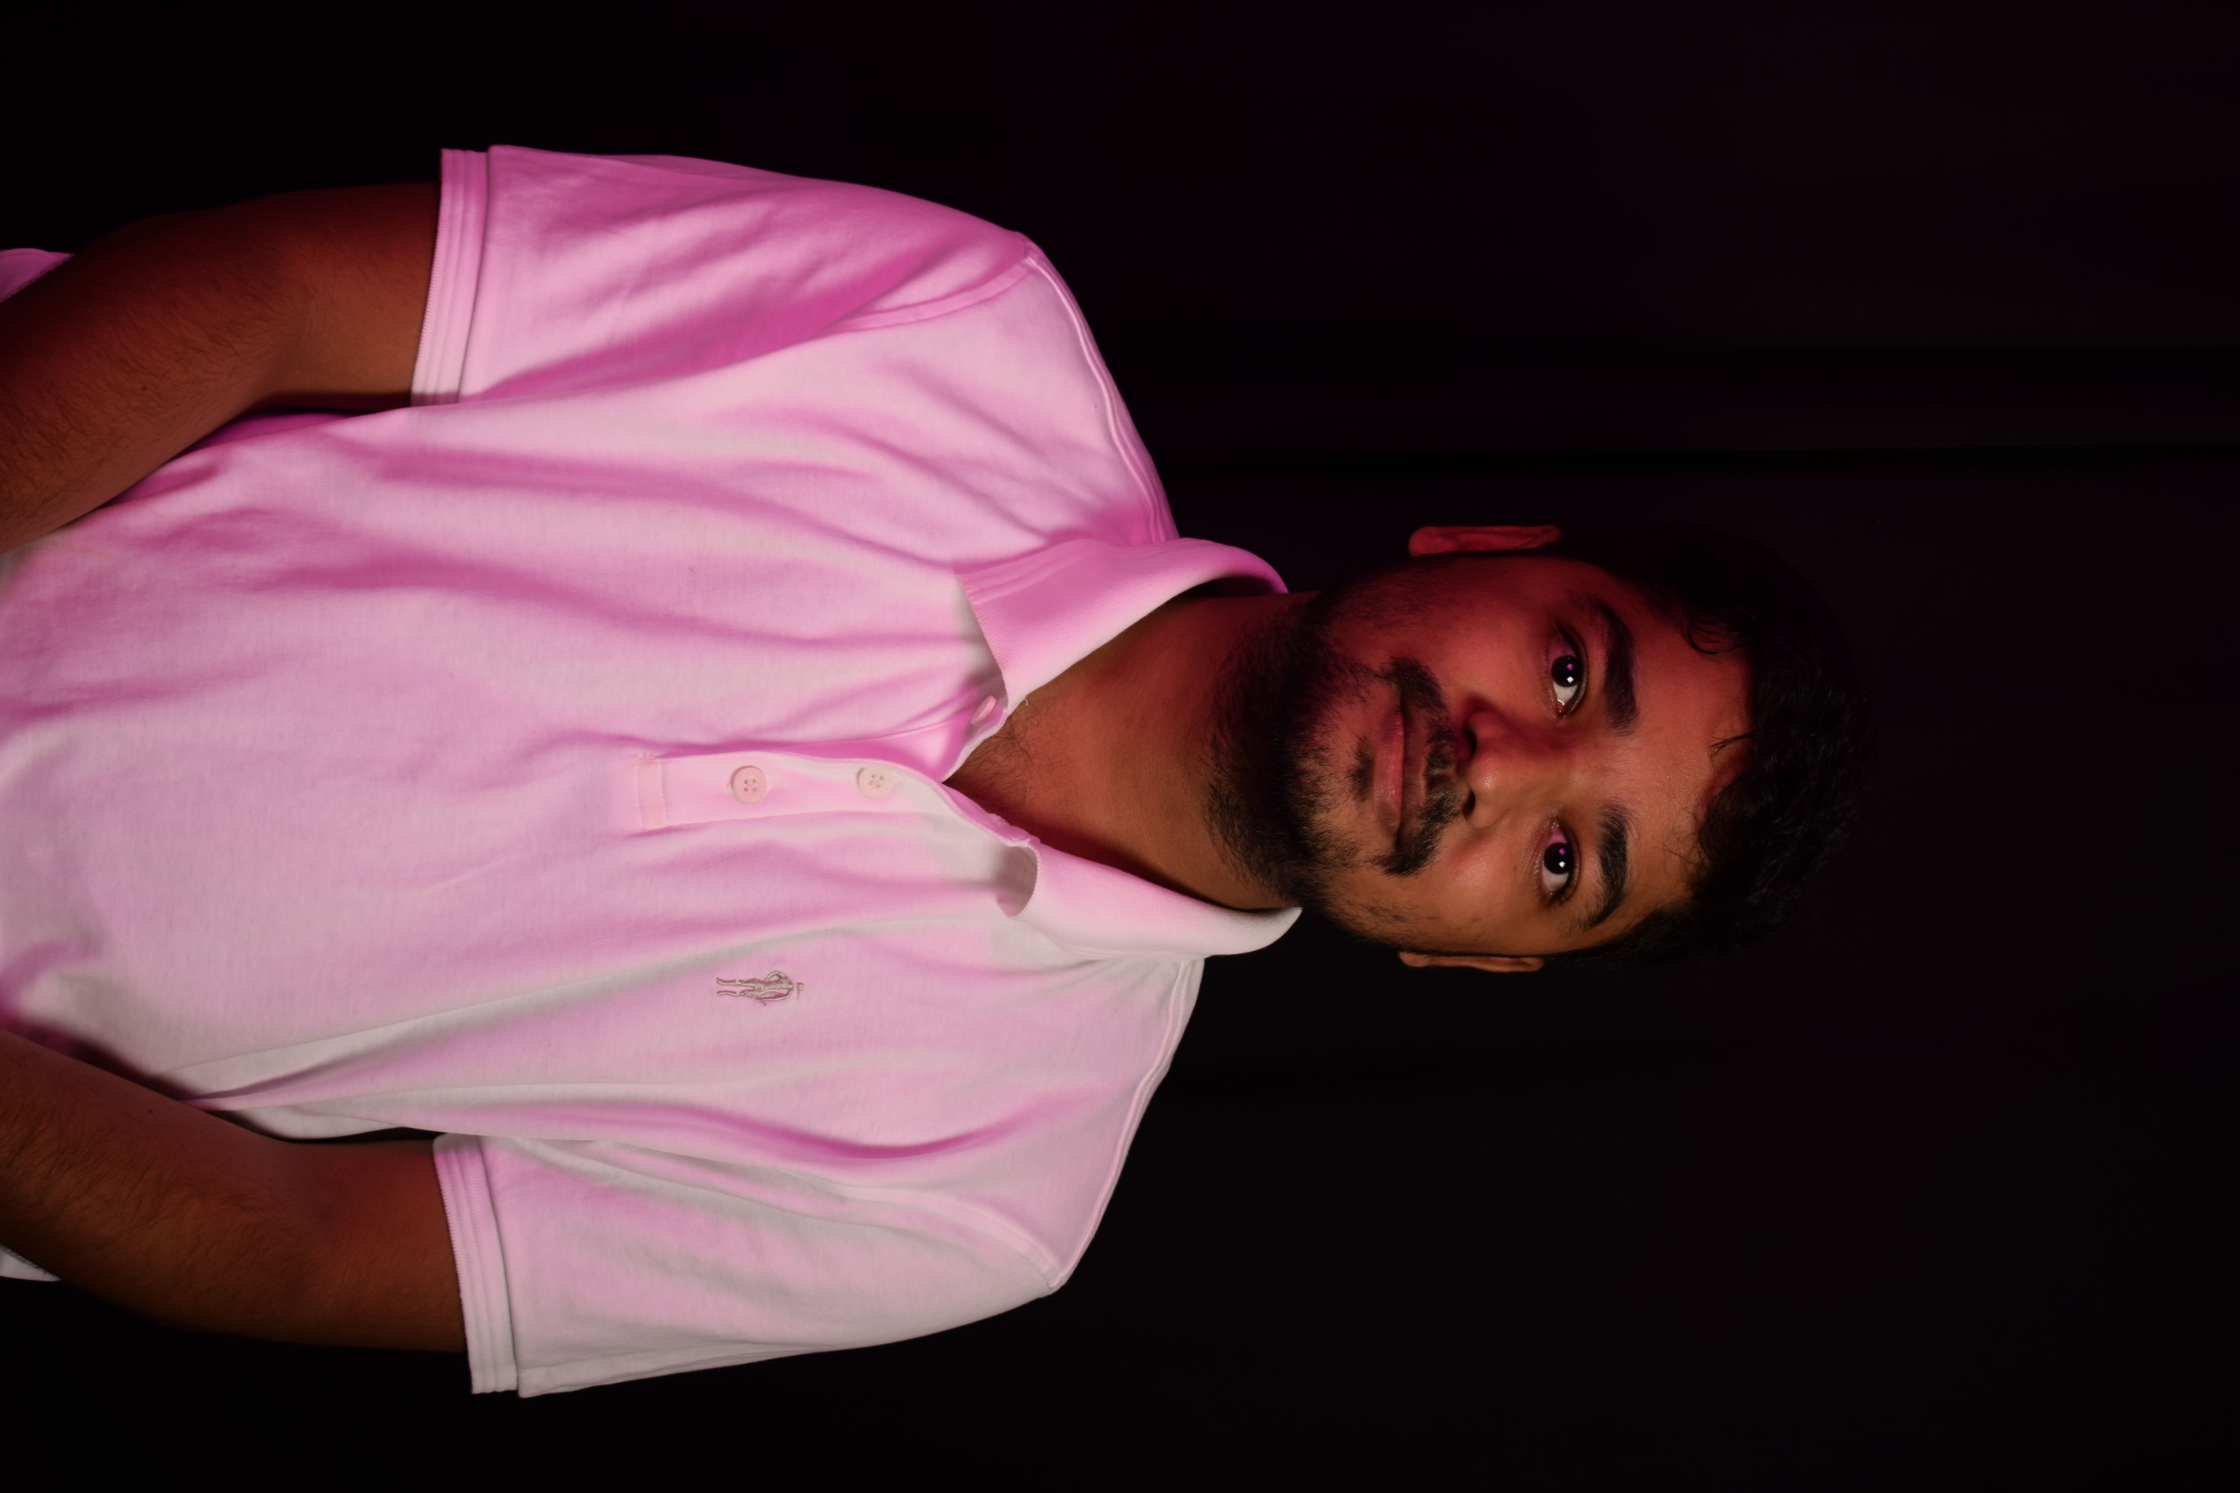

**Educational Qualification**

|  |  |  |  |
| --- | --- | --- | --- |
| **Year** | **Degree/Examination** | **Institution/Board** | **CGPA/Percentage** |
| 2020 - 2024 | B. Tech- Civil | NIT, Trichy | 8.01 |
| 2020 | Class XII | St. Xavier’s School, Ramnagar, CBSE | 91% |
| 2018 | Class X | St. Peter’s School, Akbarpur, ICSE | 91% |

**Academic Achievements**

* C**ontributor** at **CC Extractor** org for [**Google Summer of Code 2022**](https://summerofcode.withgoogle.com/programs/2022/projects/Sg34Qe09), out of 4000+ applicants from 96 countries.
* Completed [**Kharagpur Winter of Code 2021**](https://kossiitkgp.org/public-files/KWoC/2021-Certificates/Student/jaiakash.pdf)with 5+ project contributions. [Details](https://kwoc21.kossiitkgp.org/stats/student/jaiakash)
* Completed **Hacktoberfest 2021** with 10+ project contributions.
* 3rd position in ICY Cup and 3rd position in Code Connoisseurs conducted by [**Spider – R&D Club of NIT Trichy | 2021**](https://www.instagram.com/p/COnRhI0lryA/?hl=en)
* Code chef [**Global Rank 194 Div. 2**](https://www.codechef.com/rankings/ICM2021B?itemsPerPage=100&order=asc&page=1&search=akashjaiswal03&sortBy=rank) in **International Coding Marathon IIT BHU 2021.**
* 2nd prize in [Covalent Competition (Technical Bounty)](https://www.instagram.com/p/CawrSkVMkL_/?hl=en) **Inter NIT CONCLAVE-X 2022.** Created an **NFT Crypto sheet** for NFT data using Covalent APIs.
* 1st prize in Crypto trader - Cogni 2022 IIT Roorkee and 2nd Prize in Cryptocon – Rendezvous 2022 IIT Delhi

**Internship Experience**

* **Contributor** [**CC Extractor**](https://github.com/CCExtractor)**, Google Summer of Code 2022** *Jun 2022 - Present*
* Started the [Its Urgent app](https://summerofcode.withgoogle.com/programs/2022/projects/Sg34Qe09) under CC Extractor org for GSoC’22.
* An app that lets the caller decide if the call is urgent or not, the caller can decide the urgency rating of the call. The receiver sees that message and accordingly decides whether to pick up the call or not.
* The backend tools used are **Firebase Cloud Messaging** for notifications and **Firebase Fire store** as database.
* Setup an automatic **CI/CD on GitHub** for faster testing and release using **GitHub actions**.
* Tech stack – Flutter and Firebase
* **Nyayaag Advocate | Software Developer:** [GitHub](https://github.com/jaiakash/nyayaag-client/)*Apr 2022 - Jun 2022*
* Worked as web developer for Nyayaag Advocate start-up, incubated under **CEDI NIT Trichy**.
* Designed the website with features like user registration, login, and dashboard pages for advocates and clients.
* Tech stack – Flutter, MongoDB and NodeJS

**Projects**

* **Code Character 2022:** [**GitHub**](https://github.com/delta/codecharacter-web-2022)*Jan 2022 – Apr 2022*

A turn-based strategy game in which the player controls troops in a real-time simulation. Player controls their troops by writing code in either of three languages namely – Java, C++ and Python. Player also safeguards their home-base from enemy attack by installing robust defences. **Teck Stack – Phaser3, TypeScript, Spring Boot Kotlin, Rust, RabbitMQ**. The contest was live for **10 days with 250+ participants from 106 colleges and 20,000+ match simulations**. Developed frontend features **– leader board and battle TV pages** for code character web.

* **Delta Winter of Code:** [**Website**](https://dwoc.io/)*Nov 2021*

Delta Winter of Code is **an open-source program** operated by Delta Force, NIT Trichy with the aim to introduce programmers to the world of open-source software. Developed the front-end of website, specifically the **admin page**. **Tech stack – ReactJS, GraphQL and Javascript**. I also performed as a **mentor** for Entrix organisation in DWoC 2021.

* **Sarkari Result App:** [**Play Store**](https://play.google.com/store/apps/details?id=com.amostrone.akash.sanjeevwebsolutions)*Apr 2021*

An android app that gives information about the availability government jobs opening. The app provides a one to go solution for users where previously they have to go to different websites. Improved user experience. Used **Google analytics** **and Google Ad mob**. **1k+ downloads** on Play store.

**Technical Skills and Profile Links**

* Programming Languages : C++, Java, JavaScript, Python, Kotlin, C, C#, Bash
* Tech Stack : Android development, Full Stack Web development, Flutter, React, NodeJS, Unity3D
* Tools and OS : Git, GitHub, Shell/Bash, Firebase, Azure, Docker, Linux, Custom ROMs and Rooting, ApacheMy SQL, MongoDB
* Links : [LinkedIn](https://www.linkedin.com/in/akashjaiswal03/), [Github](https://github.com/jaiakash/), [Codechef](https://www.codechef.com/users/akashjaiswal03), [Blog](https://medium.com/delta-force/rooting-custom-roms-part-1-56aff6094388), [Linktree](https://linktr.ee/akashjaiswal03)

**Positions of Responsibility**

* **Software Developer at Delta Force:** *Aug 2021 – Apr 2022*

Member of official programming club of NIT Trichy. While in the club, I worked on various project for college administration and fests. **Code Character** was one major events during **Pragyan 2022 – ISO 20121:2012** certified Techno-managerial festival of NIT Trichy. **DWoC** encourages students from various colleges to participate in winter-long open-source program.

* **Microsoft Learn Student Ambassador:** *Aug 2021 – Present*

Learn Student Ambassadors are a global group of campus leaders who are eager to help fellow students, create robust tech communities, and develop technical and career skills for the future. It is a worldwide program directly led by Microsoft where it helps in building technical skills of the students and most importantly knowledge of Microsoft technologies.

* **Deputy Manager at Technical Council, NIT Trichy:** *Sept 2021 – Present*

Technical council, wing of student council, responsible for managing ideating and supervising tech related infra and initiatives at NIT Trichy. I helped in designing the website for 3d-aero modelling cub of NIT Trichy. TeCOS responsible for encouraging open-source culture at NIT Trichy, hosted session on **How to Open Source** and **How to GIT**. Our team also conducted I**nter NIT meet – Conclave X**, the entire program was conducted in **metaverse**.

* **Web Developer & Content Writer, Moments NIT Trichy:** *Jan 2022 - Present*

Moments is technical symposium of department of civil engineering, NIT Trichy. Being part of webops team of Moments, we designed the website for Moments 2022. Being part of content team of Moments, I did anchor of Moments 2022 and conducted one guest lecture.

**Extracurricular Activities**

* Won 1st prize in **Scavenger Hunt** for **Pragyan 2022** and among the winners of **Counterplot 2022** conducted **180dc NIT Trichy**.
* Organized Gaming Lounge for part for **Aaveg 2020** including games like Call of Duty, Rocket League and Ludo King, with 100+ participants