**E-R Diagram**

This ER (Entity Relationship) Diagram represents the model of Content Management System Entity. The entity-relationship diagram of Content Management System shows all the visual instrument of database tables and the relations between Content Type, Comment, Content, Web Page etc. It used structure data and to define the relationships between structured data groups of Content Management System functionalities. The main entities of the Content Management System are Content, Content Type, Content Category, Comment, Blogs and Web Page.

**Content Management System entities and their attributes :**

* **Content Entity** : Attributes of Content are content_id, content_blog_id, content_title, content_type, content_description
* **Content Type Entity** : Attributes of Content Type are content_type_id, content_type_name, content_type_description
* **Content Category Entity** : Attributes of Content Category are content_category_id, content_category, content_category_title, content_category_type, content_category_content, content_category_description
* **Comment Entity** : Attributes of Comment are comment_id, comment_user_id, comment_type, comment_title, comment_description
* **Blogs Entity** : Attributes of Blogs are blog_id, blog_user_id blog_title, blog_type, blog_content, blog_description
* **Web Page Entity** : Attributes of Web Page are webpage_id, webpage__user_id webpage__title, webpage__type, webpage__description

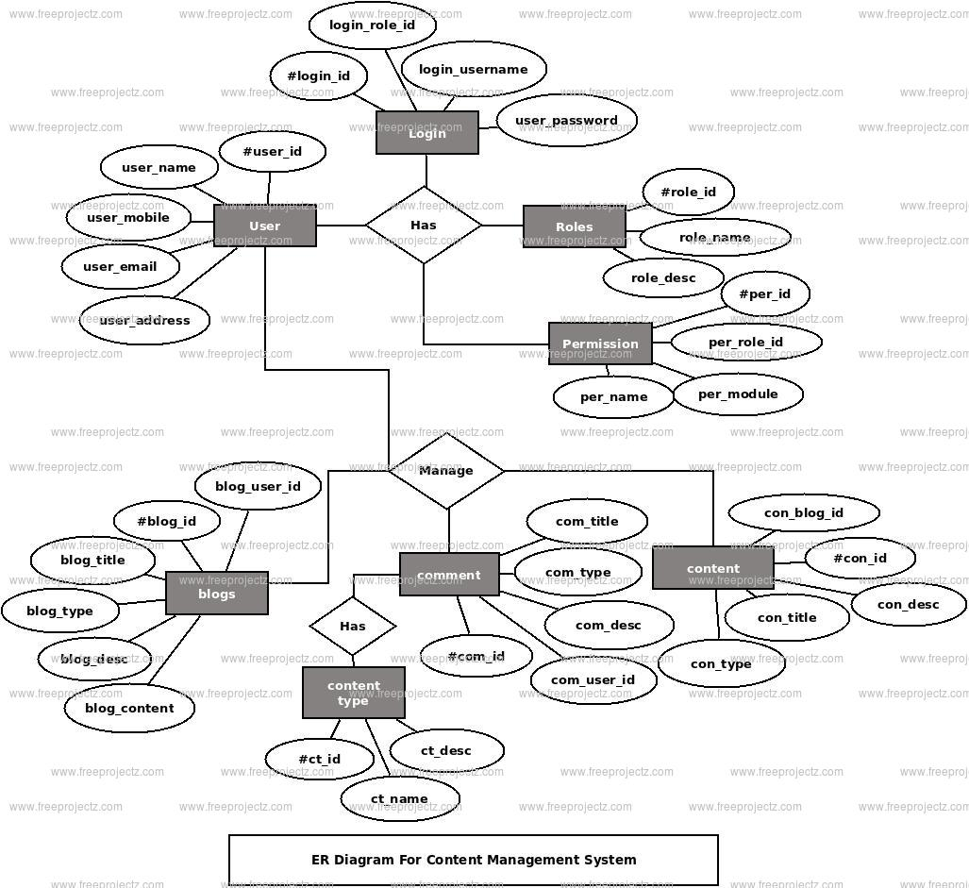

**Description of Content Management System Database :**

* The details of Content is store into the Content tables respective with all tables
* Each entity (Web Page, Content Category, Blogs, Content Type, Content) contains primary key and unique keys.
* The entity Content Category, Blogs has binded with Content, Content Type entities with foreign key
* There is one-to-one and one-to-many relationships available between Blogs, Comment, Web Page, Content
* All the entities Content, Blogs, Content Category, Web Page are normalized and reduce duplicacy of records
* We have implemented indexing on each tables of Content Management System tables for fast query execution.

**Conclusion**

In conclusion, the development of Content Management Systems has made creation, management of website contents for businesses easily, effective and secure. That is because managing a complex enterprise website with high numbers of contents is not an easy way and it is need to be done by a webmaster who will organize contents that it made by many authors. Also businesses need to have CMS because planning, creation and archiving contents will be managed by the CMS in easy way. An organization need to choose the best CMS that can help them achieve their goals without having a high total cost of ownership. Open source CMS are financially viable option for large companies with highly complex websites if they found the best one that have their requirements and it can help them to achieve their goals in the future.

**Contents**

* Introduction
* Purpose/ Objective
* Common features
* Advantages
* System Requirements (User)
* System Requirements (Developer)
* Feasibility Study
  + Economic Feasibility
  + Technical Feasibility
  + Operational Feasibility
* Description of Modules
  + Main Page(Client Area)
  + Admin Pannel
* E-R Diagram
* Description of Database
* Conclusion