Matlab Generated Section
PII at 6 2
Query user for logfile 2
Pull out the raw scans (if saved) 2
Create the waterfall horizontal and vertical axes 3
Plot SNR values versus PII values 3
PII at 7 5
Query user for logfile 5
Pull out the raw scans (if saved) 5
Create the waterfall horizontal and vertical axes 5
Plot SNR values versus PII values 5
PII at 8 7
Query user for logfile 7
Separate raw, bandpassed, and motion filtered data from scn structure 7
Pull out the raw scans (if saved) 7
Create the waterfall horizontal and vertical axes 8
Plot SNR values versus PII values 8
PII at 9 10
Query user for logfile 10
Separate raw, bandpassed, and motion filtered data from scn structure 10
Pull out the raw scans (if saved) 10
Create the waterfall horizontal and vertical axes 10
Plot SNR values versus PII values 11
PII at 10 12
Query user for logfile 12
Pull out the raw scans (if saved) 12
Create the waterfall horizontal and vertical axes 13
Plot SNR values versus PII values 13
PII at 11 15
Query user for logfile 15
Pull out the raw scans (if saved) 15
Create the waterfall horizontal and vertical axes 15
Plot SNR values versus PII values 15
PII at 12 17
Query user for logfile 17
Pull out the raw scans (if saved) 17
Create the waterfall horizontal and vertical axes 18
Plot SNR values versus PII values 18
PII at 13 20
Query user for logfile 20
Pull out the raw scans (if saved) 20
Create the waterfall horizontal and vertical axes 20
Plot SNR values versus PII values 20
PII at 14 22
Query user for logfile 22
Separate raw, bandpassed, and motion filtered data from scn structure 22
Pull out the raw scans (if saved) 22
Create the waterfall horizontal and vertical axes 23
Plot SNR values versus PII values 23
PII at 15 25
Query user for logfile 25
Pull out the raw scans (if saved) 25
Create the waterfall horizontal and vertical axes 25
Plot SNR values versus PII values 25

PII at 6

Query user for logfile
[fnmb6,dnmb6] = uigetfile('*.csv');
fprintf('Reading logfile %s\n',fullfile(dnmb6,fnmb6));
[cfgb6,reqb6,scnb6,det6] = readMrmRetLog(fullfile(dnmb6,fnmb6));
[fnmt6,dnmt6] = uigetfile('*.csv');
fprintf('Reading logfile %s\n',fullfile(dnmt6,fnmt6));
[cfgt6,reqt6,scnt6,dett6] = readMrmRetLog(fullfile(dnmt6,fnmt6));

Pull out the raw scans (if saved)
rawscansIb6 = find([scnb6.Nfilt] == 1);
rawscansV_background6 = reshape([scnb6(rawscansIb6).scn],[],length(rawscansIb6))';
rawscansIt6 = find([scnt6.Nfilt] == 1);
rawscansV_target6 = reshape([scnt6(rawscansIt6).scn],[],length(rawscansIt6))';
scan_difference6 = abs(rawscansV_background6 - rawscansV_target6);

Create the waterfall horizontal and vertical axes
Tbin = 32/(512*1.024); % ns
T0 = 0; % ns
c = 0.29979; % m/ns
Rbin = c*(Tbin*(0:size(scan_difference6(1,:),2)-1) - T0)/2;% Range Bins in meters
%Background plot
%plot(Rbin,rawscansV_background(10,:)), title('Background Plot')
%Target plot
%figure; plot(Rbin,rawscansV_target(10,:)), title('Target Plot')
% Difference plot
figure(1);plot(Rbin,scan_difference6(10,:)), title('Difference Plot at PII 6')
%[a05,i] = max(scan_difference(10,100:122)); %In a range of distance values
%Rbin=i+99; %100=0.9m, 122=1.1m
[a6,i]=max(scan_difference6(10,:));
%distance = Rbin(i)
noise_sample6 = scan_difference6(10,125:175); % 125:175 is just an example. it comes from Rbin, the index of the distance range where you want to remove noise that's close to your 1m peak
noise_var6 = var(noise_sample6); % noise variance
SNR6= 10*log10(a6^2/noise_var6); % SNR in dB

Plot SNR values versus PII values
PII6 = 2.^(6:15);
figure(2);
plot(PII6, SNR6, 'o-');
title('SNR vs. PII at 6');
xlabel('PII');
ylabel('SNR (linear)');
Reading logfile C:\Users\tonka\OneDrive\Documents\MATLAB\384_Lab\cw10_scans\Background\RetLog_6007.csv
Reading logfile C:\Users\tonka\OneDrive\Documents\MATLAB\384_Lab\cw10_scans\Target\RetLog_6003.csv
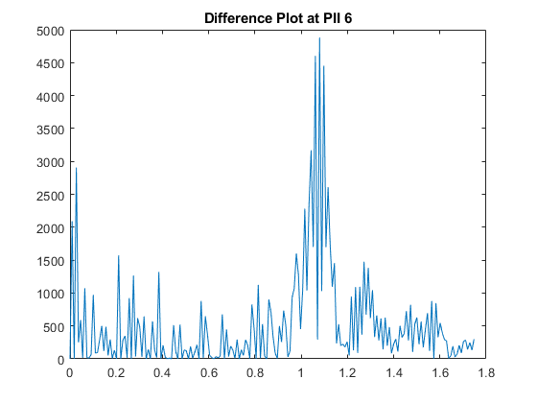
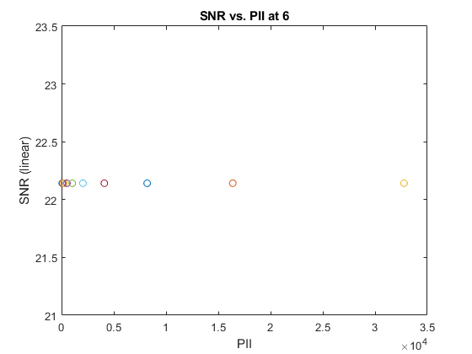

PII at 7

Query user for logfile
[fnmb7,dnmb7] = uigetfile('*.csv');
fprintf('Reading logfile %s\n',fullfile(dnmb7,fnmb7));
[cfgb7,reqb7,scnb7,det7] = readMrmRetLog(fullfile(dnmb7,fnmb7));
[fnmt7,dnmt7] = uigetfile('*.csv');
fprintf('Reading logfile %s\n',fullfile(dnmt7,fnmt7));
[cfgt7,reqt7,scnt7,dett7] = readMrmRetLog(fullfile(dnmt7,fnmt7));

Pull out the raw scans (if saved)
rawscansIb7 = find([scnb7.Nfilt] == 1);
rawscansV_background7 = reshape([scnb7(rawscansIb7).scn],[],length(rawscansIb7))';
rawscansIt7 = find([scnt7.Nfilt] == 1);
rawscansV_target7 = reshape([scnt7(rawscansIt7).scn],[],length(rawscansIt7))';
scan_difference7 = abs(rawscansV_background7 - rawscansV_target7);

Create the waterfall horizontal and vertical axes
Tbin = 32/(512*1.024); % ns
T0 = 0; % ns
c = 0.29979; % m/ns
Rbin = c*(Tbin*(0:size(scan_difference7(1,:),2)-1) - T0)/2;% Range Bins in meters
%Background plot
%plot(Rbin,rawscansV_background(10,:)), title('Background Plot')
%Target plot
%figure; plot(Rbin,rawscansV_target(10,:)), title('Target Plot')
% Difference plot
figure(3);plot(Rbin,scan_difference7(10,:)), title('Difference Plot at PII 7')
%[a05,i] = max(scan_difference(10,100:122)); %In a range of distance values
%Rbin=i+99; %100=0.9m, 122=1.1m
[a7,i]=max(scan_difference7(10,:));
%distance = Rbin(i)
noise_sample7 = scan_difference7(10,125:175); % 125:175 is just an example. it comes from Rbin, the index of the distance range where you want to remove noise that's close to your 1m peak
noise_var7 = var(noise_sample7); % noise variance
SNR7= 10*log10(a7^2/noise_var7); % SNR in dB

Plot SNR values versus PII values
PII7 = 2.^(6:15);
figure(4);
plot(PII7, SNR7, 'o-');
title('SNR vs. PII at 7');
xlabel('PII');
ylabel('SNR (linear)');
Reading logfile C:\Users\tonka\OneDrive\Documents\MATLAB\384_Lab\cw10_scans\Background\RetLog_7008.csv
Reading logfile C:\Users\tonka\OneDrive\Documents\MATLAB\384_Lab\cw10_scans\Target\RetLog_7010.csv
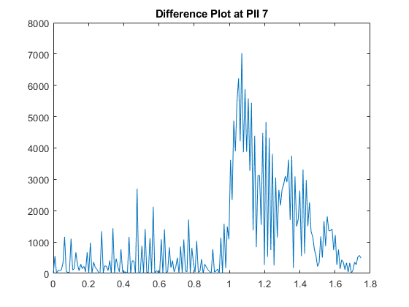
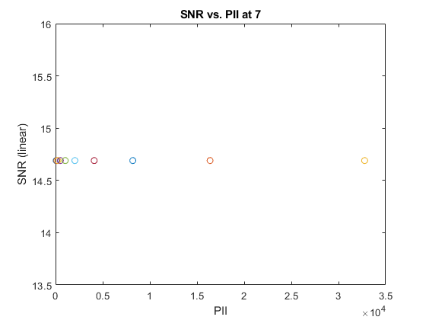

PII at 8

Query user for logfile
[fnmb8,dnmb8] = uigetfile('*.csv');
fprintf('Reading logfile %s\n',fullfile(dnmb8,fnmb8));
[cfgb8,reqb8,scnb8,det8] = readMrmRetLog(fullfile(dnmb8,fnmb8));
[fnmt8,dnmt8] = uigetfile('*.csv');
fprintf('Reading logfile %s\n',fullfile(dnmt8,fnmt8));
[cfgt8,reqt8,scnt8,dett8] = readMrmRetLog(fullfile(dnmt8,fnmt8));

Separate raw, bandpassed, and motion filtered data from scn structure
(only motion filtered is used)

Pull out the raw scans (if saved)
rawscansIb8 = find([scnb8.Nfilt] == 1);
rawscansV_background8 = reshape([scnb8(rawscansIb8).scn],[],length(rawscansIb8))';
rawscansIt8 = find([scnt8.Nfilt] == 1);
rawscansV_target8 = reshape([scnt8(rawscansIt8).scn],[],length(rawscansIt8))';
scan_difference8 = abs(rawscansV_background8 - rawscansV_target8);

Create the waterfall horizontal and vertical axes
Tbin = 32/(512*1.024); % ns
T0 = 0; % ns
c = 0.29979; % m/ns
Rbin = c*(Tbin*(0:size(scan_difference8(1,:),2)-1) - T0)/2;% Range Bins in meters
%Background plot
%plot(Rbin,rawscansV_background(10,:)), title('Background Plot')
%Target plot
%figure; plot(Rbin,rawscansV_target(10,:)), title('Target Plot')
% Difference plot
figure(5);plot(Rbin,scan_difference8(10,:)), title('Difference Plot at PII 8')
%[a05,i] = max(scan_difference(10,100:122)); %In a range of distance values
%Rbin=i+99; %100=0.9m, 122=1.1m
[a8,i]=max(scan_difference8(10,:));
%distance = Rbin(i)
noise_sample8 = scan_difference8(10,125:175); % 125:175 is just an example. it comes from Rbin, the index of the distance range where you want to remove noise that's close to your 1m peak
noise_var8 = var(noise_sample8); % noise variance
SNR8= 10*log10(a8^2/noise_var8); % SNR in dB

Plot SNR values versus PII values
PII8 = 2.^(6:15);
figure(6);
plot(PII8, SNR8, 'o-');
title('SNR vs. PII at 8');
xlabel('PII');
ylabel('SNR (linear)');
Reading logfile C:\Users\tonka\OneDrive\Documents\MATLAB\384_Lab\cw10_scans\Background\RetLog_8013.csv
Reading logfile C:\Users\tonka\OneDrive\Documents\MATLAB\384_Lab\cw10_scans\Target\RetLog_8011.csv
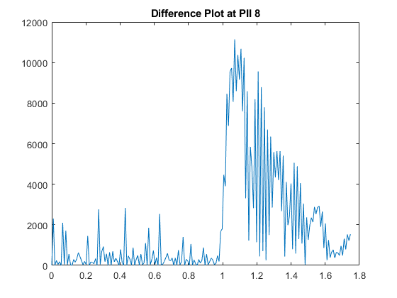
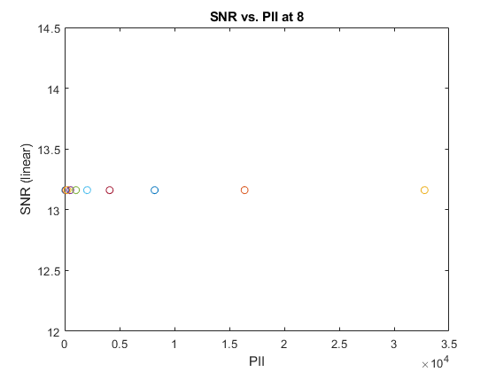

PII at 9

Query user for logfile
[fnmb9,dnmb9] = uigetfile('*.csv');
fprintf('Reading logfile %s\n',fullfile(dnmb9,fnmb9));
[cfgb9,reqb9,scnb9,det9] = readMrmRetLog(fullfile(dnmb9,fnmb9));
[fnmt9,dnmt9] = uigetfile('*.csv');
fprintf('Reading logfile %s\n',fullfile(dnmt9,fnmt9));
[cfgt9,reqt9,scnt9,dett9] = readMrmRetLog(fullfile(dnmt9,fnmt9));

Separate raw, bandpassed, and motion filtered data from scn structure
(only motion filtered is used)

Pull out the raw scans (if saved)
rawscansIb9 = find([scnb9.Nfilt] == 1);
rawscansV_background9 = reshape([scnb9(rawscansIb9).scn],[],length(rawscansIb9))';
rawscansIt9 = find([scnt9.Nfilt] == 1);
rawscansV_target9 = reshape([scnt9(rawscansIt9).scn],[],length(rawscansIt9))';
scan_difference9 = abs(rawscansV_background9 - rawscansV_target9);

Create the waterfall horizontal and vertical axes
Tbin = 32/(512*1.024); % ns
T0 = 0; % ns
c = 0.29979; % m/ns
Rbin = c*(Tbin*(0:size(scan_difference9(1,:),2)-1) - T0)/2;% Range Bins in meters
%Background plot
%plot(Rbin,rawscansV_background(10,:)), title('Background Plot')
%Target plot
%figure; plot(Rbin,rawscansV_target(10,:)), title('Target Plot')
% Difference plot
figure(7);plot(Rbin,scan_difference9(10,:)), title('Difference Plot at PII 9')
%[a05,i] = max(scan_difference(10,100:122)); %In a range of distance values
%Rbin=i+99; %100=0.9m, 122=1.1m
[a9,i]=max(scan_difference9(10,:));
%distance = Rbin(i)
noise_sample9 = scan_difference9(10,125:175); % 125:175 is just an example. it comes from Rbin, the index of the distance range where you want to remove noise that's close to your 1m peak
noise_var9 = var(noise_sample9); % noise variance
SNR9= 10*log10(a9^2/noise_var9); % SNR in dB

Plot SNR values versus PII values
PII9 = 2.^(6:15);
figure(8);
plot(PII9, SNR9, 'o-');
title('SNR vs. PII at 9');
xlabel('PII');
ylabel('SNR (linear)');
Reading logfile C:\Users\tonka\OneDrive\Documents\MATLAB\384_Lab\cw10_scans\Background\RetLog_9015.csv
Reading logfile C:\Users\tonka\OneDrive\Documents\MATLAB\384_Lab\cw10_scans\Target\RetLog_9016.csv
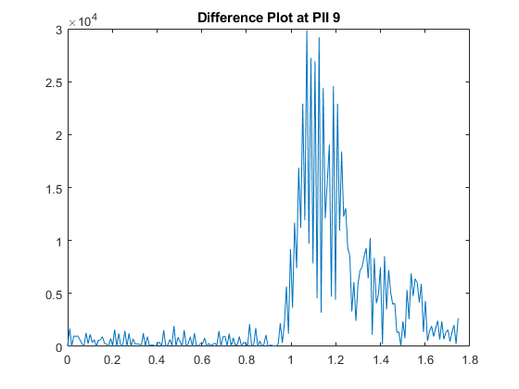
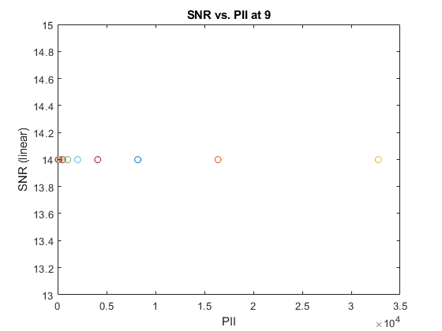

PII at 10

Query user for logfile
[fnmb10,dnmb10] = uigetfile('*.csv');
fprintf('Reading logfile %s\n',fullfile(dnmb10,fnmb10));
[cfgb10,reqb10,scnb10,det10] = readMrmRetLog(fullfile(dnmb10,fnmb10));
[fnmt10,dnmt10] = uigetfile('*.csv');
fprintf('Reading logfile %s\n',fullfile(dnmt10,fnmt10));
[cfgt10,reqt10,scnt10,dett10] = readMrmRetLog(fullfile(dnmt10,fnmt10));

Pull out the raw scans (if saved)
rawscansIb10 = find([scnb10.Nfilt] == 1);
rawscansV_background10 = reshape([scnb10(rawscansIb10).scn],[],length(rawscansIb10))';
rawscansIt10 = find([scnt10.Nfilt] == 1);
rawscansV_target10 = reshape([scnt10(rawscansIt10).scn],[],length(rawscansIt10))';
scan_difference10 = abs(rawscansV_background10 - rawscansV_target10);

Create the waterfall horizontal and vertical axes
Tbin = 32/(512*1.024); % ns
T0 = 0; % ns
c = 0.29979; % m/ns
Rbin = c*(Tbin*(0:size(scan_difference10(1,:),2)-1) - T0)/2;% Range Bins in meters
%Background plot
%plot(Rbin,rawscansV_background(10,:)), title('Background Plot')
%Target plot
%figure; plot(Rbin,rawscansV_target(10,:)), title('Target Plot')
% Difference plot
figure(9);plot(Rbin,scan_difference10(10,:)), title('Difference Plot at PII 10')
%[a05,i] = max(scan_difference(10,100:122)); %In a range of distance values
%Rbin=i+99; %100=0.9m, 122=1.1m
[a10,i]=max(scan_difference10(10,:));
%distance = Rbin(i)
noise_sample10 = scan_difference10(10,125:175); % 125:175 is just an example. it comes from Rbin, the index of the distance range where you want to remove noise that's close to your 1m peak
noise_var10 = var(noise_sample10); % noise variance
SNR10= 10*log10(a10^2/noise_var10); % SNR in dB

Plot SNR values versus PII values
PII10 = 2.^(6:15);
figure(10);
plot(PII10, SNR10, 'o-');
title('SNR vs. PII at 10');
xlabel('PII');
ylabel('SNR (linear)');
Reading logfile C:\Users\tonka\OneDrive\Documents\MATLAB\384_Lab\cw10_scans\Background\RetLog_10019.csv
Reading logfile C:\Users\tonka\OneDrive\Documents\MATLAB\384_Lab\cw10_scans\Target\RetLog_10018.csv
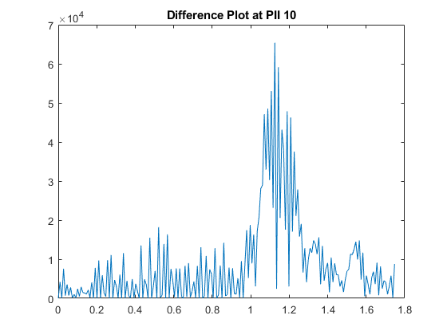
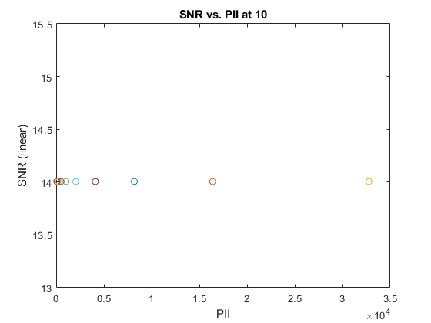

PII at 11

Query user for logfile
[fnmb11,dnmb11] = uigetfile('*.csv');
fprintf('Reading logfile %s\n',fullfile(dnmb11,fnmb11));
[cfgb11,reqb11,scnb11,det11] = readMrmRetLog(fullfile(dnmb11,fnmb11));
[fnmt11,dnmt11] = uigetfile('*.csv');
fprintf('Reading logfile %s\n',fullfile(dnmt11,fnmt11));
[cfgt11,reqt11,scnt11,dett11] = readMrmRetLog(fullfile(dnmt11,fnmt11));

Pull out the raw scans (if saved)
rawscansIb11 = find([scnb11.Nfilt] == 1);
rawscansV_background11 = reshape([scnb11(rawscansIb11).scn],[],length(rawscansIb11))';
rawscansIt11 = find([scnt11.Nfilt] == 1);
rawscansV_target11 = reshape([scnt11(rawscansIt11).scn],[],length(rawscansIt11))';
scan_difference11 = abs(rawscansV_background11 - rawscansV_target11);

Create the waterfall horizontal and vertical axes
Tbin = 32/(512*1.024); % ns
T0 = 0; % ns
c = 0.29979; % m/ns
Rbin = c*(Tbin*(0:size(scan_difference11(1,:),2)-1) - T0)/2;% Range Bins in meters
%Background plot
%plot(Rbin,rawscansV_background(10,:)), title('Background Plot')
%Target plot
%figure; plot(Rbin,rawscansV_target(10,:)), title('Target Plot')
% Difference plot
figure(11);plot(Rbin,scan_difference11(10,:)), title('Difference Plot at PII 11')
%[a05,i] = max(scan_difference(10,100:122)); %In a range of distance values
%Rbin=i+99; %100=0.9m, 122=1.1m
[a11,i]=max(scan_difference11(10,:));
%distance = Rbin(i)
noise_sample11 = scan_difference11(10,125:175); % 125:175 is just an example. it comes from Rbin, the index of the distance range where you want to remove noise that's close to your 1m peak
noise_var11 = var(noise_sample11); % noise variance
SNR11 = 10*log10(a6^2/noise_var11); % SNR in dB

Plot SNR values versus PII values
PII11 = 2.^(6:15);
figure(12);
plot(PII11, SNR11, 'o-');
title('SNR vs. PII at 11');
xlabel('PII');
ylabel('SNR (linear)');
Reading logfile C:\Users\tonka\OneDrive\Documents\MATLAB\384_Lab\cw10_scans\Background\RetLog_11021.csv
Reading logfile C:\Users\tonka\OneDrive\Documents\MATLAB\384_Lab\cw10_scans\Target\RetLog_11022.csv
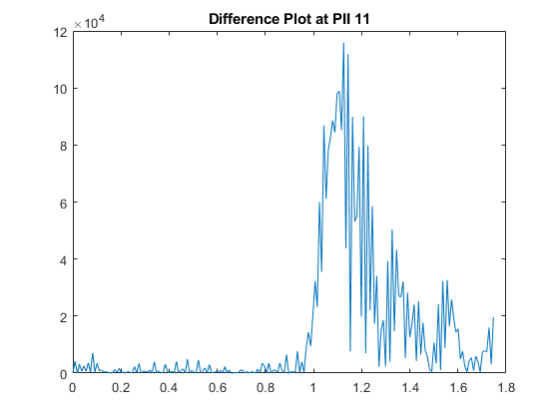
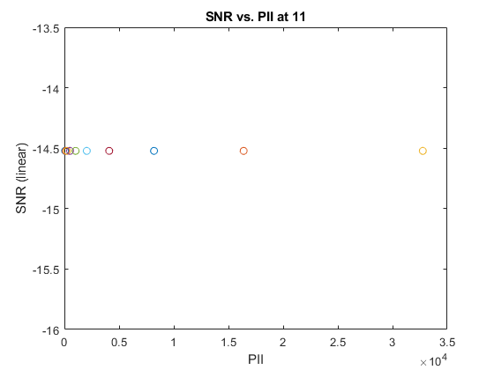

PII at 12

Query user for logfile
[fnmb12,dnmb12] = uigetfile('*.csv');
fprintf('Reading logfile %s\n',fullfile(dnmb12,fnmb12));
[cfgb12,reqb12,scnb12,det12] = readMrmRetLog(fullfile(dnmb12,fnmb12));
[fnmt12,dnmt12] = uigetfile('*.csv');
fprintf('Reading logfile %s\n',fullfile(dnmt12,fnmt12));
[cfgt12,reqt12,scnt12,dett12] = readMrmRetLog(fullfile(dnmt12,fnmt12));

Pull out the raw scans (if saved)
rawscansIb12 = find([scnb12.Nfilt] == 1);
rawscansV_background12 = reshape([scnb12(rawscansIb12).scn],[],length(rawscansIb12))';
rawscansIt12 = find([scnt12.Nfilt] == 1);
rawscansV_target12 = reshape([scnt12(rawscansIt12).scn],[],length(rawscansIt12))';
scan_difference12 = abs(rawscansV_background12 - rawscansV_target12);

Create the waterfall horizontal and vertical axes
Tbin = 32/(512*1.024); % ns
T0 = 0; % ns
c = 0.29979; % m/ns
Rbin = c*(Tbin*(0:size(scan_difference12(1,:),2)-1) - T0)/2;% Range Bins in meters
%Background plot
%plot(Rbin,rawscansV_background(10,:)), title('Background Plot')
%Target plot
%figure; plot(Rbin,rawscansV_target(10,:)), title('Target Plot')
% Difference plot
figure(13);plot(Rbin,scan_difference12(10,:)), title('Difference Plot at PII 12')
%[a05,i] = max(scan_difference(10,100:122)); %In a range of distance values
%Rbin=i+99; %100=0.9m, 122=1.1m
[a12,i]=max(scan_difference12(10,:));
%distance = Rbin(i)
noise_sample12 = scan_difference12(10,125:175); % 125:175 is just an example. it comes from Rbin, the index of the distance range where you want to remove noise that's close to your 1m peak
noise_var12 = var(noise_sample12); % noise variance
SNR12 = 10*log10(a12^2/noise_var12); % SNR in dB

Plot SNR values versus PII values
PII12 = 2.^(6:15);
figure(14);
plot(PII12, SNR12, 'o-');
title('SNR vs. PII at 12');
xlabel('PII');
ylabel('SNR (linear)');
Reading logfile C:\Users\tonka\OneDrive\Documents\MATLAB\384_Lab\cw10_scans\Background\RetLog_12025.csv
Reading logfile C:\Users\tonka\OneDrive\Documents\MATLAB\384_Lab\cw10_scans\Target\RetLog_12024.csv
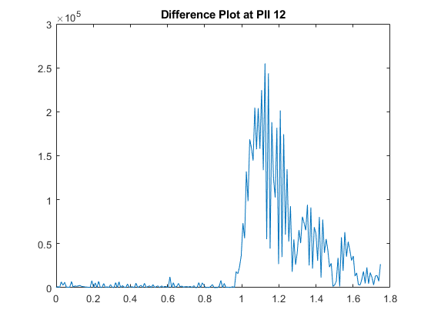
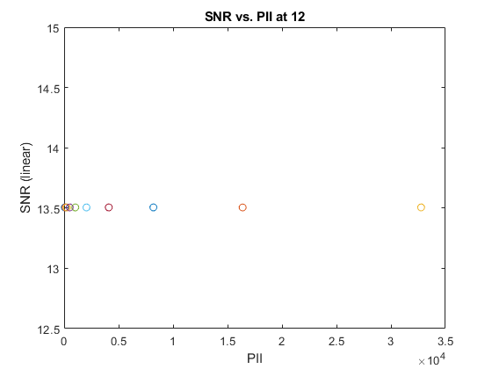

PII at 13

Query user for logfile
[fnmb13,dnmb13] = uigetfile('*.csv');
fprintf('Reading logfile %s\n',fullfile(dnmb13,fnmb13));
[cfgb13,reqb13,scnb13,det13] = readMrmRetLog(fullfile(dnmb13,fnmb13));
[fnmt13,dnmt13] = uigetfile('*.csv');
fprintf('Reading logfile %s\n',fullfile(dnmt13,fnmt13));
[cfgt13,reqt13,scnt13,dett13] = readMrmRetLog(fullfile(dnmt13,fnmt13));

Pull out the raw scans (if saved)
rawscansIb13 = find([scnb13.Nfilt] == 1);
rawscansV_background13 = reshape([scnb13(rawscansIb13).scn],[],length(rawscansIb13))';
rawscansIt13 = find([scnt13.Nfilt] == 1);
rawscansV_target13 = reshape([scnt13(rawscansIt13).scn],[],length(rawscansIt13))';
scan_difference13 = abs(rawscansV_background13 - rawscansV_target13);

Create the waterfall horizontal and vertical axes
Tbin = 32/(512*1.024); % ns
T0 = 0; % ns
c = 0.29979; % m/ns
Rbin = c*(Tbin*(0:size(scan_difference13(1,:),2)-1) - T0)/2;% Range Bins in meters
%Background plot
%plot(Rbin,rawscansV_background(10,:)), title('Background Plot')
%Target plot
%figure; plot(Rbin,rawscansV_target(10,:)), title('Target Plot')
% Difference plot
figure(15);plot(Rbin,scan_difference13(10,:)), title('Difference Plot at PII 13')
%[a05,i] = max(scan_difference(10,100:122)); %In a range of distance values
%Rbin=i+99; %100=0.9m, 122=1.1m
[a13,i]=max(scan_difference13(10,:));
%distance = Rbin(i)
noise_sample13 = scan_difference13(10,125:175); % 125:175 is just an example. it comes from Rbin, the index of the distance range where you want to remove noise that's close to your 1m peak
noise_var13 = var(noise_sample13); % noise variance
SNR13 = 10*log10(a13^2/noise_var13); % SNR in dB

Plot SNR values versus PII values
PII13 = 2.^(6:15);
figure(16);
plot(PII13, SNR13, 'o-');
title('SNR vs. PII at 13');
xlabel('PII');
ylabel('SNR (linear)');
Reading logfile C:\Users\tonka\OneDrive\Documents\MATLAB\384_Lab\cw10_scans\Background\RetLog_13027.csv
Reading logfile C:\Users\tonka\OneDrive\Documents\MATLAB\384_Lab\cw10_scans\Target\RetLog_13028.csv
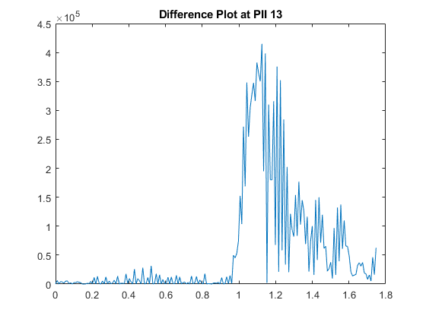
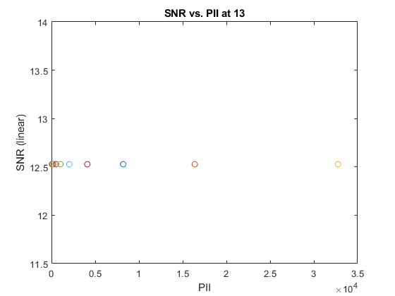

PII at 14

Query user for logfile
[fnmb14,dnmb14] = uigetfile('*.csv');
fprintf('Reading logfile %s\n',fullfile(dnmb14,fnmb14));
[cfgb14,reqb14,scnb14,det14] = readMrmRetLog(fullfile(dnmb14,fnmb14));
[fnmt14,dnmt14] = uigetfile('*.csv');
fprintf('Reading logfile %s\n',fullfile(dnmt14,fnmt14));
[cfgt14,reqt14,scnt14,dett14] = readMrmRetLog(fullfile(dnmt14,fnmt14));

Separate raw, bandpassed, and motion filtered data from scn structure
(only motion filtered is used)

Pull out the raw scans (if saved)
rawscansIb14 = find([scnb14.Nfilt] == 1);
rawscansV_background14 = reshape([scnb14(rawscansIb14).scn],[],length(rawscansIb14))';
rawscansIt14 = find([scnt14.Nfilt] == 1);
rawscansV_target14 = reshape([scnt14(rawscansIt14).scn],[],length(rawscansIt14))';
scan_difference14 = abs(rawscansV_background14 - rawscansV_target14);

Create the waterfall horizontal and vertical axes
Tbin = 32/(512*1.024); % ns
T0 = 0; % ns
c = 0.29979; % m/ns
Rbin = c*(Tbin*(0:size(scan_difference14(1,:),2)-1) - T0)/2;% Range Bins in meters
%Background plot
%plot(Rbin,rawscansV_background(10,:)), title('Background Plot')
%Target plot
%figure; plot(Rbin,rawscansV_target(10,:)), title('Target Plot')
% Difference plot
figure(17);plot(Rbin,scan_difference14(10,:)), title('Difference Plot at PII 14')
%[a05,i] = max(scan_difference(10,100:122)); %In a range of distance values
%Rbin=i+99; %100=0.9m, 122=1.1m
[a15,i]=max(scan_difference14(10,:));
%distance = Rbin(i)
noise_sample14 = scan_difference14(10,125:175); % 125:175 is just an example. it comes from Rbin, the index of the distance range where you want to remove noise that's close to your 1m peak
noise_var14 = var(noise_sample14); % noise variance
SNR14 = 10*log10(a15^2/noise_var14); % SNR in dB

Plot SNR values versus PII values
PII14 = 2.^(6:15);
figure(18);
plot(PII14, SNR14, 'o-');
title('SNR vs. PII at 14');
xlabel('PII');
ylabel('SNR (linear)');
Reading logfile C:\Users\tonka\OneDrive\Documents\MATLAB\384_Lab\cw10_scans\Background\RetLog_14031.csv
Reading logfile C:\Users\tonka\OneDrive\Documents\MATLAB\384_Lab\cw10_scans\Target\RetLog_14030.csv
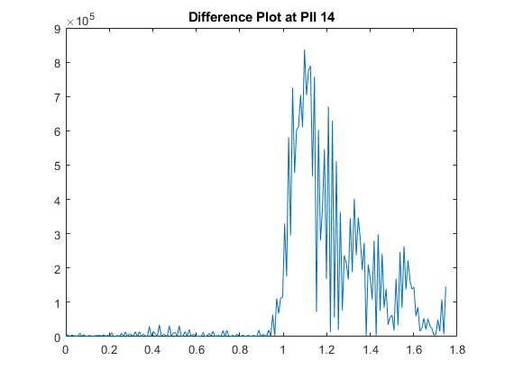
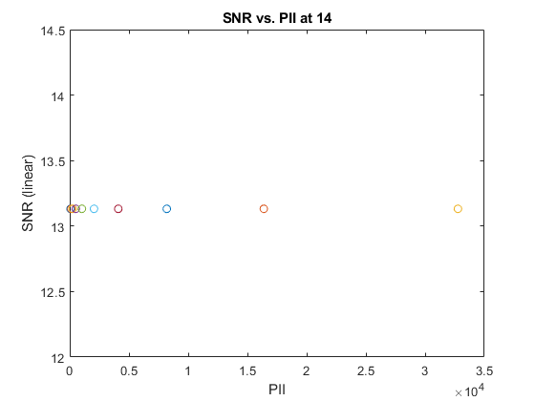

PII at 15

Query user for logfile
[fnmb15,dnmb15] = uigetfile('*.csv');
fprintf('Reading logfile %s\n',fullfile(dnmb15,fnmb15));
[cfgb15,reqb15,scnb15,det15] = readMrmRetLog(fullfile(dnmb15,fnmb15));
[fnmt15,dnmt15] = uigetfile('*.csv');
fprintf('Reading logfile %s\n',fullfile(dnmt15,fnmt15));
[cfgt15,reqt15,scnt15,dett15] = readMrmRetLog(fullfile(dnmt15,fnmt15));

Pull out the raw scans (if saved)
rawscansIb15 = find([scnb15.Nfilt] == 1);
rawscansV_background15 = reshape([scnb15(rawscansIb15).scn],[],length(rawscansIb15))';
rawscansIt15 = find([scnt15.Nfilt] == 1);
rawscansV_target15 = reshape([scnt15(rawscansIt15).scn],[],length(rawscansIt15))';
scan_difference15 = abs(rawscansV_background15 - rawscansV_target15);

Create the waterfall horizontal and vertical axes
Tbin = 32/(512*1.024); % ns
T0 = 0; % ns
c = 0.29979; % m/ns
Rbin = c*(Tbin*(0:size(scan_difference15(1,:),2)-1) - T0)/2;% Range Bins in meters
%Background plot
%plot(Rbin,rawscansV_background(10,:)), title('Background Plot')
%Target plot
%figure; plot(Rbin,rawscansV_target(10,:)), title('Target Plot')
% Difference plot
figure(19);plot(Rbin,scan_difference15(10,:)), title('Difference Plot at PII 15')
%[a05,i] = max(scan_difference(10,100:122)); %In a range of distance values
%Rbin=i+99; %100=0.9m, 122=1.1m
[a15,i]=max(scan_difference15(10,:));
%distance = Rbin(i)
noise_sample15 = scan_difference15(10,125:175); % 125:175 is just an example. it comes from Rbin, the index of the distance range where you want to remove noise that's close to your 1m peak
noise_var15 = var(noise_sample15); % noise variance
SNR15 = 10*log10(a15^2/noise_var15); % SNR in dB

Plot SNR values versus PII values
PII15 = 2.^(6:15);
figure(20);
plot(PII15, SNR15, 'o-');
title('SNR vs. PII at 15');
xlabel('PII');
ylabel('SNR (linear)');
Reading logfile C:\Users\tonka\OneDrive\Documents\MATLAB\384_Lab\cw10_scans\Background\RetLog_15033.csv
Reading logfile C:\Users\tonka\OneDrive\Documents\MATLAB\384_Lab\cw10_scans\Target\RetLog_15034.csv
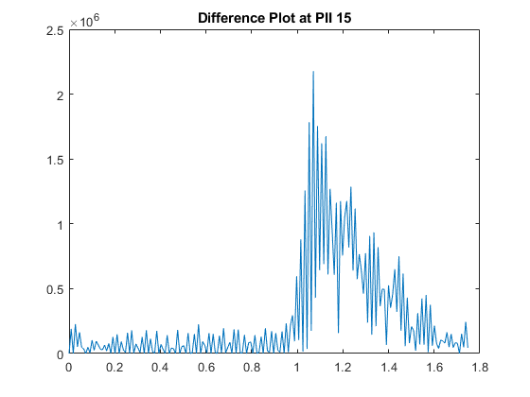
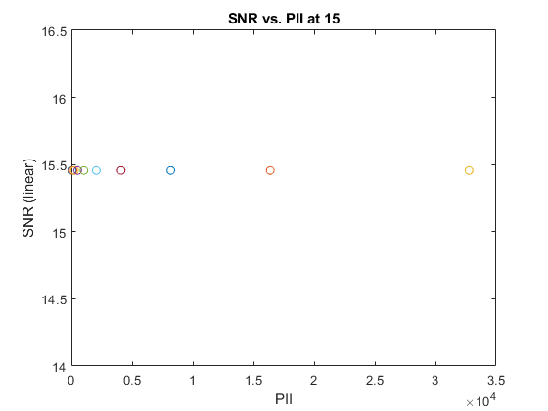
Published with MATLAB® R2022b

Question Section
- Looking at the difference plots as the PII increases you can see more and more noise in them. It seems to generally follow the trend of increasing by 3 dB. One way to improve the results is to do more noise reduction and double check for any errors in the math used to get the noise from the signal.
- As PII increases time should also increase as its acquiring more integration points. However ours seemed to relatively stay at the same time or was faster. Part this could have been due to human error of not exactly starting and stopping the stopwatch at the same instant of when the scan was started and stopped.
Background | Target | Time | Distance
6007 | 6003 | 7.11 | 1.0796
7008 | 7010 | 6.25 | 1.0704
8013 | 8011 | 7.15 | 1.0704
9015 | 9016 | 6.65 | 1.0704
10019 | 10018 | 6.76 | 1.1253
11021 | 11022 | 7.13 | 1.1253
12025 | 12024 | 6.61 | 1.1253
13027 | 13028 | 6.78 | 1.1253
14031 | 14030 | 6.75 | 1.0979
15033 | 15034 | 6.91 | 1.0704

