MatLab Code Publish
*Figures are for final result, see Additional Data for figures of other tries
Query user for logfile 1
Separate raw, bandpassed, and motion filtered data from scn structure 1
Pull out the raw scans (if saved) 1
Create the waterfall horizontal and vertical axes 2
% plotMrmRetLog.m
% This script prompts the user for a MRM-RET logfile, reads, parses, and
% produces a "waterfall plot" of the motion filtered scans and detection lists
% in the logfile
clear all; close all; clc

Query user for logfile
%dnm = '.'; fnm = 'MRM_002.csv';
[fnmb,dnmb] = uigetfile('*.csv');
fprintf('Reading logfile %s\n',fullfile(dnmb,fnmb));
[cfgb,reqb,scnb,det] = readMrmRetLog(fullfile(dnmb,fnmb));
[fnmt,dnmt] = uigetfile('*.csv');
fprintf('Reading logfile %s\n',fullfile(dnmt,fnmt));
[cfgt,reqt,scnt,dett] = readMrmRetLog(fullfile(dnmt,fnmt));
Reading logfile C:\Users\tonka\OneDrive\Documents\MATLAB\384_Lab\cw8_scans\cw8_scans\RetLog_Background006.csv
Reading logfile C:\Users\tonka\OneDrive\Documents\MATLAB\384_Lab\cw8_scans\cw8_scans\RetLog_Target007.csv

Separate raw, bandpassed, and motion filtered data from scn structure
(only motion filtered is used)

Pull out the raw scans (if saved)
rawscansI = find([scnb.Nfilt] == 1);
rawscansV_background = reshape([scnb(rawscansI).scn],[],length(rawscansI))';
rawscansI1 = find([scnt.Nfilt] == 1);
rawscansV_target = reshape([scnt(rawscansI1).scn],[],length(rawscansI1))';
scan_difference = abs(rawscansV_background(1:10,:) - rawscansV_target(1:10,:));

Create the waterfall horizontal and vertical axes
Tbin = 32/(512*1.024); % ns
T0 = 0; % ns
c = 0.29979; % m/ns
Rbin = c*(Tbin*(0:size(scan_difference(1,:),2)-1) - T0)/2;% Range Bins in meters
rbin = 90;
%Background plot
figure; plot(Rbin,rawscansV_background(10,:))
%Taget plot
figure; plot(Rbin,rawscansV_target(10,:))
% Difference plot
figure;plot(Rbin,scan_difference(10,:))
[a,i]=max(scan_difference(10,:));
distance=Rbin(i)
distance =
1.0613
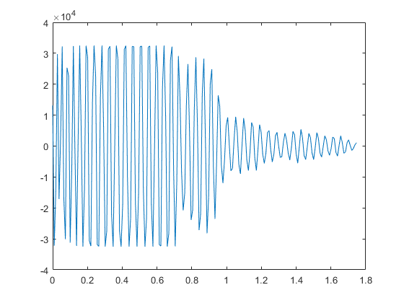
Figure 1. Background Scan
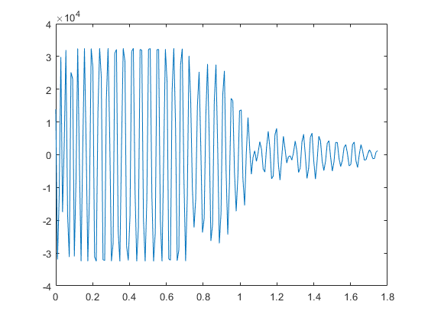
Figure 2. Target Scan
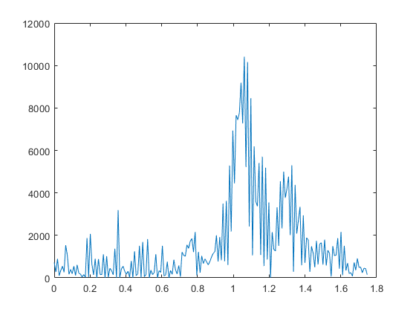
Figure 3. Difference Scan
Published with MATLAB® R2022b

Additional Data
- 4a
  - R = (c*tau)/2
  - 2 = (c*tau)/2
  - 1/c = tau
  - A scan should last 0.33 ms or 1/c. C being the speed of light
- 4c
  - Start: 11189
  - Stop: 22908

Scanning Tries/Data
- Try 1:
  - Start Time: 10000
  - Stop Time: 21718
  - Measured distance = 0.8783
  - Tau: 811.333

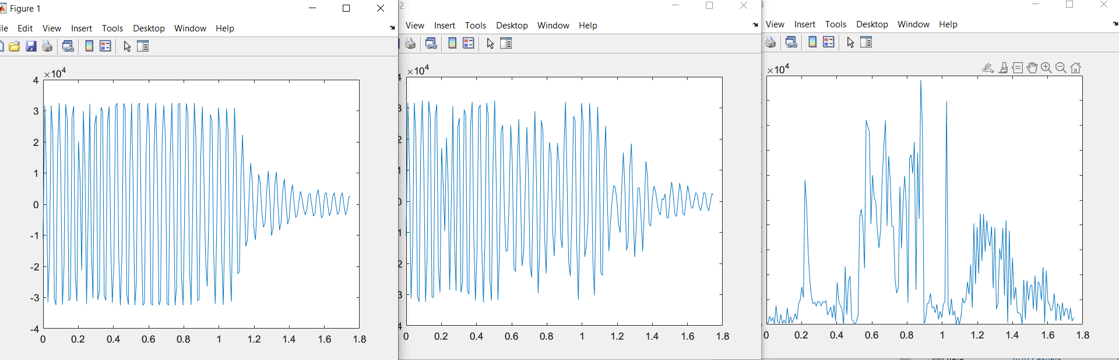

- Try 2
  - Start Time: 9189
  - Stop Time: 20907 (program rounded it to 08)
  - Measured distance = 1.4
  - Tau: 1333

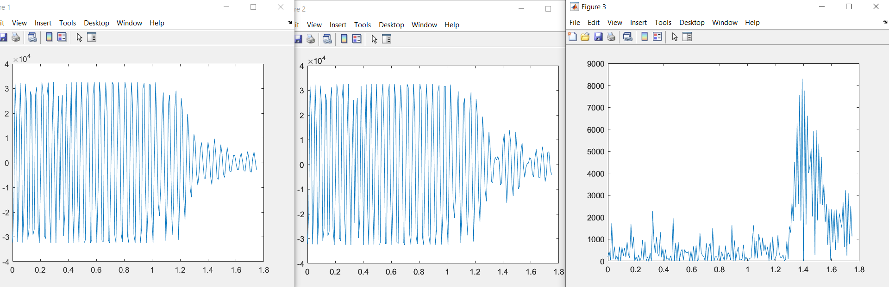

- Try 3
  - Start Time: 10522
  - Stop Time: 22241
  - Measured Distance = 1.2
  - Tau: 667 (rounded)

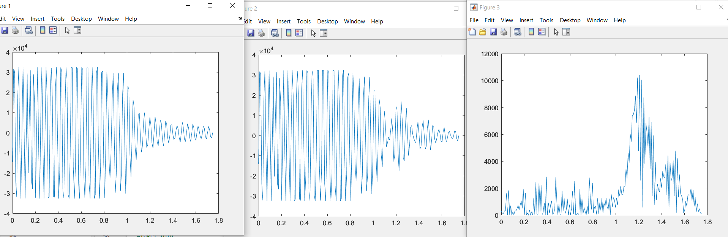

- Try 4 (Final- figures published by matlab code)
  - Start Time: 11189 (program rounded it to 88)
  - Stop Time: 22908 (program rounded it to 07)
  - Measured Distance: 1.0613

