MatLab Published Code
Query user for logfile 1
Separate raw, bandpassed, and motion filtered data from scn structure 1
Pull out the raw scans (if saved) 2
Create the waterfall horizontal and vertical axes 2
% plotMrmRetLog.m
% This script prompts the user for a MRM-RET logfile, reads, parses, and
% produces a "waterfall plot" of the motion filtered scans and detection lists
% in the logfile
clear all; close all; clc

Query user for logfile
%dnm = '.'; fnm = 'MRM_002.csv';
[fnmb,dnmb] = uigetfile('*.csv');
fprintf('Reading logfile %s\n',fullfile(dnmb,fnmb));
[cfgb,reqb,scnb,det] = readMrmRetLog(fullfile(dnmb,fnmb));
% Target 1
[fnmt05,dnmt05] = uigetfile('*.csv');
fprintf('Reading logfile %s\n',fullfile(dnmt05,fnmt05));
[cfgt05,reqt05,scnt05,dett05] = readMrmRetLog(fullfile(dnmt05,fnmt05));
% Target 2
[fnmt10,dnmt10] = uigetfile('*.csv');
fprintf('Reading logfile %s\n',fullfile(dnmt10,fnmt10));
[cfgt10,reqt10,scnt10,dett10] = readMrmRetLog(fullfile(dnmt10,fnmt10));
% Target 3
[fnmt15,dnmt15] = uigetfile('*.csv');
fprintf('Reading logfile %s\n',fullfile(dnmt15,fnmt15));
[cfgt15,reqt15,scnt15,dett15] = readMrmRetLog(fullfile(dnmt15,fnmt15));
Reading logfile C:\Users\tonka\OneDrive\Documents\MATLAB\384_Lab\cw9_scans\RetLog_Background006.csv
Reading logfile C:\Users\tonka\OneDrive\Documents\MATLAB\384_Lab\cw9_scans\RetLog_Target_05m012.csv
Reading logfile C:\Users\tonka\OneDrive\Documents\MATLAB\384_Lab\cw9_scans\RetLog_Target_1m008.csv
Reading logfile C:\Users\tonka\OneDrive\Documents\MATLAB\384_Lab\cw9_scans\RetLog_Target_15m007.csv

Separate raw, bandpassed, and motion filtered data from scn structure
(only motion filtered is used)

Pull out the raw scans (if saved)
rawscansIb = find([scnb.Nfilt] == 1);
rawscansV_background = reshape([scnb(rawscansIb).scn],[],length(rawscansIb))';
% 1
rawscansIt05 = find([scnt05.Nfilt] == 1);
rawscansV_target05 = reshape([scnt05(rawscansIt05).scn],[],length(rawscansIt05))';
scan_difference05 = abs(rawscansV_background - rawscansV_target05);
% 2
rawscansIt10 = find([scnt10.Nfilt] == 1);
rawscansV_target10 = reshape([scnt10(rawscansIt10).scn],[],length(rawscansIt10))';
scan_difference10 = abs(rawscansV_background - rawscansV_target10);
% 3
rawscansIt15 = find([scnt15.Nfilt] == 1);
rawscansV_target15 = reshape([scnt15(rawscansIt15).scn],[],length(rawscansIt15))';
scan_difference15 = abs(rawscansV_background - rawscansV_target15);

Create the waterfall horizontal and vertical axes
Tbin = 32/(512*1.024); % ns
T0 = 0; % ns
c = 0.29979; % m/ns
% Only need 1 rbin
% target 1
Rbin05 = c*(Tbin*(0:size(scan_difference05(1,:),2)-1) - T0)/2;% Range Bins in meters
% target 2
Rbin10 = c*(Tbin*(0:size(scan_difference10(1,:),2)-1) - T0)/2;% Range Bins in meters
% target 3
Rbin15 = c*(Tbin*(0:size(scan_difference15(1,:),2)-1) - T0)/2;% Range Bins in meters
% 7b
figure; plot(Rbin05,rawscansV_background(10,:)) % Background plot
figure; plot(Rbin05,rawscansV_target05(10,:)) % Target 1 plot
figure; plot(Rbin10,rawscansV_target10(10,:)) % Target 2 plot
figure; plot(Rbin15,rawscansV_target15(10,:)) % Target 3 plot
% 7c
figure; plot(Rbin05,scan_difference05(10,:)) % Target 1, difference plot
figure; plot(Rbin10,scan_difference10(10,:)) % Target 2, difference plot
figure; plot(Rbin15,scan_difference15(10,:)) % Target 3, difference plot
% #8
[a05,i]=max(scan_difference05(10,:)); % target 1 max
[a10,j]=max(scan_difference10(10,:)); % target 2 max
[a15,k]=max(scan_difference15(10,:)); % target 3 max
distance_a05=Rbin05(i);
distance_a10=Rbin10(j);
distance_a15=Rbin15(k);
pow_a05 =a05^2; % target 1 power
pow_a10 =a10^2; % target 2 power
pow_a15 =a15^2; % target 3 power
% #9, target 1
scan_difference05_avg = zeros(1,length(scan_difference05(1,:)));
for i=1:10
scan_difference05_avg = scan_difference05_avg+scan_difference05(i,:);
end
scan_difference05_avg=scan_difference05_avg/10;
[c05,i]=max(scan_difference05_avg);
distance_c05=Rbin05(i);
% #9, target 2
scan_difference10_avg = zeros(1,length(scan_difference10(1,:)));
for i=1:10
scan_difference10_avg = scan_difference10_avg+scan_difference10(i,:);
end
scan_difference10_avg=scan_difference10_avg/10;
[c10,j]=max(scan_difference10_avg);
distance_c10=Rbin10(j);
% #9, target 3
scan_difference15_avg = zeros(1,length(scan_difference15(1,:)));
for i=1:10
scan_difference15_avg = scan_difference15_avg+scan_difference15(i,:);
end
scan_difference15_avg=scan_difference15_avg/10;
[c15,k]=max(scan_difference15_avg);
distance_c15=Rbin15(k);
% #9 powers
pow_c05 = c05^2;
pow_c10 = c10^2;
pow_c15 = c15^2;
% #9 plots
figure;
plot(distance_a05,pow_a05, 'rx'); hold on
plot(distance_c05,pow_c05, 'bo'); hold on
%
plot(distance_a10,pow_a10, 'rx'); hold on
plot(distance_c10,pow_c10, 'bo'); hold on
%
plot(distance_a15,pow_a15, 'rx'); hold on
plot(distance_c15,pow_c15, 'bo'); hold on
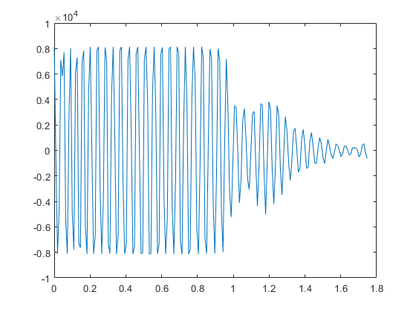
Figure 1. Background Plot
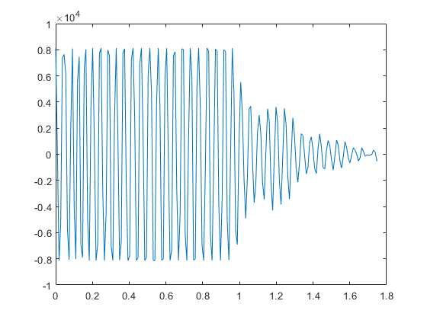
Figure 2. Target Plot 0.5 meters
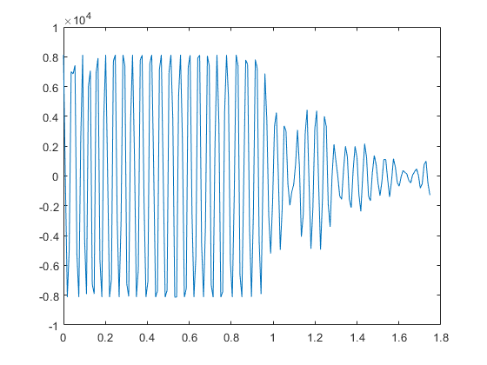
Figure 3. Target Plot 1 meter
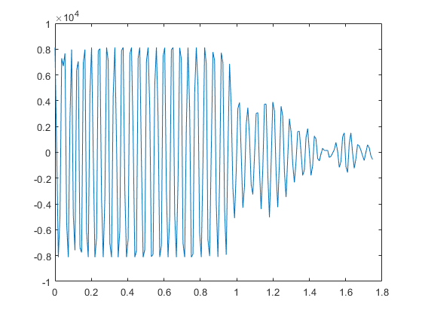
Figure 4. Target Plot 1.5 meters
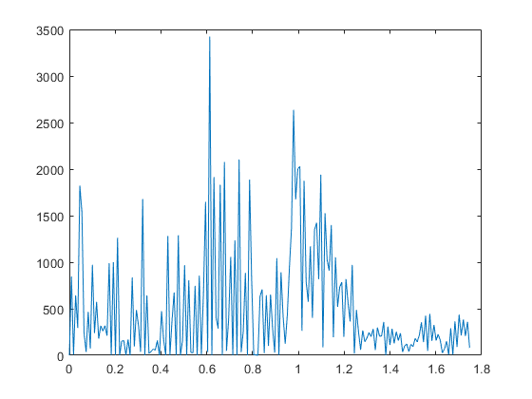
Figure 5. Difference Plot 0.5 meters
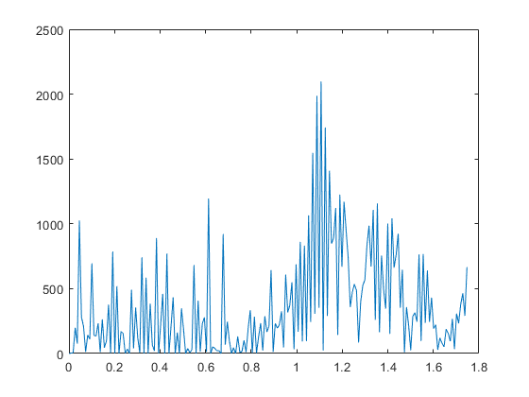
Figure 6. Difference Plot 1 meter
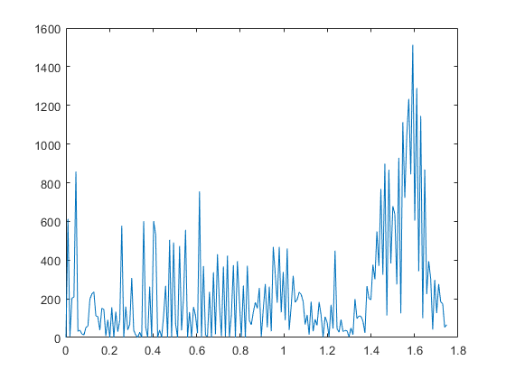
Figure 7. Difference Plot 1.5 meters
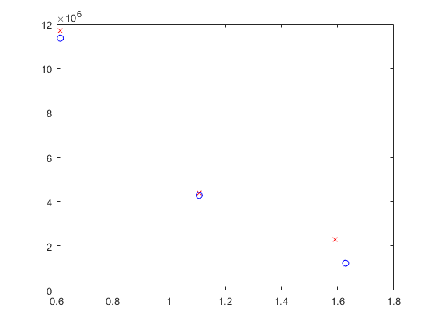
Figure 8. Distance & Power Overlaid Plot
Published with MATLAB® R2022b

Additional Questions
- 3
  - Start: 11188
  - Stop: 22907
- 7
  - Matlab Published Code
- 8 – Signal Power Comparison
  - Plot in Matlab Published Code Section Above
  - 0.5 meters: 11716929
  - 1 meter: 4397409
  - 1.5 meters: 2289169
  - 0.5meters/1 meter difference: 7319520
    - 4397409 * 1/0.5^4 = 70358544
  - 1 meter/ 1.5 meters difference: 2108240
    - 2289169 * 1/0.5^4 = 36626704
  - If I did the math correctly between from 0.5 meters to 1 meter the power dropped proportional to 1/R^4 where R is 0.5. However, from 1 to 1.5 meter it didn’t drop as much as expected. This could also be due to the distance values are not exactly 0.5, 1, and 1.5 meters.
- 9 – Average power
  - 0.5 meters: 1.136431521000000e+07
  - 1 meter: 4.274969760000000e+06
  - 1.5 meters: 1.221688090000000e+06
  - It doesn’t look like the average received powers followed the predicted performance because the 1 meter is higher than the other two.
- 10 – Told to skip
- For reference: the matlab variables. Pow_a# is the signal power and pow_c# is the average powers.
  - 