Problem 1 1
Problem 2 4

Problem 1
x = [1, 2, 3, 4, 5, 6, 7, 8];
%part a
a = fft(x);
figure(1)
plot(abs(a)), xlabel('Sample points (N-point DFT)'), ylabel('DFT values')
title("FFT using Matlab function")
%part b
b = ifft(a);
figure(2)
plot(abs(b)), xlabel('Sample points (N-point DFT)'), ylabel('Inverse DFT values')
title("Inverse FFT using Matlab function")
%part c
figure(3)
X = myDFT(x)
plot(abs(X)), hold on, plot(abs(a), 'r--')
title('FFT using the formula');
xlabel('Sample points (N-point DFT)');
ylabel('DFT values')
%inverse
figure(4)
Y = myInvDFT(X);
plot(abs(Y)), hold on, plot(abs(b), 'r--')
title('Inverse FFT using the formula');
xlabel('Sample points (N-point DFT)');
ylabel('Inverse DFT values');
legend('IFFT by Calculation', 'IFFT using Built-In')
X =
0 0 0 0 0 0 0 0
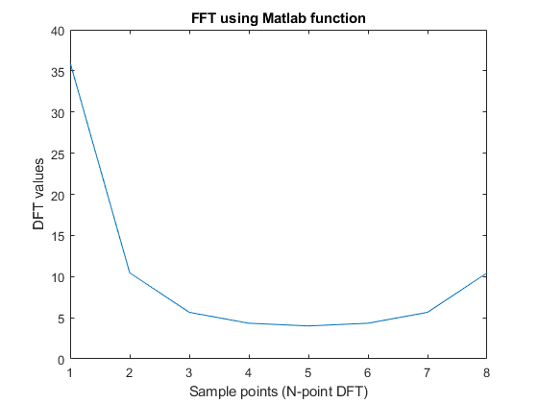
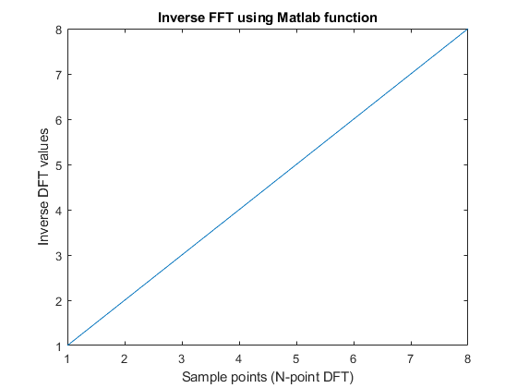
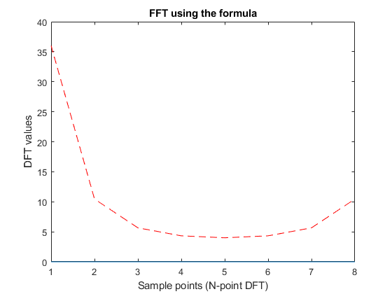
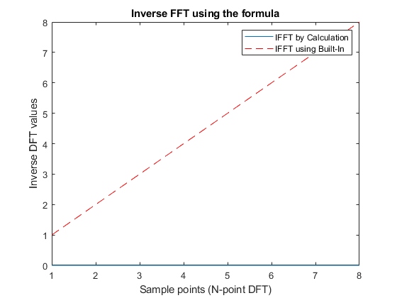

Problem 2
Fs = 8000; % 8kHz
Ts = 1/Fs;
t = 0:Ts:1;
f1 = 697; % 697 Hz
f2 = 1209; % 1209 Hz
y = sin(2*pi*f1*t) + sin(2*pi*f2*t);
figure(5)
plot(t,y), xlabel('Time t'), ylabel('Amplitude');
title(['Sine Wave with f = ', num2str(f1), 'Hz and ', num2str(f2), 'Hz'])
% part B) Freq Spectrum
y_psd = periodogram(y);
figure(6)
plot(10*log10(y_psd));
title('Frequency Spectrum using Matlab Func periodgram()')
xlabel('Frequency Hz'), ylabel('dB')
text(697, 10*log10(y_psd(697)), '697 Hz \rightarrow', 'HorizontalAlignment','right');
text(1209, 10*log10(y_psd(1209)), '1209 Hz \rightarrow', 'HorizontalAlignment','right');
%part c) sptool
% file import (input signal (y) and sampling freq (Fs) -> update, apply,
% take screen shot of peak values
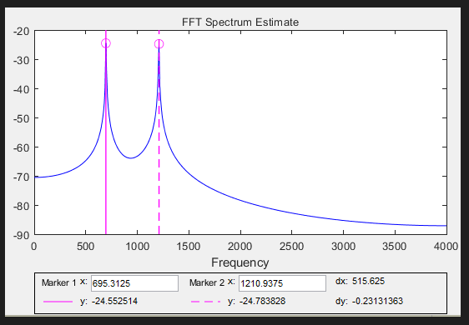
%part d) FFT
L = length(y); % Window
n = pow2(nextpow2(L)); % next power of 2 from length of y
y_dft = fft(x,n); % DFT
y_s = fftshift(y_dft); % Rearrange y values
f = (-n/2:n/2-1)*(Fs/n); % 0 centered frequency range
figure(7)
plot(f,abs(y_s)/n), xlabel('Frequency (Hz)'), title('Magnitude response of the sinusoidal signal')
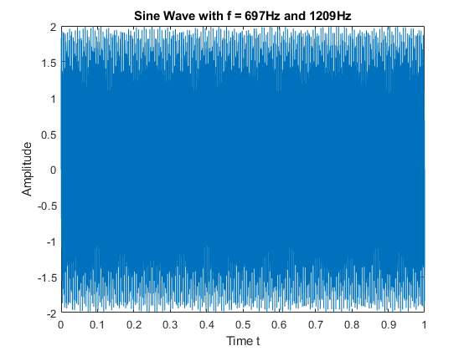
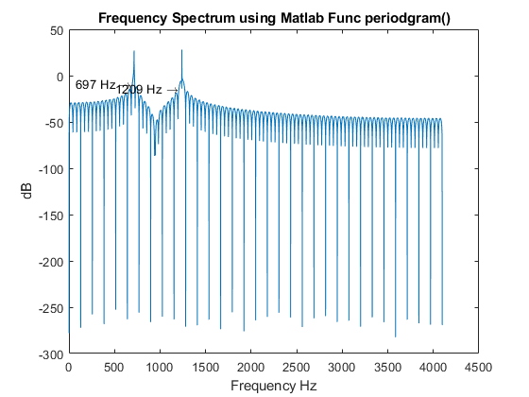
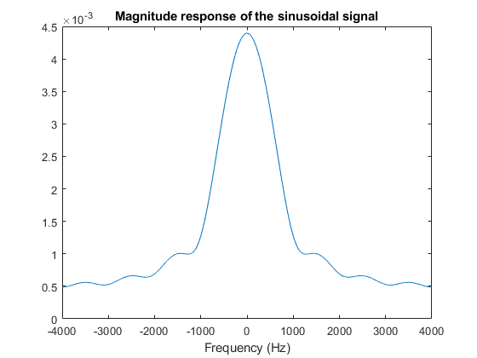
Published with MATLAB® R2022b

