My Code & Deployed:

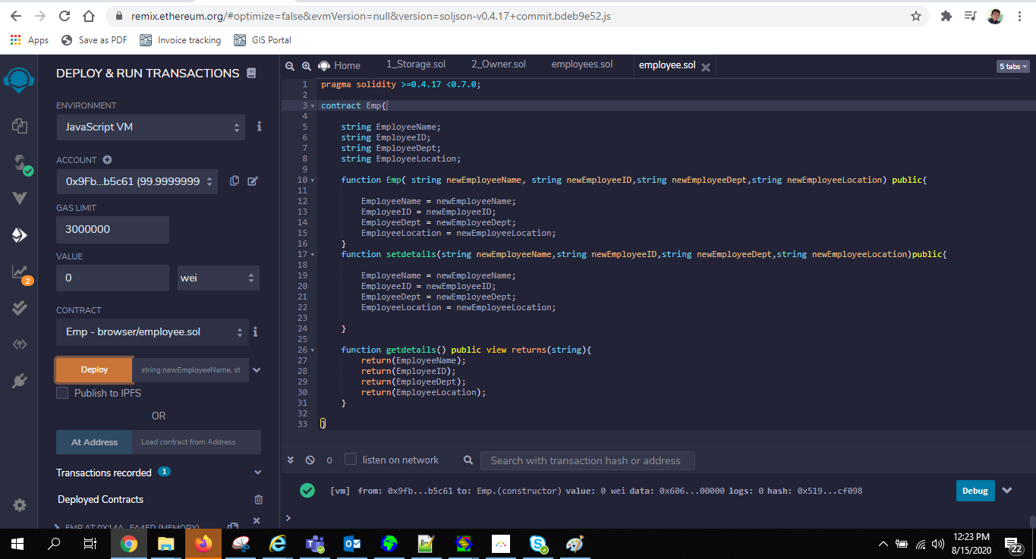

My Solidity Code:

pragma solidity >=0.4.17 <0.7.0;

contract Emp{

string EmployeeName;

string EmployeeID;

string EmployeeDept;

string EmployeeLocation;

function Emp( string newEmployeeName, string newEmployeeID,string newEmployeeDept,string newEmployeeLocation) public{

EmployeeName = newEmployeeName;

EmployeeID = newEmployeeID;

EmployeeDept = newEmployeeDept;

EmployeeLocation = newEmployeeLocation;

}

function setdetails(string newEmployeeName,string newEmployeeID,string newEmployeeDept,string newEmployeeLocation)public{

EmployeeName = newEmployeeName;

EmployeeID = newEmployeeID;

EmployeeDept = newEmployeeDept;

EmployeeLocation = newEmployeeLocation;

}

function getdetails() public view returns(string){

return(EmployeeName);

return(EmployeeID);

return(EmployeeDept);

return(EmployeeLocation);

}

}

