Train Ticket:

Solidity Code:

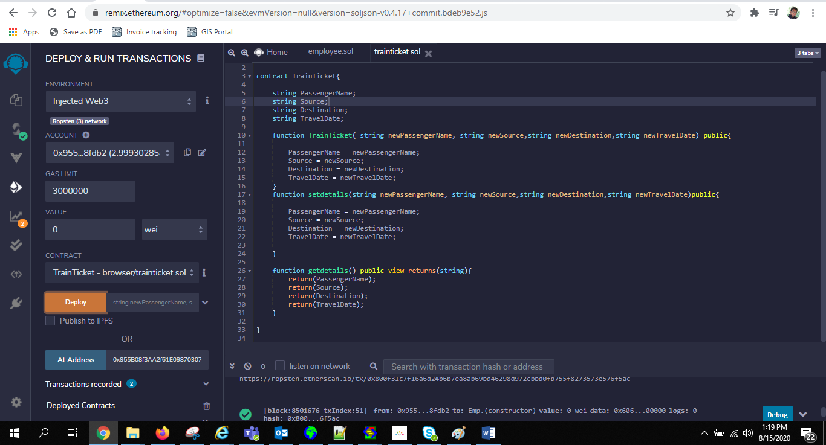

pragma solidity >=0.4.17 <0.7.0;

contract TrainTicket{

string PassengerName;

string Source;

string Destination;

string TravelDate;

function TrainTicket( string newPassengerName, string newSource,string newDestination,string newTravelDate) public{

PassengerName = newPassengerName;

Source = newSource;

Destination = newDestination;

TravelDate = newTravelDate;

}

function setdetails(string newPassengerName, string newSource,string newDestination,string newTravelDate)public{

PassengerName = newPassengerName;

Source = newSource;

Destination = newDestination;

TravelDate = newTravelDate;

}

function getdetails() public view returns(string){

return(PassengerName);

return(Source);

return(Destination);

return(TravelDate);

}

}

Contract Deployment on Ropten

