EX.NO: 01
ARITHMETIC OPERATIONS USING FUNCTION

CODE:
def add(x,y):
return x+y
def subtract(x,y):
return x-y
def multiply(x,y):
return x*y
def divide(x,y):
return x/y
print("Select Operation")
print("1.Add")
print("2.Subtract")
print("3.Multiply")
print("4.Divide")
choice=input("Enter Choice(1/2/3/4):")
num1=int(input("Enter first number:"))
num2=int(input("Enter second number:"))
if choice=="1":
print(num1,"+",num2,"=",add(num1,num2))
elif choice=="2":
print(num1,"-",num2,"=",subtract(num1,num2))
elif choice=="3":
print(num1,"*",num2,"=",multiply(num1,num2))
elif choice=="4":
print(num1,"/",num2,"=",divide(num1,num2))
else:
print("Invalid Input")

OUTPUT:
Select Operation
1.Add
2.Subtract
3.Multiply
4.Divide
Enter Choice(1/2/3/4):3
Enter first number:12
Enter second number:24
12 * 24 = 288

EX.NO: 02
WORKING WITH LIST

CODE:
mylist1 = ["apple", "banana", "cherry"]
print("Positive indexing: " + mylist1[1])
mylist2 = ["apple", "banana", "cherry"]
print("Negative indexing: " + mylist2[-1])
mylist3 = ["apple", "banana", "cherry", "orange", "kiwi", "melon", "mango"]
print("Range indexing:", mylist3[2:5])
mylist4 = ["apple", "banana", "cherry", "orange", "kiwi", "melon", "mango"]
print("Stop indexing:", mylist4[:4])

OUTPUT:
Positive indexing: banana
Negative indexing: cherry
Range indexing: ['cherry', 'orange', 'kiwi']
Stop indexing: ['apple', 'banana', 'cherry', 'orange']

EX.NO: 03
WORKING WITH LIST FUNCTIONS

CODE:
list1 = [10, 20, 30, 40, 50, 60]
print(list1)
print(list1[0])
print(list1[-1])
list1.insert(1, 10)
print(list1)
list1 = [1, 2, 3]
list1.append(4)
print(list1)
list1.remove(3)
print(list1)
print(len(list1))
list1.pop(1)
print(list1)
my_list = [10, 20, 30]
x = int(input("Enter n: "))
if x in my_list:
print("Founded at the index", my_list.index(x))
else:
print("Value not found!")

OUTPUT:
[10, 20, 30, 40, 50, 60]
10
60
[10, 10, 20, 30, 40, 50, 60]
[1, 2, 3, 4]
[1, 2, 4]
3
[1, 4]
Enter n: 24
Value not found!

EX.NO: 04
WORKING WITH TUPLE

CODE:
mytuple = ("apple", "banana", "cherry")
print(mytuple)
mytuple = ("apple", "banana", "cherry")
print(mytuple[1])
mytuple = ("apple", "banana", "cherry")
print(mytuple[-1])
mytuple = ("apple", "banana", "cherry", "mango", "grapes", "kiwi", "orange")
print(mytuple[2:5])

OUTPUT:
('apple', 'banana', 'cherry')
banana
cherry
('cherry', 'mango', 'grapes')

EX.NO: 05
WORKING WITH ARRAY
CODE:
arr = [10, 20, 30, 40, 50]
print("Array elements:", arr)
arr.insert(2, 25)
print(arr)
arr.remove(30)
print(arr)
x = 40
if x in arr:
print("Found at index:", arr.index(x))
else:
print("Not found!")
arr = [15, 3, 89, 34, 12]
print("The largest number in the array is", max(arr))
print("The smallest number in the array is", min(arr))
arr = [1, 2, 3, 4, 5]
arr.reverse()
print(arr)
arr = [10, 20, 30]
print("Sum:", sum(arr))
arr = [3, 1, 4, 2]
arr.sort()
print(arr)

OUTPUT:
Array elements: [10, 20, 30, 40, 50]
[10, 20, 25, 30, 40, 50]
[10, 20, 25, 40, 50]
Found at index: 3
The largest number in the array is 89
The smallest number in the array is 3
[5, 4, 3, 2, 1]
Sum: 60
[1, 2, 3, 4]

EX.NO: 06
WORKING WITH DICTIONARY

CODE:
#Creating a dictionary
state_capitals = {
"Tamilnadu": "Chennai",
"Kerala": "Trivandam",
"Karnataka": "Bangalore",
"Andra": "Hydrabad",
}
# Printing the dictionary
print(state_capitals)
# "Tamilnadu" - Key, "Chennai" - Value
# Access the value of keys
print(state_capitals["Tamilnadu"])
# Add item
state_capitals["Maharastra"] = "Mumbai"
print(state_capitals)
# Remove item
del state_capitals["Maharastra"]
print(state_capitals)
# To clear all items from the dictionary
state_capitals.clear()

OUTPUT:
{'Tamilnadu': 'Chennai', 'Kerala': 'Trivandam', 'Karnataka': 'Bangalore', 'Andra': 'Hydrabad'}
Chennai
{'Tamilnadu': 'Chennai', 'Kerala': 'Trivandam', 'Karnataka': 'Bangalore', 'Andra': 'Hydrabad', 'Maharastra': 'Mumbai'}
{'Tamilnadu': 'Chennai', 'Kerala': 'Trivandam', 'Karnataka': 'Bangalore', 'Andra': 'Hydrabad'}

EX.NO: 07
READING CSV FILE USING PANDAS

CODE:
# Read data from CSV file
import pandas as pd

# Read CSV into a DataFrame
df = pd.read_csv("U:\\cat24\\Book1.csv")

# Display the data
print(df)

OUTPUT:
student_id first_name last_name grade age email enrollment_date
0 1001 John Smith 10 15 john.smith@email.com 2023-09-01
1 1002 Emily Johnson 11 16 emily.j@email.com 2023-09-01
2 1003 Michelle Wong 10 15 michelle.wong@email.com 2023-09-02
3 1004 David Chen 12 17 david.chen@email.com 2023-09-01
4 1005 Sarah Williams 11 16 sarah.w@email.com 2023-09-03
6 1007 Jessica Davis 12 17 jessica.d@email.com 2023-09-02
7 1008 Michael Rodriguez 10 15 michael.r@email.com 2023-09-01
8 1009 Lisa Anderson 11 16 lisa.a@email.com 2023-09-03
9 1010 Robert Martinez 9 14 robert.m@email.com 2023-09-01
10 1011 Jennifer Taylor 10 15 jennifer.t@email.com 2023-09-02
11 1012 William Thomas 12 17 william.t@email.com 2023-09-01
12 1013 Elizabeth Jackson 11 16 elizabeth.j@email.com 2023-09-03
13 1014 Richard White 9 14 richard.w@email.com 2023-09-01
14 1015 Patricia Harris 10 15 patricia.h@email.com 2023-09-02

EX.NO: 08
CREATING DATAFRAME USING PANDAS

CODE:
import pandas as pd

# Sample DataFrame
df1 = pd.DataFrame({
"id": [1, 2, 3, 4], "Name": ["Ram", "Kumar", "Varun", "David"]
})

df2 = pd.DataFrame({
"id": [3, 4, 5, 6], "Score": [85, 90, 75, 88]
})

# Merge on column "id"
merged_df = pd.merge(df1, df2, on = "id", how = "inner")
print(merged_df)

OUTPUT:
id Name Score
0 3 Varun 85
1 4 David 90

EX.NO: 09
CREATING INDEX FOR DATAFRAME

CODE:
# Creating index for dataframe
# Create a dataframe
import pandas as pd
data = {
"Name": ["Kumar", "Ram", "Ramesh"],
"Age": [25, 28, 32],
"City": ["Chennai", "Madurai", "Trichy"]
}
df = pd.DataFrame(data)
# Display original dataframe
print("Original DataFrame:")
print(df)
print()
# Rename index
df.rename(index = {0: 'A', 1: 'B', 2: 'C'}, inplace = True)
# Display dataframe after index is renamed
print("After renaming the index of the original DataFrame:")
print(df.iloc[0])

OUTPUT:
Original DataFrame:
Name Age City
0 Kumar 25 Chennai
1 Ram 28 Madurai
2 Ramesh 32 Trichy

After renaming the index of the original DataFrame:
Name Kumar
Age 25
City Chennai
Name: A, dtype: object

EX.NO: 10
HANDLING MISSING VALUES

CODE:
# Python code to handle missing values
import pandas as pd
import numpy as np
# Create dataframe with missing values
data = {
'A': [1, 2, np.nan, 4, 5],
'B': [np.nan, 2, 3, 4, 5],
'C': [1, 2, 3, np.nan, 5],
'D': [1, 2, 3, 4, 5]
}
df = pd.DataFrame(data)
df.fillna(0, inplace = True)
print(df)

OUTPUT:
A B C D
0 1.0 0.0 1.0 1
1 2.0 2.0 2.0 2
2 0.0 3.0 3.0 3
3 4.0 4.0 0.0 4
4 5.0 5.0 5.0 5

EX.NO: 11
SORTING OF ARRAY ELEMENTS

CODE:
import numpy as np
# Create an array
arr = np.array([3, 1, 2, 4])
# Sort the array in ascending order
sorted_arr = np.sort(arr)
print("Ascending order:", sorted_arr)
# Sort the array in descending order
sorted_arr_desc = np.sort(arr)[::-1]
print("Descending order:", sorted_arr_desc)

OUTPUT:
Ascending order: [1 2 3 4]
Descending order: [4 3 2 1]

EX.NO: 12
PIVOT TABLE

CODE:
# Pivot Tables
import numpy as np
import pandas as pd
import seaborn as sns
titanic = sns.load_dataset("titanic")
print(titanic.head())
print(titanic.groupby("sex")[["survived"]].mean().to_string())
print(titanic.pivot_table("survived", index = "sex", columns = "class", observed = True))
age = pd.cut(titanic["age"], [0, 18, 80])
print(age)
print(titanic.pivot_table("survived", ["sex", "age"], "class", observed = True))
fare = pd.qcut(titanic["fare"], 2)
print(fare)
print(titanic.pivot_table("survived", ["sex", "age"], ["fare", "class"], observed = True))

OUTPUT:
survived pclass sex age ... deck embark_town alive alone
0 0 3 male 22.0 ... NaN Southampton no False
1 1 1 female 38.0 ... C Cherbourg yes False
2 1 3 female 26.0 ... NaN Southampton yes True
3 1 1 female 35.0 ... C Southampton yes False
4 0 3 male 35.0 ... NaN Southampton no True

[5 rows x 15 columns]
survived
sex
female 0.742038
male 0.188908
class First Second Third
sex
female 0.968085 0.921053 0.500000
male 0.368852 0.157407 0.135447
0 (18.0, 80.0]
1 (18.0, 80.0]
2 (18.0, 80.0]
3 (18.0, 80.0]
4 (18.0, 80.0]
...
886 (18.0, 80.0]
887 (18.0, 80.0]
888 NaN
889 (18.0, 80.0]
890 (18.0, 80.0]
Name: age, Length: 891, dtype: category
Categories (2, interval[int64, right]): [(0, 18] < (18, 80]]
class First Second Third
sex age
female 0.75 NaN NaN 1.00
1.00 NaN NaN 1.00
2.00 0.0 1.0 0.25
3.00 NaN 1.0 0.00
4.00 NaN 1.0 1.00
... ... ... ...
male 70.00 0.0 0.0 NaN
70.50 NaN NaN 0.00
71.00 0.0 NaN NaN
74.00 NaN NaN 0.00
80.00 1.0 NaN NaN

[145 rows x 3 columns]
0 (-0.001, 14.454]
1 (14.454, 512.329]
2 (-0.001, 14.454]
3 (14.454, 512.329]
4 (-0.001, 14.454]
...
886 (-0.001, 14.454]
887 (14.454, 512.329]
888 (14.454, 512.329]
889 (14.454, 512.329]
890 (-0.001, 14.454]
Name: fare, Length: 891, dtype: category
Categories (2, interval[float64, right]): [(-0.001, 14.454] < (14.454, 512.329]]
fare 0.0000 4.0125 5.0000 ... 247.5208 262.3750 263.0000 512.3292
class First Third Third First ... First First First First
sex age ...
female 0.75 NaN NaN NaN NaN ... NaN NaN NaN NaN
1.00 NaN NaN NaN NaN ... NaN NaN NaN NaN
2.00 NaN NaN NaN NaN ... NaN NaN NaN NaN
3.00 NaN NaN NaN NaN ... NaN NaN NaN NaN
4.00 NaN NaN NaN NaN ... NaN NaN NaN NaN
... ... ... ... ... ... ... ... ... ...
male 70.00 NaN NaN NaN NaN ... NaN NaN NaN NaN
70.50 NaN NaN NaN NaN ... NaN NaN NaN NaN
71.00 NaN NaN NaN NaN ... NaN NaN NaN NaN
74.00 NaN NaN NaN NaN ... NaN NaN NaN NaN
80.00 NaN NaN NaN NaN ... NaN NaN NaN NaN

[145 rows x 226 columns]

EX.NO: 13
AGGREGATION AND GROUPING

CODE:
# Aggregation and Grouping
import numpy as np
import pandas as pd
import seaborn as sns
planets = sns.load_dataset("planets")
print(planets.shape)
print(planets.head())
df = pd.DataFrame({
"key": ['A', 'B', 'C', 'A', 'B', 'C', 'D'],
"data": range(7)
}, columns = ["data", "key"])
print(df)
planets.groupby("method")
planets.groupby("method")["orbital_period"]
planets.groupby("method")["orbital_period"].median()
rng = np.random.RandomState(0)
df = pd.DataFrame({
"data": ['A', 'B', 'C', 'A', 'B', 'C'],
"data1": range(6),
"data2": rng.randint(1, 2, 6)
}, columns = ["key", "data1", "data2"])
print(df)
df.groupby("key").aggregate(["min", np.median, max])
def filter_func(x): return x["data2"].std() > 4
df.groupby("key").std()
df.groupby("key").filter(filter_func)

OUTPUT:
(1035, 6)
method number orbital_period mass distance year
0 Radial Velocity 1 269.300 7.10 77.40 2006
1 Radial Velocity 1 874.774 2.21 56.95 2008
2 Radial Velocity 1 763.000 2.60 19.84 2011
3 Radial Velocity 1 326.030 19.40 110.62 2007
4 Radial Velocity 1 516.220 10.50 119.47 2009
data key
0 0 A
1 1 B
2 2 C
3 3 A
4 4 B
5 5 C
6 6 D
key data1 data2
0 NaN 0 1
1 NaN 1 1
2 NaN 2 1
3 NaN 3 1
4 NaN 4 1
5 NaN 5 1

EX.NO: 14
HIERARCHICAL INDEXING USING PANDAS
CODE:
# Hierarchical indexing using pandas
import pandas as pd
# Creating a sample dataset
arrays = [
["Semester 1", "Semester 1", "Semester 2", "Semester 2"],
["Math", "Science", "Math", "Science"]
]
index = pd.MultiIndex.from_arrays(arrays, names = ("Semester", "Subject"))
data = {
"Student A": [88, 92, 85, 90],
"Student B": [78, 85, 80, 88],
"Student C": [92, 90, 93, 95]
}
df = pd.DataFrame(data, index = index)
print("Hierarchical Indexing DataFrame:")
print(df)
# Accessing scores of Student A in math during Semester 1
print("\nStudent A's score in Math during Semester 1:")
print(df.loc[("Semester 1", "Math"), "Student A"])
# Accessing all scores for Semester 1
print("\nScores for Semester 1:")
print(df.loc["Semester 1"])
# Swapping levels
print("\nDataFrame with swapped levels:")
swaped_df = df.swaplevel("Semester", "Subject")
print(swaped_df)
# Sorting the index
print("\nDataFrame with sorted index:")
sorted_df = df.sort_index()
print(sorted_df)
OUTPUT:
Hierarchical Indexing DataFrame:
Student A Student B Student C
Semester Subject
Semester 1 Math 88 78 92
Science 92 85 90
Semester 2 Math 85 80 93
Science 90 88 95

Student A's score in Math during Semester 1:
88

Scores for Semester 1:
Student A Student B Student C
Subject
Math 88 78 92
Science 92 85 90

DataFrame with swapped levels:
Student A Student B Student C
Subject Semester
Math Semester 1 88 78 92
Science Semester 1 92 85 90
Math Semester 2 85 80 93
Science Semester 2 90 88 95

DataFrame with sorted index:
Student A Student B Student C
Semester Subject
Semester 1 Math 88 78 92
Science 92 85 90
Semester 2 Math 85 80 93
Science 90 88 95

EX.NO: 15
DRAWING GRAPHS USING PYTHON

CODE:
# Drawing linegraph using python
import matplotlib.pyplot as plt
x = [10, 20, 30, 40]
y = [30, 5, 25, 75]
plt.title("Linear Graph", fontsize=25, color="green", fontweight="bold")
plt.ylabel("Y-Axis", color="red", fontsize="12")
plt.xlabel("X-Axis", color="red", fontsize="12")
plt.ylim(0, 80)
plt.xticks(x, labels=["one", "Two", "Three", "Four"])
plt.plot(x, y, linestyle="dashdot", color="gold", marker="*")
plt.show()
plt.bar(x, y)
a = [{"Cars": ["Maruthi", "Tata", "Toyola"], "Price": ["6L", "7L", "10L"]}]
plt.xticks(x, labels=["one", "two", "three", "four"])
plt.pie(a, x)
plt.show()

OUTPUT: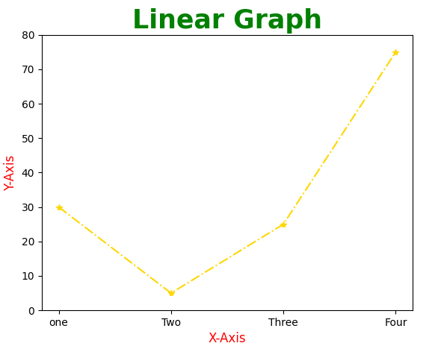
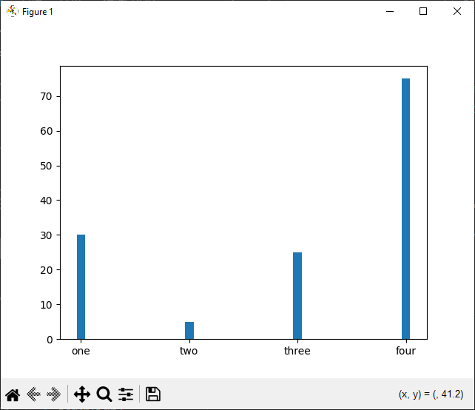
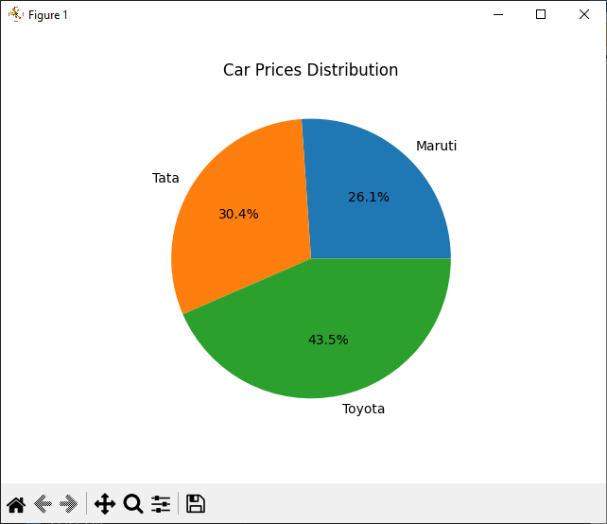

EX.NO: 16
HISTOGRAM

CODE:
# Python code to draw histogram
import matplotlib.pyplot as plt
import numpy as np
# Generate random data for the histogram
data = np.random.randn(1000)
# Plotting a basic histogram
plt.hist(data, bins = 30, color = "orange", edgecolor = "black")
# Adding labels and title
plt.xlabel("Values")
plt.ylabel("Frequency")
plt.title("Basic Histogram")
# Display the plot
plt.show()
OUTPUT: 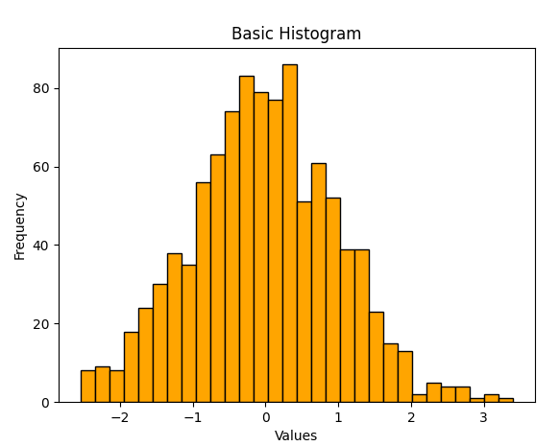

EX.NO: 17
HEATMAP

CODE:
# create correlation heatmap using python
# Import necessary modules
import matplotlib.pyplot as plt
import pandas as pd
import seaborn as sns
# Load the dataset
data = pd.read_csv("student.csv")
# Calculate the correlation matrix
co_mtx = data.corr(numeric_only = True)
# Print correlation matrix
print(co_mtx)
# Plot correlation heatmap
sns.heatmap(co_mtx, cmap = "YlGnBu", annot = True) # linewidths = 5, linecolor = "orange", cbar = False, square = False, vmin = 12, vmax = 24
# Display heatmap
plt.show()

OUTPUT:
student_id grade age
student_id 1.000000 -0.165731 -0.165731
grade -0.165731 1.000000 1.000000
age -0.165731 1.000000 1.000000
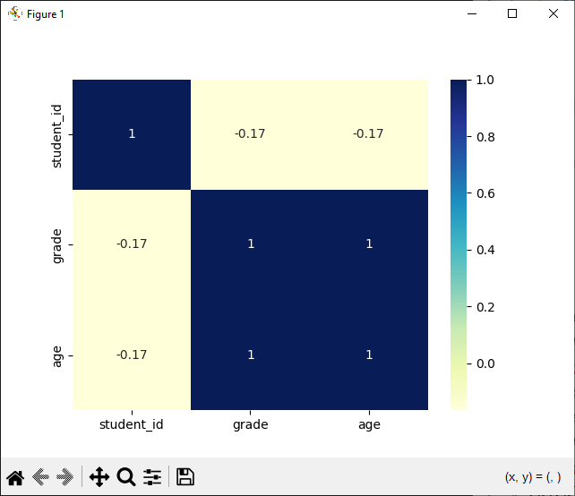

EX.NO: 18
ARITHMETIC OPERATIONS ON DATAFRAMES

CODE:
# Arithmetic operations on dataframes
import pandas as pd
# Create a sample dataframe
data = {'A': [1, 2, 3], 'B': [4, 5, 6]}
df = pd.DataFrame(data)
# Display the input dataframe
print("Input DataFrame:\n", df)
# Perform arithmetic operations
print("\nAddition:\n", df + 2)
print("\nSubtraction:\n", df - 2)
print("\nMultiplication:\n", df * 2)
print("\nDivision:\n", df / 2)
print("\nExponentiation:\n", df ** 2)
print("\nModulo:\n", df % 2)
# Create two DataFrames
import pandas as pd
df1 = pd.DataFrame({'A': [1, 2, 3], 'B': [4, 5, 6]})
df2 = pd.DataFrame({'A': [10, 20, 30], 'B': [50, 60, 70]}, index = [1, 2, 3])
# Display the input DataFrames
print("DataFrame 1:\n", df1)
print("\nDataFrame 2:\n", df2)
# Perform arithmetic operations
print("\nAddition of Two DataFrames:\n", df1 + df2)
print("\nSubtraction of Two DataFrames:\n", df1 - df2)
print("\nMultiplication of Two DataFrames:\n", df1 * df2)
print("\nDivision of Two DataFrames:\n", df1 / df2)
print("\nModulo of Two DataFrames:\n", df1 % df2)
print("\nExponentiation of Two DataFrames:\n", df1 ** df2)
print("\nFloor Division of Two DataFrames:\n", df1 // df2)
OUTPUT:
Input DataFrame:
A B
0 1 4
1 2 5
2 3 6

Addition:
A B
0 3 6
1 4 7
2 5 8

Subtraction:
A B
0 -1 2
1 0 3
2 1 4

Multiplication:
A B
0 2 8
1 4 10
2 6 12

Division:
A B
0 0.5 2.0
1 1.0 2.5
2 1.5 3.0

Exponentiation:
A B
0 1 16
1 4 25
2 9 36

Modulo:
A B
0 1 0
1 0 1
2 1 0
DataFrame 1:
A B
0 1 4
1 2 5
2 3 6

DataFrame 2:
A B
1 10 50
2 20 60
3 30 70

Addition of Two DataFrames:
A B
0 NaN NaN
1 12.0 55.0
2 23.0 66.0
3 NaN NaN

Subtraction of Two DataFrames:
A B
0 NaN NaN
1 -8.0 -45.0
2 -17.0 -54.0
3 NaN NaN

Multiplication of Two DataFrames:
A B
0 NaN NaN
1 20.0 250.0
2 60.0 360.0
3 NaN NaN

Division of Two DataFrames:
A B
0 NaN NaN
1 0.20 0.1
2 0.15 0.1
3 NaN NaN

Modulo of Two DataFrames:
A B
0 NaN NaN
1 2.0 5.0
2 3.0 6.0
3 NaN NaN

Exponentiation of Two DataFrames:
A B
0 1.000000e+00 NaN
1 1.024000e+03 8.881784e+34
2 3.486784e+09 4.887368e+46
3 NaN NaN

Floor Division of Two DataFrames:
A B
0 NaN NaN
1 0.0 0.0
2 0.0 0.0
3 NaN NaN
EX.NO: 19
3D PLOT

CODE:
# 3D plot using matplotlib in python
import matplotlib.pyplot as plt
from mpl_toolkits.mplot3d import Axes3D
import numpy as np
# Generating random 3D data
np.random.seed(42)
n_points = 100
x = np.random.rand(n_points)
y = np.random.rand(n_points)
z = np.random.rand(n_points)
# Creating a 3D scatter plot
fig = plt.figure()
ax = fig.add_subplot(111, projection = "3d")
ax.scatter(x, y, z, c = "blue", marker = 'o')
ax.set_xlabel("X Axis")
ax.set_ylabel("Y Axis")
ax.set_zlabel("Z Axis")
ax.set_title("3D Scatter Plot")
plt.show()

OUTPUT:

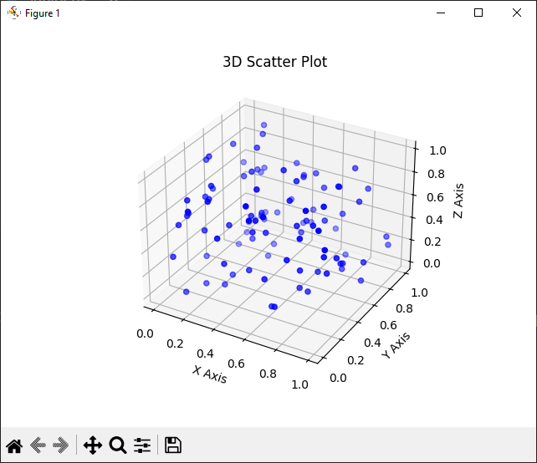

EX.NO: 20
SCATTER PLOT

CODE:
# Scatter Plot using matplotlib in python
import pandas as pd
import numpy as np
import matplotlib.pyplot as plt
df = pd.DataFrame(np.random.rand(50, 4), columns = ['A', 'B', 'C', 'D'])
df.plot.scatter(x = 'A', y = 'B')
plt.show()

OUTPUT:
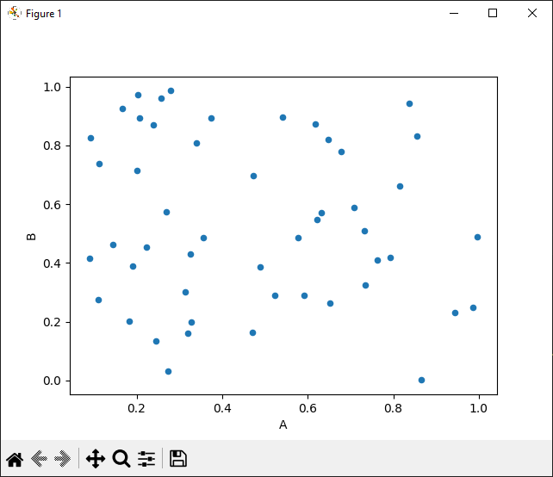
EX.NO: 21
ANNOTATIONS

CODE:
# Annotations using matplotlib
import matplotlib.pyplot as plt
# Plotting data
x = [1, 2, 3, 4, 5]
y = [2, 3, 5, 7, 11]
plt.plot(x, y, marker = 'o', linestyle = '-', color = "blue")
# Adding annotation
plt.annotate("Peak", xy = (3, 5), xytext = (3.5, 6), arrowprops = dict(facecolor = "black", arrowstyle = "->"), fontsize = 10)
plt.xlabel("X-axis")
plt.ylabel("Y-axis")
plt.title("Annotated Plot")
plt.grid(True)
plt.show()

OUTPUT:
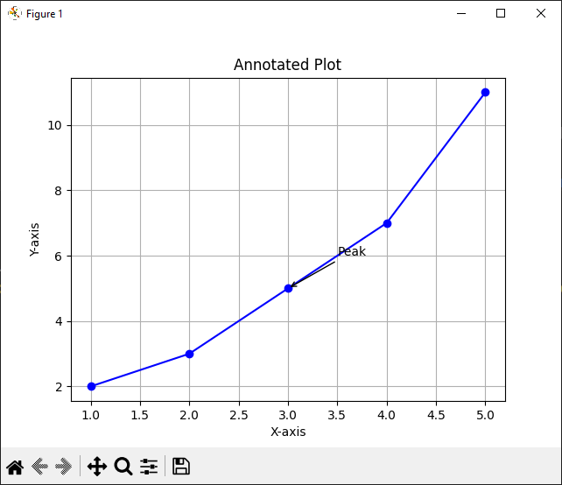

EX.NO: 22
DRAWING GRAPH USING TIMESERIES

CODE:
# Drawing graph using timeseries
import pandas as pd
import matplotlib.pyplot as plt
import numpy as np
# Generate random time-series data
np.random.seed(42)
dates = pd.date_range(start = "2022-01-01", periods = 100, freq = 'D')
values = np.random.randn(100).cumsum()
# Create a dataframe from the generated data
data = pd.DataFrame({"date": dates, "values": values})
# Set the 'data' column as the index
data.set_index("date", inplace = True)
# Plot the time-series data
plt.plot(data.index, data["values"])
plt.xlabel("Time")
plt.ylabel("Value")
plt.xticks(rotation = 45)
plt.title("Time Series Data")
plt.tight_layout()
plt.show()

OUTPUT:
