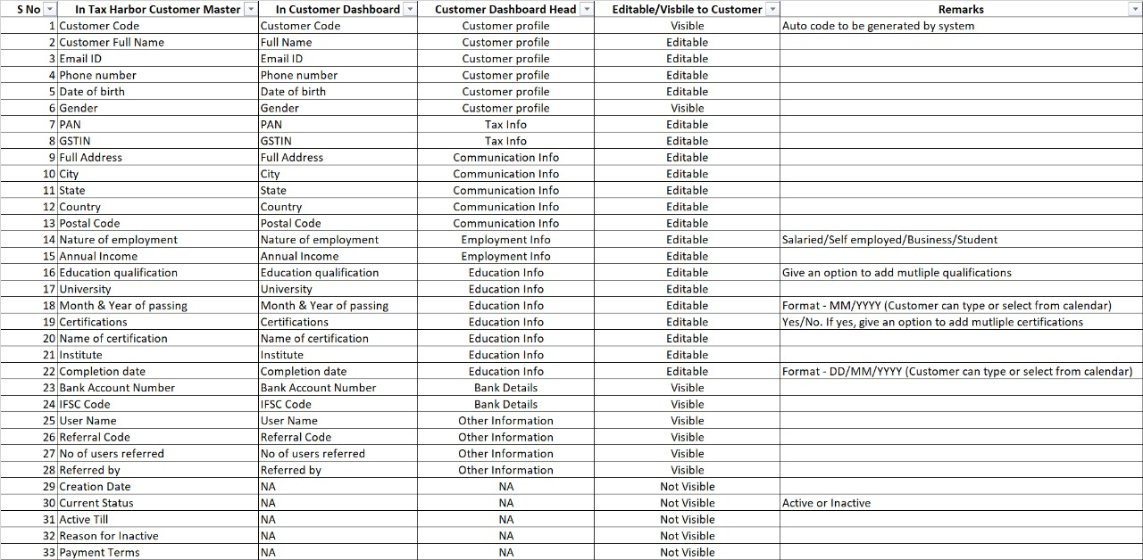

Admin Panel

In Services Tab

1. Make 80% Screens size as default which is 100%

2. All the fields in service master is not available (Refer "Service Master" sheet)- Add the fields same as in the master file ALL FIELDS ADDED

3. Due date cannot be modified In the services tab for the existing services FIXED

4. Put Clear option for all filters (Including ID, Name, Date) outside for removing filters AVAILABLE IN CALENDAR OPTION

5. Keep all fields Mandatory in services Tab while creating new service DONE

6. Change the Date format to DD/MM/YYYY DONE

7. Remove "filter by name" box and keep same as customers tab and adjust all the filters (to left) and add clear option in the last (right Side) filter by name, id and date are left now , and styling done as requested

8. Decrease the size of the Boxes styling already done

9. All Fields should appear in the PDF & Excel download same as the fields mentioned in the "Service Master" DONE

10. Remove "Add service option" from Services tab and keep it in Dashboard with all fields as per "Service Master" Sheet Will remove when site is fully finalized

11. Move Download option of Excel & PDF above the table instead of below done

12. Remove the boxes for Download for excel and PDF and replace it with Images of Excel & PDF done

13. While downloading the CSV or PDF Date and time should appear in different columns done date appears now in dd/mm/yyyy format

14. Remove "Delete" option and replace it with "In-Active" as there should not be an option to delete the service Will remove when site is fully finalized

15. Add symbols for modify and delete options in Actions field done

16. No action when clicked on notifications symbol done now redirects to message center

17. Replace "Manage SErvices" on top of the services dashboard with "Service Master" done

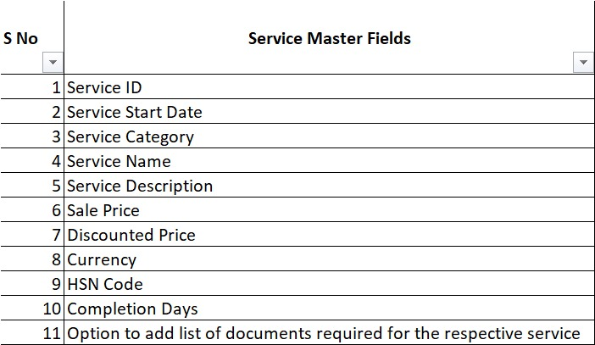

Admin Panel

In Customers Tab

1. Make 75% Screens size as default which is 100%

2. All the fields in customer master are not available (Refer "Customer Master" sheet)- Add the fields same as in the master file including bank account details DONE

3. To understand what is activate option in "Actions" field. It is for allowing users to log in , when user registers, he is activated by default

4. Put Clear option for all filters (Including ID, Name, email, Mobile no, Date) outside for removing filters done

5. Keep all fields Mandatory in Dashboard Tab while creating new customer and Remove "Select Role" & "Select Service" Drop down and "user name" done

6. Change the Date format to DD/MM/YYYY done

7. Adjust all the filters (to left) and add clear option in the last (right Side) done

8. Decrease the size of the Boxes styling already done

9. All Fields should appear in the PDF & Excel download same as the fields mentioned in the "Customer Master" sheet done

10. Move Download option of Excel & PDF above the table instead of below done

11. Remove the boxes for Download for excel and PDF and replace it with Images of Excel & PDF done

12. While downloading the CSV or PDF Date and time should appear in different columns date format fixed

13. Remove "Delete" option and replace it with "In-Active" as there should not be an option to delete the Customer Will remove when site is fully finalized

14. Reduce the size of modify and In-active boxes in action field done

15. No action when clicked on notifications symbol done now redirects to message center

16. Replace "Manage Customers" on top of the customer dashboard with "Customer Master" done

Admin Panel

In Employees Tab

1. For every employee an option should be configured to assign L+1 (employee code) and L-1 (employee code). Done fields added

2. Admin should have an option to create/modify a designation in the employees tab done field is present in table and it can be edited

3. Admin should have an option to promote (Based on designation) every employee designation is already editable

4. Admin should have an option to assign more than one service to an employee (increase/decrease)

5. Keep a modify option in the actions field which allows admin to change any data for employee. Done for all panels

6. Make 80% Screens size as default which is 100% styling already done

7. All the fields in employee master is not available (Refer "Employee Master" sheet)- Add the fields same as in the master file done

8. When we click on "Grant access" an error pops us saying "Failed to update download access". Need to understand why this is happening already fixed

9. Remove "filter by name" box and keep same as customers tab and adjust all the filters (to left) and add clear option in the last (right Side) done all filters are same now in all panels

10. Decrease the size of the Boxes styling already done

11. Change the Date format to DD/MM/YYYY done

12. Top right there is a box called "Newest first". Remove the box and add a sort symbol instead done

13. While downloading the CSV or PDF Date and time should appear in different columns date format fixed ,time not included

14. Move Download option of Excel & PDF above the table instead of below done

15. Remove the boxes for Download for excel and PDF and replace it with Images of Excel & PDF done

16. Remove "assign customer" option and add "assign order" option. This has been discussed multiples times done

17. Replace "Manage Employees" on top of the customer dashboard with "Employee Master" done

18. All the fields in the employee tab should appear in the downloaded excel and PDF. In csv all fields can appear but pdf can t render 45 fields due to space issue

19. Remove delete option in the action field will do when site finalized

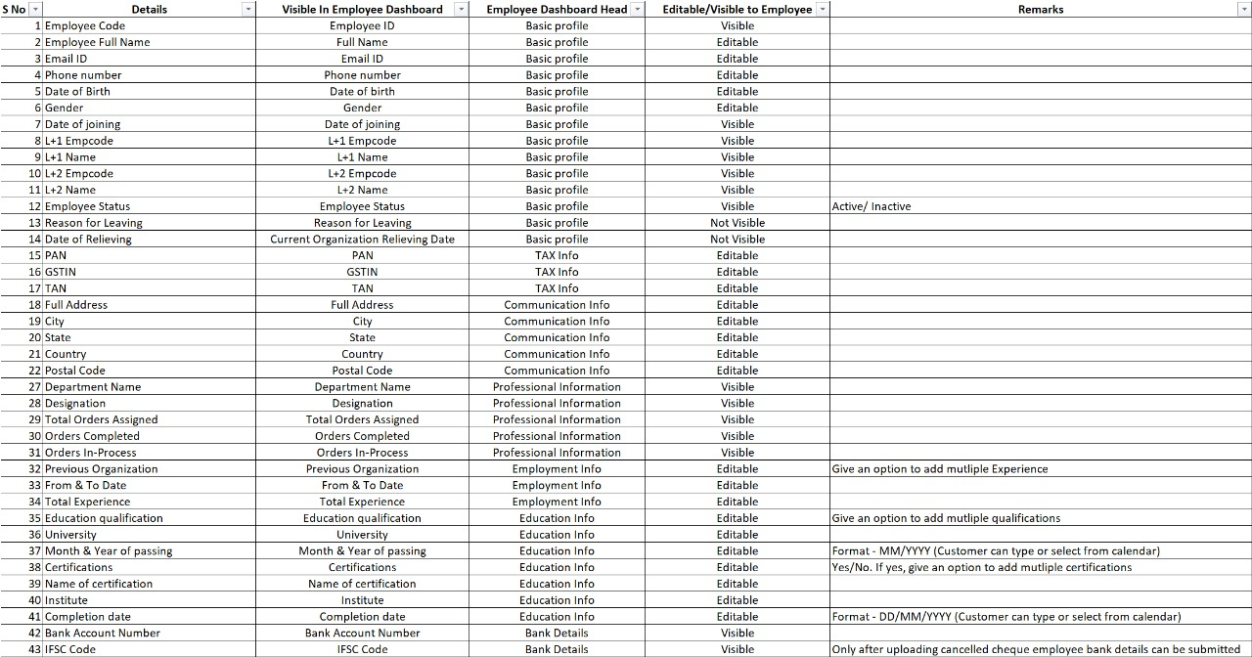

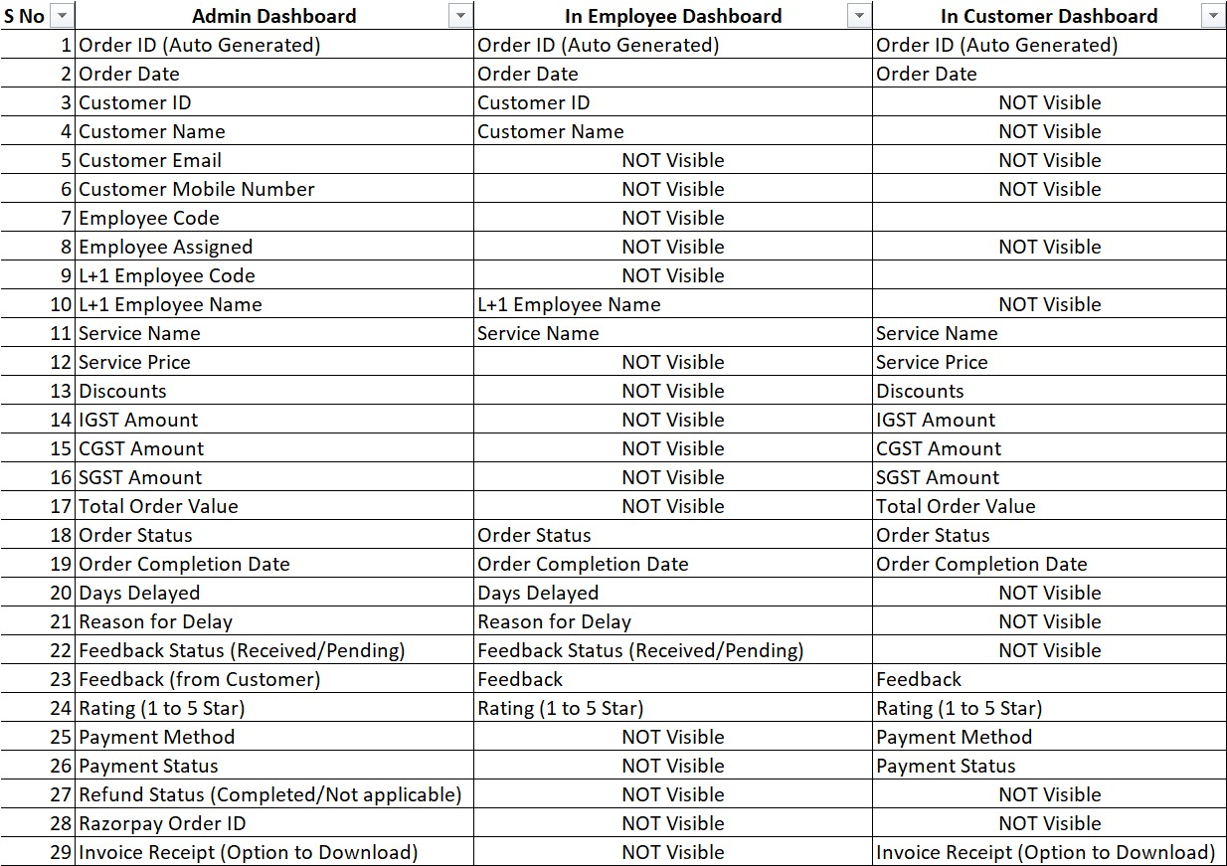

orders table format date done

add icons delete and modify in all tables done

Add loading in chat system done

promote option in employees tab done  
  
  
1) homepage and service pages made responsive now (mobile friendly)  
2)all fields added as per sheets , will remove add service, add employee buttons from tabs when site is finalized ,   
all these buttons are also present in dashboard tab   
3) there is no invoice download option , only order id and payment id is generated by Razorpay when customer pays, you can download invoice form Razorpay dashboard itself  
4) In csv all fields can appear but pdf has less space for adjusting 45 fields but it is there in all tabs, so you can check yourself if it is readable  
5)delete options will be removed when site is finalized from all panels  
6)flexi funnel logic fixed   
7) customer can register without actually purchasing a service, in case of flexifunnel customer, admin will assign the service to him , that option is added   
8) loan calculator is fixed in personal loan page, with the addition of months and ROI fields (you can check all service pages and their designs by visiting different pages from services dropdown